**Diagram: Microservice Saga Pattern**

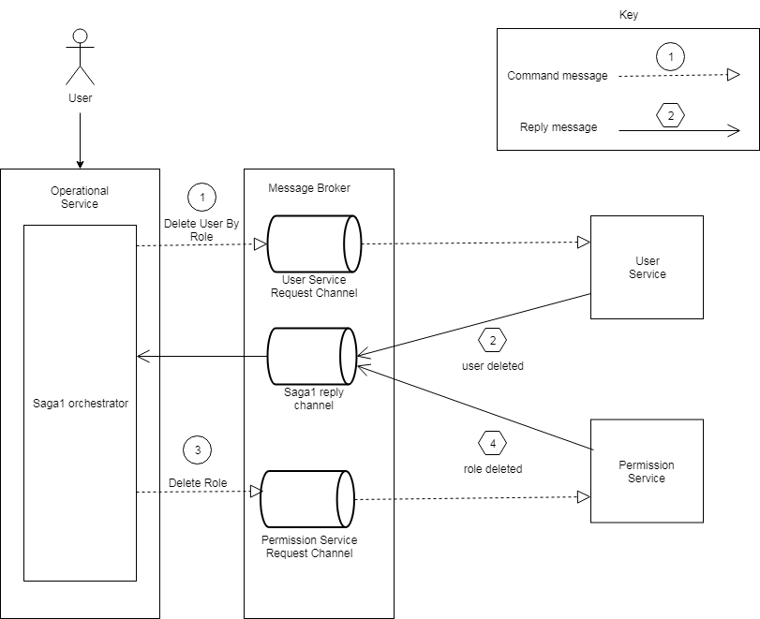

**Code Snippet: Microservice Saga Pattern**

