# Bug Fixing Report

### 2.3. As a word of observation, can I also ask you to make sure that you test the functions you deliver before you release them in order to iron out basic errors before we find them? The reason I mention this is because it doesn’t look as though there has been any great level of testing on the restore functions.

I asked you to test restoring database only. May be, you haven’t understood message because of my bad English. Sorry if so. Anyway, testing application by another person is good idea and it helped me to fix issues that weren’t me visible.

One comment only: don’t panic seeing alert box after data were submitted to service – data validation on client side is performed when validation rules do not depend on SQL server’s settings. SQL server is active participant of data validation too. It returns you error messages and that’s all – your data base isn’t corrupted in error case.

Information for programmers – all data base operations run in transaction scope and transaction’s isolation level is “Serializable” (I am working with financial databases and know how important data integrity is).

### 3.1. Can you also confirm that the previously discussed issue of needing the put the DB into ‘Single user mode’ has now been resolved? If it has does the check box at the top of the screen print actually work?

Single user mode is important in one case only: when you are restoring data base overwriting existing one (see my comments on issue 6.4). I left this flag on backup/restore page hiding this checkbox on all other pages.

### 5.1. If the directory specified for a database backup doesn’t exist the backup process fails.

The bug is fixed: service reports about invalid directory:

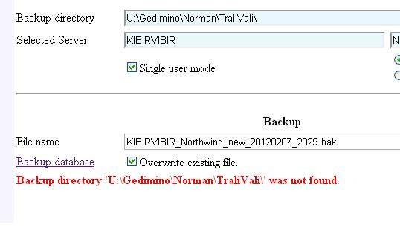

It is normal error message, not crash but a trap is here: IIS and browser are caching pages thus you are fetching the same picture after WEB.CONFIG was corrected. I killed this feature in current version and now it is enough to perform listed below procedures:

1. Correct WEB.CONFIG,
2. Refresh the page,
3. Login into database again.

### 6.1. When restoring a DB from a ‘.bak’ file the wait symbol continues to cycle even after the file has been selected.

The bug is fixed, see attached picture:

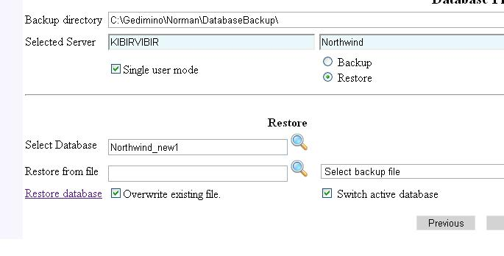

### 6.2. The restore routine doesn’t appear to be looking in the correct sub-directory for the backup file that needs to be restored. Shouldn’t this be the same as the one specified in the web-config file that the backup is written to?

Bug is fixed. The application fetches backup directory name from WEB.CONFIG, key="BackupDirectory". I did the field writable – correct it manually if someone changed WEB.CONFIG while you are working with this page.

### 6.3. If the backup folder contains more than one backup file there is no option to search and select the relevant file. Perhaps this should be the same process as the one used to select the database where there is a choice of more than one in the folder.

The bug is fixed. Take into account that the application appends date and time making name of the backup file unique. Clicking on “magnifier” will result to empty list unless you erase tail of the name. See picture below.

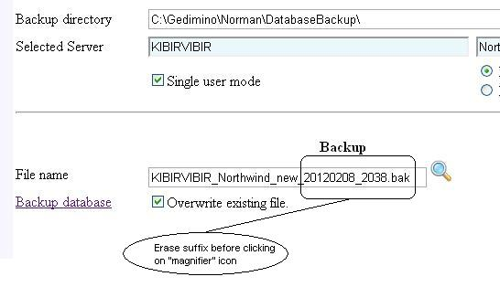

### 6.4. The system doesn’t allow the user to restore a database to a live database and so the option available to us is to leave the application and to create a new empty or blank database via SQL Express. We can then return to the application and select the newly created DB to restore to. Would it be possible to add an option to the end of list of Databases names that says something like ‘Create New’? This would allow all the activity to be completed within the control of the application itself.

I enhanced the project with procedure for killing processes running on target database (database that you are going to overwrite from backup file). Write it into source database (database that you are using for connecting to server) launching file C:\Repo.git\CFCDatabase\SQLscripts\Create_usp_KillUsers.sql. The service will kill all processes connected to target database before switching to single user mode (restore database overwriting existing one is the only place where flag “Select single user mode” is mandatory).

Experimenting with SQL 2008 R2, IIS7.5, Windows WEB Server 2008 R2 I found what goes wrong on your environment and here is instruction how to configure the application:

1. All Microsoft.SqlServer.Management.Smo operation (backup, restore, enumerate tables, …) are running under Web application’s account. Working with IIS7x you need:
   1. Create separate application pool on IIS,
   2. Assign some name and password for the pool (Harry/Potter for example),
   3. Move WEB application into this pool,
2. Create user in your SQL server with the same credentials (Harry/Potter),
3. Login into database using SQL Server Management studio; use SQL authentication mode with Harry/Potter credentials and ensure that this user has sufficient rights:
   1. Try to kill processes launching “EXEC usp_KillUsers targetDatabase”,
   2. Switch target database to single user’s mode
   3. Backup database,
   4. Restore it from the backup file,
   5. Switch target data back to multiuser mode.

usp_KillUsers will complain that it is impossible to kill running process. This is normal position and the service ignores this error message.

After configuring account the application will work: I was playing with 3 different computers: service, remote client of the application and remote client of MS SQL server (table’s editor was opened there) and got no errors:

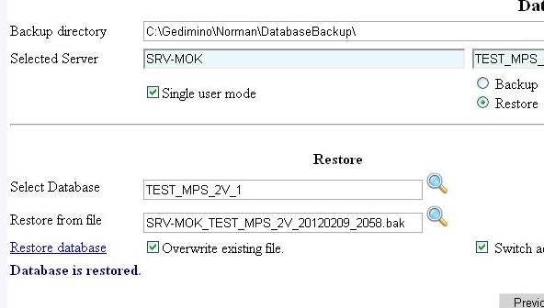

I was surprised: I could to continue data editing after database was restored, but I don’t recommend you “repeating that at home”. I got this lucky case because initial and restored databases were identical.

### 6.5. When restoring a DB the application gives the following syntax error (See the Fig. 5 screen print below). I suspect that this is because the use of “-“ in a file name isn’t allowed but the error message doesn’t say that and perhaps it should.

The bug is fixed. Input screen accepts letters, digits, points and underscores only.

### 7.1.  This appears to work but can you confirm that the database integrity is maintained (e.g. all relationships and dependencies are kept)

MSDN says that SQL server is using GUIDs, names are used for creating human messages and screens only. I found no integrity problems here.

### 8.1.  When inserting a new text column to an existing table the insert fails with an error

There is no error here: close the dialog and recreate the column following supplied instruction. Inserting new column into the table with data is possible when valid one of listed below conditions is:

1. column accepts NULLs,
2. column has default value,
3. column has identity constraint or it is of timestamp type.

Look at your screenshot and you’ll see that your data are invalid.

### 8.2.  When inserting a new text column with a default value to an existing table the insert fails with an error

I wrote you about this situation earlier: there is no error here. Server side performed data validation and rejected your data because of invalid format. Correct default value writing expression in format that SQL server understands and data will be stored. Grammar for writing default values is complex enough and I am not going to reinvent it on JavaScript. That is possible but requires much work and has little sense because most data formats depend on SQL server’s settings.

I don’t see what data type was created but xxx can be accepted for character types only. You must enclose this value with single quotes in this case. Without quotes you can write numeric values only. Here are some samples of valid default values:

100 128457.28

‘2012-01-25T21:48:27’ ‘this is string’

‘{D37F4950-CF78-49BC-BC5E-DC3A42FC1E75}’ (7 + 12)

(GETDATE()) (NEWID())

Some words about decimals: consult with programmers that works on your DB: format depends on installing specifications. Comma may be used for separating fraction part. Exotic American or English formats may be supported too but this depends on installation settings and Windows locale.

Most problematic are date constants. I wrote it in standard format that is supported by all installations (look at time part – 24 hours clock, no mystical AM, PM are there). Your native date/time format would be supported too but consult with programmers or administrator – date format depends on SQL server’s installation and Windows locale (on machine where SQL server is running, not yours desktop computer).

### 8.3. Would it be possible to display a count of rows of records that contain data when inserting new columns or renaming tables as this would give us some reassurance that the data has been maintained and not lost during the process?

Yes, current version of the service returns count of records in the table (see field RecordCount in the response object. Operations on table displays that information.

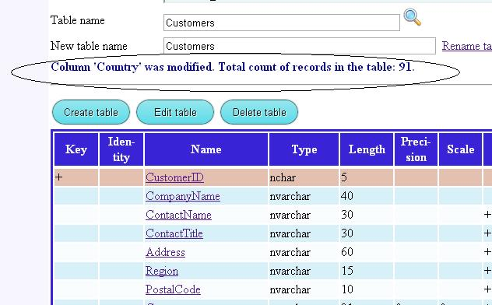

### You will recall that when we first discussed this project we requested that you use the DB_Changes table to record any changes to the database and to keep a log of the versions of the database.  Our thought here is that before anything is done to the database the application should;