### We entered an incorrect password in error and the system gave a strange error message that wasn’t particularly helpful. Could your ensure that the any error messages are relevant to the situation please. Perhaps “Incorrect username or password entered”

Well, I replaced the message but it is not mine – it came directly from AD.NET.

### Can I ask you to either suppress the ‘NEXT’ button or grey it out until it is useable please.  The reason here is that until we have successfully connected to a database the ‘NEXT’ button has no purpose.  We made the mistake of pressing the button and caused the application to freeze until we hit the ‘BACK’ button.  There was no message displayed to tell us that we had selected the wrong button.

First page shows button “Next” after successful connection to database.

### The application correctly allows the user to choose the database to be backed up, however, in our case the filename contains a hyphen “-“ (e.g. CFC_Database-v1_date_time). Unfortunately the use of this character in a filename apparently is allowed so the backup fails. This isn’t a problem once we realised what the issue was but perhaps a helpful message might help.

Not a problem – I extended set of valid characters in file name and now hyphen is valid character. Information for programmer: set of charactera in file name is restricted with Regular expression - file BackupStepEventHandlers.js, line 32. Feel free correcting it.

### The application seems to add the directory path to filename and fails to find the .bak file.  We have found that we need to manually remove this from the selection field before we are able to proceed.

The application creates unique for every session name of the backup file. It consists of:

* 1. SQL server’s name,
  2. Database name,
  3. Time (year, month, day, hours and minutes).

This allows you keeping history in backup files. It is enough to erase some information before clicking on “magnifier“ if you want to overwrite some file. Correctly configured browser will show backup history without calling the service:

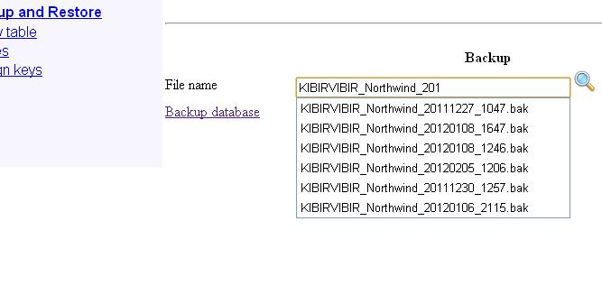

Drop down list will show the files that start with “KIBIRVIBIR_Northwind_201” only:

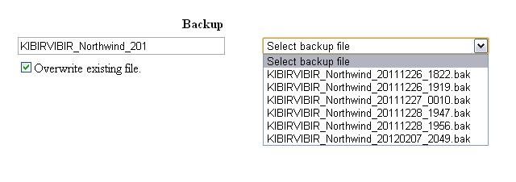

I created new setting in WEB.CONFIG:

<add key="BackupFileTemplate" value="None"/>

Text box with backup file name box will be empty after reading this key. Comment out this line in WEB.CONFIG(line 23) if you’ll find that standard mode is better.

### Having correctly carried out the backup the application then fails with a serious error which caused us to terminate the testing exercise.  The error message is shown below.

I could to recreate the situation performing these tricks:

* 1. Blocking SQL server for long time,
  2. Restarting SQL server,
  3. Restarting IIS,
  4. Left Browser inactive for time that exceeds default session time out (20 minutes).

Any of these situations has no solution from browser’s window. Close browser’s window and start the application again: the crash will not corrupt your database because every sequence of database modification is wrapped with transaction (see WEB methods in file CfcWebService.asmx.cs). The only exception are BackupDatabase and RestoreDatabase: they won’t work in transaction scope.

Crashes on time out can be reduced correcting Aplication’s and Service’s WEB.CONFIG files. Some of these values are set in machine config file.