Hello Norman.

I understood why testing failed today: you were connecting to remote SQL server. This makes a lot of problems:

1. SQL server and CfCService must have full access rights to backup directory when you are connecting to remote SQL. Moreover, this backup directory must have the same name on both computers. The easiest way to access this is using shared directory on third computer and map it to the same device on both computers (SQL server and IIS with service). See picture below

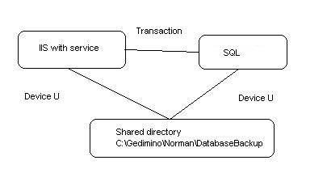

1. Second problem is transaction flow: I wrapped all vital operations with transaction scope. This is necessary for data integrity but requires Distributed Transaction coordinator Service. This schema requires full power DTS that comes with Windows 2008 Server (light weight WEB edition of the server does not have it). Windows 7 has restricted version of the DTS that coordinates transactions inside single computer only. First versions of the service were working without transactions making no problems for you.
2. Last problem is my bug - written service is using 2 different accounts:
   1. SQL server’s authentication with supplied name/password for ADO.NET operations,
   2. Windows account of service’s process for performing SMO operations. This is OK when SQL server and CFCService run on the same computer or on Local Network with Domain authentication. Well, it is my bug and I am fixing it now.

Installing service on the same machine as SQL makes life much easier, all mentioned problems have easy solution and I recommend you using this schema. I tested the service on single computer and know that it works.

Prepare me remote connection to computer where SQL server is installed. Activate IIS there and install LogMeInHamachi or TeamViewer for secure connection.