# Installation Guide

This HowTo document explains how to install Service on computer where SQL server is installed. Comments about installation CFCService on computer different from SQL server’s host is supplied at the end of this document.

Glossary:

* SQLhost – computer where SQL server is installed,
* SourceDB – CFC in your case,
* TargetDB – DB that was created from the backup and you are going to modify it.

## Prepare IIS

1. Login into SQLhost for ensuring that IIS is up and running. Click:

Start/ControlPanel/Add or Remove Programs/Add/Remove Windows Component

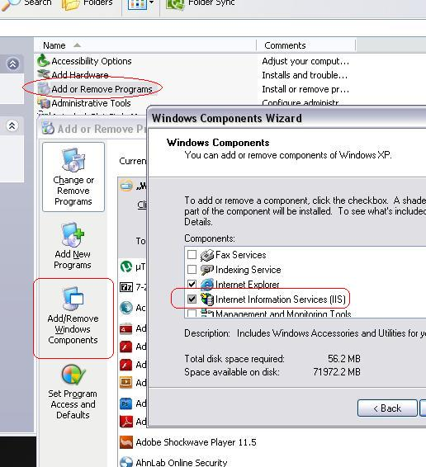

Check on “Internet Information Services (IIS) and click “Next” if IIS is not installed. The process will require DVD with Windows Installer. Move Apache 80 to another port (I am using 8080) if it is installed on your computer (standalone or with WAMP server). Restart computer after installing IIS.

I’d recommend you to copy to desktop shortcut to Internet Information Services – starting IIS management will be faster.

1. Verify default WEB site:

Start/ControlPanel/Administrative Tools/Internet Information Services

Right click on “Web Sites”, select “Properties” and go to ASP.NET tab:

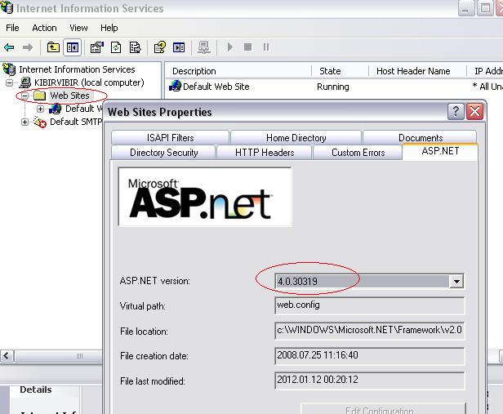

You don’t need to change setting of the default pool working with IIS 7.x. You can move application into the pool dedicated for ASP.NET 4.0 after installation.

1. Open any WEB browser and login into [www.github.com](http://www.github.com) with login kimanidev. Go to kimanidev/CFCDatabase and download ZIP into any empty directory.

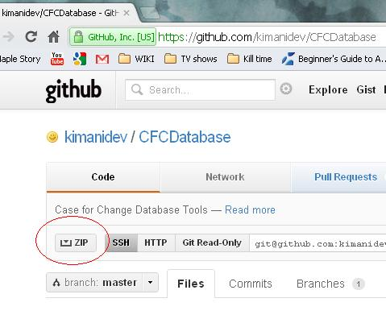

Expand ZIP file.

1. Ensure that “Microsoft WEB Deploy V2” is installed on your computer. It would be in the

C:\Program Files\IIS\Microsoft Web Deploy V2

directory. Download it from

<http://www.microsoft.com/download/en/details.aspx?id=25230>

if the package is not installed.

1. Go to “~\CfCServiceTester\obj\Debug\Package” directory. Sign ~ stands for directory where you unpacked ZIP file.
   1. Launch Command Prompt (on Windows 7 – launch it as administrator) and enter commands:

cd ~\CfCServiceTester\obj\Debug\Package

dir /w

CfcServiceTester.deploy.cmd /T

* 1. Fix the problems if last command reports errors (you can launch “CfcServiceTester.deploy.cmd /T” command again – the /T key stands “testing”).
  2. After all problems were fixed install the application launching command

CfcServiceTester.deploy.cmd /Y

and close console entering command Exit.

1. Open IIS management console again (or make the window active if you did not close it). Default WEB site has CfCServiceTester_deploy virtual directory now. It is your application. Right click on CfCServiceTester_deploy selecting Properties (Advanced Settings on IIS 7.x):

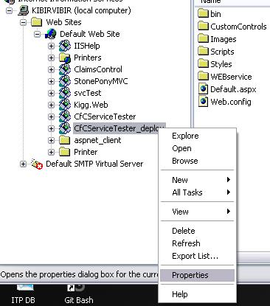

1. Go to “Virtual Directory Path”, copy the path into Windows Explorer and open WEB.CONFIG file in any text editor.

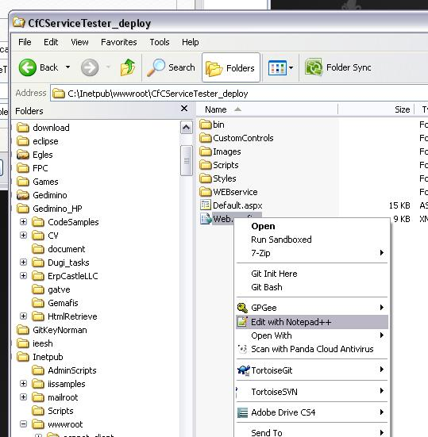

1. Correct Backup directory path:

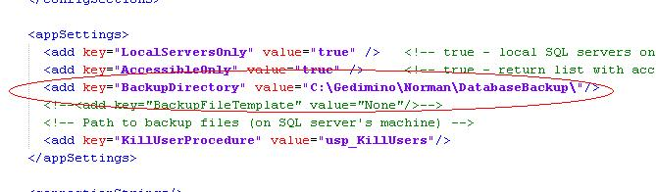

## Configuring Services

1. Open Services management console:

Start/ControlPanel/Administrative Tools/ Services

1. Enable, change Startup type to automatic and start listed below services:
   1. Distributed Transaction Coordinator,
   2. Messenger (this service is disabled by default; right click on it, select “Properties” and enable it there).
   3. SQL Server (it would be started because you are working with it),
   4. SQL Server Browser.
2. Launch Microsoft SQL Server Management Studio and connect to SourceDB:

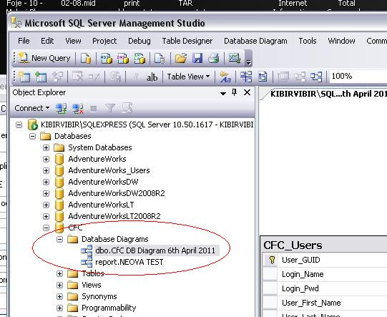

If you have no Microsoft SQL Server Management Studio, download this tool from the <http://www.microsoft.com/download/en/details.aspx?id=22985>.

1. Open file ~\SQLscripts\CFC_DB_Setup.sql in Microsoft SQL Server Management Studio, correct login name and launch the script on source and target databases:

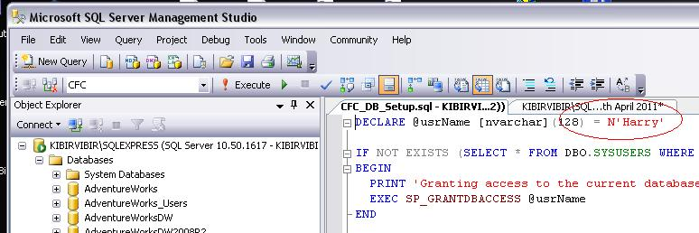

Launch corrected script on source and all target databases. **The script will remove CFC_DB_Changes table and shall recreate it with new fields.** Make backup of this table if you have some information there.

1. Installation is ready, connect to the

<http://localhost/CfCServiceTester_deploy/Default.aspx>

and test the application.

You can test the application from any computer on local network, where the IIS is visible. Write computer’s name instead of localhost:

<http://kibirvibir/CfCServiceTester_deploy/Default.aspx>

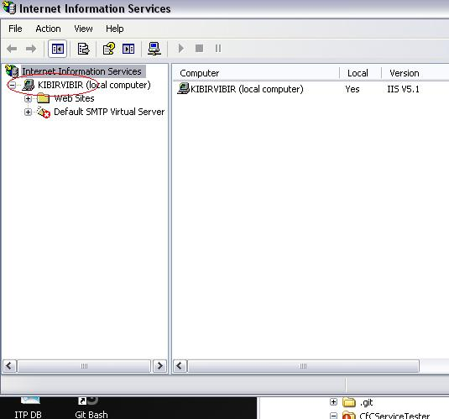

## Security considerations

The service is working at very high privileges – don’t make it visible from outside world. If your WEB Server has external address and it is impossible to hide the service from outside world then:

1. install freeware lightweight HHTP server, compatible with .NET 3.5:
   1. <http://ultidev.com/products/cassini/>,
   2. <http://www.aprelium.com/abyssws/>
2. launch it on non standard port and open the port for local network only,
3. Install WEB site on this local service and work with it.

Take into account that I never tested this scenario – so play with it after you will be sure that service is running at your own risk.

## Installing WEB site on computer, different from SQLhost

This is possible but requires full power Distributed Transaction Coordinator (coordinating transactions between different computers). This DTS version comes with Windows Server 2008 Enterprise Edition only and I have no it. Follow document BugFixingReport_3.docx if you do need this configuration and have all tools for its working.