**The Impact of Climate Change on Agriculture in Africa**

**Introduction**

Agriculture is a vital component of the African economy and way of life, providing food, employment, and income to millions. However, climate change poses a significant threat to traditional farming practices across the continent. This photographic essay explores how climate change is impacting agriculture in Africa, highlighting the challenges faced by farmers and the innovative solutions being implemented to adapt and overcome these difficulties.

**Traditional Farming Practices**

For centuries, African communities have relied on traditional farming methods tailored to local environmental conditions. These methods, including manual plowing with oxen, hand planting of crops, and the use of indigenous seed varieties, have sustained agricultural productivity and food security. The deep knowledge of local ecosystems and weather patterns has allowed farmers to manage crops and livestock effectively.

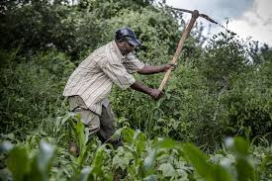

**Signs of Climate Change**

The impacts of climate change are becoming increasingly evident. Prolonged droughts, erratic rainfall, and rising temperatures are disrupting established agricultural practices. Fields that once yielded abundant crops are now facing severe drought, with soil cracking and crop failure becoming more common.

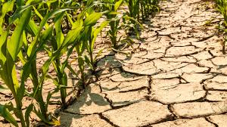

**Impact on Crop Yields**

As climate conditions become less predictable, crop yields have significantly decreased. Changes in temperature and rainfall patterns are affecting the growth cycles of essential crops such as maize, beans, and millet. Farmers are experiencing lower harvests, which threatens food security and increases the risk of malnutrition in many communities.

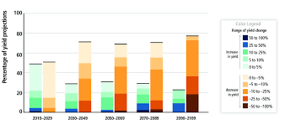

**Water Scarcity**

Water scarcity is a growing concern, exacerbated by reduced rainfall and the overuse of available water resources. Farmers are struggling to irrigate their fields and provide sufficient water for both crops and livestock. This scarcity is not only affecting agricultural productivity but also impacting daily life for many rural communities.

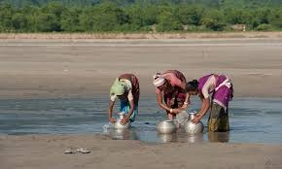

**Adapting to New Realities**

In response to the challenges posed by climate change, many farmers are adopting new techniques and technologies. Innovations such as drought-resistant crop varieties, improved irrigation systems, and soil conservation practices are helping to mitigate the impact of changing climate conditions. These adaptations are crucial for maintaining agricultural productivity and ensuring food security.

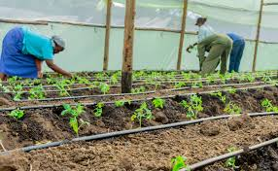

**Community Resilience**

Community resilience is essential for addressing the impacts of climate change. Local organizations and farmer groups are working together to share knowledge, resources, and strategies for adaptation. Workshops, training sessions, and collaborative projects are fostering a spirit of resilience and cooperation among farmers.

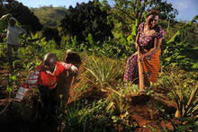

**Government and NGO Initiatives**

Governments and non-governmental organizations (NGOs) play a crucial role in supporting farmers through climate-smart agricultural practices. These initiatives include providing financial support, technical assistance, and resources to help farmers adapt to new conditions. By working together, these organizations are helping to strengthen agricultural systems and promote sustainable practices.

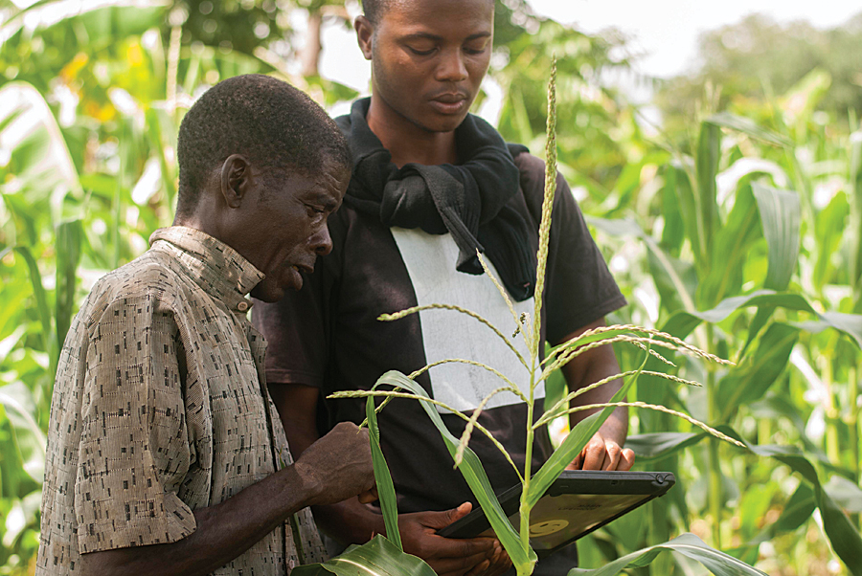

**Hope for the Future**

Despite the numerous challenges, there is hope for the future. Young farmers and innovative community projects are embracing sustainable agricultural practices that offer a glimpse of resilience and adaptation. By focusing on education, technology, and community engagement, Africa is working towards a more sustainable and secure agricultural future.



**Conclusion**

The impact of climate change on agriculture in Africa is profound, affecting crop yields, water availability, and food security. However, through innovation, adaptation, and community resilience, there is hope for a sustainable future. By integrating traditional knowledge with modern practices and fostering collaboration, African communities are finding ways to address the challenges posed by climate change and ensure the continued viability of their agricultural systems.

