Lab 1: Reproducible Data Visualization Workflow
Kimaya Lacey

Part 3: Loading Packages

Part 4: Confrim the project Root
[1] "/Users/klacey/Downloads/Data Visualizations"

Answer:
- What path was printed?” /Users/klacey/Downloads/Data Visualizations”
- Does it point to the correct course project? Yes
- Why is working from an R Project preferable to manually setting the working directory? The R Project will provide easy access to all documents, figures, and data essential for the project.

Part 5: Create the Folder Structure

Part 6: Inspect the Folder Structure
Lab1-KL.qmd Lab1-KL.rmarkdown publichealth_county.csv

Part 7: Create a Simulated Public Health Dataset
county region adult_population vaccination_rate asthma_visit_rate
1 Cook North 245,000 .92 245.6
2 Lee Central 746,218 .14 318.4
3 Dekalb South 501,321 .67 187.9
4 Lithonia South 175,093 .53 421.7
5 Rockdale North 632,844 .81 356.2
6 Cobb Central 382,742 .30 279.5
7 Fulton Central 946,129 .49 512.3
8 Gwinett South 123,456 .25 198.7
9 Chatham North 789,032 .78 384.1
10 Hill South 216,822 .42 267.8
11 Richmond Central 876,543 .56 449.6
12 Henry North 497,641 .29 331.5

Part 8: Save the Dataset
write_csv(publichealth_county, "publichealth_county.csv")
here()
[1] "/Users/klacey/Downloads/Data Visualizations"

Part 9: Remove and Re-Import the Dataset
Rows: 12 Columns: 5
── Column specification ────────────────────────────────────────────────────────
Delimiter: ","
chr (2): county, region
dbl (2): vaccination_rate, asthma_visit_rate
num (1): adult_population
ℹ Use `spec()` to retrieve the full column specification for this data.
ℹ Specify the column types or set `show_col_types = FALSE` to quiet this message.

Part 10: Inspect the Data
Rows: 12
Columns: 5
$ county <chr> "Cook", "Lee", "Dekalb", "Lithonia", "Rockdale", "Co…
$ region <chr> "North", "Central", "South", "South", "North", "Cent…
$ adult_population <dbl> 245000, 746218, 501321, 175093, 632844, 382742, 9461…
$ vaccination_rate <dbl> 0.92, 0.14, 0.67, 0.53, 0.81, 0.30, 0.49, 0.25, 0.78…
$ asthma_visit_rate <dbl> 245.6, 318.4, 187.9, 421.7, 356.2, 279.5, 512.3, 198…
# A tibble: 1 × 3
num_county mean_vaccination_rate median_asthma_visit_rate
<int> <dbl> <dbl>
1 12 0.513 325.
Answer:
- What does one row represent? One County and its corresponding metrics.
- How many variables are included? 3
- Which variables are categorical? Region and County
- Which variables are numeric? Vaccination rate, population, and asthma visit
- Which variable should be used to compare asthma burden fairly across counties? Asthma Visit Rate as it is reported per 100,000 people across each county.

Part 11: Create a Ranked Vaccination Bar Chart
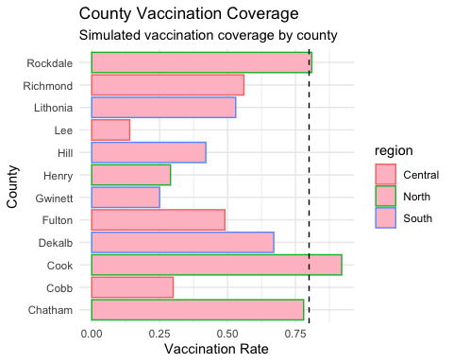
Simulated vaccination coverage by county.

Part 12: Interpret the Figure
Answer in two or three complete sentences.
- What pattern does the figure show? The figure shows that vaccination rates vary considerably across counties. Cook and Rockdale have the highest vaccination rates and exceed the 80% target, while most other counties fall below the target.
- Which counties appear furthest below the target? The Lee, Cobb, Henry, and Gwinnett counties appear the furthest below the 80% line, with Lee having the lowest vaccination rate.
- What context would be required before using this graph for a real decision? Before using this graph for a real decision, we would need to know whether the vaccination data are reliable and current, how the rates were calculated, and which population was included. The graph is based on simulated data, real and verified data would be necessary before making public health decisions.

Part 13: Save the Vaccination Figure

Part 14: Independent Visualization
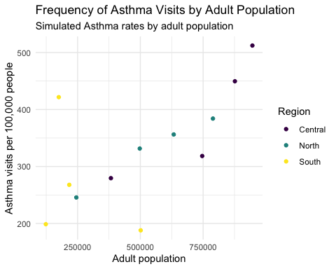
Independent visualization created by the student.

Part 15: Save the Independent Figure

Reflection Questions

Question 1
Why is reproducibility important in public health research and practice?
Reproducibility is important in public health research and practice because when working with data, trust and credibility is critical. Public Health practitioners should be able to access current projects/data with no differences from the original file. Therefore allowing practitioners to analyze the same document for either similar or different subjects.

Question 2
How does a consistent project structure improve collaboration and review?
A consistent project structure improves collaboration and review by providing an simple method in communicating research findings to peers and non-scientific audience (if necessary). Consistency is key when working with tedious project platforms, such as RStudio foe example.

Question 3
Why are relative paths preferable to absolute paths?
Relative paths are preferable because they reference files directly from the project folder rather than a specific computer’s file location/path. This makes the project easier to share, reproduce, and run on another device without changing the file directory.

Question 4
How does GitHub contribute to reproducibility?
GitHub contributes to reproducibility by storing the project’s code, data, and documentation on one site. Additionally, it provides a history of edits, allowing different users to review previous versions and recreate the analysis using the same materials.

Question 5
What was the most challenging part of the lab?
The most challenging part of the lab was pushing my R project file to Github. Of course I needed a refresher from previous lessons from last semester, but this assignment helped rekindle those useful skills!

Stretch Challenge
Improve one graph by adding one of the following:
- a colorblind-friendly palette
Write two sentences explaining why the change improves communication.
The colorblind-friendly palette improves accessibility by including color-blind friendly colors between regions easier to distinguish for viewers with color-blindness. This change improves communication by expanding the audience to thoroughly interpret the regional patterns in asthma visit rates.

