Lab03_KL
Kimaya Lacey

Learning Objectives
You will clean, reshape, summarize, and join public health data before visualization.

Setup
Load tidyverse.

Part 1: Create Raw Data
Create raw_health_data with at least eight counties, region, 2023 and 2024 population and case columns, one duplicate county, and one missing value.
county region population_2023 population_2024 cases_2023
1 Fulton Metro Atlanta 1091240 1103500 842
2 DeKalb Metro Atlanta 764400 772100 615
3 Cobb Metro Atlanta 787100 794800 487
4 Gwinnett Metro Atlanta 971300 983600 721
5 Clayton Metro Atlanta 306800 309200 268
6 Chatham Coastal 295100 298400 193
7 Richmond Central Savannah River 207400 209100 156
8 Muscogee West Central 202600 204300 141
9 Bibb Central 157800 159100 119
10 Fulton Metro Atlanta 1091240 1103500 842
cases_2024
1 901
2 643
3 512
4 756
5 291
6 207
7 164
8 153
9 NA
10 901

Part 2: Diagnose
Use glimpse(), duplicate checks, and missing-value summaries.
Rows: 10
Columns: 6
$ county <chr> "Fulton", "DeKalb", "Cobb", "Gwinnett", "Clayton", "Ch…
$ region <chr> "Metro Atlanta", "Metro Atlanta", "Metro Atlanta", "Me…
$ population_2023 <dbl> 1091240, 764400, 787100, 971300, 306800, 295100, 20740…
$ population_2024 <dbl> 1103500, 772100, 794800, 983600, 309200, 298400, 20910…
$ cases_2023 <dbl> 842, 615, 487, 721, 268, 193, 156, 141, 119, 842
$ cases_2024 <dbl> 901, 643, 512, 756, 291, 207, 164, 153, NA, 901

Part 3: Remove Duplicates
Create health_data_clean with one row per county.
county region population_2023 population_2024 cases_2023
1 Fulton Metro Atlanta 1091240 1103500 842
2 DeKalb Metro Atlanta 764400 772100 615
3 Cobb Metro Atlanta 787100 794800 487
4 Gwinnett Metro Atlanta 971300 983600 721
5 Clayton Metro Atlanta 306800 309200 268
6 Chatham Coastal 295100 298400 193
7 Richmond Central Savannah River 207400 209100 156
8 Muscogee West Central 202600 204300 141
9 Bibb Central 157800 159100 119
cases_2024
1 901
2 643
3 512
4 756
5 291
6 207
7 164
8 153
9 NA

Part 4: Reshape Long
Create county, region, year, population, and cases columns.
# A tibble: 18 × 5
county region year population cases
<chr> <chr> <chr> <dbl> <dbl>
1 Fulton Metro Atlanta 2023 1091240 842
2 Fulton Metro Atlanta 2024 1103500 901
3 DeKalb Metro Atlanta 2023 764400 615
4 DeKalb Metro Atlanta 2024 772100 643
5 Cobb Metro Atlanta 2023 787100 487
6 Cobb Metro Atlanta 2024 794800 512
7 Gwinnett Metro Atlanta 2023 971300 721
8 Gwinnett Metro Atlanta 2024 983600 756
9 Clayton Metro Atlanta 2023 306800 268
10 Clayton Metro Atlanta 2024 309200 291
11 Chatham Coastal 2023 295100 193
12 Chatham Coastal 2024 298400 207
13 Richmond Central Savannah River 2023 207400 156
14 Richmond Central Savannah River 2024 209100 164
15 Muscogee West Central 2023 202600 141
16 Muscogee West Central 2024 204300 153
17 Bibb Central 2023 157800 119
18 Bibb Central 2024 159100 NA

Part 5: Calculate Rates
Calculate cases per 100,000.

Part 6: Summarize
Calculate mean rate by region and year.
# A tibble: 10 × 3
region year mean_rate
<chr> <chr> <dbl>
1 Central 2023 75.4
2 Central 2024 NaN
3 Central Savannah River 2023 75.2
4 Central Savannah River 2024 78.4
5 Coastal 2023 65.4
6 Coastal 2024 69.4
7 Metro Atlanta 2023 76.2
8 Metro Atlanta 2024 80.1
9 West Central 2023 69.6
10 West Central 2024 74.9

Part 7: Join Contextual Data
Create a county rural-status table and join it with left_join(). Check duplicates, unmatched rows, and row counts.

Part 8: Visualize
Create a regional line graph, ranked 2024 county graph, and rural-status comparison.
Warning: Removed 1 row containing missing values or values outside the scale range
(`geom_line()`).
Warning: Removed 1 row containing missing values or values outside the scale range
(`geom_point()`).
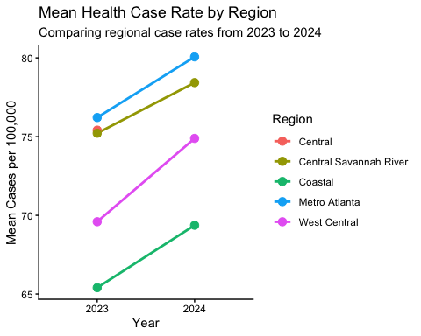
Warning: Removed 1 row containing missing values or values outside the scale range
(`geom_col()`).
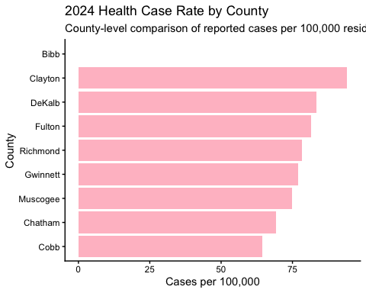
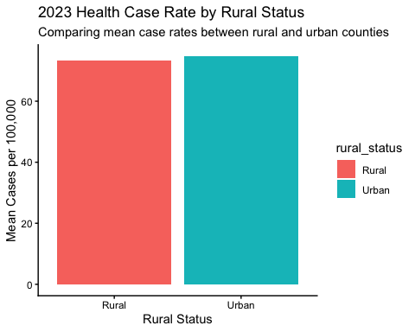

Reflection
Explain why long format was useful, what causes row multiplication during joins, and why rates are preferable to counts.
The pivot_long format was useful because it separated the case data by year. Therefore, I could visualize the compared differences between the years 2023 and 2024. Row multiplication during joins occurs when the joining key is not unique in one or both datasets, which results in multiple matching records and an increase in the number of rows. For example, if a county appears twice in a health dataset and once in a rural-status dataset, a left_join() can create duplicate rows for that county. Rates are generally preferable to counts because they account for differences in population size and allow for more accurate comparisons across counties or regions, while counts alone may provide duplicate areas with larger populations.

