Lab 2: Applying the Grammar of Graphics
  - Student Version
Table of contents

Learning Objectives
You will apply the Grammar of Graphics to several public health questions.

Part 1: Prepare the Data
gapminder_data <- gapminder %>%
rename(
life_expectancy = lifeExp,
population = pop,
gdp_per_capita = gdpPercap
)
gapminder_2007 <- gapminder_data %>%
filter(year == 2007)

Part 2: Scatterplot
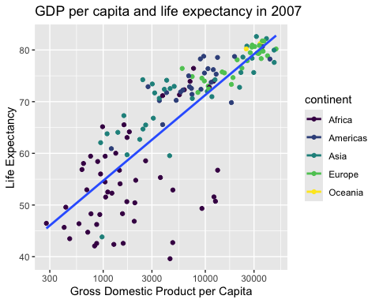
GDP per capita and life expectancy in 2007.

Part 3: Ranked Bar Chart
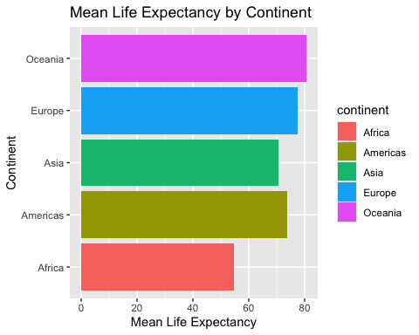

Part 4: Distribution
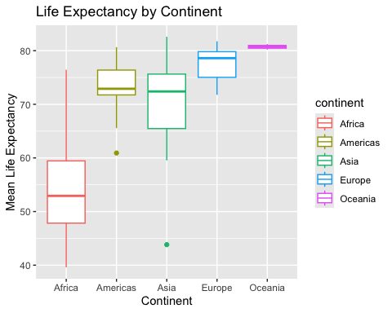

Part 5: Faceting
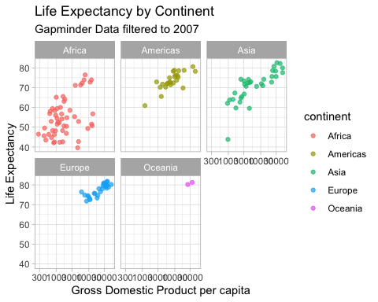

Part 6: Identify the Grammar
For one graph, identify the data, aesthetics, geometry, scales, labels, facets, and theme.
Faceted Scatterplot displaying the GDP per Capita and Life Expectancy Relationship. Data: Gapminder data from 2007
Aesthetics: x-axis: Gross Domestic Product (GDP) per capita y-axis: Life expectancy
Geometry: Geom_point
Scales: The x-axis uses a logarithmic scale for GDP per capita. The y-axis shows life expectancy in years. Color distinguishes the five continents.
Labels: Title: Life Expectancy by Continent Subtitle: Gapminder Data x-axis: Gross Domestic Product per capita y-axis: Life Expectancy Legend: continent
Facets: The graph is divided into five panels using the continent variable: Africa, Americas, Asia, Europe, and Oceania. Theme: The graph uses a white background with gray grid lines.

Part 7: Independent Visualization
Create one additional chart that answers a public health question. State the question, justify the chart, use an informative title, and add alt text.
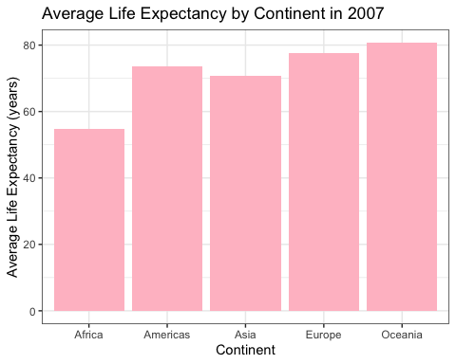

Independent Visualization Information
How does average life expectancy differ across continents in 2007? A bar chart is appropriate because the question compares average life expectancy across the continents groups. The bar chart can provide one simple finding without complex comparisons.

Reflection
- Which aesthetic mappings changed the meaning of the graph? Once manipulating the independent and dependent variables (x and y), this can change the interpretation of the graphs findings. For example, if the GDP per Capita (x) and the Life Expectancy (y), the graph will showcase how Life Expectancy is affected by GDP per Capita. If you were to flip these, the graph will highlight how GDP per capita influences the Life Expectancy.
- When did faceting improve interpretation? Faceting improved interpretation by separating the continents and providing a space clear demonstration on the patterns within each continent without overlap.
- Which graph most clearly communicated one finding? The bar chart with the Life Expectancy by Continent. The differences between continents were readable without needing to interpret multiple variables.

