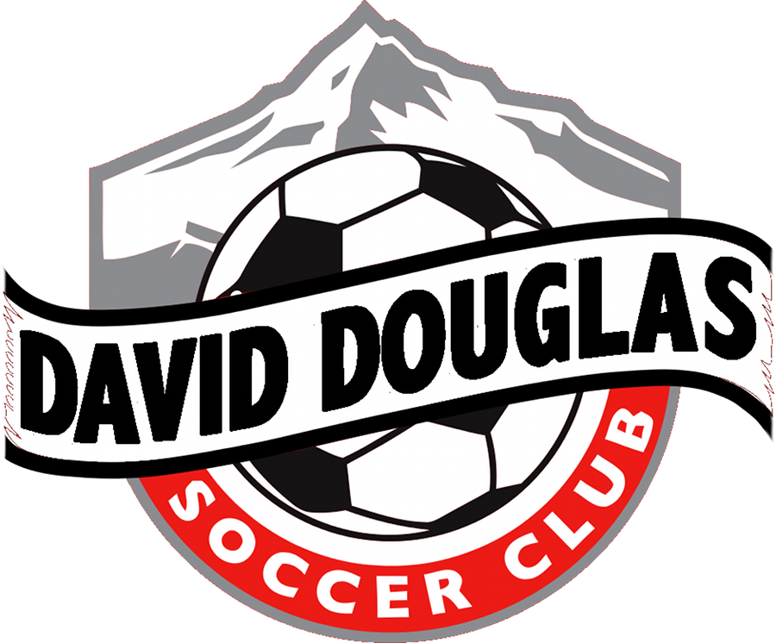
Bill Of Rights
For Young Athletes

- Right to participate in sports

- Right to participate at a level commensurate with each child’s maturity and ability

- Right to qualified adult leadership

- Right to play as a child and not as an adult

- Right of children to share in the leadership and decision=making of their sport participation

- Right to participate in safe and healthy environments

- Right to proper preparation for participation in sports

- Right to an equal opportunity for success

- Right to be treated with dignity

- Right to have FUN

