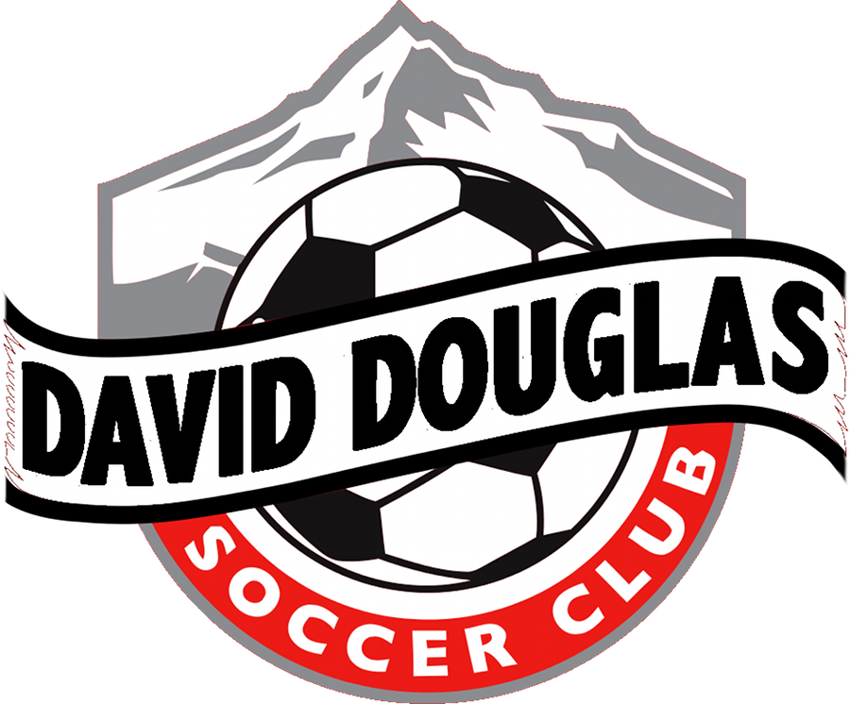

David Douglas Soccer Club Philosophy

David Douglas Soccer Club is a volunteer-led, non profit organization offers recreational soccer opportunities for players in K though 8th grade. The recreation program is designed for players to continue learning the basic skills associated with soccer in a less competitive atmosphere. Is our intent as an organization to promote honor, integrity, team work perseverance confidence and sportsmanship, both on and off the field?

Program Objective

- To provide an opportunity for girls and boys in the David Douglas School District to participate and thereby fulfill their personal needs of physical, mental and social development.

- To develop and promote the concepts of good sportsmanship and team work in a recreational sports program.

- To provide an opportunity for the youngster to learn and develop fundamental skills.

- To provide good leadership using community resources and to aid coaches by providing training.

- To work cooperatively with David Douglas School District with the use of their Fields.

Value Statement for Youth Sports

Youth sports programs provide an enjoyable learning environment for youngtsers’ physical, social and personal development. The values of youth programs are widely recognized include.

- Provide a fun and enriching experience
- Promote fitness
- Develop new skills
- Instill a desire to succeed
- Teach responsibility and commitment
- Team cooperation
- Prepare on to deal with success and failure
- Provide and outlet for release of energy
- Build character
- Teach how to cope with the realities of life
- Develop and instill positive attitudes towards authority
- Provide a fun and enriching experience.

