1a.

75

80

65

70

60

35

25

15

30

40

10

20

50

1b.

Preorder: 50 20 10 15 40 30 25 35 60 70 65 80 75

Inorder: 10 15 20 25 30 35 40 50 60 65 70 75 80

Postorder: 15 10 25 35 30 40 20 65 75 80 70 60 50

1c. delete 30

75

80

65

70

60

35

15

25

40

10

20

50

delete 20

75

80

65

70

60

40

10

50

25

35

15

2a.

struct BSTNode {

Node(int value, BSTNode\* parent) : mValue(value), leftChild(nullptr), rightChild(nullptr), mParent(parent) {}

int mValue;

BSTNode\* leftChild;

BSTNode\* rightCchild;

BSTNode\* mParent;

};

2b.

void insert(BSTNode\* curr, int value, BSTNode\* parent) {

insertHelper(curr, value, nullptr);

}

void insertHelper(BSTNode\* curr, int value, BSTNode\* parent) {

If (curr is nullptr)

create a new BSTNode with the data as value, set parent pointer to parent

and the left and right children to be null

else if(curr's value is less than the value passed in)

insertHelper(curr's left child, value, curr)

else if(curr's value is greater than the value passed in)

insertHelper(curr's right child, value, curr) }

3a.

6

6

3

3

0

2

3

2

3

6

10

0

6

10

3

4

0

2

2

0

2

6

4

9

3

8

4

6

2

0

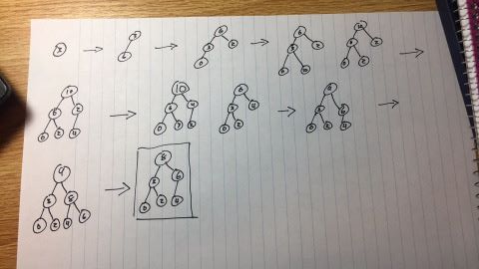

FINAL ANSWER

8

6

3

4

2

0

3b. 8 3 6 0 2 4

3c.

6

3

4

0

2

The array becomes 6 3 4 0 2

4a. O(C+logS)

4b O(logC+S)

4c. O(logC+logS)

4d. O(logS)

4e. O(1)

4f. O(logC+S)

4g. O(SlogS)

4h. O(ClogS)