**Git Version Control**

**Local Version Control Systems**

A local version control system is a local database located on your local computer, in which every file change is stored as a patch. Every patch set contains only the changes made to the file since its last version. In order to see what the file looked like at any given moment, it is necessary to add up all the relevant patches to the file in order until that given moment.

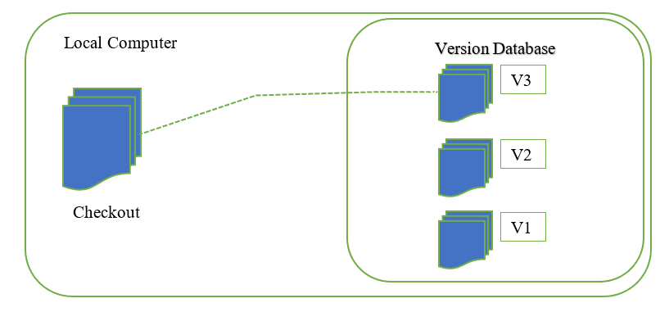

**Centralized Version Control Systems**

* A centralized version control system has a single server that contains all the file versions. This enables multiple clients to simultaneously access files on the server, pull them to their local computer or push them onto the server from their local computer. This way, everyone usually knows what everyone else on the project is doing. Administrators have control over who can do what.

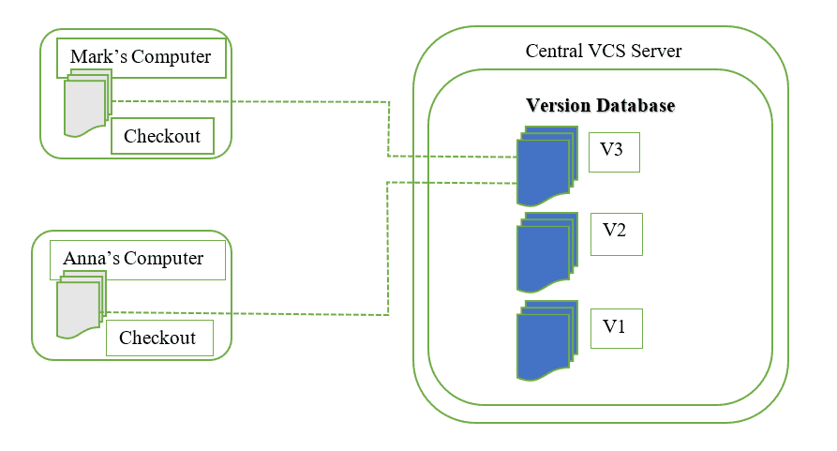

**Distributed Version Control Systems**

* With distributed version control systems, clients don’t just check out the latest snapshot of the files from the server, they fully mirror the repository, including its full history. Thus, everyone collaborating on a project owns a local copy of the whole project, i.e. owns their own local database with their own complete history. With this model, if the server becomes unavailable or dies, any of the client repositories can send a copy of the project's version to any other client or back onto the server when it becomes available. It is enough that one client contains a correct copy which can then easily be further distributed.

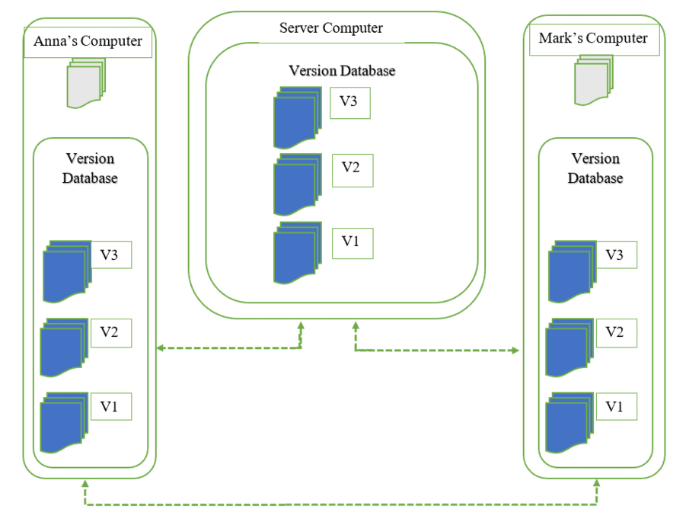

Implementation

1. You need to create a repository



1. Create a forlder



1. Open folder and type cmd in the command terminal
2. Type git init



1. Type git commit –m “sample commit”

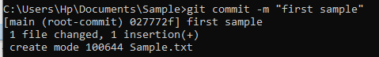

1. Type git branch –M main



1. Type git remote add origin https://github.com/kimberlybaga/Sample_Repository.git



1. Type git add .



1. Type git push –u origin main

