Project proposal
Experience/Outcome | Dataset
A clinical decision support dashboard where providers can input patient data and receive real-time risk scores for CRRT filter clotting, along with personalized recommendations and an LLM assistant for explanations. | I will use the MIMIC-IV database, which is a de-identified critical care dataset from Beth Israel Medical Center containing records from over 40,000 ICU patients. The database is widely recognized in healthcare research and has supported over 2,000 published studies.  I will extract the data via Google BigQuery from patients who received continuous renal replacement therapy. Features will include laboratory values, CRRT machine parameters, and associated anticoagulation data based on a literature review and clinical domain knowledge.
ML + LLM Integration | Anticipated challenges
The ML model will learn relative risk of CRRT patient clotting and output the risk score based on clinical data input  The LLM layer sources the model outputs into a short, clinician-friendly rationale (e.g. Platelets and fibrinogen elevated, INR low high likelihood of clotting)  The LLM will also suggest actionable recommendations/next steps for providers | - Missing data handling  - Temporal dynamics of lab values  - Class imbalance (clotting vs non-clotting)  - Feature selection from 100s+ potential variables (*will need to research variables more before finalizing dataset)  - Model interpretability for clinical trust  - Dataset(s) size  - First time working with BigQuery and SQL
REFERENCE PROJECT 1  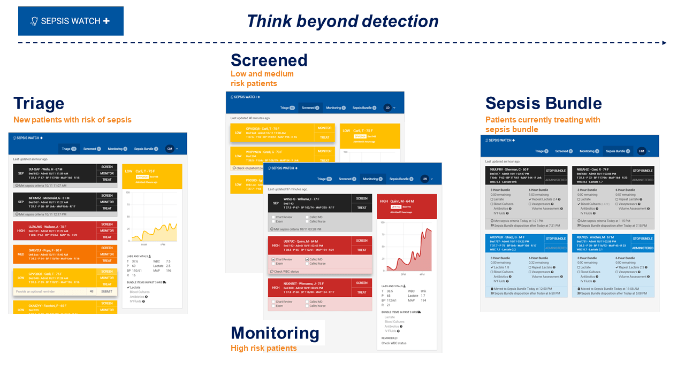  https://dihi.org/project/sepsiswatch/  Since our hospital implemented a sepsis MLmodel, I’ve seen firsthand that technical accuracy means nothing without clinical explainability. For example, when patients flag for sepsis, I round with the attending to review the alert. Easily 9/10 times, the provider asks, “Why did this patient trigger?” and we have no clear answer. The model uses ~80 hidden features, so we can’t point to the specific clinical drivers behind the alert. As a result, even though the model is high-performing and tied to CMS measures, providers routinely dismiss it because they don’t understand the reasoning. If the patient doesn’t fit the usual sepsis picture, they don’t adjust care based on a black-box algorithm. This experience reinforced the idea that accuracy alone doesn’t drive adoption, trust does, and trust comes from explainability. That is why I’m hoping this CRRT project will deliver clear, clinically intuitive rationales behind each risk prediction rather than a mystery score. Clinicians should never have to guess why an algorithm is telling them something, and a model that can’t be understood at the bedside simply won’t be used. | REFERENCE PROJECT 2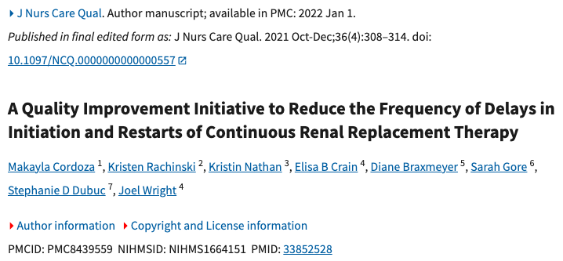  https://pubmed.ncbi.nlm.nih.gov/33852528/  The second reference highlights the patient impact of CRRT interruptions. When a circuit clots, therapy stops immediately, meaning the patient is no longer receiving continuous kidney support during a critical window. Restarting the machine is not fast as it often requires waiting for a dialysis nurse, gathering supplies, priming tubing, and re-establishing the circuit, which can take over an hour. During that time, critically ill patients accumulate fluid, lose metabolic control, and face unnecessary delays in care. For unstable patients, even short gaps in CRRT can worsen acidosis, electrolyte abnormalities, and volume overload. The goal of my project is to prevent avoidable interruptions by identifying clotting risk before the filter fails, ensuring CRRT remains continuous and patients receive the uninterrupted therapy they need to stabilize and recover.
REFERENCE PROJECT 3
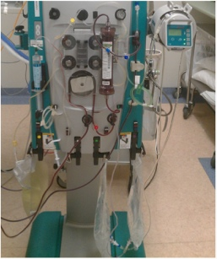

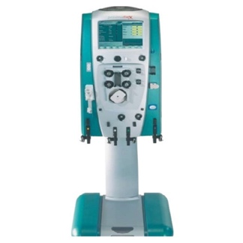
No link – just my own experience
https://pmc.ncbi.nlm.nih.gov/articles/PMC11871508/ (relevant research about lengthy process)

The third reference is the my personal lived experience in working with CRRT, which is what initially inspired this project idea. Restarting a clotted circuit is time-consuming, equipment-heavy, and disrupts care. A full setup involves multiple bags, tubing, priming the machine, and ensuring access lines are functioning. If the bedside nurse isn’t CRRT-trained (majority of nurses are not), then the patient often waits 2+ hours for a dialysis nurse to come, plus the 20–30 minutes required to get the circuit running again. A model that flags clotting risk before it happens directly saves time, reduces interruptions in therapy, supports nurses, and ultimately helps critically ill patients stay on continuous treatment without avoidable downtime.

Briefly describe how the sketches relate to the project proposal.
These interface sketches directly address my proposal's core goal of creating a clinical decision support tool that builds provider trust through transparency and explainability. In the Reference Project #1 that I included above, I discussed how I routinely encounter a frustrating pattern in my role while delivering alerts when providers ask “Why is this patient flagged?” Unfortunately, I have no satisfying answer beyond “the model says so.” This explainability deficit undermines trust and creates noticeable friction. The risk gauge provides immediate situational awareness, i.e. displaying "87% Clot Risk – High Risk", allows providers to quickly assess urgency without cognitive overload. The feature contribution bar chart directly addresses the concern identified in our hospital's sepsis model by allowing the providers to validate the reasoning against their own clinical judgment rather than blindly accepting an algorithmic black box.
My analysis revealed several open questions that will shape the interface's clinical deployment. Most critically, the model's heavy reliance on prior clotting history (45% contribution) raises concerns about utility for first-time CRRT patients—does the 99% AUC performance degrade significantly when this feature is absent? My PCA comparison showed that reducing from 57 to 30 features caused 7.14% performance loss despite capturing 80% of variance, confirming that CRRT clotting is genuinely high-dimensional and requires comprehensive lab panels. This validates my decision to show original features rather than attempting artificial simplification, but creates a practical question: how should the interface handle incomplete lab data in time-sensitive scenarios? Additionally, K-means clustering identified two distinct phenotypes with significantly different clot rates (14.4% vs 7.4%, p<0.0001), primarily separated by kidney injury markers—should the interface provide phenotype-specific clinical recommendations (e.g., "This patient exhibits kidney injury pattern—focus on volume status")? Finally, determining the appropriate alert threshold remains critical: at what risk score (75%? 85%? 95th percentile?) should the system escalate from passive monitoring to active provider notification to balance sensitivity against alert fatigue?

Highlight any new or open questions you are working with.
The most important open question from my analysis is deployment feasibility: how can this model be realistically implemented given that XGBoost requires 57 features for optimal performance? My initial vision followed the MDCalc model, which is a simple web calculator where providers manually input 5-10 values and receive an instant risk score for hundreds of different validated models. However, expecting manual entry of 57 lab values, vital signs, and machine parameters is clinically unrealistic and would never be adopted. Direct Epic integration seems like the obvious solution, automatically pulling labs and CRRT parameters from the EHR, but for lengthy and unnamed reasons I would err on deferring that as a last option. The other option would be creating a standalone Epic-integrated tool that pulls the Epic data into a separate interface, but this requires substantial institutional resources. Our hospital justified this for Sepsis Watch because sepsis is a top CMS mortality metric with major financial implications, but CRRT clotting, while clinically important, affects a much smaller patient population and lacks the same institutional urgency.
My PCA analysis revealed why feature reduction is so challenging: no single principal component explains more than 6% of variance, and 30 components are needed to capture just 80% of variance, indicating genuine high-dimensional complexity rather than redundancy. When I tested XGBoost on PCA-reduced features, performance degraded significantly (7.14% AUC loss with 30 components, 6.31% loss with 37 components), confirming that comprehensive data is necessary for the 99% AUC. My next steps involve systematic feature selection to identify the minimum viable feature set: can I achieve 95% AUC with just 15-20 features by selecting the highest SHAP contributors (prior clots, phosphate, creatinine, platelets, BUN)? If successful, this would enable a practical MDCalc-style calculator. If not, the only other option would be to advocate for lightweight direct Epic integration, perhaps paired with a BPA that alerts staff with a risk score after. That’s beyond the scope of this project, however, so I will continue to pursue improving the model performance with less features.
Lastly, one other question that came of this is determining the appropriate alert threshold remains critical: at what risk score (75%? 85%? 95th percentile?) should the system escalate from passive monitoring to active provider notification to balance sensitivity against alert fatigue?

