1. Set up Azure Machine Learning Workspace:

<https://docs.microsoft.com/en-us/azure/machine-learning/how-to-manage-workspace>

1. Configure Local Environment (follow instructions for local environment)

<https://docs.microsoft.com/en-us/azure/machine-learning/how-to-configure-environment#local>

1. Create Deployment Script

* Used to deploy service as a Docker container
* Builds Virtual environment
* Packages dependencies
* Deploys service

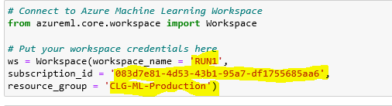1 - Connect to Azure Machine Learning Workspace

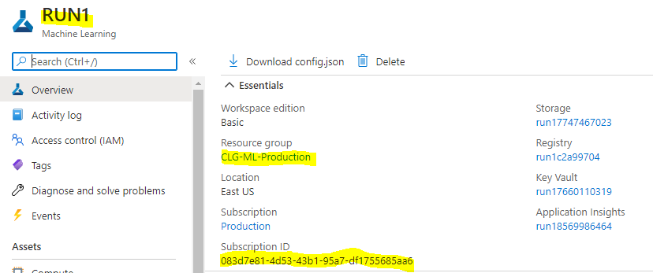What it shows in Azure Portal UI:

2 - Create Python Virtual Environment

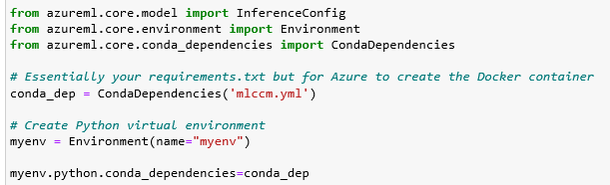

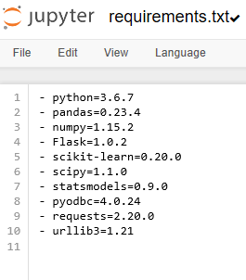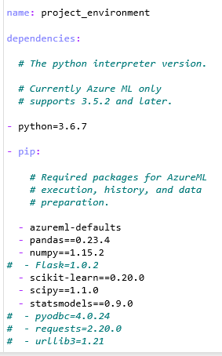mlccm.yml vs. requirements.txt from on-prem deployment

3 - Specify the rest end point script (score.py) and it's location

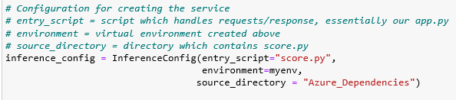

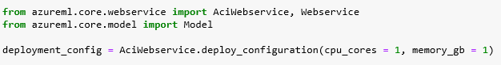4 - Specify the deployment configuration (CPU/RAM)

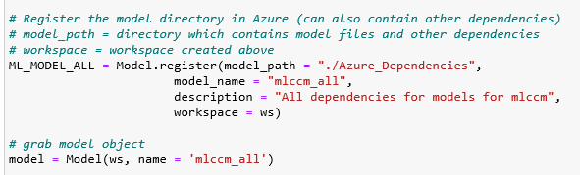5 - Register all dependencies (not in virtual environment) as a single model object

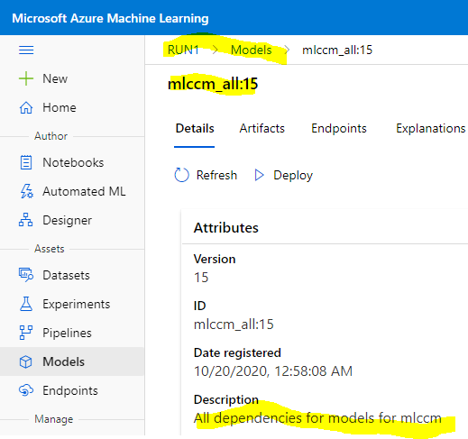 What it shows in Azure Portal UI:

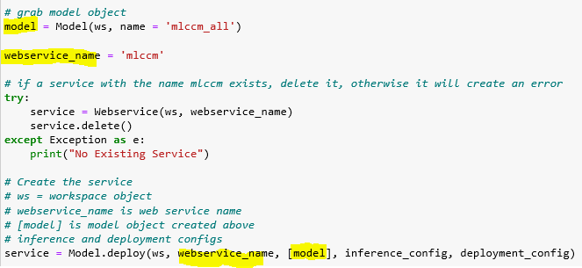6 - Deploy the service (delete current service if previously deployed)

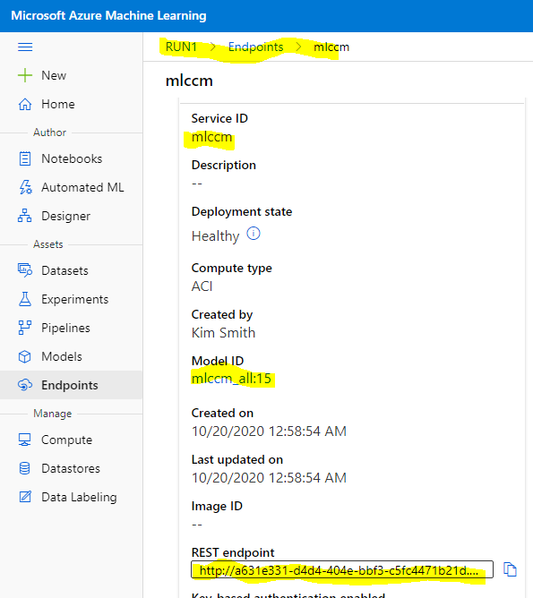What it shows in azure Portal UI:

7 - Grab URI endpoint

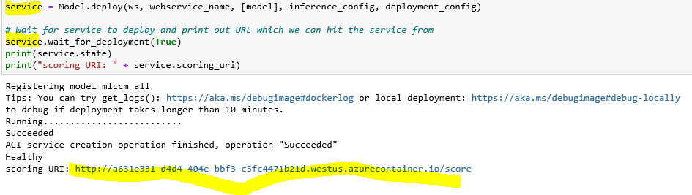

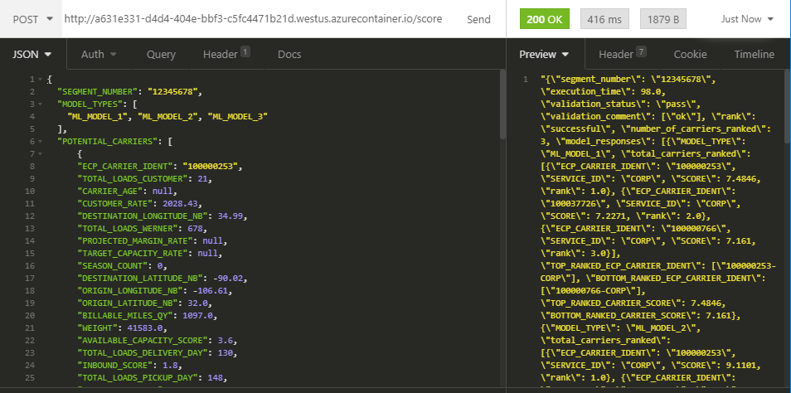Example POST service request from REST client :

8 – Print logs in case of an error



1. Create score.py

* Score.py is essential the script which enables our service to process REST calls… similar to our applications app.py scripts

1 - In init() method load all file objects (.pkl, .npy, etc) into script

- declare all objects global

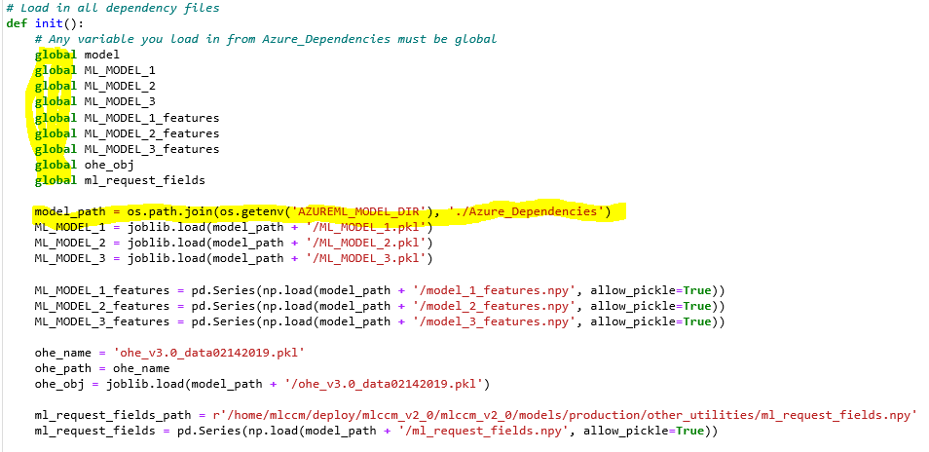

2 - In run() method, change line which loads in json object to

json.loads(raw_data)

in score.py:

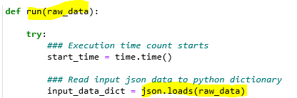

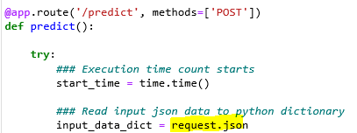in previous on-prem deployment mlccm_app.py

3 - Copy remainder of script as is

4 - at the end of run() method, use json.dumps to return final json response



5 - Can add the following to debug:

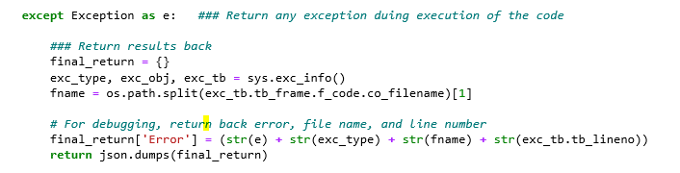

Directory structure

Root directory:

* Azure_Dependencies (contains all model files and custom dependencies in Step 3.5)
  + Model 1, Model 2, Model 3
  + All custom-written dependencies
  + Score.py (scoring script in Step 4)
* mlccm.yml (virtual environment script in Step 3.2)
* Azure_Model_Deployment.ipynb (deployment script in Step 3)