Kim Harrison

UCIRV201902DATA3

Abstract

An analysis of past KickStarter Projects using Excel PivotTables & Charts

KickStart My Chart

Homework 1

Table of Contents

1.0 Background / Problem Statement 2

2.0 Data Analysis 2

2.1. Projects by Category 2

2.2. Projects by Sub-Category 3

2.3. Projects by Date 4

2.4. Outcomes Based on Goals 5

3.0 Discussion 6

Appendix I – Project Outcome Rates by Category & Sub-Category 8

Table of Figures

Figure 1: Number of Projects by Category 2

Figure 2: Number of Projects by Sub-Category 3

Figure 3: Project Outcomes by Month Initiated 4

Figure 4: Outcome of Projects Based on Funding Goals 5

# Background / Problem Statement

Over two billion dollars have been raised using the massively successful crowdfunding service, Kickstarter, but not every project has found success. Of the over 300,000 projects launched on Kickstarter, only a third have made it through the funding process with a positive outcome.

Since getting funded on Kickstarter requires meeting or exceeding the project's initial goal, many organizations spend months looking through past projects in an attempt to discover some trick to finding success.

# Data Analysis

KickStarter data was provided for 4,114 past projects ranging that took place between 2009 to 2017. This section breaks down the data by a variety of different factors to determine if any trends can be realized from the given dataset.

## Projects by Category

Projects are categories by 9 major categories, as shown in Figure 1.

Figure 1: Number of Projects by Category

## Projects by Sub-Category

Each Category is further broken down in 41 sub-categories, as shown in Figure 2.

Figure 2: Number of Projects by Sub-Category

## Projects by Date

Figure 3 shows the number of successful, failed, or cancelled projects that occurred during each month of the years.

Figure 3: Project Outcomes by Month Initiated

## Outcomes Based on Goals

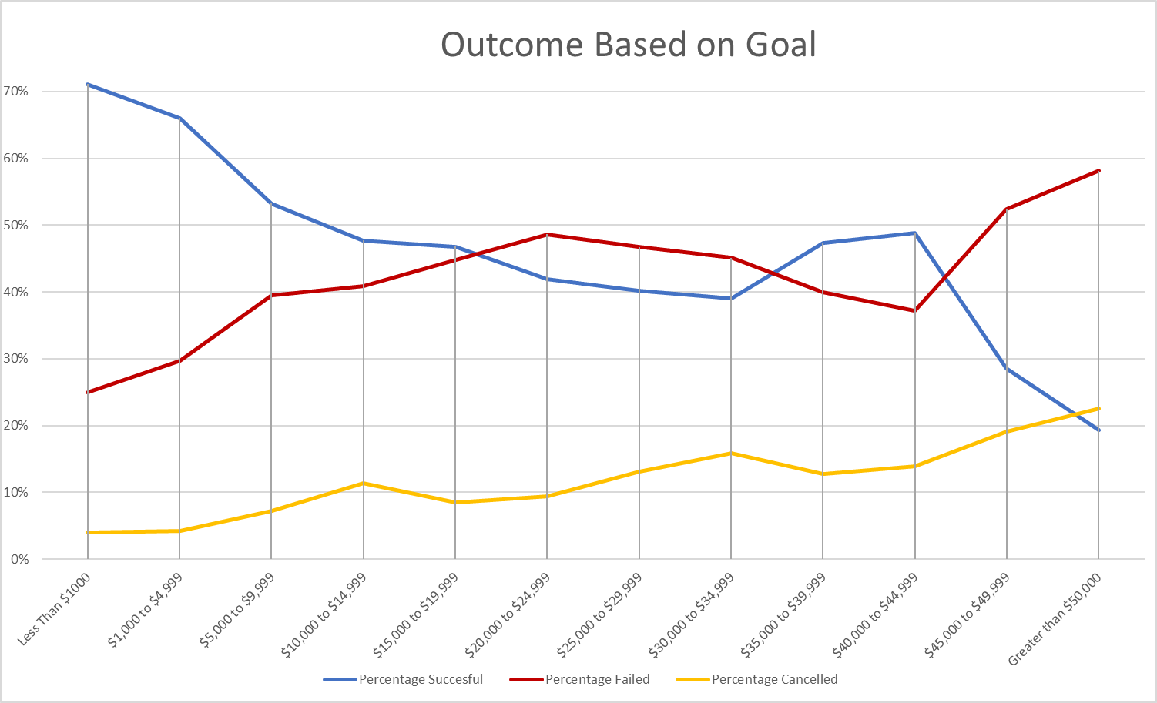Figure 4 looks at the outcome of each projects based on its initial funding goals.

Figure 4: Outcome of Projects Based on Funding Goals

# Discussion

There are various conclusions that can be made based on the data provided. In total, 53% of projects submitted have a successful funding rate. Categorically, projects classified as “theatre” are overwhelmingly the most popular type or project submitted to kickstarter (34% of total projects). Of projects classified by the “theatre” category, “plays” makes up the largest portion (77% of “theatre” projects; 25% of total projects). Theatre projects make up the largest percentage of successful projects with a 38% success rate. However, they are also the second most likely category to be canceled or fail with a rate combined percentage of 43%, with only “technology” projects having a higher non-successful rate of 65%. Projects categorized as “music” have both the second highest submission rate (17% of total projects) and success rate at (25%).

Sub-categories also provide insightful information on success and non-success (defined as projects that either fail to get funded or get cancelled) rate. For example, “small batch food” (40 projects), “table top games” (80 projects), and “photo books” (160 projects) have a 100% successful funding rate. Projects labeled as “science fiction film & video” (60 projects), “food trucks” (140 projects), “audio journalism” (24 projects), and “world music” (20 projects) have a 100% cancellation rate. Appendix I provides the pivot table used to conduct the sub-category analysis of percentages of project state.

The month a project is initiated can also provide insightful information for those aspiring to launch a successful kickstarter campaign. Figure 3 clearly shows an uptick in activity during the summer months (May-July). Projects are more likely to be successful during those months. July, however, has the highest rate of projects cancelled or failed. Activity tends to slow down in the 1st and 4th quarter of each year prior to picking up during the 2nd and 3rd quarter.

Lastly, funding targets can provide prospective on the rate of successful projects. Figure 4 shows that as funding goals increase, the successful funding rate drops. Intuitively, we can also observe that as the funding goals increase, the rate at which projects fail or get cancelled increases at a consistent rate. Therefore, it is advisable for projects to strongly consider their funding goals prior to submitting projects.

It is important for kickstarter project owners to recognized the limitations of the provided dataset. For example, the only indications of scope associated with the dataset is the funding goal. There is no information provided about the leadership of these projects, such as efforts taken during the campaign to raise awareness and funds (social media, etc). Additionally, projects usually utilize incentives for potential backers to donate to projects. This variable can often be the reason a backer decides to invest in the project and determine how much money to invest.

Future work could include looking deeper into each sub-category to determine what factors might contribute to a project’s success. For example, if a potential project owner fell into the technology category, it might be wise to look deeper into the sub-categories. In the technology example, “hardware” projects have a two-thirds success rate, whereas web projects have a 0% success rate. Additoinal analysis into funding trends could also provide valuable insight, as this is what ultimately defines the success of a project. An average donation versus total funding chart, or number of backers versus total funding could help to provide insight into the number of donors a project should target to track progress during the campaign. Additionally, the length of time a campaign is active versus it’s overall success rate could provide useful metrics for hopeful project owners.

# Appendix I – Project Outcome Rates by Category & Sub-Category

| **Category/Sub Category** | **Canceled** | **Failed** | **Live** | **Successful** | **% of Total Projects / % of Category** |
| --- | --- | --- | --- | --- | --- |
| **film & video** | **11%** | **12%** | **0%** | **14%** | **13%** |
| animation | 0% | 56% |  | 0% | 19% |
| documentary | 0% | 0% |  | 60% | 35% |
| drama | 0% | 44% |  | 0% | 15% |
| science fiction | 100% | 0% |  | 0% | 8% |
| shorts | 0% | 0% |  | 20% | 12% |
| television | 0% | 0% |  | 20% | 12% |
| **food** | **6%** | **9%** | **12%** | **2%** | **5%** |
| food trucks | 100% | 86% | 0% | 0% | 70% |
| restaurants | 0% | 14% | 0% | 0% | 10% |
| small batch | 0% | 0% | 100% | 100% | 20% |
| **games** | **0%** | **9%** | **0%** | **4%** | **5%** |
| mobile games |  | 29% |  | 0% | 18% |
| tabletop games |  | 0% |  | 100% | 36% |
| video games |  | 71% |  | 0% | 45% |
| **journalism** | **7%** | **0%** | **0%** | **0%** | **1%** |
| audio | 100% |  |  |  | 100% |
| **music** | **6%** | **8%** | **40%** | **25%** | **17%** |
| classical music | 0% | 0% | 0% | 7% | 6% |
| electronic music | 0% | 0% | 0% | 7% | 6% |
| faith | 0% | 33% | 100% | 0% | 9% |
| indie rock | 0% | 17% | 0% | 26% | 23% |
| jazz | 0% | 50% | 0% | 0% | 9% |
| metal | 0% | 0% | 0% | 4% | 3% |
| pop | 0% | 0% | 0% | 7% | 6% |
| rock | 0% | 0% | 0% | 48% | 37% |
| world music | 100% | 0% | 0% | 0% | 3% |
| **photography** | **0%** | **8%** | **0%** | **5%** | **5%** |
| nature |  | 17% |  | 0% | 9% |
| people |  | 17% |  | 0% | 9% |
| photobooks |  | 49% |  | 100% | 73% |
| places |  | 17% |  | 0% | 9% |
| **publishing** | **9%** | **8%** | **0%** | **4%** | **6%** |
| art books | 67% | 0% |  | 0% | 8% |
| children's books | 0% | 31% |  | 0% | 17% |
| fiction | 0% | 31% |  | 0% | 17% |
| nonfiction | 0% | 0% |  | 75% | 25% |
| radio & podcasts | 0% | 0% |  | 25% | 8% |
| translations | 33% | 37% |  | 0% | 24% |
| **technology** | **51%** | **14%** | **0%** | **10%** | **15%** |
| gadgets | 0% | 9% |  | 0% | 3% |
| hardware | 0% | 0% |  | 67% | 23% |
| makerspaces | 0% | 5% |  | 4% | 3% |
| space exploration | 10% | 1% |  | 19% | 10% |
| wearables | 34% | 56% |  | 10% | 33% |
| web | 56% | 28% |  | 0% | 27% |
| **theater** | **11%** | **32%** | **48%** | **38%** | **34%** |
| musical | 54% | 12% | 0% | 7% | 10% |
| plays | 0% | 72% | 79% | 83% | 77% |
| spaces | 46% | 16% | 21% | 10% | 13% |