Iris Species Classifier: Model Performance and Use Cases
Kimberly Jimenez
Capella University
Assessment 3
IT-FPX4030
Viney Ugave
April 6, 2026

This paper presents the development and evaluation of three machine learning classifiers —K-Nearest Neighbors (KNN), Decision Tree, and Logistic Regression—applied to the Iris species dataset derived from Anderson's (1936) classic botanical study. The dataset contains 150 observations across three Iris species with four morphological features. All three classifiers achieved 93.33% accuracy on the hold-out test set, with Logistic Regression and KNN reaching 96.00% mean accuracy under five-fold cross-validation. Petal length and petal width emerged as the most discriminative features. The paper discusses model performance, key data insights, and three real-world use cases for the implemented classification approach.

Keywords: machine learning, classification, K-Nearest Neighbors, Decision Tree, Logistic Regression, Iris dataset

Iris Species Classifier: Model Performance and Use Cases
The Iris flower dataset, originally compiled by Edgar Anderson and later popularized by Ronald Fisher (1936), is one of the most widely studied datasets in machine learning and statistical analysis. It contains measurements of sepal length, sepal width, petal length, and petal width for 150 specimens drawn equally from three species: Iris setosa, Iris versicolor, and Iris virginica. The dataset presents an ideal test case for multi-class classification because one species (setosa) is linearly separable from the other two, while versicolor and virginica exhibit some overlap, providing a meaningful classification challenge.
The objective of this assessment is to develop a supervised machine learning classifier to categorize Iris species based on the four morphological features. Three classifier algorithms are implemented and compared: K-Nearest Neighbors (KNN), Decision Tree, and Logistic Regression. Each algorithm is evaluated on a held-out test set and through five-fold cross-validation to assess generalization performance.

Data Exploration and Visualization
Prior to modeling, exploratory data analysis (EDA) was conducted to understand the structure and characteristics of the dataset. The dataset contains no missing values, no duplicates, and balanced class representation, with exactly 50 observations per species. Summary statistics reveal that petal features exhibit greater variance across species than sepal features, suggesting higher discriminative power.
Scatter Plots
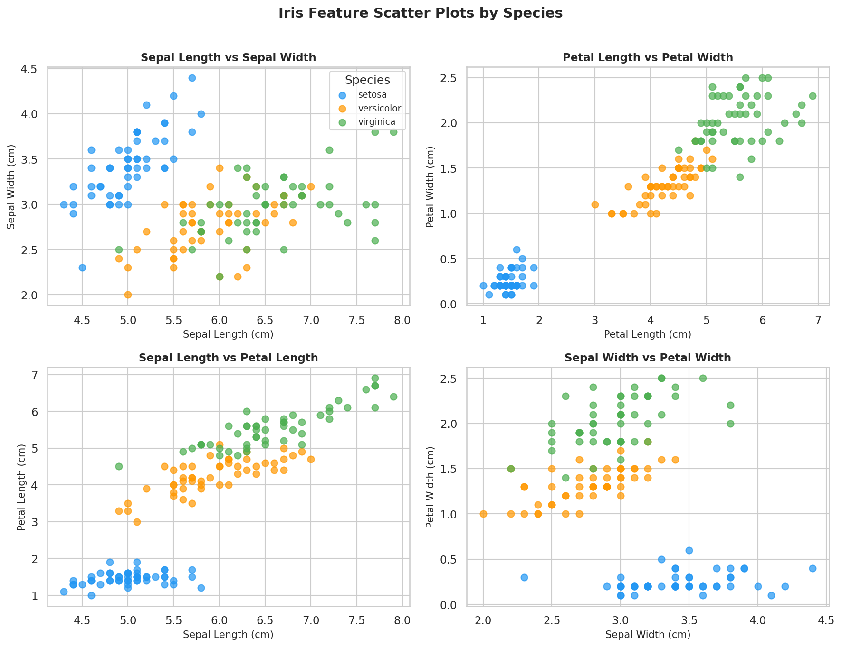
Figure 1. Scatter plots of pairwise feature combinations colored by Iris species. Setosa (blue) is clearly separable in petal space; versicolor (orange) and virginica (green) show partial overlap.
The scatter plots in Figure 1 reveal that Iris setosa forms a compact, clearly separated cluster in all pairwise comparisons involving petal features, confirming its linear separability. Iris versicolor and Iris virginica overlap in sepal space but are more distinguishable in petal space, particularly in the petal length versus petal width plot. This visual separation directly informs feature importance in the models trained.
Box Plots
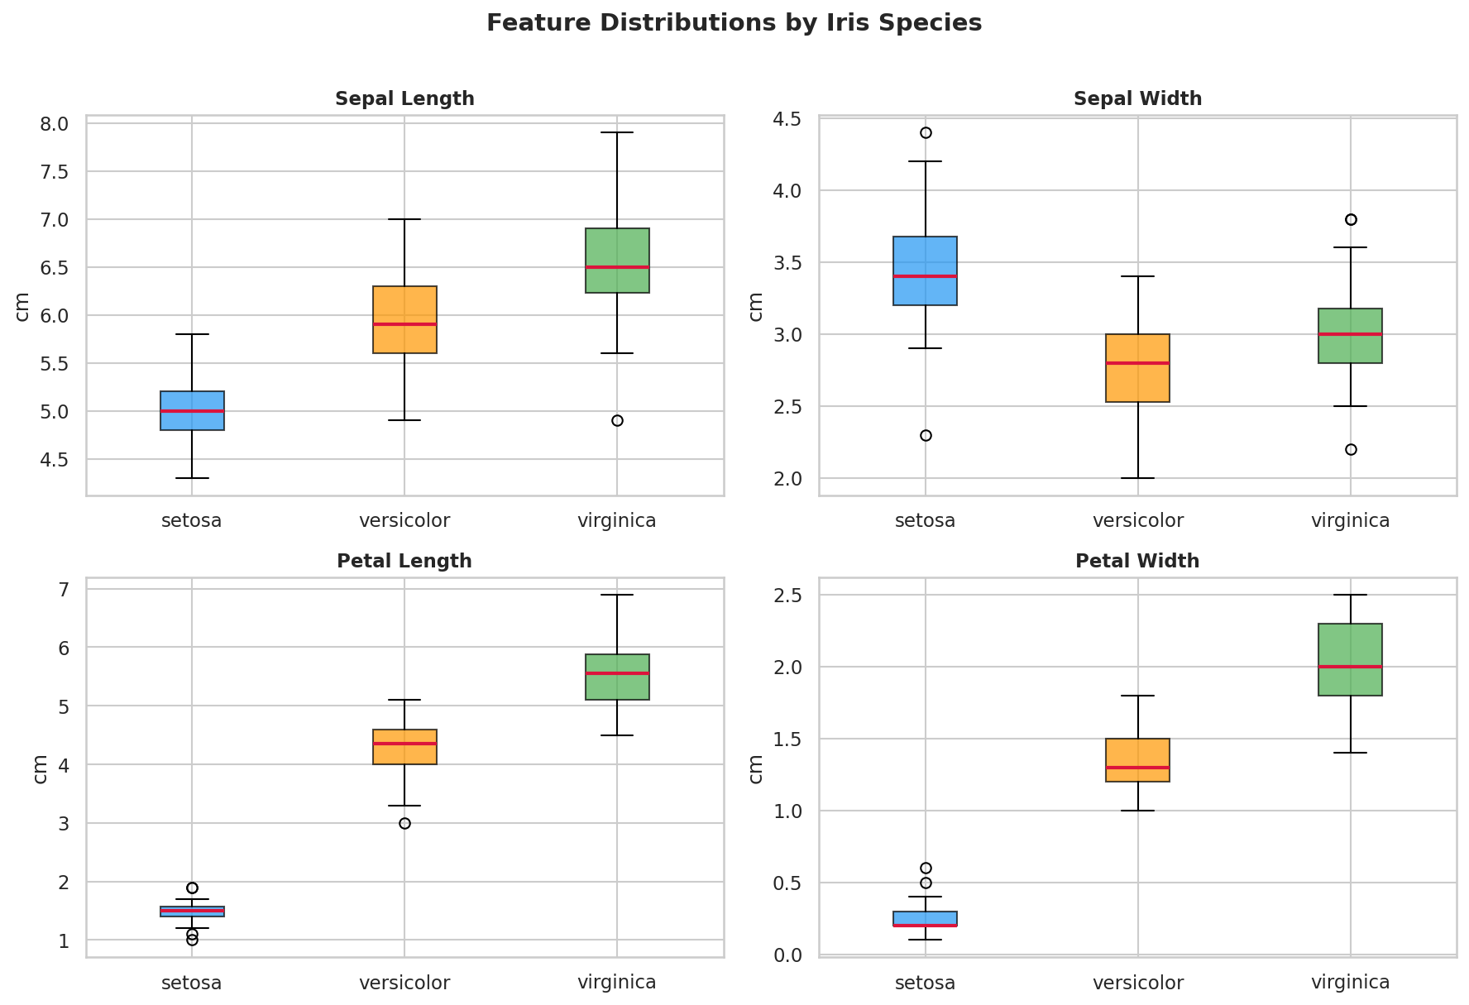
Figure 2. Box plots showing the distribution of all four features by species. Petal features show the clearest separation between species.
Figure 2 confirms that petal length and petal width have distinctly non-overlapping interquartile ranges between setosa and the other two species. Sepal width is the only feature where setosa values are actually higher than the other species. The moderate overlap in sepal length and sepal width across versicolor and virginica suggests these features alone are insufficient for reliable classification.
Correlation Heatmap
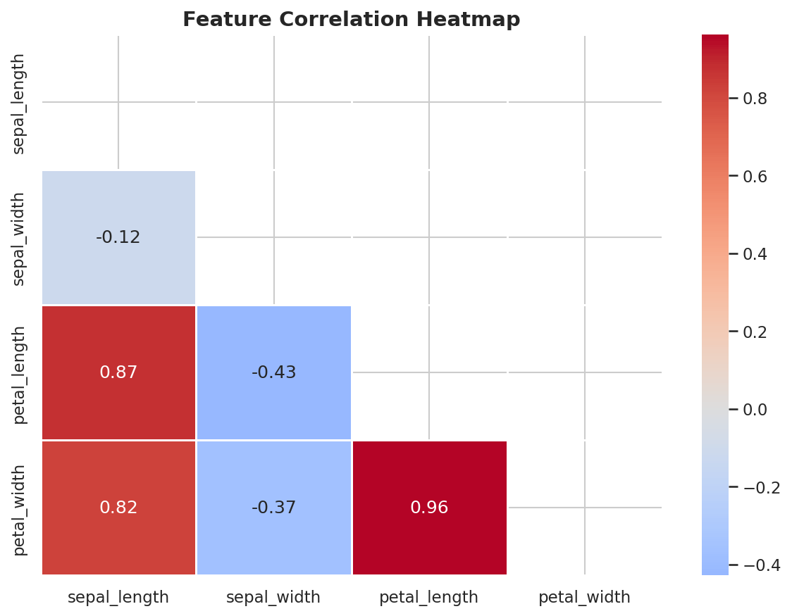
Figure 3. Pearson correlation heatmap of the four Iris features. Petal length and petal width are highly correlated (r = 0.96).
The heatmap in Figure 3 indicates that petal length and petal width are highly correlated (r ≈ 0.96), suggesting that both encode similar discriminative information. Sepal length also shows moderate correlation with petal features. Sepal width is notably uncorrelated with the other three features, which partially explains its limited predictive value when used alone.

Data Preprocessing
The dataset was divided into training (80%, n = 120) and testing (20%, n = 30) sets using a stratified split, ensuring equal representation of all three species in both partitions. Feature scaling was applied using the StandardScaler, which transforms each feature to zero mean and unit variance. Scaling is especially critical for KNN, which computes Euclidean distances directly from feature values, and for Logistic Regression, which uses gradient-based optimization sensitive to feature magnitude. The Decision Tree algorithm is invariant to feature scaling, but scaling was applied uniformly across all models for consistency. Scaler parameters were fit exclusively on the training set and applied to the test set to prevent data leakage.

Classifier Results and Performance Analysis
Classification Reports and Confusion Matrices
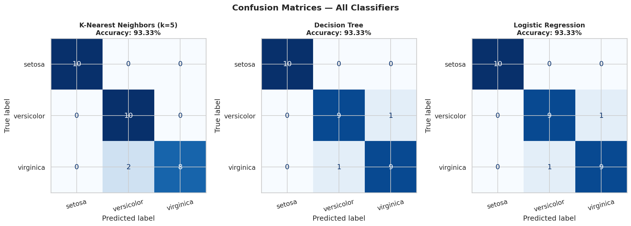
Figure 4. Confusion matrices for all three classifiers on the 30-sample test set. Each matrix shows true versus predicted species labels.
All three classifiers achieved 93.33% accuracy on the 30-sample test set (28 correct of 30). As shown in Figure 4, misclassifications in every case involved a single instance of either Iris versicolor or Iris virginica being confused for the other. Iris setosa was perfectly classified by all three models, consistent with its linear separability observed during EDA. The confusion matrices confirm that the primary classification challenge lies in distinguishing versicolor from virginica.
Classifier | Test Accuracy | CV Mean | CV Std Dev
K-Nearest Neighbors (k=5) | 93.33% | 96.00% | ±2.49%
Decision Tree | 93.33% | 95.33% | ±3.40%
Logistic Regression | 93.33% | 96.00% | ±3.89%
Table 1. Classifier performance summary (test accuracy and 5-fold cross-validation).

Model Comparison
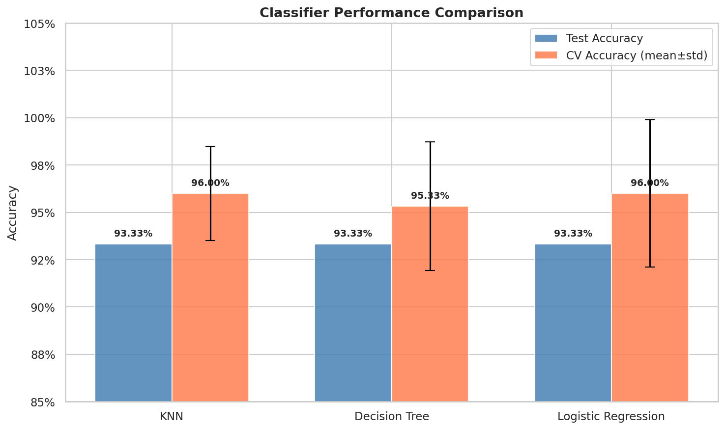
Figure 5. Test accuracy and five-fold cross-validation accuracy for all three classifiers. Error bars indicate one standard deviation.
Table 1 and Figure 5 show that all three classifiers performed equally well on the test set, achieving 93.33%. Under cross-validation, KNN and Logistic Regression tied at 96.00% mean accuracy, while the Decision Tree was slightly lower at 95.33% with a higher standard deviation, suggesting marginally greater variance and susceptibility to overfitting. Given the small and well-structured nature of the Iris dataset, all three algorithms are viable; however, Logistic Regression is generally preferred in production settings due to its interpretability, probabilistic output, and stability across different random seeds.

Decision Boundaries
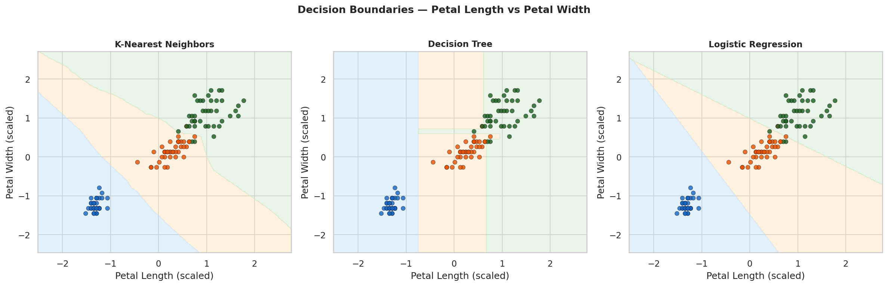
Figure 6. Decision boundaries for all three classifiers trained on petal length and petal width (scaled). Blue = setosa, orange = versicolor, green = virginica.
Figure 6 illustrates the decision boundaries each classifier learns in petal feature space. The KNN boundary is locally adaptive, creating irregular boundaries that closely follow the training data. The Decision Tree produces axis-aligned rectangular boundaries, clearly reflecting its feature-threshold splitting mechanism. Logistic Regression produces a smooth linear boundary. Despite their structural differences, all three correctly separate setosa (lower-left cluster) from the other two species. The KNN boundary is most complex and thus most prone to overfitting with noisy data.

Discussion and Conclusions
This analysis demonstrates that even simple machine learning classifiers achieve strong performance on the Iris dataset when appropriate preprocessing and evaluation methodology are applied. Several key insights emerged from the process. First, petal measurements are substantially more discriminative than sepal measurements for classifying Iris species. Petal length and petal width together account for the vast majority of inter-species variation. Second, Iris setosa is perfectly classifiable by all methods due to its compact, linearly separable distribution. Third, the versicolor-virginica boundary is where all misclassifications occur, suggesting that additional features or a more powerful model would be needed to reduce error on this boundary.
Logistic Regression is recommended as the primary classifier for this task due to its strong cross-validation performance (96.00%), interpretable coefficients, and well-calibrated probability outputs. The Decision Tree offers comparable accuracy while providing an easily visualized and explainable decision structure, which may be preferable in educational or audit contexts. KNN is effective but less suitable for deployment due to its high memory and inference-time cost at scale.

Three Use Cases for the Machine Learning Classifier
Use Case 1: Automated Botanical Species Identification
Botanists, ecologists, and conservation researchers frequently need to classify plant specimens in field conditions where laboratory analysis is impractical. A lightweight Logistic Regression or KNN classifier, trained on morphological measurements from digital calipers or image-based feature extraction, could provide instant species identification in the field. Extending this model to larger plant taxonomy databases with hundreds of species and richer feature sets (leaf area, color profile, stem diameter) would enable a scalable automated identification tool for biodiversity monitoring programs and invasive species detection.
Use Case 2: Agricultural Crop Quality Grading and Sorting
In commercial horticulture and agriculture, rapid and accurate classification of plant variety and quality grade is essential for pricing, packaging, and routing to appropriate markets. Machine vision systems equipped with classification models similar to those implemented here are used on conveyor lines to classify flowers, fruits, and vegetables by morphological features. A decision tree classifier is particularly suited to this application due to its interpretable threshold-based rules, which can be directly translated into mechanical sorting gate parameters. Training on larger, real-world agricultural datasets with additional features such as color histogram values and texture descriptors would produce commercially deployable systems.

Use Case 3: Medical Diagnostic Classification
The multi-class classification framework demonstrated in this assessment is directly transferable to medical diagnosis tasks where patient measurements must be categorized into one of several condition classes. For example, a similar pipeline could classify tumor types from biopsy measurements, assign patient risk categories from clinical lab values, or diagnose subtypes of a condition from physiological sensor data. Logistic Regression is already widely used in clinical risk scoring models such as the HEART score for cardiac risk and the Wells score for pulmonary embolism, both of which use weighted linear combinations of measurements analogous to the feature weighting mechanism in logistic regression. This use case underscores the real-world clinical relevance of the classification methodology implemented in this assessment.

References
Anderson, E. (1936). The species problem in Iris. Annals of the Missouri Botanical Garden, 23(3), 457–509. https://doi.org/10.2307/2394164
Fisher, R. A. (1936). The use of multiple measurements in taxonomic problems. Annals of Eugenics, 7(2), 179–188. https://doi.org/10.1111/j.1469-1809.1936.tb02137.x
Pedregosa, F., Varoquaux, G., Gramfort, A., Michel, V., Thirion, B., Grisel, O., Blondel, M., Prettenhofer, P., Weiss, R., Dubourg, V., Vanderplas, J., Passos, A., Cournapeau, D., Brucher, M., Perrot, M., & Duchesnay, E. (2011). Scikit-learn: Machine learning in Python. Journal of Machine Learning Research, 12, 2825–2830.

