**Southern Belle Culture- Front End/ Read.me**

This is my capstone project assignment that was given by General Assembly. My assignment included creating a website of my choice, so I chose to create Southern Belle Culture. The app will include southern sayings and it will allow users to add meme/pictures. I based it on one to many relationships and created a Single Page Application for the web that would allow a user to to interact with the website and the back end was used to authenticate the functions off CRUD.

**ERD, Wireframe and User Stories**

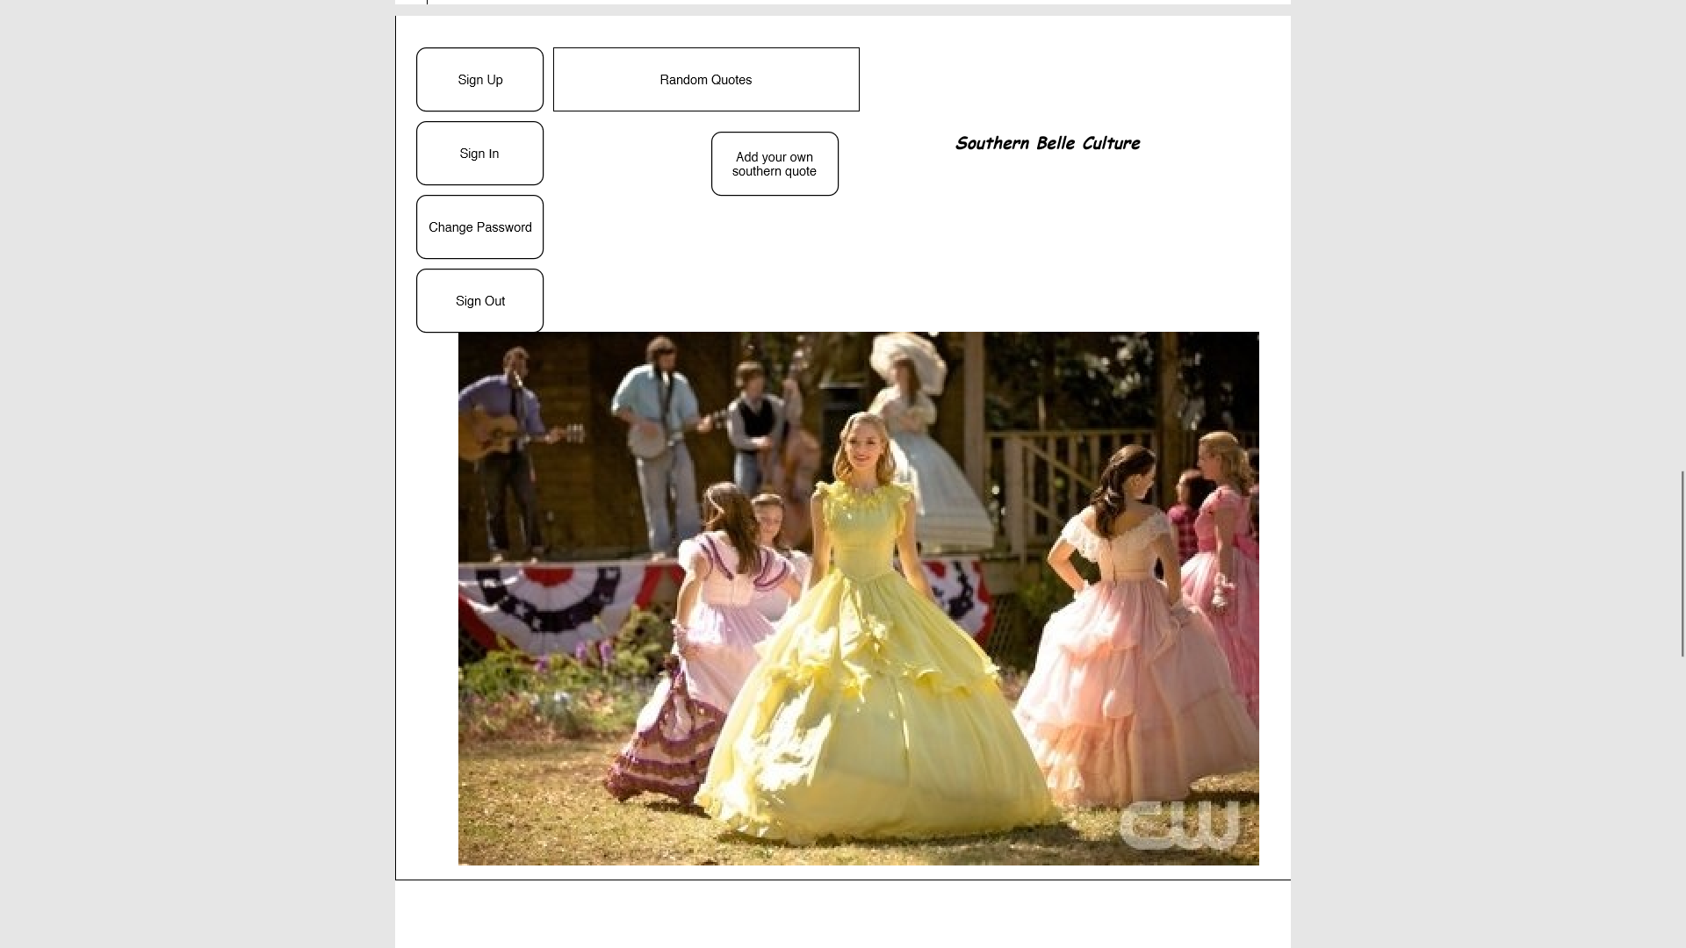

**Link to Front End**

* Deployed App : <https://kimbermenjivar.github.io/SouthernBelleCulture-Client/>
* Repository : <https://github.com/kimbermenjivar/SouthernBelleCulture-Client>
* **Links to Back End**
* Deployed Back End :  <https://southernbelle.herokuapp.com/>
* Repository : <https://github.com/kimbermenjivar/SouthernBelleCulture-BackEnd>
* **My user stories for this project were:**

As a user I can….

* sign up
* sign in
* change password and sign out of the app. Once signed in, I can:
* create a quote
* search for quotes
* delete a quote
* update a quote.
* There are visual cues and/or messages if a task was successful or not.

**Project Requirements:**

My app has been deployed on Github pages. Many cohesive commits dating back to the first day of building our project. This read.me was created to document the process and technologies used

**Technologies Used:**

* HTML5
* CSS3
* SASS
* Bootstrap
* JavaScript
* JQuery

(I used HTML5 to build the basic structure of the app and CSS3, SASS and Bootstrap to style.The forms were done using HTML and Bootstrap. Javascript is used to build the logic update the view Features/Additions Styling min Wireframe

I worked mostly with bootstrap ,html, CSS and SASS. I also worked on connecting the HTML code for log out while logged in, hiding buttons as needed. I verified the crud requirements were met such as updating method GET and get item by id. Added html code for changing password with current and new password.

**Future iterations:**

* add pop up boxes for memes related to my quotes