# Project Exam 1

Kim-Binh Vo

Word count: 1544

Introduction:

In this report, I will go through my process to complete the exam, and what I focused on under the whole process. How I plan the process, and what I did in every step.

Main:

**Research about making a blog**

I started this task without knowing so much about how to make a blog site. I started to search up different blog sites on the internet, to learn and get inspiration. I came by a blog post which called “Our food Stories” that I really like, and I wanted the same type style. Which is very simple and clean.

**Analyze the task**

I am making a plan of how the websites can look like and contain after reading the task. The main plan is it can have a home page, which consist of a navigation to other web pages. The navigation will be consist of Home, Restaurants, About us and Contact. I’m going to add a carousel which consist of the blogs below the navgitaion. And I will have my blogs under the carousel too. All this is just a plan I made before designing. Therefore it is not fixed and can be change under the process.

**Select color palette**

Gray: to achieve a mature, classic and serious look.

Blue: Blue is a very classic and common choice. It is calming and cool and symbolizes trustworthiness and maturity.

Black: Black is a sleek, modern and luxurious look, black will be a great choice. A minimalist black and white logo is the way to go if you want to keep it simple.

White: As a neutral color it works in combination with all other colors, but adds a clean, youthful and economical touch.

Create a style tile:

I decided not to create a style tile on Adobe XD. I ended up with deciding typography, colors and brand abjectives instead, which I think its useful to bring further in the project process. I don’t think that creating a style tile is necessary for me. It would be necessary if I had to show to a customer.

**HTML, CSS and responsive**

I started to design the home page in mobile version first. After finishing my home page, I used media queries to make the website responsive. I had one size for mobile, one size for Ipads/Tablets, one size for small screens/laptop, one size for desktops and one for 1200px plus.

## After the homepage, I started to design the restaurants page, specific page, contact page and last about page.

**Javascript**

I started to implement some functions in javascript to get some data from the api. I started with the restaurants page where I fetch data from the api, and made a new html with the api data. I replaced it with the old html which didn’t have api data. I used the same method to implement new html to the home page too.

After that I made a function with query string at the specific page. I fetch the id from api, and used it to get the data I needed. I used that data to make a new html. I change the title of the page too in the same function.

I started to make javascript at the contact page too. My function had to validate the name, email and text to see if they had at least 5 letters on the name, and syntax on the mail is correct. If all the information is added correctly, a message will tell the user that the text is sent. If not, the user will get a text and fix the current form.

I did the carousel function last because I find it hard to do. This code is pretty much the same as the code from w3schools – How to slidehow. I didn’t know how to make this carousel different or on my own. I still have a bug on this function. All the blogs are showing when I’m fetching the data from api. They are supposed the only show one, and the user can slide back and forth. But after the user slides once, the carousel is working as it should.

**The Design-thinking process**

I chose to use design-thinking, because it’s a good methodology for solving problems and its useful to understand the users and the users need. This methodology consists of five stages, Empathise, Define, Ideate, Prototype and Test.

Empathise

The first stage in the process is empathise, and the goal is to gain an emphatic understanding of the user and theirs needs. And understanding of the problem I am going to solve. I will do this by observing and engage in the target audience to understand their motivation and experience.

My first method is to make a contextual inquiry interview to gain a deeper understanding of the users need. This method is effective because the interview object can answer and explain during the interview. And I can ask follow-up question if I want to. I used this method after the user have check out my websites.

1. Contextual inquiry interview:

Q: How will you describe a good website?

A: Easy to use, looking professional.

Q: How will you describe a bad website?

A: look bad and bad user interface.

Q: What do you think of this (Restaurants in Oslo) website?

A: It looks cool and its good. It’s simple and neat.

Q: Improvement with what?

A: Fix some of the bugs on the home page.

Q: How was it to navigate through the websites?

A: It was easy to navigate back and forth

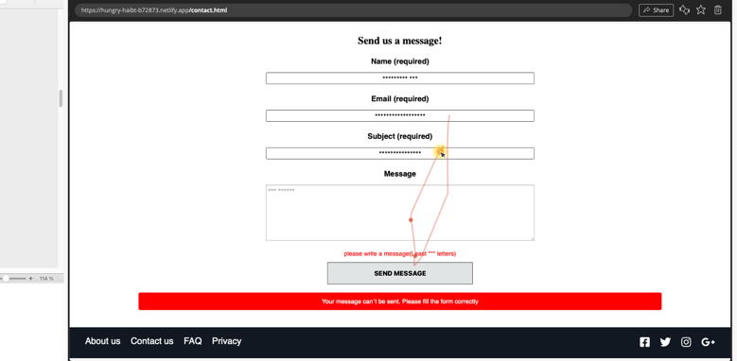

The second method is to let my users try my website while I am using Hotjar to track down the users to see how my users are using the website. This is a great tool to use to find out how the users are interacting with the websites and see potentials bad designs that make them struggle.

The third method is to let the users to perform user testing on my website to ensure it’s easy to use. I will give them one tasks. The task is to go to the contact form, fill out the information and send the message. During the test, I will count clicking errors and take the time to see how fast the users is doing the task.

The results of the accessibility testing:

* Contact page:

• Errors: 2

• Time: 40 sec

The message and the subject were to short. Need at least 15 and 15 letters.

Define

The second stage is define, where I can define the problems based on the information I got form the interview, Hotjar and the accessibility testing. After analyzing the problems from my data gathering methods, I find problems I want to focus on. I want to focus on the home page because of the bugs. The contact page and tell the user the requirement when filling out the form. After the interview, we got to know the user wants more information.

I define my problems like this:

* User need to get the bugs removed to make the page easier to use.
* User need to know what’s required when filling out information on contact page because they need to know if its correct or not.

Ideate

The third stage is Ideate, where I will come up with ideas and solutions based on the problems I have defined. The main problem was having a confusing carousel at home page, and not giving the user enough information when filling out the form.

Solutions:

* Give the user an easier way to navigate through the carousel
* Give the user information about what’s required when filling out the form.

Prototype

The fourth stage is prototype, where I use my html, css and javascript skills to improve the websites. I was not able to fix the bugs on the carousel. The carousel looks better when I didn’t have javascript. But I wanted to use javascript because I wanted the carousel to be dynamic.

Since the users goal was to get more information before filling out the form, I change the html on contact page. I changed the contact page to give the users the information they wanted. I added (least n letters) to the name, subject and message.

Testing

The fifth stage is testing, where I am going to evaluate by using the method user testing. In this user test, I will let the users do the same task as last time, which is to fill out the information on the contact page. I had to use the same person to user test because I don’t have other candidates. The most optimal is to use other candidates that haven’t seen this website before. I will use the results and compare with the last results to see if there is any improvement after the changes.

The results of the user testing:

* Contact page:

• Errors: 0

• Time: 30 sec

Conclusion

My process to complete this exam, started with to research and learn about blog sites. Then analyze the task to understand and know what to do. Then plan how to blog sites is going to look like, then build with html, css, javascript and made it responsive. The last part is the design process to see where I can improve my page.

## References

(place references to websites, books, forums etc. that helped you in the project)

W3Schools, “How to – Slideshow”

<https://www.w3schools.com/howto/howto_js_slideshow.asp> [Accessed: 23- Sep- 2021].

L.Muthesius & N.Eisermann, “Our food Stories”

<https://ourfoodstories.com> [Accessed: 25- Aug- 2021].

Noroff’s platfrom (The link below is one of them)

<https://noroff.bravais.com/document/8855/preview> [Accessed: From 25- Aug- 2021 26 to Sep- 2021].

R.Dam & T.Siang, “5 Stages in the Design Thinking Process” 2021

<https://www.interaction-design.org/literature/article/5-stages-in-the-design-thinking-process> ([Accessed: 26- Sep- 2021].

A.Resch, “How to design a logo: the ultimate guide”, 2019

<https://99designs.no/blog/logo-branding/how-to-design-logo/#payattentionto> [Accessed: 25- Sep- 2021].