Project: Sapien 190
Date: 15.05.2010
Version: 0.02

System/product architecture document
for
Sapien 190

Embedded Real-Time Systems (TI-IRTS)
Spring 2010

Peter Høgh Mikkelsen (20087291)
Anders Block Arnfast (20085515)
Kim Bjerge (20097553)

PAsien
Document history

Date | Version | Description | Author
24.04.2010 | 0.00 | Initial Version | KBE
10.05.2010 | 0.01 | Updated with Use Case View and initial UML diagrams for first delivery UC#1 | KBE
15.05.2010 | 0.02 | Updated diagrams with UC#1 and added IPump protocol in comm package | KBE

Template User guide:

- To be deleted in the final document

This Template is a highly modified version of a RUP template (Rational Unified Process) for a software architecture document. The modifications includes elements from the Danish Structured Development Handbooks (SPU) SW documentation guide. The template is based on the famous “4+1” View Model described by Philippe Kruchten, “The 4+1 View Model of Architecture”, IEEE Software Nov.1995.

The Template is written as a Microsoft Word .dot file. A double click with the mouse on the xx.dot file in the file manager will open a new word document with the default name: Document 1, including the information in the template.
Start with modifying the document title and subject. Document title and subject (e.g. System/product <name>) is modified in File/Properties – Summary. Title and subject will automatically be inserted on the front page and in the page header. Save the document with a new name.

If the .dot file is installed in the directory where word looks for template files, it will be possible to activate a new document based on this template by selecting File/New from the Word program.

For helping the user with writing the document, help text is included for each section in the document. This help text is written as “Hidden Text” in Word.

To show (enable) the help text on the screen:
Menu choice: Tools/Options – View
and check the check box: Hidden text (alternatively remove the mark – for removing the help text).

To print the template file with help text:
Menu choice: Tools/Options – Print
and check the check box Hidden text.

To modify the template:
Start Word and open the template by selecting: File/Open

Table of Contents
1. INTRODUCTION 3
1.1 Purpose and Scope 3
1.2 References 3
1.3 Definitions and acronyms 3
1.4 Document structure and reading guide 4
1.5 Document role in an iterative development process 4
2. SYSTEM OVEVIEW 4
2.1 System context 4
2.2 System introduction 4
3. SYSTEMET INTERFACES 5
3.1 Interface to human actors 5
3.2 Interface to external system actors 5
3.3 Interface to hardware actors 5
3.3.1 Pulse interface 5
3.3.2 Infusion pump interface 5
3.4 Interface to external software actors 5
4. Use Case View 5
4.1 Overview of architecture significant Use cases 6
4.2 Use case #1: Execute and Control Simulation scenarios 6
4.2.1 Use case goal 6
4.2.2 Use case scenarios 6
4.3 Use case # 2: Select and Initiate Scenario scenarios 7
5. Logical View 8
5.1 Overview 8
5.2 Architecturally significant design packages 9
5.2.1 Continuous Package 9
5.2.2 Discrete 13
5.2.3 Com 14
5.2.4 AbstractHW 14
5.2.5 AbstractOS 15
5.2.6 Application Helper Classes 15
5.3 Use case realizations 16
5.3.1 Use case #1: Execute and Control Simulation scenarios 16
5.3.2 Use case 2. realization 20
6. Process/task View 21
6.1 Process/task overview 21
6.2 Process/task implementation 21
6.3 Process/task communication and synchronization 21
6.4 Process group 1. 21
6.4.1 Process communication in group 1 21
6.4.2 Process 1. description 21
6.4.3 Process 2. description 21
6.5 Process group 2. 22
7. Deployment View 22
7.1 System configurations overview 22
7.2 System configurations 22
7.2.1 Configuration 1. 22
7.2.2 Configuration 2. 22
7.3 Node descriptions 22
7.3.1 Node 1. description 22
7.3.2 Node 2. description 22
8. Implementation View 23
8.1 Overview 23
8.2 Component descriptions 23
8.2.1 Component 1 23
8.2.2 Component 2 23
9. Data View 23
9.1 Data model 23
9.2 Implementation of persistence 23
10. Generel design decisions 23
10.1 Architectural goals and constraints 23
10.2 Architectural patterns 23
10.3 General user interface design rules 24
10.4 Exception and error handling 24
10.5 Implementation languages and tools 24
10.6 Implementation libraries 24
11. SIZE and performance 24
12. Quality 24
13. Compilation AND LINKING 24
13.1 Compilation-hardware 24
13.2 Compilation-software 24
13.3 Compilation and linking process 24
14. INSTALLATION AND Executing 24
14.1 Installation 24
14.2 Executing-hardware 24
14.3 Executing-software 24
14.4 Execution-control (start, stop and restart) 25
14.5 Error messages 25
15. Appendices 25

INTRODUCTION

Purpose and Scope
Describes the purpose of the System Architecture Document in the overall project documentation. Describes the target group for the document with an indication of how they are expected to use the document. Include a brief description of the scope for the System Architecture Document e.g. is it a system or a stand alone product.
The Sapien 190 is a patient simulator, simulating human physiological behaviour according to different patient scenarios. Scenarios are written in an open format and can be downloaded to the Sapien 190 that contains patient records from the PhysioBand database.

In conjunction with the Sapien 110 human doll, the Sapien system provides a complete simulated human interface, with EKG, ECG and respiratory measuring spots and medicine injection spots.

References
A list of relevant reference documents, this could be as well external as internal documents.
- Erich Gamma et al., Design Patterns: Elements of Reusable Object-Oriented Software, Addison Wesley (GoF)
- Bruce Powell Douglass, Real-Time Design Patterns: Robust Scalable Architecture for Real-Time Systems
- PhysioNet and PhysioBank the research resource for complex physiologic signals
http://www.physionet.org/
- Project specification for PSIMU: Patient Simulator System
http://kurser.iha.dk/eit/tiirts/Projekter/PSIMU-project.doc
- Project specification for LMON: Local Monitor System
http://kurser.iha.dk/eit/tiirts/Projekter/LMON-project.doc
- Project specification for IPUMP: Infusion Pump System
http://kurser.iha.dk/eit/tiirts/Projekter/IPUMP-project.doc
- Project Interface Specification
http://kurser.iha.dk/eit/tiirts/Projekter/ProjectInterfaces.doc
- Requirement specification for Sapien 190

Definitions and acronyms
A list of definitions and acronyms that are relevant for reading and understanding the document.
- Model – A model that represents one physical individual. The model may consist of sub-models for different body subsystems. The model uses an algorithm to compute the output signals based on the input signals or patient records.
- Model Parameters – Parameters used in the model.
- Record – A patient record file taken from the PhysioBank database
- Scenario – Model parameters and a collection of records taken from the PhysioBank database.
- Scenario Configuration – A set of files that represents model parameters and patient records.
- Signals – Signals in form of waveform files or input from external equipment
- Simulation – A continous mode, where the physiological output signals are updated according to the model and the scenario applied to it.
- ECG – Electrocardiogram
- EDR – ECG–Derived Respiration

Document structure and reading guide
A brief description of the document structure and introduction of the “4+1” view organization consisting of: Use-Case, Logical, Process, Deployment, and Implementation Views.
It can be recommended to keep a standard structure for this type of document and insert a notice, if a certain section isn’t relevant for the actual system or product.
The reading guide can be organized based on the needs from the different target groups.
Chapter 2 and 3 gives an overview of the product and the interfaces to the patient simulator in terms of other devices and user operation.

The document describes the design using the “4+1” view. For each iteration as specified in ROPES [2] we have selected one or more use cases that is used in describing the Use Case, Logical, Process, Deployment and Implementations Views. These views are described in chapters 5 – 8.

Document role in an iterative development process
A description of how the document is developed in an iterative process i.e. when and how to fill out the different document sections.
This document is updated in using the ROPES development process [2]. The document is updated for every design cycle of the ROPES spiral microcycle. Every design microcycle is using the 4+1 view

SYSTEM OVEVIEW
This section shall give a short overview of the system and its environment.
The Sapien 190 is a compact unit with a graphical user interface (GUI) and interfaces to a range of body monitoring and injection equipment. The Sapien 190 can be operated by the instructor and connected to a bedside monitor that used the output signals from the patient simulator. Optional a medicine infusion pump can be connected to the simulator.

System context
The context of the system can be illustrated by informal diagrams and/or with one or more actor-context diagrams showing the system and it external actors.
Diagrams: Informal overview diagrams and UML Actor-context diagram (from requirement document).
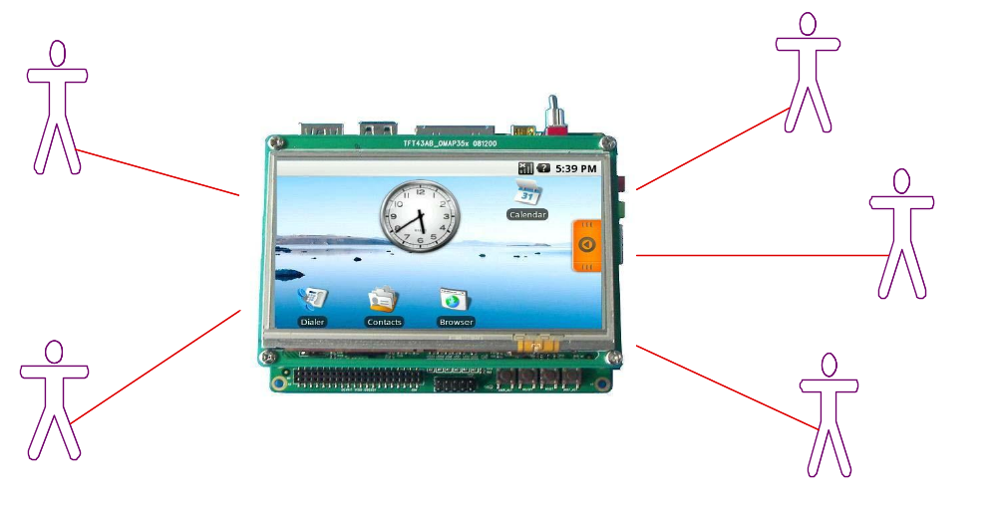

System introduction
A short description of the purpose and main functionality of the system described with reference to the system context.
The instructor will be able to control the simulation like forcing a heart attack and monitor the waveform of the signals that is send to the bedside monitor. Two analogue outputs signals can be connected to a bedside monitor to display ECG and EDR signals. It is possible remotely using an Ethernet connection to the patient simulator to update and delete files in the scenarios database on Sapien 190. The optional infusion pump injects medicine into the patient and the flow of medicine can be monitored on the Sapien 190 LCD display.

SYSTEMET INTERFACES
This section describes each of the interfaces to the external actors.

Interface to human actors
Describes the Man Machine Interface (MMI) for the human actors interacting with the system.
The MMI is described for each human actor role or alternatively insert a reference to a MMI specification document.
Instructor controls the patient simulation by inputs to the LCD touch screen….

Interface to external system actors
Describes the interface for actors representing external systems communicating with the System under development.
Describe the used communication protocol for each external system actor or alternatively insert a reference to a protocol specification document e.g. an international protocol standard.
Remotely it is possible to update the scenarios database by use of a ftp connection with a Ethernet connected to the patient simulator.

Interface to hardware actors
Describes the interface for actors representing the hardware devices connected to the system.
Describe the specific hardware interface for each hardware actor or alternatively insert a reference to a hardware interface specification document. This interface specification will often include timing requirements etc.
Analogue outputs signals to the LMON has a resolutions of 12 bits sampled at 250 hz. The analogue output has a voltage range of 0 - 4.096 volts.

Pulse interface
The pulse is send to a connected monitor using a RS232 connection (115200 baud, 8 databits, even parity, 1 stop bit).

Format of the pulse signal is a maximum 3 bytes ASCII value (beats/minute). It is transmitted from the PSIMU to the LMON with a rate of 1 second. The pulse value is terminated with a <CR>. <Pulse> <CR>

Example a terminal can be connected to display the pulse values updated each second:
103
107

Infusion pump interface
The infusion pump is connected using a RS232 connection with the protocol described below.

A fixed 64 bytes ASCII PDU is transmitted from IPUMP to PSIMU.

This PDU is transmitted every second when the pump is started.

PDU format:
4 bytes startframe (##?*)
46 bytes medicin name
12 bytes volume infused (since started)
2 bytes CRC checksum

Interface to external software actors
Describes the interface for actors representing another software subsystem, developed either as a separate project or it could be reusing a complete subsystem from earlier systems.
Describe the specific interface for each external software component or alternatively insert a reference to a software interface specification document for the actual software subsystem.

Use Case View
Mandatory view.
This section lists selected Use cases and Use Case scenarios from the Use case model.
In the first iteration the UC #1 has been selected since it provides the main functionality and is the essential use case for the architecture of the patient simulator.

Execute and Control Simulation

When the patient simulation is running it will perform reading of the digitized physiologic signals and send theses “real time” values as analogue signals to local connected bedside monitoring equipments. Up to 2 analogue channels with different signals is possible to be simulated simultaneously. The simulated signals can be ECG or EDR. The pulse will be signaled to the bedside monitoring equipment as a digital signal.

Overview of architecture significant Use cases
For large systems: select the part of the Use cases, which have an impact on the architecture. Large systems can have several Use cases of the same type, with the same impact on the system architecture. Select one of these candidates to represent the group.
Significant Use case are selected and shown on the Use case diagram:
1. if they represent some significant, central functionality of the final system
2. if they have a large architectural coverage and exercise many architectural elements
3. if they stress or illustrate a specific, delicate point of the architecture.
For smaller systems: include all Use cases
UML Use case diagram: showing the selected Use cases and associated actors
The UC #1 has been selected for the first iteration of the ROPES spiral microcycle [2] in making the architectural, mechanistic and detailed design. This use case is significant and provides the central functionality of the patient simulator. This use case provides the basis functionality that allows the monitor to be connected being able to display the ECG and EDR signals. It also reduces the risk for developing the patient monitor since it covers all the unknown technologies of the product like:

- Reading the patient record files on the target (Linux, WFDB and target)
- Generating the analogue output signals (Writing to drivers)
- Display of signal waveform using Qt on target (Working with Qt on target)

Use case #1: Execute and Control Simulation scenarios

Use case goal
A short description of the goal for the actual Use case (as stated in the requirement specification document)
To simulate signals from the patient based on the selected scenario.
The waveform of signals to monitor and the status of patient are displayed.
The instructor must be able to monitor the simulated patient.

Use case scenarios

Scenario 1 - normal:

- Opens scenario file
- Search for record file
- Opens record file
- Continues to reads samples from record file and performs:
  - Use patient model to generate ECG signal
  - Use patient model and ECG signal to calculate EDR signal
  - Use patient model and ECG signal to calculate pulse
  - Update output signals: Pulse, ECG and EDR

Scenario 2 – normal with alternative scenario record:

- Opens scenario file
- Search for record file
- Opens record file
- Continues to reads samples from record file and performs:
  - Use patient model to generate ECG signal
  - Use patient model and ECG signal to calculate EDR signal
  - Use patient model and ECG signal to calculate pulse
  - Update output signals: Pulse, ECG and EDR
- Open alternative record file after specified simulation time and continues at 2.

Scenario 3 – normal with IPUMP:

- Opens scenario file
- Search for record file
- Opens record file
- Continues to reads samples from record file and performs:
  - Reads medicine and volume from IPUMP
  - Use patient model to generate ECG signal
  - Use patient model and ECG signal to calculate EDR signal
  - Use patient model and ECG signal to calculate pulse
  - Update output signals: Pulse, ECG and EDR

Scenario 4 – error opening record file:

- Opens scenario file
- Failed to search and open record file
- Error message on LCD display

This section describes one or more significant Use case scenarios for the selected Use case no. 1. It will always include the normal scenario (the sun shine scenario) and one or more scenarios with exceptions.
For Use cases with significant nonfunctional requirement: include these nonfunctional requirements (a copy from the requirement specification).
For Use cases with human actors: include significant Pictures of the User Interface.
For Use cases with include, extends or inherit relations: include a UML Use-case diagram for the Use case.
References: The realizations of the Use case scenarios should be found in the logical view, in subsection Use case realizations 5.3.

Use case # 2: Select and Initiate Scenario scenarios
As previous section.
Initiate the simulation using a scenario configuration chosen by the instructor.

This use case is not part of the first iteration and will be updated in the next iteration.

Logical View
Mandatory view.
A description of the logical view of the architecture.
This section describes the architecturally significant parts of the design model, such as its decomposition into subsystems and packages. and their organization in a layered structure. Describe the most important classes, their organization in packages and subsystems, and the organization of these packages and subsystems into layers.

Overview
This subsection describes the overall decomposition of the design model in terms of its package hierarchy and layers and documented on UML class diagrams (showing packages).
If the system has several levels of packages, you should first describe those that are significant at the top level. Include any class diagrams showing significant top-level packages, as well as their interdependencies and layering. Next present any significant packages within these, and so on all the way down to the significant packages at the bottom of the hierarchy.
UML class diagrams: with packages, dependencies and interfaces.
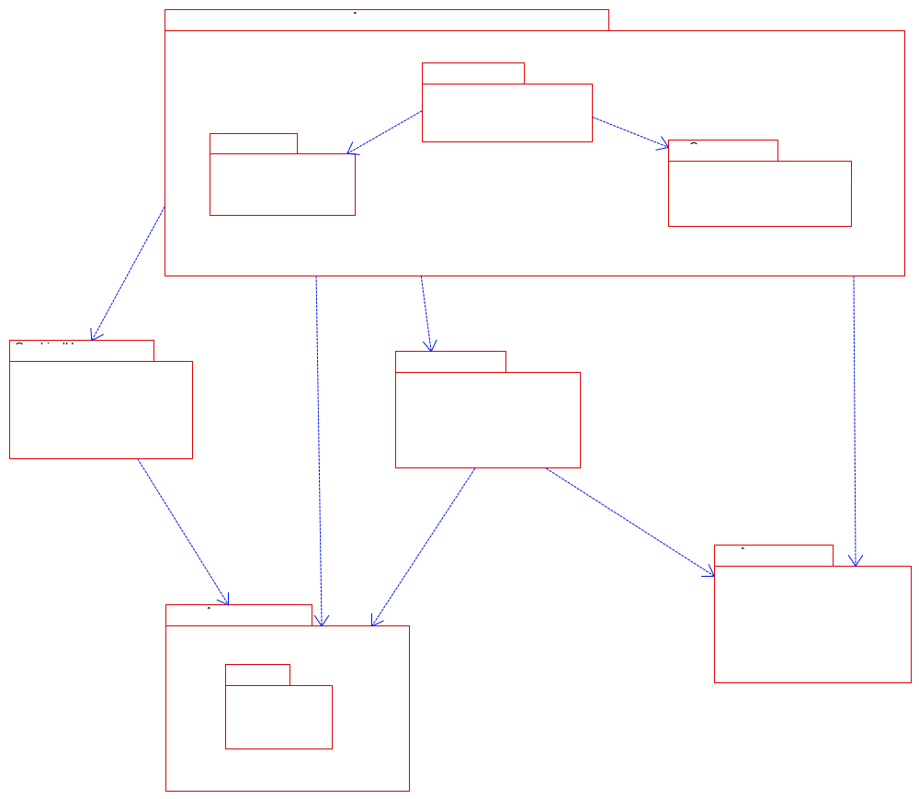

Architecturally significant design packages
A description of the design packages which have an impact on the architecture.

Continuous Package
Mandatory: A brief description of the responsibility for package 1.
Alternative 1: A UML class diagram with all significant classes and packages contained within the package. The class diagram may include classes from other packages named as package_name::class_name – this often eases the understanding of the class diagram.
For each class in the package:
include its name, a brief description of its responsibility, and, optionally a description of some of its
important operations and attributes. Also describe important associations that are necessary for
understanding the class diagram.
Describe the package interfaces.
UML Class diagram
with its decomposition into classes and optionally packages contained within the package.
UML State Chart:
for classes with a state machine include a UML state chart describing the state machine.
Alternative 2: describe the complete package in a separate design document and insert a reference here.

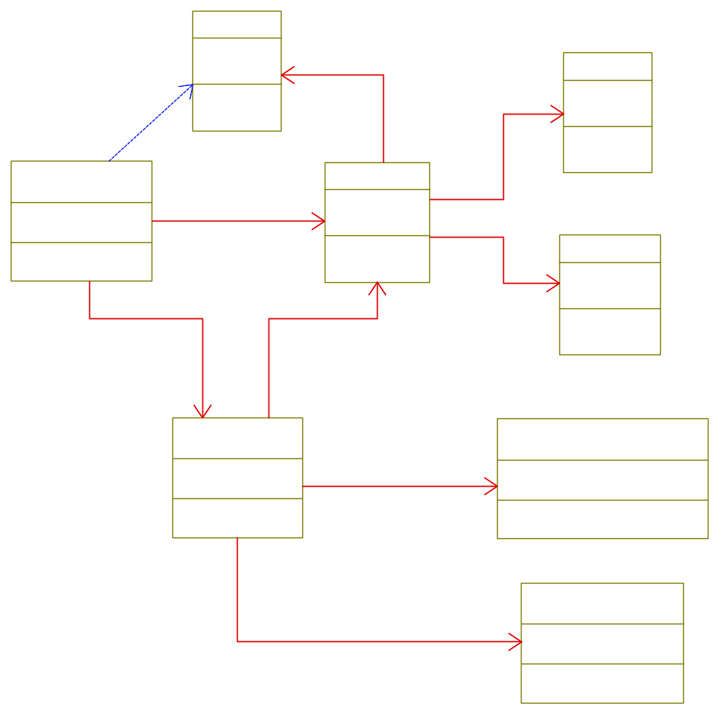
Figure 1 Major Classes in Continuous Package

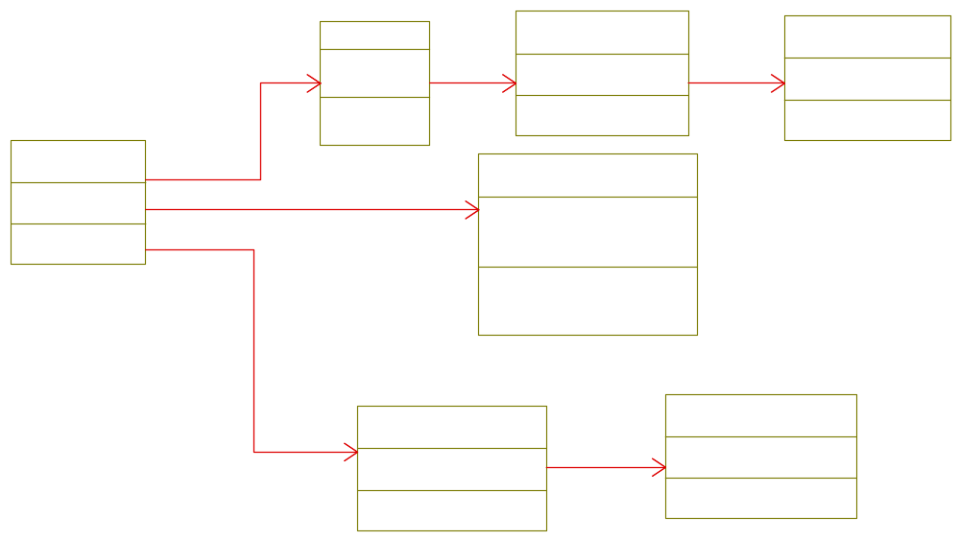
Figure 2 Boundary Classes for RealTimeThread

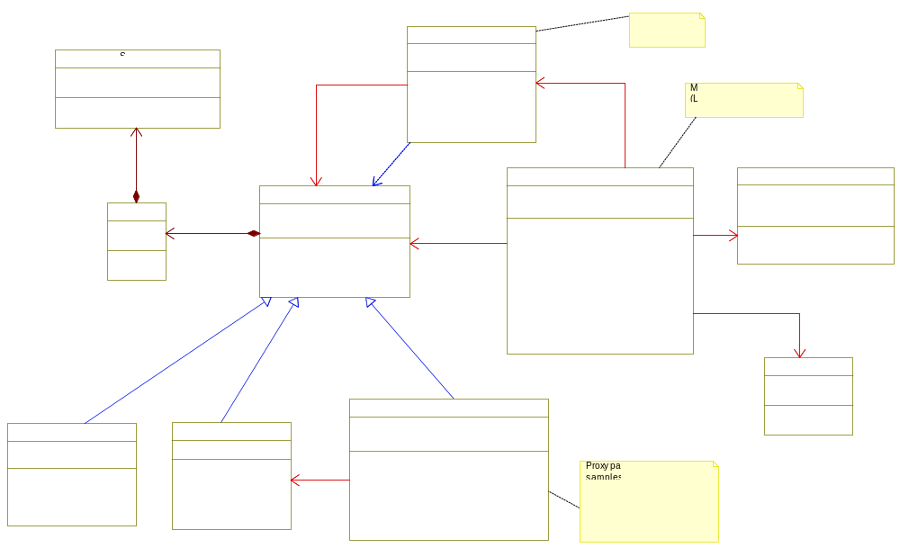
Figure 3 Proxy and Iterator Pattern used to access Records from the PatientModel

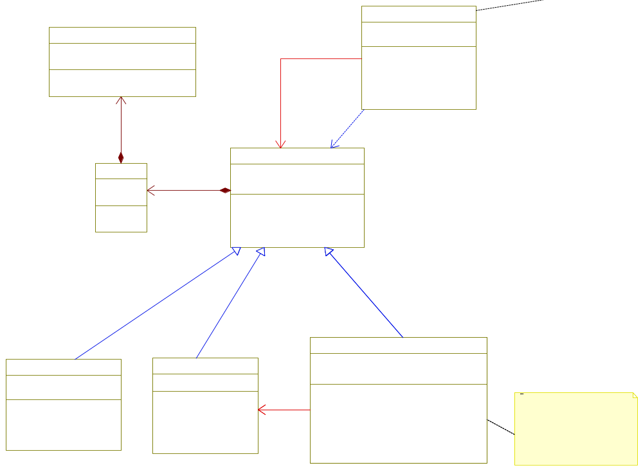
Figure 4 Record and Iterator

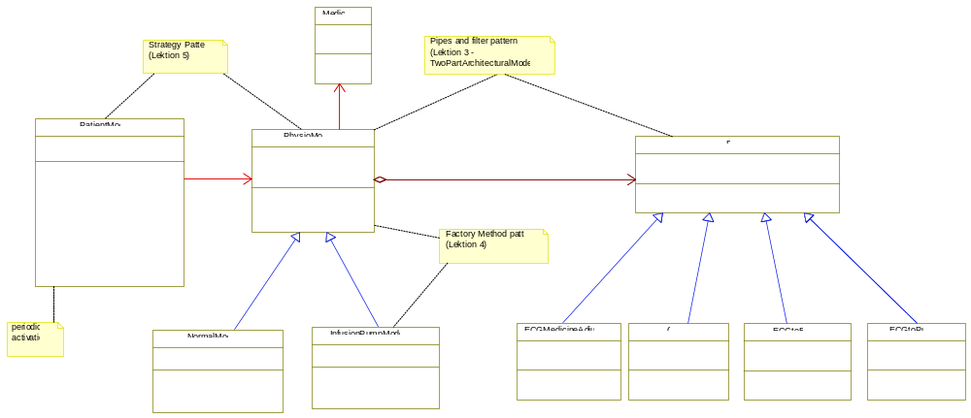
Figure 5 Strategy, Filter and Pipes Pattern used for PhysioModel

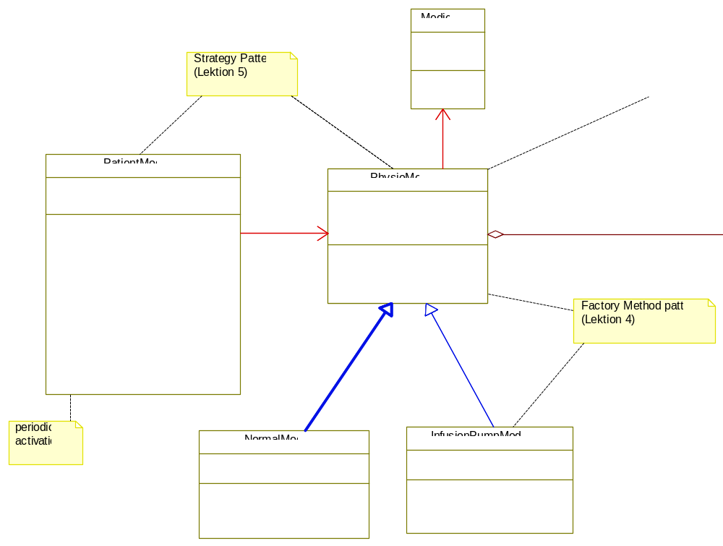
Figure 6 Strategy for PatientModel

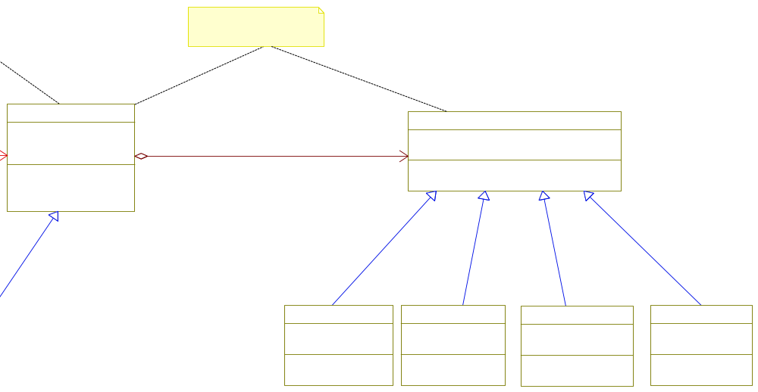
Figure 7 Filter Pattern for PhysioModel

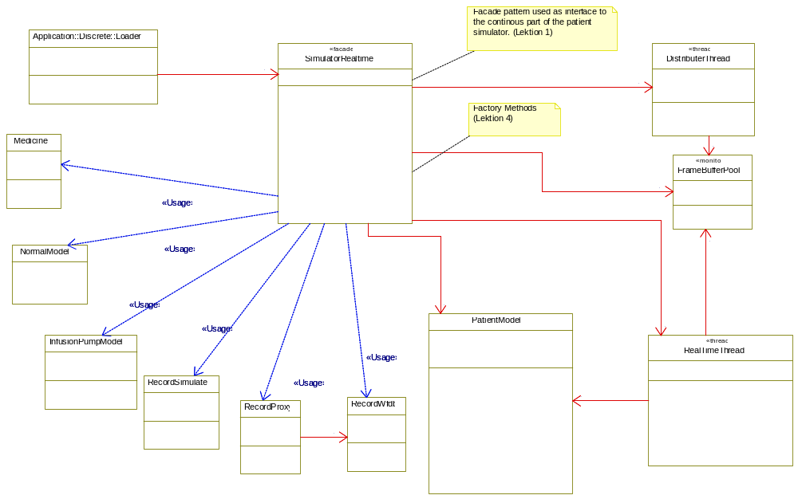
Figure 8 Façade Pattern used for interface to the Continuous Package

Discrete
As previous section.
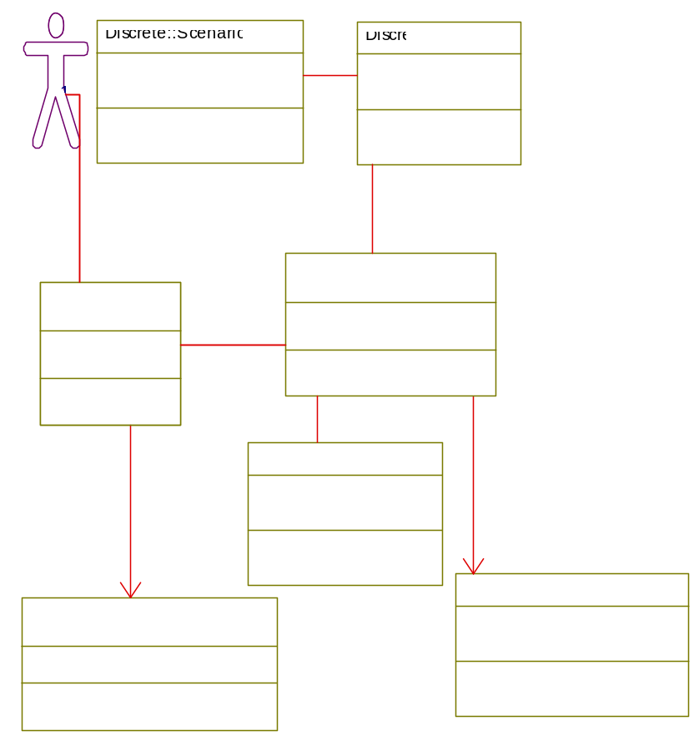
Figure 9 Application model for discrete package

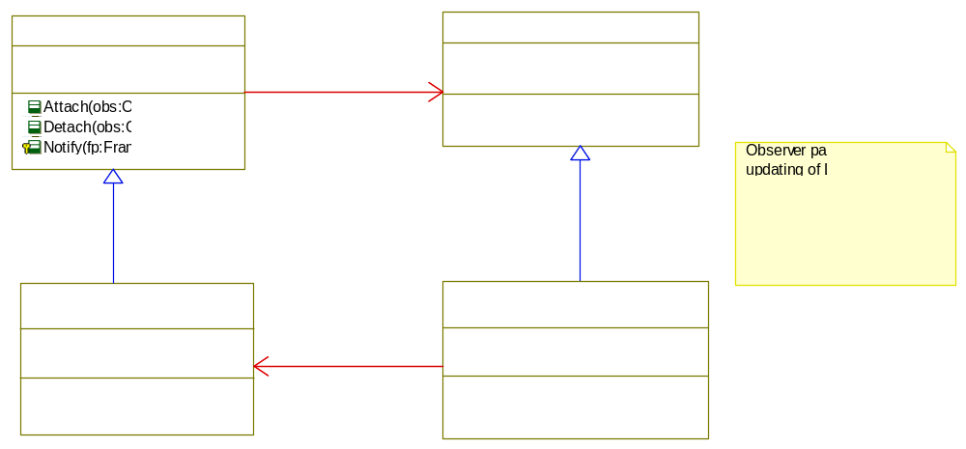
Figure 10 Observer pattern used to notify GUI with new framebuffer

Com
As previous section.
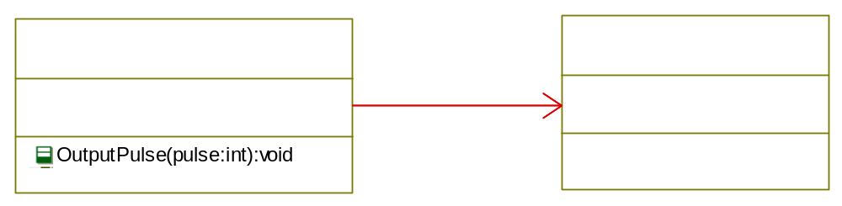
Figure 11 Communication package Serial protocol

AbstractHW
As previous section.
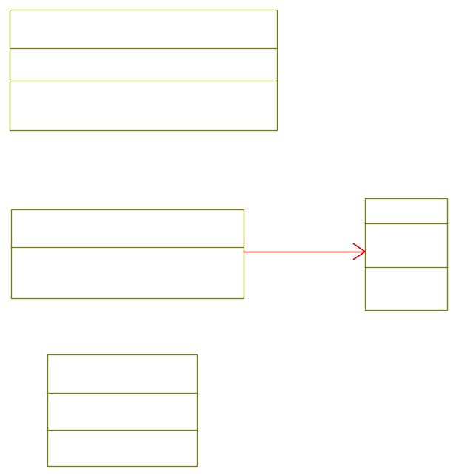
Figure 12 Hardware Abstraction

AbstractOS
As previous section.
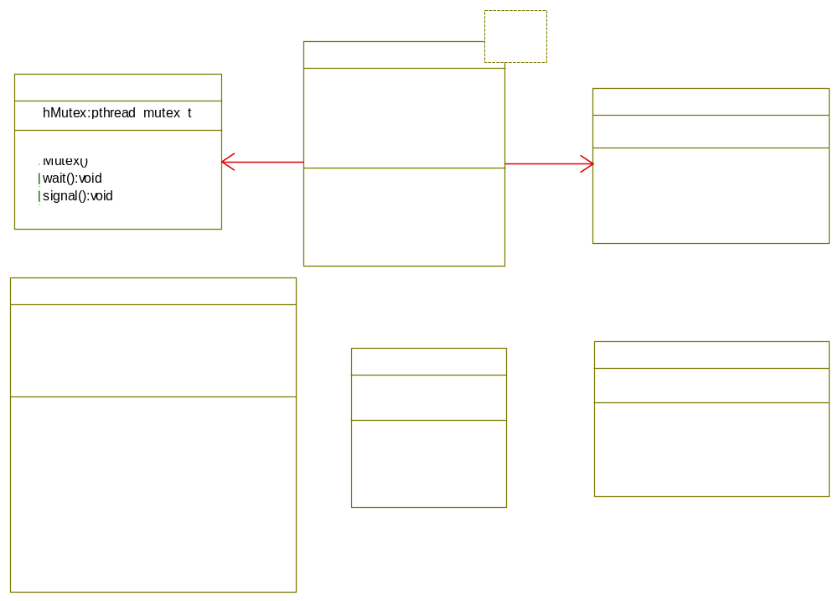
Figure 13 Abstract OS (Linux)

Application Helper Classes
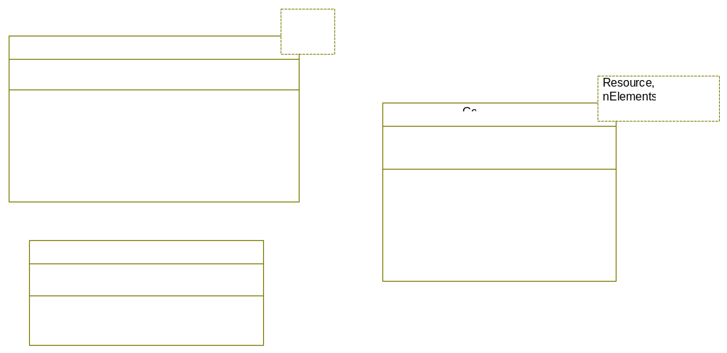
Figure 14 Application Helper classes

Use case realizations
This section illustrates how the software actually works by describing the realization for the selected Use-case (and Use case scenarios), and explains how the various design model elements contribute to their functionality.
Reference: The corresponding Use cases and scenarios of these realizations should be found in the use-case view in section 4.

Use case #1: Execute and Control Simulation scenarios
A brief description of how Use case 1. is realized in the design with references to the OO/UML model elements. The Use case logic is mapped onto packages and classes in the logical model.
UML class diagram with the classes used in the realization of the Use-case 1 scenarios.
UML interaction diagrams (sequence- or collaboration diagrams) showing how the objects interacts to fulfilling one or more of the Use-case 1. scenarios.
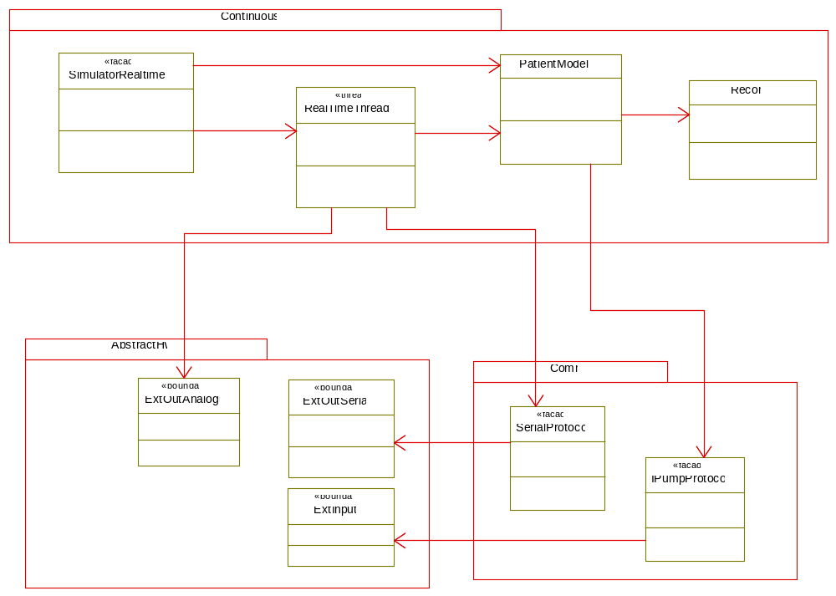
Figure 15 Logical view for use case #1 Execute and Control Simulation

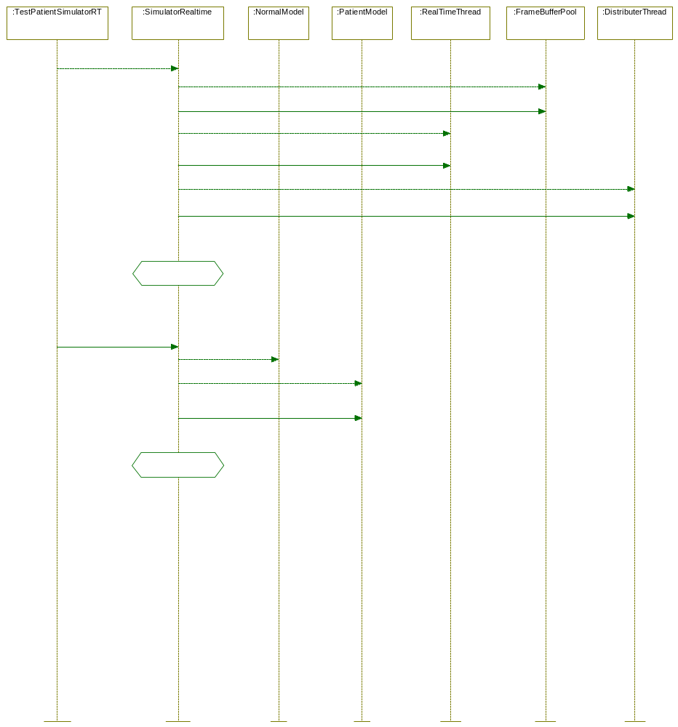
Figure 16 Sequence Diagram: Create Realtime Simulator

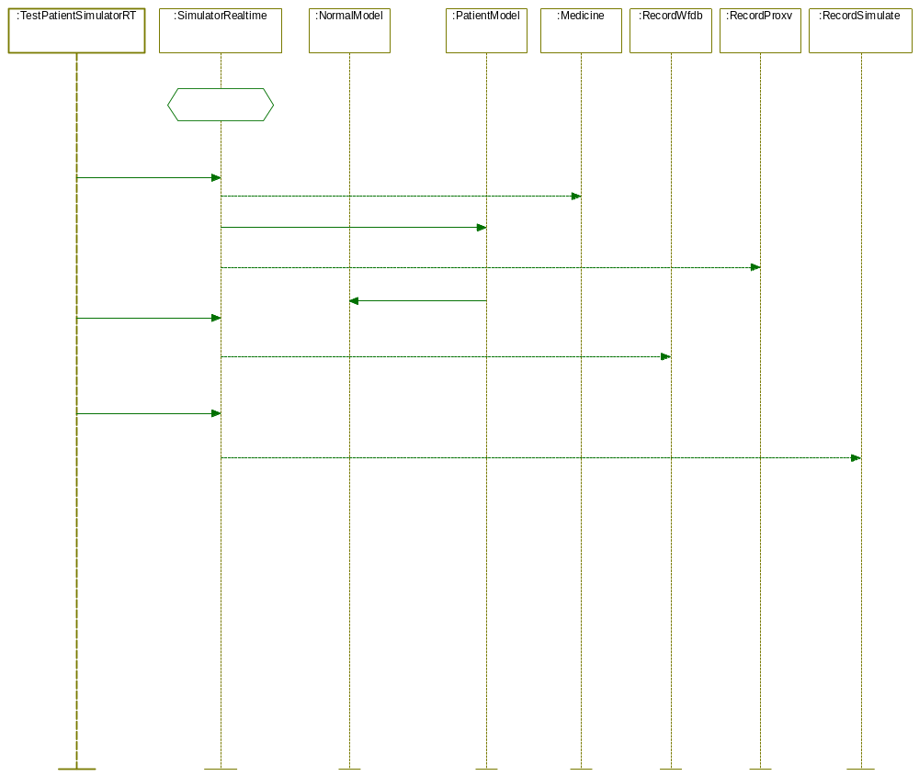
Figure 17 Sequence Diagram: Create Simulation Record and Set Medicine

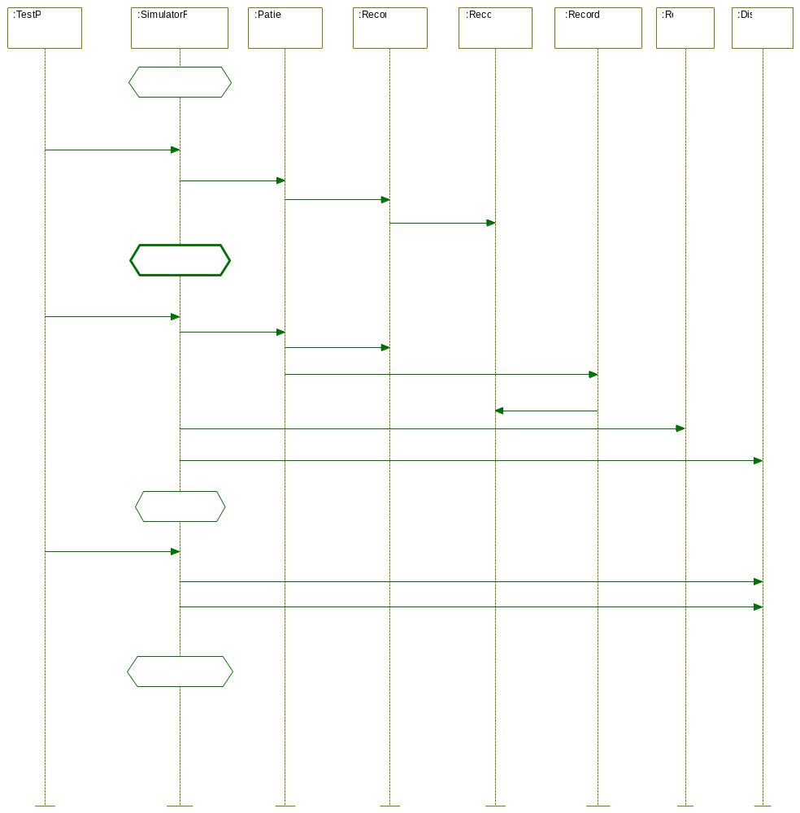
Figure 18 Sequence Diagram: Start Realtime Simulation

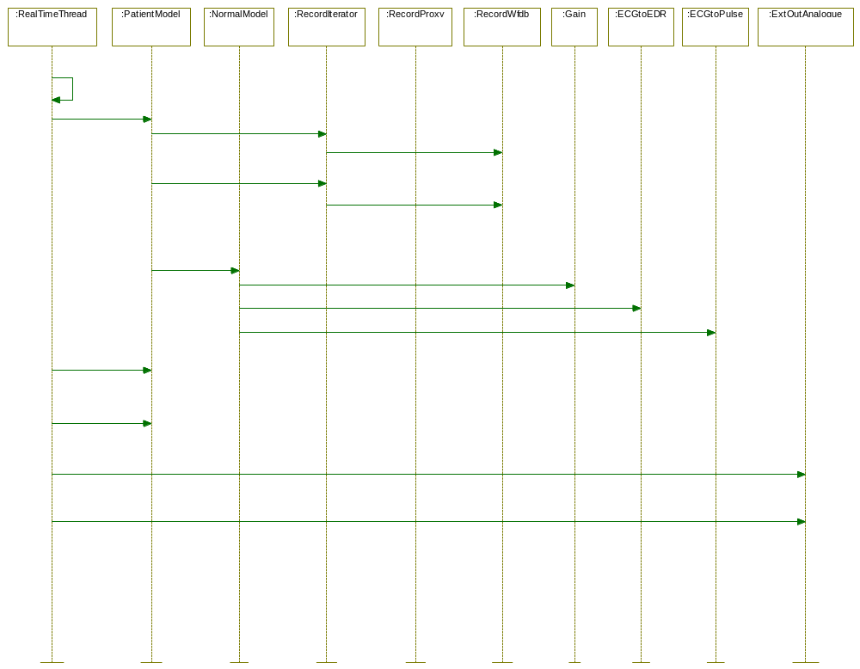

Figure 19 Sequence Diagram: RealTime thread GenerateSignals

Test setup for #UC 1 continuous package SimulatorRealtime
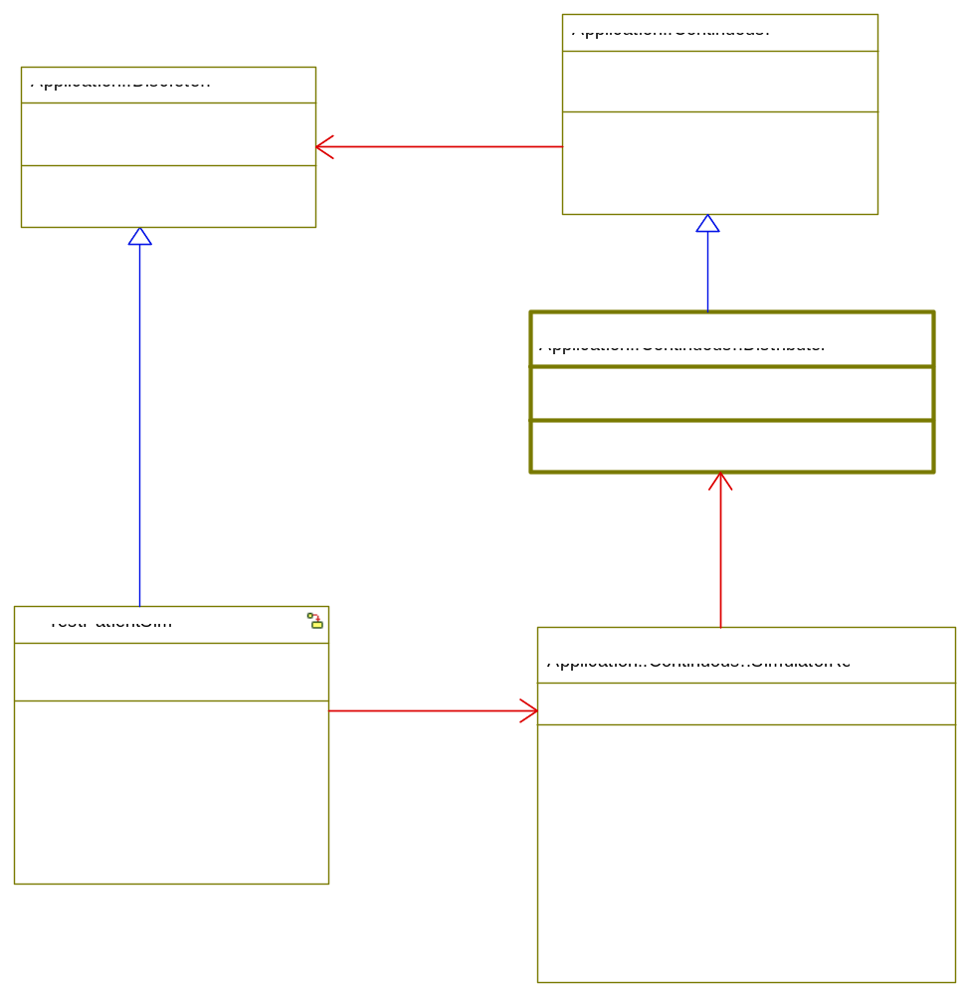
Figure 20 Test setup for UC#1 – test setup in Rhapsody only
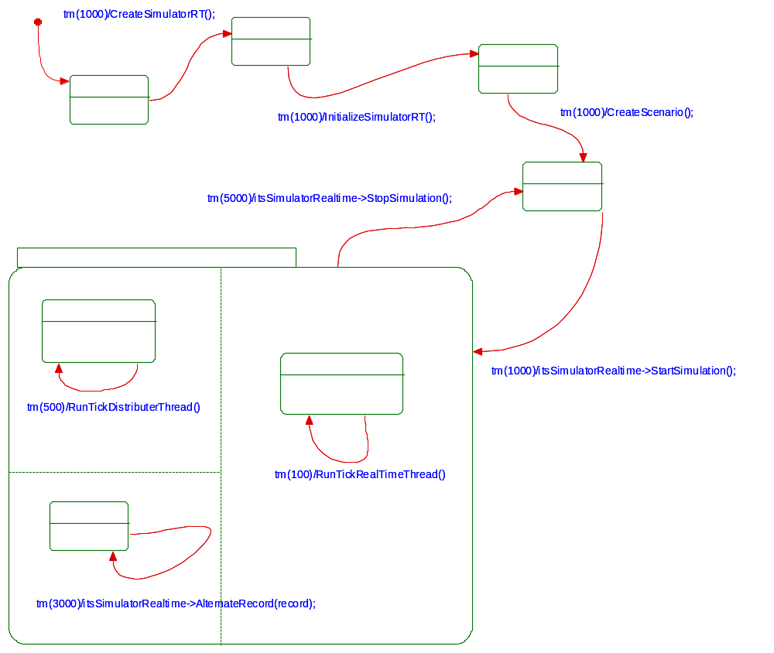
Figure 21 State machine test of UC#1 including simulation of Threads in Rhapsody

Use case 2. realization
As previous section.

Process/task View
Optional view.
A description of the process view of the architecture. Use this view if the system has more than one thread of execution.
This section describes the system's decomposition into lightweight processes (single threads of control) and heavyweight processes (groupings of lightweight processes) and the communication mechanism between these processes.

Process/task overview
For large systems: organized this view by groups of communicating processes.
UML Class diagram as a process/task diagram with active classes and passive classes of type monitor.
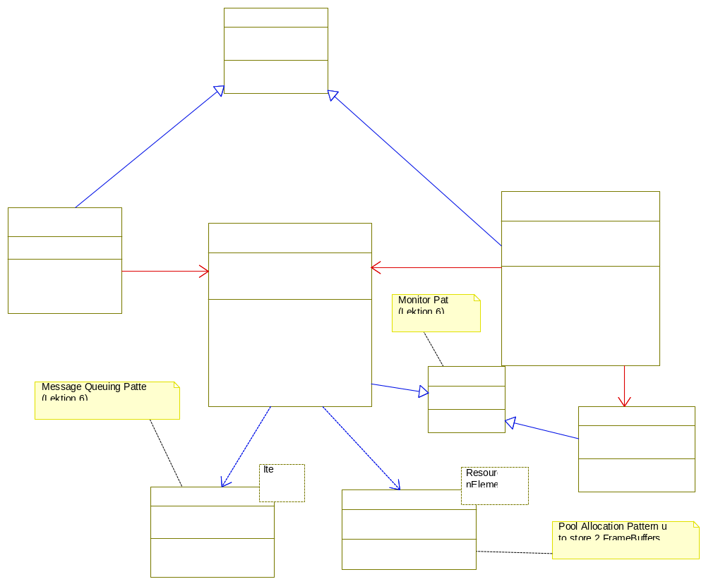
Figure 22 Process view for Distributer and RealTime threads and mechanism for synchronization

Process/task implementation
This section describes the operating system interface used in the implementation of processes/tasks and process communication. This section can specify the interface for a process/task framework (or wrapper façade classes).
An alternative is to insert a reference to the framework interface specification document.
If an operating system API is used, without wrapping, a reference to this API documentation is inserted here.

Process/task communication and synchronization
Describe the main modes of communication between processes, such as message passing, interrupts, monitors and rendezvous.

Process group 1.
This section gives a detailed description of the interactions in process group 1.

Process communication in group 1
This section describes the processes in group 1. The interactions between the processes are shown on collaboration- or sequence diagrams, in which the objects are active objects with their own threads of control.
UML class diagram as a process/task diagram with active objects (processes/tasks) and passive classes of type monitor.
UML collaboration diagram with active objects and monitors (if used)
or alternatively an
UML sequence diagram with active objects and monitors (if used).

Process 1. description
A brief description of behavior, lifetime and communication characteristics.

Process 2. description
As previous section.

Process group 2.
As previous section.

Deployment View
Optional view.
A description of the deployment view of the architecture showing the physical structure of the system with one or more interconnected computers and connected hardware units. Use this view if the system is distributed across more than one node and in situations where the connected hardware is important to clarify.
This section describes one or more physical network (hardware) configurations on which the software is deployed and run.
Indicate as a minimum for each configuration the physical nodes (computers, CPUs) that execute the software, and their interconnections (bus, LAN, point-to-point, and so on.)
Also include a mapping of the processes of the Process View onto the physical nodes.

System configurations overview
If there are many possible physical configurations, just describe a typical one and then explain the general mapping rules to follow in defining others.
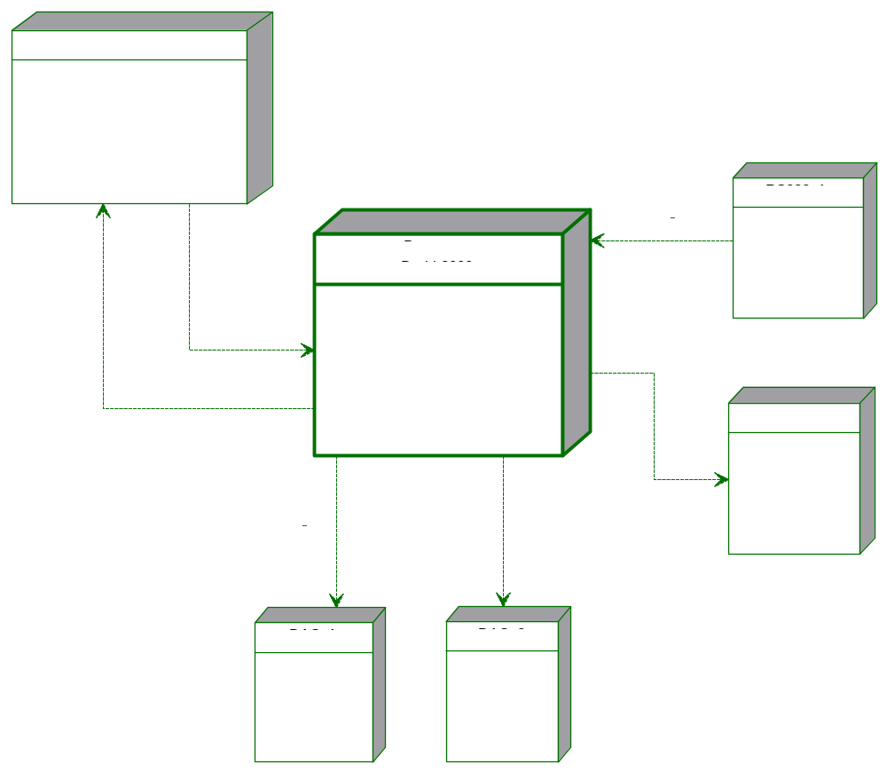

System configurations
Describe the different possible or typical system configurations. One of these could be a description of system configurations for performing software tests and simulations.

Configuration 1.
Show the configuration with a UML deployment diagram illustrating the nodes in the configuration and their communication, followed by a mapping of processes to each processor node.
UML deployment diagram showing nodes and communication stereotypes in configuration 1.
Optional: UML interaction diagram showing the interactions between the nodes in the actual configuration.

Configuration 2.
As previous section.

Node descriptions
A short description of each node represented on the deployment diagrams for the different configurations.

Node 1. description
A short description of node 1 – a processor or a hardware unit.
A processor is described by key data e.g. CPU type, clock frequency, memory (RAM, ROM) etc.
For HW nodes insert a reference to the documentation of the Hardware unit.

Node 2. description
As previous section.

Implementation View
Optional.
This section describes the decomposition of the software into layers and subsystems in the implementation model. Use this view if there is a different distribution of responsibilities between corresponding packages in the logical and implementation model.

Overview
This subsection names and defines the various subsystems components and show their dependencies in a layered structure.
A UML component: can be a source file, a configuration file, an executable file (.exe) or a dynamic load library (DLL).
UML component diagram showing the systems components in a layered component structure with their dependencies and optionally interfaces.

Component descriptions
This section describes each of the components shown on the overview diagram.

Component 1
Mandatory: insert a short description of the responsibility for component 1.
Alternative 1: Describe the component and show its part components on a component diagram.
UML component diagram with part components and their dependencies (e.g. an executable components and its source files).
Alternative 2: Insert a reference to an external component documentation.

Component 2
As previous section.

Data View
Optional view.
A description of the persistent data storage perspective of the system. This section is optional if there is little or no persistent data, or the translation between the Design Model and the Data Model is trivial.

Data model
This section describes the architecturally significant parts of the data model:
- The mapping from key persistent design classes, especially where the mapping is non-trivial.
- The architecturally significant parts of the system which have been implemented in the database, in the form of stored procedures and triggers.
- Important decisions in other views which have data implications, such as choice of transaction strategy, distribution, concurrency, fault tolerance. For example, the choice to use database-based transaction management (relying on the database to commit or abort transactions) requires that the error handling mechanism used in the architecture include a strategy for recovering from a failed transaction by refreshing the state of persistence objects cached in memory in the application.
You should present architecturally significant data model elements, describe their responsibilities, as well as a few very important relationships and behaviors (triggers, stored procedures, etc.).

Implementation of persistence
This section describes the interface to the persistency implementation. This could be the interfaces to a specific framework for handling this layer.
Alternatively: insert a reference to existing persistency framework documentation.
If a framework is developed as part of the current system – it will typically be documented in a stand alone document.

Generel design decisions
This section describes the general design decision taken in the architecture design phase and mandatory design constraints given in the requirement specification or as a part of a company standard.

Architectural goals and constraints
This section describes the non-functional software requirements and objectives that have some significant impact on the architecture e.g. use of an off-the-shelf product, portability, distribution, and reuse.
It also captures the special constraints that may apply e.g. design and implementation strategy, development tools, team structure, schedule, legacy code, and so on.
The architectural goals are to make the system modifiable and provide high performance. Since the system is a real time system, there are constraints on how modular system can be, since modular and performance work in the opposite direction. It should be easy to extend the system new types of medicine, different kind of inputs and output. The system should be encapsulated so it's easy to port the system to different platform.

Architectural patterns
This section list the standard architectural patterns used in the project and a reference to the original source.
Observer Pattern:
Observer pattern help out with mass distribution of information in a system. If a number of processes are interested in the same information, observer pattern is the pattern to choose. In Sapien the observer pattern is used to distribute information generated by our simulation to the user interface. This a very common way to use observer pattern since it also notify the user interface when new data has arrived so it can be refreshed.

Five Layered Architecture:
Layered pattern organizes domains into a hierarchical organisation based their level of abstraction. The advance of layered architectural is that it make it easier to find relevant code, and make it easier to replace whole layers, for instance if you want to port the system to another device. There used open layered architectural so it's allowed to call more than one layer down.

General user interface design rules
This section describes the general rules and principles for designing the user interface part of the system. This could also be a reference to an external document.

Exception and error handling
This section describes general rules for exception and error handling. Alternatively insert a reference to a stand alone document.

Implementation languages and tools
This section list the chosen implementation language and tools with version numbers.
Implementation languas:
  - C++
Tools
- Ecliplse
- TrollTech QT Creator

Implementation libraries
This section list the chosen implementation libraries with references and version numbers.
QT-Everywhere-4.6.1

wfdb

SIZE and performance
A description of the major dimensioning characteristics of the software that impact the architecture, as well as the target performance constraints.
In this section, list the critical size and performance dimensions of the project that shape the architecture.
The information presented may include:
- The number of key elements the system will have to handle (such as the number of concurrent flights for an air traffic control system, the number of concurrent phone calls for a telecom switch, the number of concurrent online users for an airline reservation system, etc.).
- The key performance measures of the system, such as average response time for key events; average, maximum and minimum throughput rates, etc.
- The footprint (in terms of disk and memory) of the executables - essential if the system is an embedded system which must live within extremely confining constraints.
Most of these qualities are captured as requirements; they are presented here because they shape the architecture in significant ways and warrant special focus. For each requirement, discuss how the architecture supports this requirement.

Quality
A description of how the software architecture contributes to other non-functional capabilities of the system: extensibility, reliability, portability, and so on.
In this section, list the key quality dimensions of the system that shape the architecture. The information presented may include:
- Operating performance requirements, such as mean-time between failure (MTBF).
- Quality targets, such as "no unscheduled down-time"
- Extensibility targets, such as "the software will be upgradeable while the system is running".
- Portability targets, such as hardware platforms, operating systems, languages.
For each dimension, discuss how the architecture supports this requirement.
You can organize the section by the different views (logical, implementation, and so on), or by quality.

Compilation AND LINKING
This section describes the process of compiling and linking a program.

Compilation-hardware
Describe the compilation machine.

Compilation-software
Describe the software used to compile and assemble the program.
For example: compiler, assembler, linker, include files, files with system parameters, make files etc.
Include vendor and version number for standard products.

Compilation and linking process
Describe the process to follow for compiling and linking a given program. Include a specification of special compiler and link switches.
Describe the directory structure for the program.

INSTALLATION AND Executing
Describe how to install and run the program.

Installation
This section describes the process to bring an executable file to run in the right environment. It could be to download the program to another machine or to program it on EPROMs and insert these in the target machine.
Describe the necessary configuration files and start up parameters.

Executing-hardware
Describe the necessary hardware for running the program.
It can be on the development platform or on the final target platform.

Executing-software
Describe the necessary SW requirements for running the program on a given machine. It could be operating systems or DLL files.

Execution-control (start, stop and restart)
Describes how the system is started, stopped and restarted.

Error messages
A complete description of the software error messages. For each error type give an explanation of the error and describe how to proceed to get the system working again.
Alternative: a reference to a stand alone document.

Appendices
Necessary supplementary documentation can be inserted here as appendices.

