# Linear Classification 2D (MDA projection)

UsePCA_MDAFeatureReduction = 1 % 0=PCA, 1=MDA

UseLinear2D_3D_ANN = 0 % 0=2D, 1=3D, 2 = ANN2D, 3 = ANN3D

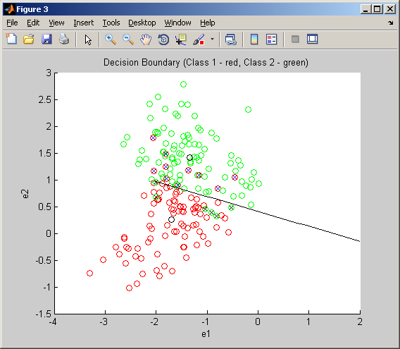

Confusion matrix on training set (16 errors)

83 6

10 87

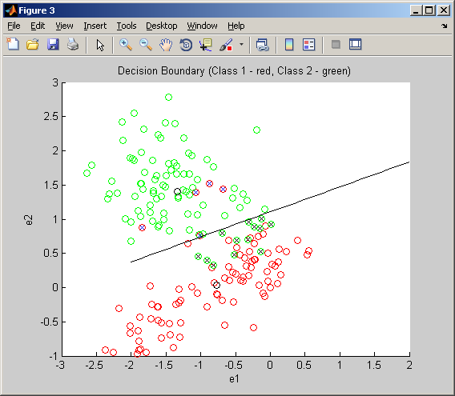

Confusion matrix on test set (18 errors)

88 13

5 80

# Linear Classification 3D (MDA projection)

UsePCA_MDAFeatureReduction = 1 % 0=PCA, 1=MDA

UseLinear2D_3D_ANN = 1 % 0=2D, 1=3D, 2 = ANN2D, 3 = ANN3D

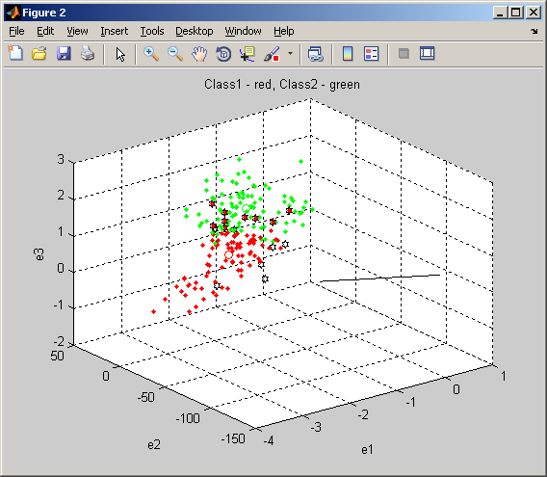

Confusion matrix on training set (16 errors)

83 6

10 87

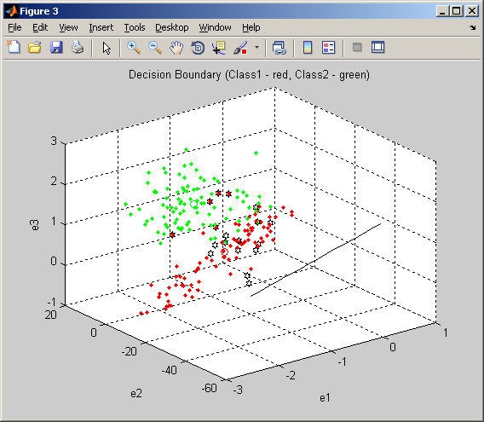

Confusion matrix on test set (18 errors)

88 13

5 80

# ANN Classification 2D (MDA projection)

UsePCA_MDAFeatureReduction = 1 % 0=PCA, 1=MDA

UseLinear2D_3D_ANN = 2 % 0=2D, 1=3D, 2 = ANN2D, 3 = ANN3D

nhidden = 5; % Number of hidden units.

alpha = 0.2; % Coefficient of weight-decay prior.

opt = 50; % Number of training cycles.

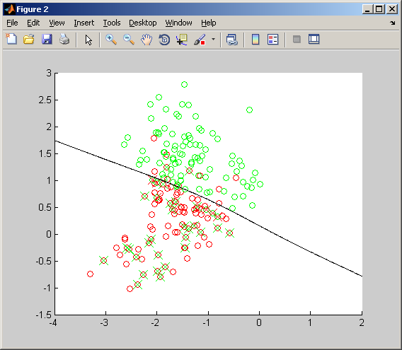

Ctrain =

82 11

6 87

err_train = 0.0914

Ctest =

65 28

6 87

err_test = 0.1828

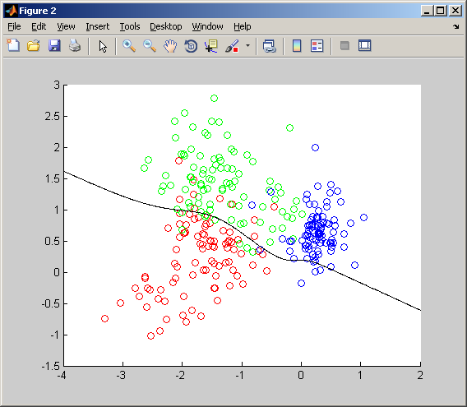

Ctrain =

83 10 0

8 83 2

1 3 89

**err_train = 0.0860**

Ctest =

49 14 30

8 83 2

1 3 89

**err_test = 0.2079**

# ANN Classification 3D (MDA projection)

UsePCA_MDAFeatureReduction = 1 % 0=PCA, 1=MDA

UseLinear2D_3D_ANN = 3 % 0=2D, 1=3D, 2 = ANN2D, 3 = ANN3D

nhidden = 5; % Number of hidden units.

alpha = 0.25; % Coefficient of weight-decay prior.

opt = 50; % Number of training cycles.

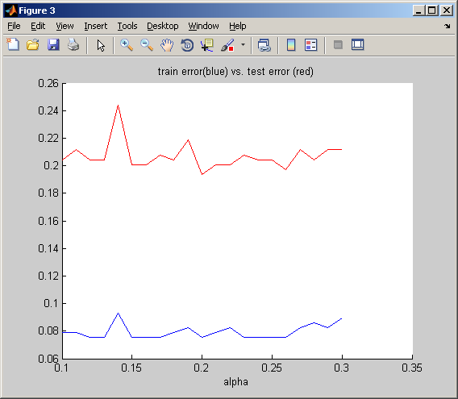

Ctrain =

83 10 0

6 86 1

1 4 88

**err_train = 0.0789**

Ctest =

48 10 35

6 86 1

1 4 88

**err_test = 0.2043**