Inventra AI
Competition Report & Concept Paper

Inventra AI
AI Decision Intelligence Platform
for Cambodian SMEs
“From Inventory Tracking to Intelligent Business Decisions”
AI Business Copilot
Decision Intelligence Platform
SME Operating Intelligence Layer
Business Growth Assistant
Prepared for the AIM Competition Version 1.0 · August 2026 Confidential
Inventra AI · Concept PaperContents
Contents

Document Structure
A concept paper positioning Inventra AI as an AI decision-intelligence platform — not an inventory tracking tool — for Cambodia’s small and medium enterprises.
1Executive Summary Problem, solution, impact, vision
2Industry Background The digital transformation challenge facing Cambodian SMEs
3Problem Analysis Beyond inventory management — the real business problem
4Solution Overview Inventra AI as an AI operating copilot for SMEs
5Core AI Capabilities Forecasting, procurement, dead stock, cash flow, health, copilot
6System Architecture Layers, models, and data flow
7User Experience Journey From raw sales data to recommended actions
8Target Users & Market Personas and market opportunity
9Competitive Differentiation Traditional systems vs. Inventra AI
10MVP Development Plan AIM Competition build-week scope and roadmap
11Business Impact Efficiency, finance, decision quality, productivity, transformation
12Future Roadmap Five-year path to a full SME operating copilot
13Conclusion The vision for SME decision intelligence in Cambodia
Inventra AI · Concept PaperSection 1
Section 1

Executive Summary
What Inventra AI is, why it exists, who it serves, and why it matters now.
Cambodia’s small and medium enterprises generate the majority of the country’s employment and a large share of its economic activity, yet most of them run on intuition, paper records, and disconnected spreadsheets. They collect a surprising amount of data every day — every sale, every delivery, every price change — but almost none of it is converted into a decision. Owners can tell you what is on the shelf; they cannot tell you what to buy next week, which products are draining their cash, or where their margin is leaking.
Inventra AI is an AI decision-intelligence platform that closes this gap. It ingests the operational data an SME already produces and returns forecasts, procurement recommendations, risk alerts, and plain-language business insight. It is designed to function less like software and more like a business analyst that never sleeps — an AI operating copilot for the owner-operator.

Problem Statement
SMEs do not have an inventory problem. They have a decision problem caused by the absence of affordable business intelligence. Stockouts, overstocking, dead stock, and trapped cash are the visible symptoms; the root cause is that operational data is never analysed, so purchasing and pricing decisions are guesses.

Solution Overview
Inventra AI adds an intelligence layer on top of day-to-day operations. Six capabilities work together: demand forecasting, smart procurement, dead-stock detection, cash-flow optimisation, business-health monitoring, and a conversational AI copilot that answers questions in natural language. The owner asks “what should I reorder?” and receives a costed, prioritised answer.
Expected Impact
Fewer stockouts and lost sales, less capital locked in slow-moving stock, faster and more confident purchasing decisions, and a measurable step toward digital operations for businesses that have never used a BI tool.
Future Vision
Inventra AI grows from inventory intelligence into a full SME operating copilot — supplier intelligence, financial forecasting, and a Khmer-language AI advisor — making enterprise-grade decision support normal for every Cambodian SME.
Traditional systems tell business owners what happened. Inventra AI tells them what to do next.
Inventra AI · Concept PaperSection 2
Section 2

The Digital Transformation Challenge Facing Cambodian SMEs
A large, essential, and under-served segment of the economy is being left behind by the tools of modern management.
SMEs are the backbone of Cambodia’s economy. They dominate retail, distribution, and light manufacturing, and they employ the majority of the non-agricultural workforce. Their health is, in aggregate, the health of the domestic economy — and their productivity ceiling is set by how well they are run day to day.
Operational management is where they struggle. A typical mini-mart or convenience store carries hundreds of SKUs with different suppliers, lead times, shelf lives, and margins. Keeping the right amount of each product in stock is a genuinely hard optimisation problem — and it is being solved with memory and habit.
The tooling gap is stark. Larger firms run ERP and BI platforms; SMEs run spreadsheets, notebooks, and supplier chat threads. Business intelligence software is priced, designed, and sold for enterprises. As a result, decisions that should be informed by data — how much to order, what to promote, what to stop stocking — are made on intuition.
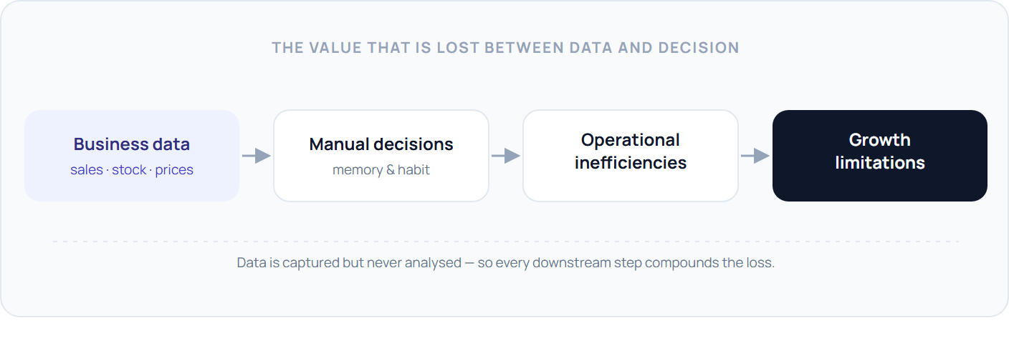
The opportunity is not to digitise inventory records — many SMEs already have a basic point-of-sale system. The opportunity is to put an analytical layer on top of that data so the business can act on it.
Inventra AI · Concept PaperSection 3
Section 3

Beyond Inventory Management: The Real Business Problem
The problem is not inventory. It is poor decision-making caused by the absence of business intelligence.
It is tempting to frame the SME challenge as an inventory-accuracy problem and solve it with a better tracking system. That is a misdiagnosis. Businesses with perfectly accurate stock counts still run out of best-sellers, still tie up cash in products that will not sell, and still cannot say which lines make them money. Accurate records are necessary but not sufficient — the missing ingredient is analysis that produces a recommendation.

3.1 Inventory problems
- Stockouts — fast-moving products run dry between deliveries, sending customers to competitors and eroding loyalty.
- Overstocking — over-ordering “to be safe” consumes shelf space, cash, and shelf life.
- Dead stock — products that were bought once and never sold sit as frozen capital and clutter.

3.2 Financial problems
- Cash trapped in inventory — working capital that could fund growth is sitting on shelves as unsold goods.
- Poor purchasing decisions — buying is driven by supplier promotions and gut feel rather than demand and margin.
- Invisible margin leakage — without product-level performance, owners cannot see which lines are unprofitable after handling and spoilage.

3.3 Strategic problems
- No forecasting — the business cannot see next week, so it cannot prepare for it.
- No trend detection — rising and falling products are noticed late, after the opportunity or the loss.
- No decision support — there is no second opinion, no analyst, no system that says “here is what I would do.”
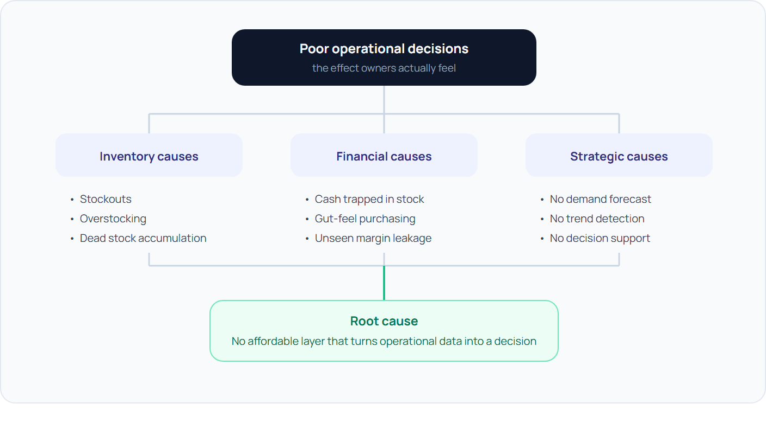
The reframe
Every item above is downstream of one gap: operational data is never analysed into a recommendation. Fix that, and the symptoms recede together.
Inventra AI · Concept PaperSection 4
Section 4

Inventra AI: An AI Operating Copilot for SMEs
A platform that behaves like a business advisor — it reads the data, forms a view, and tells the owner what to do.
Inventra AI sits on top of the systems an SME already uses. It connects to point-of-sale exports, inventory lists, and supplier records, and it accepts direct questions from the owner. From those inputs it maintains a continuously updated model of the business and produces four kinds of output: recommendations (what to do), predictions (what is coming), alerts (what needs attention now), and insights (what is going on and why).
Functionally, it plays the role a financial or operations analyst would play in a larger company. It does not just surface a dashboard and leave interpretation to the user; it interprets, prioritises, and explains — in the owner’s language, at the owner’s scale.
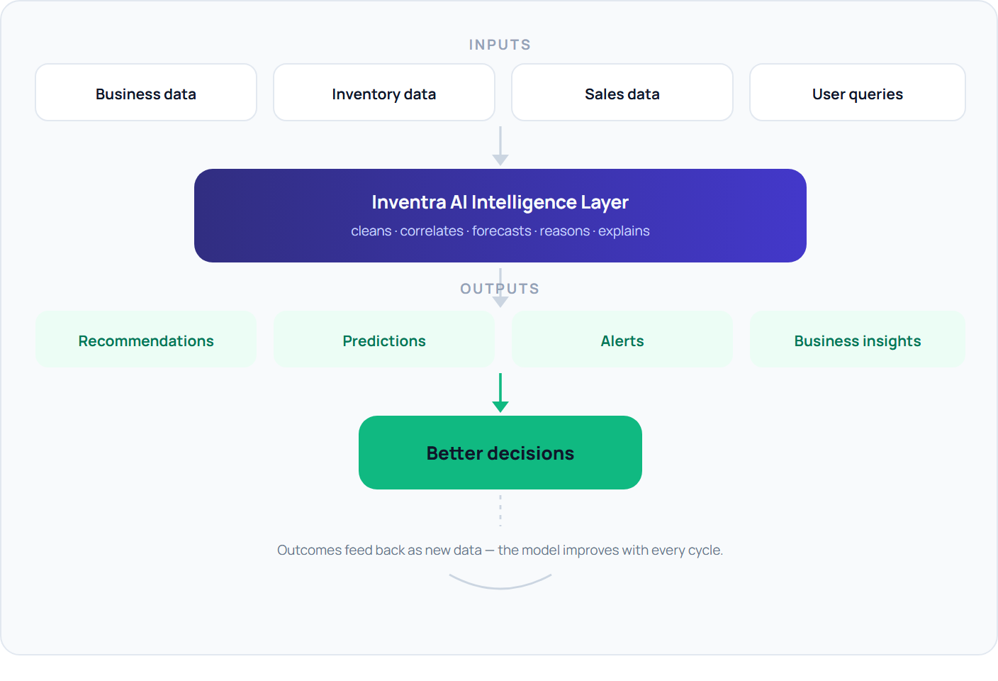
Inventra AI · Concept PaperSection 5
Section 5

Core AI Capabilities
Six capabilities that together turn an SME’s data into a running stream of decisions.

5.1 Demand Forecasting Intelligence
Predicts future demand at the product level using historical sales, recent momentum, and calendar effects.

Capabilities
Trend detection · seasonal and holiday forecasting · per-product demand prediction with a confidence range.

Business value
Purchasing is planned against expected demand, not last month’s. Fewer stockouts on rising products; less overstock on fading ones.

5.2 Smart Procurement Intelligence
Converts the forecast into a concrete buying plan: what to buy, when to buy, and how much — constrained by the cash available and current stock cover.
Inputs
Demand forecast • budget constraint • on-hand stock and lead times • supplier minimums and pack sizes

5.3 Dead Stock Intelligence
Flags products that consume shelf space and capital without generating a return, before they become a write-off.
Metric | What it measures | Signal
Inventory age | Days since the stock was received without a sale | Ageing → clearance candidate
Turnover rate | How many times the product sells through per period | Low → over-ordered or wrong product
Capital lock-up risk | Cash value held in slow or non-moving units | High → prioritise for markdown

5.4 Cash Flow Optimisation
Recommends inventory strategies that maximise the cash efficiency of every dollar on the shelf — prioritising high-turnover lines, staging large buys, and releasing capital from slow stock.
Worked example
Budget: $500 this week. Inventra AI recommends $180 Coca-Cola, $210 instant noodles, $110 bottled water — the three lines with the highest turnover per dollar and the shortest days-of-cover. It defers a $300 dried-snack reorder because 40 days of cover remain, keeping $300 in working capital.

5.5 Business Health Intelligence
Continuously monitors the business and surfaces what changed and why.
Revenue trends — week-on-week direction and the products driving it.
Product performance — best and worst lines by margin contribution.
Inventory efficiency — turnover, cover, and capital utilisation.
Operational risks — concentration, spoilage exposure, and supplier dependence.

5.6 Conversational AI Copilot
A natural-language interface to everything above. The owner asks a question in Khmer or English and gets a direct, explained answer.
The owner asks | Inventra AI answers
“What should I reorder next week?” | A costed, prioritised reorder list with quantities, sized to the current budget and stock cover.
“Which products are hurting cash flow?” | The slow-moving lines ranked by capital locked up, with a suggested markdown or stop-order action.
“What are my biggest business risks?” | Upcoming stockouts on top sellers, over-reliance on one supplier, and spoilage exposure — each with a recommended step.
Inventra AI · Concept PaperSection 6
Section 6

System Architecture
A conventional web application stack with a dedicated intelligence layer between the database and the user.
The architecture is deliberately pragmatic: a standard front-end and API, a relational database as the system of record, and an AI intelligence layer that combines a deterministic analytics engine, forecasting models, and an LLM for reasoning and explanation. Deterministic statistics do the measurable work; the language model narrates, prioritises, and answers questions.
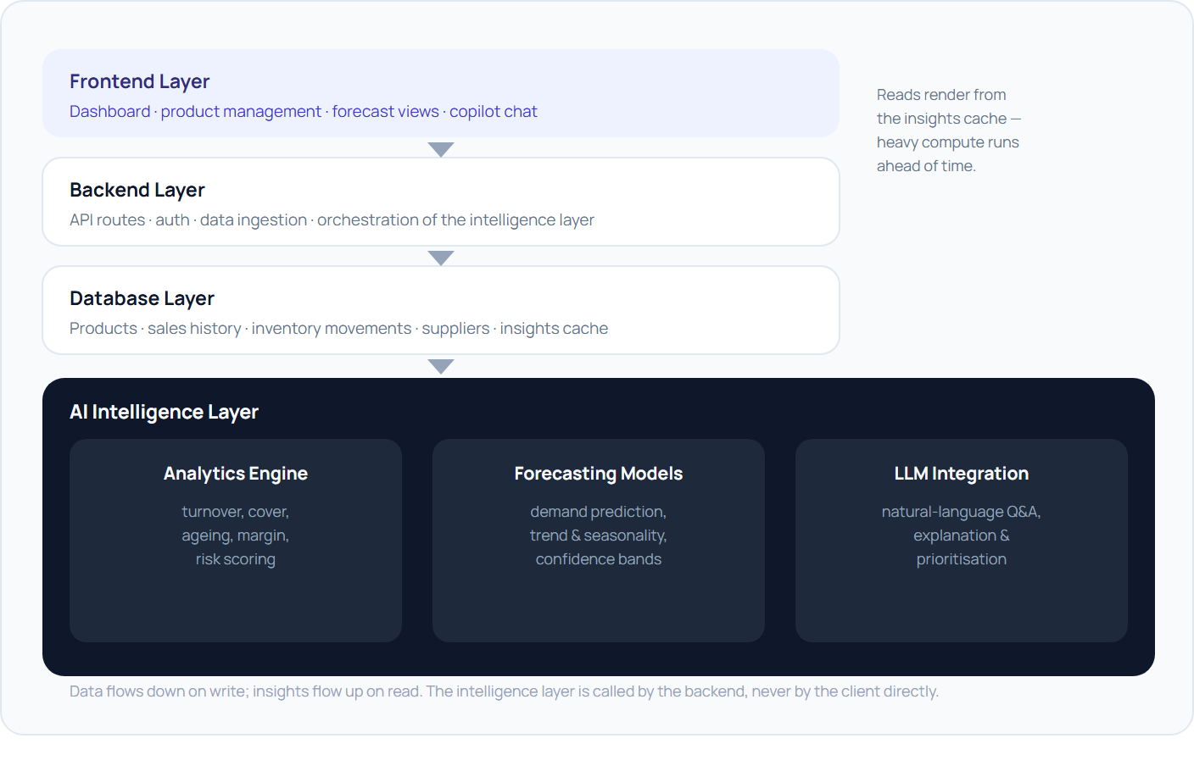

How data moves through the system
- The owner uploads or syncs sales and inventory data through the frontend; the backend validates and writes it to the database.
- On a schedule and on demand, the backend invokes the analytics engine and forecasting models to recompute metrics and predictions.
- Results are cached as structured insights; the LLM is called with those insights as context to generate explanations and answer copilot questions.
- The frontend renders dashboards, alerts, and chat responses from the cached insights — fast reads, heavy computation done ahead of time.
Inventra AI · Concept PaperSection 7
Section 7

User Experience Journey
End to end, from a spreadsheet export to a recommended action — in one sitting.
Scenario. Sophea owns a mini-mart in Phnom Penh. She exports three months of sales from her point-of-sale system and uploads the file to Inventra AI. Within minutes she has a working picture of her business and a list of things to do.
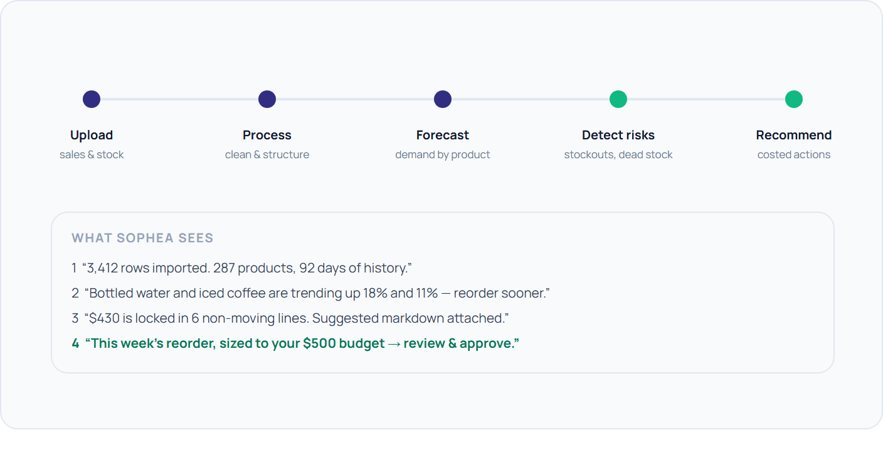
The journey is designed to deliver a “first value” moment on day one: the owner should finish the first session already holding a recommendation worth acting on. Every later session is shorter — a quick check of alerts and an approval of the week’s reorder.
Inventra AI · Concept PaperSection 8
Section 8

Target Users and Market
Owner-operated retail and distribution first; multi-branch and growing enterprises next.

Primary users
Mini marts · convenience stores · retail SMEs · small distributors — single-site, owner-run, 100–1,000 SKUs, thin margins, tight cash.

Secondary users
Multi-branch businesses and growing enterprises that need consistent purchasing discipline and cross-site visibility as they scale.

8.1 User personas
Sophea
Mini-mart owner · Phnom Penh
Context: one store, 287 SKUs, runs the till herself.
Pain: guesses reorders; regularly out of best-sellers.
Goal: stop losing sales without over-buying.
Dara
Convenience chain · 3 branches
Context: three sites, one bookkeeper, separate stockrooms.
Pain: no comparable view across branches.
Goal: one purchasing standard, less leakage.
Lina
Small distributor · Siem Reap
Context: warehouse supplying ~40 shops.
Pain: capital tied up in dead stock.
Goal: free cash, sharpen what she carries.

8.2 Market opportunity
SMEs make up the overwhelming majority of registered businesses in Cambodia, and retail and wholesale trade is the single largest category among them. The great majority operate without any analytical tool. That is the opening: enterprise-grade decision intelligence, delivered at SME pricing.
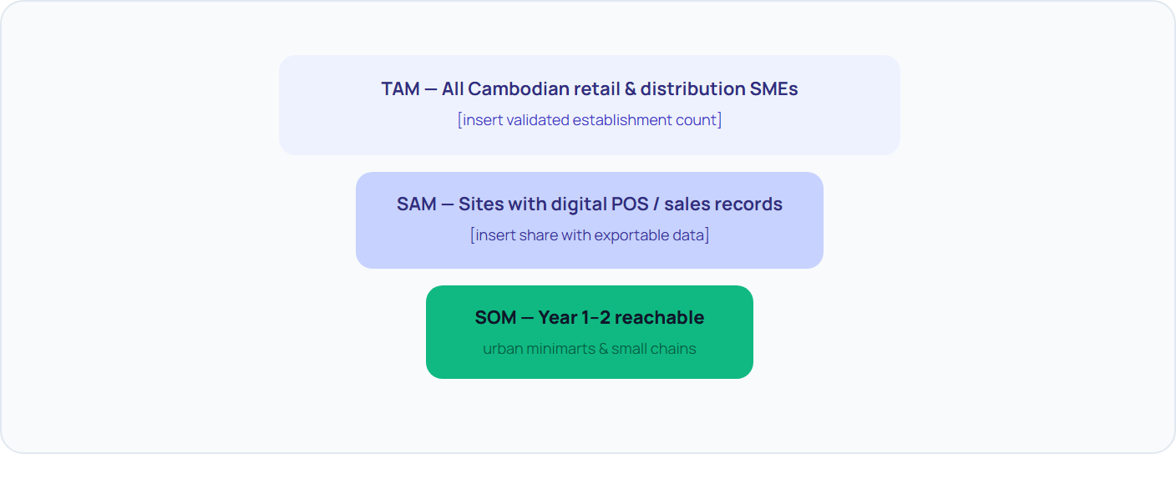
Why now
POS adoption among urban SMEs has crossed the threshold where usable data exists; LLM costs have fallen far enough to make per-SME advisory economically viable; and no incumbent serves this segment with decision intelligence.
Inventra AI · Concept PaperSection 9
Section 9

Competitive Differentiation
Inventory software records the past. Inventra AI acts on the future.
Capability | Traditional inventory systems | Inventra AI
Inventory tracking | Yes — core function | Yes — as a foundation, not the product
Forecasting | None, or simple reorder points | Per-product demand, trend & seasonality
Business intelligence | Static reports to read | Interpreted insight with the “why”
Risk detection | Low-stock alerts only | Stockout, dead-stock, supplier & spoilage risk
Cash-flow optimisation | Not addressed | Budget-aware buying, capital release
AI assistant | None | Conversational copilot, Khmer & English
Decision support | User interprets everything | Prioritised, costed recommendations

Unique advantages
- Decision-first, not record-first. Every screen ends in a recommended action, not a number to interpret.
- Built for the segment. SME scale, SME pricing, SME language — not an enterprise product with features removed.
- Explains itself. Recommendations come with the reasoning, which builds the trust needed for owners to act.
- Compounding data moat. Every approved or rejected recommendation sharpens the model for that business and the segment.
Traditional systems tell business owners what happened. Inventra AI tells them what to do next.
Inventra AI · Concept PaperSection 10
Section 10

MVP Development Plan — AIM Competition
A build-week MVP that demonstrates the full decision loop on real uploaded data.

What will be built
- Inventory dashboard — live view of stock, cover, and value
- Product management — catalogue, categories, cost & price
- Demand forecasting — per-product prediction with confidence
- Dead-stock detection — ageing, turnover, locked capital
- AI copilot chat — natural-language questions and answers

What will be demonstrated
- Upload a real sales export → structured business in < 2 min
- Forecast flags two rising and two fading products
- Dead-stock view quantifies trapped cash and proposes markdowns
- Copilot answers “what should I reorder next week?” with a costed list
Why it proves the concept
The demo shows the complete path — data in, decision out — on data the judges can supply. It proves the platform is a decision tool, not a tracking tool, and that the core intelligence works end to end at MVP scale.

Build-week roadmap
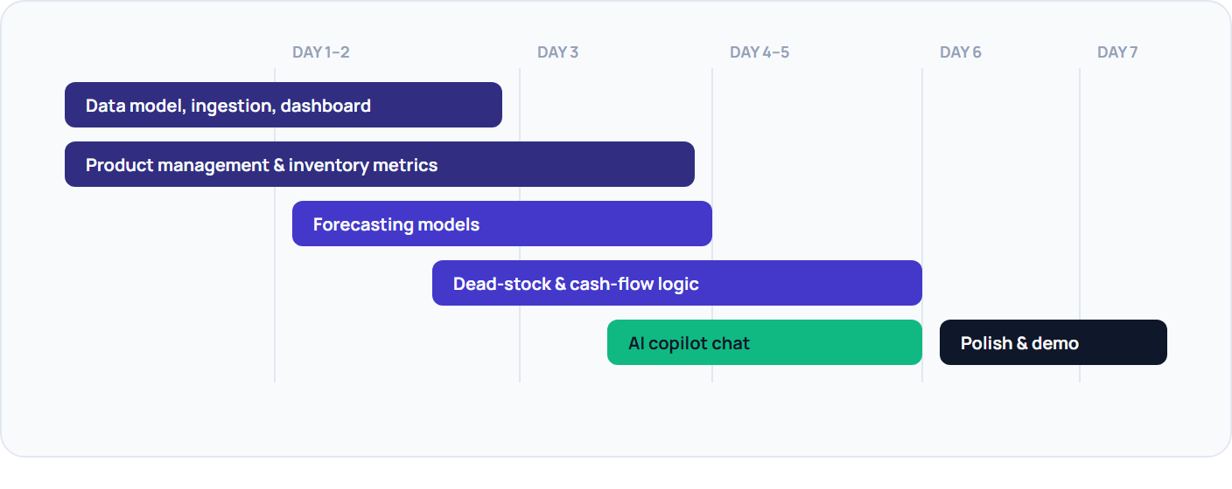
Inventra AI · Concept PaperSection 11
Section 11

Business Impact
Five dimensions of impact, each with a concrete way to measure it.
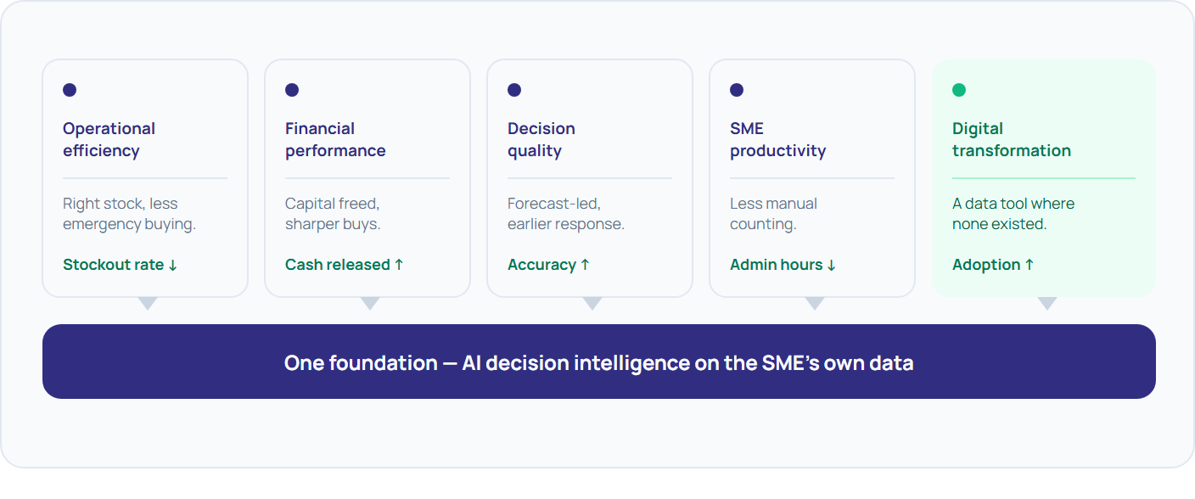
Dimension | What improves | Indicative metric
Operational efficiency | Right stock, right time; less emergency buying | Stockout rate; days of cover variance
Financial performance | Working capital freed from slow stock; better buys | Cash released; gross margin return on inventory
Decision quality | Forecast-led purchasing; earlier trend response | Forecast accuracy; recommendation acceptance rate
SME productivity | Less time on manual counting and guesswork | Owner hours per week on stock admin
Digital transformation | Adoption of a data tool where none existed | Share of decisions informed by the platform
Inventra AI · Concept PaperSection 12
Section 12

Future Roadmap
From inventory intelligence to a full SME operating copilot over five years.
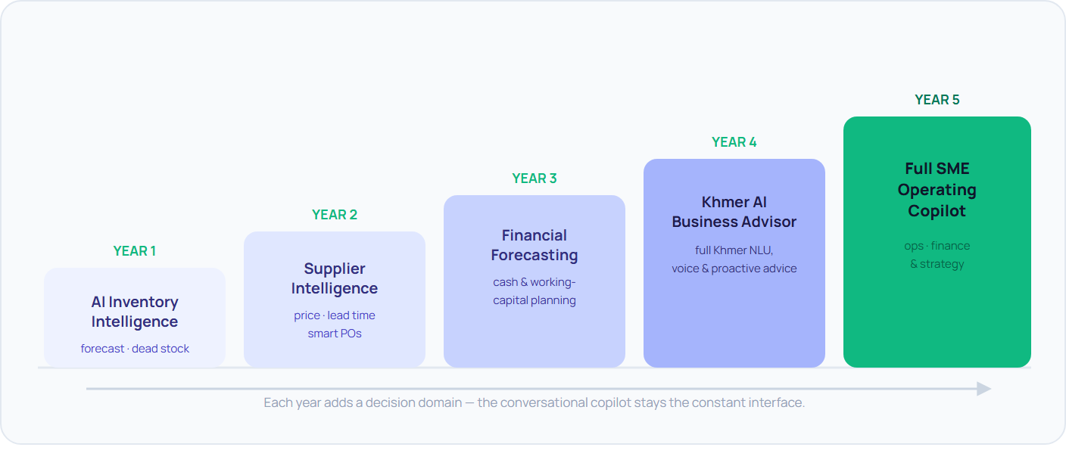
Horizon | Milestone | What it unlocks
Year 1 | AI Inventory Intelligence | The core loop — forecast, procurement, dead stock, copilot — in production with paying SMEs.
Year 2 | Supplier Intelligence | Buying decisions extend to which supplier, on price, reliability, and lead time.
Year 3 | Financial Forecasting | Cash-flow and working-capital projection; inventory planning tied to the P&L.
Year 4 | Khmer AI Business Advisor | Full Khmer-language understanding and proactive, spoken advice for non-technical owners.
Year 5 | Full SME Operating Copilot | One assistant across operations, finance, and strategy for the whole business.
Inventra AI · Concept PaperSection 13
Section 13

Conclusion
A vision for what running a small business in Cambodia could feel like.
Cambodia’s SMEs are not short of effort or ambition. They are short of the one thing every large company takes for granted: someone whose job is to look at the numbers and say what to do. That role — the analyst, the advisor, the second opinion — has always been priced out of reach for a business running a single store or a small warehouse.
Inventra AI is not another inventory application. It is an AI decision-intelligence platform that gives the owner-operator that missing role: a copilot that forecasts demand, plans purchasing around cash, catches risk early, and explains its thinking in plain language. It turns the data a business already has into the decisions it needs to make.
The competition MVP proves the loop end to end. The roadmap extends it from inventory into supplier choice, financial planning, and a fully Khmer-language advisor — step by step, toward a single operating copilot for the whole business.
Every Cambodian SME deserves access to an AI business analyst.
Inventra AI
AI Decision Intelligence Platform for Cambodian SMEs · Concept Paper v1.0

