JORDAN TOWSE
STUDENT ID: 179096813
3CB105
INTERNET OF THINGS PROJECT REPORT

Table of Contents
Introduction 3
Problem 3
Current solutions 3
Aims 3
Development 3
Hardware Requirements 3
Software Requirements 3
Threat Modelling 4
Prototyping 4
Testing 5
Production 9
Legal and Ethical 9
Conclusion 10

Introduction

Problem
Most security systems require hard-mounting to a surface, so are useless in a situation where one cannot drill for mounting plates or other hardware in order to set up the system. The system that I will design and build will be a soft-mount system which only needs WiFi connectivity to function and can alert a user when something is detected in its range.
The device will also have the function of switching a relay on and off with detections, either latching on a detection or pulsing, so the user can wire whatever they wish into the system, such as an alarm for noise or a light so the device can be used as a motion activated light. This will be controllable through a web interface.

Current solutions
Most current solutions are hard-mounted, requiring brackets and such to be mounted to existing surfaces in a way that is often irreversible, and are also fairly expensive, with quality product going for around £300 for a set with cameras or £200 for ones without. One can get a cheaper solution for less but the quality of such systems is dubious.

Aims
- Soft/No Mounting – The device can be attached using removable hardware, such as double sided tape and Velcro, or using no hardware and been placed atop something.
- Server Communication – send data to a server and act on data received from the server
- Web interface – the server is controlled by a basic website requiring login
- Multi Feature – user can choose what triggering the alarm will do, along with what the device will do when the alarm is disarmed

Development

Hardware Requirements
Arduino, Arduino Serial Cable, WiFi Shield, Sonar/Ultrasonic detector(HC-SR04), XOR gate (74HC02), Relay (NRP04-C06DT), Resistors (2 x 1000Ω, 1 x 560Ω), Capacitor (1 x 10μF), Jumper Cables, LED for relay demonstration.

Software Requirements
Arduino IDE, Web client

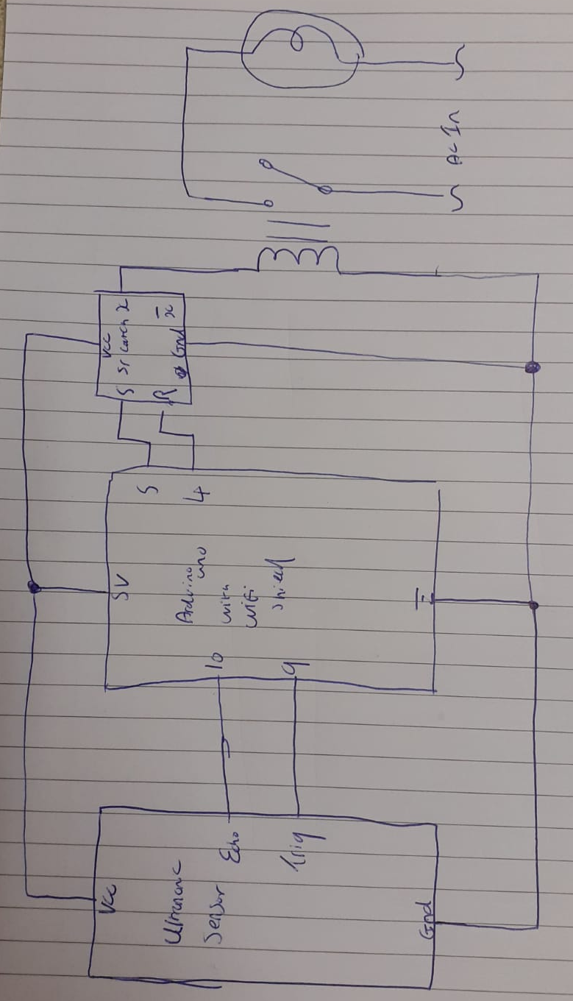
Threat Modelling
Assets:
Sensor Data, Server Communications, Hardware, Web Server
Threats:
Communication Interception/Blocking – Attacker intercepts communication between server and device – Solution: Modern encryption such as HTTPS
Brute Force against server – Attacker gains access to users details and control over the device – Solution: Implement lock-out system on too many failed password attempts, Hash user data
DoS – Attacker takes system down through a Denial of Service attack – Solution: Redundancy in Web servers, Firewalls

Prototyping
The prototyping for the device was done on paper. Below is a scan of the final prototype with the auxiliary circuit connected up to a light and an AC power source. The changes made to this prototype for the final device are:
- 10uF capacitor across VCC and GND on the ultrasonic sensor
- 5v DC from the Arduino into the relay’s switched supply instead of mains AC
- LED in the relay circuit instead of a lamp
I followed this with some testing to make sure the components were compatible and my idea works. The following section describes this process.

Testing

The first test I did was to check my SR latch setup to see if it performed as expected. To do this, I used the 5V DC power from an Arduino to power the circuit detailed below. Other than the Arduino, I used a SN74HC02 quad nor gate chip, 2 red LEDs, 3 10k resistors (2 for pulldown, one for the LEDs) and I intended to use 2 of the small momentary switches however one of them in my set had gone missing so I had to use one of the larger push buttons instead. This didn’t affect the project in any major way.
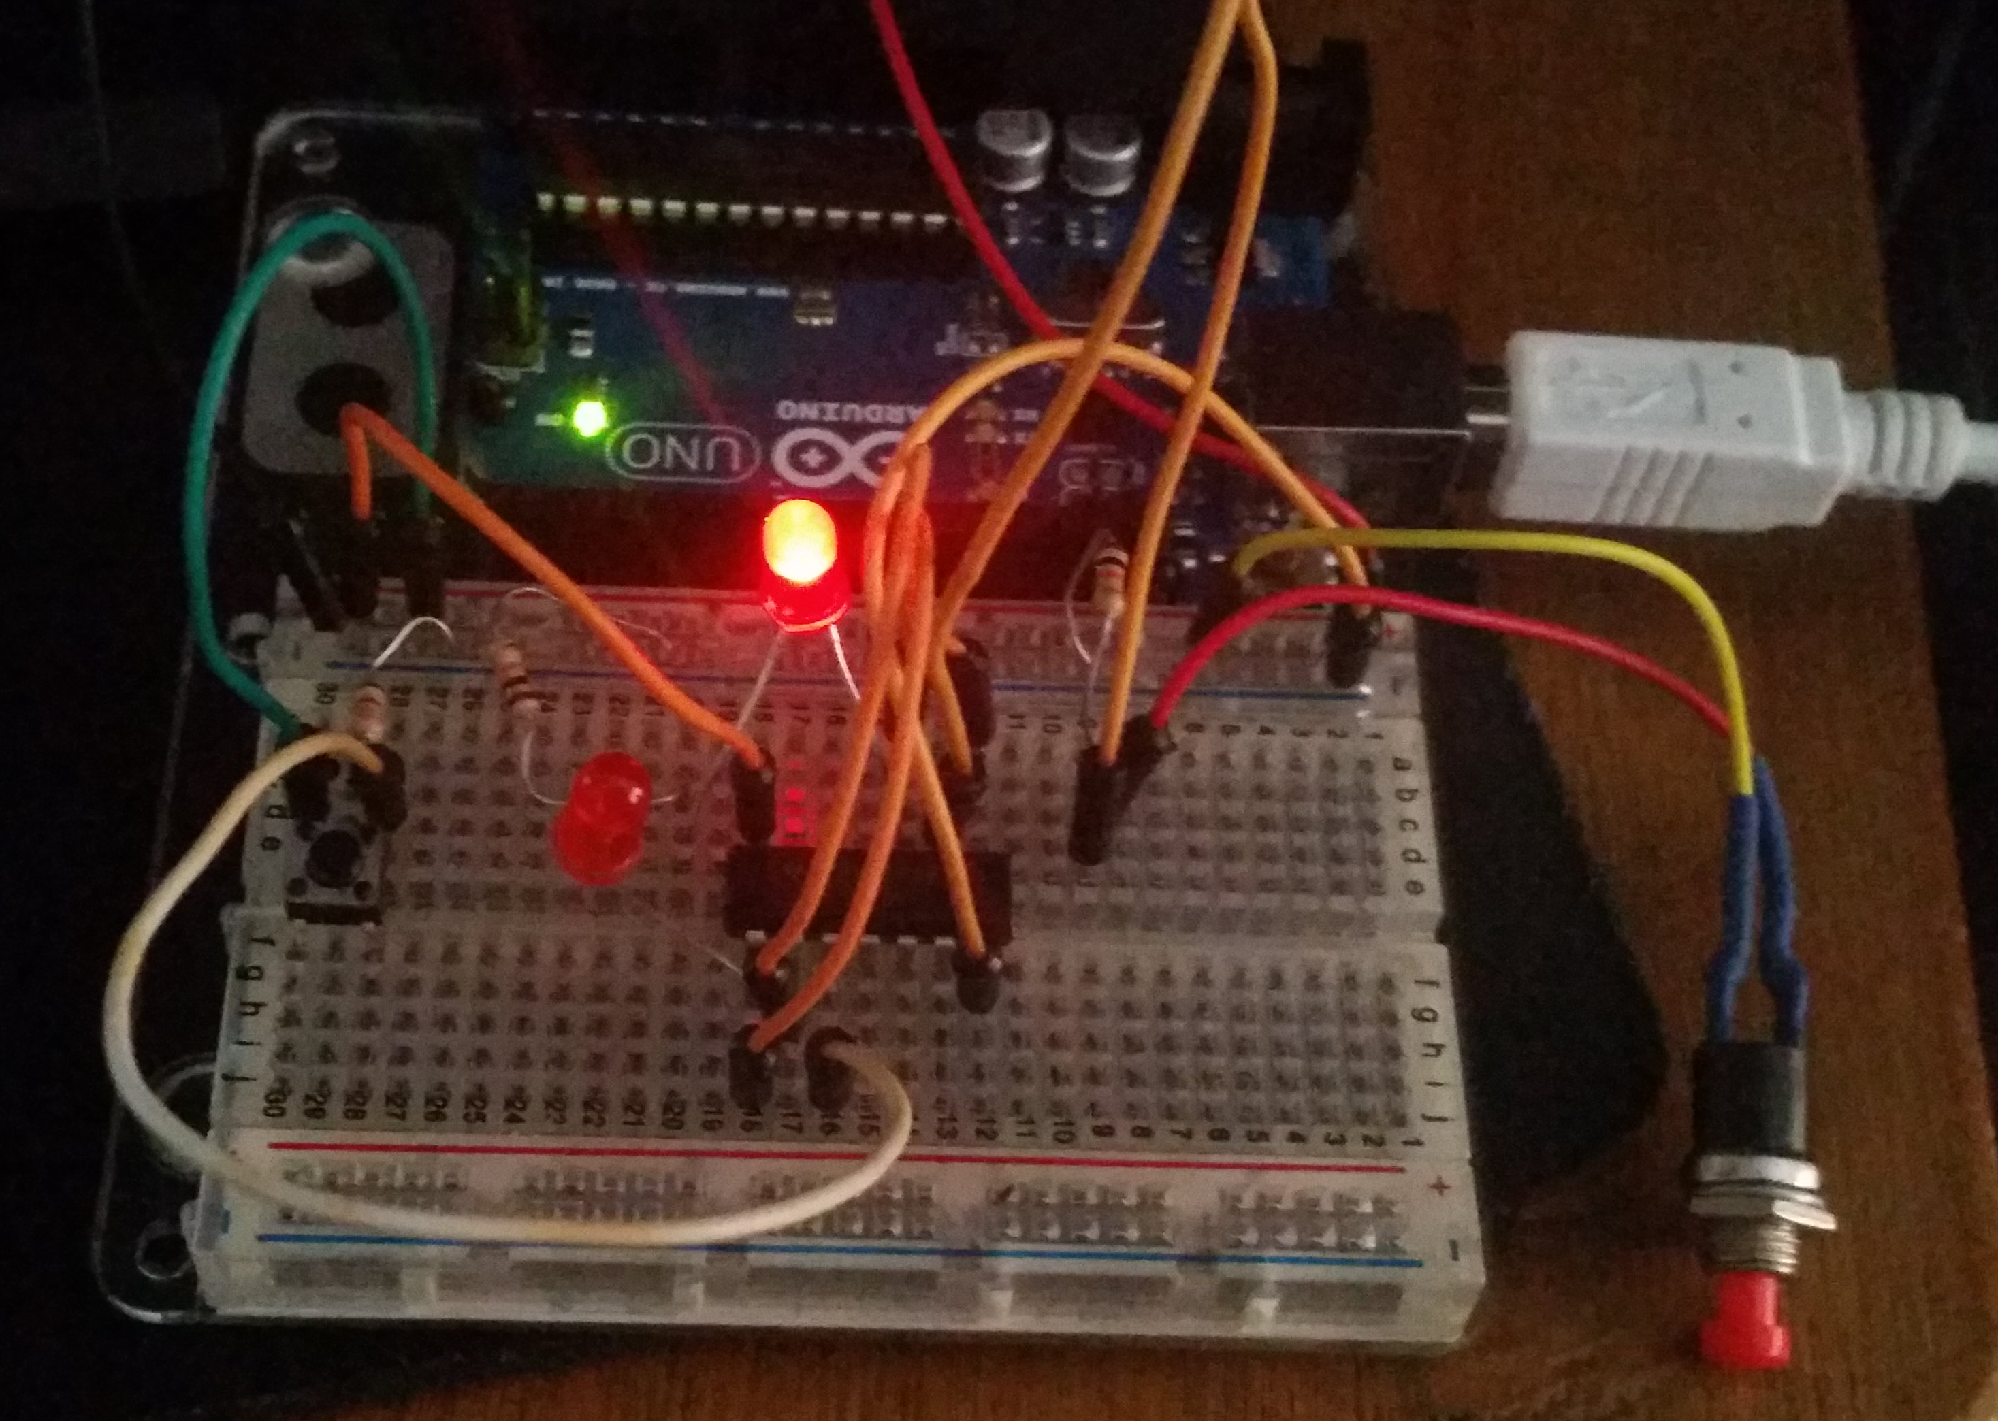

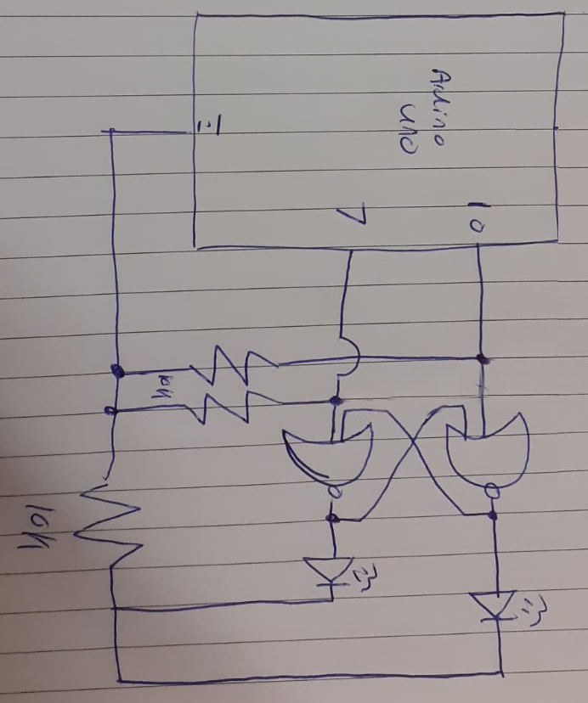
The testing was a success and I could then move on to controlling it with the Arduino. The circuit for this is much the same as the previous one except that the inputs to the nor gates are connected to pins 10 and 7 instead of switches. I wrote the pictured code to test if everything was still working then tested it. The testing was a success.
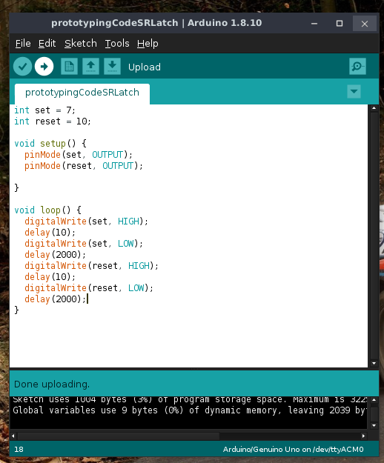
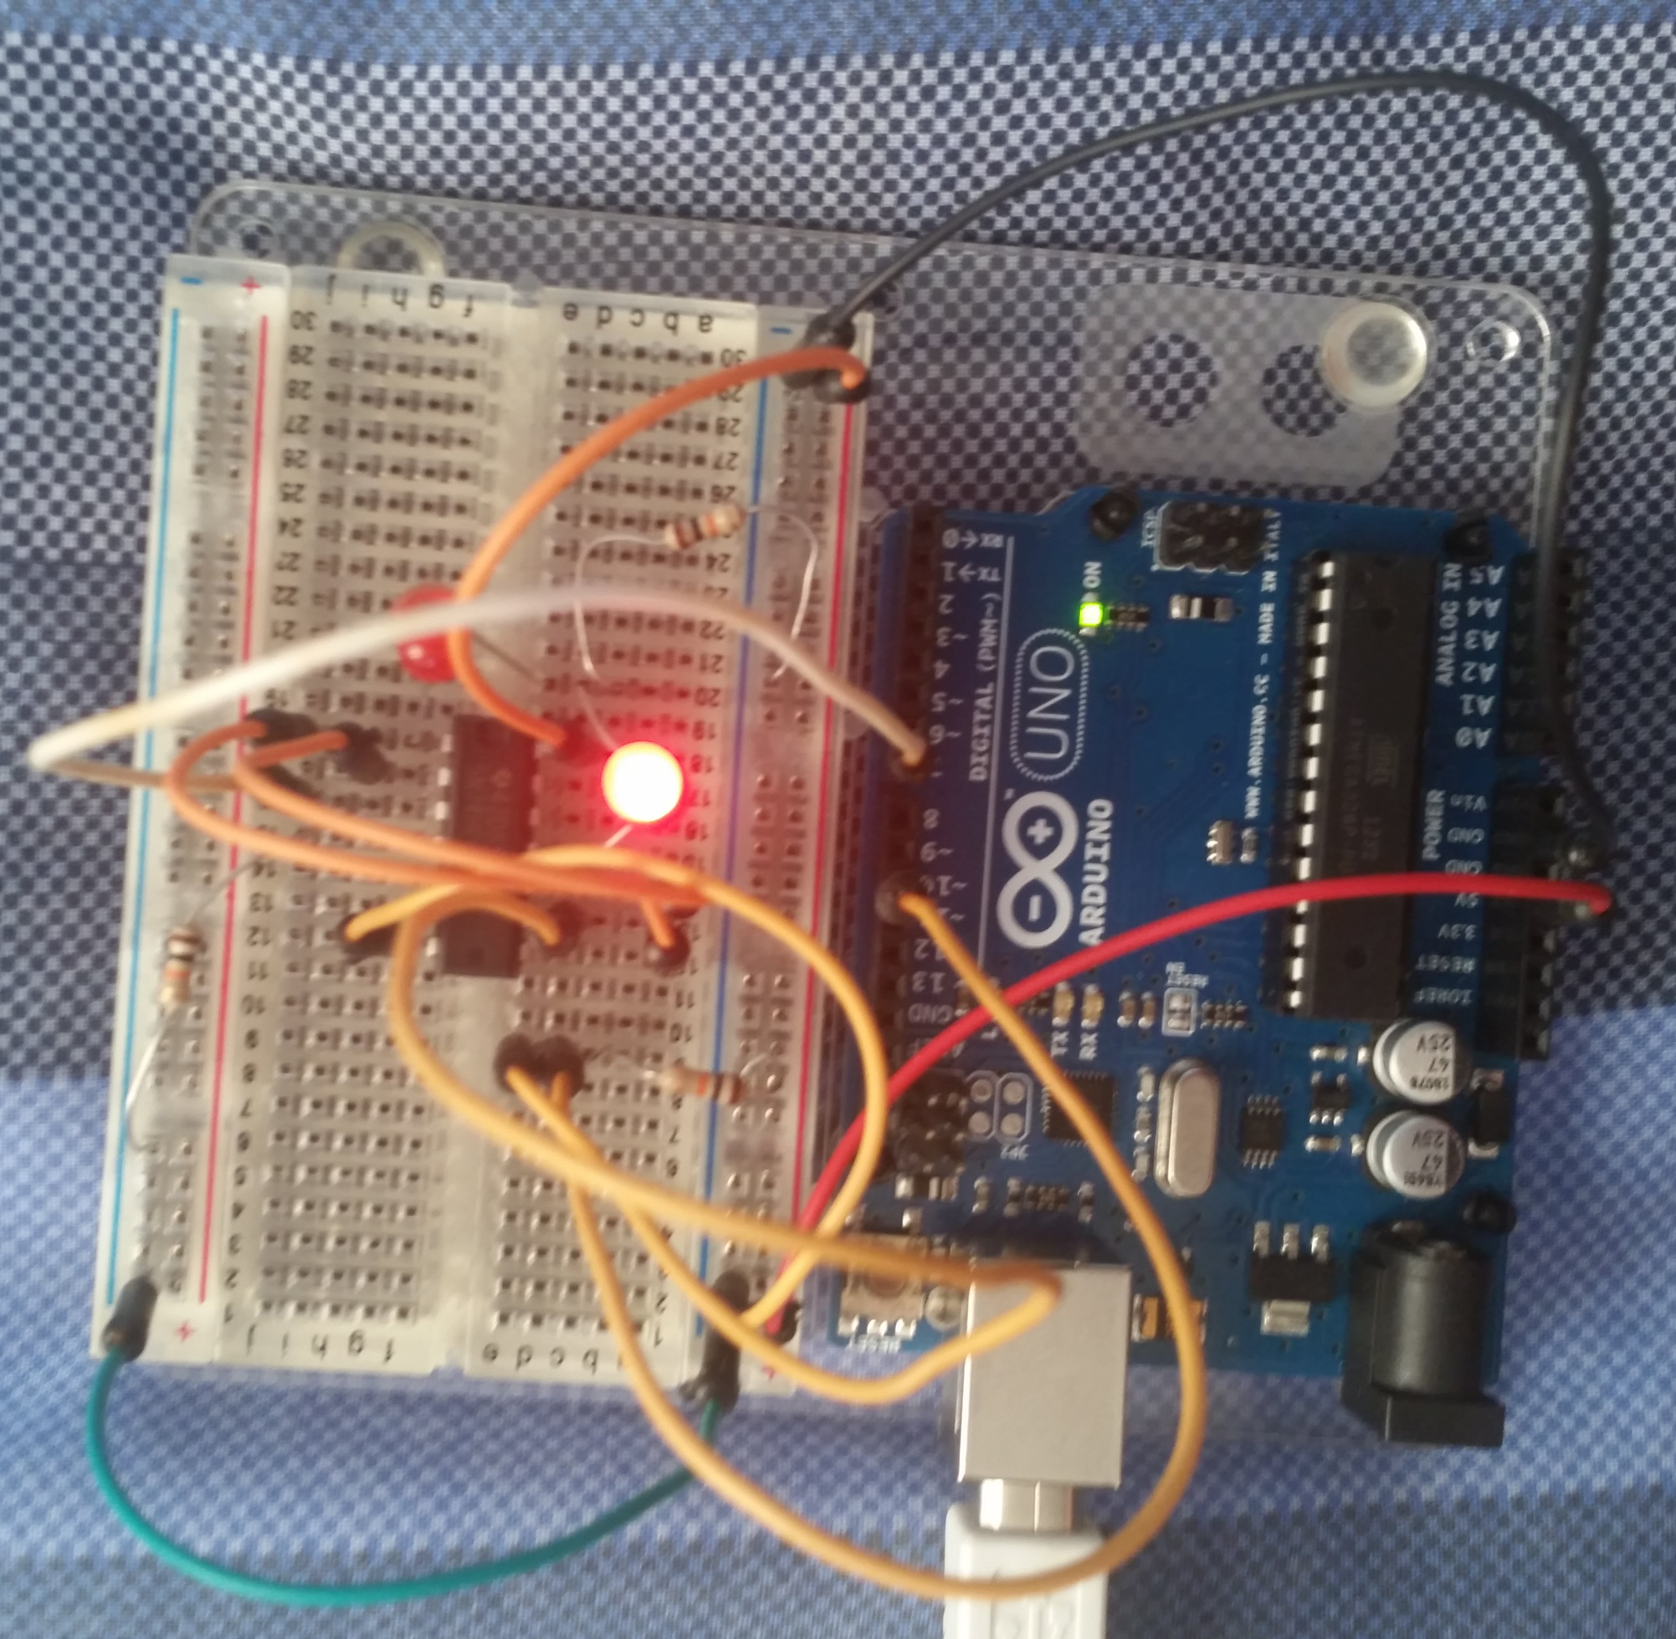
I now know that I can control the SR latch with either buttons, commands from the Arduino or a mix of both. I then removed the LEDs and their resistor, wired the relay up to the normal output and left the inverted output not connected to anything. I then wanted to test the ultrasonic module as I have had some issues with them not working. To do this, I first rearranged what I already had on the breadboard to make some room for the sensor. Then I connected the sensor to 5V and ground, trigger to pin 12, echo to pin 11, wrote some code to control the sensor and to write the result to the serial output and uploaded this new code to the Arduino. In building the sensor’s circuit, I realised I didn’t have enough male-to-male jumper cables so, as a stop gap solution, I used diodes for the VCC, TRIG and ECHO pins. This isn’t a problem since the circuit is DC.

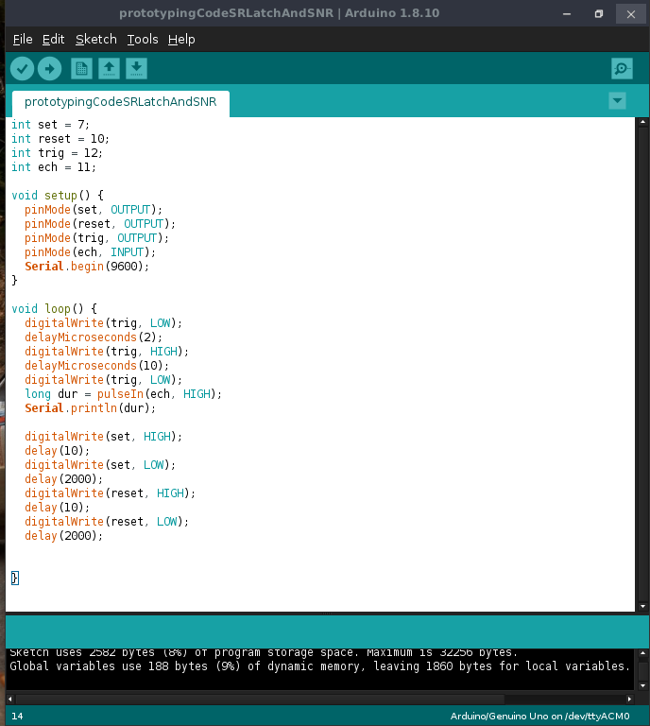
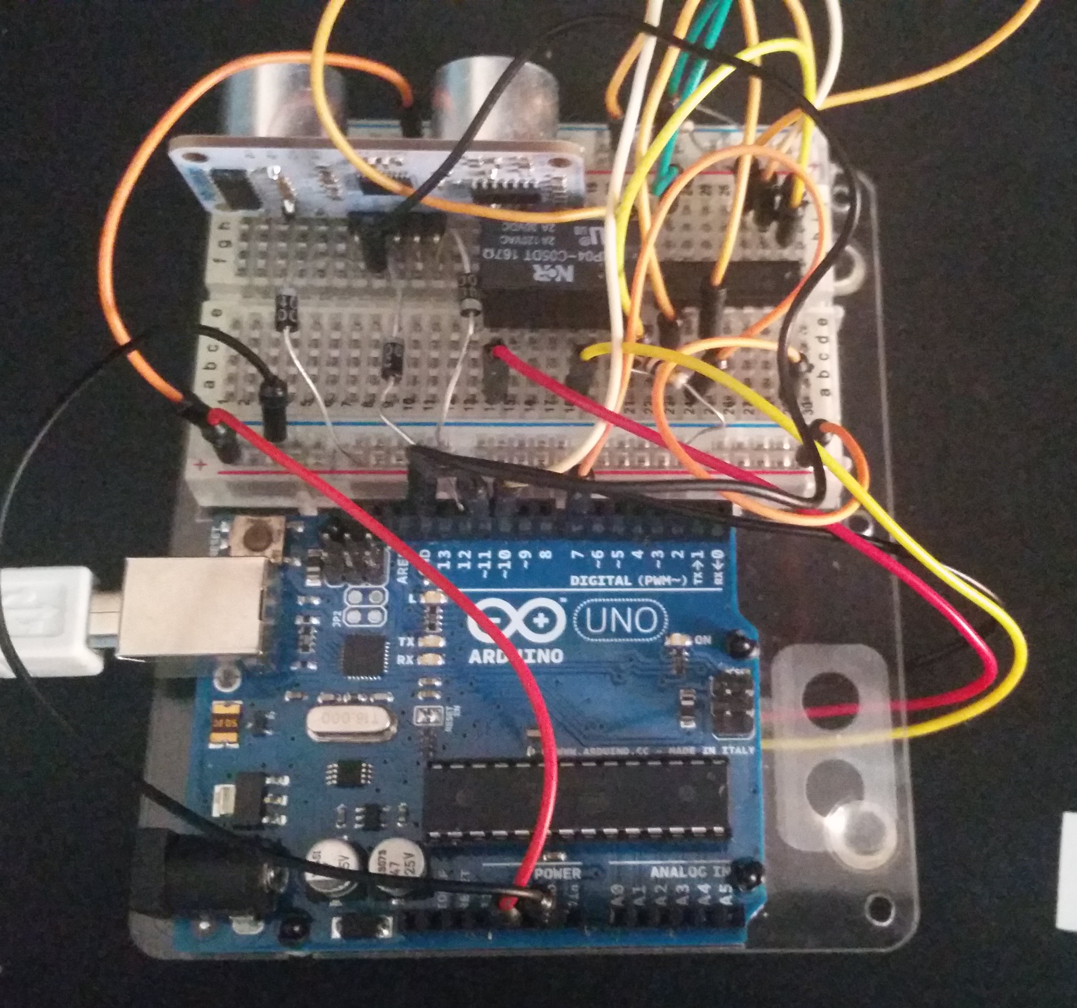

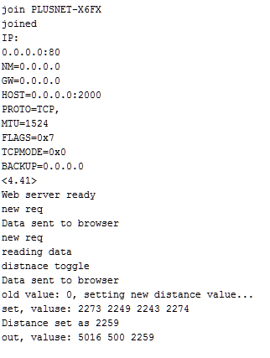
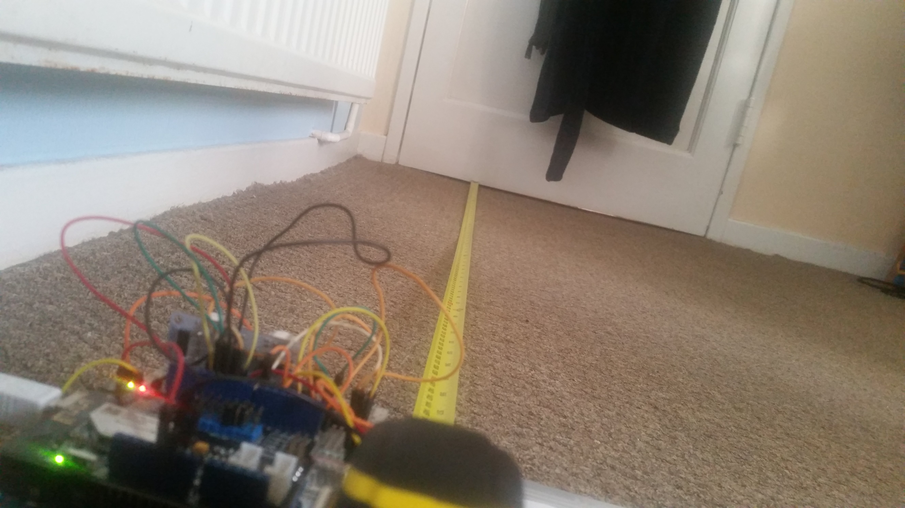
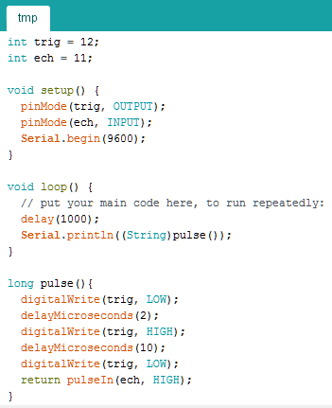
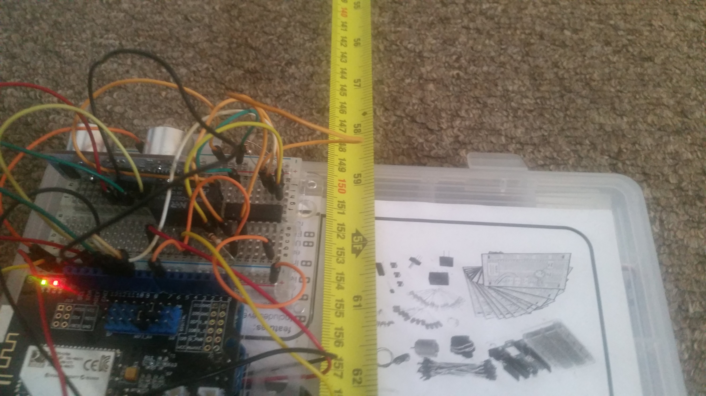
I then moved on to creating the web interface for the alarm. During this process, I found a small problem with the ultrasonic sensor I was using. As shown in the log below, which was taken with the sensor facing a wall with nothing in between, the fluctuations were bigger than the threshold of 500ms I had though would suffice. Also in the log, the IP of the shield is displayed as all zeros. I don’t know the reason for this as I can connect to the server fine from the DHCP set IP.
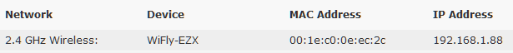
In order to test the fluctuations that was triggering a false-positive in my alarm system, I created the temporary setup and sketch shown below. The measurements to the right show that the fluctuation in measurements from 5ft away is too large to be used as an effective alarm system and I will have to think of a different way to implement this. From some research on the internet, I fount that the problem with the inconsistent reading could be down to 2 factors, either unstable power or echoes from previous tests still affecting results. By adding a delay of 3000ms before a pulse and pulsing twice before triggering the alarm I got rid of some of these false positives. I may still add a 10uF capacitor across the sensor for stability.

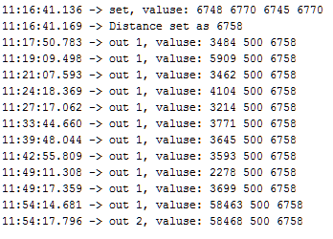
As shown in the log below, I was still getting false-positives (The last two alerts were raised to demonstrate the time frame and thus not included in the calculations). The double check of pulsing twice before raising the alarm was helping, and over the 45 minutes I tested for I didn’t get 2 false-positives in a row. However, with a mean time of 3 minutes and 30 seconds between false positives, getting two in a row is still a possibility and a defect that will render the system useless in a real world environment.
Adding a 10uF smoothing capacitor over the ultrasonic sensor’s power supply made my readings stable to the point where I was reading no false-positive at all. I them worked on moving the delay down to a point where it would activate more frequently while still retaining the current false-positive rate. The sweet spot for this delay was 2500ms so that is what I proceeded with.
The next item to test was the web server controls. Due to the limitations of the hardware, mainly the internal memory of the arduino, the web interface is very basic however it does what it needs to do. The server could be run off of a Pi to allow a greater degree of customisation and allow for the site to look a lot better than it currently does. The buttons activate a jQuery script and return 1, 2, 3 or 4 back to the Arduino which then controls whatever was selected by the user. The status text would then be updated according to the users choices.
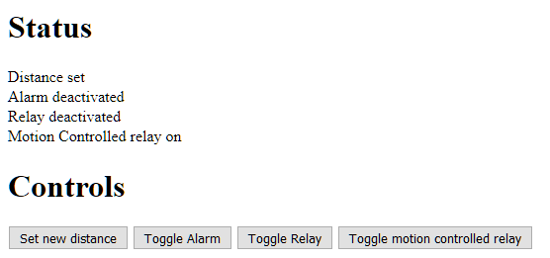
There is still the issue of the WiFi shield that I am using cannot communicate with ThingSpeak in order to send alerts to the user. To get around this, I tried using IFTTT to send an email alert however the shield cannot maintain more than one connection and the web server I was hosting from it took up this connection. If I had another Arduino and shield, I would connect the two and use the second Arduino to communicate to IFTTT or ThingSpeak however there wasn't enough Arduinos to do this so I just connected a piezo buzzer into the circuit instead.

Production
From the testing and prototyping that I did, my final design changed slightly. The diagram below reflects these changes. Also below is a link to the git repo for my code and the demonstration videos.
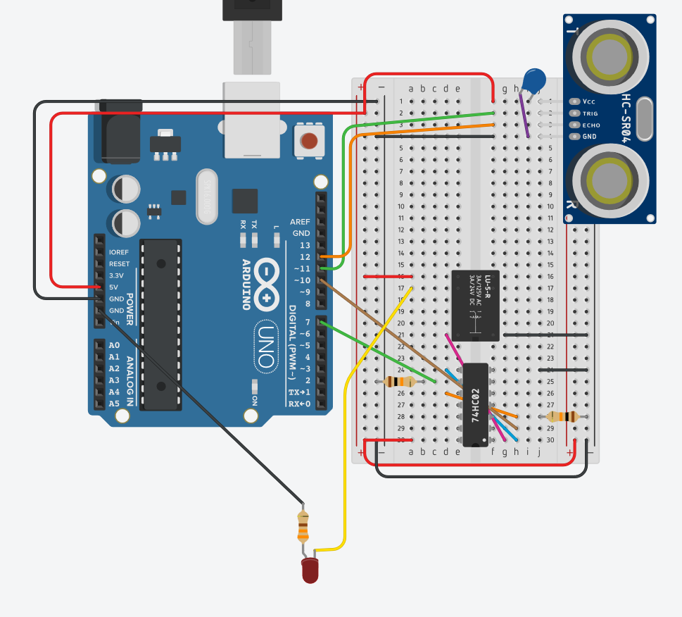
https://github.com/kimbus1/softMountAlarm

Legal and Ethical
Since my project doesn’t handle any user data, there are few legal and ethical concerns. The main concern would be someone accessing the alarm control panel without authorisation. This panel is only accessible through the home network unless the user chooses to open the ports to the internet whereby it is assumed that a user that does this understands the risks posed.

Conclusion
There are numerous things that I would change if I were to do this project again.
- I would like to use authentication on the web panel so users have to sign in before been able to change device settings.
- I would like to set up an email alert system to alert users when the alarm is set off.
- I would like to set up a system to post data to ThingSpeak for analysis and cleaning.
- I would like to use a Pi to host a better looking server and be able to handle more complex requests since the Arduino was running out of memory.
- I would like to use a sensor with better accuracy or one with a lower false positive rate so I could increase the polling rate of the sensor.
Despite this, I believe that the project went well and I enjoyed designing and building the device.

