Group:

Group members: 3D Sally Chan(3), Kimberly Chan(4), Eva Mai(25), Winnie Tse(29)

Topic: (1)Tools of food preparation or cooking

Tools:

1. Chopping Board

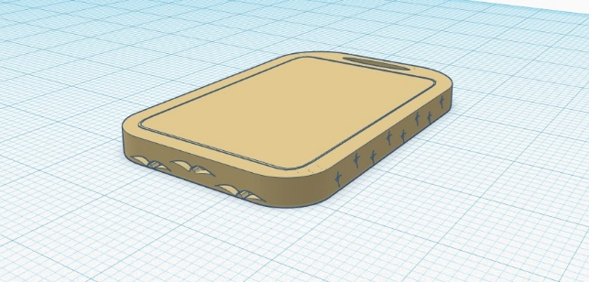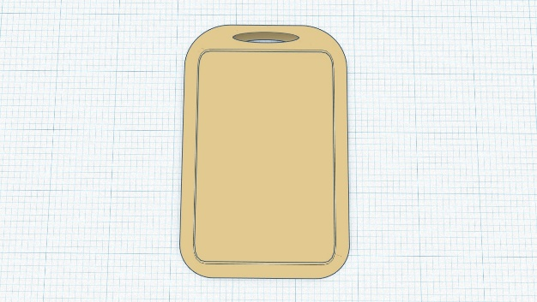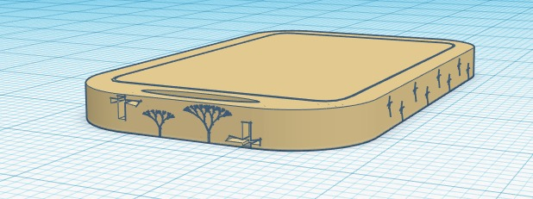



Usage: It is a chopping board. A chopping board is a durable board on which to place material for cutting. It is usually used in kitchens for preparing food. It can withstand the damages done by cutting.

Design: Firstly, I made the corner smooth. Also, the top of the chopping board has a hole for holding or hooking. Moreover, there are some patterns around the lateral faces.

1. Sushi mat

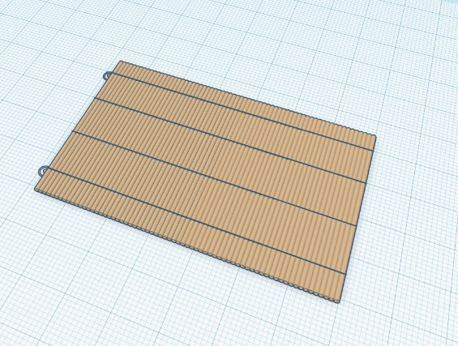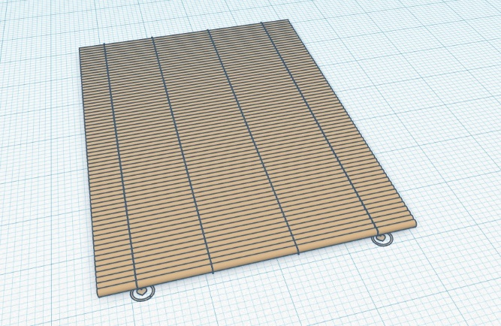



Usage: A sushi mat is used for rolling sushi. Put the ingredients on the top and the middle part of the mat, after paving the ingredients, use the mat to roll them up from the bottom up. Both the left and right sides can compactly press the rice and ingredients inwards slightly during the roll. When the sushi is rolled completely, the sushi is finished.

Design: The sushi mat is made of many sticks and linked by few ropes, we added two holes with two lovely hearts on the edge of the mat, so the mat can be hung on the wall conveniently, making drying and storing it easy.

1. Frying ladle

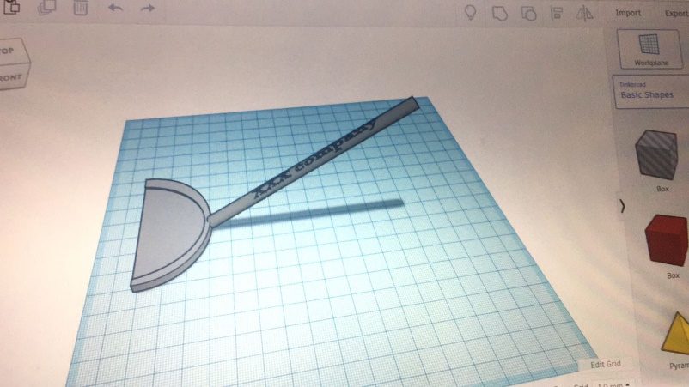



Usage: It is a frying spatula which is used to flip food, or mix or spread food. A frying spatula with wide, thin blade at the end and a handle bent upwards.

Design: Firstly I flattened the rounded roof. Secondly, I attach a rod onto the flattened rounded roof. Also, there are some words on the handle of the frying spatula and it is in grey colour.

1. Measuring cup

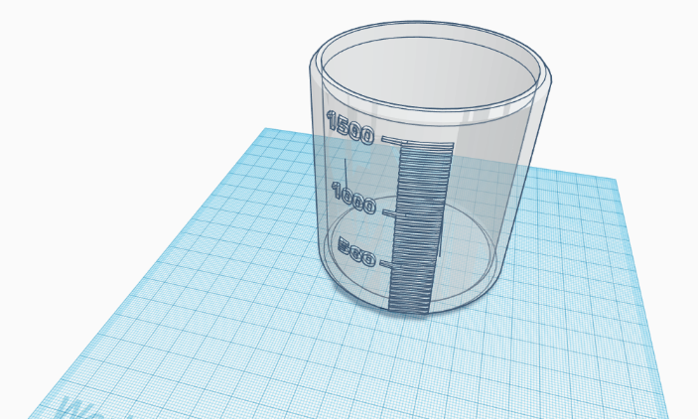



Usage: A measuring cup is used for measuring the needed volume of fluids for cooking. This measuring cup can measure fluids from 50mL to 1500mL.

Design: The wall of the cup is transparent, so we can see how much fluid there is inside. There are readings from 50mL to 1500mL so a wide range of volume can be measured.