Single chip 2.4 GHz Transceiver

nRF24L01



## FEATURES APPLICATIONS

* True single chip GFSK transceiver • Wireless mouse, keyboard, joystick
* Complete OSI Link Layer in hardware • Keyless entry
* Enhanced ShockBurst™ • Wireless data communication
* Auto ACK & retransmit • Alarm and security systems
* Address and CRC computation • Home automation
* On the air data rate 1 or 2Mbps • Surveillance
* Digital interface (SPI) speed 0-8 Mbps • Automotive
* 125 RF channel operation • Telemetry
* Short switching time enable frequency hopping • Intelligent sports equipment
* Fully RF compatible with nRF24XX • Industrial sensors
* 5V tolerant signal input pads • Toys
* 20-pin package (QFN20 4x4mm)
* Uses ultra low cost +/- 60 ppm crystal
* Uses low cost chip inductors and 2-layer PCB
* Power supply range: 1.9 to 3.6 V

# GENERAL DESCRIPTION

nRF24L01 is a single chip radio transceiver for the world wide 2.4 - 2.5 GHz ISM band. The transceiver consists of a fully integrated frequency synthesizer, a power amplifier, a crystal oscillator, a demodulator, modulator and Enhanced ShockBurst™ protocol engine. Output power, frequency channels, and protocol setup are easily programmable through a SPI interface. Current consumption is very low, only 9.0mA at an output power of -6dBm and 12.3mA in RX mode. Built-in Power Down and Standby modes makes power saving easily realizable.

# QUICK REFERENCE DATA

|  |  |  |
| --- | --- | --- |
| **Parameter** | **Value** | **Unit** |
| Minimum supply voltage | 1.9 | V |
| Maximum output power | 0 | dBm |
| Maximum data rate | 2000 | kbps |
| Supply current in TX mode @ 0dBm output power | 11.3 | mA |
| Supply current in RX mode @ 2000 kbps | 12.3 | mA |
| Temperature range | -40 to +85 | C |
| Sensitivity @ 1000 kbps | -85 | dBm |
| Supply current in Power Down mode | 900 | nA |

Table 1 nRF24L01 quick reference data

IF BPF

|  |  |  |
| --- | --- | --- |
| **Type Number** | **Description** | **Version** |
| nRF24L01 | 20 pin QFN 4x4, RoHS & SS-00259 compliant | D |
| nRF24L01 IC | Bare Dice | D |
| nRF24L01-EVKIT | Evaluation kit (2 test PCB, 2 configuration PCB, SW) | 1.0 |

Table 2 nRF24L01 ordering information

# BLOCK DIAGRAM

DVDD

VDD

VDD

VDD

VSS=0V

VSS=0V

VSS=0V

|  |
| --- |
| DEMOD |
| Clock  Recovery, DataSlicer |
| ADDR  Decode |
| CRC  Code/Decode |
| FIFO  In/Out |

Figure 1 nRF24L01 with external components.

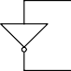

XC1

VSS=0V

XC2

CE

LNA

VDD_PA=1.8V

IRQ

CSN

ANT1

SCK

PA

100+j175 

MISO

ANT2

MOSI

IREF

22k

Frequency Synthesiser

GFSK

Filter

Enhanced ShockBurstTM

# PIN FUNCTIONS

|  |  |  |  |
| --- | --- | --- | --- |
| **Pin** | **Name** | **Pin function** | **Description** |
| 1 | CE | Digital Input | Chip Enable Activates RX or TX mode |
| 2 | CSN | Digital Input | SPI Chip Select |
| 3 | SCK | Digital Input | SPI Clock |
| 4 | MOSI | Digital Input | SPI Slave Data Input |
| 5 | MISO | Digital Output | SPI Slave Data Output, with tri-state option |
| 6 | IRQ | Digital Output | Maskable interrupt pin |
| 7 | VDD | Power | Power Supply (+3V DC) |
| 8 | VSS | Power | Ground (0V) |
| 9 | XC2 | Analog Output | Crystal Pin 2 |
| 10 | XC1 | Analog Input | Crystal Pin 1 |
| 11 | VDD_PA | Power Output | Power Supply (+1.8V) to Power Amplifier |
| 12 | ANT1 | RF | Antenna interface 1 |
| 13 | ANT2 | RF | Antenna interface 2 |
| 14 | VSS | Power | Ground (0V) |
| 15 | VDD | Power | Power Supply (+3V DC) |
| 16 | IREF | Analog Input | Reference current |
| 17 | VSS | Power | Ground (0V) |
| 18 | VDD | Power | Power Supply (+3V DC) |
| 19 | DVDD | Power Output | Positive Digital Supply output for de-coupling purposes |
| 20 | VSS | Power | Ground (0V) |

**PIN ASSIGNMENT**

Table 3 nRF24L01 pin function

VSS

DVDD

VDD

VSS

IREF

20

19

18

17

16

CE VDD



**nRF24L01**

QFN20 4x4

15

1

CSN VSS

14

2

SCK

3

MOSI

4

MISO

5

ANT2

ANT1

12

13

VDD_PA

11

6

7

8

9

10

IRQ

VDD

VSS

XC2 XC1

Figure 2 nRF24L01 pin assignment (top view) for a QFN20 4x4 package.

# ELECTRICAL SPECIFICATIONS

Conditions: VDD = +3V, VSS = 0V, TA = - 40ºC to + 85ºC

|  |  |  |  |  |  |  |  |
| --- | --- | --- | --- | --- | --- | --- | --- |
| **Symbol** | **Parameter (condition)** | **Notes** | | **Min.** | **Typ.** | **Max.** | **Units** |
|  | **Operating conditions** | | | | | | |
| VDD | Supply voltage |  | | 1.9 | 3.0 | 3.6 | V |
| TEMP | Operating Temperature |  | | -40 | +27 | +85 | ºC |
|  | **Digital input pin** | | | | | | |
| VIH | HIGH level input voltage | 1 | | 0.7VDD |  | 5.25 | V |
| VIL | LOW level input voltage |  | | VSS |  | 0.3VDD | V |
|  | **Digital output pin** |  | |  |  |  |  |
| VOH | HIGH level output voltage (IOH=-0.25mA) |  | | VDD- 0.3 |  | VDD | V |
| VOL | LOW level output voltage (IOL=0.25mA) |  | | VSS |  | 0.3 | V |
|  | **General RF conditions** | | | | | | |
| fOP | Operating frequency | 2 | | 2400 |  | 2525 | MHz |
| fXTAL | Crystal frequency |  | |  | 16 |  | MHz |
| f1M | Frequency deviation @ 1000kbps |  | |  | ±160 |  | kHz |
| f2M | Frequency deviation @ 2000kbps |  | |  | ±320 |  | kHz |
| RGFSK | Data rate ShockBurst™ |  | | >0 |  | 2000 | kbps |
| FCHANNEL | Channel spacing @ 1000kbps |  | |  | 1 |  | MHz |
| FCHANNEL | Channel spacing @ 2000kbps |  | |  | 2 |  | MHz |
|  | **Transmitter operation** | | | | | | |
| PRF | Maximum Output Power | | 3 |  | 0 | +4 | dBm |
| PRFC | RF Power Control Range | |  | 16 | 18 | 20 | dB |
| PRFCR | RF Power Accuracy | |  |  |  | ±4 | dB |
| PBW | 20dB Bandwidth for Modulated Carrier  (2000kbps) | |  |  | 1800 | 2000 | kHz |
| PRF1 | 1st Adjacent Channel Transmit Power 2MHz | |  |  |  | -20 | dBm |
| PRF2 | 2nd Adjacent Channel Transmit Power 4MHz | |  |  |  | -50 | dBm |
| IVDD | Supply current @ 0dBm output power | | 4 |  | 11.3 |  | mA |
| IVDD | Supply current @ -18dBm output power | |  |  | 7.0 |  | mA |
| IVDD | Average Supply current @ -6dBm output  power, Enhanced ShockBurst™ | | 5 |  | 0.05 |  | mA |
| IVDD | Supply current in Standby-I mode | | 6 |  | 32 |  | A |
| IVDD | Supply current in power down | |  |  | 900 |  | nA |

1 All digital inputs handle up to 5.25V signal inputs. Keep in mind that the VDD of the nRF24L01 must match the VIH of the driving device for output pins.

2 Usable band is determined by local regulations

3 Antenna load impedance = 15+j88

4 Antenna load impedance = 15+j88. Effective data rate 1000kbps or 2000 kbps

5 Antenna load impedance = 15+j88. Effective data rate 10kbps and full packets

6 Given for a 12pF crystal. Current when using external clock is dependent on signal swing.

|  |  |  |  |  |  |  |
| --- | --- | --- | --- | --- | --- | --- |
|  | **Receiver operation** | | | | | |
| IVDD | Supply current one channel 2000kbps |  |  | 12.3 |  | mA |
| IVDD | Supply current one channel 1000kbps |  |  | 11.8 |  | mA |
| RXSENS | Sensitivity at 0.1%BER (@2000kbps) |  |  | -82 |  | dBm |
| RXSENS | Sensitivity at 0.1%BER (@1000kbps) |  |  | -85 |  | dBm |
| C/ICO | C/I Co-channel (@2000kbps) | 7 |  | 78/119 |  | dB |
| C/I1ST | 1st Adjacent Channel Selectivity C/I 2MHz |  |  | 1/4 |  | dB |
| C/I2ND | 2nd Adjacent Channel Selectivity C/I 4MHz |  |  | -21/-20 |  | dB |
| C/I3RD | 3rd Adjacent Channel Selectivity C/I 6MHz |  |  | -27/-27 |  | dB |
| C/ICO | C/I Co-channel (@1000kbps) | 10 |  | 911/1212 |  | dB |
| C/I1ST | 1st Adjacent Channel Selectivity C/I 1MHz |  |  | 8/8 |  | dB |
| C/I2ND | 2nd Adjacent Channel Selectivity C/I 2MHz |  |  | -22/-21 |  | dB |
| C/I3RD | 3rd Adjacent Channel Selectivity C/I 3MHz |  |  | -30/-30 |  | dB |

Table 4 nRF24L01 RF specifications

7 Data rate is 2000kbps for the following C/I measurements

8 According to ETSI EN 300 440-1 V1.3.1 (2001-09) page 27

9 nRF24L01 equal modulation on interfering signal

10 Data rate is 1000kbps for the following C/I measurements

11 According to ETSI EN 300 440-1 V1.3.1 (2001-09) page 27

12 nRF24L01 equal modulation on interfering signal

# PACKAGE OUTLINE

nRF24L01 uses the QFN20 4x4 package, with matt tin plating.

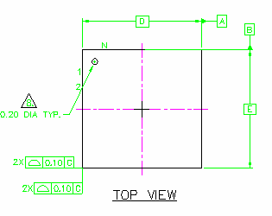

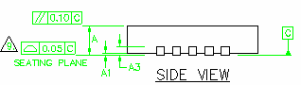

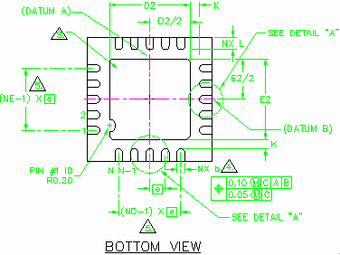

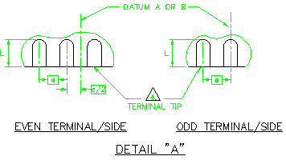

|  |  |  |  |  |  |  |  |  |  |  |  |
| --- | --- | --- | --- | --- | --- | --- | --- | --- | --- | --- | --- |
| **Package Type** |  | **A** | **A1** | **A3** | **K** | **D/E** | **e** | **D2/E2** | **L** | **L1** | **b** |
| Saw QFN20 | **Min** | 0.80 | 0.00 |  |  |  |  | 2.50 | 0.35 |  | 0.18 |
| (4x4 mm) | **Typ.** | 0.85 | 0.02 | 0.20 | 0.20 | 4.0 BSC13 | 0.5 BSC | 2.60 | 0.40 | 0.15 | 0.25 |
|  | **Max** | 0.95 | 0.05 | REF. | min |  |  | 2.70 | 0.45 | max | 0.30 |

Figure 3 nRF24L01 Package Outline.

13 BSC: Basic Spacing between Centers, ref. JEDEC standard 95, page 4.17-11/A

## Package marking:

|  |  |  |  |  |  |
| --- | --- | --- | --- | --- | --- |
| n | R | F |  | *B* | *X* |
| 2 | 4 | L | 0 | 1 |  |
| *Y* | *Y* | *W* | *W* | *L* | *L* |

Abbreviations:

1. – Build Code, i.e. unique code for production sites, package type and test platform

X – "X" grade, i.e. Engineering Samples (optional) YY – 2 digit Year number

WW – 2 digit Week number

LL – 2 letter wafer lot number code

## Absolute Maximum Ratings

### Supply voltages

VDD V to + 3.6V

VSS V

### Input voltage

VI V to 5.25V

### Output voltage

VO VSS to VDD

### Total Power Dissipation

PD (TA=85C) 60mW

### Temperatures

Operating Temperature…. - 40C to + 85C Storage Temperature….… - 40C to + 125C

*Note: Stress exceeding one or more of the limiting values may cause permanent damage to the device.*

## ATTENTION!

Electrostatic Sensitive Device Observe Precaution for handling.



# Glossary of Terms

|  |  |
| --- | --- |
| **Term** | **Description** |
| ACK | Acknowledgement |
| ART | Auto Re-Transmit |
| CE | Chip Enable |
| CLK | Clock |
| CRC | Cyclic Redundancy Check |
| CSN | Chip Select NOT |
| ESB | Enhanced ShockBurst™ |
| GFSK | Gaussian Frequency Shift Keying |
| IRQ | Interrupt Request |
| ISM | Industrial-Scientific-Medical |
| LNA | Low Noise Amplifier |
| LSB | Least Significant Bit |
| LSByte | Least Significant Byte |
| Mbps | Megabit per second |
| MCU | Micro Controller Unit |
| MISO | Master In Slave Out |
| MOSI | Master Out Slave In |
| MSB | Most Significant Bit |
| MSByte | Most Significant Byte |
| PCB | Printed Circuit Board |
| PER | Packet Error Rate |
| PID | Packet Identity Bits |
| PLD | Payload |
| PRX | Primary RX |
| PTX | Primary TX |
| PWR_DWN | Power Down |
| PWR_UP | Power Up |
| RoHS | Restriction of use of Certain Hazardous Substances |
| RX | Receive |
| RX_DR | Receive Data Ready |
| SPI | Serial Peripheral Interface |
| TX | Transmit |
| TX_DS | Transmit Data Sent |

Table 5 Glossary

# FUNCTIONAL DESCRIPTION

## Modes of operation

The nRF24L01 can be set in the following main modes depending on the level of the following primary I/Os and configuration registers:

|  |  |  |  |  |
| --- | --- | --- | --- | --- |
| **Mode** | **PWR_UP**  **register** | **PRIM_RX**  **register** | **CE** | **FIFO state** |
| RX mode | 1 | 1 | 1 | - |
| TX mode | 1 | 0 | 1 | Data in TX FIFO |
| TX mode | 1 | 0 | 1➔0 | Stays in TX mode until packet  transmission is finished |
| Standby-II | 1 | 0 | 1 | TX FIFO empty |
| Standby-I | 1 | - | 0 | No ongoing packet transmission |
| Power Down | 0 | - | - | - |

Table 6 nRF24L01 main modes

An overview of the nRF24L01 I/O pins in different modes is given in Table 7.

## Pin functions in the different modes of nRF24L01

|  |  |  |  |  |  |
| --- | --- | --- | --- | --- | --- |
| **Pin Name** | **Direction** | **TX Mode** | **RX Mode** | **Standby Modes** | **Power Down** |
| CE | Input | High Pulse >10s | High | Low | - |
| CSN | Input | SPI Chip Select, active low | | | |
| SCK | Input | SPI Clock | | | |
| MOSI | Input | SPI Serial Input | | | |
| MISO | Tri-state  Output | SPI Serial Output | | | |
| IRQ | Output | Interrupt, active low | | | |

Table 7 Pin functions of the nRF24L01

## Standby Modes

Standby-I mode is used to minimize average current consumption while maintaining short start up times. In this mode, part of the crystal oscillator is active. In Standby-II mode some extra clock buffers are active compared to Standby-I mode. Standby-II occurs when CE is held high on a PTX device with empty TX FIFO. The configuration word content is maintained during Standby modes. SPI interface may be activated. For start up time see Table 13.

## Power Down Mode

In power down nRF24L01 is disabled with minimal current consumption. When entering this mode the device is not active, but all registers values available from the SPI interface are maintained during power down and the SPI interface may be activated (CSN=0). For start up time see Table 13. The power down is controlled by the PWR_UP bit in the CONFIG register.

## Packet Handling Methods

nRF24L01 has the following Packet Handling Methods:

* ShockBurst™ (compatible with nRF2401, nRF24E1, nRF2402 and nRF24E2 with 1Mbps data rate, see page 26)
* Enhanced ShockBurst™

## ShockBurst™

ShockBurst™ makes it possible to use the high data rate offered by nRF24L01 without the need of a costly, high-speed microcontroller (MCU) for data processing/clock recovery. By placing all high speed signal processing related to RF protocol on-chip, nRF24L01 offers the application microcontroller a simple SPI compatible interface, the data rate is decided by the interface-speed the micro controller itself sets up. By allowing the digital part of the application to run at low speed, while maximizing the data rate on the RF link, ShockBurst™ reduces the average current consumption in applications.

In ShockBurst™ RX, IRQ notifies the MCU when a valid address and payload is received respectively. The MCU can then clock out the received payload from an nRF24L01 RX FIFO.

In ShockBurst™ TX, nRF24L01 automatically generates preamble and CRC, see Table 12. IRQ notifies the MCU that the transmission is completed. All together, this means reduced memory demand in the MCU resulting in a low cost MCU, as well as reduced software development time. nRF24L01 has a three level deep RX FIFO (shared between 6 pipes) and a three level deep TX FIFO. The MCU can access the FIFOs at any time, in power down mode, in standby modes, and during RF packet transmission. This allows the slowest possible SPI interface compared to the average data-rate, and may enable usage of an MCU without hardware SPI.

## Enhanced ShockBurst™

Enhanced ShockBurst™ is a packet handling method with functionality that makes bi- directional link protocol implementation easier and more efficient. In a typical bi- directional link, one will let the terminating part acknowledge received packets from the originating part in order to make it possible to detect data loss. Data loss can then be recovered by retransmission. The idea with Enhanced ShockBurst™ is to let nRF24L01 handle both acknowledgement of received packets and retransmissions of lost packets, without involvement from the microcontroller.

Figure 4: nRF24L01 in a star network configuration

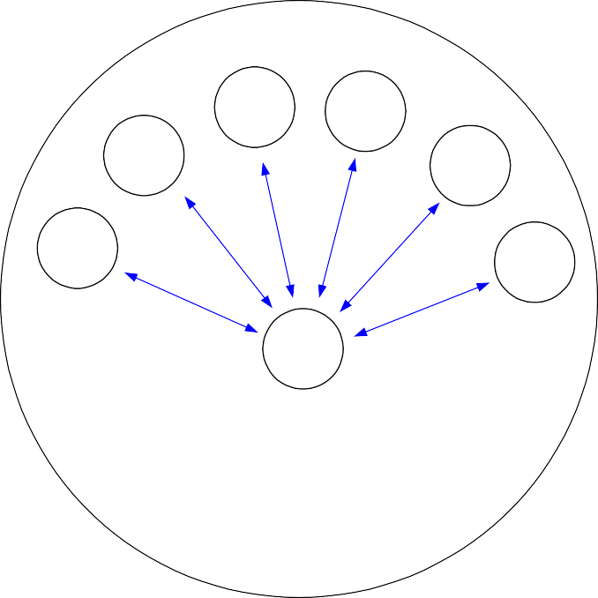

TX3

TX4

TX2

TX5

TX1

TX6

RX

Frequency Channel N

An nRF24L01 configured as primary RX (PRX) will be able to receive data trough 6 different data pipes, see Figure 4. A data pipe will have a unique address but share the same frequency channel. This means that up to 6 different nRF24L01 configured as primary TX (PTX) can communicate with one nRF24L01 configured as PRX, and the nRF24L01 configured as PRX will be able to distinguish between them. Data pipe 0 has a unique 40 bit configurable address. Each of data pipe 1-5 has an 8 bit unique address and shares the 32 most significant address bits. All data pipes can perform full Enhanced ShockBurst™ functionality.

nRF24L01 will use the data pipe address when acknowledging a received packet. This means that nRF24L01 will transmit ACK with the same address as it receives payload at. In the PTX device data pipe 0 is used to received the acknowledgement, and therefore the receive address for data pipe 0 has to be equal to the transmit address to be able to receive the acknowledgement. See Figure 5 for addressing example.

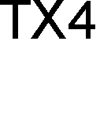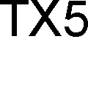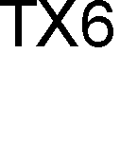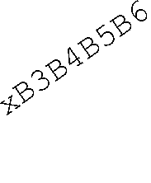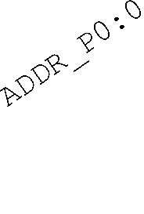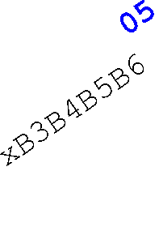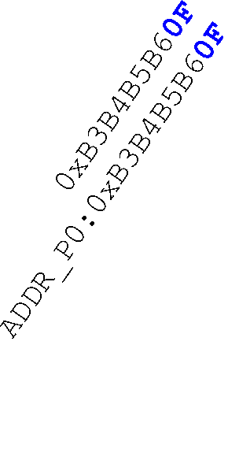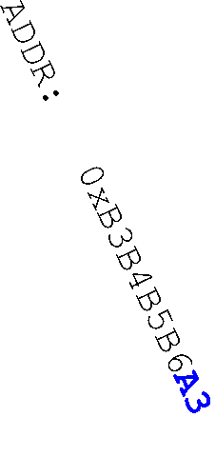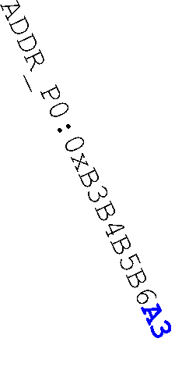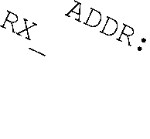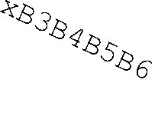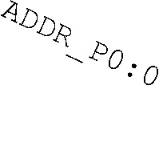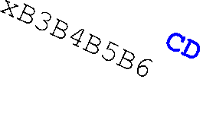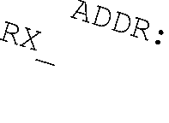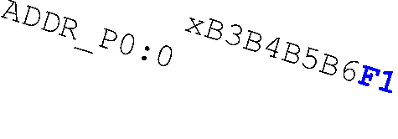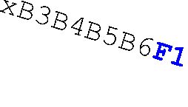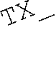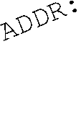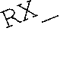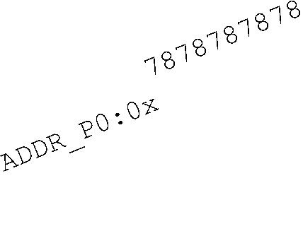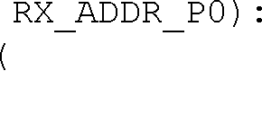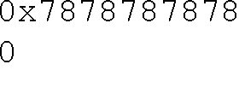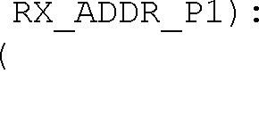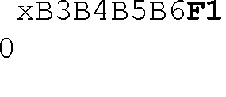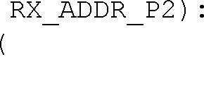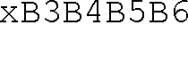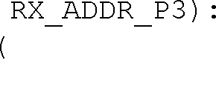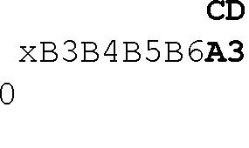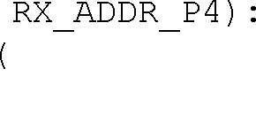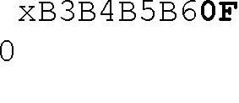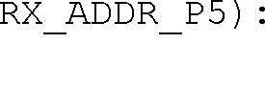

Figure 5: Example on how the acknowledgement addressing is done

An nRF24L01 configured as PTX with Enhanced ShockBurst™ enabled, will use the ShockBurst™ feature to send a packet whenever the microcontroller wants to. After the packet has been transmitted, nRF24L01 will switch on its receiver and expect an acknowledgement to arrive from the terminating part. If this acknowledgement fails to arrive, nRF24L01 will retransmit the same packet until it receives an acknowledgement or the number of retries exceeds the number of allowed retries given in the SETUP_RETR_ARC register. If the number of retries exceeds the number of allowed retries, this will be showed by the STATUS register bit MAX_RT which gives an interrupt.

Whenever an acknowledgement is received by an nRF24L01 it will consider the last transmitted packet as delivered. It will then be cleared from the TX FIFO, and the TX_DS IRQ source will be set high.

With Enhanced ShockBurst™ nRF24L01 offers the following benefits:

* Highly reduced current consumption due to short time on air and sharp timing when operating with acknowledgement traffic
* Lower system cost. Since the nRF24L01 handles all the high-speed link layer operations, like re-transmission of lost packet and generating acknowledgement to received packets, it is no need for hardware SPI on the system microcontroller to interface the nRF24L01. The interface can be done by using general purpose IO pins on a low cost microcontroller where the SPI is emulated in firmware. With the nRF24L01 this will be sufficient speed even when running a bi-directional link.
* Greatly reduced risk of “on-air” collisions due to short time on air
* Easier firmware development since the link layer is integrated on chip

## Enhanced ShockBurst™ Transmitting Payload:

1. The configuration bit PRIM_RX has to be low.
2. When the application MCU has data to send, the address for receiving node (TX_ADDR) and payload data (TX_PLD) has to be clocked into nRF24L01 via the SPI interface. The width of TX-payload is counted from number of bytes written into the TX FIFO from the MCU. TX_PLD must be written continuously while holding CSN low. TX_ADDR does not have to be rewritten if it is unchanged from last transmit. If the PTX device shall receive acknowledge, data pipe 0 has to be configured to receive the acknowledgement. The receive address for data pipe 0 (RX_ADDR_P0) has to be equal to the transmit address (TX_ADDR) in the PTX device. For the example in Figure 5 the following address settings have to be performed for the TX5 device and the RX device: TX5 device: TX_ADDR = 0xB3B4B5B605

TX5 device: RX_ADDR_P0 = 0xB3B4B5B605 RX device: RX_ADDR_P5 = 0xB3B4B5B605

1. A high pulse on CE starts the transmission. The minimum pulse width on CE is 10 µs.
2. nRF24L01 ShockBurst™:
   * Radio is powered up
   * 16 MHz internal clock is started.
   * RF packet is completed (see the packet description)
   * Data is transmitted at high speed (1 Mbps or 2 Mbps configured by MCU).
3. If auto acknowledgement is activated (ENAA_P0=1) the radio goes into RX mode immediately. If a valid packet has been received in the valid acknowledgement time window, the transmission is considered a success. The TX_DS bit in the status register is set high and the payload is removed from TX FIFO. If a valid acknowledgement is not received in the specified time window, the payload is resent (if auto retransmit is enabled). If the auto retransmit counter (ARC_CNT) exceeds the programmed maximum limit (ARC), the MAX_RT bit in the status register is set high. The payload in TX FIFO is NOT removed. The IRQ pin will be active when MAX_RT or TX_DS is high. To turn off the IRQ pin, the interrupt source must be reset by writing to the status register (see Interrupt chapter). If no acknowledgement is received for a packet after the maximum number of retries, no further packets can be sent before the MAX_RX interrupt is cleared. The packet loss counter (PLOS_CNT) is incremented at each MAX_RT interrupt. I.e. ARC_CNT counts the number of retries that was required to get a single packet through. PLOS_CNT counts the number of packets that did not get through after maximum number of retries.
4. The device goes into Standby-I mode if CE is low. Otherwise next payload in TX FIFO will be sent. If TX FIFO is empty and CE is still high, the device will enter Standby-II mode.
5. If the device is in Standby-II mode, it will go to Standby-I mode immediately if CE is set low.

## Enhanced ShockBurstTM Receive Payload:

1. RX is selected by setting the PRIM_RX bit in the configuration register to high. All data pipes that shall receive data must be enabled (EN_RXADDR register),

auto acknowledgement for all pipes running Enhanced ShockBurst™ has to be enabled (EN_AA register), and the correct payload widths must be set (RX_PW_Px registers). Addresses have to be set up as described in item 2 in the Enhanced ShockBurst™ transmit payload chapter above.

1. Active RX mode is started by setting CE high.
2. After 130µs nRF24L01 is monitoring the air for incoming communication.
3. When a valid packet has been received (matching address and correct CRC), the payload is stored in the RX-FIFO, and the RX_DR bit in status register is set high. The IRQ pin will be active when RX_DR is high. RX_P_NO in status register will indicate what data pipe the payload has been received in.
4. If auto acknowledgement is enabled, an acknowledgement is sent back.
5. MCU sets the CE pin low to enter Standby-I mode (low current mode).
6. MCU can clock out the payload data at a suitable rate via the SPI interface.
7. The device is now ready for entering TX or RX mode or power down mode.

## Two way communication with payload in both directions

If payload shall be sent in both directions, the PRIM_RX register must be toggled by redefining the device from PRX to PTX or vice versa. The controlling processors must handle the synchronicity between a PTX and a PRX. Data buffering in both RX FIFO and TX FIFO simultaneously is possible, but restricted to data pipes 1 to 5. The third level in TX FIFO shall only be written in RX, TX or Standby-II mode if data is stored in RX FIFO

## Auto Acknowledgement (RX)

The auto acknowledgement function reduces the load of the external microcontroller, and may remove the need for dedicated SPI hardware in a mouse/keyboard or comparable systems, and hence reduce cost and average current consumption. Auto acknowledgement can be configured individually for each data pipe via the SPI interface.

If auto acknowledgement is enabled and a valid packet (correct data pipe address and CRC) is received, the device will enter TX mode and send an acknowledgement packet. After the device has sent the acknowledgement packet, normal operation resumes, and the mode is determined by the PRIM_RX register and CE pin.

## Auto Re-Transmission (ART) (TX)

An auto retransmission function is available. It will be used at the TX side in an auto acknowledgement system. In the SETUP_RETR register it will be possible to state how many times the data in the data register will be resent if data is not acknowledged. After each sending, the device will enter RX mode and wait a specified time period for acknowledgement. When the acknowledgement packet is received, the device will return to normal transmit function. If there is no more unsent data in the TX FIFO and the CE pin is low, the device will go into Standby-I mode. If the acknowledgement is not received, the device will go back to TX mode and resend the data. This will continue until acknowledgment is received, or a time out occurs

(i.e. the maximum number of sending is reached). The only way to reset this is to set the PWR_UP bit low or let the auto retransmission finish. A packet loss counter will be incremented each time a packet does not succeed to reach the destination before time out. (Time out is indicated by the MAX_RT interrupt.) The packet loss counter is reset when writing to the RF channel register.

## Packet Identity (PID) and CRC used by Enhanced ShockBurstTM

Each packet contains a two bit wide PID field to detect if the received packet is new or resent. The PID will prevent that the PRX device presents the same payload more than once to the microcontroller. This PID field is incremented at the TX side for each new packet received via the SPI interface. The PID and CRC field is used by the PRX device to determine whether a packet is resent or new. When several data is lost on the link, the PID fields may in some cases become equal to last received PID. If a packet has the same PID as the previous packet, nRF24L01 will compare the CRC sums from both packets. If they also are equal, the last received packet is considered as a copy of the previous and is discarded.

1: PRX device:

The PRX device compares the received PID with the last PID. If the PID fields are different, the packet is considered to be new. If the PID is equal to last received PID, the received packet might be the same as last time. The receiver must check if the CRC is equal to the previous CRC. If the CRC is equal to the previous one, the packet is probably the same, and will be discarded.

2: PTX device:

The transmitter increments the PID field each time it sends a new packet.

TX side functionality RX side functionality

Start

New packet from MCU?

Yes

No

End

increment PID

Start

PID equal last PID?

Yes

CRC equal last CRC?

Yes

No

No

New packet is valid for MCU

Discard packet as a copy

End

Figure 6 PID generation/detection

The length of the CRC is configurable through the SPI interface. It is important to notice that the CRC is calculated over the whole packet including address, PID and payload. No packet is accepted as correct if the CRC fails. This is an extra requirement for packet acceptance that is not illustrated in the figure above.

## Stationary Disturbance Detection – CD

Carrier Detect (CD) is set high when an in-band RF signal is detected in RX mode, otherwise CD is low. The internal CD signal is filtered before presented to CD register. The internal CD signal must be high for at least 128s.

In Enhanced ShockBurst™ it is recommended to use the Carrier Detect functionality only when the PTX device does not succeed to get packets through, as indicated by the MAX_RT interrupt for single packets and by the packet loss counter (PLOS_CNT) if several packets are lost. If the PLOS_CNT in the PTX device indicates to high rate of packet losses, the device can be configured to a PRX device for a short time (Tstbt2a + CD-filter delay = 130s+128s = 258s) to check CD. If CD was high (jam situation), the frequency channel should be changed. If CD was low (out of range), it may continue on the same frequency channel, but perform other adjustments. (A dummy write to the RF_CH will clear the PLOS_CNT.)

## Data Pipes

nRF24L01 configured as PRX can receive data addressed to 6 different data pipes in one physical frequency channel. Each data pipe has its own unique address and can be configured to have individual behavior.

The data pipes are enabled with the bits in the EN_RXADDR register. By default only data pipe 0 and 1 are enabled.

The address for each data pipe is configured in the RX_ADDR_Px registers. Always ensure that none of the data pipes have the exact same address.

Data pipe 0 has a unique 40 bit configurable address. Data pipes 1-5 share the 32 most significant address bits and have only the LSByte unique for each data pipe. Figure 7 shows an example of how data pipes 0-5 are addressed. All pipes can have up to 40 bit address, but for pipe 1-5 only the LSByte is different, and the LSByte must be unique for all pipes.

|  |  |  |  |  |
| --- | --- | --- | --- | --- |
| **Byte 4** | **Byte 3** | **Byte 2** | **Byte 1** | **Byte 0** |

Data pipe 0 (RX_ADDR_P0)

|  |  |  |  |  |
| --- | --- | --- | --- | --- |
| 0xE7 | 0xD3 | 0xF0 | 0x35 | 0x77 |

Data pipe 1 (RX_ADDR_P1)

|  |  |  |  |  |
| --- | --- | --- | --- | --- |
| 0xC2 | 0xC2 | 0xC2 | 0xC2 | **0xC2** |

|  |  |  |  |  |
| --- | --- | --- | --- | --- |
| 0xC2 | 0xC2 | 0xC2 | 0xC2 | **0xC3** |

|  |  |  |  |  |
| --- | --- | --- | --- | --- |
| 0xC2 | 0xC2 | 0xC2 | 0xC2 | **0xC4** |

Data pipe 2 (RX_ADDR_P2)

Data pipe 3 (RX_ADDR_P3)

Data pipe 4 (RX_ADDR_P4)

Data pipe 5 (RX_ADDR_P5)

Figure 7: Addressing data pipes 0-5

|  |  |  |  |  |
| --- | --- | --- | --- | --- |
| 0xC2 | 0xC2 | 0xC2 | 0xC2 | **0xC5** |

|  |  |  |  |  |
| --- | --- | --- | --- | --- |
| 0xC2 | 0xC2 | 0xC2 | 0xC2 | **0xC6** |

When a packet has been received at one of the data pipes and the data pipe is setup to generate acknowledgement, nRF24L01 will generate an acknowledgement with an address that equals the data pipe address where the packet was received.

Some configuration settings are common to all data pipes and some are individual. The following settings are common to all data pipes:

* CRC enabled/disabled (CRC always enabled when ESB is enabled)
* CRC encoding scheme
* RX address width
* Frequency channel
* RF data rate
* LNA gain
* RF output power

# DEVICE CONFIGURATION

All configuration of nRF24L01 is defined by values in some configuration registers. All these registers are writable via the SPI interface.

## SPI Interface

The SPI interface is a standard SPI interface with a maximum data rate of 10Mbps. Most registers are readable.

## SPI Instruction Set

The available commands to be used on the SPI interface are shown below. Whenever CSN is set low the interface expects an instruction. Every new instruction must be started by a high to low transition on CSN.

In parallel to the SPI instruction word applied on the MOSI pin, the STATUS register is shifted serially out on the MISO pin.

The serial shifting SPI commands is on the format:

<**Instruction word**: MSBit to LSBit (one byte)>

<**Data bytes**: LSByte to MSByte, MSBit in each byte first> See Figure 8 and Figure 9.

|  |  |  |  |
| --- | --- | --- | --- |
| **Instruction Name** | **Instruction Format [binary]** | **# Data Bytes** | **Operation** |
| R_REGISTER | 000A AAAA | 1 to 5  LSByte first | Read registers. AAAAA = 5 bit Memory Map Address |
| W_REGISTER | 001A AAAA | 1 to 5  LSByte first | Write registers. AAAAA = 5 bit Memory Map Address  *Executable in power down or standby modes only.* |
| R_RX_PAYLOAD | 0110 0001 | 1 to 32 LSByte first | Read RX-payload: 1 – 32 bytes. A read operation will  always start at byte 0. Payload will be deleted from FIFO after it is read. Used in RX mode. |
| W_TX_PAYLOAD | 1010 0000 | 1 to 32 LSByte first | Used in TX mode.  Write TX-payload: 1 – 32 bytes. A write operation will always start at byte 0. |
| FLUSH_TX | 1110 0001 | 0 | Flush TX FIFO, used in TX mode |
| FLUSH_RX | 1110 0010 | 0 | Flush RX FIFO, used in RX mode  Should not be executed during transmission of acknowledge, i.e. acknowledge package will not be  completed. |
| REUSE_TX_PL | 1110 0011 | 0 | Used for a PTX device  Reuse last sent payload. Packets will be repeatedly resent as long as CE is high.  TX payload reuse is active until W_TX_PAYLOAD or FLUSH TX is executed. TX payload reuse must not be  activated or deactivated during package transmission |
| NOP | 1111 1111 | 0 | No Operation. Might be used to read the STATUS register |

Table 8 Instruction set for the nRF24L01 SPI interface.

The W_REGISTER and R_REGISTER may operate on single or multi-byte registers. When accessing multi-byte registers one will read or write MSBit of LSByte first. The

writing can be terminated before all bytes in a multi-byte register has been written. In this case the unwritten MSByte(s) will remain unchanged. E.g. the LSByte of RX_ADDR_P0 can be modified by writing only one byte to the RX_ADDR_P0 register. The content of the status register will always be read to MISO after a high to low transition on CSN.

## Interrupt

The nRF24L01 has an active low interrupt pin (IRQ). The interrupt pin is activated when TX_DS, RX_DR or MAX_RT is set high in status register. When MCU writes '1' to the interrupt source, the IRQ pin will go inactive. The interrupt mask part of the CONFIG register is used to mask out the interrupt sources that are allowed to set the IRQ pin low. By setting one of the MASK bits high, the corresponding interrupt source will be disabled. By default all interrupt sources are enabled.

## SPI Timing

The interface supports SPI. SPI operation and timing is given in Figure 8 to Figure 10 and in Table 9 and Table 10. The device must be in one of the standby modes or power down mode before writing to the configuration registers. In Figure 8 to Figure 10 the following notations are used:

Cn – SPI Instruction Bit Sn – Status Register Bit

Dn – Data Bit (note: LSByte to MSByte, MSBit in each byte first)

CSN



SCK MOSI

C7 C6 C5 C4 C3 C2 C1 C0

MISO

Figure 8 SPI read operation.

S7 S6 S5 S4 S3 S2 S1 S0 D7 D6 D5 D4 D3 D2 D1 D0 D1 5 D1 4 D1 3 D1 2 D1 1 D1 0 D9 D8

CSN



SCK MOSI

C7 C6 C5 C4 C3 C2 C1 C0 D7 D6 D5 D4 D3 D2 D1 D0 D1 5 D1 4 D1 3 D1 2 D1 1 D1 0 D9 D8

S7 S6 S5 S4 S3 S2 S1 S0

MISO

Figure 9 SPI write operation.

CSN

Tcl

Tch

Tcwh



Tcwh

Tcc Tch Tcl

Tcch

Tdh

Tdc

C7

C6

C0

Tcsd

Tcd

S7

S0

Tcdz

SCK

MOSI

MISO

Figure 10 SPI NOP timing diagram.

|  |  |  |  |  |
| --- | --- | --- | --- | --- |
| **PARAMETER** | **SYMBOL** | **MIN** | **MAX** | **UNITS** |
| Data to SCK Setup | Tdc | 2 |  | ns |
| SCK to Data Hold | Tdh | 2 |  | ns |
| CSN to Data Valid | Tcsd |  | 38 | ns |
| SCK to Data Valid | Tcd |  | 55 | ns |
| SCK Low Time | Tcl | 40 |  | ns |
| SCK High Time | Tch | 40 |  | ns |
| SCK Frequency | Fsck | 0 | 8 | MHz |
| SCK Rise and Fall | Tr,Tf |  | 100 | ns |
| CSN to SCK Setup | Tcc | 2 |  | ns |
| SCK to CSN Hold | Tcch | 2 |  | ns |
| CSN Inactive time | Tcwh | 50 |  | ns |
| CSN to Output High Z | Tcdz |  | 38 | ns |

Table 9 SPI timing parameters (CLoad = 5pF).

|  |  |  |  |  |
| --- | --- | --- | --- | --- |
| **PARAMETER** | **SYMBOL** | **MIN** | **MAX** | **UNITS** |
| Data to SCK Setup | Tdc | 2 |  | ns |
| SCK to Data Hold | Tdh | 2 |  | ns |
| CSN to Data Valid | Tcsd |  | 42 | ns |
| SCK to Data Valid | Tcd |  | 58 | ns |
| SCK Low Time | Tcl | 40 |  | ns |
| SCK High Time | Tch | 40 |  | ns |
| SCK Frequency | Fsck | 0 | 8 | MHz |
| SCK Rise and Fall | Tr,Tf |  | 100 | ns |
| CSN to SCK Setup | Tcc | 2 |  | ns |
| SCK to CSN Hold | Tcch | 2 |  | ns |
| CSN Inactive time | Tcwh | 50 |  | ns |
| CSN to Output High Z | Tcdz |  | 42 | ns |

Table 10 SPI timing parameters (CLoad = 10pF).

# MEMORY MAP

All undefined bits in the table below are redundant. They will be read out as '0'.

|  |  |  |  |  |  |
| --- | --- | --- | --- | --- | --- |
| **Address (Hex)** | **Mnemonic** | **Bit** | **Reset Value** | **Type** | **Description** |
|  | | | | | |
| 00 | CONFIG |  |  |  | Configuration Register |
|  | Reserved | 7 | 0 | R/W | Only '0' allowed |
|  | MASK_RX_DR | 6 | 0 | R/W | Mask interrupt caused by RX_DR  1: Interrupt not reflected on the IRQ pin 0: Reflect RX_DR as active low interrupt  on the IRQ pin |
|  | MASK_TX_DS | 5 | 0 | R/W | Mask interrupt caused by TX_DS  1: Interrupt not reflected on the IRQ pin 0: Reflect TX_DS as active low interrupt  on the IRQ pin |
|  | MASK_MAX_RT | 4 | 0 | R/W | Mask interrupt caused by MAX_RT  1: Interrupt not reflected on the IRQ pin  0: Reflect MAX_RT as active low interrupt on the IRQ pin |
|  | EN_CRC | 3 | 1 | R/W | Enable CRC. Forced high if one of the  bits in the EN_AA is high |
|  | CRCO | 2 | 0 | R/W | CRC encoding scheme  '0' - 1 byte  '1' – 2 bytes |
|  | PWR_UP | 1 | 0 | R/W | 1: POWER UP, 0:POWER DOWN |
|  | PRIM_RX | 0 | 0 | R/W | 1: PRX, 0: PTX |
|  | | | | | |
| 01 | EN_AA  Enhanced ShockBurst™ |  |  |  | Enable ‘Auto Acknowledgment’ Function Disable this functionality to be  compatible with nRF2401, see page 26 |
|  | Reserved | 7:6 | 00 | R/W | Only '00' allowed |
|  | ENAA_P5 | 5 | 1 | R/W | Enable auto ack. data pipe 5 |
|  | ENAA_P4 | 4 | 1 | R/W | Enable auto ack. data pipe 4 |
|  | ENAA_P3 | 3 | 1 | R/W | Enable auto ack. data pipe 3 |
|  | ENAA_P2 | 2 | 1 | R/W | Enable auto ack. data pipe 2 |
|  | ENAA_P1 | 1 | 1 | R/W | Enable auto ack. data pipe 1 |
|  | ENAA_P0 | 0 | 1 | R/W | Enable auto ack. data pipe 0 |
|  | | | | | |
| 02 | EN_RXADDR |  |  |  | Enabled RX Addresses |
|  | Reserved | 7:6 | 00 | R/W | Only '00' allowed |
|  | ERX _P5 | 5 | 0 | R/W | Enable data pipe 5. |
|  | ERX _P4 | 4 | 0 | R/W | Enable data pipe 4. |
|  | ERX _P3 | 3 | 0 | R/W | Enable data pipe 3. |
|  | ERX _P2 | 2 | 0 | R/W | Enable data pipe 2. |
|  | ERX _P1 | 1 | 1 | R/W | Enable data pipe 1. |
|  | ERX _P0 | 0 | 1 | R/W | Enable data pipe 0. |
|  | | | | | |
| 03 | SETUP_AW |  |  |  | Setup of Address Widths  (common for all data pipes) |
|  | Reserved | 7:2 | 000000 | R/W | Only '000000' allowed |
|  | AW | 1:0 | 11 | R/W | RX/TX Address field width  '00' - Illegal  '01' - 3 bytes  '10' - 4 bytes  '11' – 5 bytes  LSByte will be used if address width below 5 bytes |
|  | | | | | |
| 04 | SETUP_RETR |  |  |  | Setup of Automatic Retransmission |
|  | ARD | 7:4 | 0000 | R/W | Auto Re-transmit Delay  ‘0000’ – Wait 250+86uS |

|  |  |  |  |  |  |
| --- | --- | --- | --- | --- | --- |
| **Address (Hex)** | **Mnemonic** | **Bit** | **Reset Value** | **Type** | **Description** |
|  |  |  |  |  | ‘0001’ – Wait 500+86uS ‘0010’ – Wait 750+86uS  ……..  ‘1111’ – Wait 4000+86uS  (Delay defined from end of transmission to start of next transmission)14 |
|  | ARC | 3:0 | 0011 | R/W | Auto Retransmit Count  ‘0000’ –Re-Transmit disabled  ‘0001’ – Up to 1 Re-Transmit on fail of AA  ……  ‘1111’ – Up to 15 Re-Transmit on fail of AA |
|  | | | | | |
| 05 | RF_CH |  |  |  | RF Channel |
|  | Reserved | 7 | 0 | R/W | Only '0' allowed |
|  | RF_CH | 6:0 | 0000010 | R/W | Sets the frequency channel nRF24L01  operates on |
|  | | | | | |
| 06 | RF_SETUP |  |  |  | RF Setup Register |
|  | Reserved | 7:5 | 000 | R/W | Only '000' allowed |
|  | PLL_LOCK | 4 | 0 | R/W | Force PLL lock signal. Only used in test |
|  | RF_DR | 3 | 1 | R/W | Data Rate  ‘0’ – 1 Mbps  ‘1’ – 2 Mbps |
|  | RF_PWR | 2:1 | 11 | R/W | Set RF output power in TX mode '00' – -18 dBm  '01' – -12 dBm  '10' – -6 dBm  '11' – 0 dBm |
|  | LNA_HCURR | 0 | 1 | R/W | Setup LNA gain |
|  | | | | | |
| 07 | STATUS |  |  |  | Status Register (In parallel to the SPI instruction word applied on the MOSI pin, the STATUS register is shifted  serially out on the MISO pin) |
|  | Reserved | 7 | 0 | R/W | Only '0' allowed |
|  | RX_DR | 6 | 0 | R/W | Data Ready RX FIFO interrupt. Set high when new data arrives RX FIFO15.  Write 1 to clear bit. |
|  | TX_DS | 5 | 0 | R/W | Data Sent TX FIFO interrupt. Set high when packet sent on TX. If AUTO_ACK is activated, this bit will be set high only when ACK is received.  Write 1 to clear bit. |
|  | MAX_RT | 4 | 0 | R/W | Maximum number of TX retries interrupt Write 1 to clear bit. If MAX_RT is set it must be cleared to enable  further communication. |
|  | RX_P_NO | 3:1 | 111 | R | Data pipe number for the payload |

14 Accurate formula for delay from start of transmission, to start of re-transmission: TRD (us) = 250us * (ARD+1) + 4us *(AW + PW + CRCW) +138,5us.

TRD= total retransmit delay, AW=Address Width (#bytes), PW=Payload Width(#bytes)

, CRCW= CRC Width (#bytes)

15 The Data Ready interrupt is set by a new packet arrival event. The procedure for handling this interrupt should be: 1) read payload via SPI, 2) clear RX_DR interrupt, 3) read FIFO_STATUS to check if there are more payloads available in RX FIFO, 4) if there are more data in RX FIFO, repeat from 1).

|  |  |  |  |  |  |
| --- | --- | --- | --- | --- | --- |
| **Address (Hex)** | **Mnemonic** | **Bit** | **Reset Value** | **Type** | **Description** |
|  |  |  |  |  | available for reading from RX_FIFO 000-101: Data Pipe Number  110: Not Used  111: RX FIFO Empty |
|  | TX_FULL | 0 | 0 | R | TX FIFO full flag. 1: TX FIFO full. 0:  Available locations in TX FIFO. |
|  | | | | | |
| 08 | OBSERVE_TX |  |  |  | Transmit observe register |
|  | PLOS_CNT | 7:4 | 0 | R | Count lost packets. The counter is overflow protected to 15, and discontinue at max until reset. The counter is reset by  writing to RF_CH. See page 14 and 17. |
|  | ARC_CNT | 3:0 | 0 | R | Count resent packets. The counter is reset  when transmission of a new packet starts. See page 14. |
|  | | | | | |
| 09 | CD |  |  |  |  |
|  | Reserved | 7:1 | 000000 | R |  |
|  | CD | 0 | 0 | R | Carrier Detect. See page 17. |
|  | | | | | |
| 0A | RX_ADDR_P0 | 39:0 | 0xE7E7E7E7E7 | R/W | Receive address data pipe 0. 5 Bytes maximum length. (LSByte is written first. Write the number of bytes defined by  SETUP_AW) |
| 0B | RX_ADDR_P1 | 39:0 | 0xC2C2C2C2C2 | R/W | Receive address data pipe 1. 5 Bytes maximum length. (LSByte is written first.  Write the number of bytes defined by SETUP_AW) |
| 0C | RX_ADDR_P2 | 7:0 | 0xC3 | R/W | Receive address data pipe 2. Only LSB. MSBytes will be equal to  RX_ADDR_P1[39:8] |
| 0D | RX_ADDR_P3 | 7:0 | 0xC4 | R/W | Receive address data pipe 3. Only LSB. MSBytes will be equal to  RX_ADDR_P1[39:8] |
| 0E | RX_ADDR_P4 | 7:0 | 0xC5 | R/W | Receive address data pipe 4. Only LSB. MSBytes will be equal to  RX_ADDR_P1[39:8] |
| 0F | RX_ADDR_P5 | 7:0 | 0xC6 | R/W | Receive address data pipe 5. Only LSB. MSBytes will be equal to  RX_ADDR_P1[39:8] |
|  | | | | | |
| 10 | TX_ADDR | 39:0 | 0xE7E7E7E7E7 | R/W | Transmit address. Used for a PTX device only. (LSByte is written first)  Set RX_ADDR_P0 equal to this address to handle automatic acknowledge if this is a PTX device with Enhanced ShockBurst™ enabled. See page 14. |
|  | | | | | |
| 11 | RX_PW_P0 |  |  |  |  |
|  | Reserved | 7:6 | 00 | R/W | Only '00' allowed |
|  | RX_PW_P0 | 5:0 | 0 | R/W | Number of bytes in RX payload in data pipe 0 (1 to 32 bytes).  0 Pipe not used  1 = 1 byte  …  32 = 32 bytes |
|  | | | | | |
| 12 | RX_PW_P1 |  |  |  |  |
|  | Reserved | 7:6 | 00 | R/W | Only '00' allowed |
|  | RX_PW_P1 | 5:0 | 0 | R/W | Number of bytes in RX payload in data pipe 1 (1 to 32 bytes).  0 Pipe not used |

|  |  |  |  |  |  |
| --- | --- | --- | --- | --- | --- |
| **Address (Hex)** | **Mnemonic** | **Bit** | **Reset Value** | **Type** | **Description** |
|  |  |  |  |  | 1 = 1 byte  …  32 = 32 bytes |
|  | | | | | |
| 13 | RX_PW_P2 |  |  |  |  |
|  | Reserved | 7:6 | 00 | R/W | Only '00' allowed |
|  | RX_PW_P2 | 5:0 | 0 | R/W | Number of bytes in RX payload in data pipe 2 (1 to 32 bytes).  0 Pipe not used  1 = 1 byte  …  32 = 32 bytes |
|  | | | | | |
| 14 | RX_PW_P3 |  |  |  |  |
|  | Reserved | 7:6 | 00 | R/W | Only '00' allowed |
|  | RX_PW_P3 | 5:0 | 0 | R/W | Number of bytes in RX payload in data pipe 3 (1 to 32 bytes).  0 Pipe not used  1 = 1 byte  …  32 = 32 bytes |
|  | | | | | |
| 15 | RX_PW_P4 |  |  |  |  |
|  | Reserved | 7:6 | 00 | R/W | Only '00' allowed |
|  | RX_PW_P4 | 5:0 | 0 | R/W | Number of bytes in RX payload in data pipe 4 (1 to 32 bytes).  0 Pipe not used  1 = 1 byte  …  32 = 32 bytes |
|  | | | | | |
| 16 | RX_PW_P5 |  |  |  |  |
|  | Reserved | 7:6 | 00 | R/W | Only '00' allowed |
|  | RX_PW_P5 | 5:0 | 0 | R/W | Number of bytes in RX payload in data pipe 5 (1 to 32 bytes).  0 Pipe not used  1 = 1 byte  …  32 = 32 bytes |
|  | | | | | |
| 17 | FIFO_STATUS |  |  |  | FIFO Status Register |
|  | Reserved | 7 | 0 | R/W | Only '0' allowed |
|  | TX_REUSE | 6 | 0 | R | Reuse last sent data packet if set high. The packet will be repeatedly resent as long as CE is high. TX_REUSE is set by the SPI instruction REUSE_TX_PL, and is reset by the SPI instructions  W_TX_PAYLOAD or FLUSH TX |
|  | TX_FULL | 5 | 0 | R | TX FIFO full flag. 1: TX FIFO full. 0:  Available locations in TX FIFO. |
|  | TX_EMPTY | 4 | 1 | R | TX FIFO empty flag. 1: TX FIFO empty.  0: Data in TX FIFO. |
|  | Reserved | 3:2 | 00 | R/W | Only '00' allowed |
|  | RX_FULL | 1 | 0 | R | RX FIFO full flag. 1: RX FIFO full. 0:  Available locations in RX FIFO. |
|  | RX_EMPTY | 0 | 1 | R | RX FIFO empty flag. 1: RX FIFO empty.  0: Data in RX FIFO. |
| N/A | TX_PLD | 255:0 | X | W | Written by separate SPI command TX data payload register 1 - 32 bytes.  This register is implemented as a FIFO with 3 levels. Used in TX mode only |
| N/A | RX_PLD | 255:0 | X | R | Written by separate SPI command  RX data payload register. 1 - 32 bytes. This register is implemented as a FIFO |

|  |  |  |  |  |  |
| --- | --- | --- | --- | --- | --- |
| **Address (Hex)** | **Mnemonic** | **Bit** | **Reset Value** | **Type** | **Description** |
|  |  |  |  |  | with 3 levels.  All receive channels share the same FIFO |

Table 11 Memory map of nRF24L01

## Configuration for compatibility with nRF24XX

How to setup nRF24L01 to receive from an nRF2401/nRF2402/nRF24E1/nRF24E2:

* Use same CRC configuration as the nRF2401/nRF2402/nRF24E1/nRF24E2 uses
* Set the PRIM_RX bit to 1
* Disable auto acknowledgement on the data pipe that will be addressed
* Use the same address width as the PTX device
* Use the same frequency channel as the PTX device
* Select data rate 1Mbit/s on both nRF24L01 and nRF2401/nRF2402/nRF24E1/nRF24E2
* Set correct payload width on the data pipe that will be addressed
* Set PWR_UP and CE high

How to setup nRF24L01 to transmit to an nRF2401/nRF24E1:

* Use same CRC configuration as the nRF2401/nRF2402/nRF24E1/nRF24E2 uses
* Set the PRIM_RX bit to 0
* Set the Auto Retransmit Count to 0 to disable the auto retransmit functionality
* Use the same address width as the nRF2401/nRF2402/nRF24E1/nRF24E2 uses
* Use the same frequency channel as the nRF2401/nRF2402/nRF24E1/nRF24E2 uses
* Select data rate 1Mbit/s on both nRF24L01 and nRF2401/nRF2402/nRF24E1/nRF24E2
* Set PWR_UP high
* Clock in a payload that has the same length as the nRF2401/nRF2402/nRF24E1/nRF24E2 is configured to receive
* Pulse CE to send the packet

# PACKET DESCRIPTION

An Enhanced ShockBurst™ packet with payload (1-32 bytes).

|  |  |  |  |  |
| --- | --- | --- | --- | --- |
| Preamble | Address 3-5 byte | 9 bit | Payload 1 - 32 byte | CRC 0/1/2  byte |

flag bits.

A ShockBurst™ packet compatible to nRF2401/nRF2402/nRF24E1/nRF24E2 devices.

|  |  |  |  |
| --- | --- | --- | --- |
| Preamble | Address 3-5 byte | Payload 1 - 32 byte | CRC 0/1/2  byte |

|  |  |
| --- | --- |
| Preamble | * Preamble is used to detect 0 and 1 levels. It is stripped off (RX) and added (TX) by nRF24L01. |
| Address | * The address field contains the receiver address. * The address can be 3, 4 or 5 bytes wide * The address fields can be individually configured for all RX channels and the TX channel * Address is automatically removed from received packets.16 |
| Flags | * PID: Packet Identification. 2 bits that is incremented for each new payload * 7 bits reserved for packet compatibility with future products * Not used when compatible to nRF2401/nRF24E1 |
| Payload | * 1 - 32 bytes wide. |
| CRC | * The CRC is optional. * 0-2 bytes wide CRC * The polynomial for 8 bits CRC check is X8 + X2 + X + 1 * The polynomial for 16 bits CRC check is X16+ X12 + X5 + 1. |

Table 12 Data packet description

16 Suggested use of addresses. In general more bits in the address gives less false detection, which in the end may give lower data Packet-Error-Rate (PER).

* 1. The address made by (5, 4, or 3) equal bytes are not recommended because it in general will make the packet-error-rate increase.
  2. Addresses where the level shift only one time (i.e. 000FFFFFFF) could often be detected in noise that may give a false detection, which again may give raised packet-error-rate.
  3. Addresses as a continuation of the preamble (hi-low toggling) will raise the Packet-Error-Rate (PER).

# IMPORTANT TIMING DATA

The following timing applies for operation of nRF24L01.

## nRF24L01 Timing Information

|  |  |  |  |
| --- | --- | --- | --- |
| **nRF24L01 timing** | **Max.** | **Min.** | **Name** |
| Power Down ➔ Standby mode | 1.5ms |  | Tpd2stby |
| Standby modes ➔ TX/RX mode | 130s |  | Tstby2a |
| Minimum CE high |  | 10s | Thce |
| Delay from CE pos. edge to CSN low |  | 4s | Tpece2csn |

Table 13 Operational timing of nRF24L01

When the nRF24L01 is in power down it must always settle in Standby for 1.5ms before it can enter one of the TX or RX modes. Note that the configuration word will be lost if VDD is turned off and that the device then must be configured before going to one of the TX or RX mode.

## Enhanced ShockBurst™ timing

ESB cycle



0us

250 us

1

2

1 byte payload with ACK (339 us)

CE high minimum 10 us

2 us

STBY I

TX

RX

TX

Payload (33 us + 4 us /byte)

128 us

5 us

ACK (33 us)

1 0

5 us

SPI: IRQ Clear

128 us

STBY I

RX

TX

RX

PTX: CE PTX: IRQ (TX_DS)

PTX: Mode

Ante nna

PRX: CE

PRX: IRQ (RX_D R)

PRX: Mode

Pac ket:

A ddress: 5 bytes CRC: 1 byte Payload: 1 byte

Figure 11 Timing of Enhanced ShockBurst™ for one packet upload (2Mbps).

In Figure 11 the sending of one packet and the acknowledgement of this packet is shown. The loading of payload to the PTX device is not shown in the figure. The PRX device is turned into RX mode (CE=1), and the PTX device is set into TX mode (CE=1 for minimum 10 s). After 130 s the transmission starts and is finished after another 37 s (1 byte payload). The transmission ends, and the PTX device is automatically turned around to RX mode to wait for the acknowledgement from the PRX device. After the PTX device has received the acknowledgement it gives an interrupt to the MCU (IRQ (TX_DS) =>TX-data sent). After the PRX device has received the packet it gives an interrupt to the MCU (IRQ (RX_DR) =>RX-data ready).

# PERIPHERAL RF INFORMATION

## Antenna output

The ANT1 & ANT2 output pins provide a balanced RF output to the antenna. The pins must have a DC path to VDD, either via a RF choke or via the center point in a dipole antenna. A load of 15+j88 (simulated values) is recommended for maximum output power (0dBm). Lower load impedance (for instance 50 ) can be obtained by fitting a simple matching network between the load and ANT1 and ANT2.

## Output Power adjustment

|  |  |  |
| --- | --- | --- |
| **SPI RF-SETUP (RF_PWR)** | **RF output power** | **DC current consumption** |
| 11 | 0 dBm | 11.3 mA |
| 10 | -6 dBm | 9.0 mA |
| 01 | -12 dBm | 7.5 mA |
| 00 | -18 dBm | 7.0 mA |

Conditions: VDD = 3.0V, VSS = 0V, TA = 27ºC, Load impedance = 15+j88.

Table 14 RF output power setting for the nRF24L01.

## Crystal Specification

Frequency accuracy includes initial accuracy (tolerance) and stability over temperature and aging.

|  |  |  |  |  |
| --- | --- | --- | --- | --- |
| **Frequency** | **CL** | **ESR max** | **C0max** | Frequency accuracy |
| 16MHz | 8 – 16 pF |   | 7.0pF | ±60ppm |

Table 15 Crystal specification of the nRF24L01

To achieve a crystal oscillator solution with low power consumption and fast start-up time, it is recommended to specify the crystal with a low value of crystal load capacitance. Specifying a lower value of crystal parallel equivalent capacitance, C0 will also work, but this can increase the price of the crystal itself. Typically C0=1.5pF at a crystal specified for C0max=7.0pF.

The crystal load capacitance, CL, is given by:

1.   *C*1 '*C*2 ' , where C1’ = C1 + CPCB1 +CI1 and C2’ = C2 + CPCB2 + CI2

*C* ' *C* '

*L*

1 2

C1 and C2 are SMD capacitors as shown in the application schematics. CPCB1 and CPCB2 are the layout parasitic on the circuit board. CI1 and CI2 are the capacitance seen into the XC1 and XC2 pin respectively; the value is typical 1pF.

## nRF24L01 sharing crystal with a micro controller.

When using a micro controller to drive the crystal reference input XC1 of the nRF24L01 transceiver some rules must be followed.

## Crystal parameters:

When the micro controller drives the nRF24L01 clock input, the requirement of load capacitance CL is set by the micro controller only. The frequency accuracy of ±60 ppm is still required to get a functional radio link. The nRF24L01 will load the crystal by 0.5pF at XC1 in addition to the PBC routing.

## Input crystal amplitude & Current consumption

The input signal should not have amplitudes exceeding any rail voltage, but any DC- voltage within this is OK. Exceeding rail voltage will excite the ESD structure and the radio performance is degraded below specification. If testing the nRF24L01 with a RF source with no DC offset as the reference source, the input signal will go below the ground level, which is not acceptable.



XO_OUT

Buffer: Sine to full swing

Amplitude controlled current source

Current starved inverter:

XOSC core

Vdd

Vdd

Vss

ESD

Vss

ESD

XC1

XC2

Figure 12 Principle of crystal oscillator

The nRF24L01 crystal oscillator is amplitude regulated. To achieve low current consumption and also good signal-to-noise ratio when using an external clock, it is recommended to use an input signal larger than 0.4 V-peak. When clocked externally, XC2 is not used and can be left as an open pin.

## PCB layout and de-coupling guidelines

A well-designed PCB is necessary to achieve good RF performance. Keep in mind that a poor layout may lead to loss of performance, or even functionality, if due care is not taken. A fully qualified RF-layout for the nRF24L01 and its surrounding components, including matching networks, can be downloaded from [**www.nordicsemi.no**.](http://www.nordicsemi.no/)

A PCB with a minimum of two layers including a ground plane is recommended for optimum performance. The nRF24L01 DC supply voltage should be de-coupled as close as possible to the VDD pins with high performance RF capacitors, see Table 16. It is preferable to mount a large surface mount capacitor (e.g. 4.7F tantalum) in parallel with the smaller value capacitors. The nRF24L01 supply voltage should be filtered and routed separately from the supply voltages of any digital circuitry.

Long power supply lines on the PCB should be avoided. All device grounds, VDD connections and VDD bypass capacitors must be connected as close as possible to the nRF24L01 IC. For a PCB with a topside RF ground plane, the VSS pins should be connected directly to the ground plane. For a PCB with a bottom ground plane, the best technique is to have via holes as close as possible to the VSS pads. At least one via hole should be used for each VSS pin.

Full swing digital data or control signals should not be routed close to the crystal or the power supply lines.

# APPLICATION EXAMPLE

nRF24L01 with single ended matching network crystal, bias resistor, and decoupling capacitors.

50ohm, RF I/O

VDD

C7 33nF

0402

R2 22K

0402

C9 10nF

0402

C8

1nF 0402

U1

CE 1

CSN 2

SCK 3

MOSI 4

MISO 5

CE CSN SCK MOSI MISO

nRF24L01

VDD 15

VSS 14

C5

ANT2

ANT1 VDD_PA

13

12

11

L3

L1 8.2nH

0402

3.9nH

0402

1.5pF

0402

C6

L2 1.0pF

0402

NRF24L01

2.7nH

0402

IRQ

X1

C3 C4

2.2nF 4.7pF

0402 0402

16 MHz R1

1M

C1 22pF

0402

C2 22pF

0402

6 IRQ

20

19

18

17

16

VSS DVDD VDD VSS IREF

7 VDD

8 VSS

9 XC2

10 XC1

Figure 13 nRF24L01 schematic for RF layouts with single ended 50 RF output.

|  |  |  |  |
| --- | --- | --- | --- |
| **Part** | **Designator** | **Footprint** | **Description** |
| 22pF17 | C1 | 0402 | NPO, +/- 2%, 50V |
| 22pF17 | C2 | 0402 | NPO, +/- 2%, 50V |
| 2.2nF | C3 | 0402 | X7R, +/- 10%, 50V |
| 4.7pF | C4 | 0402 | NPO, +/- 0.25 pF, 50V |
| 1.5pF | C5 | 0402 | NPO, +/- 0.1 pF, 50V |
| 1,0pF | C6 | 0402 | NPO, +/- 0.1 pF, 50V |
| 33nF | C7 | 0402 | X7R, +/- 10%, 50V |
| 1nF | C8 | 0402 | X7R, +/- 10%, 50V |
| 10nF | C9 | 0402 | X7R, +/- 10%, 50V |
| 8,2nH | L1 | 0402 | chip inductor +/- 5% |
| 2.7nH | L2 | 0402 | chip inductor +/- 5% |
| 3,9nH | L3 | 0402 | chip inductor +/- 5% |
| 1M | R1 | 0402 | +/-10% |
| 22K | R2 | 0402 | +/- 1 % |
| nRF24L01 | U1 | QFN20 4x4 |  |
| 16MHz | X1 |  | +/-60ppm, CL=12pF17 |

Table 16 Recommended components (BOM) in nRF24L01 with antenna matching network

17 C1 and C2 must have values that match the crystals load capacitance, CL.

## PCB layout examples

Figure 14 shows a PCB layout example for the application schematic in Figure 13.

A double-sided FR-4 board of 1.6mm thickness is used. This PCB has a ground plane on the bottom layer. Additionally, there are ground areas on the component side of the board to ensure sufficient grounding of critical components. A large number of via holes connect the top layer ground areas to the bottom layer ground plane.

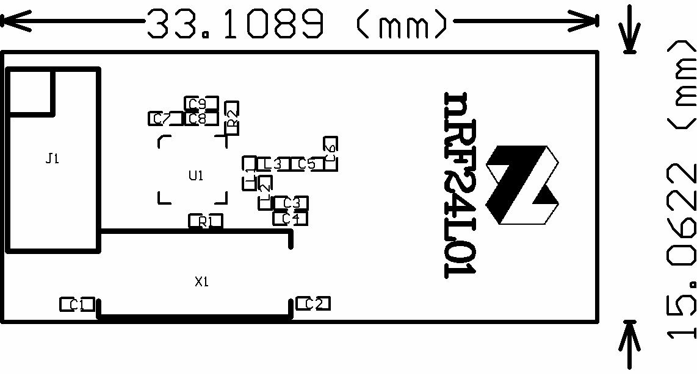

Top overlay

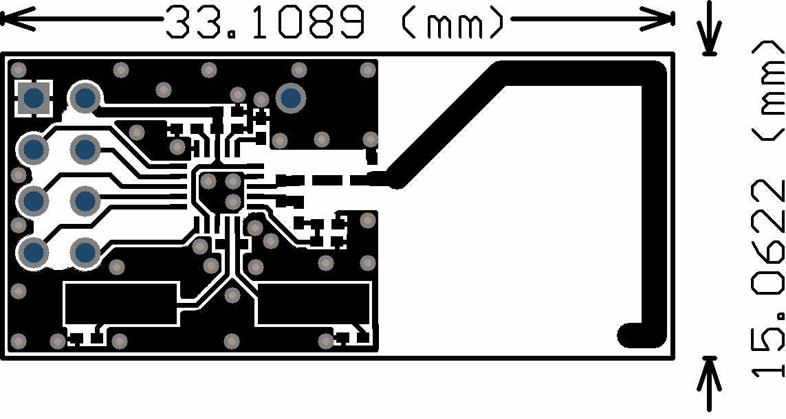

Top layer

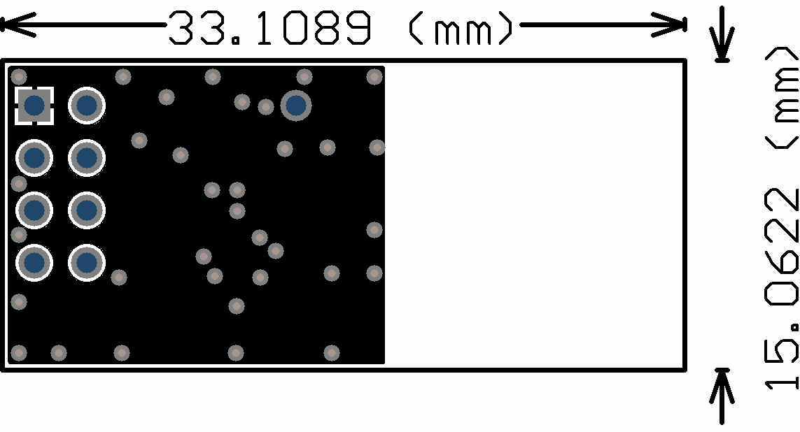

Bottom layer

Figure 14 nRF24L01 RF layout with single ended connection to PCB antenna and 0603 size passive components

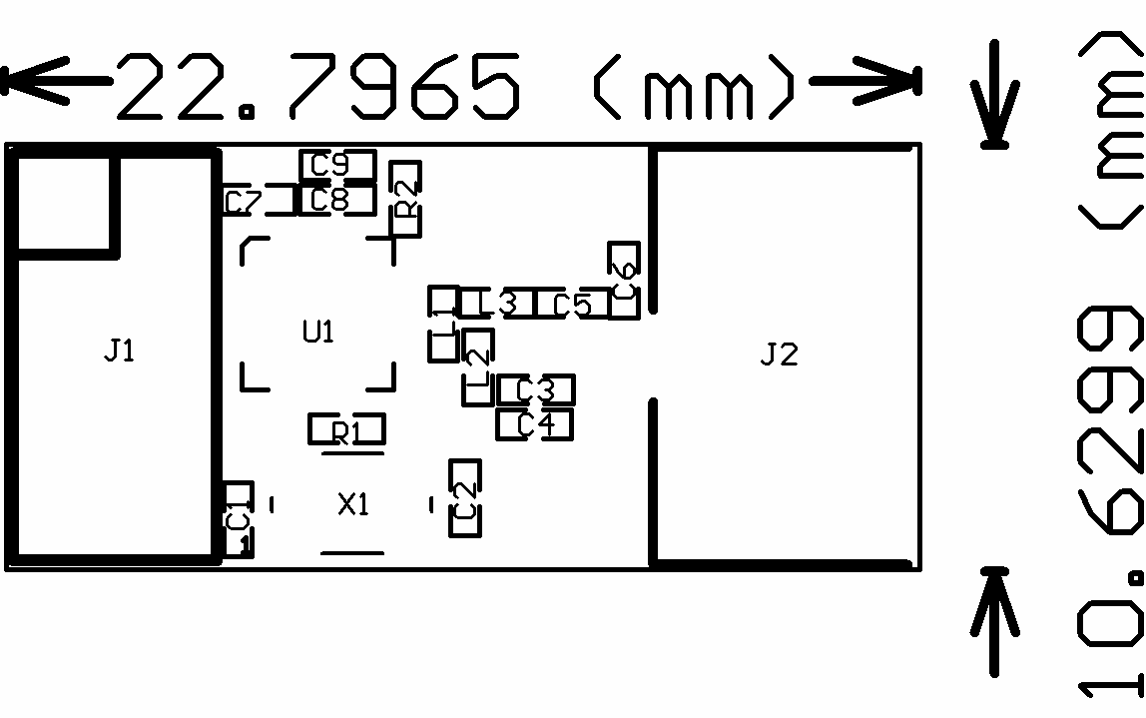The nest figure (Figure 15) is for the SMA output to have a board for direct measurements at a 50 SMA connector.

Top Overlay

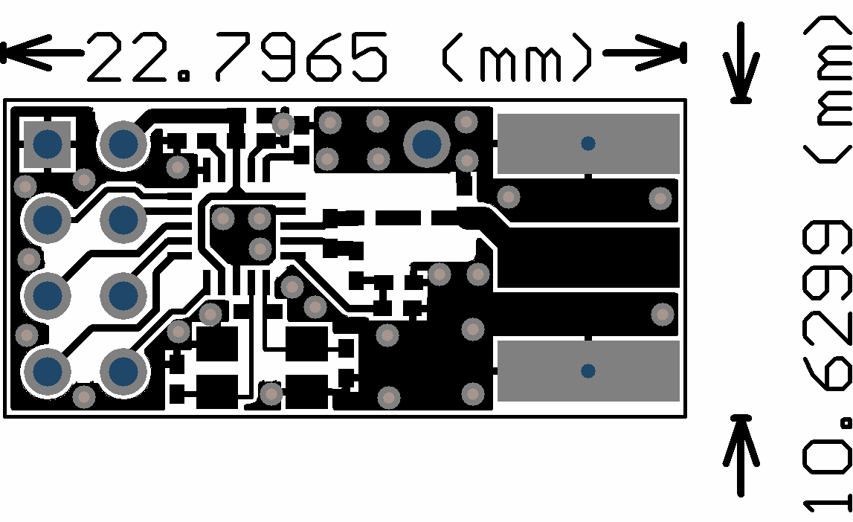

Top Layer

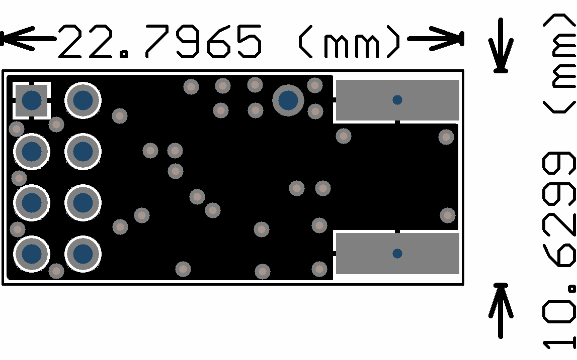

Bottom Layer

Figure 15 Module with OFM crystal and SMA connector

# DEFINITIONS

|  |  |
| --- | --- |
| **Data sheet status** | |
| Objective product specification | This data sheet contains target specifications for product development. |
| Preliminary product  specification | This data sheet contains preliminary data; supplementary data may be  published from Nordic Semiconductor ASA later. |
| Product specification | This data sheet contains final product specifications. Nordic Semiconductor ASA reserves the right to make changes at any time without notice in order to  improve design and supply the best possible product. |
| **Limiting values** | |
| Stress above one or more of the limiting values may cause permanent damage to the device. These are stress ratings only and operation of the device at these or at any other conditions above those given in the Specifications sections of the specification is not implied. Exposure to limiting values for extended periods may  affect device reliability. | |
| **Application information** | |
| Where application information is given, it is advisory and does not form part of the specification. | |

Table 17. Definitions

Nordic Semiconductor ASA reserves the right to make changes without further notice to the product to improve reliability, function or design. Nordic Semiconductor ASA does not assume any liability arising out of the application or use of any product or circuits described herein.

# LIFE SUPPORT APPLICATIONS

These products are not designed for use in life support appliances, devices, or systems where malfunction of these products can reasonably be expected to result in personal injury. Nordic Semiconductor ASA customers using or selling these products for use in such applications do so at their own risk and agree to fully indemnify Nordic Semiconductor ASA for any damages resulting from such improper use or sale.

Preliminary Product Specification: Revision Date: 08.03.2006. Data sheet order code: 080306-nRF24L01

All rights reserved ®. Reproduction in whole or in part is prohibited without the prior written permission of the copyright holder.

# YOUR NOTES

**Nordic Semiconductor ASA – World Wide Distributors**

**For Your nearest dealer, please see** [**http://www.nordicsemi.no**](http://www.nordicsemi.no/)



**Main Office:**

Vestre Rosten 81, N-7075 Tiller, Norway Phone: +47 72 89 89 00, Fax: +47 72 89 89 89

**Visit the Nordic Semiconductor ASA website at** [**http://www.nordicsemi.no**](http://www.nordicsemi.no/)

