*Readings 4 – Kim de Bie, 11077379*

**Patterns, colors and maps**

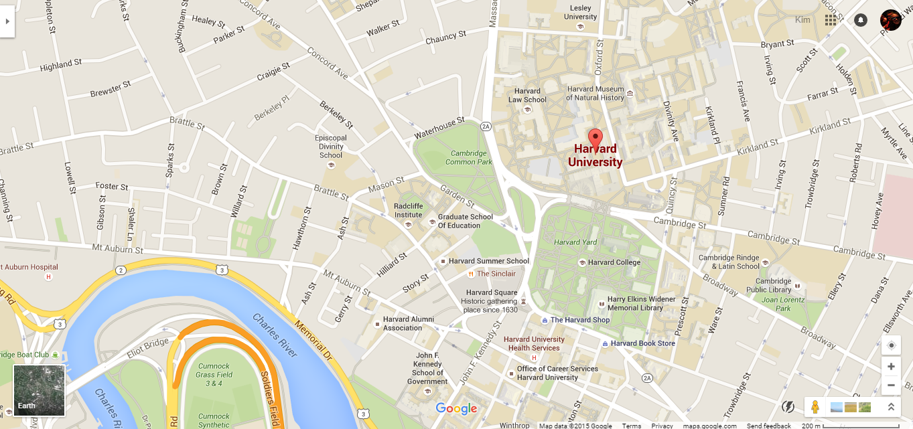

1. *Harvard University on Google Maps*

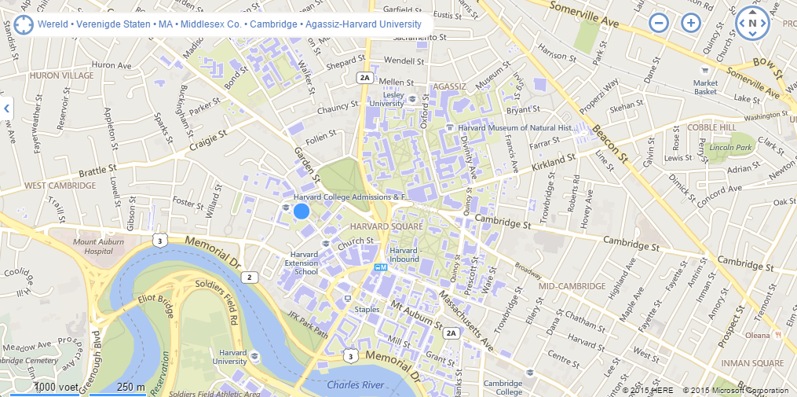

1. *Harvard University on Bing Maps*

The two figures above are screenshots of the Harvard University campus on Google Maps and Bing Maps. Although at first sight, both maps look quite similar, there are important distinct differences between the two. (Note that the zoom levels are slightly different; unfortunately it was not possible have the same zoom level on both maps. As a consequence, more detail is displayed on the Google map, some of which will disappear when zooming out.)

Although both maps aim to represent the same information (namely the important geographical features of the Harvard University campus and surroundings), they differ in the details of which exact patterns are included. Overall, on first sight, the Google map has a ‘cleaner’ feel than the Bing map, and it seems easier to understand the Google map quickly. The underlying reason for this seems to be that the Bing map includes more different objects, but these objects stand out less, i.e. are less ‘different’ from each other than the objects on the Google map. In chapters 3 and 4 of his book, Ware discusses different concepts relating to patterns and colors that can help us understand the differences between the two maps.

Firstly, the Google map includes more textual labels on buildings, making it easier to identify the location of such a building on the map. However, on the Bing map, buildings stand out more in terms of color: the contrast between the purple buildings and the grey background of the Bing map is larger than the grey/brown contrast on the Google map. As Ware points out in chapter 4, the more contrasting colors are, the easier it becomes to distinguish them. Moreover, when hovering over the Bing map, buildings become darker, making the contrast between buildings and their background even greater (although it does not seem possible to click the buildings or engage in an interaction that provides more information). Taking these two points (labels and colors) together, I would say that it is easier to see where buildings are located (in general) on the Bing map, but that the labels of the Google map make it easier to find a specific building. However, it is important to note that both colors and labels are only used to mark significant buildings – regular houses are simply grey on both maps.

Secondly, both maps require different levels of effort for finding routes between places. On the Google map, it is easier to distinguish between smaller and larger roads. Three levels of color are visible (orange, yellow and white, with orange being the biggest roads and white the smallest), and arrows are placed in unidirectional streets. Another important difference is that on the Bing map, many more roads are displayed at smaller zoom levels. On the Google map, many of the smaller streets will only be displayed when zooming in further, whereas on the Bing map, small streets become visible much more quickly. For this reason, the Bing map seems more crowded and it is more difficult to select the correct route, because the small streets are somewhat distracting when they may not be needed to find the most efficient route. In chapter 3, Ware makes this point when he says that “performing visual queries on patterns that are more complex than a single apprehendable chunk requires substantially greater attentional resources” (p. 56): the more complex a visualization, the more effort it costs to understand it.

In conclusion, I would say that the Google map is a better visualization of the Harvard University area than the Bing map. Besides the points mentioned above, it seems that overall, the Google map is better at pointing the viewer to what is important. By limiting the number of elements included in the visualization (compared to the Bing map), the Google designers make it easier for the viewer to get a general idea of the area on the map. However, for both maps, if a viewer cannot find something on the current map (e.g. in the case of Google because it is not there, or because it is hard to find on the Bing map), the search function will most likely help the user to find the object that he was looking for.

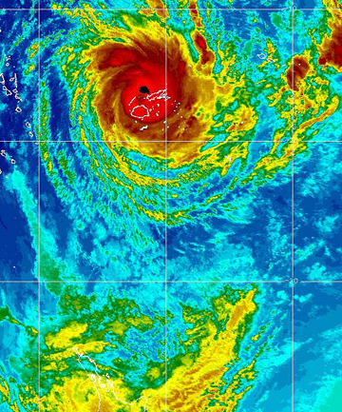

<http://www.stuff.co.nz/world/south-pacific/8087232/Fiji-battered-by-Cyclone-Evan>

This is an image of Cyclone Evan hitting the Fiji Islands in December 2012. The image was posted on a news website from New Zealand accompanying a report on the aftermath of the cyclone, and had the goal to indicate the location of the cyclone in relation to Fiji’s major islands. The news report (and thus the image) was intended for the general public with an interest in regional affairs, and did not require specialist knowledge about Fiji or hurricanes.

Despite the critiques of rainbow maps that Borland and Taylor offer, I do not think this particular rainbow is particularly ambiguous or difficult to understand. It is clear where the center of the hurricane is, and how wind speeds decrease further from its center. However, the big advantage of this specific map is that it is generally known what a hurricane looks like. From just the shape of the green-yellow-orange-red object in the top of the image (so not even from its colors), the average viewer will realize that this is the hurricane. Moreover, the average viewer will also know that wind speeds are higher towards the center of the hurricane, and decrease when moving outwards. For this reason, the color ordering – that, as Borland and Taylor rightfully argue, is not perceptually logical without context – will be clearly understandable by the average viewer. Because the yellow areas are more towards the center of the hurricane than the green areas, the viewer will understand that yellow precedes green in this particular map’s color ordering.

However, although the rainbow color scheme does not exactly seem to hinder understanding of the map in this case, it probably also does not necessarily contribute to it. Another color scheme, with a more intuitively logical ordering, would facilitate the interpretation of this map even better. For example, Borland and Taylor suggest a color scheme going from grey to red with different degrees of saturation. Another solution would be to leave the color spectrum altogether and to represent higher wind speeds by lines that are placed increasingly closer together, as on the image below (which shows typhoon Fung Wong moving past Taiwan in 2008).

