*Kim de Bie – 11077379*

**Readings week 5**

1. According to Ware, the human visual perception involves 2.5 dimensions, rather than three. When visually examining our environment, we get much more information from the *up* and *sideways* dimensions than from the third dimension, depth or, as Ware calls it, *towards-away* (p. 90). There are different ways in which we can gather information about depth. Ware distinguishes between pictorial and non-pictorial clues. The former covers aspects such as occlusion (some objects cover others), whereas the non-pictorial clues could not be gathered from a static picture (such as a painting). Different types of depth cues support different kinds of visual queries. For example, depth of focus or sharpness of objects can help the viewer identify whether objects are important or not, and shadows can indicate distance between objects. However, this information in the third dimension remains limited and much harder to obtain than information in the first two dimensions. Then, using three-dimensional design is only useful when the object to be visualized inherently exists in a three-dimensional space (Ware mentions architectural designs, p. 97), so that it becomes virtually impossible to display the object in any other way. Thus, displaying an object in three-dimensional space comes with significant costs for the viewer, because it is more difficult to extract information from the third dimension, and the third dimension should therefore only be used if these benefits really outweigh the costs.
2. 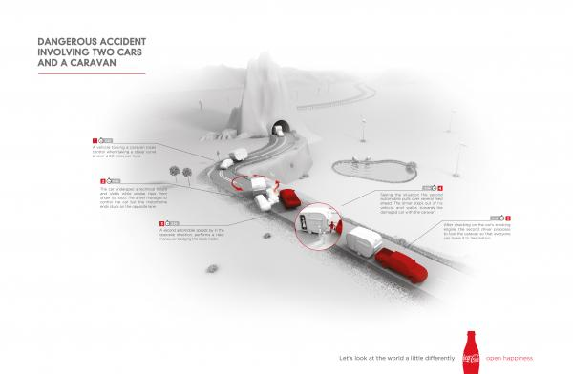

The following advertisement by CocaCola violates some of the design principles as laid out by Ware in chapter 6 of his book. Being an advertisement, it can be inferred that the main goal of the designer was (or should have been) that the viewer would remember the design immediately after only viewing it for a short time. The viewer usually has no interest to view an advertisement for much longer than usual, so ideally the ad is understandable (and will be remembered) in a single visual query. However, as there are many, detailed objects contained in the image, the viewer would have to make multiple queries to fully grasp the image: Ware states that only one to three objects at the time can be contained in the working memory (p. 119). Multiple fixations on the advertisment are necessary to see all the objects in the design. For this reason, the advertisement cannot be understood (or remembered) within one fixation, and the advertisement designer seems to have quite a poor job in designing something that is immediately compelling and will be remembered easily.

1. D3 is useful for building visualizations that use large amounts of data. Moreover, it builds on top of the DOM, so that it is relatively intuitive and easy to integrate into a web page. D3 can thus be built on top of features that many developers are already familiar with, such as HTML and CSS. This would for example be useful when building the temperature graph, like we did last week. Other examples include geographical maps that bind data to regions; visualizations of networks, etcetera. As I understand it from the article by Bostock et al., D3 is a JavaScript toolkit that simply provides extra functions to make handling data easier. It is especially good at interactions and movement of elements. In addition, D3 can just run in the browser without any additional plug-ins, because it’s JavaScript based. A downside would be that D3 is another tool to learn on top of HTML/CSS/JS, which may make it less accessible. Bostock et al. mention that the learning curve of D3 has been identified as rather steep (p. 2308).
2. 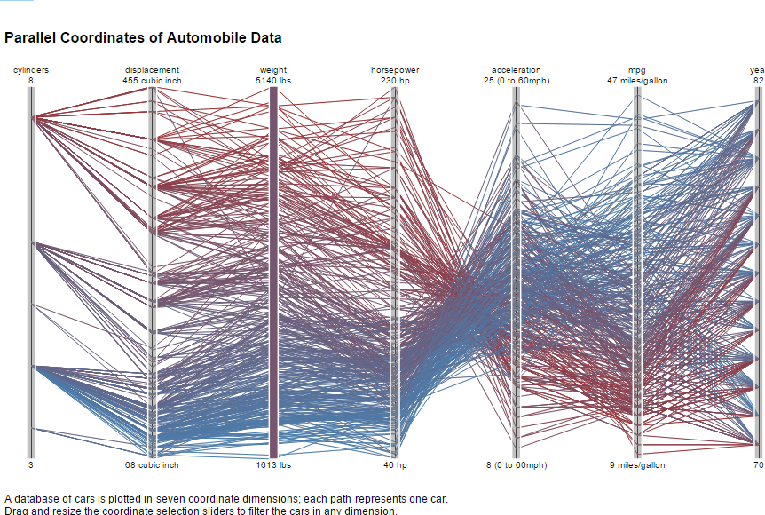

I found the above graph, which displays automobile data, particularly difficult to understand. Firstly, there are a lot of elements (lines) in the display, but it seems like these lines when taken together do not show a very clear overall pattern. With regards to perception, multiple visual queries have to be made to understand relationships between (parts of) lines: the section between horsepower and acceleration for example makes quite clear that more horsepower generally means faster acceleration, and vice versa. However, in most other sections, such a relationship seems non-existent, or at least it is not made visible through this particular visualization. Above all, any overall pattern that spans the entire range of the graph is impossible to distinguish. Furthermore, another problematic aspect is the color usage in this visualization. It seems unclear what the color ranking on a red-blue scale is based on: for example at the start of the graph, cars with the same number of cylinders still have different colors. Thus, color does not seem to add any meaning, but only noise. Lastly, it is impossible to select individual cars to get an understanding of their performance, and because of the large amount of lines, it is impossible to trace individual lines without being able to select them.

1. For figure 1A in De Heer et al., I think the interactive element is quite helpful in getting a deeper understanding of the data. Instead of displaying the absolute gains or losses of certain stocks, the visualization lets the user identify how much gains or losses a stock has made from a certain point in time forward. However, downsides are that the y-axis changes constantly, making comparisons difficult, and the portion of the graph that is left of the cursor seems to make little sense intuitively (to me). Besides, because so many lines are close together at many points, it is difficult to identify the path of a single stock. Another option would be to display the graphs as small multiples. As De Heer et al. indicate, this would make the patterns of individual lines clearer, because not so many lines would have to be stacked on top of each other. Then, if the visualization would work with static axes and a cursor that moves over a time bar at the top of the visualization (see my sketch below), it would still be possible to compare performance of stocks from a certain point in time forward. Moreover, the part left of the cursor would be covered, because it seems to have no substantial meaning anymore. (What is not included in my sketch is that the base point of the graphs would move to the same base level upon moving the cursor.)

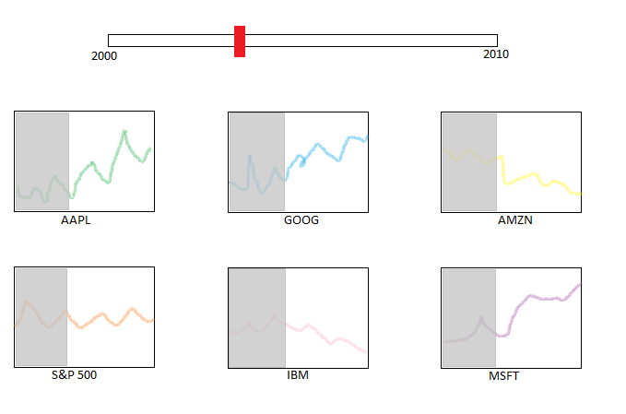

**Works Cited**

Bostock, M., V. Ogievetsky, and J. Heer. 2011. “D3: Data-Driven Documents”. *IEEE Transactions on Visualization and Computer Graphics* (17: 12).

Heer, J., M. Bostock, and V. Ogievetsky. 2010. “A tour through the visualization zoo”, *Commun. ACM* (53: 6).

Ware, Colin. 2008. *Visual Thinking for Design.* Burlington: Morgan Kaufmann.