**F1-score**

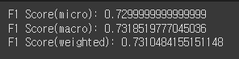

**Confusion Matrix**

