DCEE-CausalVerse: Event-Grounded Causal Planning for Ending-Controllable Visual Storytelling
Anonymous Submission
Anonymous affiliation

Abstract
Recent text-to-image diffusion models produce high-quality single images, but visual storytelling remains difficult because image sequences must preserve identity, world state, event continuity, and emotional progression. We study ending-controllable causal visual storytelling, where a generated story must express a target ending emotion and visually justify why that emotion emerges. We propose DCEE-CausalVerse, which decomposes a target ending emotion into Desire, Conflict, Event Chain, and Ending Emotion. A DCEE-Tree planner explores multiple Desire-Conflict routes and selects the event chain that best supports the target emotion. The selected plan is canonicalized into drawable events and evidence, maintained through causal sink memory and a DCEE anchor bank, and translated into factorized diffusion controls by a decoder-encoder-decoder Butterfly Visual Controller. The controller generates Character, World, Emotion, Event, and Evidence control branches that are injected as cross-attention tokens for SDXL. Multi-candidate generation and event-evidence-aware reranking improve visual grounding and continuity. Automatic and human evaluations show stronger cross-frame consistency and clear preference for caption reflection, object/action visibility, emotion delivery, and emotion-cause explainability.
1. Introduction
Text-to-image diffusion models have made rapid progress in producing visually compelling images from natural language prompts (Ho, Jain, and Abbeel 2020). However, visual storytelling is more demanding than single-image generation because each frame must simultaneously satisfy local text-image alignment and global story consistency. The protagonist should remain recognizable, important objects should persist or reappear when causally needed, the world should evolve coherently, and the emotional tone should change in a narrative rather than arbitrary manner (Rombach et al. 2022).
Most existing visual storytelling systems treat the input as a sequence of captions and attempt to visualize each caption while maintaining history consistency. This is useful when the story is already fixed, but it does not directly answer a more controllable question: given an initial premise and a target ending emotion, what sequence of events should happen so that the final emotion becomes believable, and how should those events be visually grounded? A direct prompt such as 'generate a sad ending' may produce a gloomy portrait, but it often fails to show the event and visual evidence that explain the sadness.
We argue that ending-controllable visual storytelling requires causal narrative planning. The final emotion should not be a surface-level style label; it should be the result of a protagonist's desire, a central conflict, and a chain of visually drawable events. Moreover, every emotional transition should have visible evidence. For example, a sad frame should not simply contain a sad face; it should show the lost object, empty hands, rainy riverbank, or broken clue that makes the sadness understandable.
To address this problem, we propose DCEE-CausalVerse. The core representation is DCEE: Desire - Conflict - Event Chain - Ending Emotion. We further extend this representation with DCEE-Tree Planning, which samples multiple Desire-Conflict trajectories before selecting the event chain that most strongly supports the target ending emotion. The selected plan is canonicalized into explicit entities, drawable events, visual evidence, and world-state cues. During generation, causal sink memory selects not just visually similar history but emotionally causal memory, while the DCEE anchor bank maintains recurring characters, evidence objects, and world anchors.
A key component of our method is the DCEE Butterfly Visual Controller. Unlike a simple prompt generator, this module follows a decoder-encoder-decoder structure. It first expands a DCEE frame into diverse visual hypotheses, then encodes them with causal memory and anchor constraints, and finally decodes the fused state into factorized Character, World, Emotion, Event, and Evidence controls. These controls are converted into cross-attention tokens for SDXL (Podell et al. 2024), enabling structured conditioning while avoiding overly long prompts and control entanglement.
Contributions.
• We formulate ending-controllable causal visual storytelling, where a generated visual story must justify a target ending emotion through a causally ordered event chain
• We introduce DCEE-Tree Planning, which explores multiple Desire-Conflict routes and selects the event chain with the strongest causal support for the target ending emotion.
• We propose causal sink memory and a DCEE anchor bank to preserve identity, world state, conflict state, event evidence, and emotion-cause information across frames.
• We design a decoder-encoder-decoder DCEE Butterfly Visual Controller that maps symbolic DCEE frames into factorized Character, World, Emotion, Event, and Evidence controls.
• We introduce event-evidence-aware reranking and retry generation using event grounding, evidence visibility, emotion visibility, and event-emotion causal consistency.
2. Related Work
2.1. Story Visualization and Subject Consistency
Story visualization methods generate one image per sentence while preserving sequence coherence (Huang et al. 2016). GAN- and transformer-based methods such as StoryGAN (Li et al. 2019) and StoryDALL-E (Maharana, Hannan, and Bansal 2022) initiated this task, and diffusion-based approaches such as AR-LDM (Pan et al. 2024), Make-A-Story (Rahman et al. 2023), ACM-VSG (Feng et al. 2023), StoryGen (Liu et al. 2024), Causal-Story (Song et al. 2024), and ViSTA (Dong et al. 2026) further improve auto-regressive generation through visual memory, adaptive context, causal attention, or history adapters. These methods are strong at rendering a given caption sequence, but they usually assume that the event chain is already specified rather than planning why a target ending emotion should occur.
A related line studies subject-consistent generation. IP-Adapter (Ye et al. 2023), ConsiStory (Tewel et al. 2024), StoryDiffusion (Zhou et al. 2024), One-Prompt-One-Story (Liu et al. 2025), and DreamStory (He et al. 2025) preserve recurring characters or styles across frames by sharing attention, reusing subject features, or constructing multi-subject prompts. Such identity preservation is necessary for visual storytelling, but it is not sufficient for ending-controllable storytelling: a stable protagonist may still fail to perform the intended event, interact with the required evidence object, or express an emotion for a visible reason.
2.2. Planning, LLM Guidance, and Faithfulness
LLM-guided visual story systems use language models as story directors, prompt generators, or reference resolvers. StoryGPT-V (Shen and Elhoseiny 2025), DreamStory (He et al. 2025), and SEED-Story (Yang et al. 2025) show that LLMs can organize story context and improve multi-modal story generation. In parallel, narrative planning work such as hierarchical story generation (Fan, Lewis, and Dauphin 2018), Plan-and-Write (Yao et al. 2019), PlotMachines (Rashkin et al. 2020), and reward-shaped plot generation (Tambwekar et al. 2019) shows that coherent stories benefit from explicit intermediate plans. DCEE-CausalVerse combines these ideas by using an LLM as a structured causal planner rather than a prompt writer: the target ending emotion is decomposed into Desire, Conflict, Event Chain, and Ending Emotion, then canonicalized into drawable events and visible evidence.
Faithfulness evaluation is also important because visually appealing frames can omit the intended action or causal clue. TIFA (Hu et al. 2023) evaluates text-to-image faithfulness with VQA-style questions, and ViSTA (Dong et al. 2026) adopts related criteria for story visualization. Our evaluation extends this direction to causal emotional storytelling by checking not only text-image alignment and identity consistency, but also whether the generated sequence makes the final emotion explainable from visible events and evidence.
3. Method
Figure 1 summarizes the overall DCEE-CausalVerse pipeline. Given an input image or text prompt, a protagonist description, and a target ending emotion, the framework builds a Global Story Bible, explores multiple DCEE routes, canonicalizes the selected route into drawable events and evidence, retrieves causal memory and anchors, and generates each frame through factorized cross-attention control. Table B1 in the appendix provides the full step-by-step pipeline summary.
3.1. Problem Formulation
Let x denote the input premise, a the protagonist description, e* the target ending emotion, and K the number of frames. The goal is to generate an image sequence Y1:K and storyboard S1:K such that the final emotion aligns with e* and every frame grounds the event and visible evidence that cause the protagonist's emotion. Unlike standard story visualization, the event chain is planned rather than assumed to be fully given: I_1:K = G(x, protagonist, e*)
DCEE = {Desire, Conflict, Event Chain, Ending Emotion}

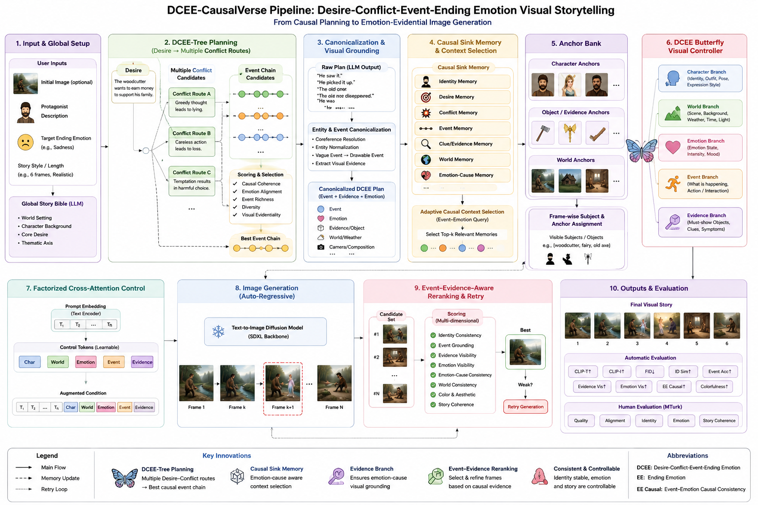
Figure 1. Overall pipeline of DCEE-CausalVerse.

3.2. Global Story Bible
The Global Story Bible stores protagonist identity, world setting, key objects, visual style, central desire, possible conflicts, symbolic motifs, and target ending emotion. If an initial image is provided, an image-text understanding module extracts characters, scene, objects, mood, weather, and plot clues. The story bible becomes the persistent context used by later planning, memory, anchor, and generation modules.
3.3. DCEE-Tree Planning
DCEE-Tree Planning explores multiple Desire-Conflict routes instead of committing to a single narrative path. Each route is expanded into event-chain candidates, and every event must be causally related to the conflict, visually drawable, and capable of changing the protagonist's emotion. Routes are scored by causal coherence, target-emotion alignment, event richness, visual evidentiality, diversity, and narrative coherence. The highest-scoring route becomes the selected DCEE plan.
Route_j = Desire -> Conflict_j -> EventChain_j -> EndingEmotion
Score(Route_j) = alpha Causal + beta Emotion + gamma VisualEvidence + delta Diversity + eta Coherence
3.4. Entity-Event Canonicalization
Entity-event canonicalization resolves ambiguous references, normalizes recurring entities, and converts abstract events into drawable visual obligations. For example, an abstract event such as "he loses everything" is rewritten into visible evidence such as an empty-handed protagonist, a broken clue, or an object drifting away. The canonical storyboard records subjects, objects, actions, world context, emotion cues, and evidence objects for every frame.
3.5. Emotion-World Trajectory Planning
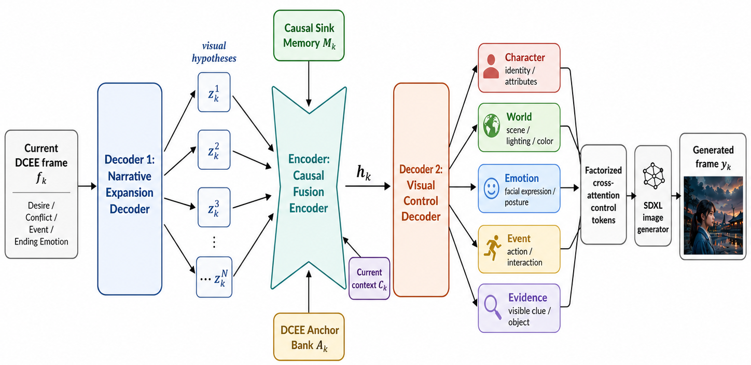
The emotion-world trajectory planner assigns each frame an emotion state, intensity, facial cue, body cue, lighting, color palette, weather, camera shot, and composition. Emotions are not treated as labels alone: the planner records emotion_evidence and must_show fields that specify which objects or events must be visible to explain the current affective state.
Figure 2. Decoder-encoder-decoder structure of the DCEE Butterfly Visual Controller.
3.6. Causal Sink Memory and Adaptive Context Selection
Causal sink memory stores the information needed for future story coherence and emotional causality: identity, desire, conflict, event, clue/evidence, world, and emotion-cause memory. At each frame, adaptive context selection retrieves memories using an event-emotion query, so the model conditions on causally relevant history rather than merely recent history.
M_k = Top-r Memories(q_k^{event-emotion})
score(m_i, q_k) = w1 event + w2 conflict + w3 emotion-cause + w4 clue + w5 identity/world
3.7. DCEE Anchor Bank
The DCEE anchor bank maintains persistent character, object/evidence, and world anchors. Character anchors preserve appearance and signature attributes; evidence anchors preserve causally important objects; and world anchors preserve recurring environments. This extends subject consistency to evidence-object and world-state consistency.
3.8. DCEE Butterfly Visual Controller
The DCEE Butterfly Visual Controller bridges symbolic narrative causality and diffusion-based generation. Directly placing the full storyboard into a long prompt is unreliable because key evidence may be truncated or entangled with identity, world, and emotion constraints. The controller therefore uses a decoder-encoder-decoder structure: the first decoder expands the current DCEE frame into visual hypotheses, the central encoder fuses them with causal memory and anchor information, and the second decoder outputs factorized Character, World, Emotion, Event, and Evidence controls.
Figure 2 shows how the controller converts a DCEE frame into factorized cross-attention tokens. The Character branch preserves identity, the World branch controls scene and atmosphere, the Emotion branch controls facial expression and posture, the Event branch specifies the action, and the Evidence branch specifies the visible clue or object that explains the emotion.
3.9. Factorized Cross-Attention Control for SDXL
Each control branch is encoded as branch-specific tokens and appended to the original SDXL prompt embedding: H_aug = [H_prompt; H_char; H_world; H_emotion; H_event; H_evidence]. This factorization reduces prompt truncation and lets retry generation strengthen a weak branch, such as Event or Evidence, without rewriting the whole prompt.

3.10. Auto-regressive Generation, Reranking, and Retry
Frames are generated autoregressively. For each frame, the system samples multiple candidates and reranks them using image quality, identity consistency, event grounding, evidence visibility, emotion visibility, event-emotion causal consistency, world consistency, and story coherence. If the best candidate falls below event/evidence/emotion thresholds, the weak branch is strengthened and generation is retried.
S = lambda_id S_id + lambda_q S_quality + lambda_e S_event + lambda_v S_evidence + lambda_m S_emotion + lambda_c S_causal + lambda_w S_world + lambda_color S_color
3.11. Method Comparison and Algorithmic Summary
DCEE-CausalVerse differs from prior history- and subject-consistency methods in objective and control granularity. Prior methods mainly render a given sequence consistently, whereas our framework treats the ending emotion as a causal target that must be explained by visible events and evidence. Table 1 summarizes this distinction, and Algorithm 1 in Appendix B gives the full inference procedure.
Table 1. Comparison between prior history-/subject-consistency approaches and DCEE-CausalVerse.
Aspect | Prior history- or subject-consistent methods | DCEE-CausalVerse | Reason for the design choice
Primary goal | Improve temporal coherence or preserve recurring subjects across frames. | Justify a target ending emotion through a causally grounded event chain and visible evidence. | Ending-controllable storytelling requires a believable cause for the final affective state, not only visual consistency.
Input assumption | The caption/story sequence is usually already given. | The event chain is planned from an initial premise, protagonist, and target ending emotion. | Our setting requires the system to decide what should happen before rendering the frames.
History use | Condition on recent or salient text-image history. | Retrieve causal sink memory according to event-emotion relevance. | The current frame uses the history that explains the current emotional state, rather than simply the most recent frame.
Control unit | Caption, subject prompt, or generic history feature. | Factorized Character, World, Emotion, Event, and Evidence controls. | Factorization separates identity preservation from action, setting, emotion, and causal evidence.
Event modeling | Events are often implicit in the caption or absorbed into prompt text. | Events are explicit DCEE units that are planned, canonicalized, grounded, and evaluated per frame. | Explicit event units make it possible to verify whether the generated image depicts the intended action.
Evidence modeling | Evidence objects or clues are usually not modeled separately. | Evidence is a separate branch specifying the visible cause, clue, or object that supports the protagonist emotion. | The target ending emotion is only narratively convincing when its cause is visible.
Generation controller | Prompt generator, history adapter, or identity-conditioning module. | Decoder-encoder-decoder Butterfly controller with causal fusion. | The controller translates symbolic narrative causality into low-level diffusion conditions.
Selection criterion | Image quality, text-image alignment, or subject consistency. | Event grounding, evidence visibility, emotion visibility, event-emotion causal consistency, identity consistency, and world consistency. | Candidate selection directly reflects the causal storytelling objective.

4. Experiments
4.1. Datasets and Input Construction
We evaluate DCEE-CausalVerse on six-frame visual storytelling examples and a counterfactual ending-control setting in which the same premise can be paired with different target ending emotions. Each input contains a premise, protagonist profile, target ending emotion, and optional reference description; the system outputs a DCEE plan, storyboard, visual control packets, final image sequence, and evaluation logs.
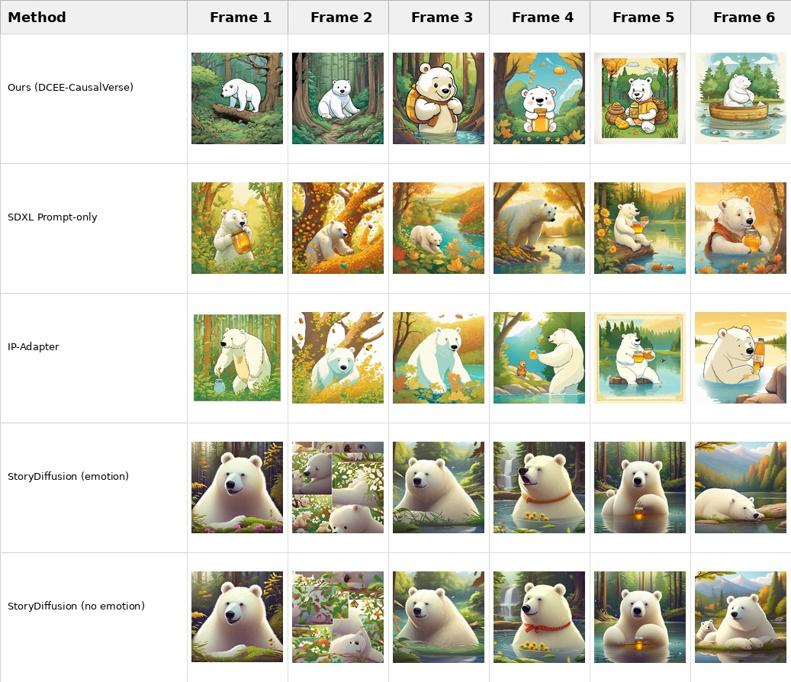
4.2. Baselines and Metrics
Figure 3. Qualitative comparison using the shared six-frame storyboard
We compare DCEE-CausalVerse with Direct LLM + SDXL, SDXL Prompt-only, LLM Storyboard + SDXL, ViSTA-style history conditioning, ConsiStory/StoryDiffusion-style subject-consistent generation, and ablations without the Evidence branch or Tree Planning. For controlled image-level comparison, baselines without a causal planner are conditioned on the same six-frame storyboard. We report CLIP-T, CLIP-I (Radford et al. 2021), and TIFA in the main paper; Appendix C lists the full baseline and metric definitions.
4.3. Implementation Details
The implementation uses an LLM for DCEE planning and canonicalization, SDXL as the base image generator, and lightweight PyTorch modules for branch-specific cross-attention control tokens. The pipeline writes the selected DCEE plan, storyboard, visual control packets, memory log, evaluation log, final story, and contact sheet, making planning-to-rendering errors auditable.

4.4. Quantitative Results
We report CLIP-T, CLIP-I, and TIFA. CLIP-T measures frame-caption alignment, CLIP-I measures cross-frame visual consistency, and TIFA measures text-image faithfulness through question answering. We do not report FID (Heusel et al. 2017) because this setting evaluates a modular inference pipeline on story-level examples rather than a trained image distribution.
All baselines are conditioned on the same six-frame storyboard when they do not perform independent causal planning. Table 2 shows that DCEE-CausalVerse obtains the highest CLIP-I score (0.6904), indicating stronger cross-frame visual consistency. It does not yet outperform baselines on CLIP-T or TIFA, showing that local object/action faithfulness and explicit evidence rendering remain important areas for improvement. Figure 3 shows the qualitative comparison.
4.5. Human Evaluation
We follow the compact reporting style of ViSTA and summarize human evaluation using Textual Alignment and Image Alignment. Ten participants compared five anonymized sequences, where Method A denotes DCEE-CausalVerse. Textual Alignment averages Q3-Q6 (caption reflection, object/action visibility, ending-emotion delivery, and emotion-cause explainability). Image Alignment averages Q2 and Q8 (reference adherence and overall visual quality). Table 3 shows that Method A achieves the highest Textual Alignment (4.60) and competitive Image Alignment (3.85). Detailed questionnaires, Likert scores, and preference counts are in Appendix A.

Table 2. Automatic quantitative results averaged over the selected six frames.
Method | CLIP-T ↑ | CLIP-I ↑ | TIFA ↑
Ours (DCEE-CausalVerse) | 0.3352 | 0.6904 | 0.3667
SDXL Prompt-only | 0.3456 | 0.6274 | 0.6667
IP-Adapter | 0.3422 | 0.6699 | 0.6667
StoryDiffusion (emotion) | 0.3418 | 0.6699 | 0.5000
StoryDiffusion (no emotion) | 0.3479 | 0.6673 | 0.6333

Table 3. ViSTA-style human evaluation summary. Scores are averaged over ten participants. Method A denotes DCEE-CausalVerse.
Model | Textual Align. ↑ | Image Align. ↑
Method A (Ours) | 4.60 | 3.85
Method B | 2.88 | 3.25
Method C | 3.80 | 3.90
Method D | 2.33 | 2.55
Method E | 2.05 | 2.55

5. Discussion
DCEE-CausalVerse is designed to make visual storytelling more causally explainable. The automatic results show stronger cross-frame consistency, and the human study shows that viewers prefer our method on story-grounded textual alignment. At the same time, the lower CLIP-T/TIFA scores indicate that local evidence rendering remains challenging, especially for small objects and fine-grained actions. This suggests that future work should combine causal planning with stronger local grounding modules or trainable evidence-aware diffusion adapters. A full component-wise ablation of DCEE-Tree Planning, causal sink memory, anchor bank, and the Evidence branch is left to future work rather than reported as an incomplete ablation plan.
6. Conclusion
We presented DCEE-CausalVerse, an event-grounded framework for ending-controllable visual storytelling. The method decomposes a target ending emotion into Desire, Conflict, Event Chain, and Ending Emotion, explores multiple causal routes, canonicalizes events into drawable evidence, maintains causal memory and anchors, and uses a decoder-encoder-decoder Butterfly controller to produce factorized diffusion controls. Results indicate stronger cross-frame consistency and higher human preference for story-grounded textual alignment, while also revealing the remaining challenge of local event/evidence faithfulness. Overall, our work moves visual storytelling from sequence consistency alone toward causal, interpretable, and emotionally controllable visual narratives.
References
[1] S. Dong, I. Shaheen, M. Shen, R. Mallick, and S. A. Bargal. ViSTA: Visual Storytelling using Multi-modal Adapters for Text-to-Image Diffusion Models. WACV, 2026.
[2] X. Pan, P. Qin, Y. Li, H. Xue, and W. Chen. Synthesizing Coherent Story with Auto-Regressive Latent Diffusion Models. WACV, 2024.
[3] T. Rahman, H.-Y. Lee, J. Ren, S. Tulyakov, S. Mahajan, and L. Sigal. Make-A-Story: Visual Memory Conditioned Consistent Story Generation. CVPR, 2023.
[4] Z. Feng et al. Improved Visual Story Generation with Adaptive Context Modeling. ACL Findings, 2023.
[5] C. Liu et al. Intelligent Grimm: Open-ended Visual Storytelling via Latent Diffusion Models. CVPR, 2024.
[6] T. Song et al. Causal-Story: Local Causal Attention Utilizing Parameter-Efficient Tuning for Visual Story Synthesis. ICASSP, 2024.
[7] X. Shen and M. Elhoseiny. StoryGPT-V: Large Language Models as Consistent Story Visualizers. CVPR, 2025.
[8] Y. Zhou et al. StoryDiffusion: Consistent Self-Attention for Long-Range Image and Video Generation. NeurIPS, 2024.
[9] Y. Tewel et al. ConsiStory: Training-Free Consistent Text-to-Image Generation. ACM TOG, 2024.
[10] H. He et al. DreamStory: Open-Domain Story Visualization by LLM-Guided Multi-Subject Consistent Diffusion. TPAMI, 2025.
[11] S. Yang et al. SEED-Story: Multimodal Long Story Generation with Large Language Models. arXiv, 2024.
[12] Y. Hu et al. TIFA: Accurate and Interpretable Text-to-Image Faithfulness Evaluation with Question Answering. ICCV, 2023.
[13] D. Podell et al. SDXL: Improving Latent Diffusion Models for High-Resolution Image Synthesis. ICLR, 2024.
[14] StoryGAN, CVPR 2019
[15] StoryDALL-E, ECCV 2022
[16] Plan-and-Write, AAAI 2019
[17] PlotMachines, EMNLP 2020
[18] Controllable Neural Story Plot Generation via Reward Shaping, IJCAI 2019
[19] One-Prompt-One-Story, ICLR, 2025
[20] Hierarchical Neural Story Generation, ACL, 2018
A. Experimental Setup
This appendix provides the detailed human-evaluation protocol that supports the concise results reported in Section 4.6. Following the supplementary organization used by ViSTA, the main paper reports the compact human-evaluation summary, while the full questionnaire, Likert scores, and preference counts are placed after the references.
A.1. Human Evaluation Protocol
We conducted a pilot human evaluation with ten participants (P1-P10). Participants compared five anonymized visual story methods labeled Method A-E. Method A corresponds to DCEE-CausalVerse, while the remaining methods correspond to baseline-generated sequences. To reduce method-name bias, the survey used only anonymized method labels. Each participant was shown a reference image and a textual appearance description of the target white-bear protagonist, the six frame-level story captions, and the generated six-frame sequences for all methods. Participants rated each method using eight five-point Likert questions, where 1 indicates very poor and 5 indicates excellent. They also selected the best and second-best overall visual story. We compute the final preference score as 2 x First Choice + 1 x Second Choice.
For compact reporting in the main paper, we aggregate the eight Likert questions into two ViSTA-style criteria. Textual Alignment averages Q3-Q6: caption reflection, object/action visibility, ending-emotion delivery, and emotion-cause explainability. Image Alignment averages Q2 and Q8: reference-image adherence and overall visual quality/completeness. We do not include a separate Consistency column in the main text, because the current paper emphasizes whether the visual sequence reflects the causal event-evidence structure and image-level visual quality; the detailed consistency-related questions are still reported below.
A.2. Questionnaire

Table A1. Human evaluation questionnaire and evaluation dimensions.
Question | Dimension | Question used for evaluation | Relevance to DCEE-CausalVerse
Q1 | Character consistency | Does the protagonist look like the same character across Frames 1-6? | Identity continuity
Q2 | Reference adherence | Does the generated protagonist follow the reference image appearance? | Reference-based character fidelity
Q3 | Caption reflection | Does each frame reflect its corresponding caption? | Frame-level story grounding
Q4 | Object/action visibility | Are key objects and actions such as the honey jar, branches, searching, hiding, discovering, and eating visible? | Event and evidence visibility
Q5 | Ending emotion delivery | Is the happy/joyful emotion clearly felt in the latter part of the sequence? | Emotional progression
Q6 | Emotion-cause explainability | Can the viewer understand why the protagonist feels happy at the end based only on the generated images? | Central event-evidence causal objective
Q7 | Style consistency | Is the visual style consistent across frames? | Cross-frame visual coherence
Q8 | Overall visual quality | Are the generated frames high quality in terms of background, completeness, and overall finish? | Visual appeal and completeness
Table A1 shows that the questionnaire directly evaluates the main claims of DCEE-CausalVerse. Q3 and Q4 measure frame-level story grounding and visible event/evidence realization. Q5 and Q6 measure whether the target happy ending is delivered and whether the viewer can infer its cause from the image sequence. Q6 is therefore the closest human-evaluation counterpart of the proposed event-evidence-grounded emotional storytelling objective.

A.3. Detailed Human Evaluation Results

Table A2. Detailed Likert results averaged over ten participants. Method A denotes DCEE-CausalVerse.
Method | Q1 | Q2 | Q3 | Q4 | Q5 | Q6 | Q7 | Q8 | Overall | Rank
Method A (Ours) | 2.90 | 3.10 | 4.50 | 4.70 | 4.60 | 4.60 | 2.20 | 4.60 | 3.90 | 1
Method B | 3.20 | 3.10 | 1.60 | 3.40 | 4.00 | 2.50 | 3.30 | 3.40 | 3.06 | 3
Method C | 3.80 | 3.60 | 2.90 | 4.20 | 4.00 | 4.10 | 3.60 | 4.20 | 3.80 | 2
Method D | 4.70 | 3.00 | 2.40 | 2.30 | 2.40 | 2.20 | 4.30 | 2.10 | 2.93 | 4
Method E | 4.70 | 3.00 | 1.90 | 2.00 | 2.40 | 1.90 | 4.30 | 2.10 | 2.79 | 5
Table A2 reports the full Likert results. Method A obtains the highest overall mean score (3.90), and is strongest on the criteria most closely tied to our research objective: caption reflection (Q3 = 4.50), object/action visibility (Q4 = 4.70), ending-emotion delivery (Q5 = 4.60), emotion-cause explainability (Q6 = 4.60), and overall visual quality (Q8 = 4.60). Although Method A is not the strongest on every identity/style question, it is judged strongest on the story-grounding and causal-emotion dimensions that define ending-controllable causal visual storytelling.

Table A3. Aggregated ViSTA-style human-evaluation criteria used in the main paper.
Model | Textual Align. ↑ | Image Align. ↑ | Definition
Method A (Ours) | 4.60 | 3.85 | Textual: avg(Q3-Q6); Image: avg(Q2,Q8)
Method B | 2.88 | 3.25 | Textual: avg(Q3-Q6); Image: avg(Q2,Q8)
Method C | 3.80 | 3.90 | Textual: avg(Q3-Q6); Image: avg(Q2,Q8)
Method D | 2.33 | 2.55 | Textual: avg(Q3-Q6); Image: avg(Q2,Q8)
Method E | 2.05 | 2.55 | Textual: avg(Q3-Q6); Image: avg(Q2,Q8)
Table A3 defines the two main-paper aggregates. Method A ranks first on Textual Alignment, while Method C is slightly higher on Image Alignment.

Table A4. Final preference results. Preference points are computed as 2 x First Choice + 1 x Second Choice.
Method | First choice | Second choice | Preference points | Preference rank
Method A (Ours) | 6 | 3 | 15 | 1
Method B | 0 | 1 | 1 | 3
Method C | 4 | 6 | 14 | 2
Method D | 0 | 0 | 0 | 4
Method E | 0 | 0 | 0 | 4
Table A4 reports the final preference results. Method A receives six first-choice votes and three second-choice votes, yielding the highest preference score of 15 points. Method C is competitive with 14 points, but Method A is selected as the best visual story by the majority of participants. These results reinforce the Likert analysis: DCEE-CausalVerse is perceived as the strongest method overall, particularly because viewers can follow the captioned events, observe the relevant objects/actions, and understand why the protagonist reaches the final happy emotion.

B. Additional Method Details
This appendix preserves detailed method materials that are useful for reproducibility but too long for the main body. The detailed method-comparison table is reported in the main paper, while this appendix keeps the pipeline overview and inference algorithm.
Table B1. Compact step-by-step overview of the DCEE-CausalVerse pipeline.
Stage / role in the pipeline
Input specification — receives the initial image/text prompt, protagonist description, and target ending emotion.
Global Story Bible — stores story-wide identity, world, object, style, and affective constraints.
DCEE-Tree planning — explores multiple Desire-Conflict-Event Chain-Ending Emotion routes.
Route selection — selects the route with the strongest causal and emotional support.
Canonicalization — converts abstract events into drawable subjects, actions, evidence, and world states.
Causal memory and anchors — retrieves event-emotion memory and preserves character, evidence-object, and world anchors.
Butterfly controller — expands visual hypotheses, fuses them with memory/anchors, and decodes factorized controls.
Factor branches — separates Character, World, Emotion, Event, and Evidence controls.
Cross-attention injection — converts factor branches into SDXL cross-attention control tokens.
Generation and reranking — generates candidates autoregressively and selects frames by event/evidence/emotion and consistency scores.
Final assembly — outputs the visual story sequence, storyboard, control packets, and evaluation logs.
Algorithm 1. DCEE-CausalVerse inference procedure.
Input: x: input premise; a: protagonist description; e*: target ending emotion; K: number of frames; N: number of image candidates per frame
Output: final image sequence Y1:K, storyboard S1:K, selected DCEE plan P*, visual control packets, and evaluation logs
B ← BuildStoryBible(x, a, e*)
R ← GenerateDCEERoutes(B) // multiple Desire-Conflict-Event routes
for each route rj in R do
Ej ← ExpandEventChain(rj)
vj ← EvaluateRoute(rj, Ej, e*) using causal coherence, emotion alignment, visual evidentiality, diversity, and narrative coherence
end for
P* ← arg maxj vj
S1:K ← Canonicalize(P*) into drawable subjects, actions, evidence objects, world states, and emotion cues
M0, A0 ← Initialize causal sink memory and DCEE anchor bank
for k ← 1 to K do
qk ← event-emotion query from current DCEE frame fk and storyboard Sk
Mk ← RetrieveCausalMemory(qk, Mk−1) using event, conflict, clue, emotion-cause, identity, and world relevance
Zk ← Decoder1(fk) = {zk1, zk2, ..., zkN} // narrative expansion into visual hypotheses
hk ← CausalFusionEncoder(Zk, Mk, Ak, Ck)
Bk ← Decoder2(hk) = {bchar, bworld, bemotion, bevent, bevidence}
Haug ← [Hprompt; Hchar; Hworld; Hemotion; Hevent; Hevidence]
{yk,n}n=1..N ← SDXLGenerate(Haug)
y*k ← Rerank({yk,n}) using event grounding, evidence visibility, emotion visibility, event-emotion causal consistency, identity consistency, world consistency, and image quality
if y*k fails event/evidence/emotion thresholds then
Strengthen the weak control branch and regenerate candidates for frame k
end if
Mk+1, Ak+1 ← UpdateMemoryAndAnchors(y*k, Sk, Bk)
end for
Return Y1:K = {y*1, ..., y*K}, S1:K, P*, control packets, and evaluation logs
Algorithm 1 gives the complete inference procedure, from DCEE route generation and selection to autoregressive frame generation, reranking, retry, and memory update.

C. Additional Experimental Details
This appendix lists the baseline and metric definitions used in the experiments.
Table C1. Baselines used to evaluate DCEE-CausalVerse.
Baseline / comparison purpose
Direct LLM + SDXL — tests whether direct prompt engineering can support ending-controllable visual storytelling.
SDXL Prompt-only — measures local caption-to-image rendering without sequence-level memory or structured controls.
LLM Storyboard + SDXL — isolates the value of DCEE planning over generic LLM storyboarding.
ViSTA-style history — compares causal sink memory with relevance-based history conditioning.
ConsiStory / StoryDiffusion-style backend — tests whether identity consistency alone is sufficient for causally justified ending control.
DCEE w/o Evidence Branch — quantifies the contribution of explicitly modeling visible causal evidence.
DCEE w/o Tree Planning — measures the importance of multi-route DCEE-Tree exploration.
Full DCEE-CausalVerse — uses all proposed modules: planning, canonicalization, memory, anchors, Butterfly control, reranking, and retry.
Table C2. Automatic and diagnostic metrics used in the evaluation protocol.
Metric / use in this paper
CLIP-T ↑ — measures frame-caption semantic alignment.
TIFA ↑ — checks whether required objects, attributes, and relations are visible using VQA-style faithfulness.
CLIP-I ↑ — measures visual similarity and consistency across selected story frames.
Ending Emotion Accuracy ↑ — evaluates whether the final frame expresses the requested ending emotion.
Event Grounding Score ↑ — diagnoses whether the planned event/action is visually depicted.
Evidence Visibility Score ↑ — checks whether the causal clue or evidence object is visible.
Event-Emotion Causal Score ↑ — measures whether the visible event plausibly explains the protagonist emotion.
Counterfactual Trajectory Diversity ↑ — tests whether different target emotions produce distinct event chains from the same premise.

