Project 2: 1-D Multigroup FDM P3 and B1 Codes

Due May 18, 2016

This project consists of writing two codes: 1-D P3 code and 0D B1 code. If you can’t do both in time, pick one out of the two which is more suitable for your need. The one who finishes both will get bonus points.

Part A. 1-D Multigroup FDM P3
Use your own 1-D multigroup FDM diffusion code as the base. The base code needs to be extended to solve the P₃ equations which are given by the following simplified form:

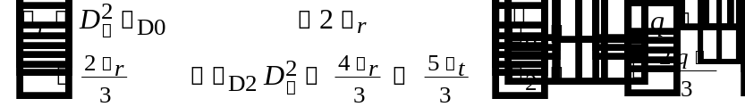 (1)

where 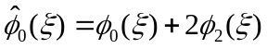 is the pseudo zeroth flux moment and the diffusion cross section is defined in terms of the diffusion coefficients and node width as the following:

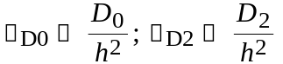, 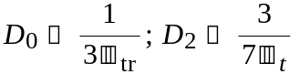, (2)

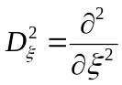 is the second order derivative operator.

The modal currents are related by the following Fick’s law

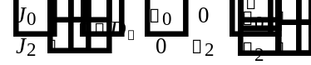 (3)

where relative diffusivity is defined as:
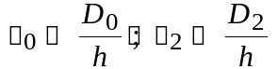 (4)

while the modal currents at the vacuum boundary are related with the flux moments with the albedo matrix as:

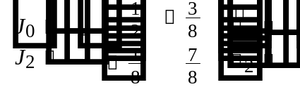 (5)

Equations (3) and (5) should be used to derive the finite difference approximation for the currents at the interior surface and the boundary surface, respectively. Follow the steps below to write a 1-D FDM code.

1. Modify the input processing routine to define the additional second order diffusion coefficient which requires the total cross section. Modify the linear system setup routine such that the 2x2 matrix appearing in Eq. (1) is used in the finite differenced nodal balance equation. Note that the off-diagonal terms which are required to discretize Eq. (3) become also a 2x2 diagonal matrix.

2. Write a LU factorization routine for a block tridiagonal matrix. The block size is 2x2. Write also the forward and backward substitution routine to the block LU factors in solving the block tridiagonal linear system. Establish the outer iteration scheme with the solution obtained from the LU solver. Note that the solution for Eq. (1) is for the pseudo zero-th order flux so that the true zero-th order flux needs to be obtained by subtracting two times the second order flux from the pseudo flux. The true zeroth order flux should be used in the fission and scattering source determination.

3. Solve the 1-D 4-G problem which consists of Fuel(Composition 1), Control Rod(Composition 2), and Reflector(Composition 3) strip as shown in the following input.

4 3 ! nregions, ncomps
10.0 20.0 20.0 20.0 ! region width
1 2 1 3 !composition assignment
2 4 4 4 !number of nodes per region
0 2 !boundary condition, 0 for reflective, 2 for vacuum
1.e-6 1.e-5 !k and fission source convergence criterion
500 !max number of outers

total abs. nu-fission chi
1 Fuel
1 1.24526E-01 7.14117E-03 1.79043E-02 9.08564E-01
2 2.01025E-01 8.00576E-03 1.59961E-02 8.73070E-02
3 2.86599E-01 1.45876E-02 2.40856E-02 4.12900E-03
4 3.68772E-01 4.98120E-02 7.33104E-02 0.00000E+00
1 1.05964E-01 1.12738E-02 1.46192E-04 9.62178E-07
2 0.00000E+00 1.89370E-01 3.64847E-03 1.06888E-06
3 0.00000E+00 0.00000E+00 2.70207E-01 1.80479E-03
4 0.00000E+00 0.00000E+00 0.00000E+00 3.18960E-01
2 Control Rod
1 1.39085E-01 8.62218E-03 0.00000E+00 9.08564E-01
2 2.28152E-01 2.91302E-02 0.00000E+00 8.73070E-02
3 3.18806E-01 7.40851E-02 0.00000E+00 4.12900E-03
4 6.27366E-01 3.12550E-01 0.00000E+00 0.00000E+00
1 1.17722E-01 1.26066E-02 1.33314E-04 1.08839E-06
2 0.00000E+00 1.94699E-01 4.32219E-03 1.85491E-07
3 0.00000E+00 0.00000E+00 2.44352E-01 3.68781E-04
4 0.00000E+00 0.00000E+00 0.00000E+00 3.14816E-01
3 Reflector
1 1.59346E-01 4.64814E-04 0.00000E+00 9.08564E-01
2 2.16355E-01 4.76496E-04 0.00000E+00 8.73070E-02
3 3.48692E-01 1.23810E-03 0.00000E+00 4.12900E-03
4 6.24249E-01 4.94333E-03 0.00000E+00 0.00000E+00
1 1.47969E-01 1.06607E-02 2.49956E-04 1.82565E-06
2 0.00000E+00 2.10410E-01 5.46711E-03 1.00157E-06
3 0.00000E+00 0.00000E+00 3.42085E-01 5.36879E-03
4 0.00000E+00 0.00000E+00 0.00000E+00 6.19306E-01

4. Examine the node size dependence of the solution by trying several refined mesh calculations. Estimate the true value of k-eff and regionwise fission source distribution.

5. Compare the P3 results with the diffusion code result and discuss the reasons for the differences. Compare then the result with the Monte Carlo result that you can obtain by using your previously written Monte Carlo code. Use sufficient number of histories in the Monte Carlo calculation. Plot the angular flux shape as a polar diagram at the two region interfaces.

6. Prepare a self-explanatory report about the method, coding and the results.

Part B. B1 Leakage Correction
In order to find the critical leakage the B₁ method, the following 0-D multigroup eigenvalue problem needs to be solved:
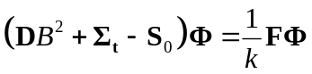 (6)
where D is the diffusion matrix which is the inverse of the following diagonally modified P1 scattering matrix:
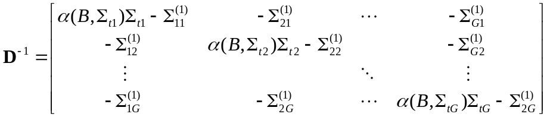 (7)
Note that the diffusion matrix is function of buckling through the α parameter which takes the form of either arctan or ln depending on the sign of B². The critical buckling that would give k=1 needs to be searched.
1. Prepare an input processing routine that reads in the multigroup cross section data which are given in the following format.

47 Group Xsecs
g E Abs Scat nu-Fis Chi Flux Tot Trans TrC-SM-gg TrC-Scat
1 2.000000E+07 6.645822E-03 1.233815E-01 2.324442E-02 2.551374E-02 2.517108E-01 1.300273E-01 7.343034E-02 1.044663E-03 6.678451E-02
2 6.065300E+06 6.192969E-03 1.604575E-01 1.261388E-02 1.106268E-01 1.049202E+00 1.666505E-01 8.983538E-02 8.758643E-03 8.364241E-02
.
.
47 1.239596E-02 3.630231E-01 2.928799E+00 6.547721E-01 0.000000E+00 4.859305E-02 3.291822E+00 3.079324E+00 9.758364E-01 2.716301E+00
Scatttering Matrix
from to P0 P1
1 1 5.764166E-02 4.126963E-02
1 2 2.417913E-02 7.131560E-03
2 2 8.557375E-02 5.684755E-02
1 3 1.186071E-02 4.223010E-03
2 3 3.358886E-02 9.396597E-03
.
.
46 47 2.119799E-01 1.095688E-01
47 47 1.188334E+00 3.158999E-01

Note that the cross section data for a group are given in one line, not two lines as appeared above due to the page width limitation. ‘TrC’ above means transported corrected. The scattering matrix would contain upscattering components.

2. Write a routine that constructs the modified P1 scattering matrix (D⁻¹) as a function of Buckling and total cross section. Refer to the MATLAB function attached at the end to determine the alpha values. Then write a routine that finds the inverse of D⁻¹ by repeated solutions of the linear system involving D⁻¹ with the RHS replaced with elementary vectors.

3. Write a routine that solves the eigenvalue problem (7). Note that you don’t need to actually construct fission matrix because you only need the fission spectrum and the normalized fission source. The spectrum obtained with zero leakage should be close to the groupwise fluxes given in the input file once they are normalized. The multiplication factor for this case is 1.40108.

4. Implement a search algorithm that changes the buckling value to find the unity eigenvalue. Use this algorithm to find the critical buckling. Then determine the current spectrum and consequently the diffusion coefficient for each group.

5. Compare the critical spectrum with the zero-leakage spectrum and discuss the difference in the spectra. Compare the flux and current spectra at the critical condition. Compare the diffusion coefficients obtained with the transport cross section based values and discuss the importance of the leakage correction.

6. Prepare a self-explanatory report about the method, coding and the results.

Function for α
function x=falpha(Bsq,sigt)
if(Bsq>0)
B=sqrt(Bsq);
a00=atan(B/sigt)/B;
else
B=sqrt(-Bsq);
a00=log((sigt+B)/(sigt-B))/(2*B);
end
x=a00*Bsq/sigt/(3*(1-a00*sigt));

