**User Manual**

**1.0 Introduction**

This document breaks down the system for the user and provides a guideline on how to use the system.

**1.1 System Overview**

This system represents a web portal for Kisumu County Health sector. The portal is integrated with the DHIS2 to fetch data from the DHIS2 system. The data will be filtered for Kisumu County on key health indicators and displayed on the top manager’s dashboard for informed decision making.

**1.2 Users**

The web portal has 3 users: Top manager, CHRIO and the Public. Each of these users has their own dashboard. This section describes the navigation on these various dashboards:

**1.2.1 The Public**

The general public that accesses the system from time to time seeking information on health activities in the county, or to post inquiries they may have regarding health.

**i. Dashboard**

This represents the landing page of the portal. The public will be redirected to this page. Here, county health activities will be displayed for the public.

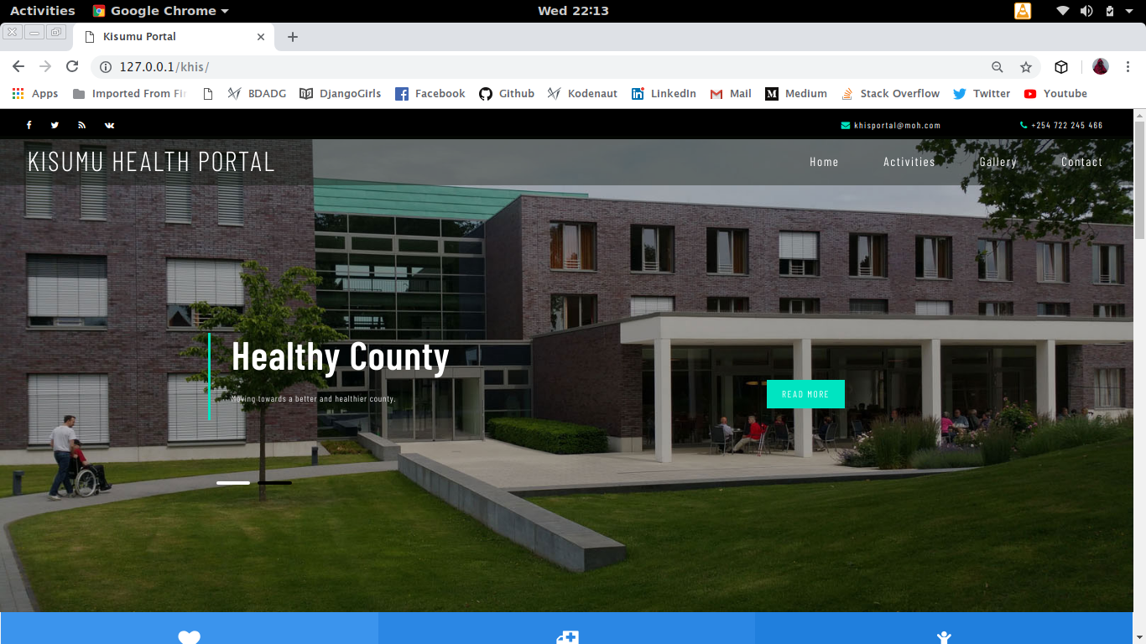

**ii. Activities**

The public can see county health activities on the landing page:

**iii. Inquiries**

The public is able to post any inquiries they might have on the form available in the home page.

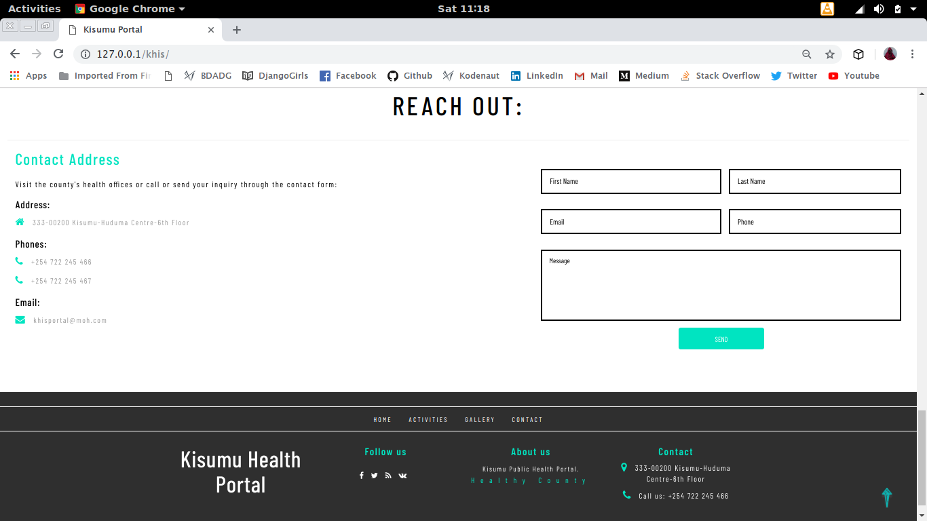

**1.2.2 CHRIO**

The County Health Records Information Officer, responsible for posting data on key health indicators to the system, adding health activities and managing inquiries.

**i. Login**

The CHRIO will be directed to a login page before being allowed to the CHRIO dashboard. The CHRIO logs in with a username and a password.

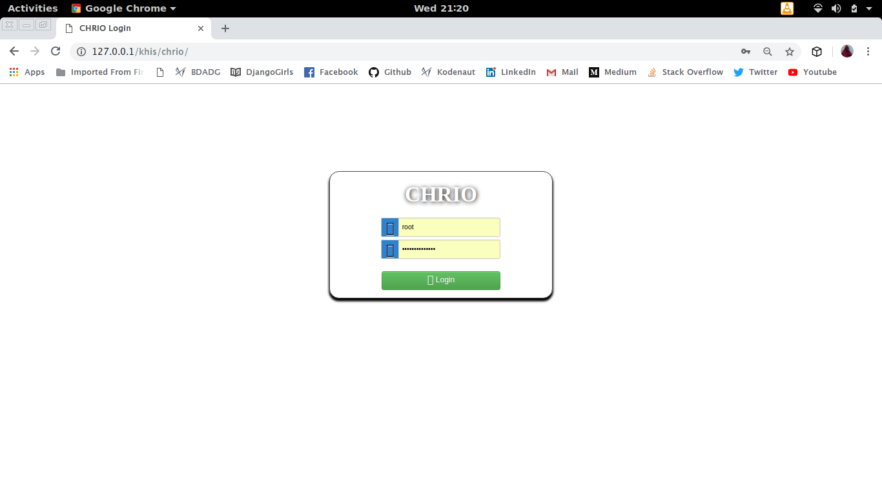

**ii. Dashboard**

After a successful login, the CHRIO is directed to the CHRIO’s dashboard.

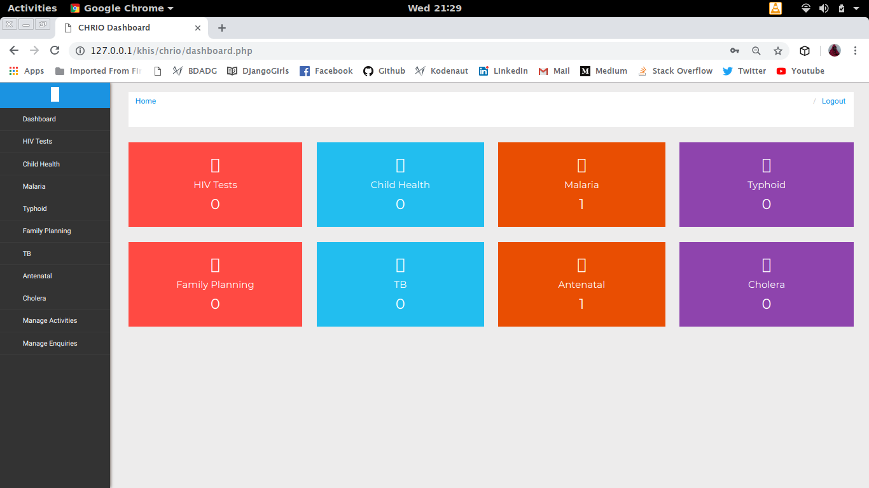

**iii. Add Data**

To add data on key health indicators in the county. The CHRIO clicks on the particular indicator to which he intends to add data for. This opens up a form that allows the CHRIO to add data on a monthly basis.

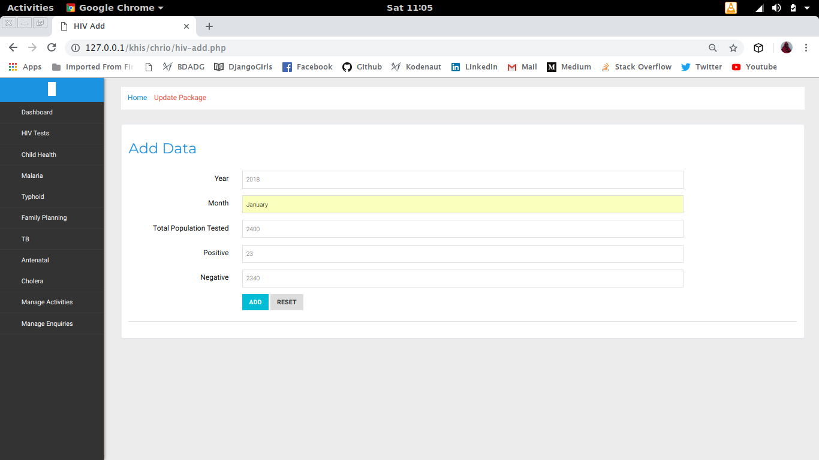

**iv. Add Activity**

To add an activity, the CHRIO clicks on the Manage Activity menu item. This opens up a form that allows the CHRIO to add Health Activities based on key health indicators in the county.

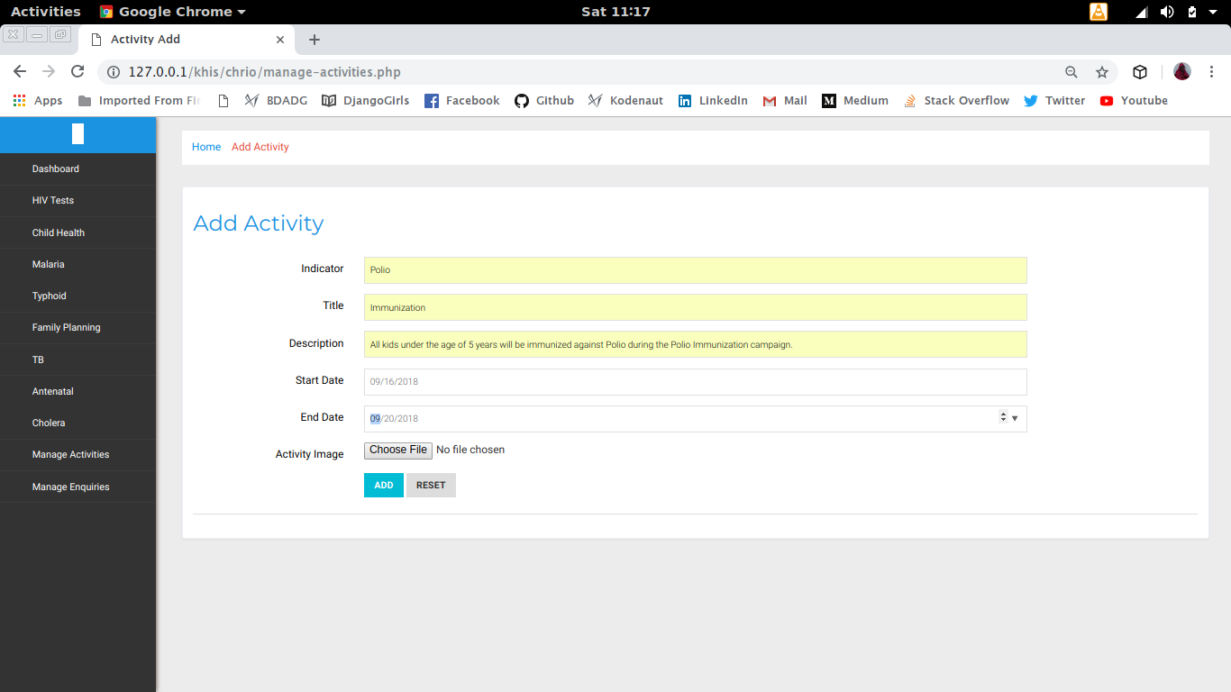

**v. Manage Inquiries**

To manage inquiries, click the Manage Inquiries menu item. This will display all the inquiries made by the public.

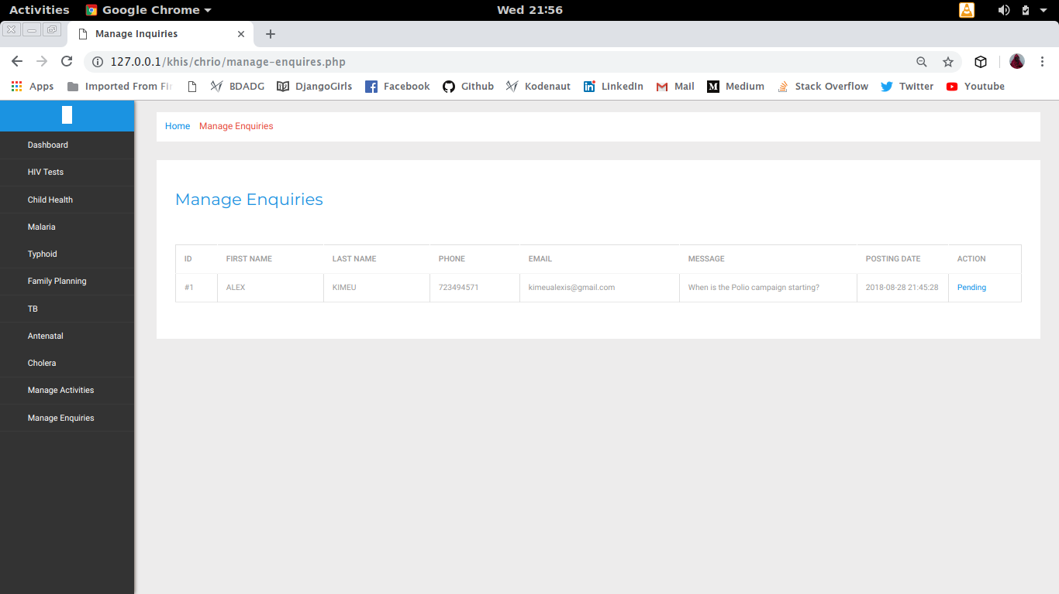

**vi. Logout**

To logout, click the Logout link on the top let corner. This logs out the CHRIO and redirects to the Login page.

**1.2.3 Top Manager**

The county health officials who are in need of summarized data on key health indicators in the county for informed decision making.

**i. Login**

The Top Manager will be directed to a login page before being allowed to the manager’s dashboard. The manager logs in with a username and a password.

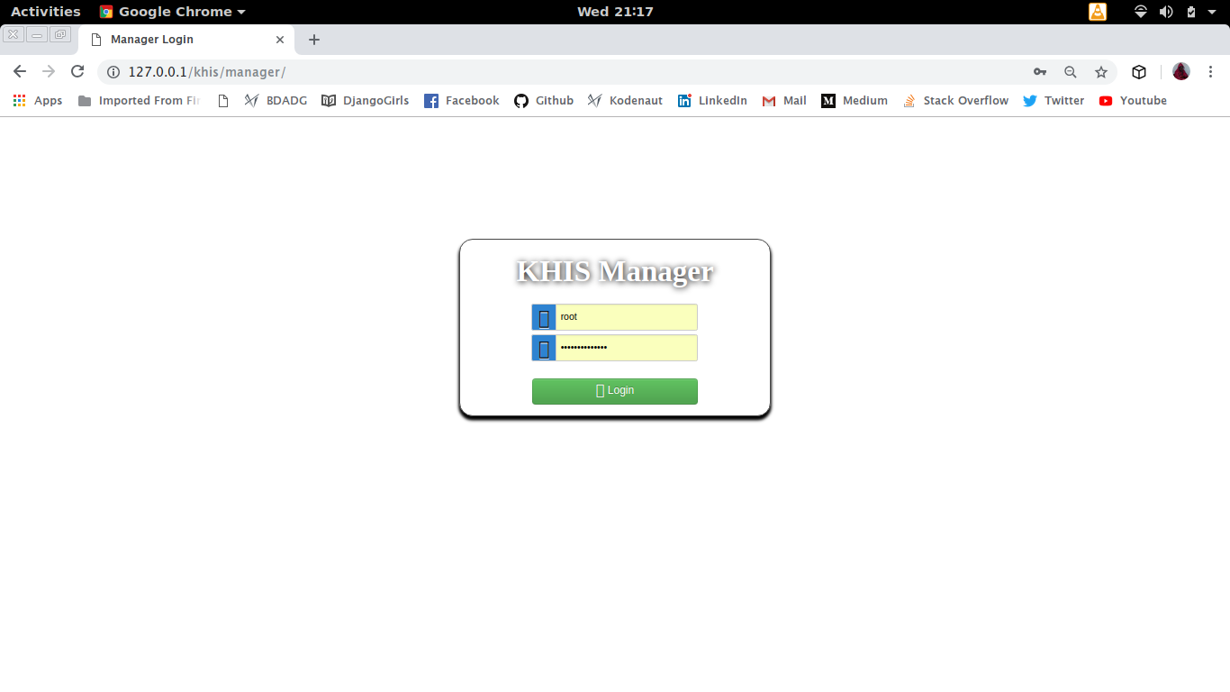

**ii. Dashboard**

After a successful login, the manager is directed to the manager’s dashboard.

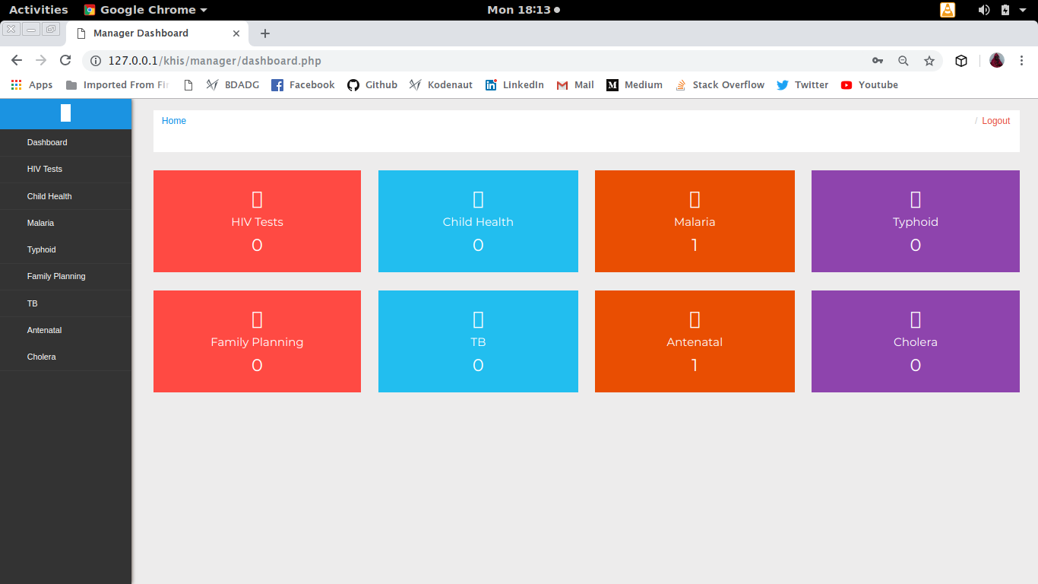

**iii. View Data**

To view data on the county key health indicators, click the particular indicator menu item on the sidebar. This opens up a representation of data on the indicator on annual basis.

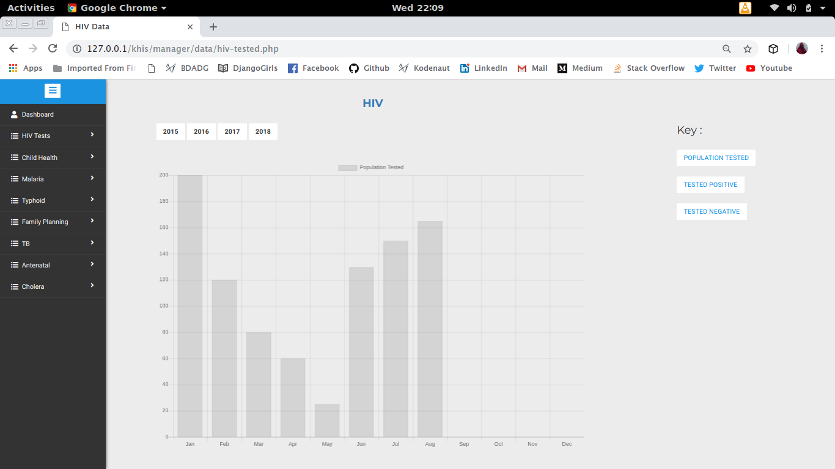

**iv. Logout**

To logout, click the Logout link on the top let corner. This logs out the manager and redirects to the Login page.