Figure legends
Figure 1. Overview of outbreak identification process and modeling of vaccination impact. (A) Flowchart showing the identification of cholera outbreaks and selecting a subset for vaccine impact modeling. (B) Schematic illustrating vaccine impact under different outbreak scenarios. The top panel shows a hypothetical cholera outbreak with and without vaccination. Outbreak response can be triggered either by elapsed time since outbreak onset or by reaching a cumulative case threshold (red thick line). Vaccination then occurs after a random delay (thick green line) and vaccines take effect again after a random delay post-vaccination (thick purple line). Percentage reduction in cases is calculated as the ratio of cases reduced because of vaccines to cases under no vaccination. The second panel demonstrates early outbreaks that end before vaccination takes place (grey line) or before vaccines effectively protect vaccine recipients and others (black line). The third and the bottom panel show that vaccination impact in a smaller and a larger outbreak, respectively. The percentage reduction in cases is typically larger in outbreaks with more cases (inequality 1 in the third panel). The overall percentage reduction in cases across multiple heterogeneous outbreaks is larger when outbreaks are weighted by their total case count than when each outbreak is given equal weight regardless of size (inequality 2 in the third panel).

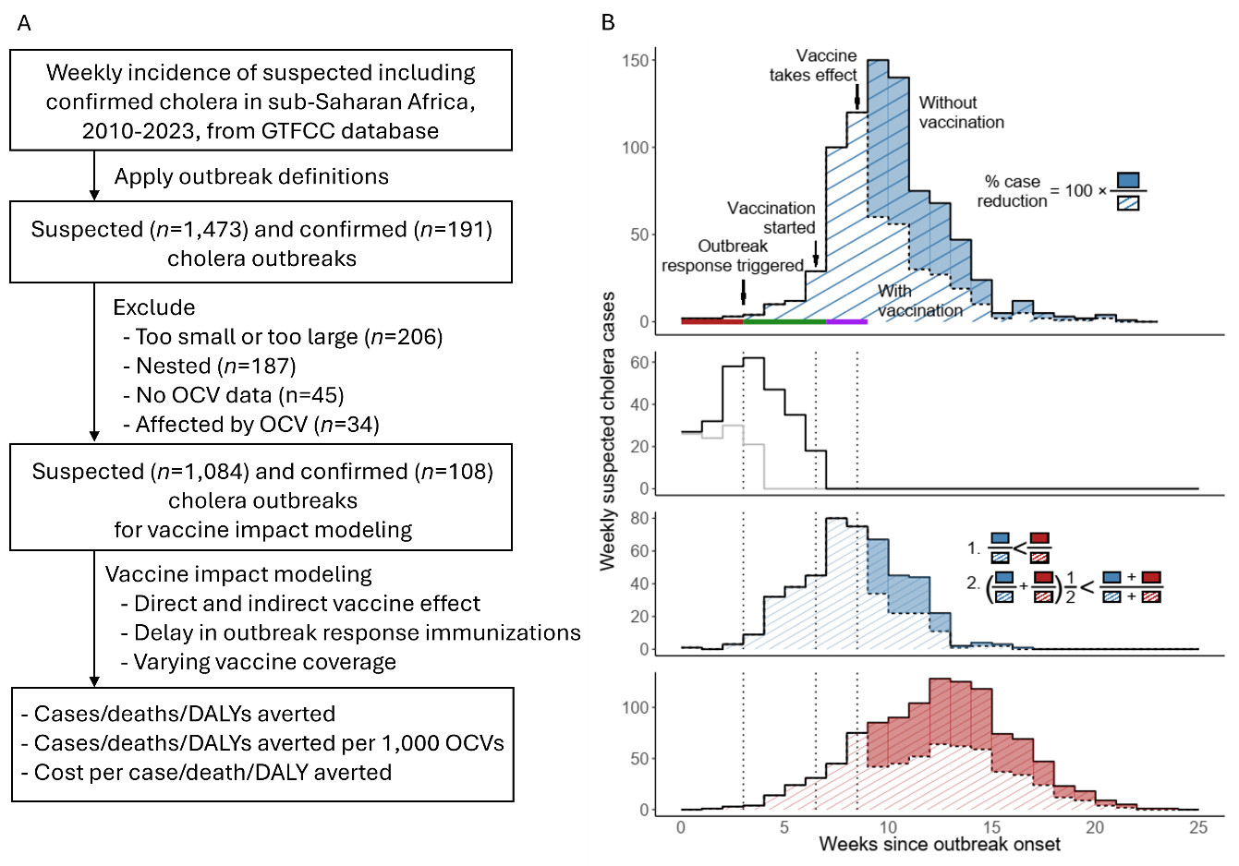
Figure 2. Characteristics of cholera outbreaks in sub-Saharan Africa, 2010–2020. Outbreak data set. (A) Monthly time series of suspected cholera cases, stacked by African subregion. (B) Geographic distribution of outbreaks by administrative levels 1, 2, and 3. Darker shading indicates areas with repeated outbreaks. (C) Median epidemic curve with 95% central percentiles; inset shows the cumulative probability distribution of time to peak (in weeks). (D) Total number of suspected cases versus outbreak duration, both on a logarithmic scale. (E) Total number of suspected cases versus attack rate (per 10,000 population), both on a logarithmic scale.

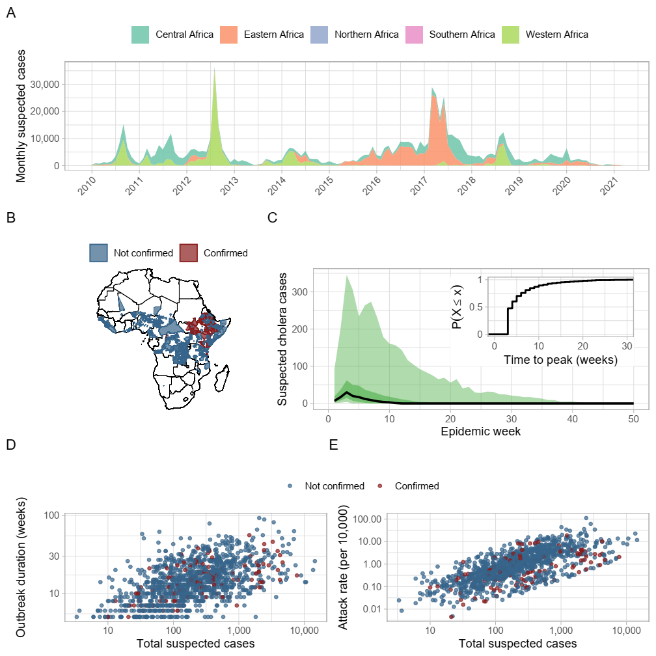

Figure. 3. Impact of outbreak response immunization (ORI). (A) Percent of cases averted for ORIs initiated 1 to 15 weeks after outbreak onset under vaccine coverage of 60%, 75%, and 90% (ORI is triggered at outbreak onset) (B) Exponential-decay fits to the proportion of cases averted, normalized to the week-1 value, under 75% vaccine coverage: thin colored curves show 30 representative outbreaks; the thick red curve is the median; darker shading denotes the interquartile (50%) envelope and lighter shading the 95% envelope. (C) Proportion of outbreaks eligible for analysis at each delay (i.e., outbreaks long enough for an ORI to have occurred by that delay). (D-F) Median cases averted per 1, 000 OCVs across delay in ORI implementation under 75% vaccine coverage for subsets defined by (D) attack rate, (E) outbreak duration, and (F) outbreak size. Y-axis labels of the form, Q_{X%}, denote subsets containing outbreaks at or above the Xth percentile of the corresponding characteristic.

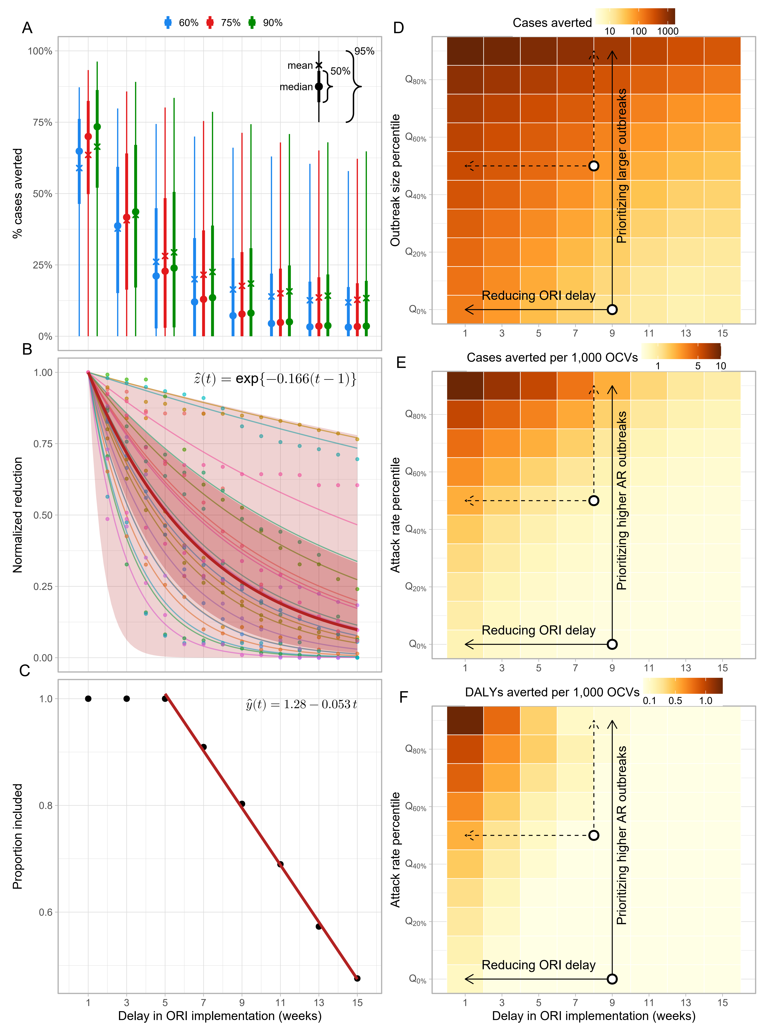
Figure 4. Impact of ORI implemented with 9 weeks of delay under 75% coverage for subsets of outbreaks. (A) The number of outbreaks targeted against the number of OCV doses deployed. The red dashed lines indicate the number of OCV doses deployed for reactive vaccination up to 2020 (maximum year in our dataset) and 2024. (B) The number of cases averted. (C) The number of cases averted per 1,000 OCVs. (D) DALY (disability-adjusted life year) averted per 1,000 OCVs. (E) Cost per case averted. (F) Cost per DALY averted. Empty circles and filled upward triangles represent median values across 200 samples of outbreaks for ORIs implemented with the delay of 9 weeks and 1 week, respectively. Error bars show interquartile ranges for the impact from ORIs with the delay of 9 weeks. Q[x%] (z), denote subsets containing outbreaks at or above the xth percentile of the variable z.



