Figure legends
Figure 1. Overview of outbreak identification process and modeling of vaccination impact. (A) Flowchart showing the identification of cholera outbreaks and selecting a subset for vaccine impact modeling. (B) Schematic illustrating vaccine impact under different outbreak scenarios. The top panel shows a hypothetical cholera outbreak with and without vaccination. Outbreak response can be triggered either by elapsed time since outbreak onset or by reaching a cumulative case threshold (red thick line). Vaccination then occurs after a random delay (thick green line) and vaccines take effect again after a random delay post-vaccination (thick purple line). Percentage reduction in cases is calculated as the ratio of cases reduced because of vaccines to cases under no vaccination. The second panel demonstrates early outbreaks that end before vaccination takes place (grey line) or before vaccines effectively protect vaccine recipients and others (black line). The third and the bottom panel show that vaccination impact in a smaller and a larger outbreak, respectively. The percentage reduction in cases is typically larger in outbreaks with more cases (inequality 1 in the third panel). The overall percentage reduction in cases across multiple heterogeneous outbreaks is larger when outbreaks are weighted by their total case count than when each outbreak is given equal weight regardless of size (inequality 2 in the third panel).

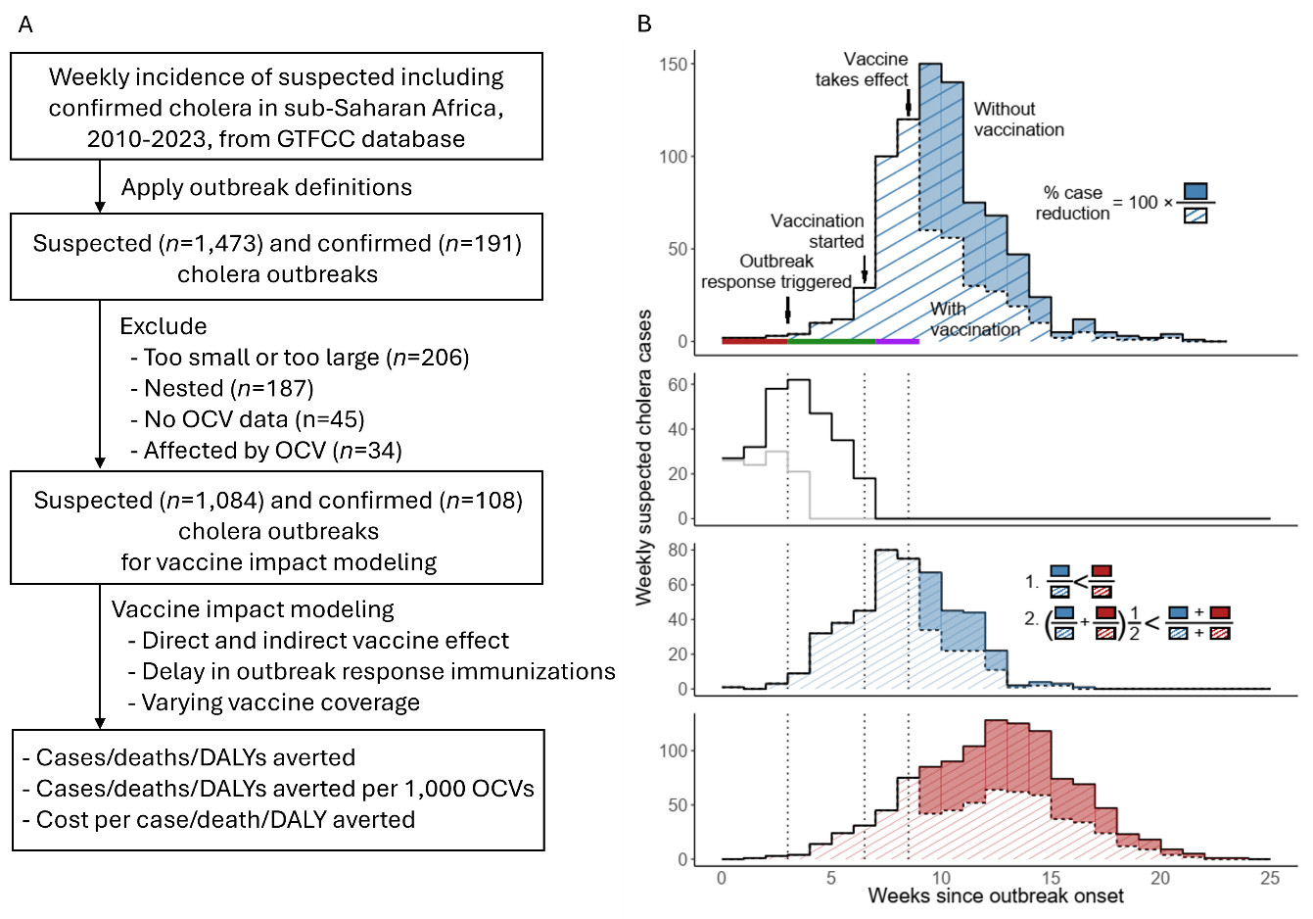
Figure 2. Characteristics of cholera outbreaks in sub-Saharan Africa, 2010–2020. Outbreak data set. (A) Monthly time series of suspected cholera cases, stacked by African subregion. (B) Geographic distribution of outbreaks by administrative levels 1, 2, and 3. Darker shading indicates areas with repeated outbreaks. (C) Median epidemic curve with 95% central percentiles; inset shows the cumulative probability distribution of time to peak (in weeks). (D) Total number of suspected cases versus outbreak duration, both on a logarithmic scale. (E) Total number of suspected cases versus attack rate (per 10,000 population), both on a logarithmic scale.

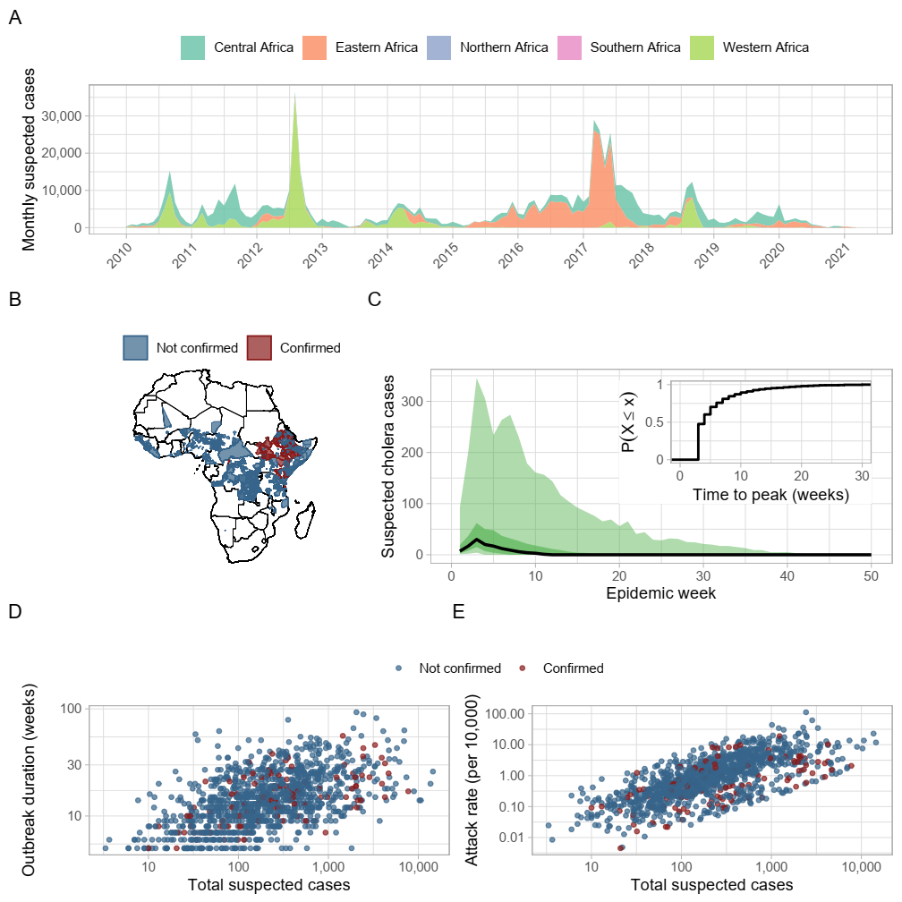

Figure. 3. Impact of outbreak response immunization (ORI). (A) Percentage of cases averted for ORIs implemented with 1 to 15 weeks of delay for vaccine coverage levels of 60%, 75%, and 90%. ORIs is assumed to be triggered at outbreak onset. (B) Exponential decay fitting to the percentage case averted. Fitting results are shown for 30 example outbreaks. Think line and shades show median, 50%, and 95% percentiles. (C) Percent outbreaks in which ORI occurred and were therefore included in the analysis. (D), (E), and (F) show cases averted per 1, 000 OCVs across delay in ORI implementation and percentiles by attack rate, outbreak duration, and outbreak size, respectively.

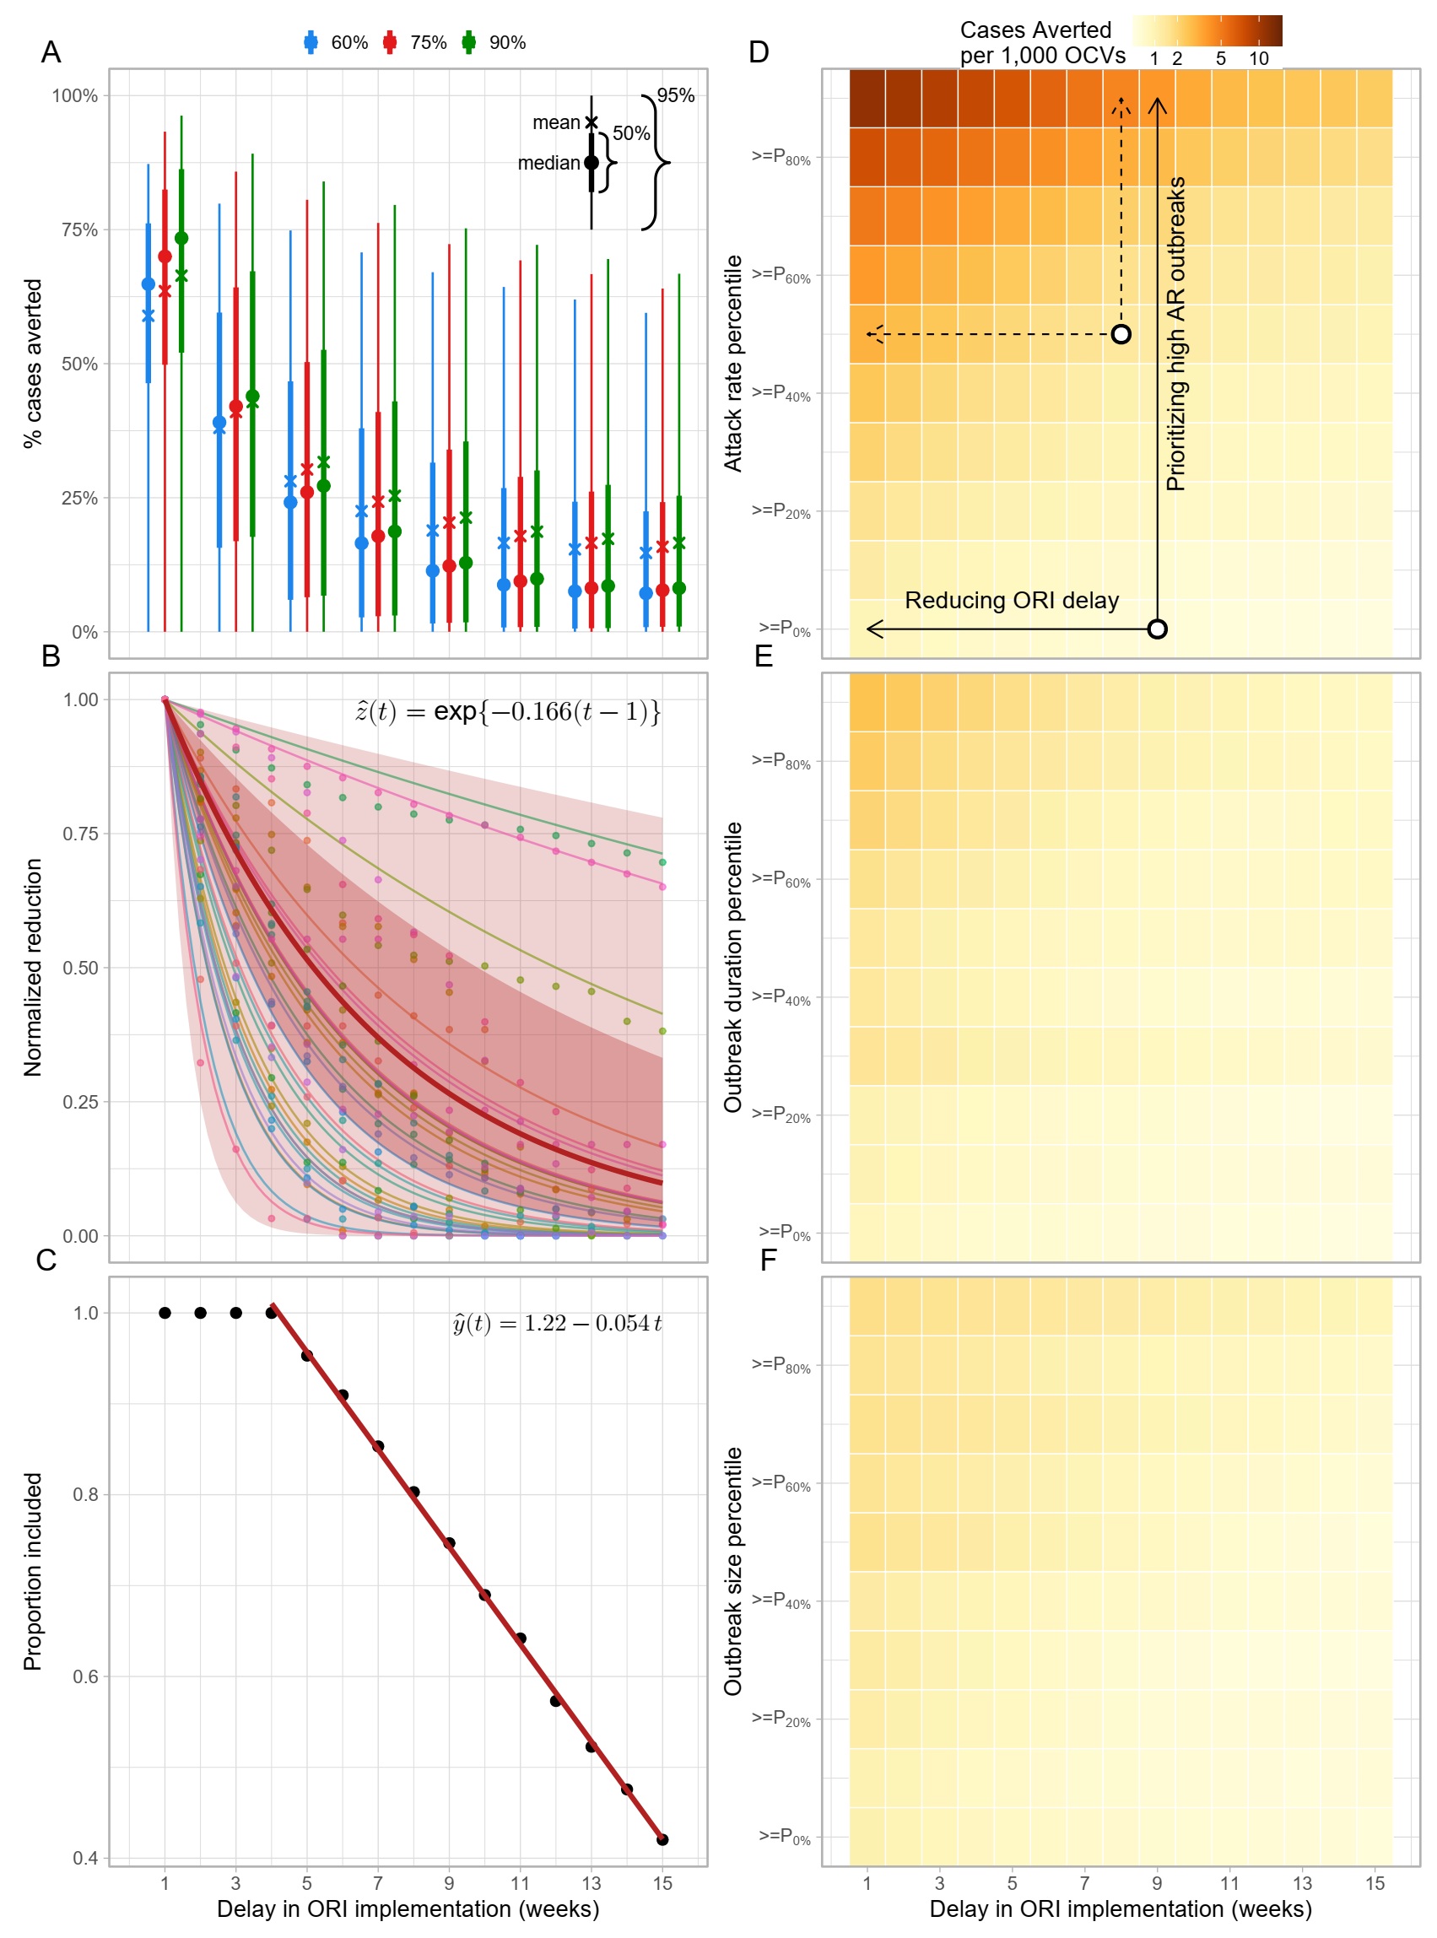

Figure 4. Impact of ORI implemented with 9 weeks of delay under 75% coverage for subsets of outbreaks.

