Impact of oral cholera vaccine outbreak response immunization in sub-Saharan Africa, 2010–2020: a modeling analysis

Table of Contents
S1. Vaccine impact 3
S2. Indirect vaccine effectiveness 4
Figure S1. 5
S3. Parameter exploration using Sobol low-discrepancy sampling 6
S4. Delay in immunogenicity of oral cholera vaccine 7
S5. Number of workdays lost to patients and caregivers 8
S6. Mean age of infection 8
S7. Vaccine coverage proportion 9
S8. Cost-effective analyses (CEA) 9
Figure S2 11
Figure S3 12
Table S1 14
Table S2 16
Figure S4 18
Table S3 19
S9. Vaccine effectiveness comparison using dynamic models 24
Figure S5 26
Figure S6 28
Figure S7 29
Table S4 31
References 33

S1. Vaccine impact
Following the notations used in the previous study,¹ we define population $A$, in which a fraction, $π$, of the population is vaccinated and the rest, $1-π$, of the population remains unvaccinated. We define another population, $B$, in which no one was vaccinated. Let $C_{A0}$ and $C_{A1}$ denote cumulative incidence in the unvaccinated and vaccinated individuals of population $A$. Similarly, let $C_{B0}$ denote cumulative incidence in population $B$. Four measures of vaccine effectiveness—direct ($DVE),$indirect ($IVE$), total ($TVE$), and overall ($OVE)$—can be defined as follows:
$$DVE=1-\frac{C_{A1}}{C_{A0}}, IVE=1-\frac{C_{A0}}{C_{B0}}, TVE=1-\frac{C_{A1}}{C_{B0}}, OVE=1-\frac{{πC}_{A1}+{\left(1-π\right)C}_{A0}}{C_{B0}}.$$
We see that the following relationships hold true.
$$OVE=1-\left[π\left(1-TVE\right)+\left(1-π\right)\left(1-IVE\right)\right],$$
$$TVE=1-\left(1-DVE\right)\left(1-IVE\right),$$
The impact of vaccine was modeled based on the definition of overall effectiveness, given the direct and indirect vaccine effectiveness, of which estimates are available. Following the notions based on the study,¹ the cumulative incidence, $C_{i,π }^{'}$, for age group $i$ in a population in which a proportion, $π$, of population was vaccinated can be defined as follows:
$$C_{i, π}^{'}=C_{i}(1-OVE).$$
where $C_{i}$, represents the incidence in the population without vaccines. We replace $OVE$ in the equation using the $DVE$ and $IVE$, for which estimates are available, based on the relationship we stated above:
$$C_{i,π}^{'}=C_{i}\left[π\left(1-DVE\right)\left(1-IVE\right)+\left(1-π\right)\left(1-IVE\right)\right].$$

S2. Indirect vaccine effectiveness
Indirect vaccine effectiveness (IVE) of the oral cholera vaccine was estimated using incidence rates among unvaccinated individuals residing in clusters with varying vaccine coverage levels, as observed in a randomized trial conducted in Matlab, Bangladesh.² Vaccine coverage rates were reported as a range and the mid-point was taken as the representative value. Observed IVE at vaccine coverage $x$, was calculated as $1-{{IR}_{x}}/{{IR}_{0}}$, where ${IR}_{x}$ represents the incidence rate among unvaccinated people in a population with vaccine coverage rate $x$, and ${IR}_{0}$ denotes the incidence rate in a population with no vaccination. While ${IR}_{0}$ was not provided in the original analysis of the clinical trial, a subsequent dynamic modeling study³ provided a plausible value of ${IR}_{0}$, which was used to compute IVE. This approach resulted in five IVE values at 5 vaccine coverage rates.
To model the relationship between IVE and vaccine coverage, we used a Bayesian Beta regression. The expected value of IVE, $Y$, was an expit-transformed function of $η$, which itself was modeled as a linear function of the independent variable, vaccine coverage rate $X$. The response variable $Y$ was assumed to follow a Beta distribution, parameterized by its mean, $μ$, and precision, $ϕ$. Weekly informative priors were assigned to the linear predictor coefficients, $β$, and the precision parameter, $ϕ>0$, based on the standard recommendations for Bayesian analysis.⁴ The regression model was implemented in the probabilistic programming language Stan,⁵ and the code is available on GitHub.⁶
$$E\left(Y\right)=μ=\frac{1}{1+e^{-η}}$$
$$η=β_{0}+β_{1}X$$
$$Y \sim Beta(μ, ϕ)$$
$$β \sim Normal\left(0, 5\right)$$
$$ϕ \sim Cauchy(0, 5)$$

Figure S1.
Posterior predicted values for the indirect vaccine effectiveness based on a Bayesian beta regression with cholera incidence data from Matlab, Bangladesh. Dynamic model represents the values from the dynamic model by Longini et al.³
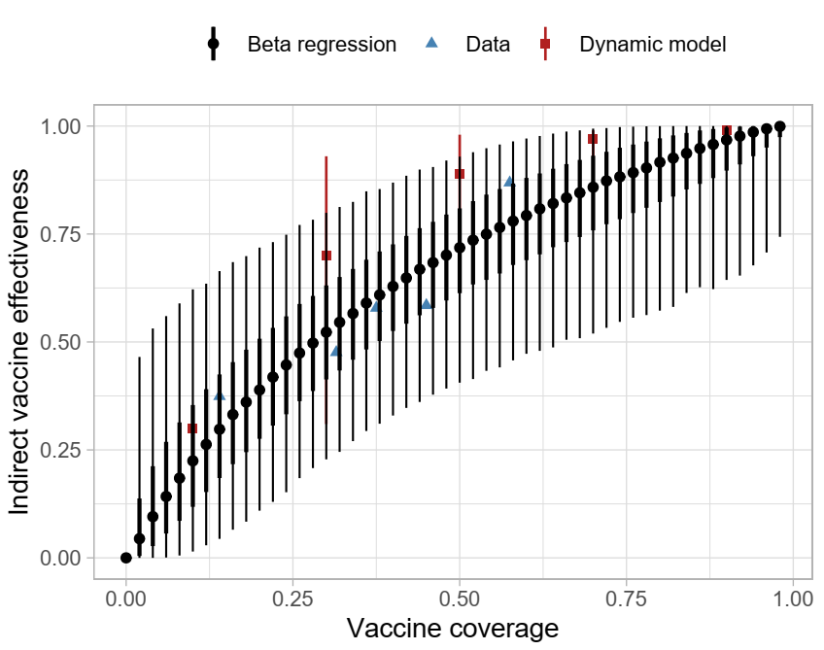

S3. Parameter exploration using Sobol low-discrepancy sampling
To comprehensively explore the effects of key model parameters on cholera outbreak dynamics and the impact of OCV campaigns, we conducted a systematic parameter sampling using the Sobol low-discrepancy sequence.^{7,8} This method provides an efficient way to thoroughly cover complex parameter spaces while minimizing clustering or overrepresentation of specific regions, making it particularly suitable for sensitivity and uncertainty analyses.
We examined a range of plausible values for the following parameters: vaccine efficacy (<5 years and 5+ years), indirect vaccine effectiveness, delay from vaccination and development of partially protective immunity, and campaign duration (days required to complete vaccination in a target population). Different distributions are assumed for each parameter based on the assumption of the estimation and on our best judgement. For the direct vaccine efficacy, we assumed that the log incidence rate ratio (e.g., vaccine efficacy = 1 – incidence rate ratio) as the confidence interval of the original estimates may usually be constructed this way. Indirect vaccine efficacy was drawn from the posterior predictive values of the Bayesian beta regression model we have developed (S2). Delay from vaccination and development of partially protective immunity has been assumed to be uniformly distributed due to the paucity of the data. The duration of a vaccination campaign was assumed to follow a truncated normal distribution with the minimum and maximum based on the data and our judgement.
We employed the Sobol low-discrepancy sequence to generate pseudo-random numbers for each parameter, ensuring uniform coverage across their respective distributions. Each Sobol sequence element, ranging from 0 to 1, was transformed into the target parameter space using the inverse cumulative distribution function (CDF) of the specified distribution. The Sobol sequence generation was implemented using the ‘pomp’ R package, with custom routines to map values onto the respective distributions (GitHub⁶). A total of 200 parameter sets were utilized, covering the entire feasible range of values for each parameter.
Validation involved visually inspecting histograms of the generated parameter values to confirm that the transformations were accurate and that the values adhered to the intended distributions.

S4. Delay in immunogenicity of oral cholera vaccine
We assumed a period of delay before protective immunity develops following vaccination. Studies investigating the immunogenicity of OCV typically measure the rate of seroconversion (considered a proxy for protection), defined as a four-fold or greater increase in antibody/vibriocidal titres compared to baseline titres ^{9–17}. However, dosing schedules, follow-up times, and populations varied across studies. For instance, Ng’ombe et al. investigated a two-dose schedule for the Shanchol OCV in Zambia, administering the first and second doses 28 days apart and collecting blood samples at baseline and after day 28 (before second dose), month 6, month 12, month 24, month 30, month 42, and month 48 ⁹. They observed a significant rise in vibriocidal antibody titres at day 28, which declined nearly to baseline levels at month 6. Other studies by Mohan et al. (India) and Chowdhury et al. (Bangladesh) investigated a two-dose schedule for Shanchol with doses being administered 14 days apart instead, and blood collections performed at days 0, 14 (before second dose), and 28 ^{11,12}. Both studies found that vibriocidal antibody titres were significantly increased at day 14 and day 28, compared to baseline, and that this increase was higher after the first dose, compared to the increase following the second dose of vaccine. Charles et al. (Haiti) investigated a two-dose Shanchol schedule administered 28 days apart, with blood collection occurring 7 days post-vaccination for each dose ¹³. They found that each age cohort had a significant vibriocidal antibody response by as early as day 7, compared to baseline, and increased further by day 21. Additionally, O-antigen specific IgA serum responses were also significant at day 7 and 21. We believe that these findings make it reasonable to conclude a time to immunity post-vaccination of 14 days for modeling purposes. This assumption will be tested via sensitivity analyses using a range of values (from 7 to 28 days) to explore the robustness of our results.

S5. Number of workdays lost to patients and caregivers
To estimate the average number of productivity days lost due to cholera illness, we compiled patient-level data from four published studies conducted in sub-Saharan Africa between 2012 and 2017. These studies were drawn from diverse geographical settings including Malawi¹⁸, Ghana¹⁹, Mozambique²⁰, and Zanzibar²¹. Two additional studies from Somalia ²²and Zambia²³ were reviewed but excluded. The Somalia study reported only the average duration of stay at the cholera treatment center only and did not account for post-discharge recovery while the Zambia study provided only categorical durations without reporting a mean or median, and the upper bound of the categories was undefined. The four included studies used varying definitions of productivity loss, such as self-reported inactivity periods, missed workdays, and illness duration. We treated these as conceptually comparable, interpreting each as reflecting the total number of days of productivity lost per patient, including both hospitalization and recovery periods. Two studies (Malawi¹⁸, Ghana¹⁹) also reported productivity loss from the caregiver’s perspective. Using these data, we calculated a weighted average of days lost per episode, applying applying study-specific sample sizes as weights. This yielded an average of 6.5 days per patient and 3.3 days lost per caregiver per cholera episode.

S6. Mean age of infection
The mean age of infection was estimated as the weighted mean of infected individuals’ ages, based on outbreak investigations in Sudan²⁴, South Sudan²⁵, Nigeria²⁶ , Ethiopia²⁷, and Uganda^{28,29}. In the Nigeria study²⁶, the mean age was approximated using the formula, (Q1 + 2*median + Q3) /4, which closely matched the actual mean in a Ugandan outbreak³⁰, where median, Q1, Q3, and mean were all reported. In the Ethiopia study²⁷, age-specific case counts were provided; the midpoint of each age group was used as the representative age. For the oldest age group (>=45 years), we assumed a midpoint of 60 years. Similarly, for the >= 60 age group in the Uganda study²⁹, the midpoint was assumed to be 67.5 years. These choices were both based on an estimated upper age bound of 75 years.

S7. Vaccine coverage proportion
We explored the vaccine coverage rates ranging from 60 to 95 percent of the population. Vaccine coverage rates were chosen to account for observations from OCV campaigns during 2013-2018³¹ and a recent OCV campaigns in Ethiopia.³² In particular, we chose 75% as the most representative value for a single-dose regimen. This value was obtained by first computing the ratio of estimated coverage to the administrative coverage, $r$, and then multiplying r with the observed administrative coverage rates during the first dose, ${AC}_{1}$. $r$ was computed the estimated by taking the ratio of estimates to administrative coverage for the at least one dose from the OCV campaigns. (${EC}_{≥1}$and ${AC}_{≥1}$, respectively). ${EC}_{≥1}$ were available in the study and were derived assuming random allocation during vaccination during the first and the second dose. Let ${AC}_{1}$and ${AC}_{2}$ be administrative vaccine coverage rates for the first and the second dose, respectively. Then,

$${AC}_{≥1}=1-\left(1-{AC}_{1}\right)\left(1-{AC}_{2}\right)$$
$$r=\frac{{EC}_{≥1}}{{AC}_{≥1}}$$
In particular, we used ${EC}_{≥1}$ during humanitarian crises or outbreaks (73.2%, and 86.3%, respectively). Finally, we computed the estimated coverage rates for the first dose during humanitarian crises or outbreaks (62.6% and 85.3%) using the following relationship.
$${EC}_{1}=r{AC}_{1}$$
Arithmetic average of ${EC}_{1}$during humanitarian crises or outbreaks is 74% and used 75% as a convenient proxy value.

S8. Cost-effective analyses (CEA)
Disability-adjusted life years (DALYs) were computed as:
$$DALYs=Years of life lost from mortality (YLLs) + Years of life lost to due to disability (YLDs)$$
$YLLs$ were computed by multiplying the number of deaths with life-expectancy at the average age of death. Average age of death was derived from the average of infections observed during outbreaks and clinical trials as explained in S6. Life expectancy at a given age, mean remaining years of life expected by an individual at that age, was derived from United Nations Life Expectancy at Exact Age for both sexes.⁴⁴ $YLDs$ were computed by multiplying the number of cases with the duration of the disease in years and the disability weight. The duration of disease was assumed to be 2 days and the disability weight was assumed to be 0.188 and 0.247 to account for the moderate and severe cases a based on the disability weights of diarrhea from the 2019 Global Burden of Disease Study,⁴² assuming that reported cases in our data set were moderate or severe cases.
We evaluated cost-effectiveness by calculating the cost per case, death, and DALY averted. Costs related to the cholera vaccine and illness were selected based on recency, generalizability to our modeling data, and quality after a literature review. Prices were adjusted to 2023 USD$ cost-equivalents by converting the costs from the reporting year and inflating them based on the sub-Saharan African average annual consumer price index percent change for each year up until 2023.^{45–47} Consumer prices were obtained from the publicly available International Monetary Fund database.⁴⁸ This was performed using the following equation:

$${Cost}_{2023}={Cost}_{t}×\prod_{t+1}^{2023}{\left(1+\frac{C{PI change}_{t}}{100}\right),}$$

where $t$ is the year that the original cost was reported, and $C{PI change}_{t}$ is the consumer price index annual percent change for each year $t$.

The vaccine procurement cost ($1.65) and shipping cost ($0.06) were sourced from UNICEF reports published in 2024, which did not specify the USD year.^{49,50} We assumed these costs were comparable to 2023 and, therefore, left them unadjusted. After adjusting for inflation, cost of vaccine delivery was set to $2.32. Out-of-pocket costs for those hospitalized was set to $109.32 and out-of-pocket costs for outpatient cases was set to $16.06. Costs on the public health system for those hospitalized and outpatient cases was set to $184.97 and $7.99, respectively.

Figure S2
Outbreak data set in the study. Yellow, blue and red colors represent excluded, suspected, and confirmed cholera outbreaks, respectively. (A) weekly suspected cases across time. (B) displays the total number of suspected cases throughout the outbreak against the duration of the outbreak on a log scale for both X and Y axes. (C) shows the geographical location of the outbreak at the administrative unit levels 0,1, and 2.
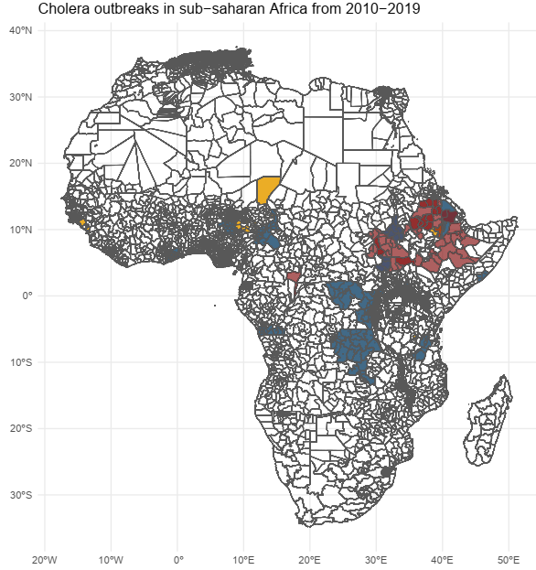
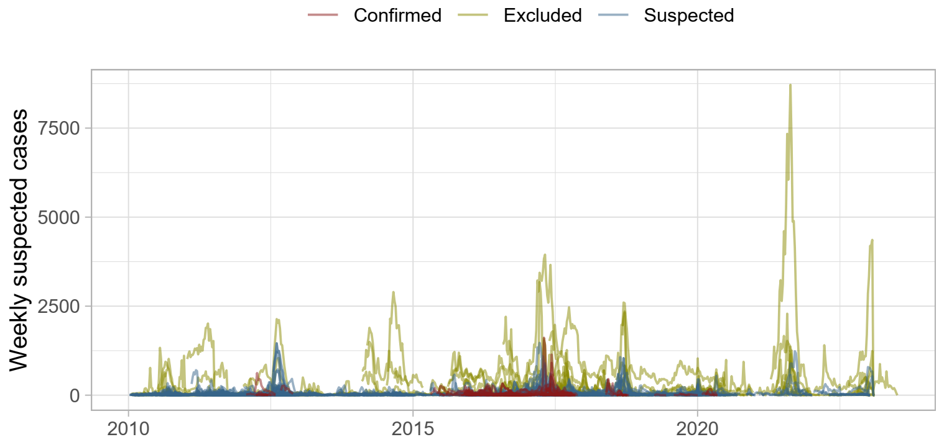
A
B
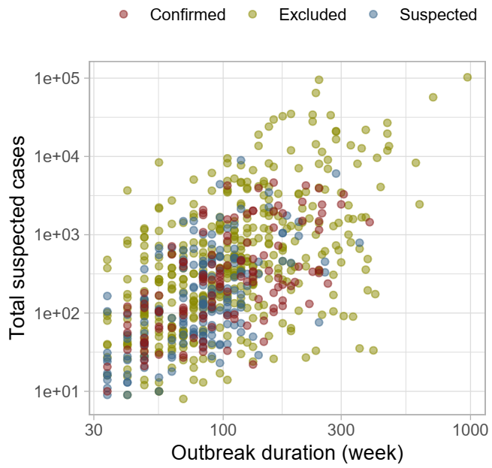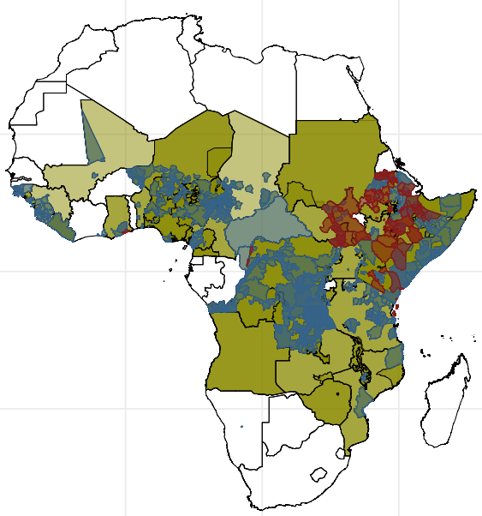
C

Figure S3
Impact and efficency of outbreak response immunization (ORI) across implementation delays and subsets by attack rate, case fatality ratio, duration, and size. (A) Case averted (B) percentage case averted, (C) case averted per 1,000 OCV and (D) DALY averted per 1,000 OCVs.
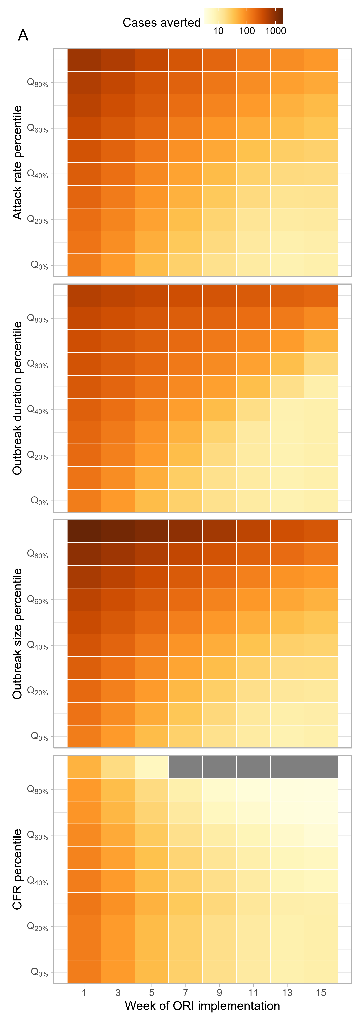
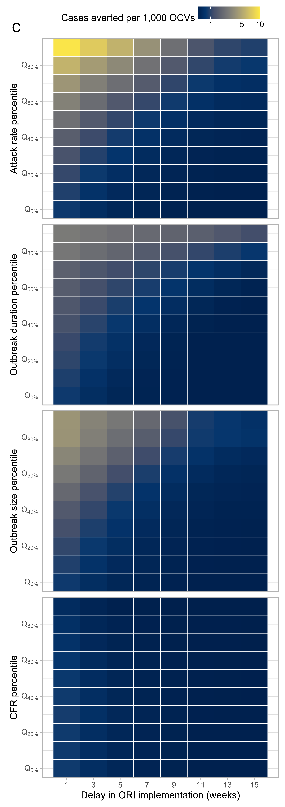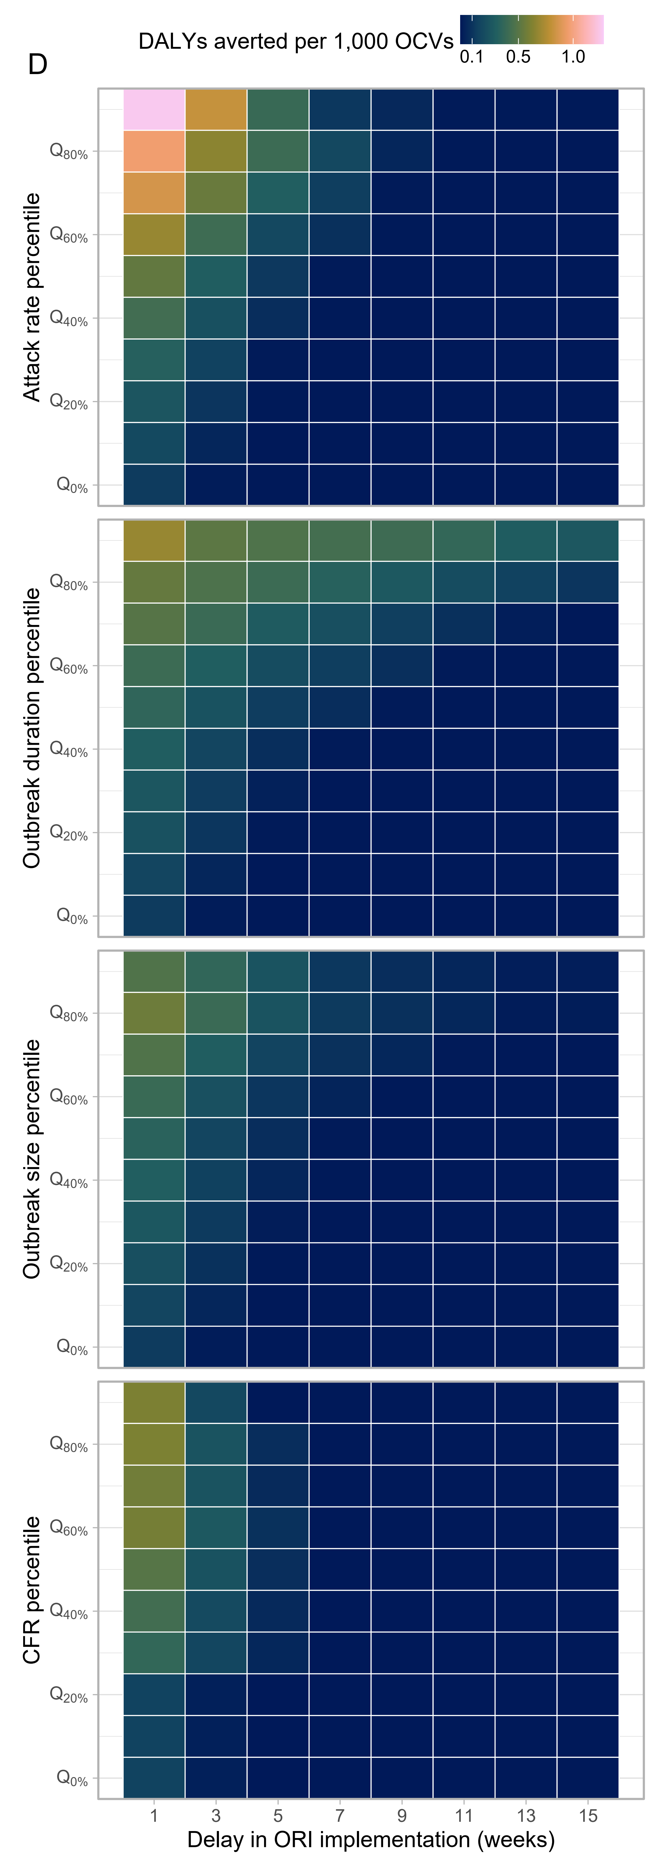

Table S1
Impact of ORI under the outbreak onset-triggered scenario. Values represent medians with interquartile ranges (IQRs).
Week of ORI implementation | Vaccine coverage | Number of outbreaks included | % case reduction | Case averted | DALY averted | Case averted per  1,000 OCVs | DALY averted per 1,000 OCVs | Cost  per case averted | Cost  per DALY averted
1 | 0.6 | 1,192 (100%) | 64.9 (46.4 - 76.2) | 120 (38 - 347) | 23 (0 - 118) | 0.801 (0.217 - 2.782) | 0.148 (0.001 - 0.787) | 3,914.4 (792.8 - 15,341.3) | 21,079.6 (3,289.9 - 4,025,339)
5 | 0.6 | 1,192 (100%) | 21.1 (2.7 - 44.9) | 36 (3 - 179) | 0 (0 - 43) | 0.229 (0.017 - 1.266) | 0.001 (0 - 0.276) | 8,092.1 (1,515.3 - 34,826.9) | 303,894.4 (6,979.7 - 21,274,967)
9 | 0.6 | 1,017 (85.3%) | 7.2 (0 - 27.4) | 15 (0 - 104) | 0 (0 - 22) | 0.1 (0 - 0.763) | 0 (0 - 0.141) | 11,111.8 (2,145.7 - 51,664.6) | 1,504,166 (9,941.1 - 34,763,429)
13 | 0.6 | 765 (64.2%) | 3.3 (0 - 19.1) | 8 (0 - 81) | 0 (0 - 20) | 0.054 (0 - 0.571) | 0 (0 - 0.078) | 13,451.2 (2,436.2 - 65,219) | 2,733,219 (11,318.7 - 44,556,414)
1 | 0.75 | 1,192 (100%) | 70 (49.8 - 82.5) | 129 (41 - 375) | 24 (0 - 128) | 0.692 (0.188 - 2.399) | 0.128 (0.001 - 0.679) | 4,661.8 (984.8 - 17,916.7) | 24,770.1 (4,065.8 - 4,679,419)
5 | 0.75 | 1,192 (100%) | 22.8 (3 - 48.4) | 39 (3 - 193) | 0 (0 - 46) | 0.198 (0.015 - 1.093) | 0.001 (0 - 0.238) | 9,486.7 (1,843.7 - 40,532.9) | 354,747.1 (8,338.3 - 24,678,219)
9 | 0.75 | 1,017 (85.3%) | 7.8 (0 - 29.5) | 16 (0 - 112) | 0 (0 - 23) | 0.086 (0 - 0.658) | 0 (0 - 0.122) | 13,042.9 (2,574.7 - 60,025.6) | 1,745,455 (11,816.2 - 40,406,869)
13 | 0.75 | 765 (64.2%) | 3.6 (0 - 20.7) | 9 (0 - 87) | 0 (0 - 22) | 0.047 (0 - 0.491) | 0 (0 - 0.067) | 15,745.1 (2,912.8 - 75,909.7) | 3,183,230 (13,251.2 - 51,572,816)
1 | 0.9 | 1,192 (100%) | 73.4 (52.1 - 86.3) | 135 (43 - 392) | 25 (0 - 135) | 0.604 (0.164 - 2.088) | 0.111 (0.001 - 0.593) | 5,456.7 (1,195.7 - 20,664.3) | 28,690.9 (4,890.4 - 5,396,109)
5 | 0.9 | 1,192 (100%) | 23.9 (3.1 - 50.6) | 41 (3 - 202) | 0 (0 - 48) | 0.172 (0.013 - 0.953) | 0.001 (0 - 0.207) | 10,975.7 (2,193.8 - 46,544.4) | 410,361.3 (9,840 - 28,345,288)
9 | 0.9 | 1,017 (85.3%) | 8.1 (0 - 30.9) | 17 (0 - 117) | 0 (0 - 24) | 0.075 (0 - 0.573) | 0 (0 - 0.106) | 15,022 (3,036.5 - 68,905.7) | 2,004,934 (13,899.1 - 46,464,569)
13 | 0.9 | 765 (64.2%) | 3.7 (0 - 21.7) | 9 (0 - 91) | 0 (0 - 23) | 0.041 (0 - 0.429) | 0 (0 - 0.058) | 18,294.1 (3,427.6 - 87,223) | 3,668,705 (15,291.5 - 59,098,076)

Table S2
Impact, efficiency, and cost effectiveness of ORI under the outbreak onset-triggered scenario for varying delays to stop ORI after outbreak end and varying delays in ORI implementation after outbreak onset. Values represent medians with interquartile ranges (IQRs).
Week of ORI implementation | Delay to stop ORI after outbreak end (weeks)) | Number of outbreaks included | % case reduction | Case averted | DALY averted | Case averted per  1,000 OCVs | DALY averted per 1,000 OCVs | Cost  per case averted | Cost  per DALY averted
1 | 1 | 1,192 (100%) | 70 (49.8 - 82.5) | 129 (41 - 375) | 24 (0 - 128) | 0.692 (0.188 - 2.399) | 0.128 (0.001 - 0.679) | 4,661.8 (984.8 - 17,916.7) | 24,770.1 (4,065.8 - 4,679,419)
1 | 3 | 1,192 (100%) | 70 (49.8 - 82.5) | 129 (41 - 375) | 24 (0 - 128) | 0.692 (0.188 - 2.399) | 0.128 (0.001 - 0.679) | 4,661.8 (984.8 - 17,916.7) | 24,770.1 (4,065.8 - 4,679,419)
1 | 5 | 1,192 (100%) | 70 (49.8 - 82.5) | 129 (41 - 375) | 24 (0 - 128) | 0.692 (0.188 - 2.399) | 0.128 (0.001 - 0.679) | 4,661.8 (984.8 - 17,916.7) | 24,770.1 (4,065.8 - 4,679,419)
1 | 7 | 1,192 (100%) | 70 (49.8 - 82.5) | 129 (41 - 375) | 24 (0 - 128) | 0.692 (0.188 - 2.399) | 0.128 (0.001 - 0.679) | 4,661.8 (984.8 - 17,916.7) | 24,770.1 (4,065.8 - 4,679,419)
5 | 1 | 1,192 (100%) | 24 (4.2 - 49.1) | 42 (4 - 202) | 0 (0 - 47) | 0.215 (0.022 - 1.143) | 0.001 (0 - 0.25) | 9,486.7 (1,843.7 - 40,532.9) | 354,747.1 (8,338.3 - 24,678,219)
5 | 3 | 1,192 (100%) | 22.4 (2.7 - 48.2) | 38 (3 - 190) | 0 (0 - 46) | 0.192 (0.012 - 1.077) | 0.001 (0 - 0.234) | 9,486.7 (1,843.7 - 40,532.9) | 354,747.1 (8,338.3 - 24,678,219)
5 | 5 | 1,192 (100%) | 22.4 (2.7 - 48.2) | 38 (3 - 190) | 0 (0 - 46) | 0.192 (0.012 - 1.077) | 0.001 (0 - 0.234) | 9,486.7 (1,843.7 - 40,532.9) | 354,747.1 (8,338.3 - 24,678,219)
5 | 7 | 1,192 (100%) | 22.4 (2.7 - 48.2) | 38 (3 - 190) | 0 (0 - 46) | 0.192 (0.012 - 1.077) | 0.001 (0 - 0.234) | 9,486.7 (1,843.7 - 40,532.9) | 354,747.1 (8,338.3 - 24,678,219)
9 | 1 | 957 (80.3%) | 9.8 (0.2 - 31.7) | 22 (1 - 128) | 0 (0 - 24) | 0.112 (0.001 - 0.764) | 0 (0 - 0.152) | 13,042.9 (2,574.7 - 60,025.6) | 1,745,455 (11,816.2 - 40,406,869)
9 | 3 | 1,084 (90.9%) | 5.8 (0 - 27.4) | 12 (0 - 101) | 0 (0 - 23) | 0.063 (0 - 0.57) | 0 (0 - 0.094) | 13,042.9 (2,574.7 - 60,025.6) | 1,745,455 (11,816.2 - 40,406,869)
9 | 5 | 1,192 (100%) | 3.4 (0 - 24) | 6 (0 - 80) | 0 (0 - 21) | 0.03 (0 - 0.456) | 0 (0 - 0.053) | 13,042.9 (2,574.7 - 60,025.6) | 1,745,455 (11,816.2 - 40,406,869)
9 | 7 | 1,192 (100%) | 2.7 (0 - 22.9) | 5 (0 - 74) | 0 (0 - 20) | 0.021 (0 - 0.422) | 0 (0 - 0.036) | 13,042.9 (2,574.7 - 60,025.6) | 1,745,455 (11,816.2 - 40,406,869)
13 | 1 | 683 (57.3%) | 5.7 (0 - 23.4) | 15 (0 - 109) | 0 (0 - 23) | 0.078 (0 - 0.605) | 0 (0 - 0.112) | 15,745.1 (2,912.8 - 75,909.7) | 3,183,230 (13,251.2 - 51,572,816)
13 | 3 | 822 (69%) | 2.1 (0 - 18) | 5 (0 - 72) | 0 (0 - 16) | 0.026 (0 - 0.387) | 0 (0 - 0.021) | 15,745.1 (2,912.8 - 75,909.7) | 3,183,230 (13,251.2 - 51,572,816)
13 | 5 | 957 (80.3%) | 0.3 (0 - 13.9) | 1 (0 - 49) | 0 (0 - 0) | 0.004 (0 - 0.255) | 0 (0 - 0.001) | 15,745.1 (2,912.8 - 75,909.7) | 3,183,230 (13,251.2 - 51,572,816)
13 | 7 | 1,084 (90.9%) | 0 (0 - 10.8) | 0 (0 - 34) | 0 (0 - 0) | 0 (0 - 0.179) | 0 (0 - 0.001) | 15,745.1 (2,912.8 - 75,909.7) | 3,183,230 (13,251.2 - 51,572,816)

S9. Vaccine effectiveness comparison using dynamic models
To assess the robustness of the vaccine impact projections from our static modeling approach, we compared these predictions with those from a dynamic modeling approach. The dynamic model accounts for cholera transmissibility and population immunity, enabling it to capture outbreak-specific variations and feedback loops inherent to epidemic processes—such as the amplification of the force of infection with increasing cases or the mitigating effect of population immunity. While our primary analysis of the static model focused on reactive vaccination scenarios (i.e., outbreak response immunization, ORIs), the comparison between the static and dynamic models was conducted solely for pre-emptive vaccination scenarios. This decision was made after accounting for the limitation in coarse weekly time resolution of the static model and the dynamic model’s limited ability to account for delays in vaccination rollout and subsequent immunological responses, which complicates a direct comparison for ORIs. Pre-emptive vaccination scenarios, on the other hand, provide a more straightforward alignment between the two approaches, allowing us to identify similarities and differences. These differences likely stem from the indirect vaccine effectivness, which is natural in the dynamic model but must be externally specified in the static model.
We employed the standard Susceptible-Exposed-Infected-Recovered (SEIR) framework in which E and I states were modeled with two compartments such that the residence time in each compartment follows an Erlang distribution with the shape of 2, rather than the unrealistic exponential distribution (Figure S3).
The following is a set of equations to represent the model. The first subscript, $i$, and the second subscripts, $j$, (both 1 or 2) represent the age groups (< 5 yo and 5+ yo) and the $j$th compartments for each state, respectively, except for the $S$ state. $S$ state and the vaccine efficacy, $χ$, have only one subscript representing the age group.
$$λ= {\left\{β\left(\sum_{i=1}^{2}{\sum_{j=1}^{2}{I_{i,j}}+I_{i,j}^{V}+ζ\left(A_{i,j}+A_{i,j}^{V}\right)}\right)\right\}}/N$$
$$\frac{dS_{i}}{dt}=-\left(λ_{p}+λ_{w}\right)S_{i}$$
$$\frac{dE_{i,1}}{dt}=λS_{1}- 2ϵE_{i,1}$$
$$\frac{\text{d}E_{i,2}}{\text{d}t}=2ϵE_{i,1}- 2ϵE_{i,2}$$
$$\frac{dI_{1,1}}{dt}=2\left(1-θ\right)ϵE_{i,2}- 2γI_{i,1}$$
$$\frac{dI_{i,2}}{dt}=2γI_{i,1}-2γI_{i,2}$$
$$\frac{dA_{i,1}}{dt}=2θϵE_{i,2}-2γA_{i,1}$$
$$\frac{dA_{i,2}}{dt}=2γA_{i,1}-2γA_{i,2}$$
$$\frac{dR_{i}}{dt}= 2γ\left(I_{i,2}+A_{i,2}\right)$$
$$\frac{dV_{i,1}}{dt}=vS_{i}-λV_{i,1}-2δV_{i,1}$$
$$\frac{dV_{i,2}}{dt}=2δ\left(V_{i,1}-V_{i,2}\right)-λV_{i,2}$$
$$\frac{dV_{i,3}}{dt}=2δ\left(V_{i,2}-V_{i,3}\right)- λ\left(1-χ_{i}\right)V_{i,3}$$
$$\frac{dV_{i,4}}{dt}=2δ\left(V_{i,3}-V_{i,4}\right)- λ\left(1-χ_{i}\right)V_{i,4}$$
$$\frac{dE_{i,1}^{V}}{dt}= λ\left(V_{i,1}+V_{i,2}+\left(1-χ_{i}\right)\left(V_{i,3}+V_{i,4}\right)\right)-2ϵE_{i,1}^{V}+vE_{i,1}$$
$$\frac{\text{d}E_{i,2}^{V}}{\text{d}t}=2ϵE_{i,1}^{V}-2ϵE_{i,2}^{V}+vE_{i,2}$$
$$\frac{dI_{i,1}^{V}}{dt}=2 \left(1-θ\right)ϵE_{i,2}^{V}-2γI_{i,1}^{V}$$
$$\frac{dI_{i,2}^{V}}{dt}=2γI_{i,1}^{V}-2γI_{i,2}^{V}$$
$$\frac{dA_{i,1}^{V}}{dt}=2θϵE_{i,2}^{V}-2γA_{i,1}^{V}+vA_{i,1}$$
$$\frac{dA_{i,2}^{V}}{dt}=2γA_{i,1}^{V}-2γA_{i,2}^{V}+vA_{i,2}$$
$$\frac{dR_{i,1}^{V}}{dt}=2γ\left(I_{i,2}^{V}+A_{i,2}^{V}\right)+vR_{i,1}-2σR_{i,1}^{V}$$
$$\frac{dR_{1,2}^{V}}{dt}=2σ\left(R_{i,1}^{V}-R_{i,2}^{V}\right)+vR_{i,2}$$

Figure S5
Compartmental flows for the dynamic model. S, E, I, A, R, V represent susceptible, exposed, infectious, asymptomatic, recovered, and vaccinated states. Superscript, P, for V represents those vaccinated and partially protected (rather than vaccinated but fully susceptible V state). Superscript, V, for E, I, A, and R represents vaccinated but infected population. Each compartment is modeled with two sub-compartments representing age groups (<5 yo or 5+ yo) and E, I, A, R, V, and Vp states are additionally modeled with two compartments to model the Erlang-distributed residence times.
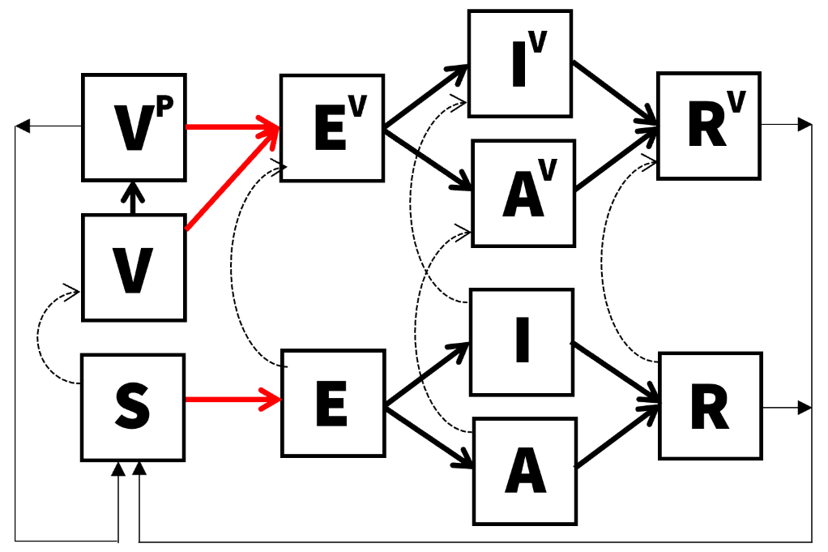
The incubation period was modeled using an Erlang distribution. This was achieved by fitting the Erlang distribution to a dataset of 1,000 samples, which were generated through a log-normal distribution with a median of 1.4 days and a dispersion of 1.98, as determined by a systematic literature review.⁵¹ In our approach, we varied the shape parameter of the Erlang distribution by setting it to 1, 2, 3, and 4. These values represent the potential number of compartments for the incubation state within the ODE model of cholera transmission. The rate parameter was the only variable allowed to be adjusted and was determined through the maximization of the log likelihood. The selection of the optimal shape parameter was based on the comparison of likelihood values, ultimately identifying a shape of 2 and a rate of 1.115044 as the most suitable for our model.
We tried fitting the model to weekly incidence for all 1,406 outbreaks by calibrating four parameters: the proportion of the population that is susceptible in the beginning of the outbreak, $s_{0}$, basic reproduction ratio, $R_{0}$, initial proportion of people already infected at the start of the outbreak, $i_{0}$, and the proportion of effective population size, $n_{0}$. The $n_{0}$ parameter was introduced to address the possibility that the population experiencing the outbreak is likely to have been a fraction of the population of the administrative unit where the outbreak was reported. Fitting involved assuming that the number of observed cases at a given week, $y\left(t\right)$, follows a Poisson distribution with its mean, $Y\left(t\right)$, and modelled incidence of symptomatic cases. The likelihood function $L\left(θ\right)$ of the model, defined by the parameters $θ$ (as shown below), was maximized using the differential evolution method.⁵²
$$L\left(θ;y_{1},…,y_{n}\right)=\prod_{j=1}^{n}{\frac{e^{-Y_{j}}{Y_{j}}^{y_{j}}}{y_{j}!}}$$
The differential evolution algorithm is a stochastic search algorithm and uses Latin Hypercube sampling as initial parameter values to explore within the bounds and local maxima. We explored a wide range of bounds for parameters to make sure that all reasonable values are examined. Acknowledging that the algorithm may end up in a local minimum by chance, we ran the algorithm with five different random seeds and chose the values that maximized the log likelihood that the algorithm reached at least twice.
After reviewing the fitting results, we selected 341 outbreaks where the model captured the dynamics of the outbreak sufficiently well by excluding fits where a) modeled and observed weekly incidences diverged upon visual inspection, b) parameter estimates were too close (0.1%) to the bounds of parameter inputs, raising concerns that the estimated parameter values were not robust, and c) the number of data points was smaller than 8, corresponding to twice the number of data points. While the number of parameters to be estimated is four, we consider the possibility that the number of data points may need to be much larger to inform the parameter values in practice. The dynamic model was implemented in Julia language⁵³ and codes used are available on GitHub.⁶

Figure S6
Comparison of weekly incidence between the dynamic model and the observed data. Numbers at the top indicate IDs assigned to each outbreak. For outbreaks with IDs 1 and 23, the dynamic model (red lines) successfully captured the observed data (black dots). Conversely, outbreaks with IDs 3 and 40 exhibited complex patterns that the dynamic model failed to accurately represent.
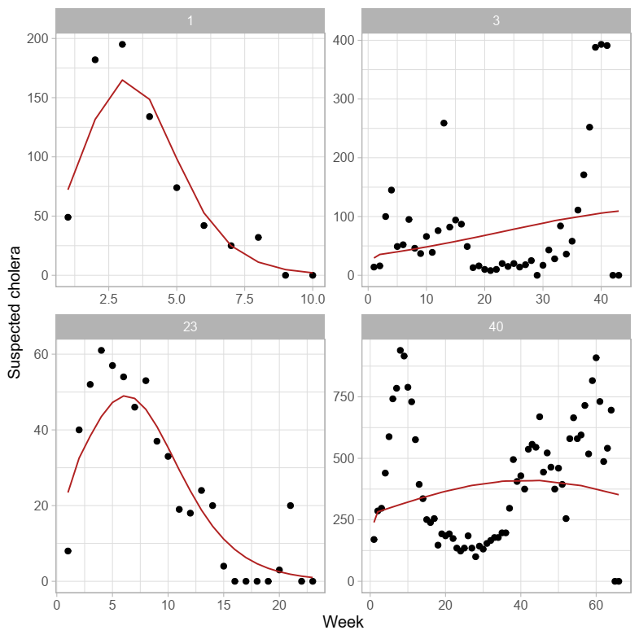

Figure S7
Direct, indirect, total, and overall vaccine effectiveness in the dynamic and static models. Vaccine effectiveness was measured under the pre-emptive vaccination scenario where a proportion of the individuals, determined by the vaccine coverage rate, were in the compartments of individuals who acquired vaccine-derived protection, $V^{P}$ (Figure S3), in the beginning of the simulation.
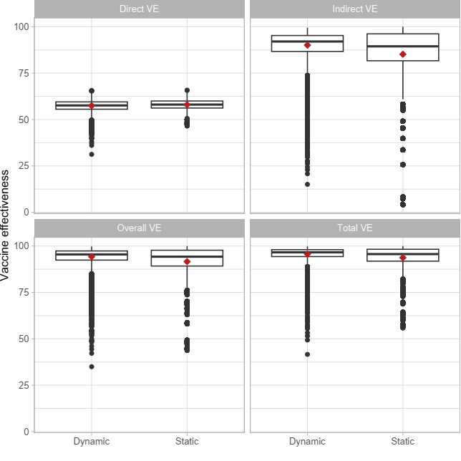

Table S4
Impact of ORI under the outbreak onset-triggered scenario across alternative outbreak datasets. Values represent medians with interquartile ranges (IQRs). Scenario A: Original outbreak dataset, allowing ORIs even after outbreaks have ended; Scenario B: Broader outbreak dataset, restricting ORIs to ongoing outbreaks only; Scenario C: Broader outbreak dataset, allowing ORIs even after outbreaks have ended.
Vaccine coverage | Camp-aign week | % case reduction | Case averted | Death averted | Case averted per  1,000 OCVs | Death averted per 1,000 OCVs | Cost per case averted | Cost per death averted | Cost per DALY averted
0.6 | 1 | 63.2 (44.2 - 76.4) | 114 (35 - 343) | 1 (0 - 5) | 0.727 (0.181 - 2.53) | 0.005 (0 - 0.033) | 4,245.8 (867.9 - 17,771.5) | 140,020.6 (23,789.7 - 470,469.4) | 23,603.2 (3,287.6 - 4,325,215)
 | 5 | 21.6 (2.6 - 45.8) | 35 (2 - 180) | 0 (0 - 2) | 0.283 (0.037 - 1.427) | 0 (0 - 0.015) | 8,143.9 (1,558 - 36,591.8) | 163,611.8 (38,358.2 - 551,736.1) | 223,046.3 (6,370.2 - 21,600,340)
 | 9 | 3.1 (0 - 23.7) | 5 (0 - 78) | 0 (0 - 1) | 0.188 (0.017 - 1.057) | 0 (0 - 0.011) | 10,820.2 (2,133.9 - 49,917.3) | 201,300 (53,422 - 584,093.7) | 630,538.3 (8,955.8 - 32,787,064)
 | 13 | 0 (0 - 8.6) | 0 (0 - 25) | 0 (0 - 0) | 0.144 (0.011 - 0.9) | 0 (0 - 0.008) | 13,399.3 (2,431.2 - 68,113.9) | 227,046.3 (57,944 - 646,204.9) | 1,552,157 (10,908.9 - 45,121,471)
0.75 | 1 | 70.7 (49.5 - 83.8) | 126 (39 - 377) | 1 (0 - 6) | 0.642 (0.16 - 2.235) | 0.005 (0 - 0.029) | 4,910.4 (1,045.1 - 20,123.9) | 163,463.9 (31,534.4 - 537,303.5) | 26,687.6 (3,937.7 - 4,898,163)
 | 5 | 24 (2.8 - 50.7) | 38 (3 - 200) | 0 (0 - 2) | 0.249 (0.032 - 1.257) | 0 (0 - 0.013) | 9,281 (1,839.5 - 41,383.7) | 189,749 (49,196.8 - 627,373.1) | 255,773.7 (7,458.6 - 24,501,831)
 | 9 | 3.4 (0 - 26.2) | 6 (0 - 86) | 0 (0 - 1) | 0.166 (0.015 - 0.931) | 0 (0 - 0.01) | 12,274.1 (2,522 - 56,598.7) | 228,332 (64,012.7 - 663,584.2) | 714,001.8 (10,365.1 - 37,125,419)
 | 13 | 0 (0 - 9.5) | 0 (0 - 28) | 0 (0 - 0) | 0.127 (0.01 - 0.793) | 0 (0 - 0.007) | 15,321 (2,845.1 - 77,421) | 262,486.1 (69,566.3 - 724,127.2) | 1,779,903 (12,520.9 - 51,293,408)
0.9 | 1 | 73.9 (52.2 - 87) | 131 (41 - 394) | 1 (0 - 6) | 0.56 (0.14 - 1.946) | 0.004 (0 - 0.025) | 5,765 (1,280.4 - 23,296.7) | 193,918.6 (41,476.8 - 624,196.7) | 31,028.5 (4,765.8 - 5,587,784)
 | 5 | 25.2 (3 - 52.8) | 40 (3 - 209) | 0 (0 - 2) | 0.216 (0.028 - 1.098) | 0 (0 - 0.011) | 10,787.8 (2,197.1 - 47,394) | 225,339.5 (63,485.3 - 727,154.1) | 290,183.4 (8,714.3 - 28,079,470)
 | 9 | 3.6 (0 - 27.4) | 6 (0 - 90) | 0 (0 - 1) | 0.144 (0.013 - 0.811) | 0 (0 - 0.009) | 14,129.6 (2,992.5 - 64,966.1) | 262,653.9 (78,840 - 763,830.9) | 819,894.6 (12,165.1 - 42,520,648)
 | 13 | 0 (0 - 9.9) | 0 (0 - 29) | 0 (0 - 0) | 0.111 (0.008 - 0.688) | 0 (0 - 0.006) | 17,860.9 (3,359.7 - 88,673.5) | 303,593.1 (85,414.3 - 835,307) | 2,042,844 (14,608.3 - 59,000,625)

References
1. Halloran ME, Struchiner CJ. Study designs for dependent happenings. Epidemiology. 1991 Sep;2(5):331–8.
2. Clemens J, Harris J, Khan MR, Kay B, Yunus M, Svennerholm AM, et al. FIELD TRIAL OF ORAL CHOLERA VACCINES IN BANGLADESH. The Lancet. 1986 Jul;328(8499):124–7.
3. Longini IMJ, Nizam A, Ali M, Yunus M, Shenvi N, Clemens JD. Controlling endemic cholera with oral vaccines. PLoS Med. 2007 Nov 27;4(11):e336.
4. Stan Development Team. Stan Modeling Language Users Guide and Reference Manual [Internet]. 2024. Available from: https://mc-stan.org
5. Carpenter B, Gelman A, Hoffman MD, Lee D, Goodrich B, Betancourt M, et al. Stan: A Probabilistic Programming Language. Journal of Statistical Software. 2017 Jan 11;76:1–32.
6. Kim JH. cholera-outbreak-vaccine-impact-modeling [Internet]. 2024. Available from: https://github.com/kimfinale/cholera-outbreak-vaccine-impact-modeling
7. Sobol′ IM. Global sensitivity indices for nonlinear mathematical models and their Monte Carlo estimates. Mathematics and Computers in Simulation. 2001 Feb;55(1–3):271–80.
8. Renardy M, Joslyn LR, Millar JA, Kirschner DE. To Sobol or not to Sobol? The effects of sampling schemes in systems biology applications. Math Biosci. 2021 Jul;337:108593.
9. Ng Ombe H, Simuyandi M, Mwaba J, Luchen CC, Alabi P, Chilyabanyama ON, et al. Immunogenicity and waning immunity from the oral cholera vaccine (ShancholTM) in adults residing in Lukanga Swamps of Zambia. PLoS One. 2022;17(1):e0262239.
10. Kanungo S, Paisley A, Lopez AL, Bhattacharya M, Manna B, Kim DR, et al. Immune responses following one and two doses of the reformulated, bivalent, killed, whole-cell, oral cholera vaccine among adults and children in Kolkata, India: a randomized, placebo-controlled trial. Vaccine. 2009 Nov 16;27(49):6887–93.
11. Chowdhury F, Bhuiyan TR, Akter A, Bhuiyan MS, Khan AI, Hossain M, et al. Immunogenicity of a killed bivalent whole cell oral cholera vaccine in forcibly displaced Myanmar nationals in Cox’s Bazar, Bangladesh. PLoS Negl Trop Dis. 2020 Mar;14(3):e0007989.
12. Raghava Mohan V, Raj S, Dhingra MS, Aloysia D’Cor N, Singh AP, Saluja T, et al. Safety and immunogenicity of a killed bivalent (O1 and O139) whole-cell oral cholera vaccine in adults and children in Vellore, South India. Borrow R, editor. PLoS ONE. 2019 Jun 18;14(6):e0218033.
13. Charles RC, Hilaire IJ, Mayo-Smith LM, Teng JE, Jerome JG, Franke MF, et al. Immunogenicity of a killed bivalent (O1 and O139) whole cell oral cholera vaccine, Shanchol, in Haiti. PLoS Negl Trop Dis. 2014 May;8(5):e2828.
14. Chac D, Bhuiyan TR, Saha A, Alam MM, Salma U, Jahan N, et al. Gut Microbiota and Development of Vibrio cholerae-Specific Long-Term Memory B Cells in Adults after Whole-Cell Killed Oral Cholera Vaccine. Infect Immun. 2021 Aug 16;89(9):e0021721.
15. McCarty JM, Cassie D, Bedell L, Lock MD, Bennett S. Long-Term Immunogenicity of Live Oral Cholera Vaccine CVD 103-HgR in Adolescents Aged 12-17 Years in the United States. Am J Trop Med Hyg. 2021 Apr 5;104(5):1758–60.
16. McCarty JM, Lock MD, Hunt KM, Simon JK, Gurwith M. Safety and immunogenicity of single-dose live oral cholera vaccine strain CVD 103-HgR in healthy adults age 18–45. Vaccine. 2018 Feb;36(6):833–40.
17. Chowdhury F, Ali Syed K, Akter A, Rahman Bhuiyan T, Tauheed I, Khaton F, et al. A phase I/II study to evaluate safety, tolerability and immunogenicity of Hillchol®, an inactivated single Hikojima strain based oral cholera vaccine, in a sequentially age descending population in Bangladesh. Vaccine. 2021 Jul 22;39(32):4450–7.
18. Ilboudo PG, Huang XX, Ngwira B, Mwanyungwe A, Mogasale V, Mengel MA, et al. Cost-of-illness of cholera to households and health facilities in rural Malawi. PLoS One. 2017;12(9):e0185041.
19. Awalime DK, Davies-Teye BBK, Vanotoo LA, Owoo NS, Nketiah-Amponsah E. Economic evaluation of 2014 cholera outbreak in Ghana: a household cost analysis. Health Econ Rev. 2017 Dec 4;7(1):45.
20. Poulos C, Riewpaiboon A, Stewart JF, Clemens J, Guh S, Agtini M, et al. Costs of Illness Due to Endemic Cholera. Epidemiol Infect. 2012 Mar;140(3):10.1017/S0950268811000513.
21. Schaetti C, Weiss MG, Ali SM, Chaignat CL, Khatib AM, Reyburn R, et al. Costs of illness due to cholera, costs of immunization and cost-effectiveness of an oral cholera mass vaccination campaign in Zanzibar. PLoS Negl Trop Dis. 2012;6(10):e1844.
22. Figuereo S, Yoon I, Kaddu SS, Lubogo M, Baruch J, Hossain AA, et al. Cost of Cholera for Households and Health Facilities, Somalia. J Epidemiol Glob Health. 2024 Sep 1;14(3):1219–30.
23. Tembo T, Simuyandi M, Chiyenu K, Sharma A, Chilyabanyama ON, Mbwili-Muleya C, et al. Evaluating the costs of cholera illness and cost-effectiveness of a single dose oral vaccination campaign in Lusaka, Zambia. Thet Wai K, editor. PLoS ONE. 2019 May 31;14(5):e0215972.
24. Bushra H. Retrospective analysis of a large-scale cholera outbreak in Sudan. EMHJ [Internet]. [cited 2025 May 13]; Available from: http://www.emro.who.int/emhj-volume-30-2024/volume-30-issue-10/retrospective-analysis-of-a-large-scale-cholera-outbreak-in-sudan.html
25. Nsubuga F, Garang SC, Tut M, Oguttu D, Lubajo R, Lodiongo D, et al. Epidemiological description of a protracted cholera outbreak in Tonj East and Tonj North counties, former Warrap State, South Sudan, May-Oct 2017. BMC Infectious Diseases. 2019;19(1):4.
26. Dalhat MM, Isa AN, Nguku P, Nasir SG, Urban K, Abdulaziz M, et al. Descriptive characterization of the 2010 cholera outbreak in Nigeria. BMC Public Health. 2014;14(1):1167.
27. Worku Demlie Y, Gedefaw A, Jeon Y, Hailu D, Getahun T, Mogeni OD, et al. Retrospective Analysis of Cholera/Acute Watery Diarrhea Outbreaks in Ethiopia From 2001 To 2023: Incidence, Case Fatality Rate, and Seasonal and Multiyear Epidemic Patterns. Clin Infect Dis. 2024 Jul 12;79(Suppl 1):S8–19.
28. Bwire G, Munier A, Ouedraogo I, Heyerdahl L, Komakech H, Kagirita A, et al. Epidemiology of cholera outbreaks and socio-economic characteristics of the communities in the fishing villages of Uganda: 2011-2015. Ryan ET, editor. PLOS Neglected Tropical Diseases. 2017;11(3):e0005407.
29. Bwire G, Malimbo M, Maskery B, Kim YE, Mogasale V, Levin A. The Burden of Cholera in Uganda. Ryan ET, editor. PLoS Neglected Tropical Diseases. 2013;7(12):e2545.
30. Bwire G, Munier A, Ouedraogo I, Heyerdahl L, Komakech H, Kagirita A, et al. Epidemiology of cholera outbreaks and socio-economic characteristics of the communities in the fishing villages of Uganda: 2011-2015. PLoS Negl Trop Dis. 2017 Mar 13;11(3):e0005407.
31. Pezzoli L. Global oral cholera vaccine use, 2013–2018. Vaccine. 2020 Feb 29;38:A132–40.
32. Edosa M, Jeon Y, Gedefaw A, Hailu D, Mesfin Getachew E, Mogeni OD, et al. Comprehensive Review on the Use of Oral Cholera Vaccine (OCV) in Ethiopia: 2019 to 2023. Clin Infect Dis. 2024 Jul 12;79(Suppl 1):S20–32.
33. Ilboudo PG, Mengel MA, Gessner BD, Ngwira B, Cavailler P, Le Gargasson JB. Cost-effectiveness of a reactive oral cholera immunization campaign using ShancholTM in Malawi. Cost Eff Resour Alloc. 2021 Mar 10;19(1):17.
34. Odevall L, Hong D, Digilio L, Sahastrabuddhe S, Mogasale V, Baik Y, et al. The Euvichol story - Development and licensure of a safe, effective and affordable oral cholera vaccine through global public private partnerships. Vaccine. 2018 Oct 29;36(45):6606–14.
35. Matias WR, Guillaume Y, Cene Augustin G, Vissieres K, Ternier R, Slater DM, et al. Effectiveness of the Euvichol® oral cholera vaccine at 2 years: A case-control and bias-indicator study in Haiti. Int J Infect Dis. 2024 Feb;139:153–8.
36. Sarker AR, Khan AI, Islam MT, Chowdhury F, Khanam F, Kang S, et al. Cost of oral cholera vaccine delivery in a mass immunization program for children in urban Bangladesh. Vaccine X. 2022 Dec;12:100247.
37. Teshome S, Desai S, Kim JH, Belay D, Mogasale V. Feasibility and costs of a targeted cholera vaccination campaign in Ethiopia. Human Vaccines & Immunotherapeutics. 2018 Oct 3;14(10):2427–33.
38. Kar SK, Sah B, Patnaik B, Kim YH, Kerketta AS, Shin S, et al. Mass Vaccination with a New, Less Expensive Oral Cholera Vaccine Using Public Health Infrastructure in India: The Odisha Model. Ryan ET, editor. PLoS Negl Trop Dis. 2014 Feb 6;8(2):e2629.
39. Mogasale V, Ngogoyo SM, Mogasale VV. Model-based estimation of the economic burden of cholera in Africa. BMJ Open. 2021 Mar;11(3):e044615.
40. Khan AI, Levin A, Chao DL, DeRoeck D, Dimitrov DT, Khan JAM, et al. The impact and cost-effectiveness of controlling cholera through the use of oral cholera vaccines in urban Bangladesh: A disease modeling and economic analysis. Maheu-Giroux M, editor. PLoS Negl Trop Dis. 2018 Oct 9;12(10):e0006652.
41. Kirigia JM, Sambo LG, Yokouide A, Soumbey-Alley E, Muthuri LK, Kirigia DG. Economic burden of cholera in the WHO African region. BMC Int Health Hum Rights. 2009 Dec;9(1):8.
42. GBD 2017 Disease and Injury Incidence and Prevalence Collaborators. Global, regional, and national incidence, prevalence, and years lived with disability for 354 diseases and injuries for 195 countries and territories, 1990-2017: a systematic analysis for the Global Burden of Disease Study 2017. Lancet. 2018 Nov 10;392(10159):1789–858.
43. Jackson BR, Talkington DF, Pruckler JM, Fouché MDB, Lafosse E, Nygren B, et al. Seroepidemiologic survey of epidemic cholera in Haiti to assess spectrum of illness and risk factors for severe disease. Am J Trop Med Hyg. 2013 Oct;89(4):654–64.
44. United Nations, Department of Economic and Social Affairs, Population Division. World Population Prospects 2022 [Internet]. 2022. Available from: https://population.un.org/wpp/Download/Standard/Mortality/
45. Mogasale V, Ramani E, Wee H, Kim JH. Oral Cholera Vaccination Delivery Cost in Low- and Middle-Income Countries: An Analysis Based on Systematic Review. Ryan ET, editor. PLoS Negl Trop Dis. 2016 Dec 8;10(12):e0005124.
46. Turner HC, Lauer JA, Tran BX, Teerawattananon Y, Jit M. Adjusting for Inflation and Currency Changes Within Health Economic Studies. Value in Health. 2019 Sep;22(9):1026–32.
47. Bureau of Labor Statistics. Math calculations to better utilize CPI data [Internet]. Bureau of Labor Statistics; Available from: https://www.bls.gov/cpi/factsheets/cpi-math-calculations.pdf
48. International Monetary Fund. Inflation rate, average consumer prices [Internet]. Available from: https://www.imf.org/external/datamapper/PCPIPCH@WEO/OEMDC/ADVEC/WEOWORLD
49. UNICEF. Oral cholera vaccine (OCV) price data [Internet]. 2024 Oct. Available from: https://www.unicef.org/supply/media/22781/file/OCV-vaccines-prices-29102024.pdf
50. UNICEF. Emergency stockpile availability - oral cholera vaccine [Internet]. 2024 Nov. Available from: https://www.unicef.org/supply/media/22091/file/EmergencyStockpileAvailabilityReportOCV11112024.pdf
51. Azman AS, Rudolph KE, Cummings DAT, Lessler J. The incubation period of cholera: A systematic review. Journal of Infection. 2013 May 1;66(5):432–8.
52. Gao S, Wang Y, Wang J, Cheng J. Understanding differential evolution: A Poisson law derived from population interaction network. Journal of Computational Science. 2017 Jul;21:140–9.
53. Julia: A Fresh Approach to Numerical Computing | SIAM Review [Internet]. [cited 2024 Dec 3]. Available from: https://epubs.siam.org/doi/10.1137/141000671

