Main-manuscript Methods and Results: PPV adjustment
  - Draft text and proposed main figures

Methods

Adjustment for the positive predictive value of suspected cases
The outbreak time series used in the outbreak-response immunization (ORI) model comprised suspected cases meeting study-specific clinical definitions. We therefore defined the relevant positive predictive value (PPV) as the probability of latent true typhoid among all suspected cases in an outbreak, $π_{o}=P(D=1∣C=1,o)$, rather than the proportion positive among patients selected for blood culture. Blood-culture positivity is an imperfect proxy for this estimand because blood culture has incomplete, volume-dependent sensitivity and patients selected for culture may differ from those not tested.
We estimated blood-culture sensitivity and outbreak-specific PPV jointly in a Bayesian latent-class model. The culture-accuracy layer included nine historical studies (577 patients) in which blood and bone-marrow cultures were performed in the same patients. Joint outcomes—blood positive/bone-marrow positive, blood positive/bone-marrow negative, blood negative/bone-marrow positive, and negative by both—were modeled with a multinomial likelihood conditional on latent disease status. Blood-culture sensitivity in study $s$ was modeled as
$$logit(Se_{BC,s})=α_{0}+α_{1}log(V_{s})+τu_{s}, u_{s}∼N(0,1),$$
where $V_{s}$ was cultured blood volume and $τ$ represented residual between-study heterogeneity. The prior for the log-volume slope was informed by the Antillón et al. meta-regression. Blood- and bone-marrow-culture specificities were assigned priors concentrated near one, while bone-marrow sensitivity was estimated rather than treated as a perfect reference standard. Vallenas (1985) was excluded because the joint cells reported in the source review were inconsistent with the primary paper’s marginal yields and did not identify a defensible both-negative cell.
Community PPV evidence was assembled from 107 candidate outbreak records identified through the Koh et al. and Appiah et al. outbreak reviews. Eight independent outbreaks supplied a clinically defined suspected-case denominator, a blood-culture-specific tested count drawn from that denominator, and a blood-culture-positive count from the same tested subset. The audit classified 80 records as ineligible, retained 14 for sensitivity analyses, and held five pending source reconstruction or retrieval. Counts were corrected to blood-specific values where supported by primary reports, including 19/54 for Neil (2012) and 56/364 for Kabwama (2017).
Population PPV was modeled hierarchically:
$$logit(π_{o})=μ_{π}+σ_{π}z_{o}, z_{o}∼N(0,1).$$
To allow preferential verification, $q_{1o}$ and $q_{0o}$ denoted the probabilities of culture among true-typhoid and non-typhoid suspected cases. Their log-odds difference was modeled as
$$logit(q_{1o})−logit(q_{0o})=μ_{δ}+β_{bias}B_{o}+σ_{δ}z_{δo},$$
where the prespecified audit grade $B_{o}$ was coded 0, 1, or 2 for negligible/low, moderate, or major verification concern. Culture-positive, culture-negative, and untested counts followed a three-category multinomial likelihood. Because aggregate testing counts do not separately identify population PPV and preferential selection, the selection component was interpreted as prior-dependent and evaluated under six structural assumptions: no enrichment, skeptical, base, and permissive priors, binary rather than ordinal grades, and no grade effect.
Models were fitted in Stan using four chains, 1,500 warm-up and 1,500 retained iterations per chain, seed 2026, target acceptance probability 0.98, and maximum tree depth 12. We report posterior medians and 90% credible intervals (CrIs). The main fit had no divergent transitions, maximum $\hat{R}$ of 1.004, and minimum bulk and tail effective sample sizes of 1,704 and 1,631, respectively.

Propagation into the ORI model
The complete PPV posterior, rather than posterior medians, was propagated jointly with vaccine efficacy and campaign-timing uncertainty. ORI outbreaks matching a PPV study identifier received draws from their local $π_{o}$ posterior. For outbreaks without a direct anchor, each iteration drew an outbreak-specific PPV from the fitted logit-normal population distribution conditional on that iteration’s $μ_{π}$ and $σ_{π}$.
The primary analysis used an additive observation model, $S_{t}=I_{t}+B_{t}$, where $S_{t}$ was observed suspected incidence, $I_{t}$ was latent true-typhoid incidence, and $B_{t}$ was a constant non-typhoid febrile background. For each PPV draw, $B=(1−π)\overset{‾}{S}$ was subtracted from the suspected curve, negative values were truncated, and the resulting curve was renormalized so that t​It=πt​St. The vaccine acted only on $I_{t}$.
At a second additive level, true typhoid was represented as $I_{t}=X_{t}+P_{t}$, with background/common-source typhoid $X_{t}$ and propagated typhoid Pt=RtPu≥1​wuIt−u. Vaccination reduced both components directly, whereas only propagated cases generated feedback through the renewal recursion. The source fraction $θ$ allocated baseline incidence inside that shared recursion. The former post hoc calculation $θA_{static}+(1−θ)A_{renewal}$ was retained only as a paired historical comparator, using the same PPV-adjusted curve and parameter draws. We distinguished the percentage reduction in latent true typhoid from the smaller percentage reduction observable in all-cause suspected-case surveillance. Typhoid-attributed deaths were treated as disease-specific and were not multiplied by PPV; non-fatal cases, years lived with disability, treatment costs, and antimicrobial-resistance case counts were PPV-adjusted.

Results

Culture sensitivity and outbreak PPV
Estimated blood-culture sensitivity increased from 0.56 (90% CrI 0.46–0.66) at 2 mL to 0.65 (0.56–0.73) at 5 mL and 0.72 (0.62–0.80) at 10 mL. Estimated bone-marrow-culture sensitivity was 0.92 (0.90–0.94). These results imply that observed blood-culture positivity systematically understates the proportion of suspected patients with true typhoid.
Community PPV was strongly heterogeneous. Study-specific posterior medians ranged from 0.10 for Dhadwal (2008) to 0.86 for Hu (2022). The fitted median PPV for a typical outbreak was 0.31 (90% CrI 0.16–0.52), with a between-outbreak logit-scale standard deviation of 1.35 (0.85–2.03). The audit-grade selection coefficient was positive (median 0.39, 90% CrI 0.05–0.94), but the selection hyperparameters remained substantially prior-dependent and were not interpreted as empirical proof of preferential culture.
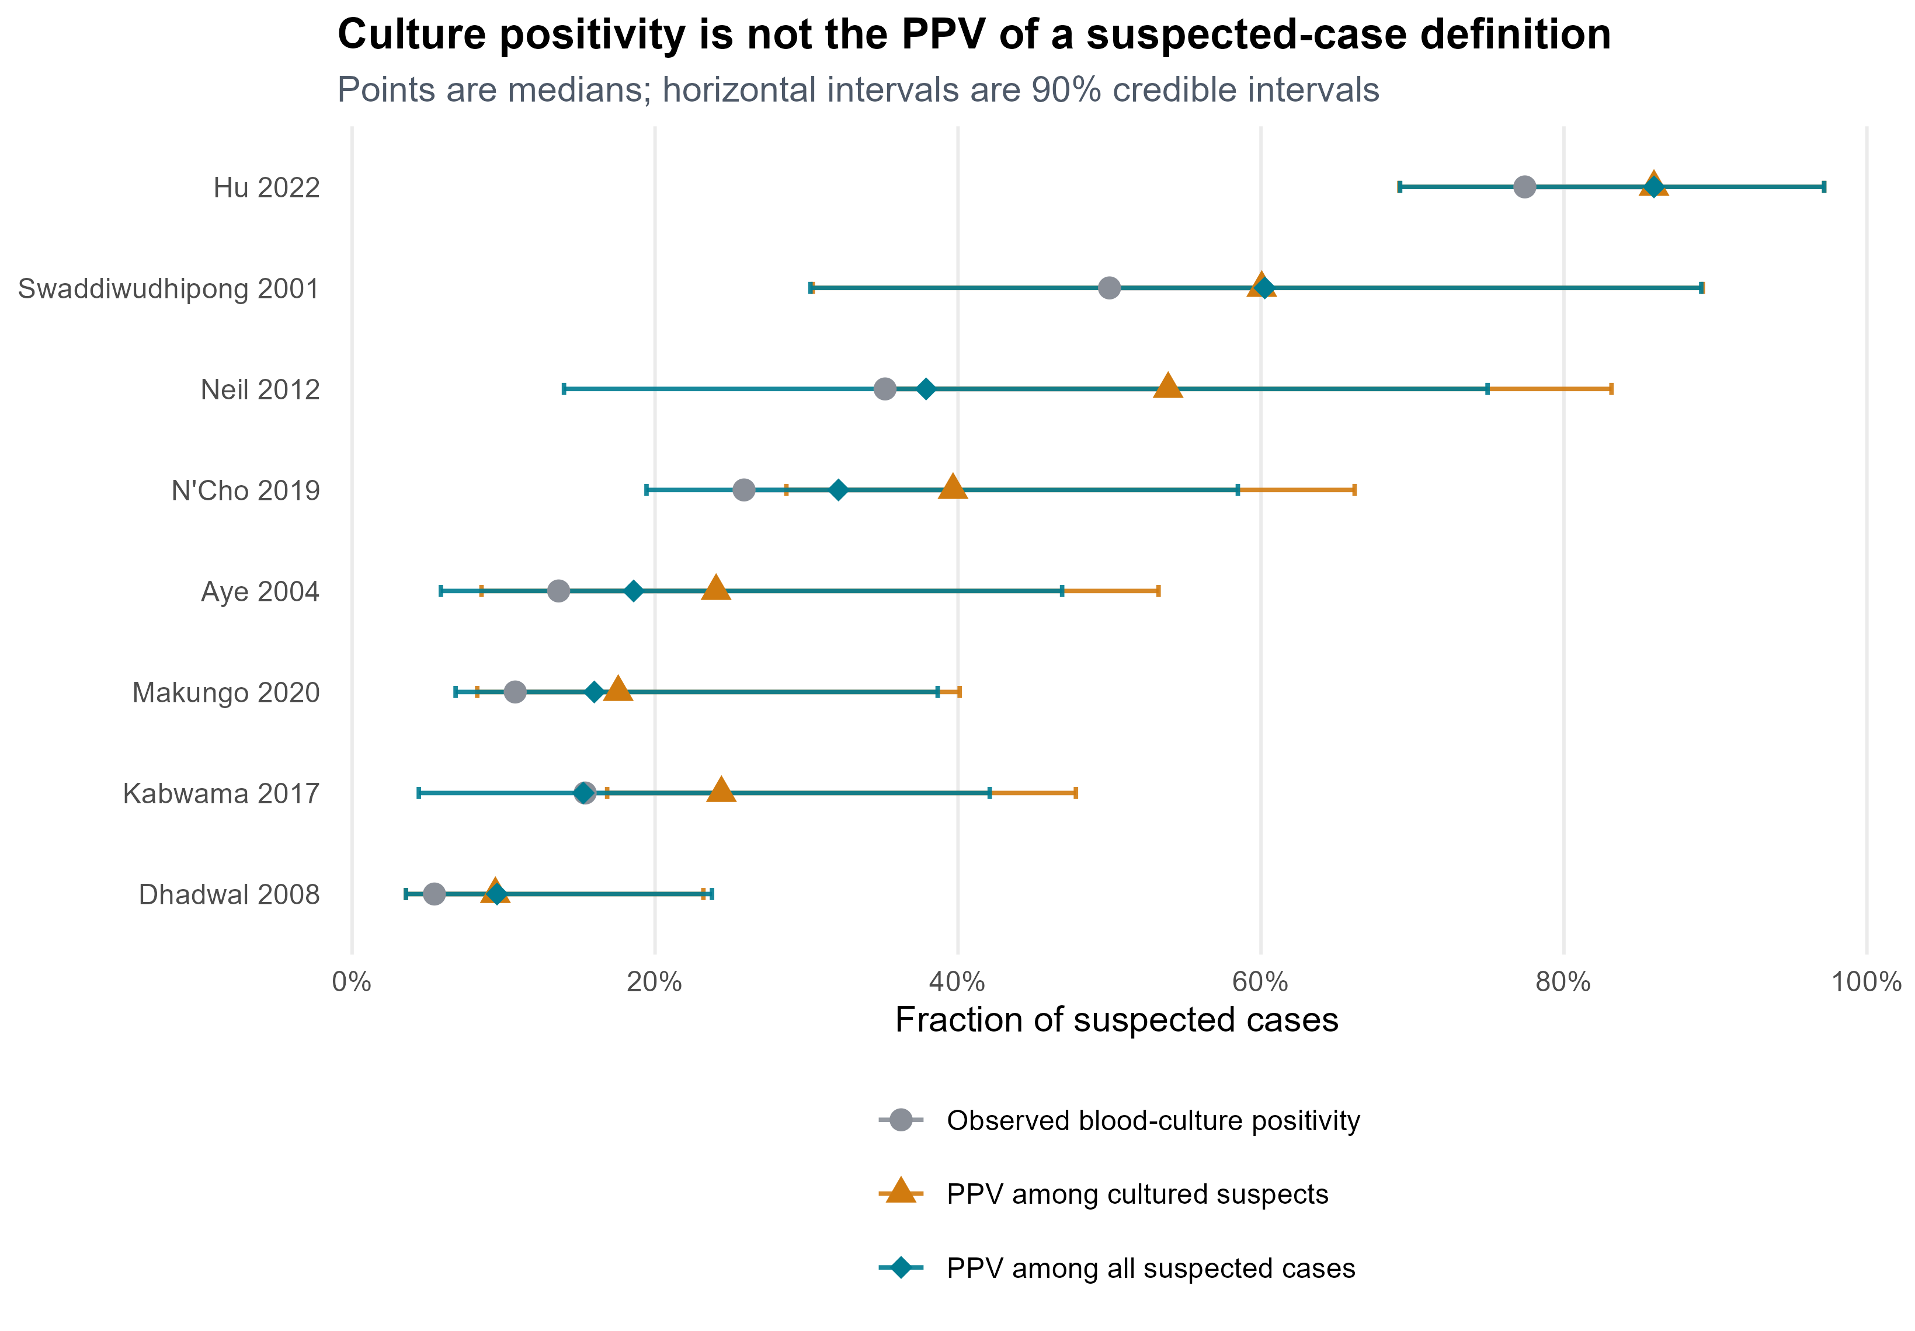
Figure 1: Observed blood-culture positivity, PPV among cultured suspects, and selection-adjusted PPV among all suspected cases. Points show posterior medians and horizontal bars show 90% CrIs; observed positivity is plotted without an interval.
Figure Figure 1 separates three quantities that are often conflated. Correcting only for imperfect blood-culture sensitivity raises the estimated PPV among cultured patients, while the selection model can lower the corresponding PPV among all suspected cases when true typhoid is preferentially cultured. The difference was largest in outbreaks assigned major verification concern, although intervals remained wide.

Effect on estimated ORI impact
In the base-case two-level additive analysis, ORI averted a pooled median 1,846 true typhoid cases (95% simulation interval 644–3,742), corresponding to a 25.6% reduction in latent true typhoid and a 7.0% reduction observable in suspected-case surveillance. The historical $θ$-weighted calculation gave 25.9%; the paired additive-minus-weighted difference was −0.5 percentage points (−2.4 to 0.7) or −37 cases (−212 to 52). The similar pooled estimates mask larger outbreak-specific differences and do not make the two formulations mechanistically equivalent.
In a separate observation-layer sensitivity using the pure-renewal propagation workflow, selection assumptions changed estimated true cases averted from 1,511 to 2,277, while the true-typhoid percentage reduction remained between 29.8% and 30.7% and the apparent suspected-case reduction ranged from 5.5% to 8.9%. These values quantify PPV-selection sensitivity conditional on that propagation workflow; they are not uncertainty limits for the primary source-plus-propagated model.
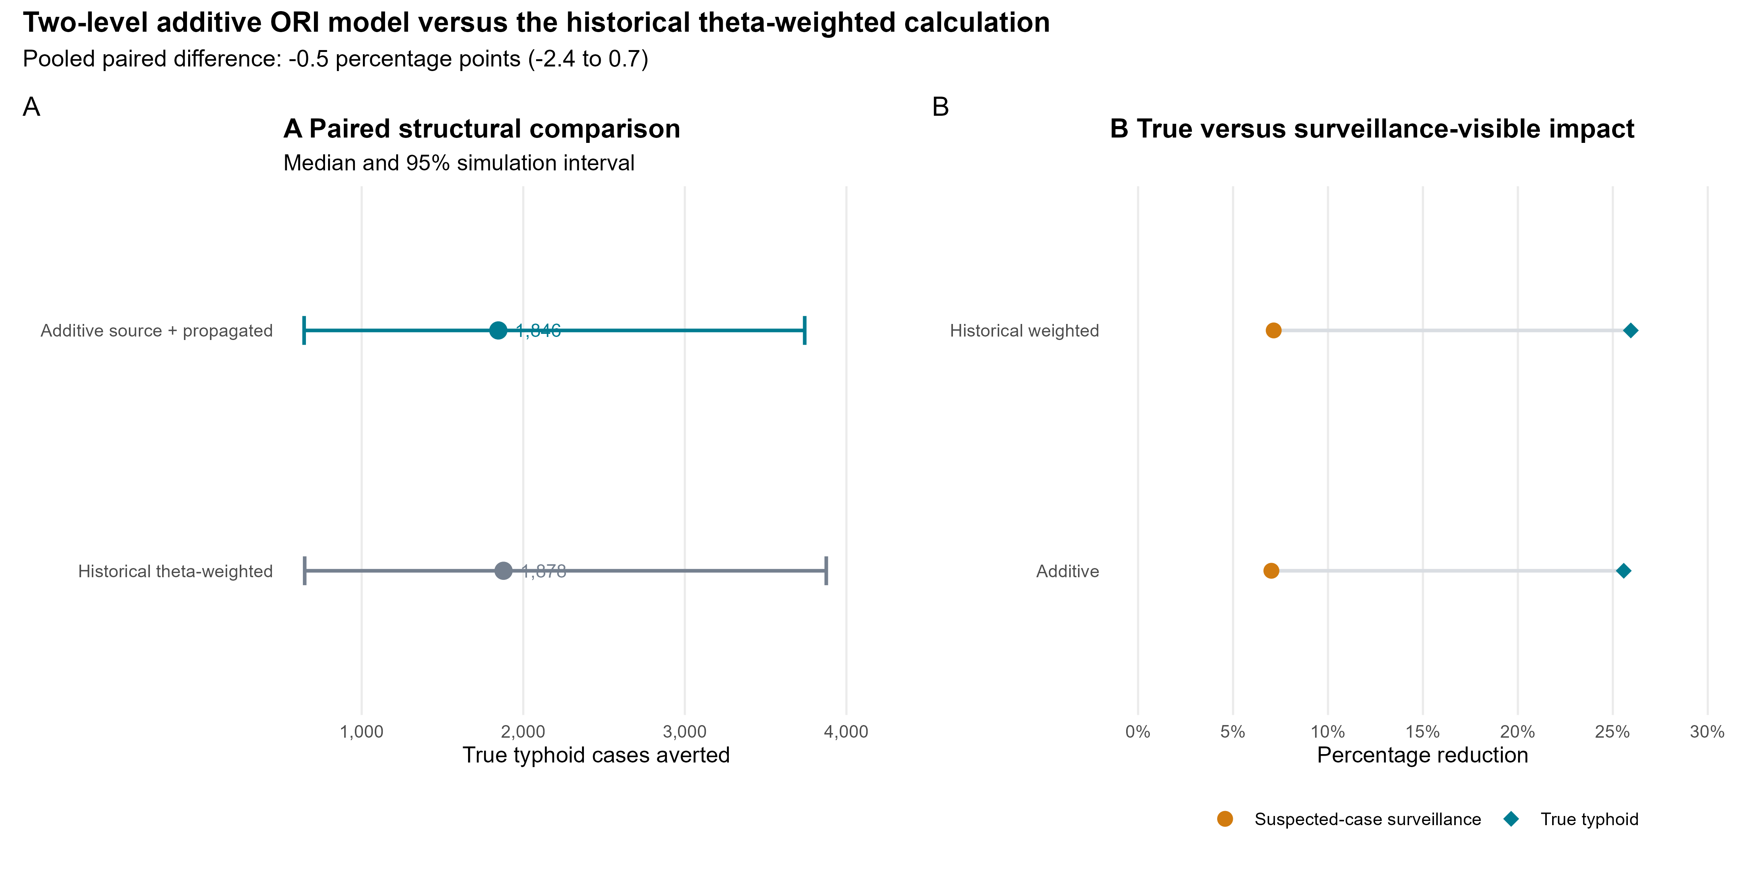
Figure 2: Two-level additive ORI model versus the historical theta-weighted calculation. Panel A compares true typhoid cases averted using paired inputs and 95% simulation intervals. Panel B contrasts reductions in latent true typhoid with reductions observable in suspected-case surveillance.
Four of eight direct PPV anchors matched renewal time series. Their diagnostic-testing frames were not always numerically or temporally identical to the corresponding incidence curves; the largest mismatch was N’Cho (2019), whose hospital testing frame contained 583 suspected patients while the canonical outbreak curve summed to 2,744 cases. This transport step, together with the prior-dependence of preferential verification and the assumption of a constant non-typhoid background, remains an important limitation of the adjusted impact estimates.

Proposed figure placement
- Main Figure: Figure Figure 2. It communicates the manuscript-level policy result: suspected-case surveillance can substantially overstate absolute vaccine-preventable burden while understating the relative effect observable after vaccination.
- Main or extended-data figure: Figure Figure 1. It makes the diagnostic argument visually explicit and prevents readers from interpreting blood-culture positivity as PPV.
- Supplement: retain the blood-volume sensitivity curve and detailed hospital/community PPV forest plot, which are important for validation but less direct for the main ORI narrative.

