Supplementary Methods and Results: Adjustment for the Positive Predictive Value of Suspected Typhoid Case Definitions
  - Supporting the outbreak-response immunization impact analysis

2026-07-31

1. S1. Purpose and estimand
The outbreak time series used in the outbreak-response immunization (ORI) analysis contain predominantly suspected typhoid cases. Suspected-case definitions are designed for sensitive outbreak detection and may include patients with other febrile illnesses. Consequently, not every reported suspected case represents vaccine-preventable Salmonella enterica serovar Typhi infection.
We define the positive predictive value (PPV) of the suspected clinical case definition in setting $o$ as
$$π_{o}=P(D=1∣C=1,o),$$
where $D=1$ denotes latent true typhoid and $C=1$ denotes satisfaction of the study’s suspected-case definition. This quantity is the prevalence of true typhoid among suspected cases, not the PPV of blood culture. It is setting-dependent because it reflects the local ratio of typhoid to other febrile illnesses, the breadth of the clinical definition, care-seeking, and surveillance practice.
The purpose of this analysis was to propagate uncertainty in $π_{o}$ into estimates of absolute true typhoid cases averted, morbidity, treatment costs, and cases averted per vaccine dose. This targeted evidence synthesis was constructed as an observation model for the ORI analysis. It was not a systematic review of all typhoid clinical case definitions; a broader PRISMA-DTA review is planned as a separate study.

2. S2. Evidence inputs

2.1 S2.1 Paired blood- and bone-marrow-culture studies
Blood culture is highly specific but incompletely sensitive, so culture positivity alone cannot be equated with the PPV of a clinical definition. We used nine historic studies, consolidated from Mogasale et al. (2016), in which the same suspected patients received both blood culture and bone-marrow culture. These studies supplied the four joint outcomes BC+BM+, BC+BM-, BC-BM+, and BC-BM-. Together they included 577 paired observations.
Table 1: Paired blood- and bone-marrow-culture evidence used in the latent-class model.
Study | Location | BC+ BM+ | BC+ BM- | BC- BM+ | BC- BM- | N | Blood volume used (mL)
Akoh 1991 | Zaria Nigeria | 8 | 3 | 11 | 9 | 31 | 2.0
Hirsowitz 1951 | Transvaal S.Africa | 13 | 0 | 5 | 10 | 28 | 4.0
Farooqui 1991 | Karachi Pakistan | 58 | 0 | 30 | 12 | 100 | 5.0
Gasem 1995 | Semarang Indonesia | 39 | 13 | 28 | 0 | 80 | 3.0
Gasem 2002 | Semarang Indonesia | 43 | 1 | 10 | 7 | 61 | 9.0
Chaicumpa 1992 | Jakarta Indonesia | 17 | 5 | 15 | 15 | 52 | 3.0
Wain 2008 | Dong Thap Vietnam | 53 | 4 | 16 | 30 | 103 | 5.0
Gilman 1975 | Mexico City | 24 | 1 | 32 | 5 | 62 | 2.0
Guerra-Caceres 1979 | Lima Peru | 26 | 0 | 31 | 3 | 60 | 5.0

Blood volume was not reported for Hirsowitz (1951) and was imputed at the median of the reported study volumes (4 mL). Gasem (1995) cultured 3 mL and 10 mL blood volumes, but its available aggregate $2×2$ table could not be separated by volume, so the consolidated analysis used 3 mL. Wain (2008) reported separate paired comparisons for 5 mL and 15 mL blood cultures; the analysis used its 5 mL comparison. Vallenas (1985) was excluded because its primary report supplied only marginal blood- and bone-marrow-culture yields, while the joint cells reported by Mogasale et al. were internally inconsistent with those marginals and did not establish a defensible both-negative cell. The remaining volume decisions were treated as data-quality limitations rather than known without error.

2.2 S2.2 Blood-volume information
The prior for the effect of blood volume on blood-culture sensitivity was informed by the meta-regression of Antillón et al. (2018), which demonstrated increasing sensitivity with cultured blood volume. The model used a Normal(0.36, 0.15) prior for the log-volume slope. The Antillón study-level observations informed this slope prior rather than entering the paired-test likelihood as independent patients.

2.3 S2.3 Community outbreak observations
The community layer estimates the positive predictive value of the clinical suspected-case definition — the probability $π_{o}=P(\text{true typhoid}∣\text{suspected})$ among all suspected cases in outbreak $o$ — because the renewal impact model scales suspected-case incidence curves rather than culture-confirmed counts. Admissibility for this estimand, rather than culture positivity itself, governed selection: a report had to provide a syndromic suspected-case denominator, a blood-culture-specific tested count drawn from that denominator, and a blood-culture-positive count.
Candidate outbreaks were pooled from two systematic reviews of typhoid outbreaks. Koh et al. (2025) contributed its outbreaks with usable time series together with reports it had excluded for lacking time-series data, which we re-screened specifically for PPV eligibility; Appiah et al. (2020) contributed further records not already represented. After de-duplication at the publication level this yielded 107 candidate outbreak records. Primary full texts were audited where retrievable; review tables, indexed abstracts, and existing project extractions were used for the remainder, and records whose structure could not be resolved were held pending rather than assumed eligible.
A record entered the primary community model only if it satisfied all of: (1) a suspected-case count defined by a clinical case definition independently of culture result, rather than a confirmed-case or isolate series; (2) a blood-culture-specific tested count, not pooled across blood, stool, urine, or bone marrow; (3) a blood-culture-positive count from the same cultured subset; and (4) outbreak independence, that is, a single observation per epidemic. Small samples were retained where the denominator and the culture-selection mechanism were sound, with uncertainty propagated through the binomial likelihood rather than removed by a fixed sample-size threshold. Small records were placed in sensitivity analysis or excluded when they also had unresolved or inferred denominators, unclear specimen scope, or poorly characterized culture selection.
Table 2: Selection of community outbreak observations for PPV estimation.
Stage | n
Candidate outbreak records (Koh 2025 review + no-time-series re-screen + Appiah 2020) | 107
Excluded from PPV modeling | 80
Retained for sensitivity analysis only | 14
Awaiting primary-source retrieval | 5
Included in the primary community PPV model | 8

Exclusions fell into recurring classes: confirmed-only or culture-defined case series with no independent syndromic denominator; pooled-specimen or non-blood tested denominators, for which positivity does not equal blood-culture PPV; hospital, phase-specific, or severity-gated frames whose estimand differs from all suspected outbreak cases; and off-target records such as genomic isolate-characterization or water-sanitation survey papers carrying no testing flow. A full-text reconstruction audit of the records whose summary counts were ambiguous confirmed that none yielded an admissible blood-culture-specific triple—the dominant failure modes being pooled-specimen confirmation and absent tested denominators. Qamar (2018) yielded a flagged pair retained for sensitivity analysis; Al-Sanouri (2008) remained excluded because its tested denominator was inferred rather than reported. Five records remained pending source reconstruction or retrieval.
The 107 records resolved to 103 independence groups. Three duplicate families accounted for the difference: the Limpitikul 2014 period-1, period-2, and total records; the two Baddam 2012 records; and the overlapping N’Cho 2019 and Poncin 2022 reports of the 2017–2018 Harare outbreak. All Limpitikul and Baddam observations were excluded. For Harare, N’Cho supplied the only compatible blood-culture-tested denominator and was retained; Poncin lacked a corresponding tested denominator and was excluded from the likelihood. Where the primary paper permitted, blood-culture counts were corrected at extraction to their blood-specific values—for example, Neil 2012 as 19/54 rather than the pooled 25/63, and Kabwama 2017 as 56/364 rather than a stale 51/364.
Table 3: Community outbreak evidence used to estimate suspected-case-definition PPV.
Study | Country | Year | Suspected | Cultured | Culture positive | Observed positivity | Latent true-typhoid PPV, median [90% CrI]
Aye 2004 | Madaya, Myanmar | 2000 | 49 | 22 | 3 | 0.136 | 0.19 [0.06, 0.47]
Neil 2012 | Kasese, Uganda | 2007-2009 | 577 | 54 | 19 | 0.352 | 0.38 [0.14, 0.75]
Kabwama 2017 | Kampala, Uganda | 2015 | 10230 | 364 | 56 | 0.154 | 0.15 [0.04, 0.42]
Hu 2022 | Lanling, China | 2016 | 31 | 31 | 24 | 0.774 | 0.86 [0.69, 0.97]
Makungo 2020 | Makhuduthamaga, South Africa | 2017 | 122 | 65 | 7 | 0.108 | 0.16 [0.07, 0.39]
N’Cho 2019 | Harare, Zimbabwe | 2017-2018 | 583 | 286 | 74 | 0.259 | 0.32 [0.19, 0.58]
Dhadwal 2008 | School, military station, central India | 2005 | 98 | 92 | 5 | 0.054 | 0.10 [0.04, 0.24]
Swaddiwudhipong 2001 | Rural village, Poppra District, Tak Province, Thailand (Thai-Myanmar border) | 1999 | 11 | 10 | 5 | 0.500 | 0.60 [0.30, 0.89]

The eight included outbreaks span three verification-adjustment grades — four major (Aye 2004, Neil 2012, Kabwama 2017, N’Cho 2019), one moderate (Makungo 2020), and three negligible or low (Hu 2022, Dhadwal 2008, Swaddiwudhipong 2001) — reflecting how far each cultured subset departs from a random sample of all suspected cases. Six derive from the Koh 2025 review; Dhadwal 2008 and Swaddiwudhipong 2001 were recovered from its no-time-series re-screen. Because blood volume was not reported in any of the eight, the primary fit assumed 5 mL and varied this assumption from 3 to 10 mL as its principal structural sensitivity.
Two limitations are quantified rather than assumed. The verification-adjustment grade enters a selection sub-model whose magnitude is prior-dominated (Section S5.4), and the suspected-case denominator is not always the same population as the renewal time-series curve it scales, as reported in the denominator-frame alignment table (Section S5). One retained anchor carries a specimen caveat: N’Cho 2019’s 74/286 is reported as “cultures processed,” not disaggregated to blood culture, under a blood, stool, or rectal-swab confirmation definition. It is retained as a genuine tested and positive pair within its 583-patient hospital frame, with a leave-N’Cho-out sensitivity analysis to bound its influence.

3. S3. Latent-class model

3.1 S3.1 Blood-culture sensitivity
For paired study $s$, blood-culture sensitivity was modeled as
$$logit(Se_{BC,s})=α_{0}+α_{1}log(V_{s})+τu_{s}, u_{s}∼Normal(0,1),$$
where $V_{s}$ is blood volume, $α_{0}$ is the sensitivity level, $α_{1}$ is the volume slope, and $τ$ is residual between-study heterogeneity. Bone-marrow sensitivity ($Se_{BM}$) was estimated rather than fixed, acknowledging that bone marrow is a better but imperfect reference.

3.2 S3.2 Paired-test likelihood
Let $ϕ_{s}=P(D=1∣C=1,s)$ be the latent true-typhoid prevalence among the hospital-referred suspected patients in paired study $s$. Under conditional independence of blood and bone-marrow culture given latent disease status, the four cell probabilities were
$$\begin{aligned}p_{++}&=ϕ_{s}Se_{BC,s}Se_{BM}+(1−ϕ_{s})(1−Sp_{BC})(1−Sp_{BM}), \\ p_{+−}&=ϕ_{s}Se_{BC,s}(1−Se_{BM})+(1−ϕ_{s})(1−Sp_{BC})Sp_{BM}, \\ p_{−+}&=ϕ_{s}(1−Se_{BC,s})Se_{BM}+(1−ϕ_{s})Sp_{BC}(1−Sp_{BM}), \\ p_{−−}&=ϕ_{s}(1−Se_{BC,s})(1−Se_{BM})+(1−ϕ_{s})Sp_{BC}Sp_{BM}.\end{aligned}$$
The observed four-cell vector followed a multinomial distribution. The paired layer identifies the sensitivity of both cultures and the study-specific hospital PPV without treating either culture as a perfect gold standard.

3.3 S3.3 Community likelihood
For community outbreak $o$, let $N_{o}$ be all suspected cases, $n_{o}$ the number cultured, and $k_{o}$ the number culture-positive. PPV among all suspected cases was modeled hierarchically:
$$logit(π_{o})=μ_{π}+σ_{π}z_{o}, z_{o}∼Normal(0,1).$$
To represent preferential verification, $q_{1o}$ and $q_{0o}$ denote the probabilities of culture among true-typhoid and non-typhoid suspected cases. Their log-odds difference was
$$δ_{o}=logit(q_{1o})−logit(q_{0o})=μ_{δ}+β_{bias}B_{o}+σ_{δ}z_{δo},$$
where $B_{o}∈\{0,1,2\}$ is the prespecified audit grade for low, moderate, or major verification concern. Counts $(k_{o},n_{o}−k_{o},N_{o}−n_{o})$ followed a multinomial distribution for culture-positive, culture-negative, and untested suspected cases. Thus, both testing fraction and positivity inform the model, while true cases may be preferentially cultured. Structured priors remain necessary because selection and population PPV are not identified by these counts alone.

3.4 S3.4 Priors and computation
Table 4: Priors used in the final latent-class model.
Parameter | Prior | Rationale
Blood-culture intercept, alpha0 | Normal(0, 1.5) | Weakly informative sensitivity level
Log-volume slope, alpha1 | Normal(0.36, 0.15) | Antillon-informed volume effect
Between-study Se SD, tau | half-Normal(0, 1) | Residual sensitivity heterogeneity
Bone-marrow sensitivity | Beta(12, 2) | High but imperfect sensitivity
Culture specificities | Beta(200, 1) | A positive culture is highly specific
Hospital PPV, phi_s | Beta(1, 1) | Local paired-study prevalence
Population logit-PPV mean, mu_pi | Normal(logit(0.25), 1) | Weakly informative population PPV
Between-outbreak PPV SD, sigma_pi | half-Normal(0, 0.8) | Genuine between-outbreak PPV variation
Baseline selection, mu_delta | Normal(0, 0.5) | No baseline enrichment favored
Bias-grade slope, beta_bias | Normal+(0.5, 0.4) | Higher audit concern permits enrichment
Residual selection SD, sigma_delta | half-Normal(0, 0.5) | Unmeasured selection heterogeneity
Non-typhoid testing logit, logit(q0) | Normal(logit observed testing fraction, 1) | Anchors testing to observed coverage

The model was fitted in Stan using four chains, 1,500 warm-up iterations and 1,500 retained iterations per chain, seed 2026, target acceptance probability 0.98, and maximum tree depth 12. Posterior summaries are medians and 90% credible intervals (CrIs). Structural selection sensitivities used two chains with 800 warm-up and 800 retained iterations per chain. Their maximum $\hat{R}$ was 1.014; the main four-chain fit’s maximum $\hat{R}$ is reported separately below.

4. S4. Model validation and diagnostics
The final fit produced 0 divergent transitions; the maximum rank-normalized $\hat{R}$ was 1.004, and the minimum bulk effective sample size was 1704. These diagnostics indicated satisfactory sampling.
Simulation studies evaluated recovery of the shared sensitivity parameters and local PPVs. The identifiable parameters were recovered with the generating values inside their 90% CrIs under the tested design. A single-test demonstration reproduced the expected PPV–sensitivity ridge: PPV and blood-culture sensitivity were individually weakly identified, while their product was precise. The paired-test layer removed this ridge. An earlier severity offset was not identified because the paired blood/bone-marrow evidence came from hospital populations and no comparable paired evidence exists for ambulatory disease. The final model therefore omitted a severity term and transferred blood-culture sensitivity through observed or assumed blood volume plus residual heterogeneity.
In a stress test, data generated with positive conditional dependence between blood and bone-marrow culture but fitted under independence increased estimated blood-culture sensitivity by approximately 0.08 and decreased PPV by approximately 0.08. Conditional independence is therefore a directional limitation: shared culture failure, for example after antibiotic exposure, could make the primary model overestimate sensitivity and underestimate PPV.

5. S5. Results

5.1 S5.1 Culture accuracy
Table 5: Posterior estimates of culture-accuracy parameters.
Parameter | Median [90% CrI]
Blood-culture sensitivity at 2 mL | 0.56 [0.46, 0.66]
Blood-culture sensitivity at 5 mL | 0.65 [0.56, 0.73]
Blood-culture sensitivity at 10 mL | 0.72 [0.62, 0.80]
Bone-marrow-culture sensitivity | 0.92 [0.90, 0.94]
Blood-culture specificity | 1.00 [0.98, 1.00]
Log-volume slope | 0.42 [0.18, 0.66]
Between-study SD | 0.54 [0.28, 1.00]

At the assumed 5 mL community blood volume, blood culture detected an estimated 0.65 of latent true typhoid infections. Sensitivity increased with cultured volume, while estimated bone-marrow sensitivity was approximately 0.92. Thus, raw culture positivity materially underestimated the proportion of suspected patients with true typhoid.
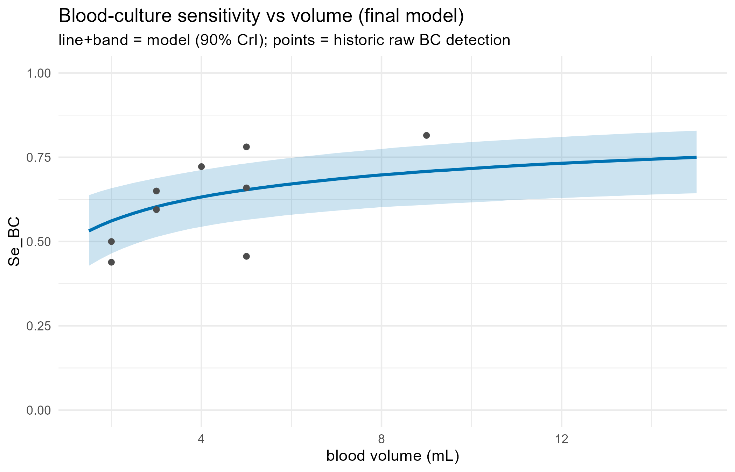
Figure 1: Posterior blood-culture sensitivity by cultured blood volume. The line and band show the posterior median and 90% CrI; points show raw paired-study detection proportions.

5.2 S5.2 Hospital and community PPV
Hospital-referred PPVs across the nine paired studies ranged from 0.65 to 0.99 (median 0.89). Community outbreak PPV was heterogeneous across 8 audited, independence-checked observations, ranging from 0.10 to 0.86. These are local estimates and should not be interpreted as a universal PPV for typhoid surveillance. In particular, N’Cho 2019 is the sole diagnostic-yield observation retained from the 2017–2018 Harare outbreak; Poncin 2022 summarizes overlapping historical counts but supplies no blood-culture-tested denominator.
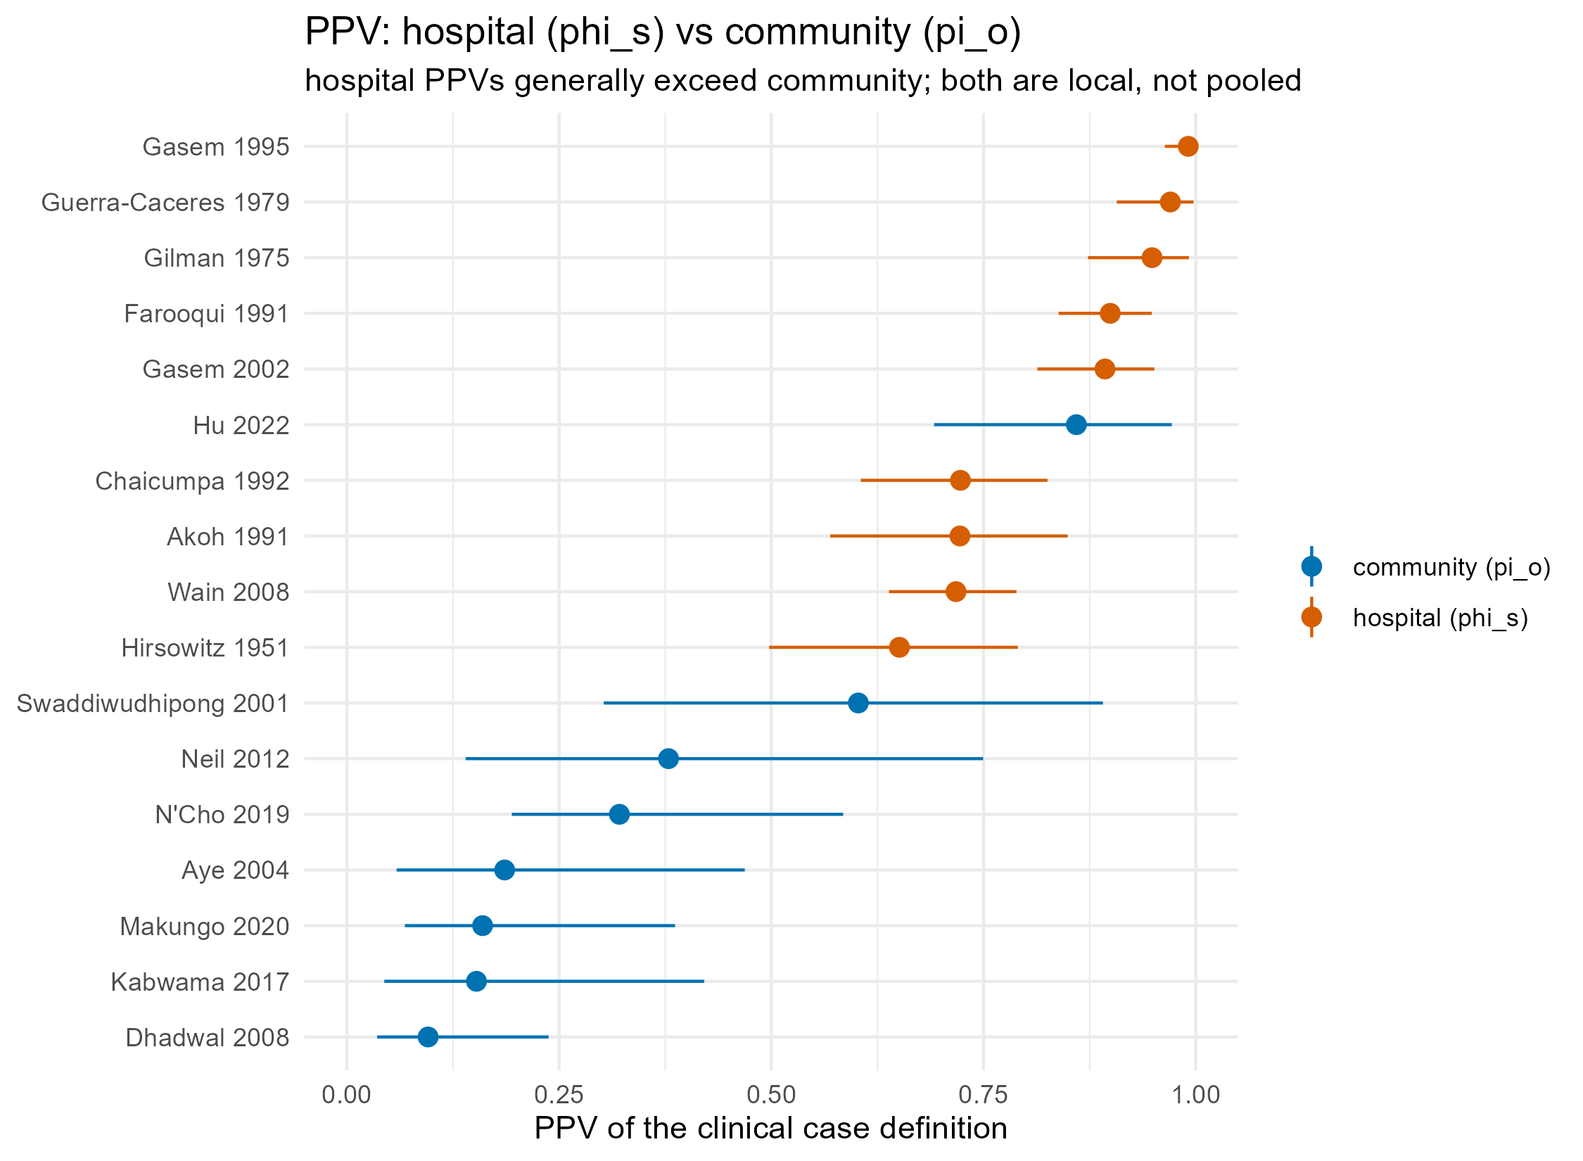
Figure 2: Posterior PPV of the suspected clinical definition in hospital-referred and community outbreak populations. PPVs are study-specific; intervals are 90% CrIs.
The fitted population median PPV was 0.31 [0.16, 0.52], and the genuine between-outbreak logit-scale SD was 1.35 [0.85, 2.03]. The audit-grade selection coefficient was positive: 0.39 [0.05, 0.94]. This should not be interpreted as data-driven evidence for enrichment: the selection hyperparameters changed little from their priors, unlike the clearly updated between-outbreak PPV SD.
Table 6: Posterior culture-selection probabilities among true and non-typhoid suspected cases.
Study | Selection log-OR, median [90% CrI] | P(cultured | non-typhoid) | P(cultured | true typhoid)
Aye 2004 | 0.73 [-0.49, 2.20] | 0.42 [0.30, 0.55] | 0.60 [0.34, 0.87]
Neil 2012 | 0.78 [-0.32, 2.16] | 0.07 [0.04, 0.11] | 0.13 [0.08, 0.32]
Kabwama 2017 | 0.69 [-0.47, 2.06] | 0.03 [0.02, 0.04] | 0.06 [0.03, 0.18]
Hu 2022 | 0.02 [-0.91, 1.08] | 0.99 [0.96, 1.00] | 0.99 [0.96, 1.00]
Makungo 2020 | 0.36 [-0.71, 1.46] | 0.52 [0.44, 0.61] | 0.61 [0.39, 0.81]
N’Cho 2019 | 0.77 [-0.35, 2.24] | 0.43 [0.34, 0.53] | 0.61 [0.44, 0.85]
Dhadwal 2008 | -0.05 [-1.05, 0.99] | 0.94 [0.90, 0.97] | 0.94 [0.84, 0.98]
Swaddiwudhipong 2001 | -0.00 [-0.93, 1.03] | 0.90 [0.75, 0.97] | 0.90 [0.73, 0.98]

Table 7: Study-specific hospital PPV estimates from the paired-test layer.
Study | Blood volume used (mL) | PPV, median [90% CrI]
Akoh 1991 | 2.0 | 0.72 [0.57, 0.85]
Hirsowitz 1951 | 4.0 | 0.65 [0.50, 0.79]
Farooqui 1991 | 5.0 | 0.90 [0.84, 0.95]
Gasem 1995 | 3.0 | 0.99 [0.96, 1.00]
Gasem 2002 | 9.0 | 0.89 [0.81, 0.95]
Chaicumpa 1992 | 3.0 | 0.72 [0.61, 0.83]
Wain 2008 | 5.0 | 0.72 [0.64, 0.79]
Gilman 1975 | 2.0 | 0.95 [0.87, 0.99]
Guerra-Caceres 1979 | 5.0 | 0.97 [0.91, 1.00]

5.3 S5.3 Sensitivity to assumed outbreak blood volume
Table 8: Community PPV sensitivity to assumed blood volume in outbreak surveillance.
Assumed blood volume (mL) | Study | Blood-culture sensitivity | PPV median
3 | Aye 2004 | 0.60 | 0.20
3 | Neil 2012 | 0.60 | 0.41
3 | Kabwama 2017 | 0.60 | 0.17
3 | Hu 2022 | 0.60 | 0.87
3 | Makungo 2020 | 0.60 | 0.18
3 | N’Cho 2019 | 0.60 | 0.35
3 | Dhadwal 2008 | 0.60 | 0.11
3 | Swaddiwudhipong 2001 | 0.60 | 0.61
5 | Aye 2004 | 0.65 | 0.18
5 | Neil 2012 | 0.65 | 0.35
5 | Kabwama 2017 | 0.65 | 0.14
5 | Hu 2022 | 0.65 | 0.86
5 | Makungo 2020 | 0.65 | 0.15
5 | N’Cho 2019 | 0.65 | 0.32
5 | Dhadwal 2008 | 0.65 | 0.09
5 | Swaddiwudhipong 2001 | 0.65 | 0.60
8 | Aye 2004 | 0.70 | 0.17
8 | Neil 2012 | 0.70 | 0.34
8 | Kabwama 2017 | 0.70 | 0.14
8 | Hu 2022 | 0.70 | 0.86
8 | Makungo 2020 | 0.70 | 0.15
8 | N’Cho 2019 | 0.70 | 0.30
8 | Dhadwal 2008 | 0.70 | 0.09
8 | Swaddiwudhipong 2001 | 0.70 | 0.57
10 | Aye 2004 | 0.72 | 0.16
10 | Neil 2012 | 0.72 | 0.34
10 | Kabwama 2017 | 0.72 | 0.13
10 | Hu 2022 | 0.72 | 0.85
10 | Makungo 2020 | 0.72 | 0.14
10 | N’Cho 2019 | 0.72 | 0.29
10 | Dhadwal 2008 | 0.72 | 0.09
10 | Swaddiwudhipong 2001 | 0.72 | 0.58

Increasing assumed blood volume raised estimated blood-culture sensitivity and correspondingly lowered inferred PPV. The direction was expected from the approximate identity $\text{positivity}≈πSe_{BC}$; the qualitative separation between hospital and community settings was unchanged.

5.4 S5.4 Sensitivity to selection assumptions
The selection decomposition was examined under no enrichment; skeptical, base, and permissive enrichment priors; binary rather than ordinal audit grades; and no grade effect. These are structural sensitivity analyses, not data-supported model rankings.
Table 9: Sensitivity of inferred PPV and ORI impact to selection priors and audit-grade coding.
Scenario | Population PPV median | Predictive PPV, median [90% interval] | Kabwama population/tested PPV ratio | True cases averted | Observed suspected-case reduction (%)
Base priors | 0.31 | 0.31 [0.03, 0.84] | 0.60 | 1567 | 6.3
Binary grade | 0.32 | 0.34 [0.04, 0.85] | 0.73 | 1731 | 6.6
No enrichment | 0.37 | 0.38 [0.05, 0.85] | 1.00 | 2277 | 8.9
No grade effect | 0.34 | 0.34 [0.04, 0.85] | 0.94 | 2182 | 8.1
Permissive priors | 0.31 | 0.31 [0.04, 0.86] | 0.56 | 1511 | 5.5
Skeptical priors | 0.34 | 0.36 [0.04, 0.87] | 0.81 | 1988 | 7.9

Across these assumptions, estimated true cases averted ranged from 1511 to 2277. This spread is consequential and is driven by the analyst-specified enrichment prior and grade encoding; the data do not select among these scenarios.

6. S6. Propagation into the ORI analysis
Posterior PPV draws were propagated jointly with vaccine-effectiveness and campaign-timing draws. All 8 audited anchors use their study-specific $π_{o}$ posterior when the ORI dataset contains the same study identifier. For outbreaks without direct PPV data, the current implementation draws an outbreak-specific value from the fitted logit-normal population distribution using each draw’s $μ_{π}$ and $σ_{π}$. This propagates genuine fitted between-outbreak heterogeneity. Preferential selection into blood culture is represented jointly through the tested, test-negative, test-positive, and untested counts, conditional on the prespecified audit bias grade.
The testing-frame denominator used to estimate an anchor’s PPV is not necessarily the same population or time window as the renewal incidence curve. The audit below makes that transport step explicit. A numerical mismatch is not repaired by the selection model and is not included in the selection-prior sensitivity range.
Table 10: Alignment of Stan suspected-case testing frames with canonical renewal time-series totals.
Study | Stan testing frame | Canonical curve total | Used in renewal model | Alignment
Aye 2004 | 49 | 33 | Yes | different denominator/time frame
Neil 2012 | 577 | 514 | Yes | different denominator/time frame
Kabwama 2017 | 10230 | 10152 | Yes | different denominator/time frame
Hu 2022 | 31 | 31 | No | exact numeric match
Makungo 2020 | 122 | 84 | No | different denominator/time frame
N’Cho 2019 | 583 | 2744 | Yes | different denominator/time frame
Dhadwal 2008 | 98 | No matching curve | No | no matching canonical time series
Swaddiwudhipong 2001 | 11 | No matching curve | No | no matching canonical time series

Two observation regimes are available:
- Multiplicative regime: $I_{t}=πS_{t}$, where $S_{t}$ is suspected incidence and $I_{t}$ is latent true typhoid incidence. With constant $π$, percentage reduction and reconstructed transmission are invariant, while absolute cases, YLDs, costs, and cases per dose are scaled by $π$.
- Additive-background regime: $S_{t}=I_{t}+B_{t}$, where the non-typhoid febrile background is assumed constant over the outbreak. The implementation sets $B=(1−π)\overline{S}$, truncates negative $I_{t}$, and renormalizes the true-typhoid curve to sum to πt​St. Vaccination acts on $I_{t}$ only, so background illness dilutes the percentage change observable in suspected surveillance.
The current ORI configuration uses the additive-background regime. At a second additive level, true typhoid is decomposed as $I_{t}=X_{t}+P_{t}$, where $X_{t}$ is background/common-source typhoid and Pt=RtPu≥1​wuIt−u is propagated typhoid. Under vaccination, the remaining susceptibility multiplier $q_{t}$ acts on both components: $X_{t}^{v}=q_{t}X_{t}$ and Ptv=qtRtPu≥1​wuIt−uv. Other febrile illness remains fixed, whereas propagated typhoid additionally declines through transmission feedback.
The former calculation $A_{θ}=θA_{static}+(1−θ)A_{renewal}$ averages completed outcomes and is retained only as a historical comparator. In the primary model, the source fraction $θ$ allocates baseline true-typhoid incidence within the shared additive recursion; it is informed by field-epidemiologic source classification because its level was not identifiable from curve shape alone.
Because the other-febrile background curve is not directly observed, the multiplicative observation regime should be reported as a structural sensitivity analysis. Deaths attributed to typhoid were not multiplied by PPV; deaths/YLLs were treated as already disease-specific, whereas non-fatal case counts, YLDs, treatment costs, and AMR case counts were adjusted.
Table 11: Effect of PPV adjustment in the current ORI base-case run.
Quantity | Without PPV adjustment | With PPV adjustment
Summed per-outbreak median cases averted | 8498 | 1567
Pooled true-typhoid percentage reduction | 36.7% | 29.8%
Pooled percentage reduction observable in suspected surveillance | Not applicable | 6.3%

PPV adjustment reduced the estimated absolute vaccine-preventable burden substantially. Under the additive observation model, it also distinguished the reduction in latent true typhoid from the smaller change expected in all-cause suspected-case surveillance.
In paired base-case simulations, the additive source-plus-propagated model averted 1846 true-typhoid cases (644–3742) and reduced true typhoid by 25.6%. The historical $θ$-weighted version reduced true typhoid by 25.9%. The paired difference was -0.5 percentage points (-2.4 to 0.7). The primary model produced a 7.0% reduction in suspected-case surveillance. All 10 prespecified mass-balance, endpoint, non-negativity, and pairing checks passed.

7. S7. Assumptions and limitations
- Targeted evidence base. The model used a deliberately selected evidence set suitable for the ORI observation model, not a completed systematic review of clinical-definition accuracy or positivity. Numerical estimates should be updated when the planned systematic evidence synthesis is complete.
- Community anchors. 8 independence-checked outbreak observations directly informed community PPV. The predictive distribution remains sensitive to case-definition and testing-selection heterogeneity across these studies.
- Representativeness of cultured patients. The selection layer adjusts for preferential culture of true cases using testing fractions and audit bias grades, but this structure is prior-dominated: the available aggregate counts do not identify population PPV separately from enrichment into culture. Results remain sensitive to its priors and grade coding, as the reported structural sensitivity sweep demonstrates, and to unmeasured selection factors such as severity, antibiotics, laboratory capacity, and clinician judgment.
- Blood volume. Community blood volume was assumed rather than observed. The 3–10 mL sensitivity analysis quantifies this uncertainty but cannot replace outbreak-specific collection volumes.
- Denominator-frame transport. Several local PPV anchors use a suspected-case testing frame that differs from the canonical renewal curve in population, time window, or total count. The 1,511–2,277 selection-prior range conditions on those frame choices and therefore does not quantify this additional uncertainty. N’Cho is especially consequential (583 in the hospital testing frame versus 2,744 cases in the canonical curve).
- Conditional independence. Shared blood- and bone-marrow-culture failure could cause the model to overestimate sensitivity and underestimate PPV.
- Historic data quality. One blood volume was imputed, two studies combined multiple volumes, and one both-negative cell was reconstructed from the reported total.
- Definition heterogeneity. Clinical definitions differed across studies. The present model estimates setting-specific PPV but does not yet include definition stringency as a covariate.
- Background structure. The additive observation regime assumes a constant non-typhoid background. Seasonal or outbreak-correlated alternative febrile illness would violate this assumption.
- Ratio versus absolute outcomes. Under multiplicative scaling, PPV affects absolute burden but cancels from percentage reductions and reconstructed $R_{t}$. Under the additive regime it also changes epidemic shape and observed percentage reduction, making its structural assumptions more consequential.
- Source-fraction structure. The source fraction is externally informed and represents an allocation of true-typhoid incidence inside the renewal recursion, not an identified causal decomposition. The paired historical weighted result is a structural comparator rather than an uncertainty bound.

8. S8. Reproducibility
The final latent-class model is implemented in latent_class_ppv/stan/model_final.stan and fitted by latent_class_ppv/run_final.R. The fit uses seed 2026 and writes posterior draws, parameter tables, diagnostics, sensitivity tables, and figures under latent_class_ppv/outputs, latent_class_ppv/tables, and latent_class_ppv/figures. The ORI propagation is implemented in renewal/R/ppv.R and renewal/R/renewal_core.R, configured in renewal/config.yml, and compared with the historical weighted formulation by source_decomposition/run_source_decomposition.R.
To reproduce the PPV fit and this supplement from the repository root:
Rscript latent_class_ppv/run_final.R
Rscript renewal/run_analysis.R
Rscript source_decomposition/run_source_decomposition.R
Rscript revision/run_selection_sensitivity.R
quarto render revision/ppv_supplement.qmd --to html
quarto render revision/ppv_supplement.qmd --to docx --output ppv_supplement_selection_sensitivity.docx
Move-Item ppv_supplement_selection_sensitivity.docx revision/ppv_supplement_selection_sensitivity.docx -Force
The canonical DOCX deliverable is revision/ppv_supplement_selection_sensitivity.docx. revision/ppv_supplement.docx is a superseded locked artifact and should not be distributed.

9. References
Antillón M, Saad NJ, Baker S, Pollard AJ, Pitzer VE. The relationship between blood sample volume and diagnostic sensitivity of blood culture for typhoid and paratyphoid fever: a systematic review and meta-analysis. Journal of Infectious Diseases. 2018;218(Suppl 4):S255–S267.
Arora P, Thorlund K, Brenner DR, Andrews JR. Comparative accuracy of typhoid diagnostic tools: a Bayesian latent-class network analysis. PLoS Neglected Tropical Diseases. 2019;13:e0007303.
Dendukuri N, Joseph L. Bayesian approaches to modeling the conditional dependence between multiple diagnostic tests. Biometrics. 2001;57:158–167.
Hui SL, Walter SD. Estimating the error rates of diagnostic tests. Biometrics. 1980;36:167–171.
Mogasale V, Ramani E, Mogasale VV, Park JY, Wierzba TF. What proportion of Salmonella Typhi cases are detected by blood culture? A systematic literature review. Annals of Clinical Microbiology and Antimicrobials. 2016;15:32.

