# Transmission and Natural History of Typhoid fever

## Transmission rate

Weyant et al. reported transmission rate with calibration. [[Weyant, 2024; Vaccine]](https://www.ncbi.nlm.nih.gov/pmc/articles/PMC11033679/#b0180)

Bilcke et al. reported transmission rate divided into 0-2 years group and 2-5 years group as beta distribution 0.37, beta (a=0.79, b=1.36) and 0.68, beta (a=1.55, b=0.72), respectively. Bilcke noted the source used for this model was a random sample from the parameters for the five sites modeled in [[Antillón, 2017; Vaccine.]](https://www.ncbi.nlm.nih.gov/pmc/articles/PMC5462484/). [[Bilcke, 2019; Lancet ID]](https://www.thelancet.com/journals/laninf/article/PIIS1473-3099(18)30804-1/fulltext#supplementaryMaterial)

## Symptomatic infections (% of total)

## 

Weyant et al. reported a percentage of symptomatic infections as 4.26 % [3.37–5.16] with calibration. [[Weyant, 2024; Vaccine]](https://www.ncbi.nlm.nih.gov/pmc/articles/PMC11033679/#b0180)

No other article (Ginny’s group) reported the parameter of symptomatic infection.

## 

## Duration of immunity against clinical infection

## 

Weyant et al. reported Duration of immunity agains\ clinical infection as 19.18 years [13.34–29.19] with calibration. [[Weyant, 2024; Vaccine]](https://www.ncbi.nlm.nih.gov/pmc/articles/PMC11033679/#b0180)

Antillón et al. reported the Duration of immunity (1/ω) as 104 weeks referencing [[Hornick, 1970; NEJM]](https://drive.google.com/file/d/1zPMNLJrtmrWW-B8hYwJeMrkZAVWCI9lg/view?usp=drive_link) (Supplementary table 2). Bilcke et al. also reported the Duration of immunity (1/ω) as 104 weeks, exponential sourcing [[Hornick, 1970; NEJM]](https://drive.google.com/file/d/1zPMNLJrtmrWW-B8hYwJeMrkZAVWCI9lg/view?usp=drive_link) (Table 1). The two articles share co-authors (Ginny’s team)

## Case fatality fraction - 0.025

Although [GBD 2017 Typhoid and Paratyphoid Collaborators](https://www.thelancet.com/journals/laninf/article/PIIS1473-3099(18)30685-6/fulltext) estimated a global case fatality of 0.95% in 2017, we used typhoid fever case fatality fraction of 2.49% (95% CI, 1.65% - 3.75%) from a systematic review and meta-analysis conducted for enteric fever endemic countries since our modeling targets sub-Saharan Africa.[[Pieters, 2018; Clin Infect Dis.]](https://www.ncbi.nlm.nih.gov/pmc/articles/PMC6070077/)

Out of the 44 case fatality outcomes, 16 (36.4%) and 15(34.1%) were reported in World Health Organization (WHO) African region(AFRO) and South-East Asia region (SEARO), respectively.

The sub-group analysis of case fatality based on WHO region were reported as 3.82% (95% CI, 1.97% - 7.26%) and 2.27% (0.91% – 5.55%) (maybe if we are going to use only African CFR)

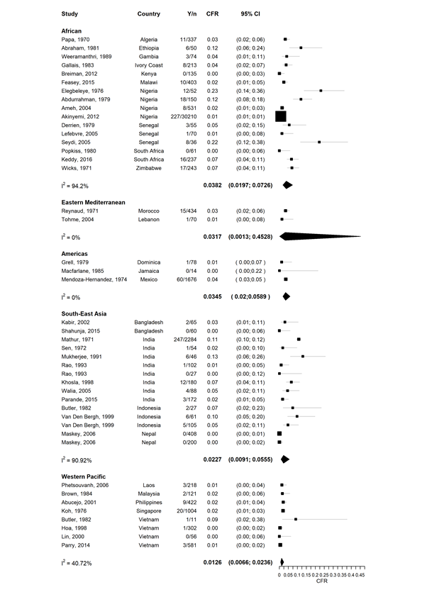

## Duration of infection - 11.88 days (SD, 6.62)

Duration of infection was estimated from three typhoid fever outbreak investigation studies; [Mamo et al.](https://academicjournals.org/journal/JIDI/article-full-text/63F799C57384), [Neil et al.](https://academic.oup.com/cid/article/54/8/1091/366183), [Roy et al.](https://journals.lww.com/ijmr/fulltext/2016/44040/Epidemiological_investigation_of_an_outbreak_of.16.aspx) Mamo and Neil reported the median duration of onset of illness before visiting the health facility as **11.8 days (range, 1days) and 7 days (range, 1–150 days).** Roy reported the duration of infection of each patient investigated for the 2014 outbreak in India. The calculated median and range of duration of infection was **12 days (range, 1-20)**. [**[Mamo, 2018; J. Infect. Dis. Immun.]**](https://academicjournals.org/journal/JIDI/article-full-text/63F799C57384) [**[Neil, 2012; CID]**](https://academic.oup.com/cid/article/54/8/1091/366183) [**[Roy, 2016; indian j med res]**](https://journals.lww.com/ijmr/fulltext/2016/44040/Epidemiological_investigation_of_an_outbreak_of.16.aspx)

The meta-analysis for the 3 medians and range was estimated to mean and standard deviation and performed using the inverse variance method. (Hozo et al. (2005)). The estimated mean duration of infection was **11.88 days** with a combined standard deviation of approximately **6.62 days**. (draft, need to be confirmed)

[**https://chatgpt.com/share/c870cb94-058e-4fda-884e-f5dcb17d2da1**](https://chatgpt.com/share/c870cb94-058e-4fda-884e-f5dcb17d2da1)

## Percent of infections that progress to the carrier - 0.003

Progression percentage to become typhoid fever carrier estimate was reproduced from [**[Ames, 1943; Am. J. Public. Health Nations Health]**](https://www.ncbi.nlm.nih.gov/pmc/articles/PMC1527221/). Under age 20, the percentage of infection that progresses to the carrier was fixed at 0.3%. The probability for 20 and over age increased to 5.3% and the all-age probability was 2.9%.

|  |  |  |  |
| --- | --- | --- | --- |
| Age at time of typhoid | cases | carriers | Percent cases resulting in carriers |
| <10 | 628 | 2 | 0.3% |
| 10-19 | 902 | 3 | 0.3% |
| 20-29 | 579 | 12 | 2.1% |
| 30-39 | 409 | 18 | 4.4% |
| 40-49 | 295 | 26 | 8.8% |
| 50-59 | 188 | 19 | 10.1% |
| >=60 | 129 | 10 | 7.8% |
| <20 | 1530 | 5 | 0.3% |
| >=20 | 1600 | 85 | 5.3% |
| All ages | 3130 | 90 | 2.9% |

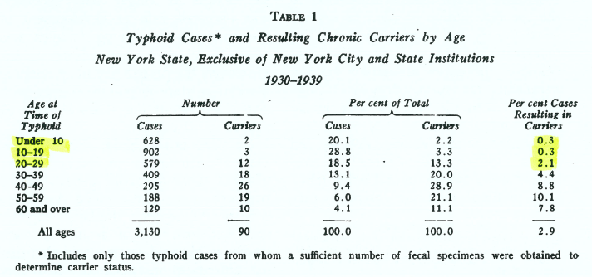

## Duration of carriage - 10 years [5–15] Based on Ames et al.[48], Bhan et al.[49], Gunn et al.[50]

Weyant et al. reported Duration of carriage as 10 years [5–15] referencing [[Ames](https://www.ncbi.nlm.nih.gov/pmc/articles/PMC1527221/), 1943; Am J Public Health Nations Health], [[Bhan](https://www.sciencedirect.com/science/article/pii/S0140673605671814?via%3Dihub), 2005; Lancet], [[Gunn](https://www.ncbi.nlm.nih.gov/pmc/articles/PMC4252485/), 2014; Trends Microbiol.]. However, The duration value could not be found in all 3 articles. [[Weyant, 2024; Vaccine]](https://www.ncbi.nlm.nih.gov/pmc/articles/PMC11033679/#b0180)

No other modeling article reported the duration of carriage.

## Relative infectiousness of carriers, compared with acute infections

Weyant et al. reported Relative infectiousness of carriers, compared with acute infections as 7.5 % [5.5–9.5] sourcing estimate calibrated from [[Lo, 2018; JID]](https://www.ncbi.nlm.nih.gov/pmc/articles/PMC6226717/). [[Weyant, 2024; Vaccine]](https://www.ncbi.nlm.nih.gov/pmc/articles/PMC11033679/#b0180)

Lo et al. fitted the Relative infectiousness of long-term carriers as frequency distribution below. (Supplementary Figure 1) [[Lo, 2018; JID]](https://www.ncbi.nlm.nih.gov/pmc/articles/PMC6226717/)

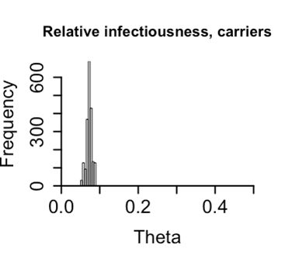

Blicke et al., estimated relative infectiousness of carriers compared with acute infection as 0.25 with beta distribution of (a=6.34, b=19.4). Blicke noted that they retrieved the indirect protection data observed from Vi-polysaccharide vaccine cluster-randomised trial in Kolkata, India.[[Sur, 2009; NEJM](https://pubmed.ncbi.nlm.nih.gov/19625715/)] (Table 1) [[Bilcke, 2019; Lancet ID]](https://www.thelancet.com/journals/laninf/article/PIIS1473-3099(18)30804-1/fulltext#supplementaryMaterial)

Antillón et al. estimated a prior distribution for the relative infectiousness of chronic carriers (***r***) by leveraging data from a cluster-randomized study of Vi-polysaccharide vaccine in Kolkata which uses the same data. However, Antillón estimates the Relative infectiousness of carriers as a fraction of 0.35 (0.15, 0.67) (Supplementary table 2) [[Antillón, 2017; Vaccine.]](https://www.ncbi.nlm.nih.gov/pmc/articles/PMC5462484/)

The two articles share co-authors (Ginny’s team)

**S3 Estimating the contribution of chronic carriers to transmission**

We estimated a prior distribution for the relative infectiousness of chronic carriers (***r***) by leveraging data from a cluster-randomized study of Vi-polysaccharide vaccine in Kolkata. **[[Sur D, Ochiai RL, Bhattacharya SK, Ganguly NK, Ali M, et al. (2009) A cluster-randomized effectiveness trial of Vi typhoid vaccine in India. N Engl J Med 361: 335–344.](https://pubmed.ncbi.nlm.nih.gov/19625715/)]**

As previously shown, the indirect protection conferred on a population is a function of the contribution of chronic carriers to the overall force of infection.[Pitzer VE, Bowles CC, Baker S, Kang G, Balaji V, Farrar JJ, et al. Predicting the impact of vaccination on the transmission dynamics of typhoid in South Asia: a mathematical modeling study. PLoS Negl Trop Dis. 2014;8: e2642. doi:10.1371/journal.pntd.0002642]

The contribution of the chronic carriers is the product of two components:

1) the prevalence of chronic carriers in the population and

2) the relative infectiousness of chronic carriers (***r***) as compared to acute typhoid infections.

**The prevalence of chronic carriers** (the first component) was based on the model output, while the trial data allowed us to **estimate the relative infectiousness of chronic carriers (the second component).**

We fit the transmission model to the incidence data in Kolkata while fixing r at values from 0.01 to 1 in increments of 0.01. We estimated the transmission rate parameter conditional on each value of r, and then simulated the overall and indirect effects of a mass vaccination campaign using the Vi-polysaccharide vaccine, assuming 60% coverage of individuals 2 years of age and older, as described in Sur et al.[**Sur D, Ochiai RL, Bhattacharya SK, Ganduly NK, Ali M, Manna B, et al. A cluster-randomized effectiveness trial of Vi typhoid vaccine in India. N Engl J Med. 2009;361: 335–344. doi:10.1056/NEJMc091690**]

Briefly, the indirect effect of vaccination is the percent decrease in incidence among unvaccinated individuals in a partially vaccinated population compared to the incidence in a completely unvaccinated population. The overall effect is defined as the incidence among both vaccinated and unvaccinated individuals in the population with vaccination compared to the incidence in the unvaccinated population.[Halloran ME, Longini IM, Struchiner CJ. Design and interpretation of vaccine field studies. Epidemiol Rev. 1999;21: 73–88. ]

We then evaluated the likelihood of each parameter set (including r) by comparing the value of the simulated indirect effect against the observed indirect effect in the trial, which we parameterized using a beta distribution according to the method of moments **(IE~Beta(3.27,4.16))**.

We recovered a comparable sample of parameter sets if we evaluated the likelihood against the observed overall effect **(OE~Beta(18.00,13.58))**.

In summary, for each of the 100 values of r from 0.01 to 1 we:

1) Estimated the transmission parameter (***b***) conditional on the fixed value of ***r***.

2) Simulated the impact of vaccination and calculated the model-predicted indirect effect.

3) Evaluated the likelihood of the model-predicted indirect effect based on the current parameter set (***r***, ***b***) given the beta-distributed observed indirect effect.

We then sampled from the 100 values of ***r*** weighted by the likelihood in step 3.

Finally, we fit a beta distribution to the sampled values of ***r***, **resulting in Beta(3.69, 6.79)**, which we used as the prior distribution for ***r*** when we fit the dynamic model to the incidence data in all sites.

# 

# Vaccine‐related parameters

## 

## Vaccine efficacy 83% - 3 years

Patel et al., reported the efficacy of Vi-TT(Typbar-TCV) in Malawi patients as 78.3% for 4.61 years of follow-up which is the longest single study. [[Patel, 2024; Lancet]](https://www.sciencedirect.com/science/article/pii/S0140673623020317?ssrnid=4411421&dgcid=SSRN_redirect_SD)

Along with the Malawian trial, in April 2024, Batool et al., reported in a systematic review and meta-analysis that the pooled efficacy of a single shot of TCV at 2 years post-immunization was 83% with four RCTs ([Mitra, 2016; Hum Vaccin Immunother](https://www.ncbi.nlm.nih.gov/pmc/articles/PMC4962969/), [[Qadri, 2021, Lancet]](https://www.thelancet.com/journals/lancet/article/PIIS0140-6736(21)01124-7/fulltext), [[Shakya, 2021; Lancet Global Health]](https://www.thelancet.com/journals/langlo/article/PIIS2214-109X(21)00346-6/fulltext), [[Patel, 2021; NEJM]](https://www.nejm.org/doi/full/10.1056/NEJMoa2035916)). [[Batool, 2024; Lancet Global Health]](https://www.thelancet.com/journals/langlo/article/PIIS2214-109X(23)00606-X/fulltext#%20)

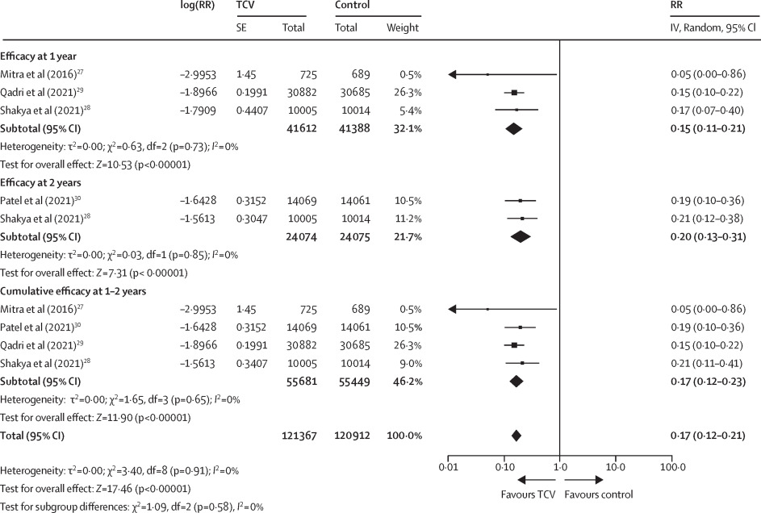

**[Patel, 2024; Lancet] - Malawi**

“In the intention-to-treat population, efficacy of **Vi-TT(Typbar-TCV)** was 78·3% (95% CI 66·3–86·1), and 163 (129–222) children needed to be vaccinated to prevent one case.”

Protective efficacy of Vi-TT (95% CI) - Cumulative time since vaccination

1 years 83·4% (60·1–94·3)

2 years 80·7% (63·8–90·5)

3 years 80·1% (65·0–89·4)

4 years 77·1% (63·7–86·1)

4.61 years 78·3% (66·3–86·1)

**[Patel, 2021; NEJM] - Malawi**

Overall, the efficacy of **Vi-TCV(Typbar-TCV)** was 80.7% (95% confidence interval [CI], 64.2 to 89.6) in the intention-to-treat analysis and 83.7% (95% CI, 68.1 to 91.6) in the per-protocol analysis.

**[Shakya, 2021; Lancet Global Health] - Nepal**

A single dose of **Typbar TCV** had an efficacy of **81·6%** (95% CI 58·8–91·8; p<0·001) in the first year after vaccination.

The protective efficacy of **Typbar TCV** against blood culture-confirmed typhoid fever at 2 years was **79·0%** (95% CI 61·9–88·5; p<0·0001).

**[Qadri, 2021, Lancet] - Bangladesh**

**Vi-TT** vaccinees (total Vi-TT protection **85%;** 97·5% CI 76 to 91, p<0·0001).

The study population was followed for an average of 17·1 months.

**[Yousafzai, 2021; Lancet Global Health] - Pakistan**

**Typbar-TCV** Vaccine effectiveness was 55% (95% CI 52–57) against suspected S Typhi (regardless of culture confirmation), **95%** (93–96) against culture-confirmed S Typhi, and **97%** (95–98) against XDR S Typhi.

This cohort was periodically followed up (at 28–42 days, 6 months, 1 year, and 2 years) for serial measurement of serum antibody concentrations against S Typhi Vi-IgG (data not reported), and fortnightly telephone calls were made by the research assistants to enquire about history of illness, including fever or admission to hospital, or both, during the past 2 weeks. Data on the immunogenicity of Typbar-TCV will be published at a later date, once all blood samples have been analysed for Vi-IgG concentrations.

Vietnam reported that two doses of another typhoid conjugate vaccine (Vi bound to non-toxic recombinant Pseudomonas aeruginosa exotoxin A) had a protective efficacy of 91·5% (95% CI 77·1–96·6) against culture-confirmed S Typhi for 27 months.Lin FYC Ho VA Khiem HB et al.

The efficacy of a Salmonella typhi Vi conjugate vaccine in two-to-five-year-old children.

N Engl J Med. 2001; 344: 1263-1269

## Indirect vaccine protection - 19%

## 

Qadri et al. reported indirect vaccine protection of Vi-TT in the Bangladesh trial as **19%**. [**[Qadri, 2021, Lancet]**](https://www.thelancet.com/journals/lancet/article/PIIS0140-6736(21)01124-7/fulltext)

## 

## Duration of immunity (TCV) - 10 years

The following calculation was estimated through linear regression analysis with the 5 efficacy points derived from Patel et al.(2024).[[Patel, 2024; Lancet]](https://www.sciencedirect.com/science/article/pii/S0140673623020317?ssrnid=4411421&dgcid=SSRN_redirect_SD)

**Protective Efficacy = −1.54 × (Time (years)) + 84.41**

From the linear regression, at least in 10 years, the protective efficacy of TCV would last 69% which we assumed the duration of immunity to be 10 years. (draft, might need another fitting or modeling for better estimation)

|  |  |
| --- | --- |
| Timepoint after TCV vaccination (years) | Efficacy (%) |
| 1 | 83.4 |
| 2 | 80.7 |
| 3 | 80.1 |
| 4 | 77.1 |
| 4.61 | 78.3 |

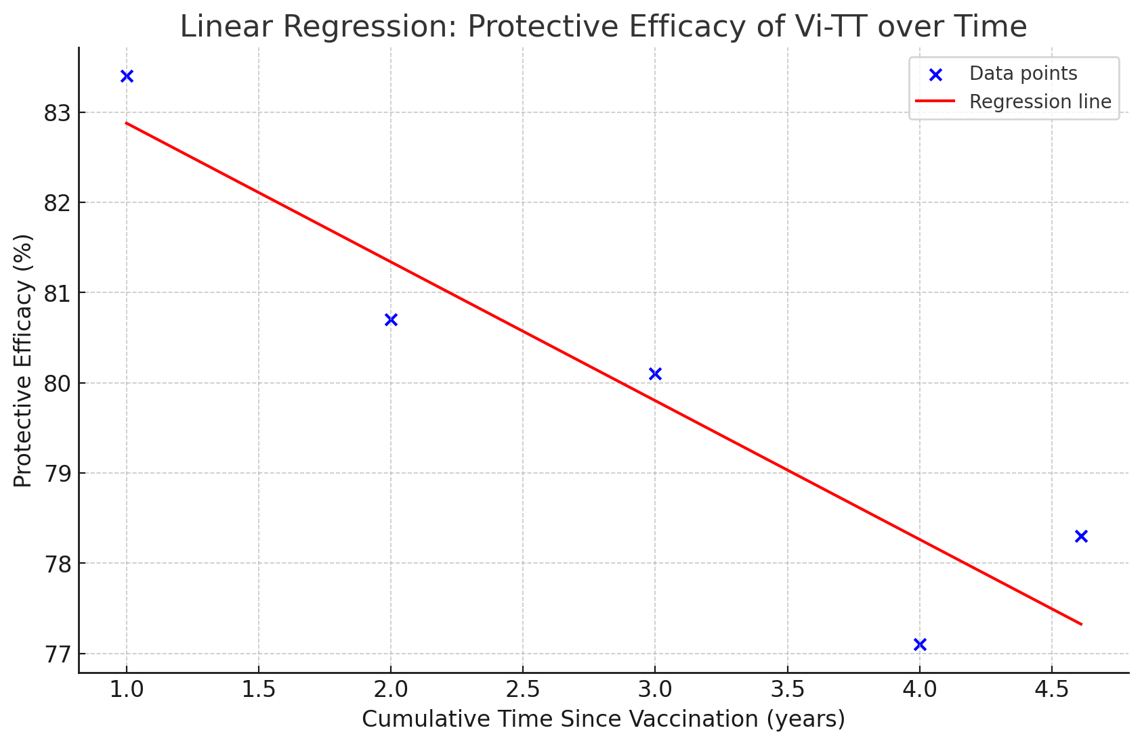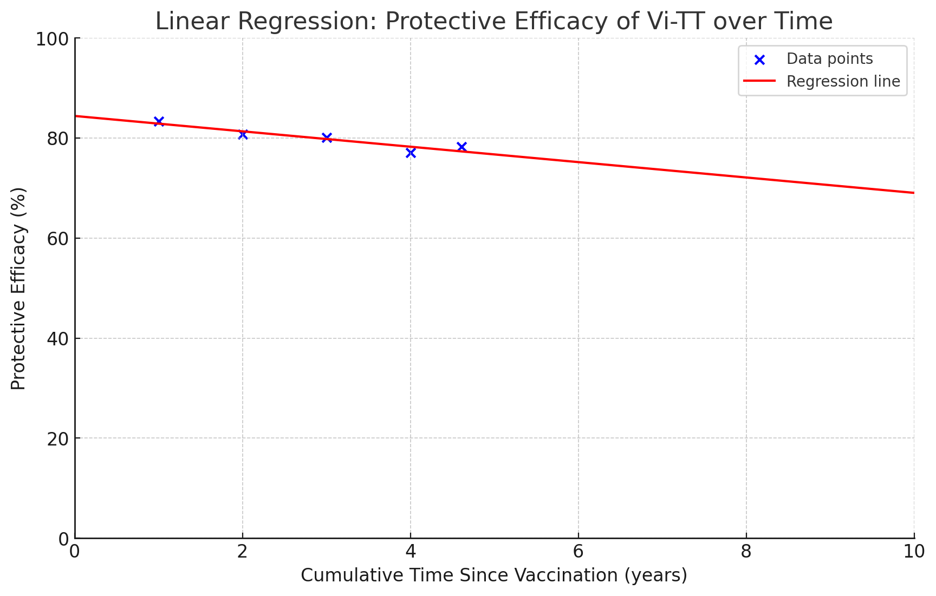

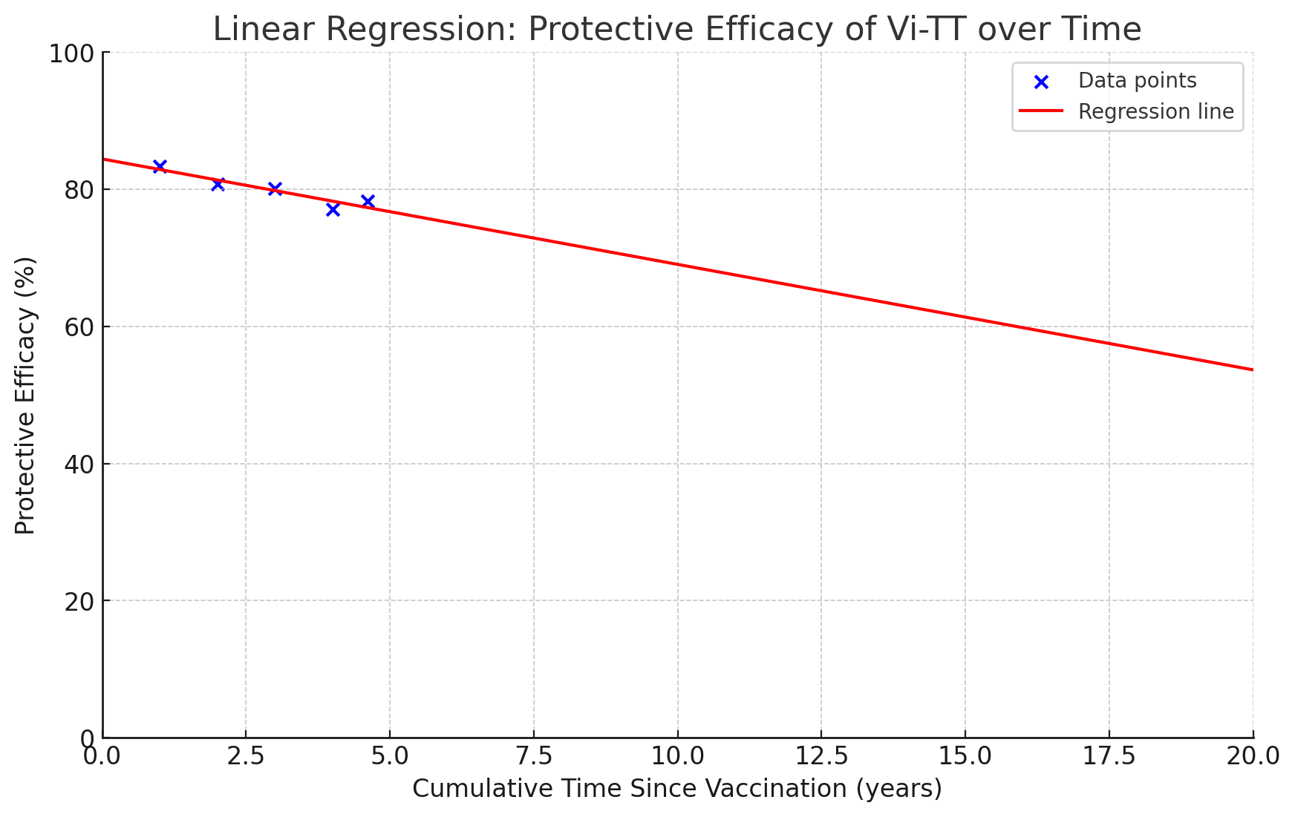

## Onset of protection from vaccine - 7 days assumed, at least 28 days (10 days possible(OCV))

From all 3 types of TCV(Vi-TT, Vi-DT, Vi-CRM197) articles, at least in 28 days, 100% seroconversions are achieved. The shortest timeline for seroconversion analysis was 28 days, therefore there was no straight evidence of which timepoint for the onset of TCV protection.[[Bhutta, 2014; Lancet infectious diseases]](https://www.thelancet.com/journals/laninf/article/PIIS1473-3099(13)70241-X/abstract) [[Jin, 2017; Lancet]](https://www.thelancet.com/journals/lancet/article/PIIS0140-6736(17)32149-9/fulltext), [[Rai, 2022; Lancet Infectious diseases]](https://www.thelancet.com/journals/laninf/article/PIIS1473-3099(21)00455-2/fulltext)

No other conjugate vaccines such as the Pneumococcal Conjugate Vaccine (PCV13), Meningococcal Conjugate Vaccine (MenACWY), or Haemophilus influenzae type b (Hib) Vaccine had evidence of immunogenicity data.

However, one COVID-19 Pfizer booster vaccine trial suggested that at least in 7 days, the vaccine efficacy could be obtained as 47.3%. [[Moreira, 2022; NEJM]](https://www.nejm.org/doi/10.1056/NEJMoa2200674)

Although Vaxchora is not a conjugate vaccine, the trial of OCV shows 90.3% efficacy in 10 days. [[Chen, 2016; CID]](https://academic.oup.com/cid/article/62/11/1329/1745227)

[Single-dose Live Oral Cholera Vaccine CVD 103-HgR Protects Against Human Experimental Infection With Vibrio cholerae O1 El Tor | Clinical Infectious Diseases | Oxford Academic](https://academic.oup.com/cid/article/62/11/1329/1745227)

* Clinical Response to Challenge at 10 Days and 3 Months Postvaccination
  + Challenge with virulent V. cholerae O1 elicited MSC diarrhea in 39 of 66 (59.1%) placebo recipients but in only 2 of 35 (5.7%) vaccinees challenged at **10 days (P < .0001; efficacy 90.3%)** postvaccination and in only 4 of 33 (12.1%) vaccinees challenged **3 months postvaccination (P < .0001; efficacy 79.5%)**

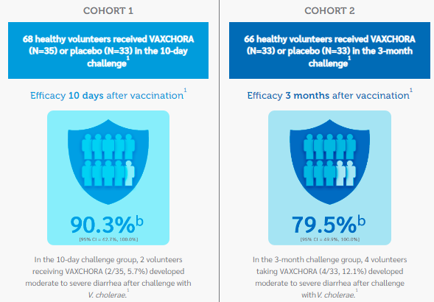

[Vaxchora](https://vaxchora.com/#:~:text=VAXCHORA%20demonstrated%20a%20seroconversion%20rate%20of%2098.5%25%20in%20subjects%202%20through%2017%20years%20of%20age%20at%2010%20days%20post%2Dvaccination1)

* Study 5 — Immunogenicity Study in Children and Adolescents Aged 2–17
* Study Design: Study 5 was a randomized, double-blind, saline placebo-controlled safety and immunogenicity study conducted in the US. A total of 550 subjects 2 through 17 years of age not previously exposed to cholera were randomized 6:1 to receive one dose of VAXCHORA or placebo. Randomization was stratified by age into 3 cohorts: Cohort 1: 12 to <18 years of age; Cohort 2: 6 to <12 years of age; Cohort 3: 2 to <6 years of age.
* VAXCHORA demonstrated a **seroconversion rate of 98.5%** in subjects **2 through 17 years of age at 10 days** post-vaccination

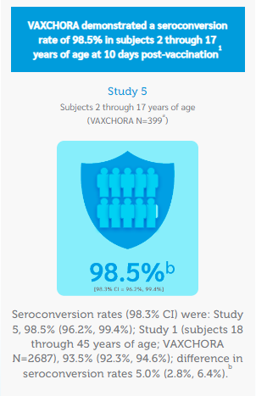

[Safety and Efficacy of a Third Dose of BNT162b2 Covid-19 Vaccine | New England Journal of Medicine](https://www.nejm.org/doi/10.1056/NEJMoa2200674)

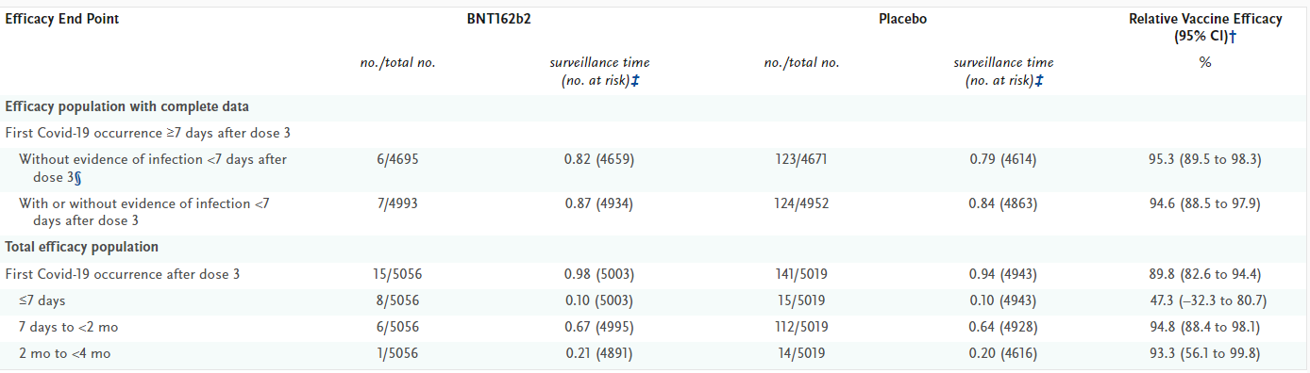

* [Immunogenicity and safety of the Vi-CRM197 conjugate vaccine against typhoid fever in adults, children, and infants in south and southeast Asia: results from two randomised, observer-blind, age de-escalation, phase 2 trials](https://www.thelancet.com/journals/laninf/article/PIIS1473-3099(13)70241-X/abstract) | Lancet Infectious Disease
  + Vi-CRM197 is used by EuTYPH-C (EuBiologic)
    - adults (aged 18–45 years), children (24–59 months), older infants (9–12 months), infants (6–8 weeks)
    - Rate of seroconversion was 100% in adults, children, and older infants after the first dose of conjugate vaccine **(28 days)**, and seroconversion was 85% or more 6 months after immunisation. **In infants aged 6–8 weeks, seroconversion reached 85% after the third dose,** but decreased to 25% 6 months after immunization
    - seroconversion is defined as a post-vaccination **increase of at least four times the pre-vaccination Vi antibody concentration**.
* [Safety and immunogenicity of the Vi-DT typhoid conjugate vaccine in healthy volunteers in Nepal: an observer-blind, active-controlled, randomised, non-inferiority, phase 3 trial - The Lancet Infectious Diseases](https://www.thelancet.com/journals/laninf/article/PIIS1473-3099(21)00455-2/fulltext)
  + Vi-DT is used by BioTCV (PT Biofarma) and SKYTyphoid (SK Bioscience) and TYPHIBEV (Biological E.)
    - In the immunogenicity analysis **(at 4 weeks post vaccination)**, the anti-Vi-IgG seroconversion rate in all age strata was
    - **99·33%** (97·5% CI 98·61 to 99·68; 1331 of 1340 participants) in **Vi-DT** vaccine groups
    - **98·88%** (97·10 to 99·57; 441 of 446) in **Vi-TT** vaccine group D.
    - The difference in seroconversion rates between Vi-DT vaccine groups A–C combined versus Vi-TT group D was **0·47%** (97·5% CI −0·68 to 1·61), **indicating non-inferiority of the Vi-DT vaccine.**
* [Efficacy and immunogenicity of a Vi-tetanus toxoid conjugate vaccine in the prevention of typhoid fever using a controlled human infection model of Salmonella Typhi: a randomised controlled, phase 2b trial - The Lancet](https://www.thelancet.com/journals/lancet/article/PIIS0140-6736(17)32149-9/fulltext)
  + Vi-TT is used by Typbar-TCV (Bharat Biotech)
    - Seroconversion **(≥four-fold rise in antibody titre 28 days after vaccination)** was **100% in the Vi-TT group** and 88·6% in the Vi-PS group.
    - Vi-TT vaccination induced significantly higher anti-Vi IgG titres than Vi-PS, geometric mean titre (GMT) adjusted for baseline of 562·9 EU/mL (95% CI 396·9–798·4) versus 140·5 EU/mL (91·0–216·9; p<0·0001; figure 3B; appendix p 2)

## Vaccine supply (2022-2024 in millions) - 40 million/yr

## 

- 39.2 for 3 years (~13/yr), additional SKYtyphoid (~5)

UNICEF has awarded 39.2 million doses of 2 types of TCV for 3 years in 2022-2024 as Long-term Arrangement Awards, estimated to be 13 million doses per year. [[UNICEF, 2022]](https://www.unicef.org/supply/reports/typhoid-conjugate-vaccines-tcv-supply-and-demand-update) The demand forecast conducted by GAVI has estimated annual demand to be around 40 million doses per year with 20 million to 70 million doses in range. In addition, the new TCV by SK Bioscience has received WHO PQ facilitating the expectation of achieving the demand forecast. [[GAVI;2022]](https://www.gavi.org/news/document-library/typhoid-conjugate-vaccine-roadmap-public-summary)

Therefore, based on the UNICEF procurement history and demand forecast, we fixed the annual TCV supply parameter to **40 million.**

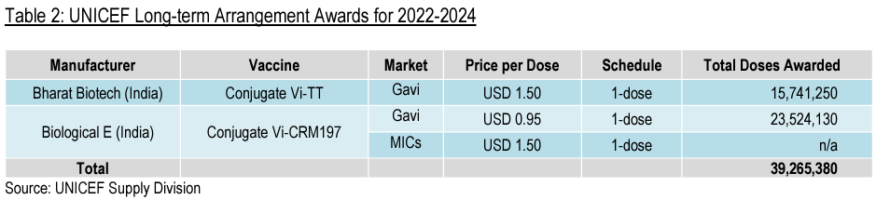

[Progress in the Typhoid Conjugate Vaccine Program Rollout Supported by Gavi During the COVID-19 Pandemic and the Path Forward - PMC](https://www.ncbi.nlm.nih.gov/pmc/articles/PMC10236508/#:~:text=TCV%20supply%20is%20expected%20to,health%20services%20that%20they%20need).

Gavi. Market shaping roadmaps. 2022Available at:<https://www.gavi.org/our-alliance/market-shaping/supply-and-procurement-roadmaps>.

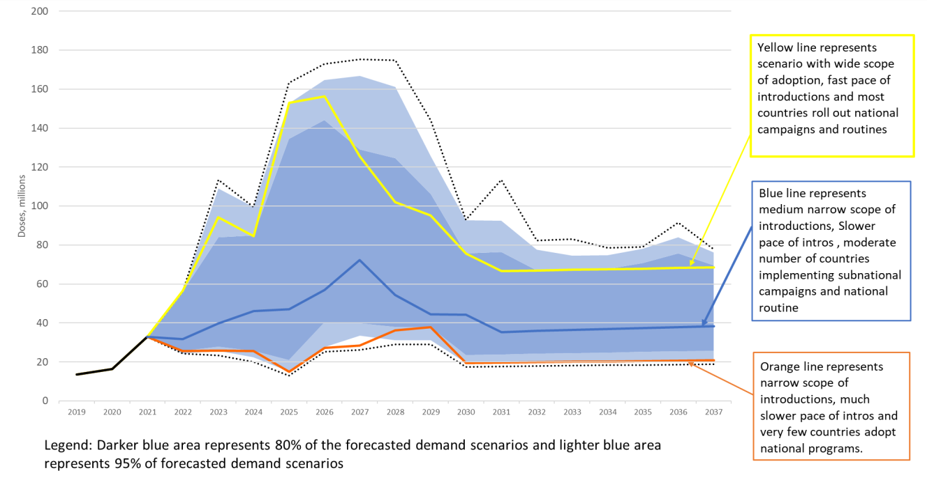

[Vaccine Deep Dive: 2023 Gavi Funding & Process Briefings-JUL 2023](https://www.coalitionagainsttyphoid.org/wp-content/uploads/2023/11/Typhoid-Deep-Dive-webinar-July-2023.pdf)

## Vaccine Coverage - 82% (median, range 63%-95%), 83.4% (mean)

1. Median position is at:.30,084,401​/2 = 15,042,200
2. **Find the cumulative population and locate the median:**
   * After 63%; 1,197,000
   * After 69%; 5,470,172.26
   * After 70.9%; 5,583,612.26
   * After 77.5%; 10,124,069.385
   * After 82%; 18,334,948.965
   * After 84%; 18,357,088.485
   * After 88%; 23,805,656.005
   * After 95%; 30,084,400.805
3. Since the cumulative population reaches 15,042,200 between 10,124,070 and 18,334,949, the median coverage percentage falls within the 82% category.

Thus, the **median coverage percentage** is **82%**.

1. **Calculate the mean percentage:**

Mean=30,084,401/36,053,474≈83.42%

Therefore, the mean coverage percentage is approximately **83.42%**.

**Table #. was reproduced with real-world data reported as ‘Typhoid conjugate vaccine introductions into routine immunization programs - worldwide, 2019–2022’** [**[Hancuh, 2023; MMWR]**](https://www.ncbi.nlm.nih.gov/pmc/articles/PMC9949843/#FN5) **referred from** [**World Health Organization. SAGE meeting; April 4–7, 2022**](https://terrance.who.int/mediacentre/data/sage/SAGE_eYB_Apr2022.pdf)**. The median value of vaccine campaign coverage was calculated with post-campaign coverage and target population size.**

Table #. Typhoid conjugate vaccine introductions into routine immunization programs - worldwide, 2019–2022

|  |  |  |  |  |  |
| --- | --- | --- | --- | --- | --- |
| **Country** | **Targeted vaccination area** | **Target population size** | **Catch-up campaign dates** | **Post-campaign coverage, %** | **Estimated actual population vaccinated** |
| India, | Navi Mumbai Municipal Corporation | 160,000 | July-Aug 2018 in 11 out of 22 Urban Public Health Center (UPHC) areas. | 70.9%  (range from 46% in high-income to 92% in low-income areas) | 113,440 |
| Pakistan | Sindh | 10,013,569 | Nov 2019 | 82 | 8,210,879.58 |
| Punjab and Islamabad | 12,383,108 | Feb 2021 | 88 (Punjab)  69 (Islamabad) | 5,448,567.52  4,273,172.26 |
| Broader Punjab | 6,609,204 | Jun 2021 | 95 | 6,278,743.80 |
| Liberia | National | 1,900,000 | Apr 2021 | 63 | 1,197,000 |
| Zimbabwe | National | 5,861,235 | May 2021 | 77.5 | 4,540,457.13 |
| Samoa | Upolu, Apia urban area | 26,358 | Aug–Sep 2021 | 84 | 22,139.52 |
| Total |  | 36,953,474 |  | 82 (range 63-95) | 30,084,401 |

## Vaccine procurement cost per dose - $ (0.19 and $ 0.30)

**For GAVI-eligible countries, UNICEF has fixed the 5-dose vial TCVs at a flat rate of $0.95 (Biologic E, 2022-2024) and $ 1.50 (Bharat, 2018-2024). With the 3rd WHO PQ TCV by SK Bioscience, we assumed the price would be consistent in this range. [**[**UNICEF - Typhoid Conjugate Vaccine (TCV) price data**](https://www.unicef.org/supply/media/10086/file/Typhoid-vaccine-prices-17112021.pdf)**] The UNICEF procurement price of TCV is for 5-dose vial, in which per dose, it can be calculated as $ 0.19 and $ 0.30.**

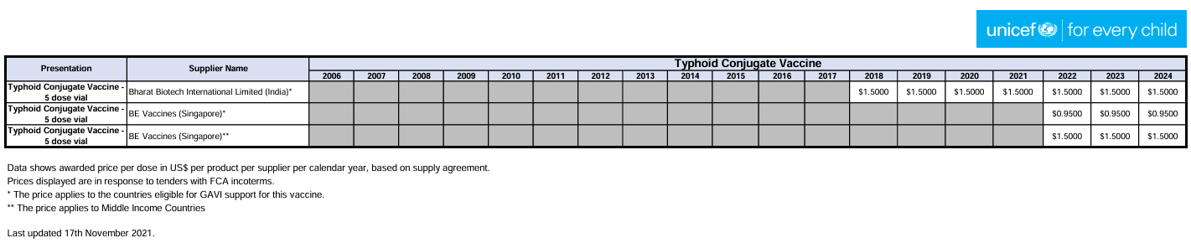

## Syringes and safety equipment per dose - $1.50 (financial cost), $2.40 (economic cost)

The market cost of the TCV vaccine introduction in India (5-dose vial) was $2.93 ($ 0.57 per dose) and 36% of the vaccines were subsidized via donation of a share of doses by the distributor, Bharat Biotech.

With the 36% subsidies, the vaccine cost per 5-dose vial could be calculated as $1.86 in which $0.37 per dose. If $0.37 of vaccine cost per dose is subtracted from **Vaccine, syringe, and safety boxes’** cost, we could estimate the cost for **Syringes and safety equipment per dose as** $1.50 and $2.40 as financial cost and economic cost, respectively.

|  |  |  |
| --- | --- | --- |
|  | Total weighted average cost of UHP level (11 UHPs) and NMMC cost | |
| Activity | [Financial cost per dose-USD (INR)*](https://www.ncbi.nlm.nih.gov/pmc/articles/PMC10022355/table/pgph.0001396.t004/?report=objectonly#t004fn001) | [Economic cost per dose-USD (INR)*](https://www.ncbi.nlm.nih.gov/pmc/articles/PMC10022355/table/pgph.0001396.t004/?report=objectonly#t004fn001) |
| **Vaccine, syringe, and safety boxes** | **$1.87 (127.70)** | **$2.96 (202.40)** |

## Campaign delivery costs per dose - $0.38 (financial cost), $1.49 (economic cost)

**Song et al. reported the delivery cost of TCV introduction in Navi Mumbai, India, in 2018. They reported the total cost (including vaccine, syringes, and safety boxes) and total delivery cost (excluding vaccine, syringes, and safety boxes), which were reported by the financial and economic cost per dose administered.** [**[Song, 2023; Plos GPH]**](https://www.ncbi.nlm.nih.gov/pmc/articles/PMC10022355/)

**The definition of the two different costs is as follows:**

**Financial costs = Direct expenditures**

**Economic costs = Financial costs + Personnel Costs + Training materials + Travel costs + Organizational expenses**

**The total financial and economic costs of TCV introduction per dose were $2.25 and $4.45, respectively. With the exclusion of vaccines, syringes, and safety boxes, total financial and economic delivery costs were $0.38 and $1.49, respectively.**

## 

# 

# Economic parameters

## Cost of Illness (for symptomatic infections)

[typhoid fever cost of illness in Africa](https://docs.google.com/spreadsheets/d/1zf-Knj3zct2rXTqJHSIKdAnxpeXHghsFs7pyT7DeGfE/edit?gid=457155238#gid=457155238)

Cost of illness studies were conducted in two African countries; Malawi (2020) and Tanzania (2010). Inflation for the cost of illness in both studies was adjusted using CPI (Consumer Price Index) suggested by [Turner et al, 2019; Value in Health](https://www.valueinhealthjournal.com/article/S1098-3015(19)32149-7/fulltext#%20). [[Limani, 2022; PLoS One]](https://www.ncbi.nlm.nih.gov/pmc/articles/PMC9683590/) [[Riewpaiboon, 2014; J Health Popul Nutr.]](https://www.ncbi.nlm.nih.gov/pmc/articles/PMC4221443/)

**Adjusted Cost = Original Cost× CPI in Original Year / CPI in Target Year​**

According to the U.S. Bureau of Labor Statistics, <https://data.bls.gov/timeseries/CUUR0000SA0>

**Relevant CPI values were retrieved:**

**2010**: 218.056

**2020**: 258.811

**2024**: 314.069 (as of May 2024)

Table #. Inflation adjustment by CPI

|  |  |  |  |
| --- | --- | --- | --- |
| **Year** | **May** | **Annual Average** | **Cost Multiplier to 2024 USD** |
| 2010 | 218.178 | **218.055** | 1.440 |
| 2020 | 256.394 | **258.811** | 1.213 |
| 2024 | **314.069** | 311.738 | Ref. |

The cost of typhoid fever illness in Africa is summarized in table #. Both originally reported costs and adjusted USD in 2024 are outlined.

Table #. Cost of illness of typhoid fever

|  |  |  |  |  |  |
| --- | --- | --- | --- | --- | --- |
| **Reference** | **Parameter** | **Cost in Original Year** | **Range (Original Year)** | **Cost (USD in 2024)** | **Range (2024 USD)** |
| Malawi, (2020 U.S. $)  Limani et al, 2022 | Children Inpatients | 311.5 | 178.54 - 444.45 | 377.87 | 216.52 - 539.05 |
| Malawi, (2020 U.S. $)  Limani et al, 2022 | Children Outpatients | 70.29 | 32.58 - 110.19 | 85.27 | 39.52 - 133.61 |
| Malawi, (2020 U.S. $)  Limani et al, 2022 | Adults Inpatients | 473.54 | 267.29 - 679.79 | 574.38 | 324.24 - 824.62 |
| Malawi, (2020 U.S. $)  Limani et al, 2022 | Adults Outpatients | 51.16 | 27.86 - 74.61 | 62.03 | 33.81 - 90.50 |
| Tanzania, (2010 U.S. $)  Riewpaiboon et al, 2014 | Total cost of illness | 138.28 | 54.43 - 399.45 | 199.13 | 78.39 - 575.20 |
| Tanzania, (2010 U.S. $)  Riewpaiboon et al, 2014 | Children (up to 15 years) | 151.24 | 103.17 - 399.45 | 217.79 | 148.56 - 575.20 |
| Tanzania, (2010 U.S. $)  Riewpaiboon et al, 2014 | Adults (>15 years) | 119.35 | 54.43 - 245.84 | 171.82 | 78.39 - 353.01 |

or

|  |  |  |  |  |  |
| --- | --- | --- | --- | --- | --- |
| **Reference** | **Parameter** | **Cost in Original Year (USD)** | **Range in Original Year (USD)** | **Cost (USD in 2024)** | **Range (2024 USD)** |
| Malawi, (2020 U.S. $)  Limani et al, 2022 | Children | 190.9 | 105.56 - 277.32 | 231.57 | 128.02 - 336.33 |
| Malawi, (2020 U.S. $)  Limani et al, 2022 | Adults | 262.35 | 147.58 - 377.20 | 318.21 | 179.02 - 457.56 |
| Tanzania, (2010 U.S. $)  Riewpaiboon et al, 2014 | Children (up to 15 years) | 151.24 | 103.17 - 399.45 | 217.79 | 148.56 - 575.20 |
| Tanzania, (2010 U.S. $)  Riewpaiboon et al, 2014 | Adults (>15 years) | 119.35 | 54.43 - 245.84 | 171.82 | 78.39 - 353.01 |

or

|  |  |  |  |  |  |
| --- | --- | --- | --- | --- | --- |
| **Reference** | **Parameter** | **Cost in Original Year (USD)** | **Range in Original Year (USD)** | **Cost (USD in 2024)** | **Range (2024 USD)** |
| Malawi, (2020 U.S. $) Limani et al, 2022 & Tanzania, (2010 U.S. $) Riewpaiboon et al, 2014 | Children | 171.07 | 104.37 - 338.39 | 224.68 | 138.29 - 455.77 |
| Malawi, (2020 U.S. $) Limani et al, 2022 & Tanzania, (2010 U.S. $) Riewpaiboon et al, 2014 | Adults | 190.85 | 101.01 - 311.52 | 245.02 | 128.71 - 405.29 |

## 

## Disability-Adjusted Life-Years

**DALY= YLD + YLL**

**YLDs = incidence cases X proportion of cases X duration X Disability weight**

[GBD 2017 Typhoid and Paratyphoid Collaborators](https://www.ncbi.nlm.nih.gov/pmc/articles/PMC6437314/#sec1) estimated the proportion of cases, duration (years), and disability weights with 4 different states of typhoid fever disease severity; moderate, severe uncomplicated, severe with GI bleeding, severe typhoid fever with other complications. With cumulation, the proportion of YLDs was estimated to be 0.010101.

YLD was estimated by each incidence case in countries extracted from [Kim et al., 2024; PLOS NTD](https://journals.plos.org/plosntds/article?id=10.1371/journal.pntd.0011902) and multiplied with 0.010101.

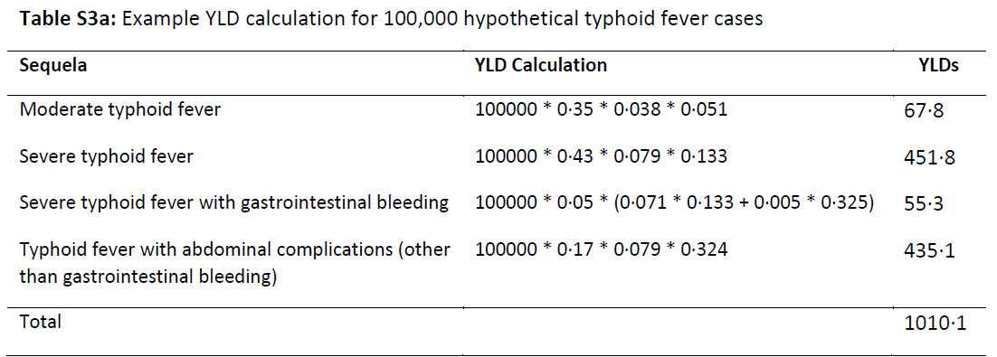

**YLLs = number of deaths × standard life expectancy at age of death in years.**

Table S8: Number of typhoid/paratyphoid cases and deaths, by country or non-sovereign location, in 1990 and 2017

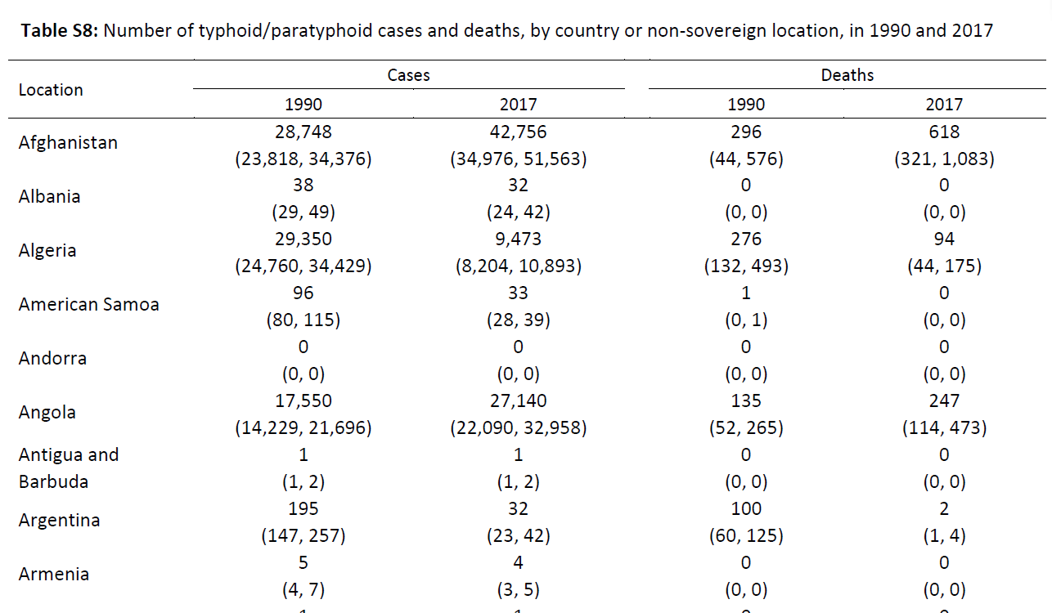

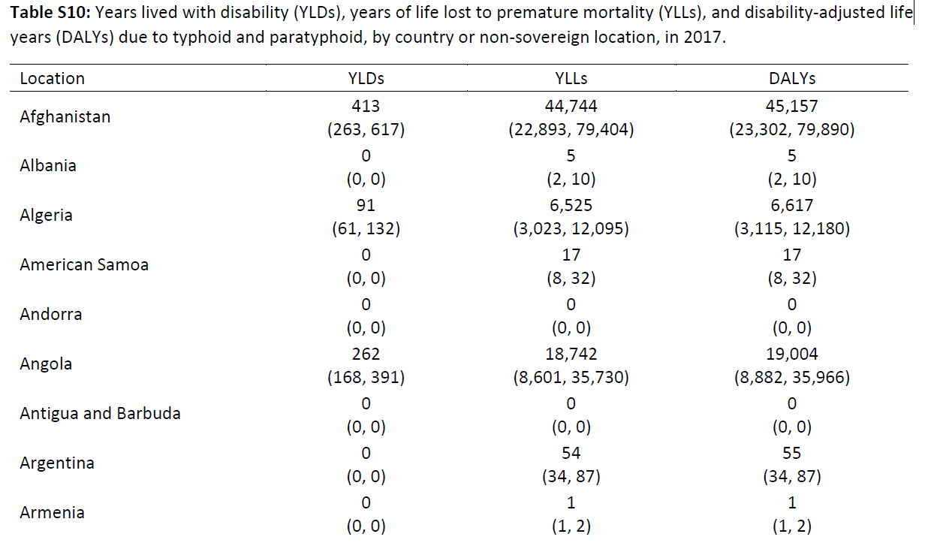

Standard life expectancy?

[Global, regional, and national age-sex-specific mortality for 282 causes of death in 195 countries and territories, 1980–2017: a systematic analysis for the Global Burden of Disease Study 2017 - PMC](https://www.ncbi.nlm.nih.gov/pmc/articles/PMC6227606/)

# Demographics

## Population turnover rate in sub-Saharan Africa

[<https://population.un.org/wpp/>]

* Life Expectancy at Birth, both sexes (years), Sub-Saharan Africa

|  |  |  |  |  |  |  |  |  |  |  |  |  |
| --- | --- | --- | --- | --- | --- | --- | --- | --- | --- | --- | --- | --- |
| **Year** | **Life Expectancy at Birth, both sexes (years)** | **Male Life Expectancy at Birth (years)** | **Female Life Expectancy at Birth (years)** | **Life Expectancy at Age 15, both sexes (years)** | **Male Life Expectancy at Age 15 (years)** | **Female Life Expectancy at Age 15 (years)** | **Life Expectancy at Age 65, both sexes (years)** | **Male Life Expectancy at Age 65 (years)** | **Female Life Expectancy at Age 65 (years)** | **Life Expectancy at Age 80, both sexes (years)** | **Male Life Expectancy at Age 80 (years)** | **Female Life Expectancy at Age 80 (years)** |
| 2020 | 60.6 | 58.6 | 62.6 | 51.9 | 50.1 | 53.8 | 13.0 | 12.0 | 13.8 | 6.0 | 5.4 | 6.5 |
| 2021 | 60.1 | 58.2 | 62.1 | 51.2 | 49.4 | 53.0 | 12.7 | 11.9 | 13.4 | 5.8 | 5.3 | 6.1 |
| 2022 | 61.1 | 59.0 | 63.2 | 52.3 | 50.4 | 54.3 | 13.4 | 12.5 | 14.1 | 6.2 | 5.6 | 6.6 |
| 2023 | 62.1 | 60.1 | 64.1 | 53.0 | 51.2 | 54.8 | 13.6 | 12.7 | 14.3 | 6.2 | 5.7 | 6.6 |