Gokbanjeong Ward User Guide
For members · Learn the word together, no sign-in needed
https://gokbanjeong-gospel-class.vercel.app
Created by Brother Honggyeom Kim · Brother Nokhyeong Park
Feedback & ideas · kimhk35@ajou.ac.kr
Last updated · 2026-09-28
All materials on this site (scriptures, manuals, images and more) are © The Church of Jesus Christ of Latter-day Saints.

Contents
Contents 2
For members 3
About this site 3
Getting started 3
Bottom menu 4
Daily study 5
Think together (see others' thoughts) 6
Ward calendar 7
Add to your phone's home screen 8
Viewing in other languages 8
Reading scripture right in the site 9
Today's insight card 10
Saving a reply as a card image 11
Notes on a verse 12
Highlights and notes on the lesson text 13
Installing, updating and removing the Android app 14
Help 15
Common problems 15
Privacy and records 15

For members

About this site
A learning space for the Gokbanjeong Ward Gospel Doctrine class that brings together daily scripture study, the ward calendar and shared questions. It is not an official Church website.
- Created by Brother Honggyeom Kim · Brother Nokhyeong Park
- Please send feedback and ideas to kimhk35@ajou.ac.kr.
- The last-updated date is shown at the bottom of the site.
All materials on this site (scriptures, manuals, images and more) are © The Church of Jesus Christ of Latter-day Saints.

Getting started
- No sign-up or sign-in is needed. Just open the address.
- The first time you open study pages, choose a nickname (2+ characters).
- The ward calendar and shared questions open right away, even without a nickname.
- Use the language buttons at the top right (한국어·EN·ES·FIL) to switch language. The first visit follows your device language automatically.
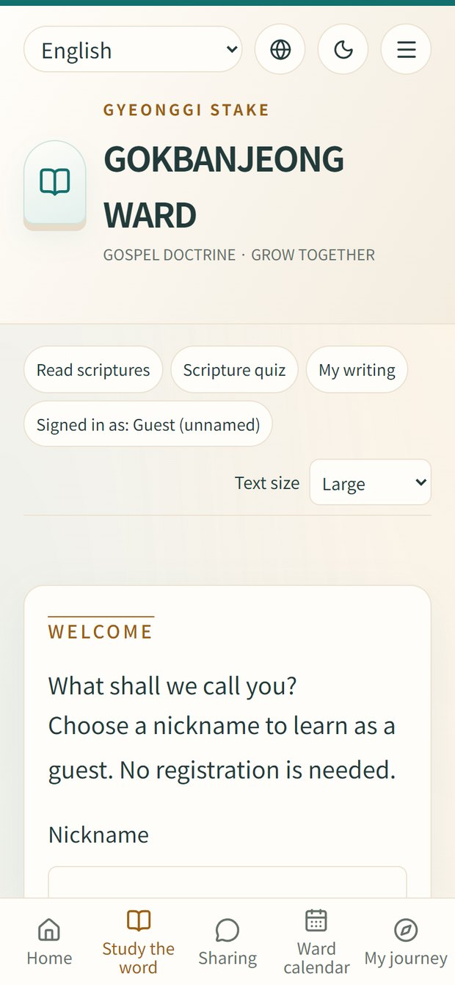

Bottom menu
The menu is at the bottom on phones, on the left on tablets and at the top on computers.
Menu | What it does
Home | Today's study, upcoming ward events, recent thoughts
Study the word | 52 weeks of Old Testament lessons and daily readings
Sharing | Think together · Thought wall · Discussion
Ward calendar | Ward meetings and organization activities
My journey | Your study record and rewards
Scriptures, quizzes, worksheets and this guide are in the ☰ menu at the top right.
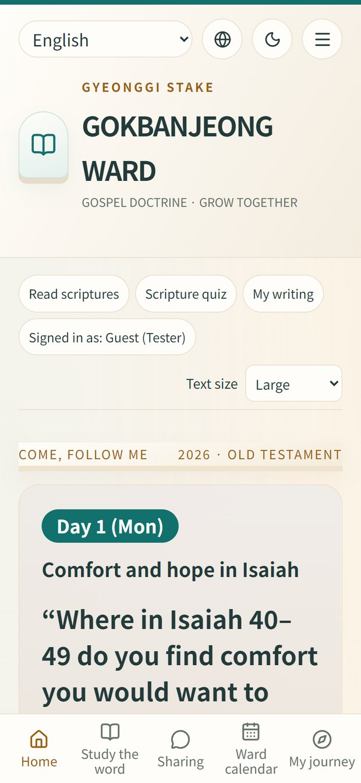

Daily study
- Open Study the word → this week's lesson → today.
- Read, then write what stayed with you and today's action. Only you can see it.
- Finishing earns rewards such as a sprout or bookmark.
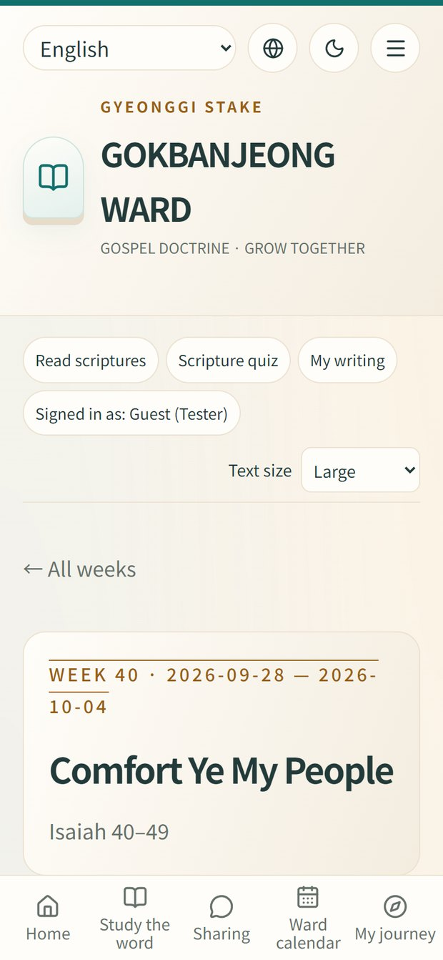

Think together (see others' thoughts)
- Go to Sharing → Think together and pick a question from a teacher.
- Your name is filled in for you. Leave it blank to post as 'Anonymous'.
- Write your thought and press Post reply. You can heart and comment on others' replies.
- It's fine to leave mid-way: 0.8 s after you stop typing the draft is saved on this device. It is not public until you post it.
- Use Share to send the question link to others.
Drafts stay on that device only; they do not follow you to another phone.
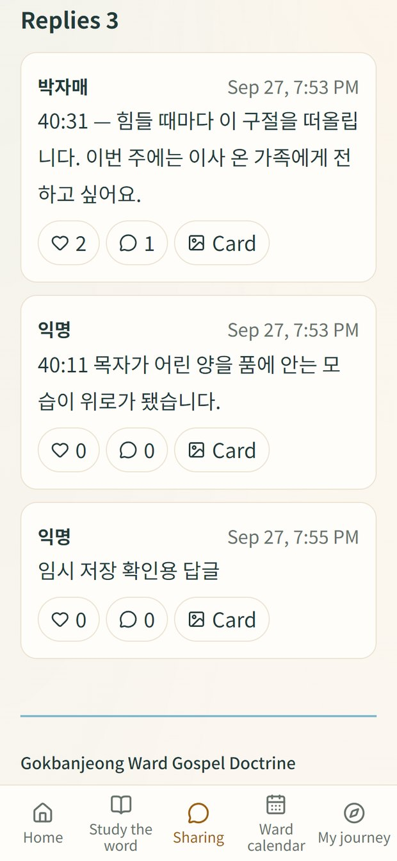

Ward calendar
- Choose Month or List. Phones start in list view.
- Tap an organization such as Primary or Youth to filter.
- Tap an event for its poster, time and place, and share its link.
- All times are Korea time.
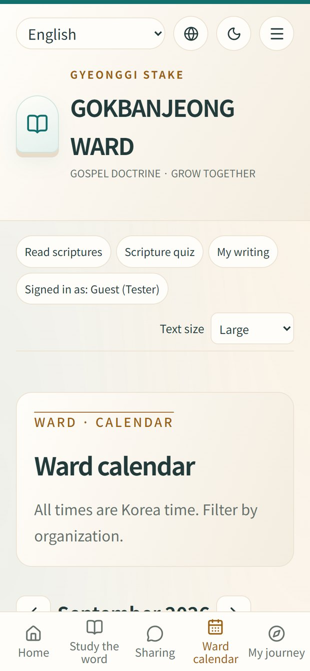

Add to your phone's home screen
- iPhone: open in Safari → Share → Add to Home Screen.
- Android: open in Chrome → ⋮ → Add to Home screen.

Viewing in other languages
Korean, English, Spanish and Filipino switch instantly with the language buttons at the top right. For any other language, turn on your phone's or computer's built-in translation and the whole site is translated right away.
- Android Chrome: ⋮ at the top right → Translate… → choose a language.
- Samsung Internet: ≡ menu at the bottom → Translate page (or the translate icon) → choose a language.
- iPhone Safari: tap aA at the left of the address bar → Translate → choose a language.
- Computer Chrome or Edge: the translate icon at the right of the address bar → choose a language.
Automatic translation is machine translation and may read awkwardly. For scripture, the Church's official site in your language is most accurate.
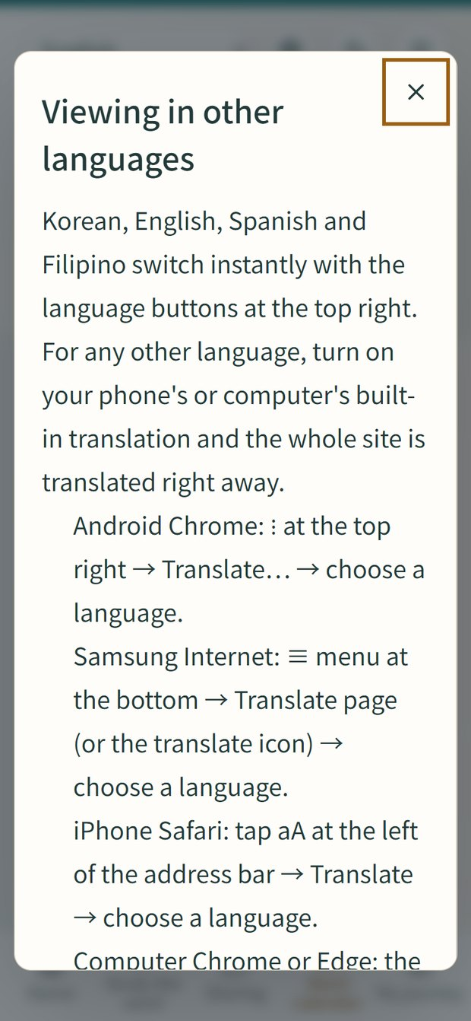

Reading scripture right in the site
- Open ☰ → Read scriptures and choose a book and chapter, or tap a chapter button on a week page.
- The Bible, Book of Mormon, Doctrine and Covenants and Pearl of Great Price all open here; use ◀ ▶ for the previous or next chapter.
- Tap a verse number to add a note to that verse.
The text comes unchanged from churchofjesuschrist.org and is © The Church of Jesus Christ of Latter-day Saints. Chapters not published in your language are shown in English.
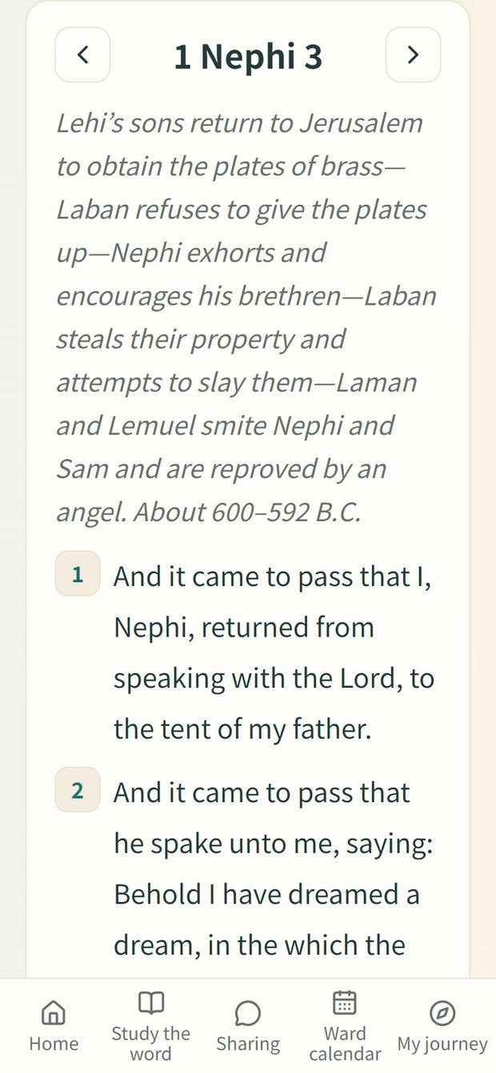

Today's insight card
The first time you open the site each day, today's insight card appears: the day of the week's study, today's question, the key topic (today's reading) and the key message. Once closed it won't pop up again that day, and it is always at the top of Home.
- Tap Start today's study to go straight to today's lesson.
- Tap Save or share image to keep the card as a picture or send it by chat.
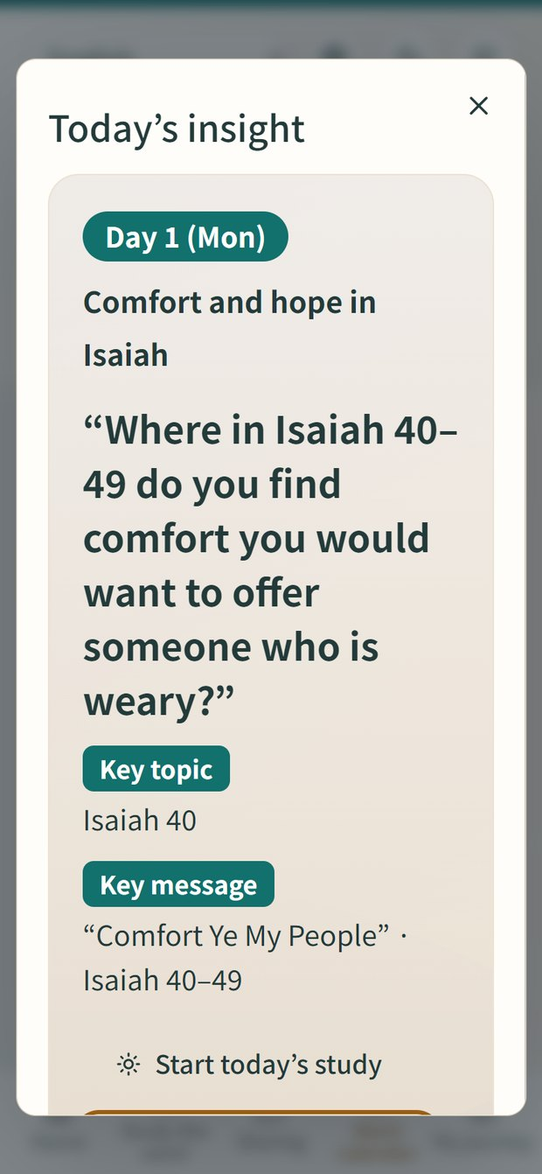

Saving a reply as a card image
- Tap the Card button under a reply in Think together.
- Choose square, portrait or landscape, a background, and whether to show the author's name.
- Tap Save image or Share. The image is made on your phone and never sent to the server.
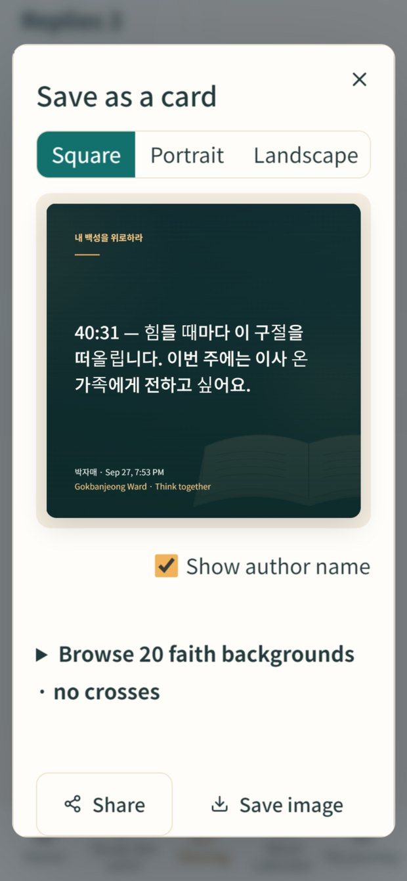

Notes on a verse
- Open Verse notes at the bottom of a week page, or scroll to the bottom of Read scriptures.
- Choose the chapter and the starting verse (end verse optional), then add a short quote (up to 200 characters) and your thought.
- Other people's notes are grouped by verse; you can heart and comment on them.
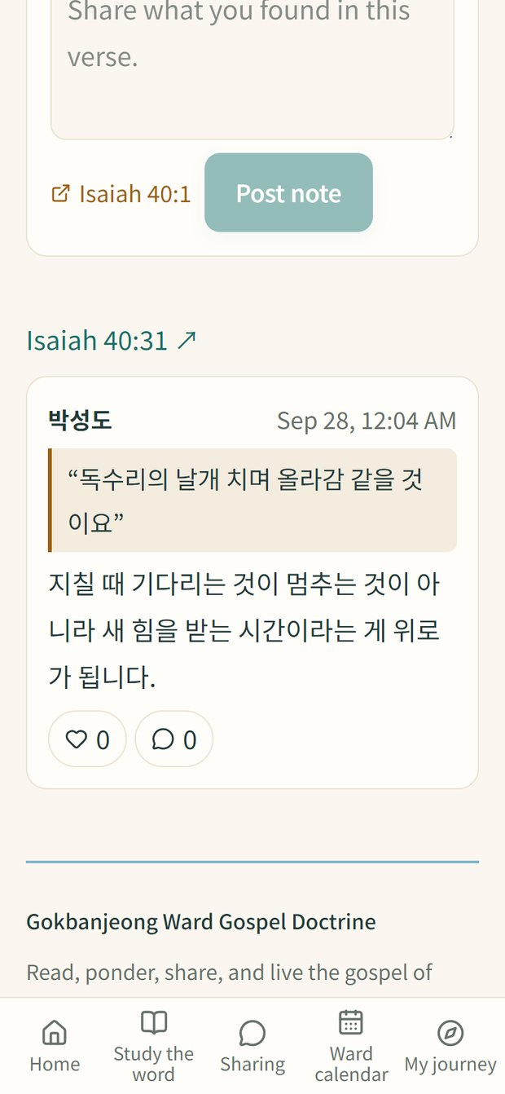

Highlights and notes on the lesson text
In weeks when a teacher has posted the lesson text, open Read the lesson text and add notes on the week page.
- Press and hold or drag to select a sentence; buttons appear at the bottom.
- Highlight marks it just for you and is saved on this device.
- Add note is public. Sentences with notes get a dotted underline; tap one to see just its notes.
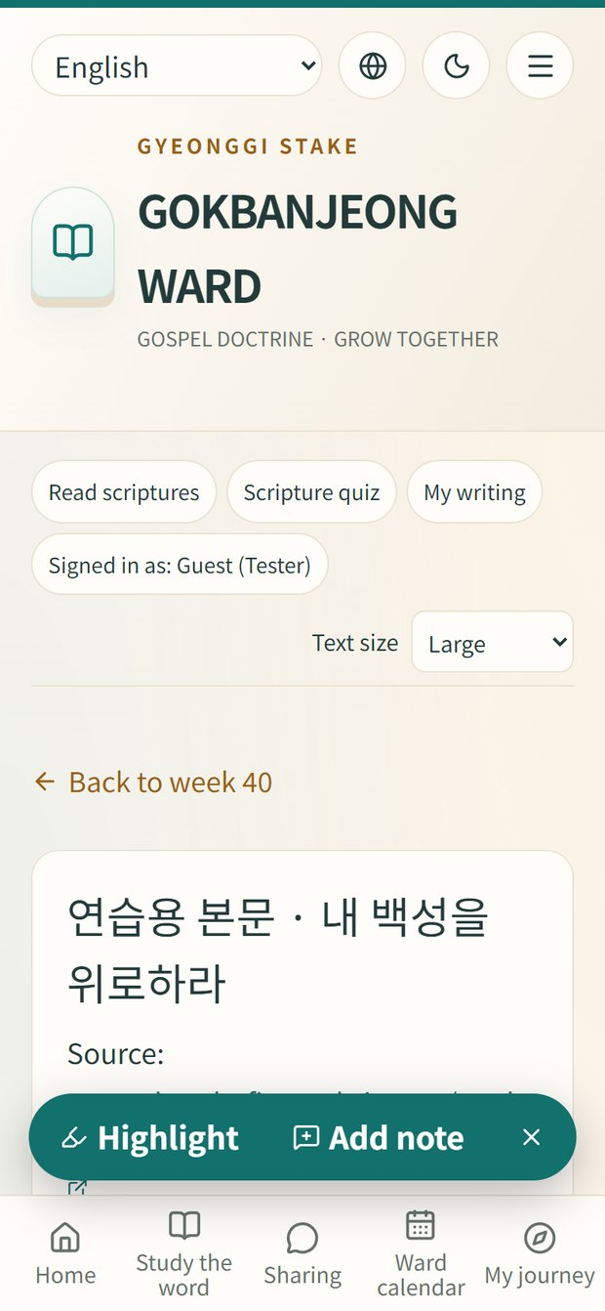

Installing, updating and removing the Android app
The app opens the site full screen using Google's official method (TWA), so it always shows the latest site. It asks for no phone permissions such as contacts, photos or location.
- On your phone, tap the gokbanjung.apk file an operator sent by chat, email or Google Drive. (In chat apps, save the file first, then open it.)
- If you see 'For your security, your phone is not allowed to install unknown apps from this source', tap Settings, turn on Allow from this source, then go back.
- Tap Install, then Open. If Google Play Protect suggests scanning, you can tap Scan app.
- Open it any time from the Gokbanjeong Ward icon (a sunrise over a book) on your home screen.
- Updating: content updates by itself. Only when an operator sends a new app file, install it the same way; it replaces the old app and keeps your data.
- Removing: press and hold the icon, then App info → Uninstall.
On iPhone, use Safari's Add to Home Screen instead; it works like an app.

Help

Common problems
Message | What to do
origin_rejected | The site address may have changed. Clear NEXT_PUBLIC_SITE_URL in Vercel or set it to the real address.
Image storage is not connected | Run 2_DB업데이트.cmd and check SUPABASE_SERVICE_ROLE_KEY is set.
Schema verification failed | The DATABASE_URL may belong to another project. Use the Gospel Doctrine database.
Vercel: Build failed | Run 1_설치확인.cmd first to see where it stops.
Can't sign in | Ask an administrator to reset your password.

Privacy and records
- Replies, comments and published events are visible to every visitor.
- Private study notes are yours only; teachers cannot read them.
- Clearing browser data means you can no longer edit or delete earlier posts.

