Project Report
for
PSIMU

Group:
Maria Soler Climent 20074846
Kim Hedegaard Madsen 20074382
Lasse Lorenzen 20012001

Abstract
This document describes the creation of an embedded real time system called PSIMU that will simulate a human patient. The PSIMU is part of a larger system which also includes a remote administration, called RemoteAdministration. A web based database from Physio Bank is used to get different patient simulations. This document also describes the development of the RemoteAdministration and how it is built to handle multiple PSIMU clients.
This entire system is called the DPSIMU.

The PSIMU was based on a project for the vxWorks platform, but was ported to Linux and adapted to be used in a distributed context. For the PSIMU application a Model, View, Controller architecture is used assisted by the Two-part view to identify processes/tasks.

The RemoteAdministration is a Windows XP program, developed to handle multiple clients in a distributed network. The RemoteAdministration has a POSA pattern architecture, which includes both a Reactor and a Leader-Follower architecture.

The designing of the applications is done using different design patterns, with the GoF observer pattern as the dominant one.

The development process is bases on ROPES and Crystal Clear. The DPSIMU is developed in several iterations.

Index
Table of Contents
Abstract 2
Index 3
Preface 4
Introduction 4
How to read this document 4
Project description 4
Project overview 4
Limitations in the project 5
Extend of delivery 5
Project Course 5
Methods 5
Work process 5
Crystal Clear in 2 minutes 5
Development process 7
Two-part view 7
Development tools 8
Dia 8
Subversion 8
Doxygen 8
OpenOffice 9
Eclipse 9
Visual Studio 9
Specification process 9
Identifying functions 9
Identifying objects and behavior 10
Design process 10
PSIMU 10
Architectural style 10
Threads 13
Patterns 13
Results 17
What have we achieved in terms of product. 17
What have we learned 18
Good parts in the project 18
Potential improvements 18
Problems 19
Conclusion 19
References 19

Preface

Introduction
This report contains the description of a distributed system with multiple clients that simulate patients, and a remote administration module to control the clients.
The focus on this report is on how we have made the system, and what we have learned.

How to read this document
This document is intended to be read as a whole from start to end, its not an encyclopedia.

Abbreviations:
DPSIMU – The entire solution.
PSIMU – Patient Simulator (the clients)
RA – Remote Administration

Project description
The purpose of the project is to develop a prototype of a distributed system, with multiple clients and a central remote administration. The clients is to be based on another Operating System than the remote administration software, to create a heterogeneous environment.

Project overview

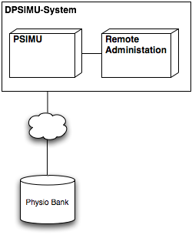
As shown on the diagram, there is a clear seperation between the PSIMU and the RA, and for each RA there can be multiple PSIMU. Each PSIMU has one connection to the Physio Bank database.

Limitations in the project
The clients are not based on a small embedded real PSIMU, but running on a laptop with Ubuntu Linux. Focus has not been on the graphical interface, there is a well working user interface, but its no based on fancy Windows Forms components and such like.

Extend of delivery
A project report, design document and a requirements specification.
Also the complete source code and projects for the development.

Project Course

Methods
During the project, the project team, has used different methods to help achieve the end goal. These methods can be dived into to different categories. One for how the team should work as a unit, and one for how to attack different problems in software development.

Work process
To structure the work in the three man project group, we wanted to base our cooperation in the project on a renowned process. The reason for choosing a process, and not just start working is that we all recognize the positive effect a written process has. We choose Alistair Cockburn and his Crystal processes. We choose to look at the Crystal Clear process, which is target small development teams up to the size of 8, and with no manager overhead.

Crystal Clear in 2 minutes
Alistair Cockburn have developed this process with a main focus on personal safety, efficiency and security.
Personal safety is one of the areas where Crystal Clear is very different from many agile processes, at least in their first many versions, because the fundamental rule in Crystal Clear is that everybody is different and thus the process that the team is working under should reflect the team. By giving this personal safety, the idea is that everyone in the team can find a standing point, or in other words a safe home base.
Efficiency is mostly a important feat, because this process should be applied in a project where there is economic limitations and customers. Of course a team in a school project should be efficient, but the main goal is always to learn more than produce.
Safety is to ensure that running business is also satisfied with the progress that the team is making, but also the other way around, to ensure that no team member is under a to high workload.
These three focus areas, is not listed in some sort of prioritized order, the goal is to make an process that, taking these three focus areas in mind, that should allow the team to deliver the promised on time.
To achieve this, Crystal Clear has a seven point list of requirements to the process, three of them is believed to be vital to succeed. The points that we have chosen to use, is listed and describe in this section.
A) Frequent Delivery of Usable Code to Users
Short iterations, with a hand in every 1 or 2 man-month. But never more than 3 man-months.

B) Reflective Improvement
After each iteration, the team has to reflect and adjust the process, so that the good parts can be kept, the bad parts thrown out, and new solution can be tried in the next iteration.

C) Osmotic Communication
Since the team is a small team, a more informal communication should be used. There is no need to have written documentation of every small decision and discussion. And instead of calling to a meeting, people should just speak up, and use a white board placed in the project office. Opposed to Scrum, there is no daily forum to bring up issues, its supposed to be a more dynamic process, and our experience with daily Scrum, is that many people “save” their problems or solution so that they have something more interesting to say at the meeting. Which is not very helpful for the team.
D) Personal safety
Personal safety is not only about to have a home base, where the rules of the process is adopted to the person. But also to make sure that no one is afraid to speak their mind. There should never be any fear of reprisals from the other team members. This personal and honest communication is not only regarding professional issues, but also if there is issues on a personal level. An open and honest communication should give the group a better trust in the individuals as well as the group as a whole.
E) Focus
Every member should know what to work on, an have an appropriate amount of time allocated to solve the given task.

As to help manage when to what part of the project we used ROPES. ROPES is a process created by Bruce Powell Douglass, and its very keen on using a iterative approach to develop software. ROPES fits nicely into Crystal Clear, since Crystal Clear requires a iterative development structure, but does define exactly how to implement it.
ROPES is segregated in four (five if you include the party one) different sub-phases pr. Iteration. These four phases are.
- Analysis
- Design
- Development
- Testing

The party-phase is where you create the schedule and have general preparation for what to do in the next phase and perhaps make adjustments to the overall plan, due to some problems that have arrived in the just completed iteration. This is also in sync with the Crystal Clear process.
Our experience is that Crystal Clear is a well fitted process to use in a small team, and osmotic communication instead of a more formal meeting structure has been a very giving method. One thing that Crystal Clear does not directly help improve is reliability of the developed product, there is no requirement for a specific structured testing or a way to make sure that the code is of a high enough standard.

Development process
We have used peer-review and pair-programming, to ensure quality of the code, but also to make sure that no one was stuck alone with a overwhelming task.

The work was iterative, especially because in the class we had hand-ins which where to be the foundation of the RemoteAdministration.
The processes that we are using, is also considered an architectural style. The reason we consider it a process, is that we are forced to look at the system in a certain way.
We have used 4+1, Two-part view and five layer architecture. A short description of one the ones we have had the most gain from.

Two-part view
Two-part view was developed by Hans Jepsen from Danfoss Drives and Finn Hansen, IHA.
In short its a way to view a system, which contains both continuous signals and discrete time events. Even though it indicate a architectural style, we have used the Two-part view as a method to look at our system, from a perspective we would not have done ordinarily. Since this also dictates method of working with the system, there is no doubt that it is a process.
The idea is that if you have continuous signals and some discrete time events, then it could be very beneficially to split this up in two separate parts, hence the name. In our system we have two continuous signals, one for the signals that we are getting form the database and the generation of signals to the DAC. The display and input of our system is only for discrete timed events, so there we have a Two-part view like this.

While using the Two-part method, we have had another angle to the separation of components in the system than normal. In a more classic work process, we would like at characteristics like which areas are displaying data, which are generating data, which handles input and so.
Now we did also look at what parts of the system is continuous and which part is discrete. This is are development process that we will use in the future as, we had good usage of the new view that this gave us.

Development tools
We have used different tools for different purposes: design diagrams, writing documents, version control, code development, code documentation and execution.
When choosing each development tool, we have prioritized usability, openness and portability. This last one because some team members use Linux in their personal computers, so using applications that can be used both from Windows and Linux has made it easier to work from home. The possibility of their files to be version controlled has also been a high priority.

Dia
http://live.gnome.org/Dia
Dia is a GTK+ based diagram creation program for Linux, Unix and Windows released under the GPL license.
We have used it to draw the high level diagrams for the design and description of the system.
We chose this tool because two members of the team have worked with it earlier, it is usable and intuitive. It can export to nearly every kind of image file, so the diagrams can be added to the documentation without any trouble. Another big advantage is that the files it produces are xml files, so they are easy to put under version control, and easy to merge if more than one person makes a change to it.

Subversion
http://subversion.tigris.org/
Subversion (SVN) is a cross-platform version control system. We have used it to keep control of all our work and to be able to work concurrently in the project.
We have used www.googlecode.com for hosting the subversion repository. The code is actually public available from here: http://code.google.com/p/mini-framework/

The Google Code svn hosting has been a great experience for the project team. It give a simple web-interface to the code and the log. It accessible via https makes possible to access it from behind IHA's firewall and proxy servers.

Doxygen
http://www.doxygen.org
Doxygen is a documentation system for source code eg. C++, C, Java and C#. Doxygen have 2 main features:
- It can generate documentation from at set of source file in different formats eg. HTML, Latex, RTF. The documentation is extracted directly from the source files.
- It can extract the structure of the source code even if it is not documented. This can used to visualize the structure of the code by mean of include graphs, inheritance diagram and collaboration diagrams.
We have used Doxygen for generation documentation of the source code and check that the implemented code is reflecting the design. The use of doxygen will make it easier to other developers to maintain the source code. Because the documentation give a virtual introduction to the code.
Generating HTML output with Doxygen has been quit easy, but generate documentation in PDF format though Latex caused some problem.

OpenOffice
http://www.openoffice.org/
We decided to use OpenOffice Writer instead of Microsoft Office Word because we could use it from both Windows and Linux, and because we could all use the same version so we would not have layout problems. A good feature is also that it has PDF exporter built-in.

Eclipse
http://www.eclipse.org/
Eclipse is an opensource IDE for Java, with extensions to be used for C++ projects also. It has been used for developing the linux PSIMU.
It has a well integrated running console and also a good debugger, which has made life easier.

Visual Studio
http://msdn.microsoft.com/vstudio
Visual Studio is an IDE from Microsoft. It supports a lot of different languages.
It has been used for developing the Remote Administration application, that runs on Windows. All the members of the group were familiar with it, so it has been easy to use.

Specification process
Since we are using ROPES to help split up the development into different phases, the first phase we should attack is the specification process.
This phase is about generating use cases, where we look at the requirements to see what functionality there is that we can convert into a use case scenario.
For the description of the use cases we are using UML.

Identifying functions
From the analysis of the project description we have identified 5 different use cases.
- Select patient
- Show patient simulation
- Start/Stop PSIMU
- Show status of attached PSIMUs
- Init PSIMU
These use cases covers the usage of the patient simulator, as described in the project definition.

Identifying objects and behavior
Identifying objects is separated in two simultaneous workflows, one is about looking for objects in the current use cases and project definition, but one is also to look at the behavior in the system. And sometimes certain behavior brings about new objects.
Some of the things that we look at is nouns and use it as a candidate for a object. We describing the behavior of an object se have the three classic questions to answer.
- What does this object know
- What responsibility does it have.
- What actions can it take
When we have identified all the objects and described their behavior according to the three questions, then we have a good understanding of how the system should work in general terms. We have used state diagrams and sequence diagrams to discuss how the system should behave.

Design process

PSIMU

Architectural style

MVC

The PSIMU is basically a data-centric system. Everything that the system is supposed to do, is centered around manipulating and displaying data. So for our architecture we have to have this in consideration.
Whenever one works with systems that are data-centric, the Model-View-Control (MVC) architectural style should be a consideration.

In short the MCV is described as:
Model, is the data and the manipulating of data. Also known as the business-logic section.
View, could be a graphic representation of the data.
Control, constrains the access to the Model.

One of the main principles of MVC is to keep data and representation of the data separate.
By decoupling the data and the view, the complexity of the overall architecture is reduced instead of having a spaghetti-like monster, where data and view are mixed together. When applying changes to such a monster could have effects that no one could imagine.
When using a control, its possible to make a role based access to the Model. So that some objects are allowed to alter more than others, and we are always sure that the access to the data is as wanted.

A generic overview of a MVC can be seen in Figure 1: MVC architectural style.

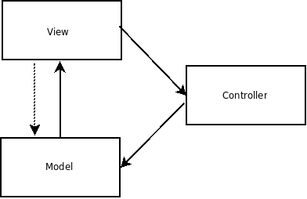Figure 1: MVC architectural style

In the PSIMU there is a Model section. This is where we take the data from the database and create the ECG, EDR and pulse signals. This is the main selling point of our software, the business-logic, one could say. Also we have the presentation of the data and the possibility to make selections and request, so the view is needed and since we can send feedback to our data representation, there is also a need for a control class to constrain this access.

The PSIMU has two very different ways of displaying data. One is the classic way on a screen where a user can see it, and the other is on the analog and digital output ports
We have been discussing if we should consider analog and digital outputs a true view in a MVC. We started considering them a true view, because the characteristics of a view is that it wants to subscribe to data from the Model and display these. There is no requirement that the display should be to some sort of user-viewed screen. So based on what a view is, we can thought of the outputs as a view.
After learning about the Two-Part View (see the Methods chapter earlier in this document) and after some considerations, we decided to take the digital and analog outputs out of the view in the MVC. The outputs cannot be treated exactly the same as the views because they have higher priority; these outputs have to meet real-time deadlines to the monitoring system reading them receives a real signal. The graphical interface, in the other hand, can be updated less frequently and it has to meet much more relaxed deadlines.

Since the MVC architectural style fitted our needs, as described above, and gives us the benefit of low decoupling between the different parts of the system, thus making it easier for us to change something in the future. We chose to use MVC when developing PSIMU.

This choice has proven to be a right one when a new view has been added to support a remote user.
This remote view sends an update to a server when there are specific changes to the model (the patient has been changed, the simulation has been started or stopped, etc) and also reacts on some requests from this server. The addition of this new view has only involved the implementation of one class and its methods, showing that the software produced in the last delivery was easily extensible.

In this second version of the Patient Simulator, the digital and analog outputs are not used to show the data, since the focus of this project was to show that the simulator could be distributed, and these outputs were the main focus in the first version.

Five-layer architecture

The five-layer architecture is a adaptation of the layered pattern, which organizes domains into a hierarchical organization based on their level of abstraction. The five-layered architecture is an open layered architecture, that means that classes in one layer may invoke operations of
classes in the same layer or any layer below it.

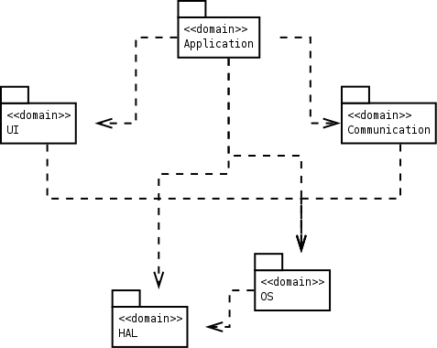

This architecture style defines five layers: application, user interface, communication, abstract OS and abstract HW.

Our system did not have communication, but it has now, since it communicates with the remote control user.
Therefore, choosing the five-layers architecture was a good choice when thinking about future development.

Threads
Something about the threads in RA.

The PatientHandler thread runs at the the highest priority in the system to make sure that the signal generation is correct and runs with a frequency equal to the sampling frequency of the signal generating. The signals that are used now have a sample rate of 360Hz.

Patterns

Observer

Overview

The Observer pattern is used to observe the state of an object. Thus, it defines a one-to-many dependency between objects so when one object changes state, all its dependents are notified and updated automatically.
The structure of the pattern is as follows:
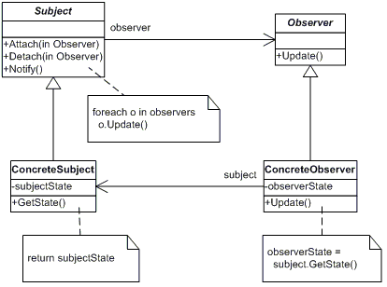
When a ConcreteObserver object wants to observe a ConcreteSubject, it calls the method Attach(), so every time there is a change in the ConcreteSubject, the subject will call Notify(), so all the ConcreteObservers that are attached to it will be updated.

Application in this project

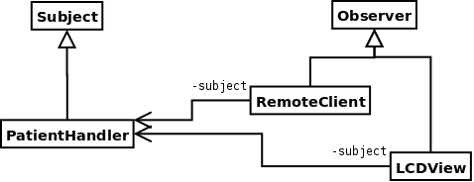

We have used the PatientHandler as the object to be observed. We have different observers: LCDview is interested in three signal types (ECG, EDR and pulse), and RemoteClient, that is interested in changes of state.

Iterator

Overview
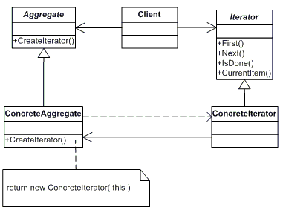
The Iterator pattern provides a way of accessing and traversing elements in an aggregate without exposing the internal representation. More than one iterator can be created for an aggregate, traversing it in a different way, such as in ascending and descending order.

Application in this project
The iterator pattern is used for traversing the elements of the different signals. The signals are accessed using the WFDB library, provided by PhysioBank, and the the iterator pattern is used also as a wrapper, so the signals can be iterated without having knowledge of the implementation of the library.
One particularity of this implementation, also, is that the iterator is cyclic, which means that it starts from the beginning again once it has reached the end. This way, these records in the database that last only for one minuted can be used again and again for simulate a patient.

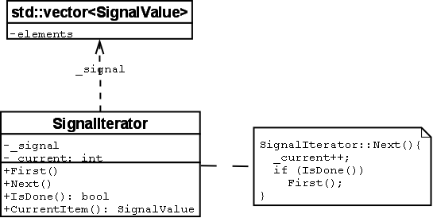

Singleton

Overview
The singleton pattern assures that a class has only one instance, and it is its unique access point.

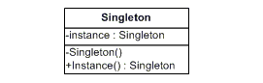

Application in this project
We have made the PatientDb class a singleton. The patients database should be unique and we should not be able to create more than one. Using the singleton pattern we assure that we only have one instance of it.

Adapter

Overview
The purpose of the Adapter pattern is to convert the interface of a class to an interface that can be used by its clients.
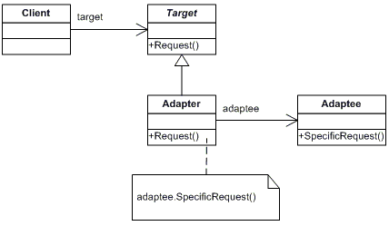
The Adapter class will convert the interface of the SpecificRequest to the Request interface, so the client can use the Request interface to call the same method.

Application in this project
The PatientHandler class creates a timer and connects a routine to it, so it will be called every time the timer expires. To connect a routine to a timer, though, it needs a special interface: it has to be static and as a parameters it needs the timer identification number and it can have more parameters, but only integers. In the handler of the timer we wanted to use the properties of the PatientHandler class, which are not accessible if the method is static.

To solve this, we wrote a private method void handler(), and then a public adapter static void handler_wrapper(int signo, siginfo_t *info, void *context). The info parameter is used to pass some information to the handler..
The adapter will call the private method:
void PatientHandler::handler_wrapper(int signo, siginfo_t *info, void *notUsed)
{
PatientHandler* myself = (PatientHandler*)
(info->si_value.sival_int);
myself->handler();
}

And then the handler will be connected to the timer like this:

//creation of timer
_sig_spec.sigev_notify = SIGEV_SIGNAL;
_sig_spec.sigev_signo = SIGRTMAX;
_sig_spec.sigev_value.sival_int = int(this);

//note: replace NULL for _sig_spec
if (timer_create(CLOCK_REALTIME, &_sig_spec, &_timerid) < 0)
cout << "timer create";

struct sigaction action;

action.sa_flags = SA_SIGINFO;
action.sa_sigaction = handler_wrapper;
sigemptyset(&action.sa_mask);

if (sigaction(_sig_spec.sigev_signo, &action, NULL))
cout << "timer not connected";

where this is the PatientHandler object, and handler_wrapper is the routine to connect to.
We have not used the adapter pattern creating more classes, but only defining an adapter method inside the class.

Results

What have we achieved in terms of product.
We have created a complete DPSIMU system as we set out to do.
We did not succeed in creating a complete PSIMU system. We did get a subset working on the simulator, due to problems discussed later in this chapter.
But we have made a product that can run on the simulator, display signals on the display, generate three different patient signals.
This simulator based software is not far from being able to run on hardware, the stub for the DAC needs to be directed to use the hardware instead of a display. And since there was no simple solution to get input devices working with our software, we need to make a small change to the system in order to be able to control which display to use.
We also have a complete and detailed architecture and software design done, which is described in detail and just needs to get implemented and deployed on the hardware. There is also made plans for how to extend the system, to include a remote operator. Its also a system based on know and well accepted architectural styles and design patterns, so that anyone familiar with these concept would easily understand, the system and its supposed to details.

What have we learned
We have learned a lot about using design patterns, how to choose the correct pattern and how to implement it in C++. We have seen a great delight in using these patterns, as the give us a general solution to a problem that many have faced before. Thus we can solve our problems, with have a solution there is tested and proven.
We have learned how to use the ROPES as an tool to approach requirement specification, and we have used use cases to describe in layman terms what the customer can expect us to deliver. UML has been a good standardized description language to make our documentation.
We have used Bruce Powel Douglass methods for designing our architecture, We have learned a lot on how to view an architecture in different views. The two-part view, was very good for our understanding , of the differences between the continuous and discrete time processing. We did find that even though a structural view from the MVC could make one believe that the DAC was a view, the two-part view showed us that its more suitable as a continuous component.
We have also learned a lot about using vxWorks, a platform we only have heard about before this course and we are particular pleased with have learned to work with Rhapsody, as it has some very nice features.

Good parts in the project
We are really pleased with the architecture we have chosen for this system. We have viewed the architecture from 3 different styles, and made sure that there is no problem between consistency of the views. We are convinced that this architecture, can used in the distributed system, which is the next expansion of this system.

We are also delighted that we have used a good portion of design patterns. This will make the system more conform to a “standard”, so when people see that its an observer relation, they would have many doubts about how the system is put together. Also the use of UML, will help newcomers to easily adopt to this system.

Potential improvements
There are several improvements that could be made in this project.
One improvement that would make a big difference would be the implementation of the graphical interface. A lot of hours have been spent on it, but unfortunately, without success. With few hours more and a bit of help we would probably have something nice to show.
The current development state and the design are not the same, so one thing that needs to be done is to improve the code up to the design level.
After this, tests can be run, using the scope tools provided by Wind River, so a proper measurement of the WCEs can be made, and also a Rate Monotonic Analysis.
It would also be nice to spend some more time analysing the memory and resources usage, as well as the concurrency and schedulability.

Problems

The main problem we have encountered during the development of this project is the complexity of the tools used for it, especially Wind River Workbench.
Wind River Workbench is a good tool for developing for VxWorks, but it is quite complex. There is some documentation that comes with the tool, and it is quite good. But it is difficult to find examples to get started and more advance examples. Not even in Google.. The wiki page in the school website is good, but not good enough as a start guide, at least for what we needed. And it has been pretty difficult to get technical support with the graphical interface, which is the part that has caused us more problems and we have decided to leave for future development.
It would probably be good to have some workshop with VxWorks and Wind River making a Hello World, involving some graphics also, at the beginning of the course.

As a general comment, getting some of the lessons at the end of the semester provokes some design changes that are pretty difficult to implement at that stage of the development and with the deadline near.

Conclusion

References

