Project Report
for
PSIMU

Group:
Maria Soler Climent 20074846
Kim Hedegaard Madsen 20074382
Lasse Lorenzen 20012001
Michael Glue Schmidt Jensen 20074381

Abstract
This document describes the creation of an embedded real time system called PSIMU that will simulate a human patient. The PSIMU is part of a larger system which involves an infusion pump system (IPUMP) and a local monitoring system (LMON). However the focus of this document is on the PSIMU part.

The team started out by examining the requirements for the PSIMU system and from there describing functional requirements by using the use case technique. Next the designing of the PSIMU system started by using an iterative development process called Crystal Clear.

The architectural style for the system is the Five Layer architecture. For the PSIMU application a Model, View, Controller architechture is used assisted by the Two-part view to identify processes/tasks.

The designing of the application is done using different design patterns, with the GoF observer pattern as the dominant one.

VxWorks Operating System, Windriver Workbench IDE and Rhapsody. These tools and applications were unknown to the team from the start and therefore proved to be an extra challenge in completing this project.

In spite of these extra challenges a PSIMU system exists that complies with the most important requirements presented in the requirement specification.

Index
Table of Contents
Abstract 2
Index 3
Introduction 5
How to read this document 5
Project description 5
Project overview 5
Limitations in the project 5
Extend of delivery 6
Methods 6
Work process 6
Crystal Clear in 2 minutes 6
Development process 8
Two-part view 8
Development tools 9
Dia 9
Rhapsody 9
Subversion 10
Doxygen 10
OpenOffice 10
Wind River Workbench 11
VxWorks Simulator 11
Specification process 11
Identifying functions 11
Identifying objects 12
Behavior model 12
Structure model 12
Design process 12
Architectural style 12
MVC 12
Five-layer architecture 13
Threads 14
Patterns 15
Observer 15
Overview 15
Application in this project 16
Iterator 20
Overview 20
Application in this project 21
Singleton 21
Overview 22
Application in this project 22
Adapter 22
Overview 22
Application in this project 23
Builder 23
Overview 24
Application in this project 24
State 24
Overview 24
Application in this project 25
Results 25
What have we achieved in terms of product. 25
What have we learned 26
Good parts in the project 26
Potential improvements 26
Problems 27
Conclusion 27
References 27

Introduction
This report contains the description of how the Patient Simulator system has been developed.
The focus on this report is on how we have made the system, and what we have learned.

How to read this document
This document is intended to be read as a whole from start to end, its not an encyclopedia.

Abbreviations:
PSIMU – Patient Simulator (this system)
LMON – Local Monitor System
IPUMP – Infusion Pump System

Project description
The purpose of the project is to develop a prototype for an embedded real time system. This project concerns the development of a patient simulator system, which should simulate different patient signals to bee monitored by a local monitoring system.

Project overview
The system consist of a database, which holds the information on different patient signals. Furthermore there is graphical user interface and a input keyboard.
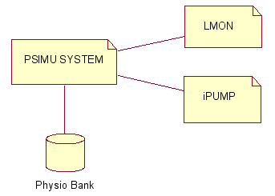
The PSIMU is connected to two other system, the iPUMP and the LMON.

Limitations in the project
The PSIMU does not use a real database in its current form. The goal of this iteration has been to generate signals, and build the structure and future base to base further development.
The focus is not on final functionality but, on making a solid base for understanding the signals and create the extend able structure.

Extend of delivery
What is it that we have made, source, hardware etc.

Methods
During the project, the project team, has used different methods to help achieve the end goal. These methods can be dived into to different categories. One for how the team should work as a unit, and one for how to attack different problems in software development.

Work process
Scrum was from Finn Hansen proposed as a method structuring the work flow process, including form of communication and deliveries. The majority of the team had to some extend already worked with Scrum as a process, and the experience was that even though that iterative development and daily scrum was a positive side, there was to much extra fillings to warrant the use of Scrum.
The use of a product owner, the many meetings including retrospective and review, and a dedicated scrum master, did not really fit well with a team size of four.

Instead we looked to another major player on the agile process market, Alistair Cockburn and his Crystal processes. We choose to look at the Crystal Clear process, which is target small development teams up to the size of 8, and with no manager overhead.

Crystal Clear in 2 minutes
Alistair Cockburn have developed this process with a main focus on personal safety, efficiency and security.
Personal safety is one of the areas where Crystal Clear is very different from many agile processes, at least in their first many versions, because the fundamental rule in Crystal Clear is that everybody is different and thus the process that the team is working under should reflect the team. By giving this personal safety, the idea is that everyone in the team can find a standing point, or in other words a safe home base.
Efficiency is mostly a important feat, because this process should be applied in a project where there is economic limitations and customers. Of course a team in a school project should be efficient, but the main goal is always to learn more than produce.
Safety is to ensure that running business is also satisfied with the progress that the team is making, but also the other way around, to ensure that no team member is under a to high workload.
These three focus areas, is not listed in some sort of prioritized order, the goal is to make an process that, taking these three focus areas in mind, that should allow the team to deliver the promised on time.
To achieve this, Crystal Clear has a seven point list of requirements to the process, three of them is believed to be vital to succeed. The points that we have chosen to use, is listed and describe in this section.
A) Frequent Delivery of Usable Code to Users
Short iterations, with a hand in every 1 or 2 man-month. But never more than 3 man-months.

B) Reflective Improvement
After each iteration, the team has to reflect and adjust the process, so that the good parts can be kept, the bad parts thrown out, and new solution can be tried in the next iteration.

C) Osmotic Communication
Since the team is a small team, a more informal communication should be used. There is no need to have written documentation of every small decision and discussion. And instead of calling to a meeting, people should just speak up, and use a white board placed in the project office. Opposed to Scrum, there is no daily forum to bring up issues, its supposed to be a more dynamic process, and our experience with daily Scrum, is that many people “save” their problems or solution so that they have something more interesting to say at the meeting. Which is not very helpful for the team.
D) Personal safety
Personal safety is not only about to have a home base, where the rules of the process is adopted to the person. But also to make sure that no one is afraid to speak their mind. There should never be any fear of reprisals from the other team members. This personal and honest communication is not only regarding professional issues, but also if there is issues on a personal level. An open and honest communication should give the group a better trust in the individuals as well as the group as a whole.
E) Focus
Every member should know what to work on, an have an appropriate amount of time allocated to solve the given task.

As to help manage when to what part of the project we used ROPES. ROPES is a process created by Bruce Powell Douglass, and its very keen on using a iterative approach to develop software. ROPES fits nicely into Crystal Clear, since Crystal Clear requires a iterative development structure, but does define exactly how to implement it.
ROPES is segregated in four (five if you include the party one) different sub-phases pr. Iteration. These four phases are.
- Analysis
- Design
- Development
- Testing

The party-phase is where you create the schedule and have general preparation for what to do in the next phase and perhaps make adjustments to the overall plan, due to some problems that have arrived in the just completed iteration. This is also in sync with the Crystal Clear process.
Our experience is that Crystal Clear is a well fitted process to use in a small team, and osmotic communication instead of a more formal meeting structure has been a very giving method. One thing that Crystal Clear does not directly help improve is reliability of the developed product, there is no requirement for a specific structured testing or a way to make sure that the code is of a high enough standard.
For the next term we will adjust the process using Adaptive Tailoring, developed by Bjoern Reese at Systematic Software Engineering. now B&O Aarhus, and include story based development into the process, so that its even more clear what there is expected from each team member. Stories will also make it possible to help validate the quality of the code, through inspections. We will also use a little from extreme programming considering pair-programming, since this has proved to be a very good way of breaking down difficult problems. Not that every task should have assigned to people, but an 70/30 workload sharing between to developers would help, us get the best of single work and pair-programming.

Development process
The processes that we are using, is also considered an architectural style. The reason we consider it a process, is that we are forced to look at the system in a certain way.
We have used 4+1, Two-part view and five layer architecture. A short description of one the ones we have had the most gain from.

Two-part view
Two-part view was developed by Hans Jepsen from Danfoss Drives and Finn Hansen, IHA.
In short its a way to view a system, which contains both continuous signals and discrete time events. Even though it indicate a architectural style, we have used the Two-part view as a method to look at our system, from a perspective we would not have done ordinarily. Since this also dictates method of working with the system, there is no doubt that it is a process.
The idea is that if you have continuous signals and some discrete time events, then it could be very beneficially to split this up in two separate parts, hence the name. In our system we have two continuous signals, one for the signals that we are getting form the database and the generation of signals to the DAC. The display and input of our system is only for discrete timed events, so there we have a Two-part view like this.

While using the Two-part method, we have had another angle to the separation of components in the system than normal. In a more classic work process, we would like at characteristics like which areas are displaying data, which are generating data, which handles input and so.
Now we did also look at what parts of the system is continuous and which part is discrete. This is are development process that we will use in the future as, we had good usage of the new view that this gave us.

Development tools
We have used different tools for different purposes: design diagrams, writing documents, version control, code development, code documentation and execution.
When choosing each development tool, we have prioritized usability, openness and portability. This last one because some team members use Linux in their personal computers, so using applications that can be used both from Windows and Linux has made it easier to work from home. The possibility of their files to be version controlled has also been a high priority.

Dia
http://live.gnome.org/Dia
Dia is a GTK+ based diagram creation program for Linux, Unix and Windows released under the GPL license.
We have used it to draw the high level diagrams for the design and description of the system.
We chose this tool because two members of the team have worked with it earlier, it is usable and intuitive. It can export to nearly every kind of image file, so the diagrams can be added to the documentation without any trouble. Another big advantage is that the files it produces are xml files, so they are easy to put under version control, and easy to merge if more than one person makes a change to it.

Rhapsody
http://modeling.telelogic.com/products/rhapsody/

Rhapsody is the tool that has been recommended in the IRTS course for design diagrams. This tool can be used in the computers at school, and it can also be installed in personal computers, as long as you are connected via VPN to the IHA network when using it, because the school provides the license. It is good that we can try out and use good proprietary software thanks to the school. The downside, though, is that you need to be connected via VPN, and that mean, in the first place, that you have to be connected to internet, so you can't work offline.
It is a good tool for designing and keeping consistency in the different diagrams, because if you change names or properties of one object in one diagram, they are changed in all the diagrams where this object is used. It can generate code also, but we have not used this feature.
A complaint we have about this tool is that you cannot export the diagrams into image files, which would be really useful for adding them in the documentation. Maybe this tool is not meant to be used for adding diagrams to documentation, but it would be a nice feature. We manage to do it by creating a report of all the model and then copy-pasting the images, which is not the cleanest solution, and it took us some time to discover.

Subversion
http://subversion.tigris.org/
Subversion (SVN) is a cross-platform version control system. We have used it to keep control of all our work and to be able to work concurrently in the project.
We first started using a subversion repository hosted by one of the members of the team. We had some problems with it, because we could not access it from the IHA network, or when connected to it via VPN, and that made the development a bit hard. For some reason, some network traffic like that is not allowed from the school.
We moved to a SVN repository hosted by DAIMI department of Aarhus Universitet, which we could create and maintain ourselves. This one has not given us any problems.

Doxygen
http://www.doxygen.org
Doxygen is a documentation system for source code eg. C++, C, Java and C#. Doxygen have 2 main features:
- It can generate documentation from at set of source file in different formats eg. HTML, Latex, RTF. The documentation is extracted directly from the source files.
- It can extract the structure of the source code even if it is not documented. This can used to visualize the structure of the code by mean of include graphs, inheritance diagram and collaboration diagrams.
We have used Doxygen for generation documentation of the source code and check that the implemented code is reflecting the design. The use of doxygen will make it easier to other developers to maintain the source code. Because the documentation give a virtual introduction to the code.
Generating HTML output with Doxygen has been quit easy, but generate documentation in PDF format though Latex caused some problem.

OpenOffice
http://www.openoffice.org/

OpenOffice is a free, open and cross-platform office suite.
When we looked at which tools to use to write our reports we had different options: Microsoft Office Word, OpenOffice Writer and LaTex.
Even though it is a really useful tool, specially when working concurrently in a document and using version control, we discarded the last option because it requires some learning time, and not all of the team members have used it before. Another reason for discarding it was that we had some templates for writing reports and requirement specifications in the course website, which were in Microsoft Office Word format.

We decided to use OpenOffice Writer instead of Microsoft Office Word because we could use it from both Windows and Linux, and because we could all use the same version so we would not have layout problems. A good feature is also that it has PDF exporter built-in.

Wind River Workbench
http://www.windriver.com/products/workbench/

Wind River Workbench is a collection of tools for developing for the VxWorks RTOS. In is based on Eclipse, which makes it cross-platform instantly. Being based on Eclipse also makes the learning curve faster, as we are all a bit familiar with Eclipse.
It includes also a lot of features specific for VxWorks, such as performance analyses, memory scope tools, system viewer, etc. They are pretty good, but they are quite complex tools with a high learning curve, and we did not have time to learn by our selves nor training to be able to use them. We have tried for a while, but we ended giving up.
IHA provides license for this application, so we can install it in our personal computer and work from home. To be able to work from home, though, the computer has to be connected to the IHA network via VPN because the application checks the license against the license server at IHA. This lowers the performance considerably, making impossible to work with it some times. This is so because the license is checked very frequently, and even if you have a good internet connection, this fails many times, and a pup up appears, saying that it failed to connect to the register. You have to click OK in this pop-up before you can continue typing your code. And if you are trying to use the simulator it fails many many times because it could not connect to the registry while you were trying to launch the simulator.

VxWorks Simulator
http://spacegrant.colorado.edu/~dixonc/vxworks/docs/vxworks/guide/x-vxsim.html

Wind River Workbench comes with a simulator for VxWorks. It is really useful for prototyping and checking that your product works. In the middle of the project time line, we decided to use exclusively the simulator, because it was supposed to be exactly the same as working in the real hardware, and the development time was much lower. Furthermore, we did not spend time on trying to use the SBC boards, which we know for experience that it would have taken a lot of time.
At the end of the development process we have discovered that the maximum clock rate of the simulator is 1000 ticks/second, which is much lower than the one in the SBC, which is a Pentium.
We discovered that when we were trying to measure the performance of the system, trying to see if we were meeting the time constraints. But we realized we could not measure times below 1ms, so we got 0ms when measuring the routine that is executed every time we get a signal from the timer. We did not have the time to migrate it to the SBC, so this times are not measured.

Specification process
Since we are using ROPES to help split up the development into different phases, the first phase we should attack is the specification process.
This phase is about generating use cases, where we look at the requirements to see what functionality there is that we can convert into a use case scenario.
For the description of the use cases we are using UML.

Identifying functions
From the analysis of the project description we have identified 5 different use cases.
- Add medicine
- Select patient information detail
- Configure patient simulation
- Show patient information
- Generate patient simulation signals
These use cases covers the usage of the patient simulator, as described in the project definition. There is a requirement that it should be possible for the iPUMP to add medicine to this simulator, and this gives us a use case describing this, called “Add medicine”.

Identifying objects and behavior
Identifying objects is separated in two simultaneous workflows, one is about looking for objects in the current use cases and project definition, but one is also to look at the behavior in the system. And sometimes certain behavior brings about new objects.
Some of the things that we look at is nouns and use it as a candidate for a object. We describing the behavior of an object se have the three classic questions to answer.
- What does this object know
- What responsibility does it have.
- What actions can it take
When we have identified all the objects and described their behavior according to the three questions, then we have a good understanding of how the system should work in general terms. We have used state diagrams and sequence diagrams to discuss how the system should behave.

Design process

Architectural style

MVC

The PSIMU is basically a data-centric system. Everything that the system is supposed to do, is centered around manipulating and displaying data. So for our architecture we have to have this in consideration.
Whenever one works with systems that are data-centric, the Model-View-Control (MVC) architectural style should be a consideration.

In short the MCV is described as:
Model, is the data and the manipulating of data. Also known as the business-logic section.
View, could be a graphic representation of the data.
Control, constrains the access to the Model.

One of the main principles of MVC is to keep data and representation of the data separate.
By decoupling the data and the view, the complexity of the overall architecture is reduced instead of having a spaghetti-like monster, where data and view are mixed together. When applying changes to such a monster could have effects that no one could imagine.
When using a control, its possible to make a role based access to the Model. So that some objects are allowed to alter more than others, and we are always sure that the access to the data is as wanted.

A generic overview of a MVC can be seen in Figure 1: MVC architectural style.

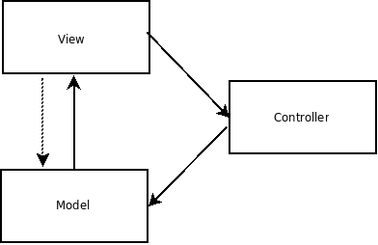Figure 1: MVC architectural style

In the PSIMU there is a Model section. This is where we take the data from the database and create the ECG, EDR and pulse signals. This is the main selling point of our software, the business-logic, one could say. Also we have the presentation of the data and the possibility to make selections and request, so the view is needed and since we can send feedback to our data representation, there is also a need for a control class to constrain this access.

The PSIMU has two very different ways of displaying data. One is the classic way on a screen where a user can see it, and the other is on the analog and digital output ports
We have been discussing if we should consider analog and digital outputs a true view in a MVC. We started considering them a true view, because the characteristics of a view is that it wants to subscribe to data from the Model and display these. There is no requirement that the display should be to some sort of user-viewed screen. So based on what a view is, we can thought of the outputs as a view.
After learning about the Two-Part View (see the Methods chapter earlier in this document) and after some considerations, we decided to take the digital and analog outputs out of the view in the MVC. The outputs cannot be treated exactly the same as the views because they have higher priority; these outputs have to meet real-time deadlines to the monitoring system reading them receives a real signal. The graphical interface, in the other hand, can be updated less frequently and they have to meet much more relaxed deadlines.

We still think it is interesting to keep the architecture as a MVC, because when adapting this view approach we would also have the benefit of being able to easy extend PSIMU with new types of views. An example could be an XML-view meant on for displaying on a PDA. This new view would just subscribe to the data, and the only changes there is to be made in local for the new view. Another example would be the addition of a remote display or user.

Since the MVC architectural style fits our needs, as described above, and gives us the benefit of low decoupling between the different parts of the system, thus making it easier for us to change something in the future. We have chosen to use MVC.

Five-layer architecture

The five-layer architecture is a adaptation of the layered pattern, which organizes domains into a hierarchical organization based on their level of abstraction. The five-layered architecture is an open layered architecture, that means that classes in one layer may invoke operations of
classes in the same layer or any layer below it.
This architecture style defines five layers: application, user interface, communication, abstract OS and abstract HW.

Our system does not have communication, but it will in the future, as it will have to communicate with the IPUMP system and also with the remote users.
Therefore, we used the five-layered architecture because it fits in out system.

Threads
In VxWorks, the active objects are called tasks, instead of threads.
In the current implementation of the system there is only one task running all the application. This is not the way it is intended to be. We have discussed how this should be at the end of the semester, after being taught about schedulability, concurrency and resources in class. But it is not implemented.
We have designed the system following the Two-Parts View, having one task taking care of the continuous part (TaskPatientHandler), and one task taking care of the discrete part (TaskGUI).

The TaskPatientHandler must have a higher priority than TaskGUI and must be able to pre-empt the TaskGUI to guarantee the correctness of the signal generation. An RMA (Rate Monotonic Analysis ) should be made to guarantee that the system can be scheduled.

The communication between these two task will be synchronized/protected by the PatientHandler class, using mutexes. The resources that have to be shared are the values of the signal, which the TaskPatientHandler writes to and the TaskGUI only reads. There will not be any circular wait condition, so we will not have problems with deadlocks.

TaskPatientHandler must run at the the highest priority in the system to make sure that the signal generation is correct. The TaskPatientHandler must run with a frequency equal to the sampling frequency of the signal generating. The signals that are used now have a sample rate of 360Hz.

Patterns

Observer

Overview

The Observer pattern is used to observe the state of an object. Thus, it defines a one-to-many dependency between objects so when one object changes state, all its dependents are notified and updated automatically.

The structure of the pattern is as follows:

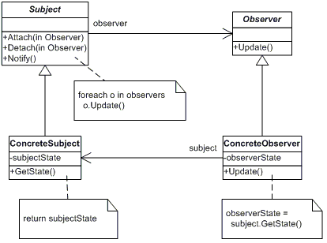
When a ConcreteObserver object wants to observe a ConcreteSubject, it calls the method Attach(), so every time there is a change in the ConcreteSubject, the subject will call Notify(), so all the ConcreteObservers that are attached to it will be updated.

Application in this project

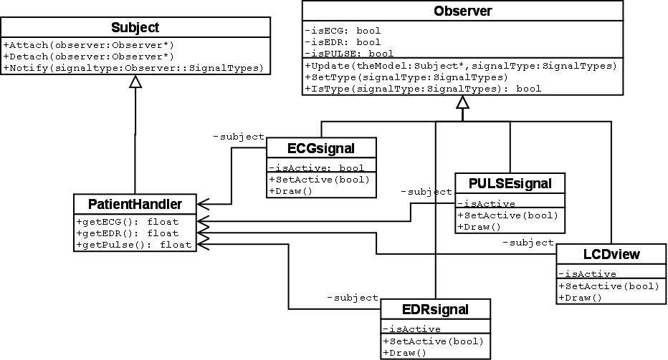

We have used the PatientHandler as the object to be observed. We have different observers: ECGsignal, EDRsignal and PULSEsignal are views specialized in only one signal, and LCDview is interested in the three signal types. These observers are part of the user interface, and the method Draw() will output their values to the user interface.
At the beginning of the program, all these observers are attached to PatientHandler, but they can be active or not. The class GUI (see the State pattern later in this document) is the one controlling which of these are the active observers. When there is a change in the signals, Notify will be called in the handler with the type of the signal that has changes as a parameter. All the observers will be notified and updated, but only the ones that are active will draw its values.

Iterator

Overview
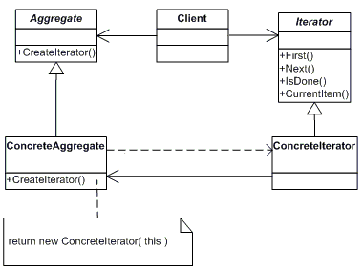
The Iterator pattern provides a way of accessing and traversing elements in an aggregate without exposing the internal representation. More than one iterator can be created for an aggregate, traversing it in a different way, such as in ascending and descending order.

Application in this project
The iterator pattern is used for traversing the elements of the different signals. The signals are stored in aggregates of type vector (from the Standard Template Library). This data type already has associated an iterator but we wanted to traverse the elements in a slightly different way, so we defined a new iterator. It is a circular iterator, that starts from the beginning again when it arrives at the end.

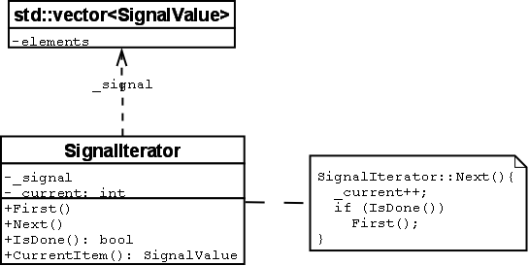

Singleton

Overview
The singleton pattern assures that a class has only one instance, and it is its unique access point.

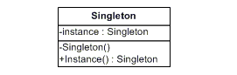

Application in this project
We have made the PatientDb class a singleton. The database should be unique and we should not be able to create more than one. Using the singleton pattern we assure that we only have one instance of it.

Adapter

Overview
The purpose of the Adapter pattern is to convert the interface of a class to an interface that can be used by its clients.
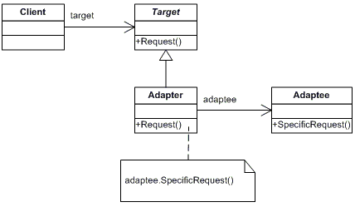
The Adapter class will convert the interface of the SpecificRequest to the Request interface, so the client can use the Request interface to call the same method.

Application in this project
The PatientHandler class creates a timer and connects a routine to it, so it will be called every time the timer expires. To connect a routine to a timer, though, it needs a special interface: it has to be static and as a parameters it needs the timer identification number and it can have more parameters, but only integers. In the handler of the timer we wanted to use the properties of the PatientHandler class, which are not accessible if the method is static.
To solve this, we wrote a private method void handler(), and then a public adapter static void handler_wrapper( timer_t timerid, int pointerToObject). The pointerToObject parameter is the pointer to the PatientHandler object.
The adapter will call the private method:
void PatientHandler::handler_wrapper(timer_t timerid,int pointerToObject)
{
PatientHandler* myself = (PatientHandler*) pointerToObject;
myself->handler();
}
And then the handler will be connected to the timer like this:
timer_connect (_timerid, (VOIDFUNCPTR)PatientHandler::handler_wrapper, int(this));
where this is the PatientHandler object.
We have not used the adapter pattern creating more classes, but only defining an adapter method inside the class.

Builder

Overview
The purpose of the builder pattern is to separate the construction of a complex object from its representation, so that the same construction can create different representations.

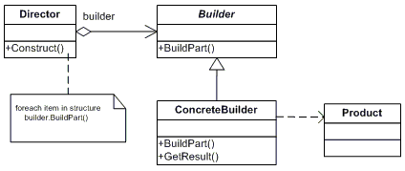

Application in this project
We have applied this pattern in the construction of the PatientDb. In our case, though, there is only one part and only one concrete builder. But it allowed us to separate the construction of the PatientDb from its source. Now we are creating this database from static files, but we might create it from an internet database, in the future. This way, only the construction of the PatientDb will have to be extended, not the rest of the code.
The creation of the database happens in the main function, calling WfdbLoader::InitDb(), which builds the PatientDb from static files.

State

Overview
The state pattern allows a class to alter its behavior when the state changes.

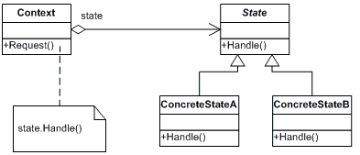
The Context class will maintain an instance of a concrete state that defines the current state.

Application in this project

The class GUI maintains the state of the active view, and it also knows which is the next state. When SelectView() is called, it moves to its next state, making one of the views active and the rest inactive.

Results

What have we achieved in terms of product.
We did not succeed in creating a complete PSIMU system. We did get a subset working on the simulator, due to problems discussed later in this chapter.
But we have made a product that can run on the simulator, display signals on the display, generate three different patient signals.
This simulator based software is not far from being able to run on hardware, the stub for the DAC needs to be directed to use the hardware instead of a display. And since there was no simple solution to get input devices working with our software, we need to make a small change to the system in order to be able to control which display to use.
We also have a complete and detailed architecture and software design done, which is described in detail and just needs to get implemented and deployed on the hardware. There is also made plans for how to extend the system, to include a remote operator. Its also a system based on know and well accepted architectural styles and design patterns, so that anyone familiar with these concept would easily understand, the system and its supposed to details.

What have we learned
We have learned a lot about using design patterns, how to choose the correct pattern and how to implement it in C++. We have seen a great delight in using these patterns, as the give us a general solution to a problem that many have faced before. Thus we can solve our problems, with have a solution there is tested and proven.
We have learned how to use the ROPES as an tool to approach requirement specification, and we have used use cases to describe in layman terms what the customer can expect us to deliver. UML has been a good standardized description language to make our documentation.
We have used Bruce Powel Douglass methods for designing our architecture, We have learned a lot on how to view an architecture in different views. The two-part view, was very good for our understanding , of the differences between the continuous and discrete time processing. We did find that even though a structural view from the MVC could make one believe that the DAC was a view, the two-part view showed us that its more suitable as a continuous component.
We have also learned a lot about using vxWorks, a platform we only have heard about before this course and we are particular pleased with have learned to work with Rhapsody, as it has some very nice features.

Good parts in the project
We are really pleased with the architecture we have chosen for this system. We have viewed the architecture from 3 different styles, and made sure that there is no problem between consistency of the views. We are convinced that this architecture, can used in the distributed system, which is the next expansion of this system.

We are also delighted that we have used a good portion of design patterns. This will make the system more conform to a “standard”, so when people see that its an observer relation, they would have many doubts about how the system is put together. Also the use of UML, will help newcomers to easily adopt to this system.

Potential improvements
There are several improvements that could be made in this project.
One improvement that would make a big difference would be the implementation of the graphical interface. A lot of hours have been spent on it, but unfortunately, without success. With few hours more and a bit of help we would probably have something nice to show.
The current development state and the design are not the same, so one thing that needs to be done is to improve the code up to the design level.
After this, tests can be run, using the scope tools provided by Wind River, so a proper measurement of the WCEs can be made, and also a Rate Monotonic Analysis.
It would also be nice to spend some more time analysing the memory and resources usage, as well as the concurrency and schedulability.

Problems

The main problem we have encountered during the development of this project is the complexity of the tools used for it, especially Wind River Workbench.
Wind River Workbench is a good tool for developing for VxWorks, but it is quite complex. There is some documentation that comes with the tool, and it is quite good. But it is difficult to find examples to get started and more advance examples. Not even in Google.. The wiki page in the school website is good, but not good enough as a start guide, at least for what we needed. And it has been pretty difficult to get technical support with the graphical interface, which is the part that has caused us more problems and we have decided to leave for future development.
It would probably be good to have some workshop with VxWorks and Wind River making a Hello World, involving some graphics also, at the beginning of the course.

As a general comment, getting some of the lessons at the end of the semester provokes some design changes that are pretty difficult to implement at that stage of the development and with the deadline near.

Conclusion

References

