System architecture/design document
for
DPSIMU

Group:
Maria Soler Climent 20074846
Kim Hedegaard Madsen 20074382
Lasse Lorenzen 20012001

Document history

Date | Version | Description | Author
2008-11-20 | 1.00 | First version | Group DPSIMU

Table of Contents
1. INTRODUCTION 6
1.1 Purpose and Scope 6
1.2 References 6
1.3 Definitions and acronyms 6
1.4 Document structure and reading guide 6
2. SYSTEM OVERVIEW 7
2.1 System context 7
2.2 System introduction 7
3. SYSTEM INTERFACES 7
3.1 Interface to human actors 8
3.1.1 Nurse 8
3.1.2 Operator 8
3.1.3 Remote operator. 8
3.2 Interface to external system actors 8
3.2.1 IPUMP 8
3.2.2 LMON 8
3.3 Interface to hardware actors 9
3.3.1 Signal output 9
3.3.1 Touchscreen (display and mouse) 9
3.4 Interface to external software actors 9
3.4.1 Operating system 9
4. Use Case View 9
4.1 Overview of architecture significant Use cases 9
4.2 Use case Generate patient simulation signals scenarios 11
4.2.1 Use case goal 11
4.2.2 Use case scenarios 11
4.1 Start and stop PSIMU 11
4.1.1 Use case goal 11
4.1.2 Use case scenarios 11
1. Logical View 13
1.1 Overview 13
1.2 PSIMU 13
1.2.1 Architecturally significant design packages 14
1.3 Remote Administration 17
1.4 Mini Framework 18
1.5 Use case realizations 18
1.5.1 Use case “Generate patient simulation signals” realization 18
1.5.2 Use case “Show Patient signal” realization 19
1.5.3 Use case “Start and Stop a PSIMU” realization 20
2. Process/task View 20
2.1 PSIMU 21
2.1.1 Task overview 21
2.1.2 Task implementation 21
2.1.3 Task communication and synchronization 22
2.2 RemoteAdministrator 22
2.2.1 Task overview 22
3. Deployment View 22
3.1 System configurations overview 23
3.2 System configurations 23
3.2.1 Configuration Simulation 23
3.2.2 Configuration SBC 23
3.3 Node descriptions 24
3.3.1 Node SBC description 24
3.3.2 Remote PC 24
3.3.3 Node Network description 24
3.3.4 Node DAC description 24
3.3.5 Node UART description 24
3.3.6 Node display 24
4. Implementation View 24
4.1 Overview 24
4.2 Component descriptions 25
4.2.1 Component PSIMU 25
4.2.2 Remote Administration 25
4.2.3 Mini Framework 25
4.2.4 Protocol 25
5. design decisions 26
5.1 Architectural goals and constraints 26
5.1 Architectural patterns 27
5.2 General user interface design rules 27
5.3 Implementation languages and tools 27
5.1 Implementation libraries 27
6. SIZE and performance 28
1. Quality 28
1.1 Portability 29
1.2 Extendability 29
1.3 Maintainability 29
1.4 Correctness 29
2. Compilation AND LINKING 29
2.1 Compilation-hardware 30
2.2 Compilation-software 30
3. INSTALLATION AND Executing 30
3.1 Installation 30
3.2 Executing-hardware 30
3.1 Executing-software 30
3.1 Execution-control (start, stop and restart) 31
3.1 Error messages 31

INTRODUCTION

Purpose and Scope
The purpose of the project is to develop a prototype for an distributed real time system, so that the students of the course DRTS get some practical experience with designing a distributed real time system. This project is based on the work done in the PSIMU project which was part of the IRTS course. This project concerns the development of a distributed patient simulator system (DPSIMU), which is specified in the DPSIMU_requirement specification document [10].

The purpose of this document is to describe an architecture for the DPSIMU.

References
A list of relevant reference documents, this could be as well external as internal documents.
[1] PSIMU-project.doc
[2] ProjectInterfaces.doc
[3] http://www.physionet.org/physiobank/physiobank-intro.shtml
[4] PSIMU_requirement_specification.doc
[5] Real-Time Design patterns by Bruce Powel Douglass
[6] Design Patterns by Erich Gamma, Richard Helm, Ralph Johnson, John Vlissides
[7] http://kurser.iha.dk/eit/tiirts/
[8] Two part architectural model: TwoPartArchitecturalModel-Paper.pdf
[9] http://en.wikipedia.org/wiki/Model-view-controller
[10] DPSIMU_requirement_specification
[11] Pattern-Oriented Software Architecture by Douglas Schmidt, Michael Stal, Hans Rohnert, Frank Buschmann

Definitions and acronyms
A list of definitions and acronyms that are relevant for reading and understanding the document.
DPSIMU Distributed Patient Simulator System
PSIMU Patient Simulator system
IPUMP Infusion Pump System
ECG Electro Cardiogram
EDR ECG-Derived Respiration
WCE Worst Case Execution time
RMA Rate Monotonic Analysis

Document structure and reading guide
A brief description of the document structure and introduction of the “4+1” view organization consisting of: Use-Case, Logical, Process, Deployment, and Implementation Views.
It can be recommended to keep a standard structure for this type of document and insert a notice, if a certain section isn’t relevant for the actual system or product.
The reading guide can be organized based on the needs from the different target groups.
The structure of the system architecture document in the website for IRTS [7] has been kept. Note, however, that the Data view has been skipped because we have no persistence data in the system.

SYSTEM OVERVIEW
This section shall give a short overview of the system and its environment.
This section shall give a short overview of the system and its environment.

System context
The context of the system can be illustrated by informal diagrams and/or with one or more actor-context diagrams showing the system and it external actors.
Diagrams: Informal overview diagrams and UML Actor-context diagram (from requirement document).
PSIMU is a patient simulator which can generate patient signals like pulse, EGC, EDR based on some real patient record. PSIMU can be connected to a remote server which can control and monitor the PSIMU's.

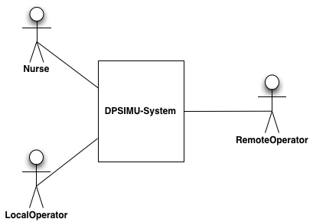Illustration 1:Context diagram

System introduction
A short description of the purpose and main functionality of the system described with reference to the system context.
The main purpose of the DPSIMU is to control and monitor a number of distributed patient simulators (PSIMU's).

SYSTEM INTERFACES
This section describes each of the interfaces to the external actors.
This section describes the interfaces to the external actors.

Interface to human actors
Describes the Man Machine Interface (MMI) for the human actors interacting with the system.
The MMI is described for each human actor role or alternatively insert a reference to a MMI specification document.
Specification of the MMI (Man Machine Interface) can be found in the MMI-specification document [8].

Nurse
The Nurse can view the patient signals, and adjust the PSIMU to show the information that he/she wants.

Operator
The Operator can adjust and fine-tuning the PSIMU. Every time a new PSIMU simulation is to be run, the Operator must adjust the PSIMU.

Remote operator.
The Remote Operator is responsible for adjusting and fine-tunning the PSIMU. Every time a new PSIMU simulation is to be run, the Remote Operator has to adjust the needed features.

Interface to external system actors
Describes the interface for actors representing external systems communicating with the System under development.
Describe the used communication protocol for each external system actor or alternatively insert a reference to a protocol specification document e.g. an international protocol standard.

IPUMP
IPUMP (Infusion Pump System) is a secondary system that can add medicine to the PSIMU, and thus having influence on the signals that the PSIMU generates.
IPUMP uses RS232 communication with the PSIMU.

A fixed 64 bytes ASCII PDU is transmitted from IPUMP to PSIMU.

This PDU is transmitted every second when the pump is started.

PDU format:
4 bytes start frame (##?*)
46 bytes medicine name
12 bytes volume infused (since started)
2 bytes CRC checksum

LMON
The LMON is a second system that can use the signals that this PSIMU is generating and sending out to the analogue and digital outputs.

Interface to hardware actors

Describes the interface for actors representing the hardware devices connected to the system.
Describe the specific hardware interface for each hardware actor or alternatively insert a reference to a hardware interface specification document. This interface specification will often include timing requirements etc.

Signal output
PSIMU generates the following outputs:
- ECG signal (continuous 12 bit analogue value 0-10V) on PV2019, Aout0.
- EDR signal (ECG derived respiration signal) (continuous 12 bit analogue value 0-10V) on PV2019, Aout1.
- Pulse (discrete, 8 bit digital value) (0-250 beats/minute) – IO686 Card Output Port A (PA7-PA0) + Data ready signal IO686 Card output Port C, PC3)

Touchscreen (display and mouse)
The user interface is a touchscreen. The user interface for our development platform is, however, a display, a keyboard and a mouse. This, though, will not make any difference from the software's point of view.

Interface to external software actors
Describes the interface for actors representing another software subsystem, developed either as a separate project or it could be reusing a complete subsystem from earlier systems.
Describe the specific interface for each external software component or alternatively insert a reference to a software interface specification document for the actual software subsystem.

Operating system
The PSIMU application is implemented on the Linux, which supports most of the POSIX interface.

Use Case View
Mandatory view.
This section lists selected Use cases and Use Case scenarios from the Use case model.
This section shows some use cases from the requirement specification which have large impact on the architecture.

Overview of architecture significant Use cases
The diagram below shows the use case diagram from the requirement specification document.
For large systems: select the part of the Use cases, which have an impact on the architecture. Large systems can have several Use cases of the same type, with the same impact on the system architecture. Select one of these candidates to represent the group.
Significant Use case are selected and shown on the Use case diagram:
1. if they represent some significant, central functionality of the final system
2. if they have a large architectural coverage and exercise many architectural elements
3. if they stress or illustrate a specific, delicate point of the architecture.
For smaller systems: include all Use cases
UML Use case diagram: showing the selected Use cases and associated actors

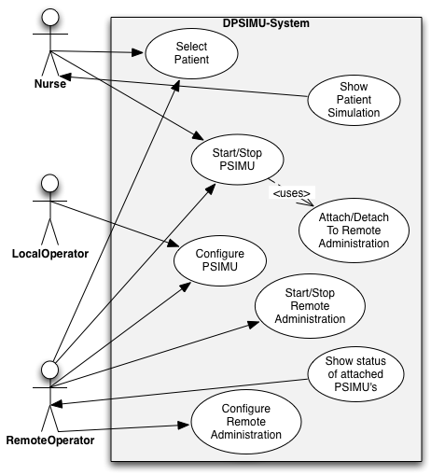Illustration 2:Use case diagram for PSIMU system

From the requirement specification we have selected two use case which are believed to be important to the architecture. The two use cases are “Generate patient simulation signals” and “show patient information”.

Use case Generate patient simulation signals scenarios

Use case goal
To generate patient signal which are similar to whose from a real patient.

Use case scenarios
Main scenario:
- Operator selects an input file.
- System reads the file and starts to generate signal.
- [Operator selects a new file]
- [The file can not be read]
- LMON is able to monitor the signals.

Extensions:
Her angives hvad der skal ske for de forskellige undtagelser, der er angivet under beskrivelsen.
Operator selects a new file::
Generation of signals stopped until a new file is selected.
The file can not be read:
No generation of patient signals are performed. Operator is able to select another file.

This section describes one or more significant Use case scenarios for the selected Use case no. 1. It will always include the normal scenario (the sun shine scenario) and one or more scenarios with exceptions.
For Use cases with significant nonfunctional requirement: include these nonfunctional requirements (a copy from the requirement specification).
For Use cases with human actors: include significant Pictures of the User Interface.
For Use cases with include, extends or inherit relations: include a UML Use-case diagram for the Use case.
References: The realizations of the Use case scenarios should be found in the logical view, in subsection Use case realizations 5.5.

Start and stop PSIMU

Use case goal
The goal of this use case is to start and stop the patient simulation.

Use case scenarios
Scenario 1:
- The nurse starts the PSIMU
- The PSIMU start to simulate a patient
  - [The simulation does not start]
- The nurse stops the PSIMU
- The PSIMU stops generating patient signals
Scenario 2:
- The remote operator start the connected PSIMU's
- The PSIMU's starts to simulate a patient
  - [The simulation dos not start]
- The remote operator stops the PSIMU's
- The PSIMUs stops generation patient signals.
Extensions:
- [The simulation does not start]
  - The patient can't be located.

Logical View
Mandatory view.
A description of the logical view of the architecture.
This section describes the architecturally significant parts of the design model, such as its decomposition into subsystems and packages. and their organization in a layered structure. Describe the most important classes, their organization in packages and subsystems, and the organization of these packages and subsystems into layers.

Overview
This subsection describes the overall decomposition of the design model in terms of its package hierarchy and layers and documented on UML class diagrams (showing packages).
If the system has several levels of packages, you should first describe those that are significant at the top level. Include any class diagrams showing significant top-level packages, as well as their interdependencies and layering. Next present any significant packages within these, and so on all the way down to the significant packages at the bottom of the hierarchy.
UML class diagrams: with packages, dependencies and interfaces.

At the top level, the system is split into two subsystems. The RemoteAdministrator and the PSIMU.

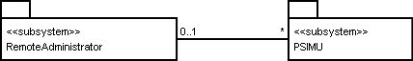

PSIMU
The PSIMU is layered after the five-layered architectural pattern from [5]. The five packages are: Application, UI (user interface), Comm (Communication), HAL (hardware abstraction layer) and Operating System (OS).

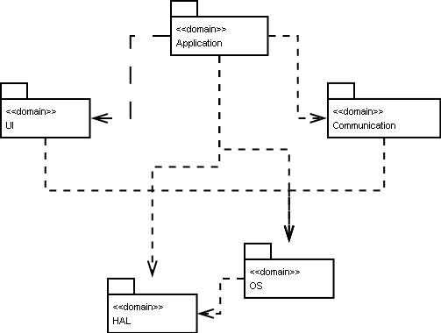

The application packages can use all the reminding 4 packages. The User interface package can use the OS. The Communication packages can use the OS and HAL. The OS packages ca n only use the HAL. The HAL may not use any other packages.

Architecturally significant design packages
A description of the design packages which have an impact on the architecture.
Two packages have been found to be significant to the architecture. These are the Discrete and the Continuous.

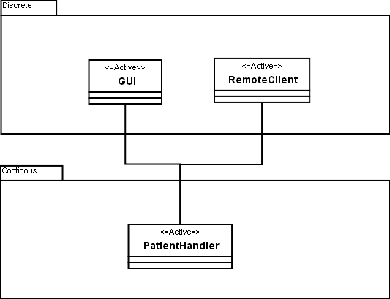Illustration 3:Two part architectural model

Package Discrete
Mandatory: A brief description of the responsibility for package 1.
Alternative 1: A UML class diagram with all significant classes and packages contained within the package. The class diagram may include classes from other packages named as package_name::class_name – this often eases the understanding of the class diagram.
For each class in the package:
include its name, a brief description of its responsibility, and, optionally a description of some of its
important operations and attributes. Also describe important associations that are necessary for
understanding the class diagram.
Describe the package interfaces.
UML Class diagram
with its decomposition into classes and optionally packages contained within the package.
UML State Chart:
for classes with a state machine include a UML state chart describing the state machine.
Alternative 2: describe the complete package in a separate design document and insert a reference here.

As previous section.

The discrete packages contains all the discrete or event based code for instant the GUI and the RemoteClient.

GUI class is responsible for handling the local user interface on the PSIMU. The RemoteClient is responsible for handling the connection to the RemoteAdministration. Both these classes are implemented as observers of the PatientHandler so they can be notified then some things have changed in the PatientHandler. So then for instant the PatientHandler has been changed by the Local user interface the RemoteClient will be notified, and can send that information to the RemoteAdministration.

Package Continuous
The continuous part of the application handles generation of patient signals. The class diagram below shows the architectural significant classes.

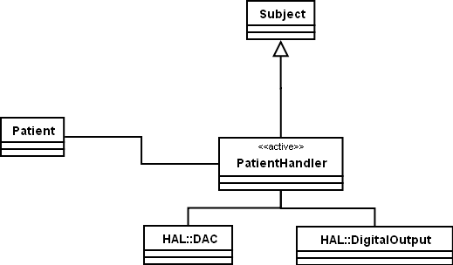
The PatientHandler inherits from the subject class so that classes in the Discrete part can observe it and get notified about changes.

Patient (signal records) which contains the simulated values is known by the PatientHandler. The PatientHandler, which is an active class, meaning that it holds its own thread/task, reads signals from the patient with the frequency at which the patient was originally sampled. PatientHandler calculates all the output signal including ECG, pulse and EDR based on the signals and write the outputs to DAC and DigitalOutput.

Remote Administration
Below the a class diagram of the RemoteAdministration is shown.
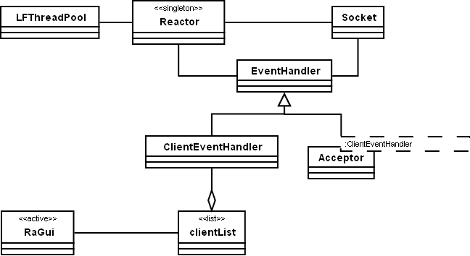

The RemoteAdministion is server application implemented using patterns for [11] implemented in your mini-framework. So in the class diagram above the only the Gui, ClientList and ClientEventHandler are application specific. The rest of the classes are part of the mini-framework.

Architecturally significant design packages
The RemoteAdministration make use of the architectural patterns Leader-Follows and Reactor by using the mini-framework.

Mini Framework
The Mini Framework is a collection of portable OO wrappers for some of the OS's C API and a framework to deal with distributed application. The patterns used in the mini-framework is described in [11].

Use case realizations
This section illustrates how the software actually works by describing the realization for the selected Use-case (and Use case scenarios), and explains how the various design model elements contribute to their functionality.
Reference: The corresponding Use cases and scenarios of these realizations should be found in the use-case view in section 4.
This section describe how the software works by describing the realization for some selected used cases.

Use case “Generate patient simulation signals” realization
A brief description of how Use case 1. is realized in the design with references to the OO/UML model elements. The Use case logic is mapped onto packages and classes in the logical model.
UML class diagram with the classes used in the realization of the Use-case 1 scenarios.
UML interaction diagrams (sequence- or collaboration diagrams) showing how the objects interacts to fulfilling one or more of the Use-case 1. scenarios.

Illustration 4:Sequence diagram for main success scenario for the use case "Generate Patient Simulation Signals"

The sequence diagram shows the main success scenario for the use case Generate Patient Simulation Signals. There is a timing constraint of 1/360 second because of the sample rate of 360 Hz.. What happens is that the PatientHandler calls GetECG() and GetAnn() from Patient. PatientHandler then calculates the EDR. It then writes thePulse to the DigitalOutput and the EDR and ECG to the DAC. Finally it calls the Notify-method which notifies the observers attached that a change has occurred.

Use case “Show Patient signal” realization
As previous section.

Illustration 5:Sequence diagram for main success scenario for use case "Show Patient Information"

The sequence diagram shows the main success scenario for the use case “Show Patient signal”. The timing constraints of 0.2 seconds means that the view is updated every 200ms. The loops indicate that they will remain in this state until the the guard is broken, meaning either a “back” or “different view” command is received.

Use case “Start and Stop a PSIMU” realization
Make a sequence diagram for the main scenario.

Process/task View
Optional view.
A description of the process view of the architecture. Use this view if the system has more than one thread of execution.
This section describes the system's decomposition into lightweight processes (single threads of control) and heavyweight processes (groupings of lightweight processes) and the communication mechanism between these processes.

PSIMU
This view describe the use of process and threads in PSIMU

Task overview
For large systems: organized this view by groups of communicating processes.
UML Class diagram as a process/task diagram with active classes and passive classes of type monitor.
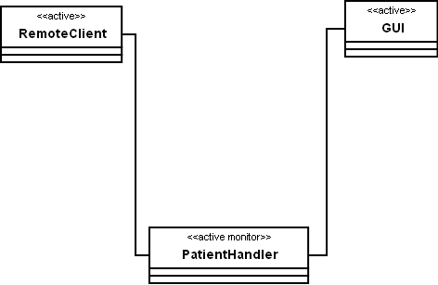

Task implementation
This section describes the operating system interface used in the implementation of processes/tasks and process communication. This section can specify the interface for a process/task framework (or wrapper façade classes).
An alternative is to insert a reference to the framework interface specification document.
If an operating system API is used, without wrapping, a reference to this API documentation is inserted here.
Active classes are implemented as threads. The PSIMU consists of 3 threads, which maps nicely to the two part view. The GUI and RemoteClient runs the discrete the part and the PatientHandler runs the continuous part. The PatientHandler must have a higher priority than GUI and RemoteClient and must be able to pre-empt the discrete treads to guarantee the correctness of the signal generation. A RMA (Rate Monotonic Analysis ) should be made to guarantee that the system can be scheduled.

Task communication and synchronization
Describe the main modes of communication between processes, such as message passing, interrupts, monitors and rendezvous.
In the PSIMU there is only one task group. This group consists of the three task shown in the task overview.

Task communication in the group
This section describes the processes in group 1. The interactions between the processes are shown on collaboration- or sequence diagrams, in which the objects are active objects with their own threads of control.
UML class diagram as a process/task diagram with active objects (processes/tasks) and passive classes of type monitor.
UML collaboration diagram with active objects and monitors (if used)
or alternatively an
UML sequence diagram with active objects and monitors (if used).
The communication between the tasks is synchronized/protected by the PatientHandler class which should be implemented as a monitor class.

Task GUI description
A brief description of behavior, lifetime and communication characteristics.
The GUI and RemoteClient runs all the discrete part of the system. This includes user interaction and system configuration and communication. The task must respond to user event within 200 ms to give a good user experience.

Task PatientHandler description
As previous section.
The PatientHandler runs all the continuous part of the system. Eg. Signal generation and writing signal to the outputs.

PatientHandler must run at the the highest priority in the system to make sure that the signal generation is correct. The PatientHandler must run with a frequency equal to the sampling frequency of the signal generating. The sampling frequency for the chosen signals is 360 [Hz].

RemoteAdministrator
This section will describe how threads and process are used in the RemoteAdministration.

Task overview
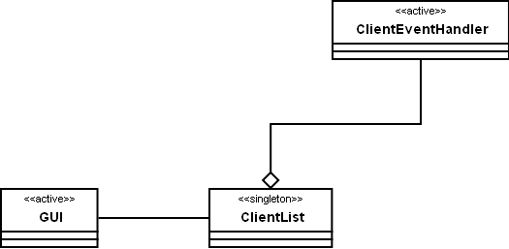

The diagram above shows the threads in the RemoteAdministration application. The GUI is running in one thread. The ClientEventHandler classes is also running in a thread, which is taken from a thread pool.

Task implementation
The threads in the RemoteAdministion application is implemented using Windows Threads.

Deployment View
This chapter describes which hardware is used in the system, and how it is connected.

System configurations overview
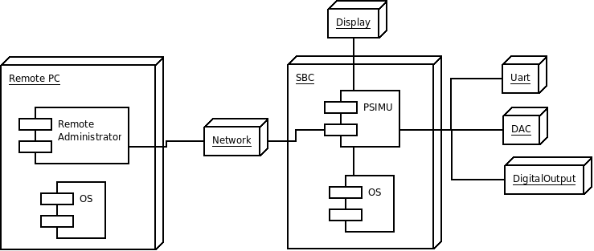

The PSIMU application runs on top of a operating system on an Intel Pentium CPU based computer. A keyboard and a display is connected to the computer. DAC is used to generate the analogue output signals, and the digital output for generating the digital output signal.. The UART is used for receiving information from the IPUMP. For future development an Ethernet network is shown so the system can communicate with a remote client.

System configurations
Describe the different possible or typical system configurations. One of these could be a description of system configurations for performing software tests and simulations.
The system have two different configurations: one for simulation on a PC and one for the SBC target.

Configuration Simulation
Show the configuration with a UML deployment diagram illustrating the nodes in the configuration and their communication, followed by a mapping of processes to each processor node.
UML deployment diagram showing nodes and communication stereotypes in configuration 1.
Optional: UML interaction diagram showing the interactions between the nodes in the actual configuration.

The Simulator is used for test and debug on a host machine which is not connected to the actual hardware. This can reduce debugging time, and make possible to run automatic test on the a PC e.g. unit test.

Configuration SBC
This configuration is for building the system for the SBC. The SBC is the target platform for the PSIMU.
As previous section.

Node descriptions
A short description of each node represented on the deployment diagrams for the different configurations.
Below, there are a description of each node:

Node SBC description
A short description of node 1 – a processor or a hardware unit.
A processor is described by key data e.g. CPU type, clock frequency, memory (RAM, ROM) etc.
For HW nodes insert a reference to the documentation of the Hardware unit.
SBC is single board computer which is used as target for the PSIMU system. More information about the SBC can be found here http://kurser.iha.dk/eit/embedded/.

Remote PC
As previous section.
The remote PC runs the Remote administrator program which is used to control multible PSIMU's.

Node Network description
The network the SBC is connected to via Ethernet.

Node DAC description
The digital to analog converter which is used to generate some of the patient signal.

Node UART description
The UART used to receive signal from the IPUMP

Node display
The display on PSIMU is a touchscreen and all user interaction is going though the touchscreen.

Implementation View
This view handles the implementation perspectives which has not been handled in the logical view.

Overview
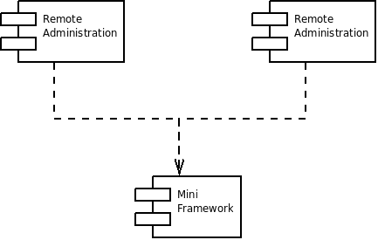
The system consists of 3 components. PSIMU application, the Remote administration and the Mini Framework developed in DRTS.

Component descriptions
This section describes each of the components shown on the overview diagram.
This section describes each of the components shown on the overview diagram.

Component PSIMU
Mandatory: insert a short description of the responsibility for component 1.
Alternative 1: Describe the component and show its part components on a component diagram.
UML component diagram with part components and their dependencies (e.g. an executable components and its source files).
Alternative 2: Insert a reference to an external component documentation.
This component contains the PSIMU application. Which is the Patient simulator.

Remote Administration
This component contains the remote administration application. Which can control a number of PSIMU's

Mini Framework
The component is a common library which contains OS independent wrapper classes for the C-API to E.G. networking. It also contains a framework for making distributed applications.

Protocol
The procotol between the PSIMU clients and the RemoteAdministration server is implemented as ASCII strings to make debugging easy.
Server requestes | Client responses
S start / stop | S start / stop
P <record name> | P <record name> / “”
G | G “recordName age .. \n  recordName age …. “

The client will send the P and S telegrams without request if the state or patient is changed locally.

design decisions
This section describes the general design decision taken in the architecture design phase and mandatory design constraints given in the requirement specification or as a part of a company standard.
This section describes the general design decisions taken in the architecture design phase and mandatory design constraints given in the requirement specification or as a part of a company standard.

Architectural goals and constraints
This section describes the non-functional software requirements and objectives that have some significant impact on the architecture e.g. use of an off-the-shelf product, portability, distribution, and reuse.
It also captures the special constraints that may apply e.g. design and implementation strategy, development tools, team structure, schedule, legacy code, and so on.
Architectural goals are the following:
- Portability
- Extendability
- Maintainability
- Correctness

Portability is important because the current system is only a prototype so it must be moved to the other platform: the actual system.

Extendability is important because it is expected that the system should be controllable from a remote client in the future.

Maintainable is important because the development of the system is not finished with this project (it is a prototype), so it should be easy for new developers to continue the work.

Correctness is important because the simulator is used to test other systems and personal, and if the signals are not generated correct then the tests are worthless.

Architectural constraints
- OS: Linux
- HW: SBC
The system should be using the Linux because the company already have some hardware running Linux.

Architectural patterns
This section list the standard architectural patterns used in the project and a reference to the original source.
This section lists the standard architectural patterns used in the PSIMU:

The Five-layer architecture pattern that is used in the PSIMU is described in [5]. This architecture is useful for structuring many embedded systems. It is a implementation of the more general layered pattern which helps especially portability.

The second architectural pattern used is the Two-part view which is described here [9]. This architectural pattern splits the system into a discrete and a continuous part. The discrete part handles all user interface and other event based things. The continuous part handles the process control part.

MVC [11] has been used use to separate model, control and view parts seen from an implementation point of view. To ensure portability and maintainable the implementation of the tree things must conform to MVC.

The MVC and two part architectural model supplement each another nicely. The MVC concerns the functionality and the two part architectural model concerns run-time behaviour. The model of MVC and the continuous part of two part architectural model contains the same functionality. The view and control parts of MVC and the discrete part of the two part architectural model as well contain the same functionality.

For the RemoteAdministration the

General user interface design rules
This section describes the general rules and principles for designing the user interface part of the system. This could also be a reference to an external document.
The principle behind the GUI of the application is that it is supposed to be as simple and well arranged as possible.

Implementation languages and tools
This section list the chosen implementation language and tools with version numbers.
- C++ including STL (Standard Template Library)
- Eclipse
- SVN: The software is host on-line at Google Code. http://code.google.com/p/mini-framework/
- Dia
- Doxygen
- MS Visual Studio C++ Express

Implementation libraries
This section list the chosen implementation libraries with references and version numbers.
Mini-Framework developed in DRTS
WFDB lib. Version 10.4.11

SIZE and performance
A description of the major dimensioning characteristics of the software that impact the architecture, as well as the target performance constraints.
In this section, list the critical size and performance dimensions of the project that shape the architecture.
The information presented may include:
- The number of key elements the system will have to handle (such as the number of concurrent flights for an air traffic control system, the number of concurrent phone calls for a telecom switch, the number of concurrent online users for an airline reservation system, etc.).
- The key performance measures of the system, such as average response time for key events; average, maximum and minimum throughput rates, etc.
- The footprint (in terms of disk and memory) of the executables - essential if the system is an embedded system which must live within extremely confining constraints.
Most of these qualities are captured as requirements; they are presented here because they shape the architecture in significant ways and warrant special focus. For each requirement, discuss how the architecture supports this requirement.
A maximum of 3 patient signals are shown concurrently.
The 3 signals are: ECG, EDR and Pulse.
The ECG and Pulse signals come from the signal database whereas the EDR is calculated from these two signals.

As described in the Use Case Realization chapter in the sequence diagrams there are some timing constraints. The system has to convert ECG and EDR to analogue signals via the DAC. This has a constraint of 1/360 seconds (2,77 ms). This means that the signal generation has to be over with before 1/360 second has passed.

The display also has some timing constraints. It has to be updated once every 200ms.

With the current system there is no possibility of having more than one user. This will change in the future when a remote operator is introduced to the system, and more PSIMU systems are present.

Quality
A description of how the software architecture contributes to other non-functional capabilities of the system: extensibility, reliability, portability, and so on.
In this section, list the key quality dimensions of the system that shape the architecture. The information presented may include:
- Operating performance requirements, such as mean-time between failure (MTBF).
- Quality targets, such as "no unscheduled down-time"
- Extensibility targets, such as "the software will be upgradeable while the system is running".
- Portability targets, such as hardware platforms, operating systems, languages.
For each dimension, discuss how the architecture supports this requirement.
You can organize the section by the different views (logical, implementation, and so on), or by quality.
In section “Architectural goals” we stated that the architectural goals were portability, extendability, maintainability and correctness. In this section we discuss how these qualities are meet. The section is organized to the different qualities.

Portability
The five layer architecture helps keeping the system portable. The five layers are restricted to which dependencies they may have. This makes it easier to replace one or more of them.

The HAL layer ensure that the application does not access the hardware directly which makes it easier to change the hardware because it does not affect the application.

All communication protocols are put in the communication layer which makes possible to change the protocol to IPUMP and the Remote control client without affecting the application.

Extendability
The use of the observer pattern between the user interface and the model make it easy to extent the system with a remote controlled user interface. This new interface will be able to connect to the model and receive updates as the current user interface and it will be able to send event to the model.

Maintainability
To make the code maintainable all the code is formatted and indents in the same way. Using a consistent formatting and indention makes the code easier to read. To ensure the consistency the formating tool in eclipse has been used. This can format and indent the source code to a specified style.

The source is documented using doxygen style comments. The benefits of using doxygen style comments are two fold. Doxygen can check all parts of the software are documented. It can even check if all parameters are documented. Apart from the checks, doxygen also can extract the documentation and put it into different formats eg. HTML, XML, latex, RTF. We have used doxygen to generate HTML output which is an easier way into the source code.

Correctness
Correct generation of the patient signal is handled by the process view. Where it is stated that the PatientHandler thread/task must be at the highest priority in the system. This ensure that the handling of user interface is not interfering with the generation of the signals.

Compilation AND LINKING
This section describes the process of compiling and linking a program.

Compilation-hardware
Describe the compilation machine.
Various laptops have been used.

Compilation-software
Describe the software used to compile and assemble the program.
For example: compiler, assembler, linker, include files, files with system parameters, make files etc.
Include vendor and version number for standard products.
For compiling the PSIMU software the GCC compiler must be available. The RemoteAdministration software is compiled using Microsoft Visual Studio.

INSTALLATION AND Executing
Describe how to install and run the program.

Installation
This section describes the process to bring an executable file to run in the right environment. It could be to download the program to another machine or to program it on EPROMs and insert these in the target machine.
Describe the necessary configuration files and start up parameters.
To run the PSIMU application certain preconditions must be fulfilled. The following must be installed:

WFDB lib: The WFDB lib from http://physionet.org/physiotools/wfdb.shtml must be installed on the PSIMU machine.

Network lib: WFDB depends on libwww or libcurl so they must be installed.

Executing-hardware
Describe the necessary hardware for running the program.
It can be on the development platform or on the final target platform.
In order to run the all the software the following hardware is required:

- Intel Pentium 4 processor minimum; 2GHz minimum
- 1GB RAM minimum
- 1.3GB disk space for a typical installation
- Local DVD-ROM drive or access to network for installation
- TCP/IP must be installed on the host system, even if it is being used as a standalone PC with a serial connection to the target
- Network interface card for debugging over a network is recommended

Executing-software
Describe the necessary SW requirements for running the program on a given machine. It could be operating systems or DLL files.

- Remote Administration SW must run on:
  - Windows XP Professional (Service Pack 2) or Windows Vista (Businesss or Enterprise)
  - Administrator rights
  - Current version of a standards-compliant browser
  - Possibility to disable firewall
- PSIMU must run on:
  - Linux OS
  - Possibility to disable firewall

Execution-control (start, stop and restart)

- Run the PSIMU application be double click on it.
- Run the Remote Administration be double click on it.
Describes how the system is started, stopped and restarted.

To restart the program, follow the steps to start the application.

Error messages
A complete description of the software error messages. For each error type give an explanation of the error and describe how to proceed to get the system working again.
Alternative: a reference to a stand alone document.
There are no error messages displayed in the PSIMU application.
Necessary supplementary documentation can be inserted here as appendices.

