Kim, Hyun Ho 1001967176

1.a)

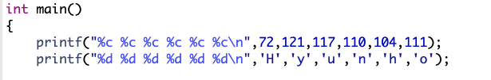

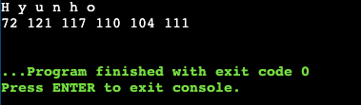

1.b)

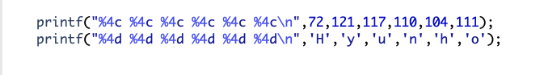

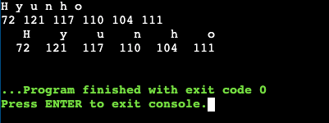

1.c)

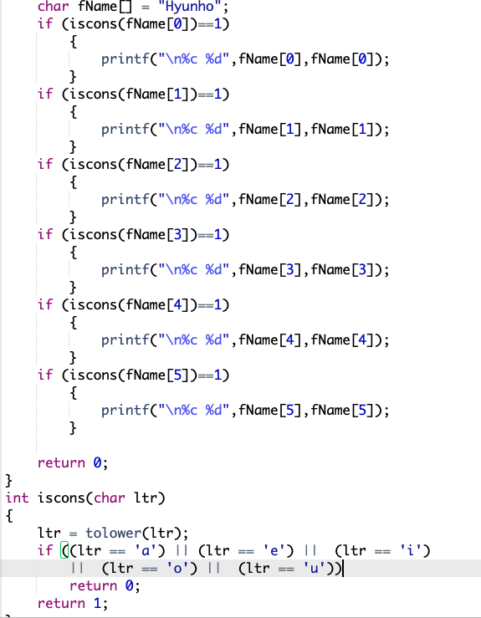

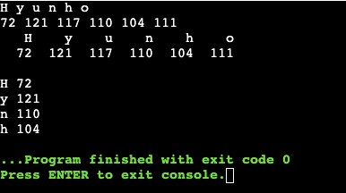

1.d) Please see file HK7176Lab2Part1d.c for this question.

1.e)

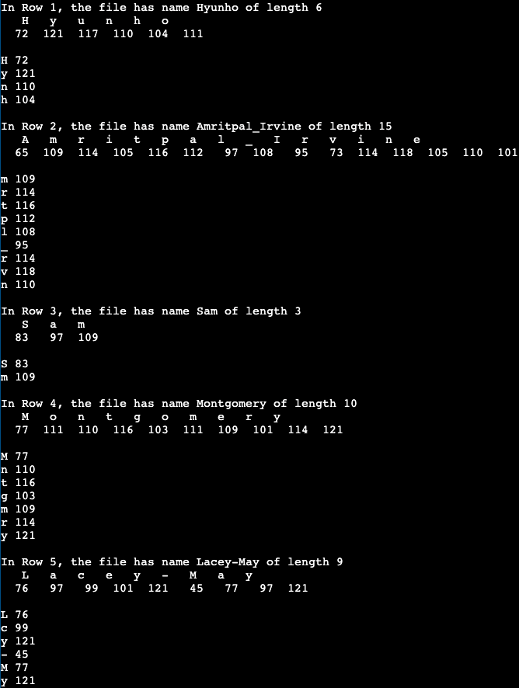

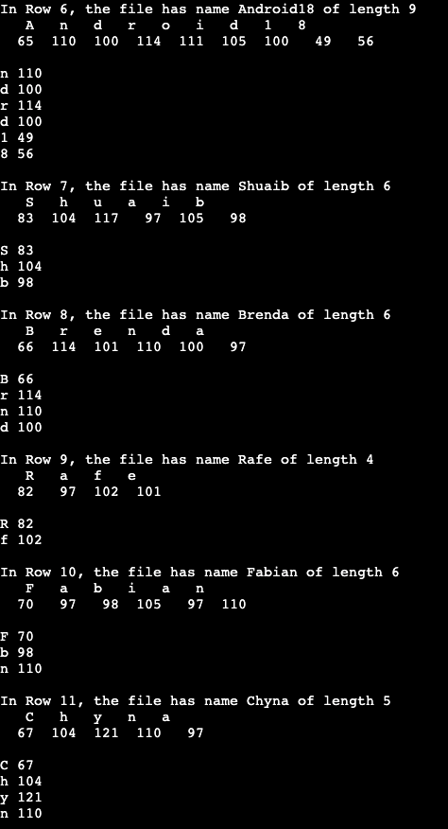

1.f) Please see file HK7176Lab2Part1e.c for this question.

Part 2

2.a.i) 0,1,2,3,4,5,6

2.a.ii) The valid year values in checkDate range are between 1000 and 9999

2.a.iii) In the dateInvalid, 2 will be assigned.

2.a.iv) It is testing if month 4,6,9, or 11 has more than 31 days. If so, the dateInvalid assigns 4.

2.a.v)

A) Yes, It’s correct

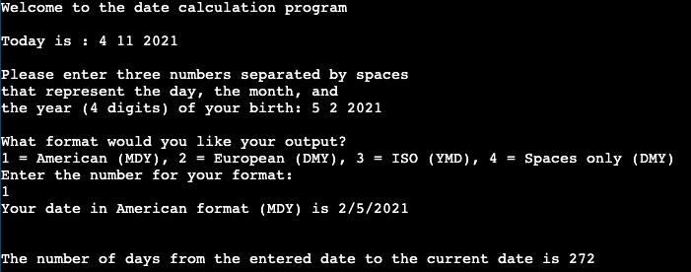

B) Yes, it is correct

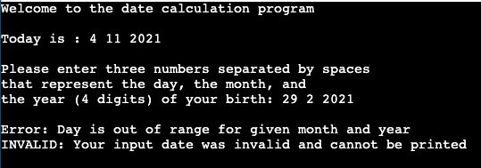

C) Yes, it’s correct.

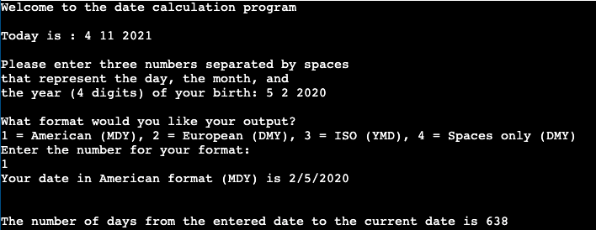

D)No, there is there is no day 30 in a leap year.

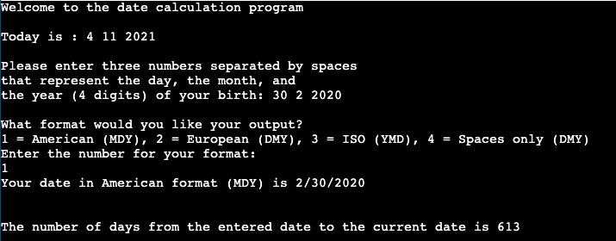

2.a.vi) function call *checkLeap* checks to see if the year is a leap year.

2.a.vii) The if (!dateInvalid) starts if dateInvalid is zero. It would not be tested if the month is out of range,0-31.

2.a.viii)

A) Yes, it’s correct.

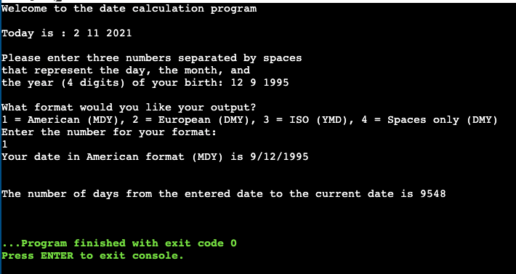

B) Yes, it’s correct.

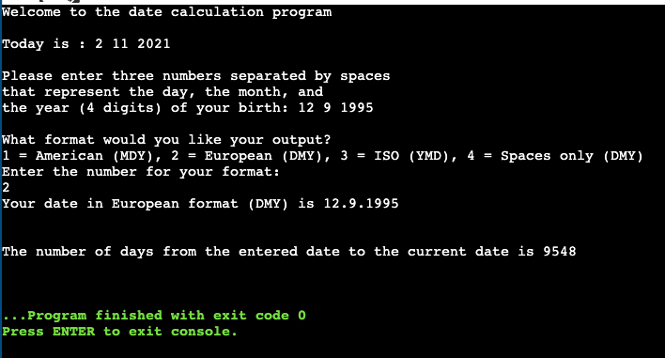

C) No, it’s printing in European format. It should be printed out in ISO format.

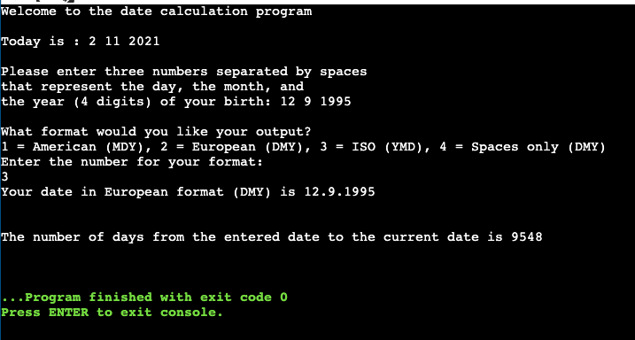

D) No, it’s printing in European format. It should be printed out in Spaces only format.

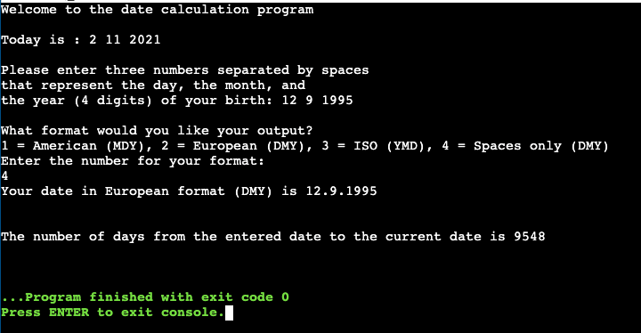

2.b)

2.a.v) D

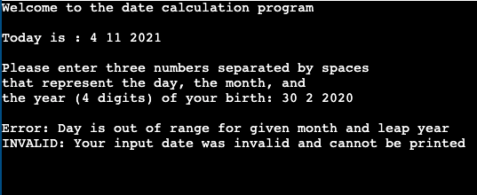

2.a.viii) C

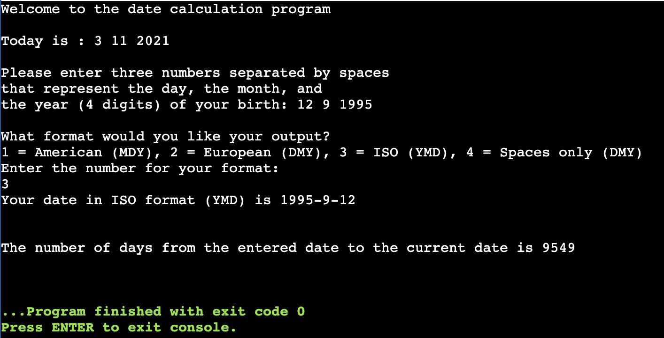

2.a.viii) D

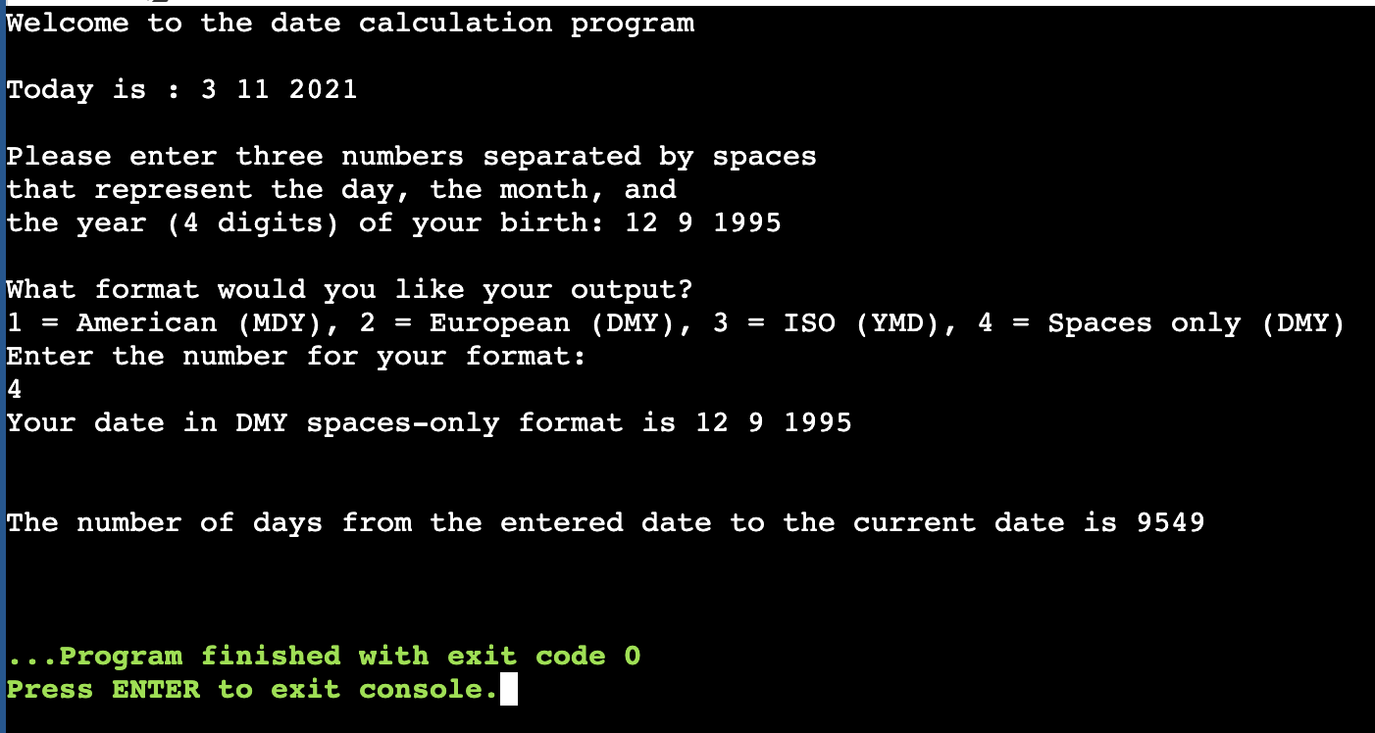

2.c)



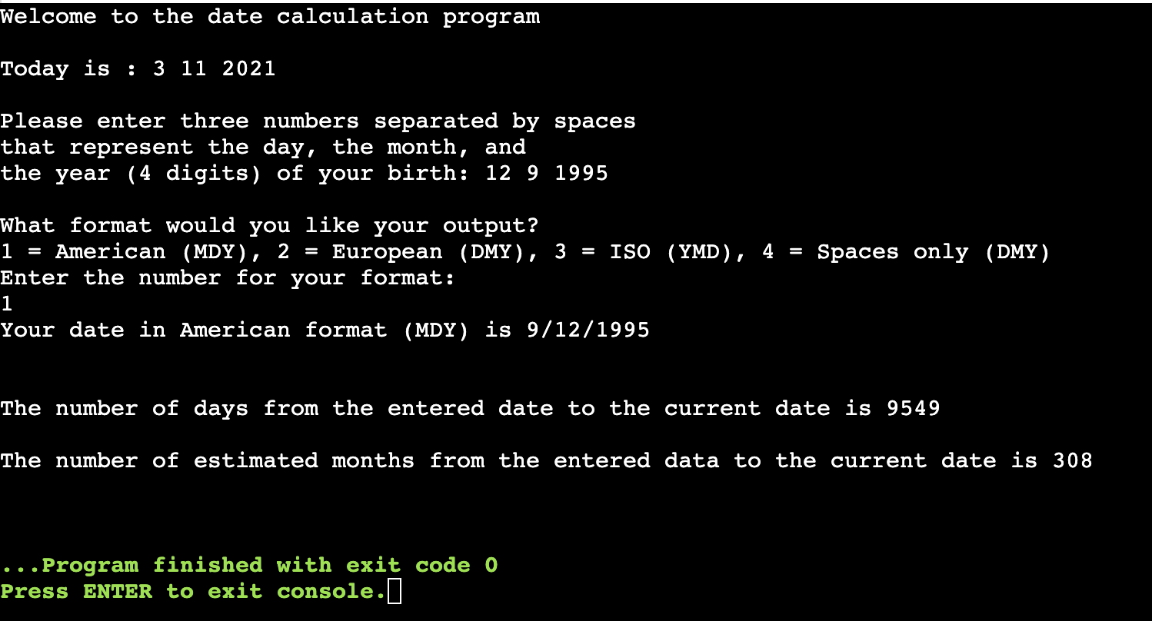

2.d)

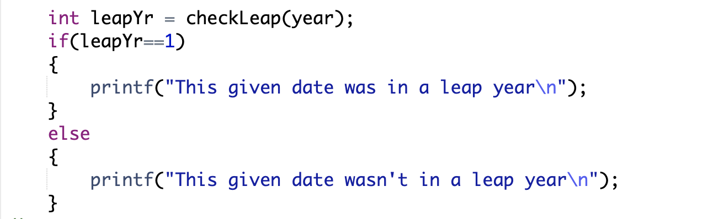

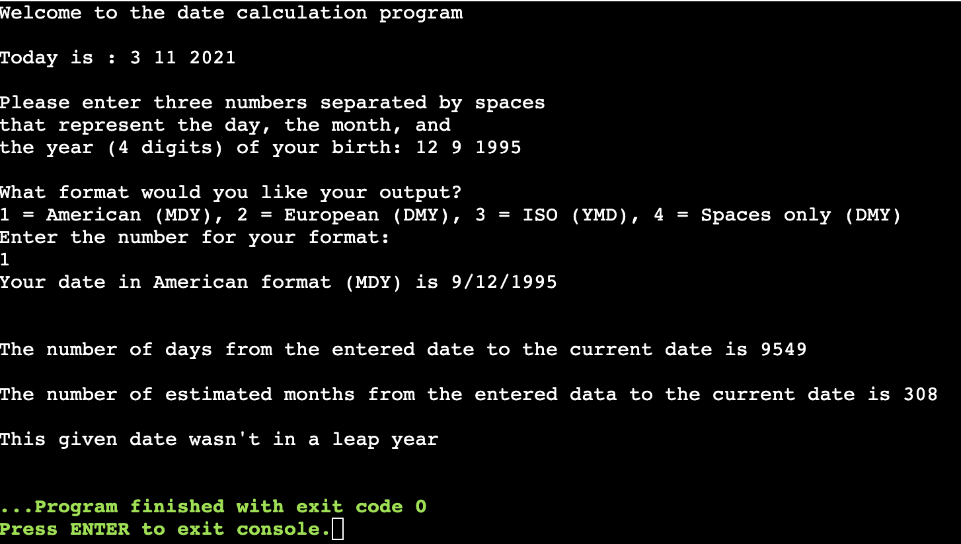

2.e)

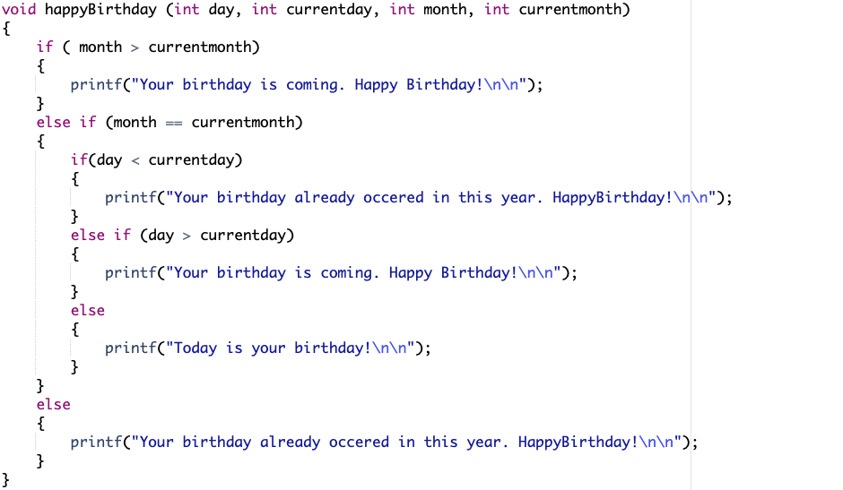

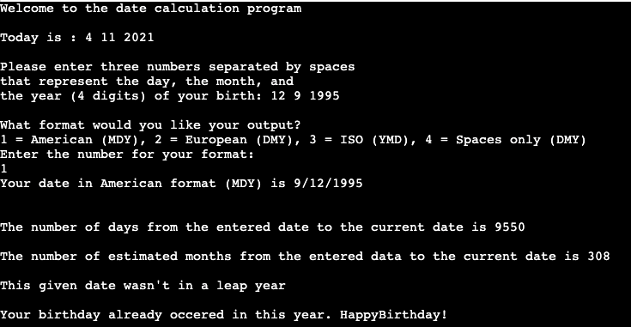

2.f)

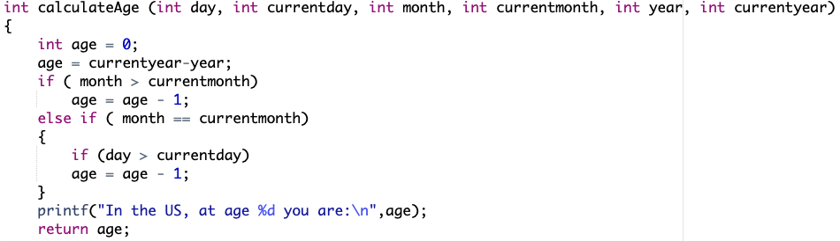

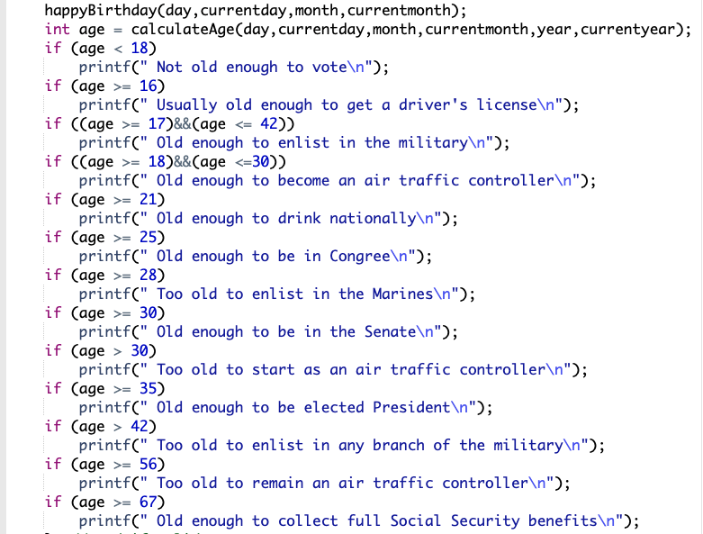

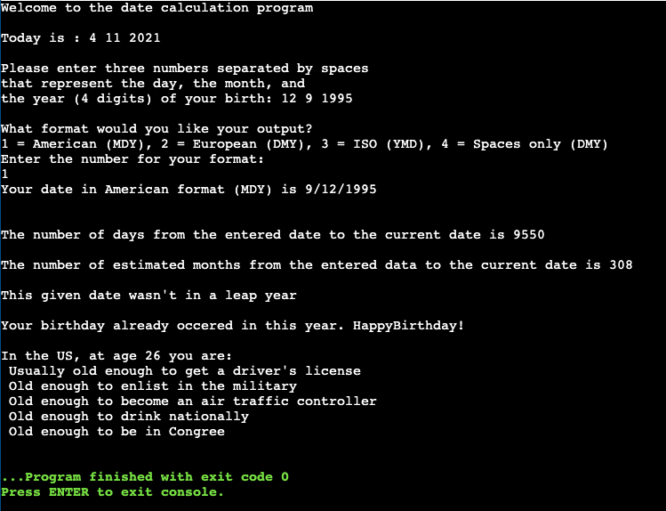

2.g) Please see file HK7176Lab2Part2.c for this question.