Hyun Ho Kim 1001967176

1.a)

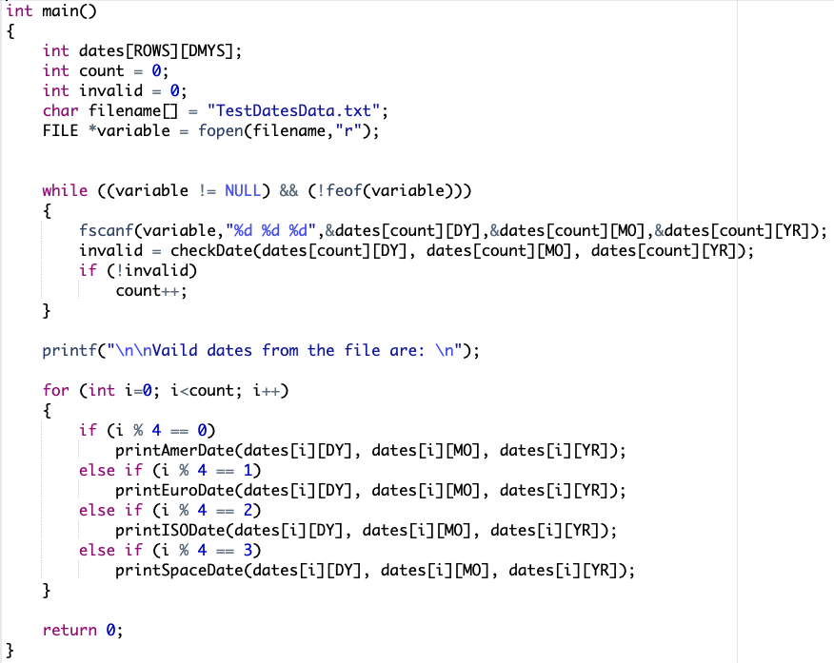

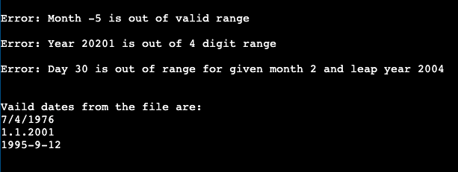

1.b)

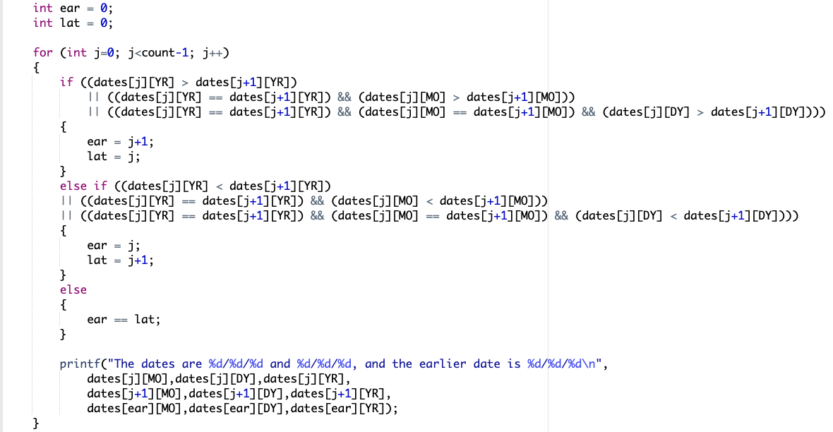

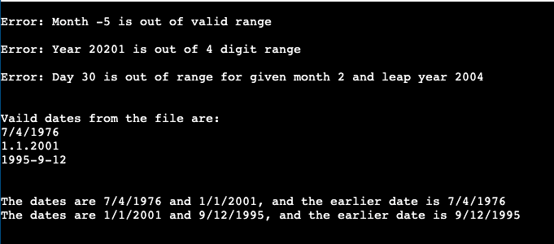

1.c)

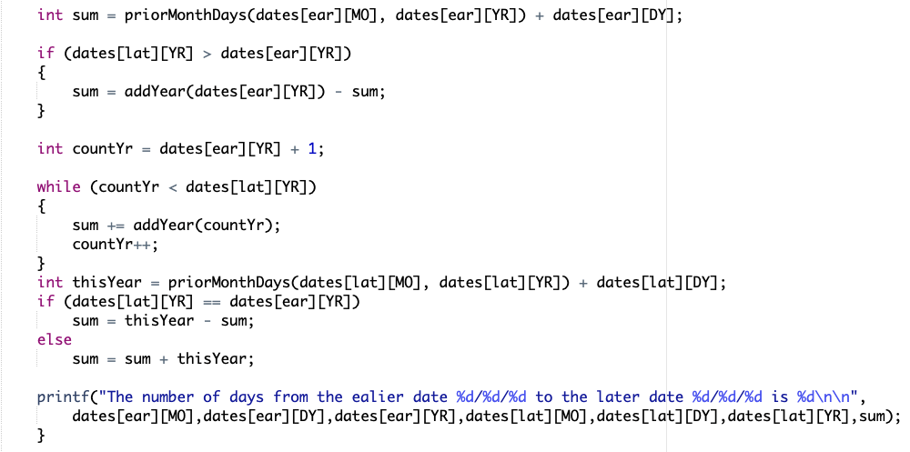

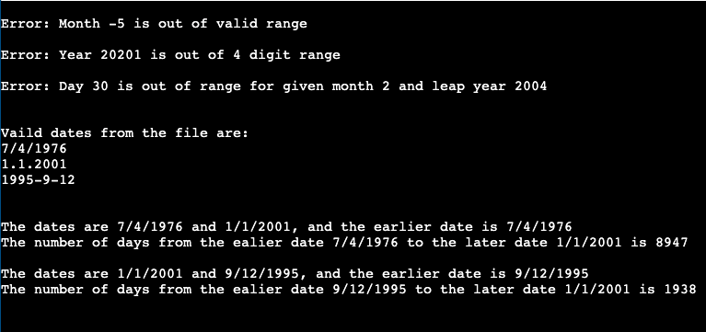

1.d) Please see file HK7176Lab3Part1.c for this question.

2.a) Please see the file people.txt for this question.

2.b)

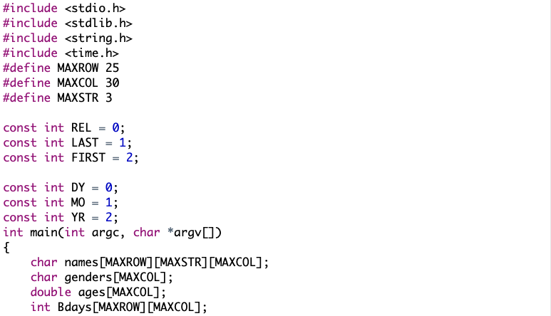

2.c)

**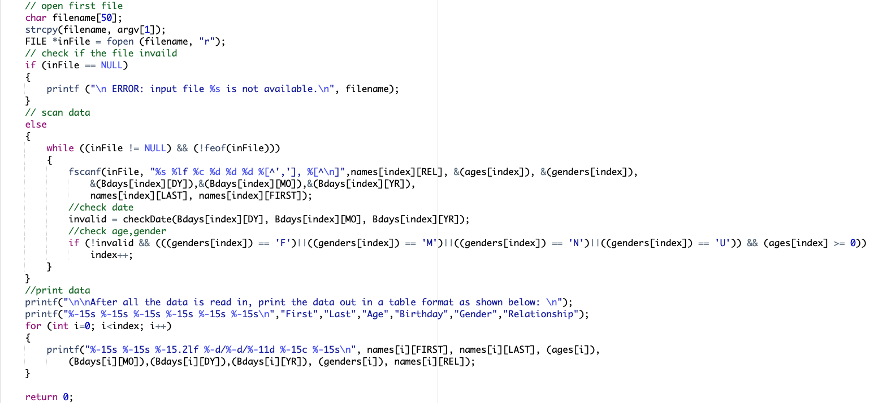  
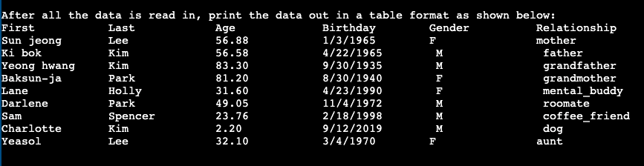**

**2.d) See file** HK7176Lab3**Part2c.c for this question**

2.e)

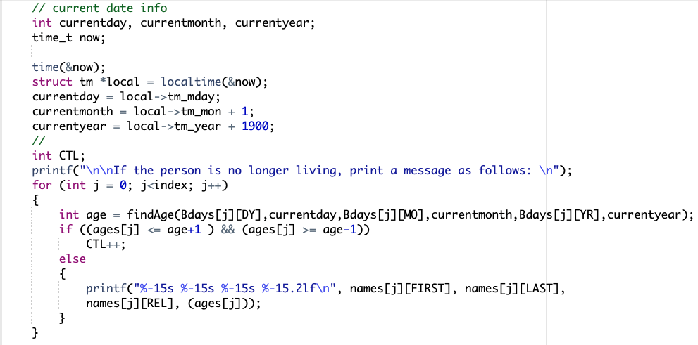

Function call

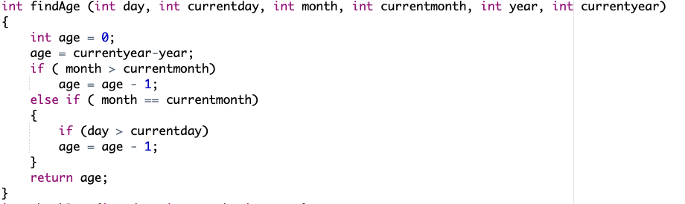



2.f)



Function call

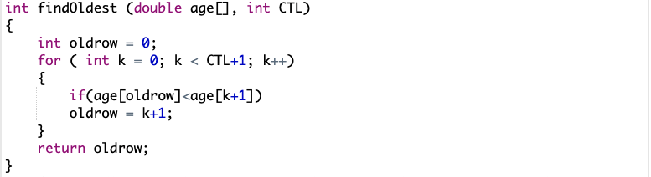



2.g)



Function call

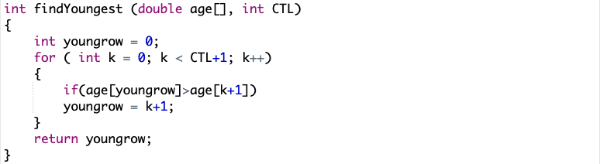



2.h)

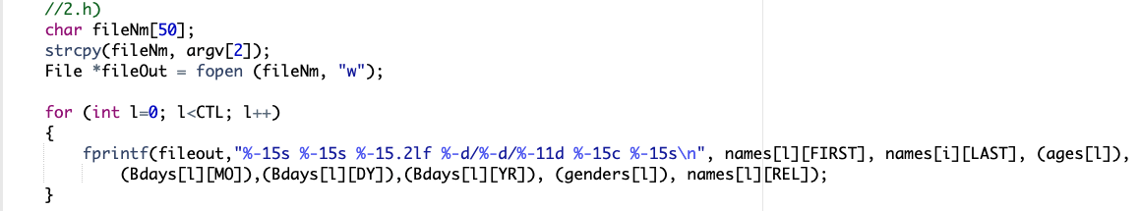

**See file** HK7176Lab3**Part2e.c for this question.**

**Extra Credit**

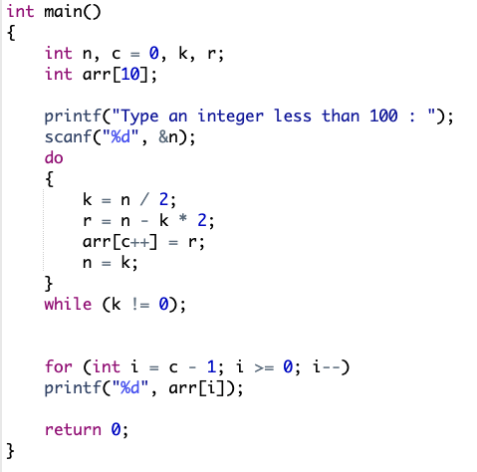



**See file** HK7176Lab**3Extra.c for this question.**