Hyun Ho Kim

1001967176

CSE 4334-002

**HW1**

**Loading the data**  
>library(datasets)

>data(mtcars)

**Check the Data**

> head(mtcars)  
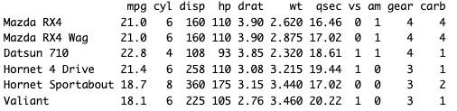

**Five Point Summary**

>summary(mtcars$gear)



**Box-plotting**

> boxplot(mtcars$wt, col="red") # box plot with wt and red color

**Histograms**

> par(mfrow=c(1,3)) # multiple graphs in one window

> hist(mtcars$wt, col = "red", breaks = 15) # histogram with 15 breaks and red color

> hist(mtcars$wt, col = "red", breaks = 39) # histogram with 39 breaks and red color

Change to par(mfrow=c(1,1)) or use dev.off() or graphics.off() to go back to one graph per page

> par(mfrow=c(1,1)) # one graph in one window

**Bar plotting**

> barplot(table(mtcars$gear), col="blue") # Bar plotting with gear and blue color

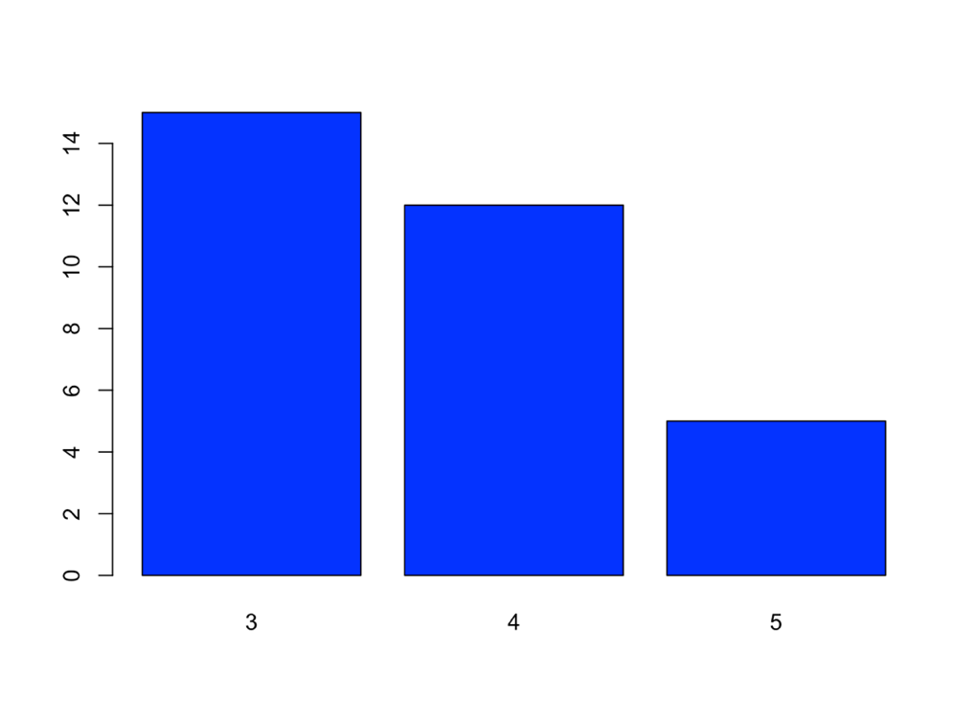

**Two-dimensional boxplot**

> boxplot(mpg~carb, data=mtcars, col = "yellow # mpg with carb and yellow color

**Scatterplot**

> with(mtcars, plot(mpg, drat)) > # mpg with drat

> points(mtcars$mpg, mtcars$drat, col="orange", pch=16) # change the circles to orange filled circles  
