Figures
HCC vs hemangioma on B-mode ultrasound — revision 3
Performance figures are test set only (n=268). Cutoffs and their equivalence intervals are derived on the validation set.
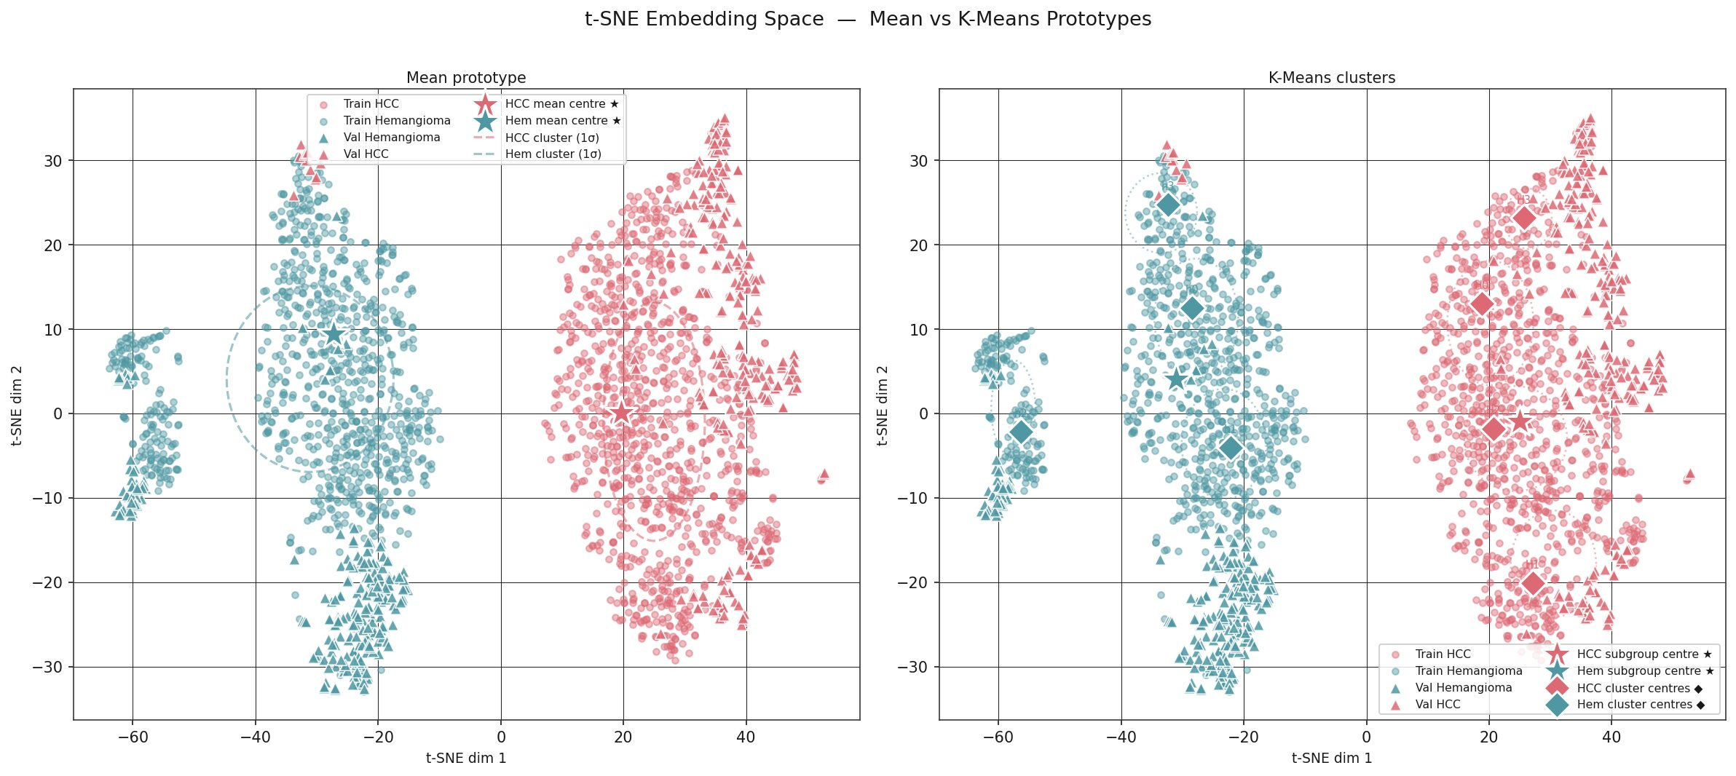
Figure 1. t-SNE Embedding Space Visualization (Primary Model: EfficientNetV2B0 + CE+SupCon).
Embedding distribution of training and validation sets showing clear intra-class compactness and inter-class separation between HCC (red) and hemangioma (teal) clusters. Left panel illustrates single mean prototype centres; right panel depicts k-means cluster prototypes (k=4).
file: figures/fig 1 TSNE visualization.jpg

(A)
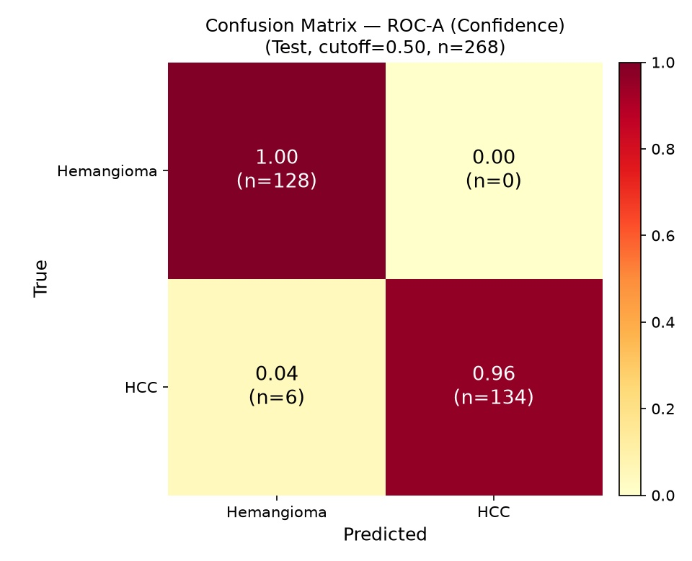
(B)
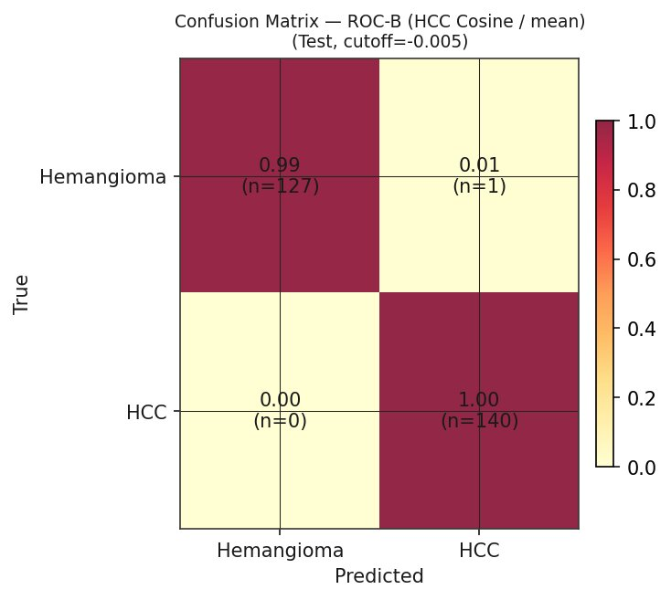
(C)
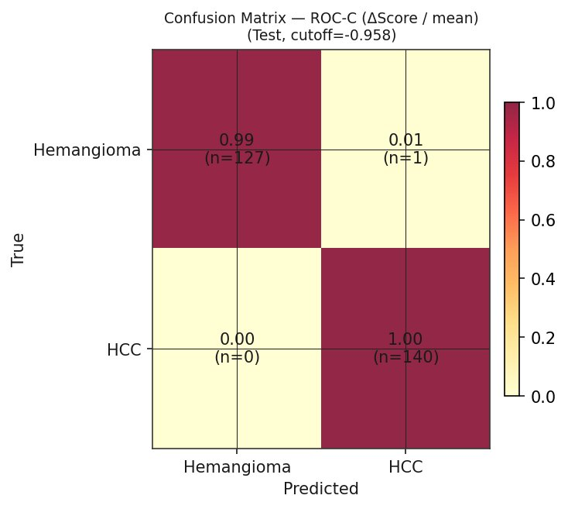
Figure 2. Confusion Matrices of Primary Model on Held-out Test Set (n=268).
Test set only. (A) Confidence score at the prespecified 0.50 operating point: 134 TP, 0 FP, 6 FN, 128 TN. (B) HCC cosine score and (C) Δscore at their validation Youden operating points (exploratory): 140 TP, 1 FP, 0 FN, 127 TN. The single false positive is the sample that is classified correctly at 0.50, so the failure modes differ by operating point (Table 3, Table 3B).
file: figures/fig 2-A Confusion matrix-A.jpg, figures/fig 2-B Confusion matrix-B.jpg, figures/fig 2-C Confusion matrix-C.jpg

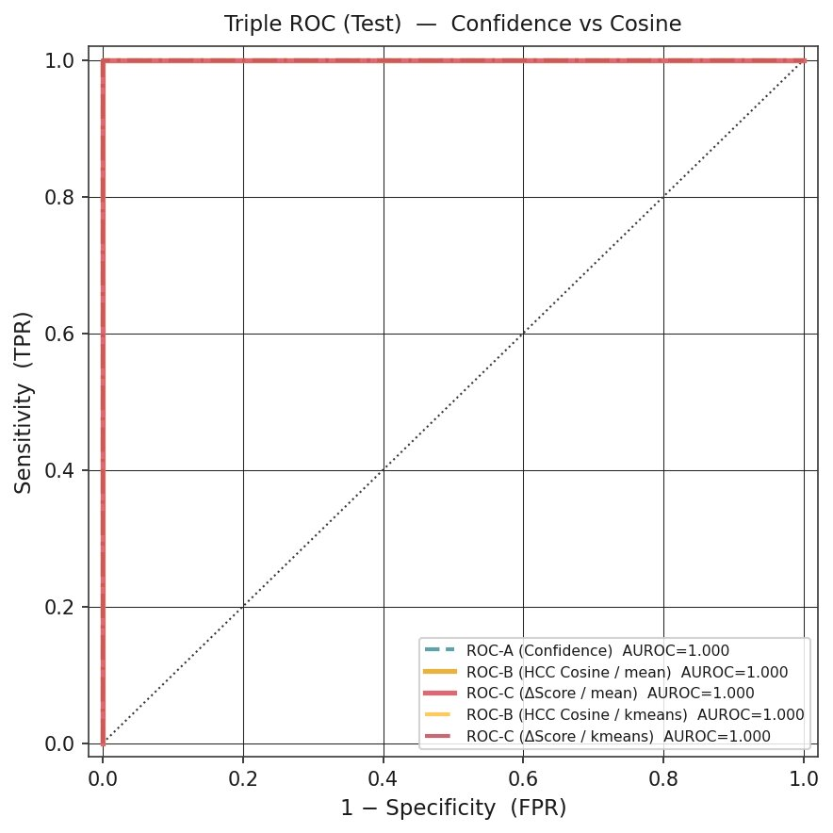
Figure 3. Triple Receiver Operating Characteristic (ROC) Curves on Test Set.
Test set only. ROC curves for ROC-A (confidence score), ROC-B (HCC cosine score) and ROC-C (Δscore). All three reach AUROC 1.000 and the curves overlap, so DeLong testing carries no information; no superiority or non-inferiority is claimed. The validation panel is not shown (test-only reporting).
file: figures/fig 3.jpg

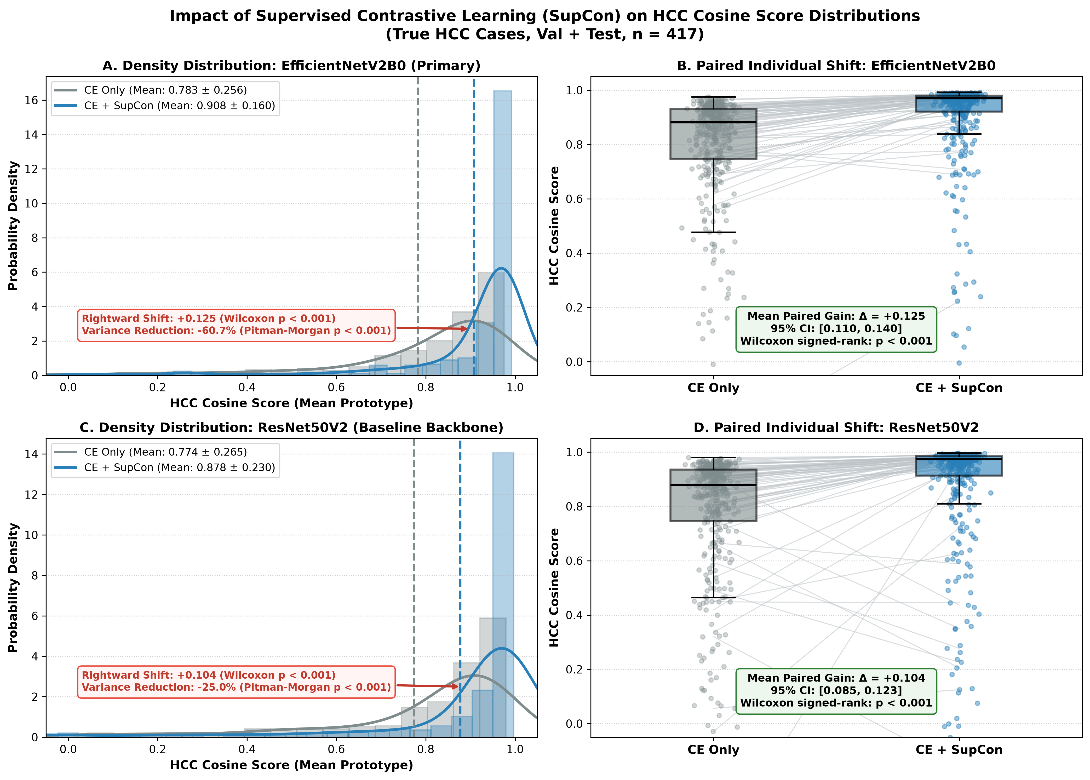
Figure 4. HCC Cosine Score Distributions with and without Supervised Contrastive Learning (SupCon) in True HCC Cases (n=417; Validation 277 + Test 140).
The same held-out HCC images were scored by the CE-only and CE+SupCon models (HCC cosine score to the training-set mean HCC prototype). (A) Density distribution, EfficientNetV2B0. (B) Paired individual shift, EfficientNetV2B0: mean 0.783 ± 0.256 (median 0.882) to 0.908 ± 0.160 (median 0.970); mean paired difference +0.125 (95% CI 0.110–0.140); paired t = 16.94; Wilcoxon signed-rank p < 0.001; score increased in 94.7% of images; variance 0.065 to 0.026 (−60.7%; Pitman-Morgan t = 16.84, p < 0.001). (C) Density distribution, ResNet50V2. (D) Paired individual shift, ResNet50V2: mean 0.774 ± 0.265 to 0.878 ± 0.230; mean paired difference +0.104; paired t = 10.98; Wilcoxon p < 0.001; variance 0.070 to 0.053 (−24.3%; Pitman-Morgan t = 4.06, p < 0.001). CE, cross-entropy.
file: figures/fig_4_hcc_cosine_distribution_comparison.png

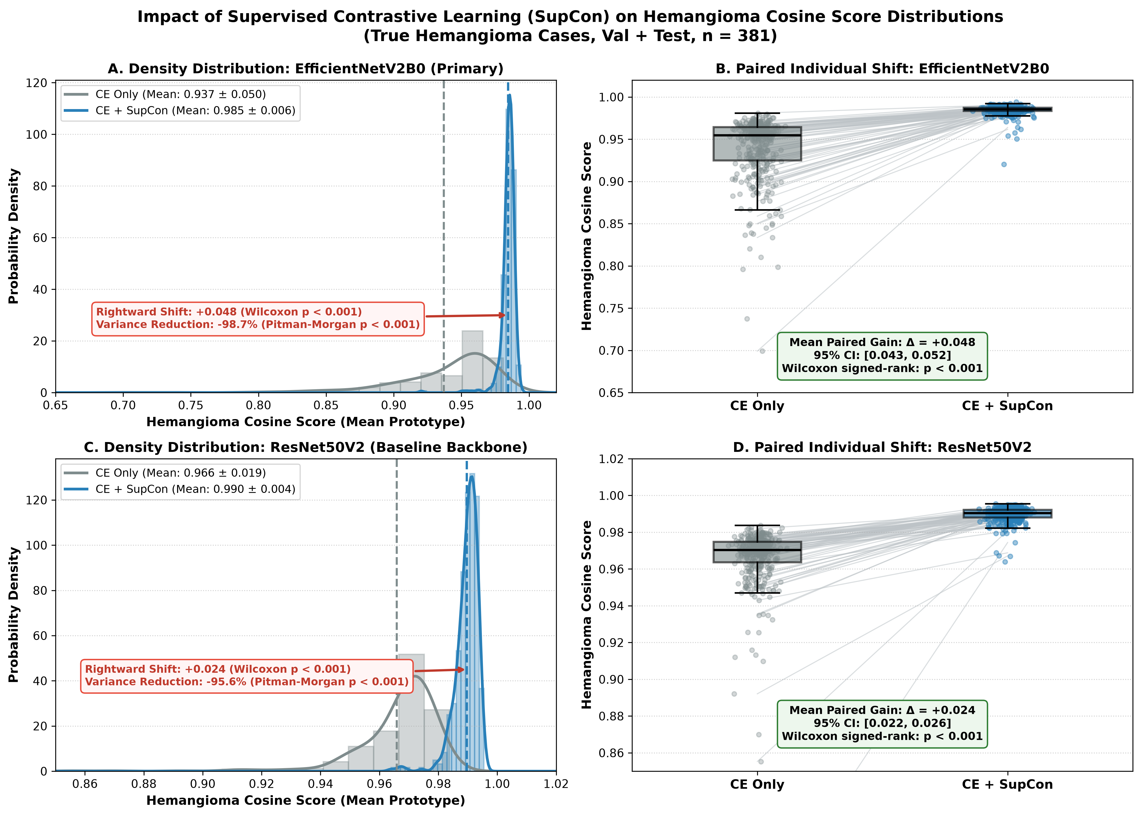
Figure 5. Hemangioma Cosine Score Distributions with and without Supervised Contrastive Learning (SupCon) in True Hemangioma Cases (n=381; Validation 253 + Test 128).
The same held-out hemangioma images were scored by the CE-only and CE+SupCon models (hemangioma cosine score to the training-set mean hemangioma prototype). (A) Density distribution, EfficientNetV2B0. (B) Paired individual shift, EfficientNetV2B0: mean 0.937 ± 0.050 (median 0.955) to 0.985 ± 0.006 (median 0.985); mean paired difference +0.048 (95% CI 0.043–0.052); paired t = 19.71; Wilcoxon signed-rank p < 0.001; variance 0.00253 to 0.00003 (Pitman-Morgan t = 106.23, p < 0.001). (C) Density distribution, ResNet50V2. (D) Paired individual shift, ResNet50V2: mean 0.966 ± 0.019 to 0.990 ± 0.004; mean paired difference +0.024 (95% CI 0.022–0.026); paired t = 26.54; Wilcoxon p < 0.001; variance 0.00036 to 0.00002 (Pitman-Morgan t = 49.18, p < 0.001). The large relative variance reduction partly reflects the already small baseline variance under CE-only training.
file: figures/fig_5_hemangioma_cosine_distribution_comparison.png

