Some of them are queries with a single condition, queries with complex conditions, queries on one table, queries on multiple tables, queries with no aggregation, queries with aggregation, etc.

viết các câu sql có cả ở 2 dbms để so sánh,

ví dụ, nosql không có phép join thì ko viết câu join

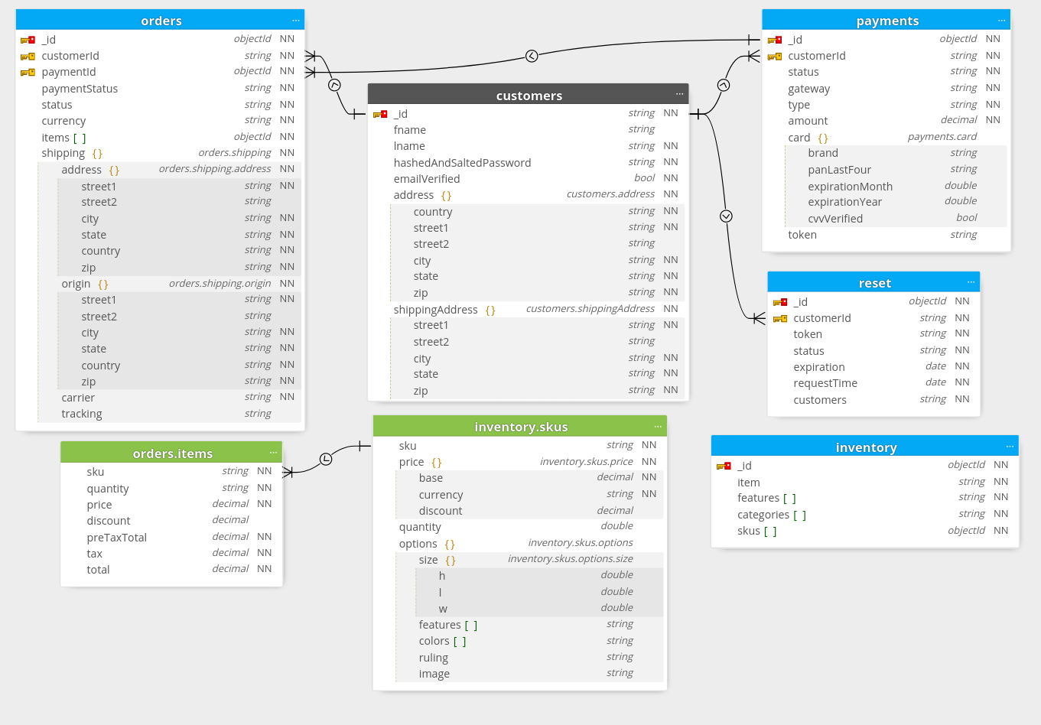

|  |  |  |  |
| --- | --- | --- | --- |
|  | Oracle | Couchbase | Comment |
| 1. with a single condition |  | SELECT *  FROM `Ecommerce`.firstCompany.orders  WHERE `customer_id` = 'jane.smith39@example.com'; | Retrieve all order of a user |
| 2. queries with complex conditions |  | SELECT *  FROM `Ecommerce`.firstCompany.inventory  WHERE ANY category IN categories SATISFIES category = 'Peripherals' END  AND `item` LIKE '%Dell%'; | Retrieve item has category is Peripherals and name has Dell |
| 3. queries on multiple tables  Chưa chạy được |  | SELECT SUM(i.skus.price.base - i.skus.price.discount) AS total_price  FROM `Ecommerce`.firstCompany.orders o  UNNEST o.items item  JOIN `Ecommerce`.firstCompany.inventory i ON item.sku = i.skus.sku  WHERE o.status = "shipped"; | Get sum of price item in a order |
| 4. Query with no aggregation on one table |  | SELECT i.item,  MIN(sku.price.base - sku.price.discount) AS min_price,  ARRAY_FLATTEN(ARRAY_AGG(DISTINCT sku.`options`.images), 1) AS images  FROM `Ecommerce`.firstCompany.inventory AS i  UNNEST i.skus AS sku  WHERE i.item LIKE '%Dell%'  GROUP BY i.item | Function to get name, price, and img of product, TO RETRIEVE |
| 5. queries with aggregation |  | SELECT items.sku, COUNT(*) AS count  FROM `Ecommerce`.firstCompany.orders  UNNEST items  GROUP BY items.sku  ORDER BY count DESC; | get skus from many buys to few buys |

|  |
| --- |
| (3) of couchbase, when just only primary index exist |
| [  {  "code": 4330,  "msg": "No index available for ANSI join term i",  "query": "SELECT SUM(i.skus.price.base - i.skus.price.discount) AS total_price\r\nFROM `Ecommerce`.firstCompany.orders o\r\nUNNEST o.items item\r\nJOIN `Ecommerce`.firstCompany.inventory i ON item.sku = i.skus.sku\r\nWHERE o.status = \"shipped\";"  }  ] |

Collection orders không có trường ngày, cần sửa ???