#Checking Adjustments of Data Augmentation

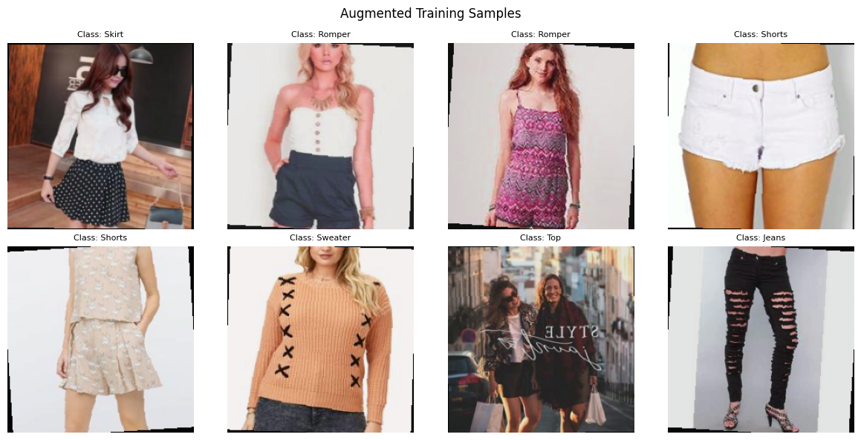

#Making a a Comparison Between Correct And Wrong Garments

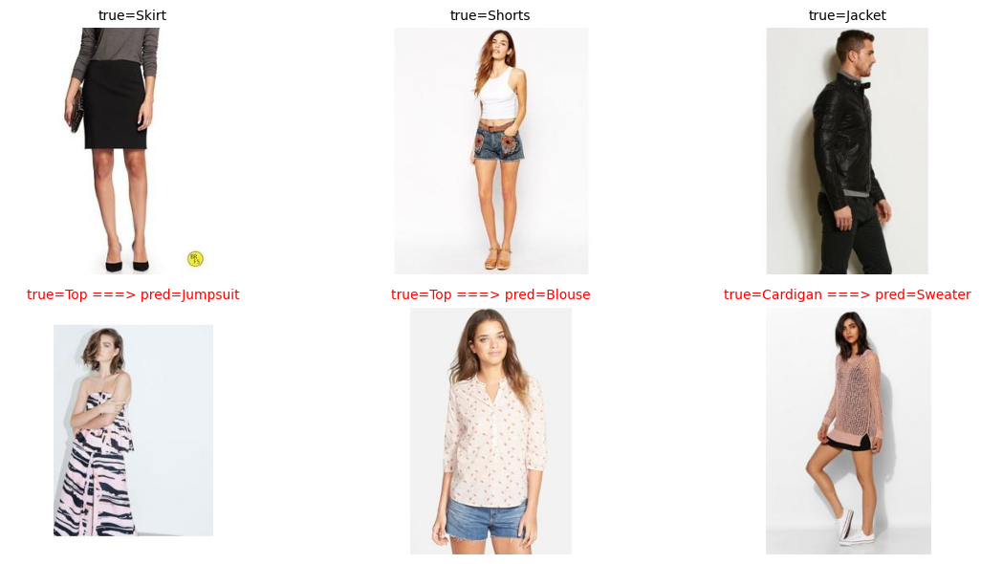

#Gathering wrong prediction from each category to look at their similarities(collar, pattern of fabric, textures, collars, style), mislabeling , etc.

