**CSIS-3860_003: Data Visualization**

**Analysis of Global Mental Health Disorders**

**Term Project Documentation– Fall 2024**

**Instructor**

**Rupa Manabala**

Contents

Description of Dataset 3

Objective and Goal 3

Tableau 4

Analysis Questions 4

User Guide 5

Most Severe Mental Disorders Worldwide? 6

Countries with The Most Prevalent Anxiety and Depression: Filled Map 7

Top 10 Countries with the Highest Depression/Anxiety Rate (10-Year-Range) 8

Bottom 10 Countries with the Lowest Depression/Anxiety Rate (10-Year-Range) 9

Trend Over Years in the 5 Most Depressed/Anxious Nations in the World 10

Depression/Anxiety Prevalence Forecast in the Next 5 Years 11

Relationship Between Anxiety and Depression Rates 12

Depression/Anxiety Rates Compared to Global Average 13

Dashboards 14

Data Story 16

Power BI 17

Analysis Questions: 17

User Guide 18

Top 5 Countries with Increasing Eating Disorder Trends 19

Global Relationship Between Anxiety and Drug Use Disorders 20

A Comparison Between 2 Different Categories Country 21

Top 5 Countries Experienced Upward and Downward Trends 22

Countries with Mental Disorders Above Global Average 23

Global Map in Power BI 24

Conclusion 25

References 26

# Description of Dataset

This dataset contains informative data from countries across the globe about the prevalence of mental health disorders including schizophrenia, bipolar disorder, eating disorders, anxiety disorders, drug use disorders, depression and alcohol use disorders.   
The knowledge gained from this dataset can help bring valuable decision-making skills such as research grants, policy making or preventative intervention plans across various countries.   
We accessed this dataset through Kaggle website and we mentioned the link in reference page.

# Objective and Goal

The objective of this report is to analyse global mental health data to identify trends and disparities across countries from 1990 to 2017. The goal is to provide actionable insights for policymakers, researchers, and healthcare providers to prioritize interventions and mitigate the rising burden of mental health disorders globally. Generally, we can say aiding in planning targeted mental health programs is our goal in this project.

# Tableau

# Analysis Questions

1. What is/are the most severe mental disorder all around the world?
2. Which countries are the top 10 with highest **depression/anxiety disorder** rate in 10-year range?
3. Which countries are the bottom 10 with highest **depression/anxiety disorder** rate in 10-year range?
4. How is the **depression/anxiety disorder** trend over the year, in those countries with the highest rate?
5. How is the **depression/anxiety disorder rate** likely to be in the next 5 years in country with highest rate? (forecast)
6. Is there any relationship between anxiety disorder and depression rate?
7. How has each country been in **depression/anxiety disorder** rate when compare with the global rate?

# User Guide

To avoid overcrowding the Tableau workbook, we hid the worksheets in the initial view.  
You can access any worksheet by navigating to the data story, right-clicking on the desired worksheet, and selecting **"Go to Sheet"**.

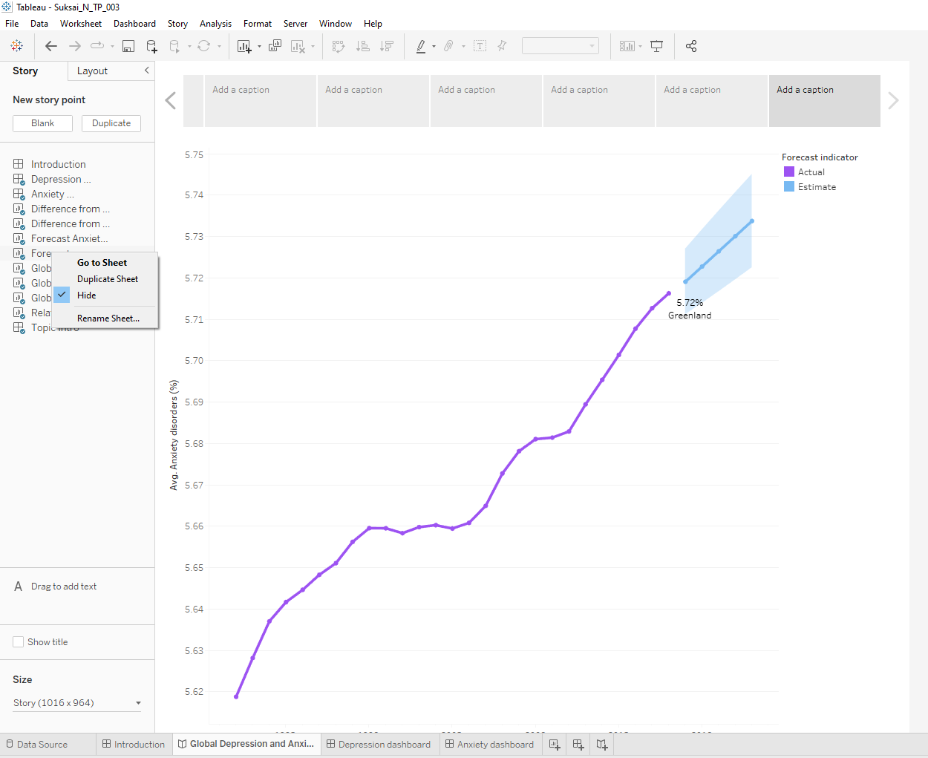

# Most Severe Mental Disorders Worldwide?

The analysis is answering Question 1, showing that both anxiety and depression are prevalent mental disorders globally. Heatmap is used to see which mental disorders have the most prevalence rate across the world. For the visualization, Anxiety and Depression seem to be the most prevalent disorders.

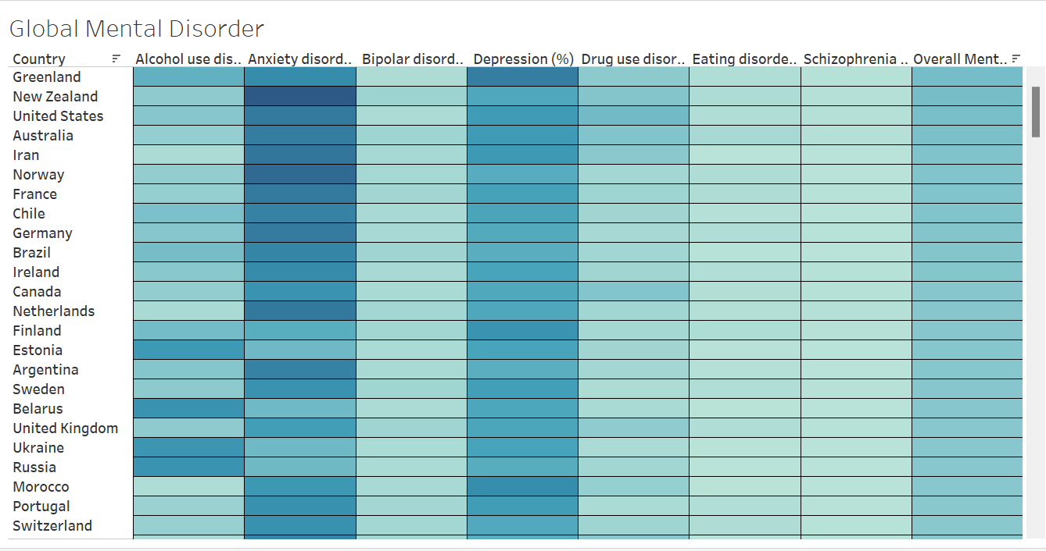

# Countries with The Most Prevalent Anxiety and Depression: Filled Map

These visualization does not answer any particular questions; however, the filled map is used to show which country has the severest prevalence in Anxiety (above picture) and Depression (below picture).

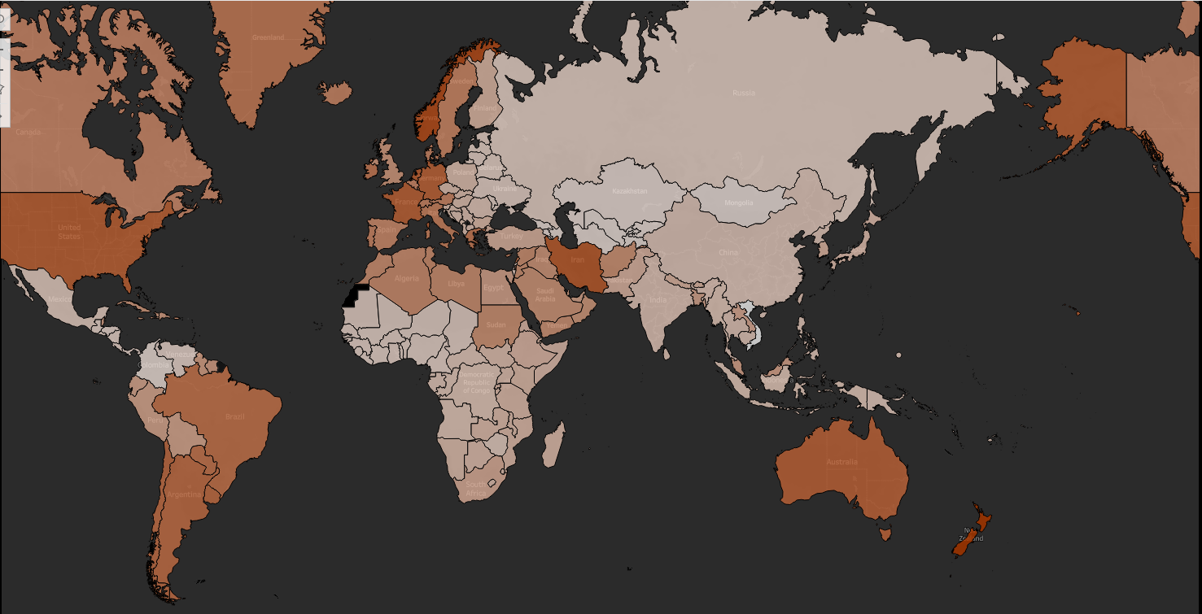

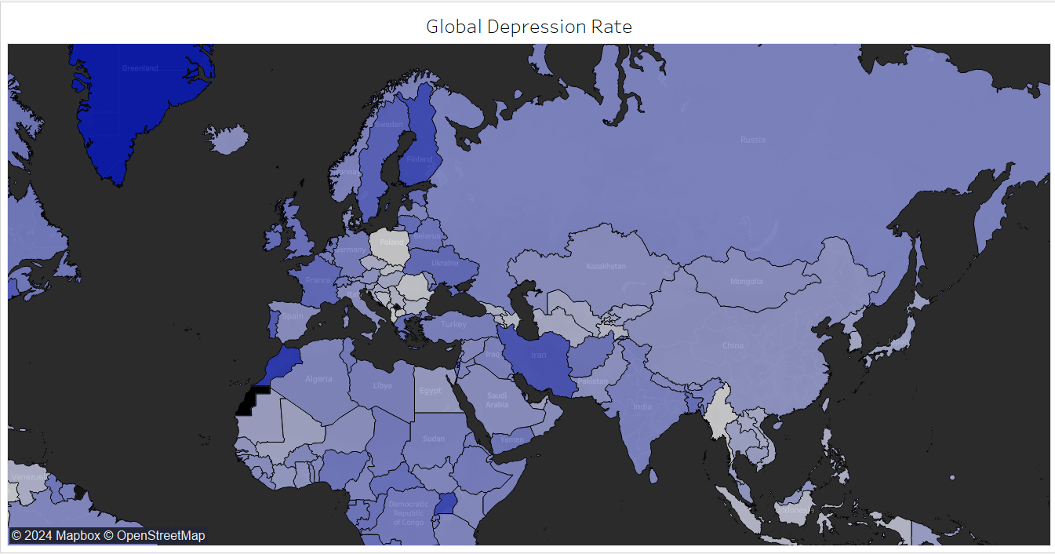

# Top 10 Countries with the Highest Depression/Anxiety Rate (10-Year-Range)

These pictures are to answer Question 2, showing countries that are the top 10 with highest depression/anxiety disorder rate in 10-year range. Bar chart is used to show the comparison across countries, filtered the top 10 countries based on the average prevalence rate. The 10 year range is created with calculated field and used as filter.

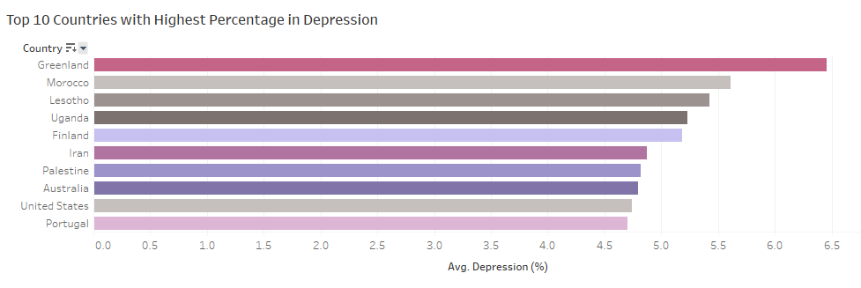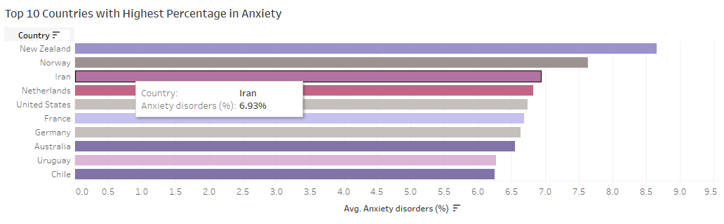

# Bottom 10 Countries with the Lowest Depression/Anxiety Rate (10-Year-Range)

These pictures are to answer Question 3, showing countries that are the bottom 10 with lowest depression/anxiety disorder rate in 10-year range. Similar to the previous question, bar chart is used to show the comparison across countries, filtered the bottom 10 countries based on the average prevalence rate. The 10-year range is created with calculated field and used as filter.

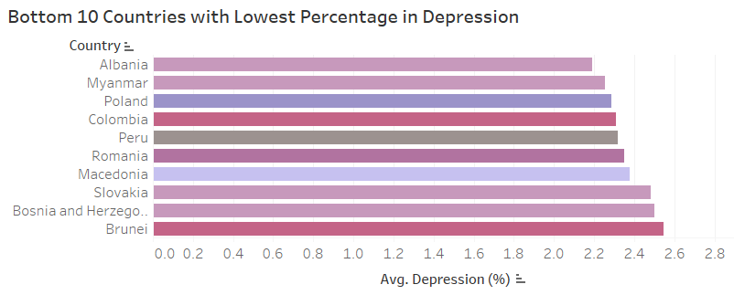

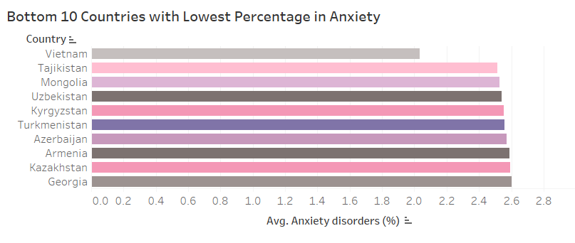

# Trend Over Years in the 5 Most Depressed/Anxious Nations in the World

These pictures below are to answer Question 4, showing the depression/anxiety disorder trend over the year, in those countries with the highest rate. Time-series chart (line chart) is used to show the trend over the year, filtered the top 5 countries based on the average prevalence rate. 10-year range filter has also been applied

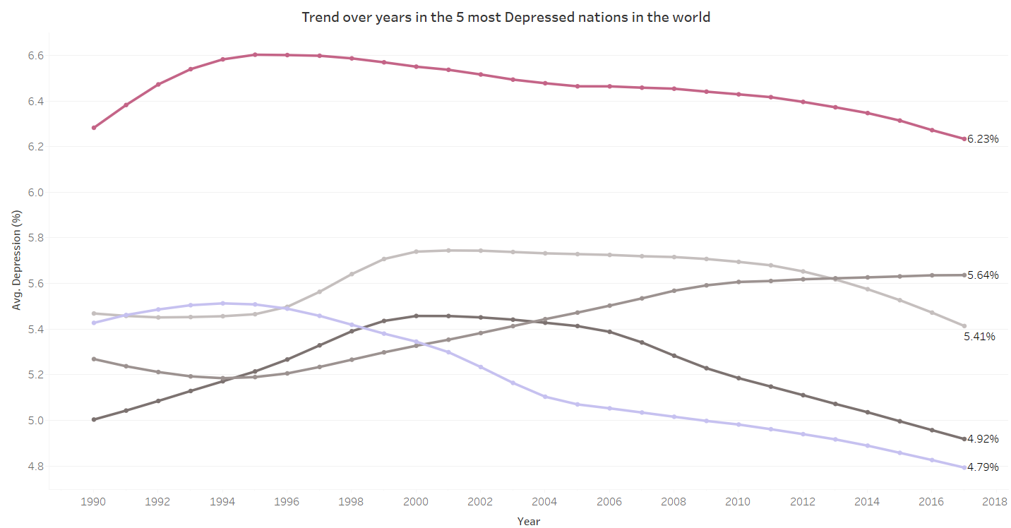

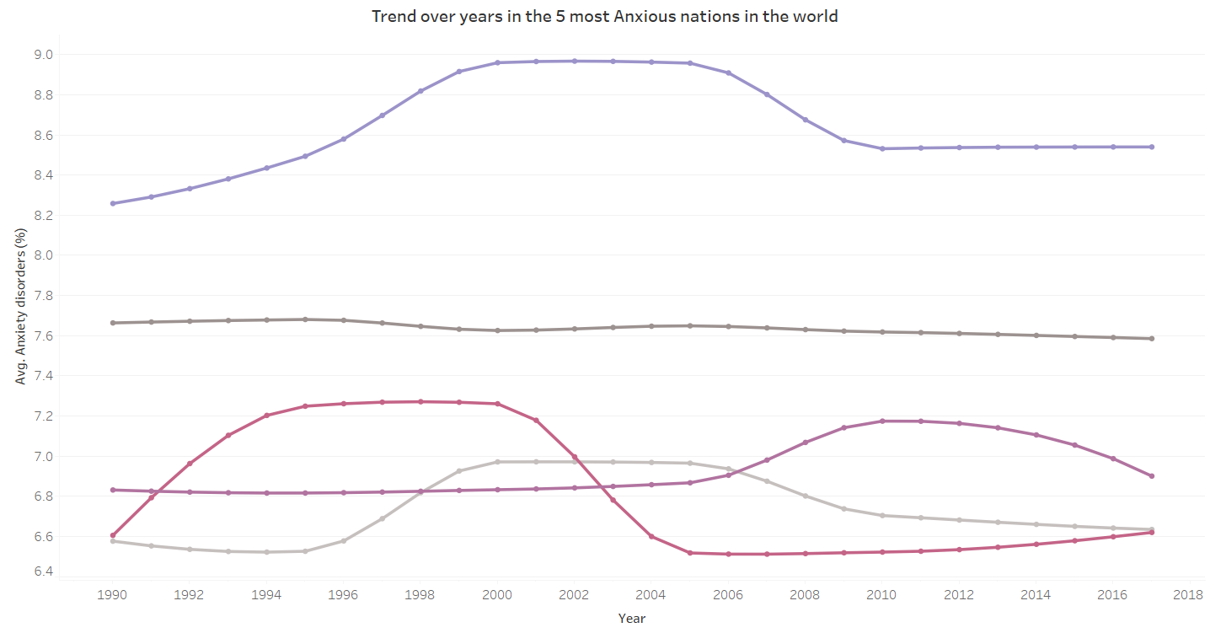

# Depression/Anxiety Prevalence Forecast in the Next 5 Years

The pictures below are answering Question 5, visualizing how the depression/anxiety disorder rate is likely to be in the next 5 years in country with highest rate. Forecasting feature has been used to project the likelihood in the specific year range.

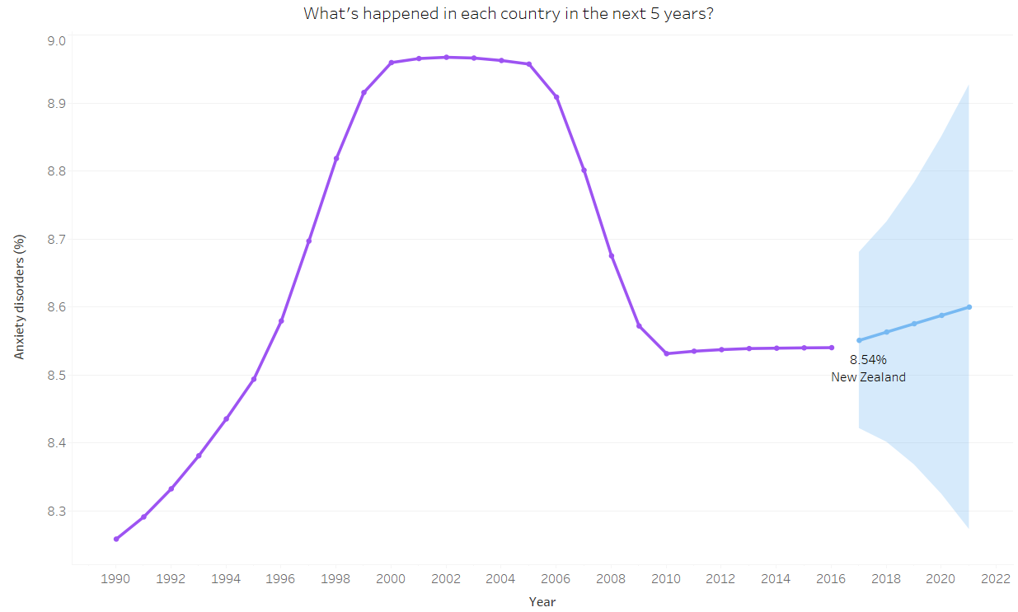

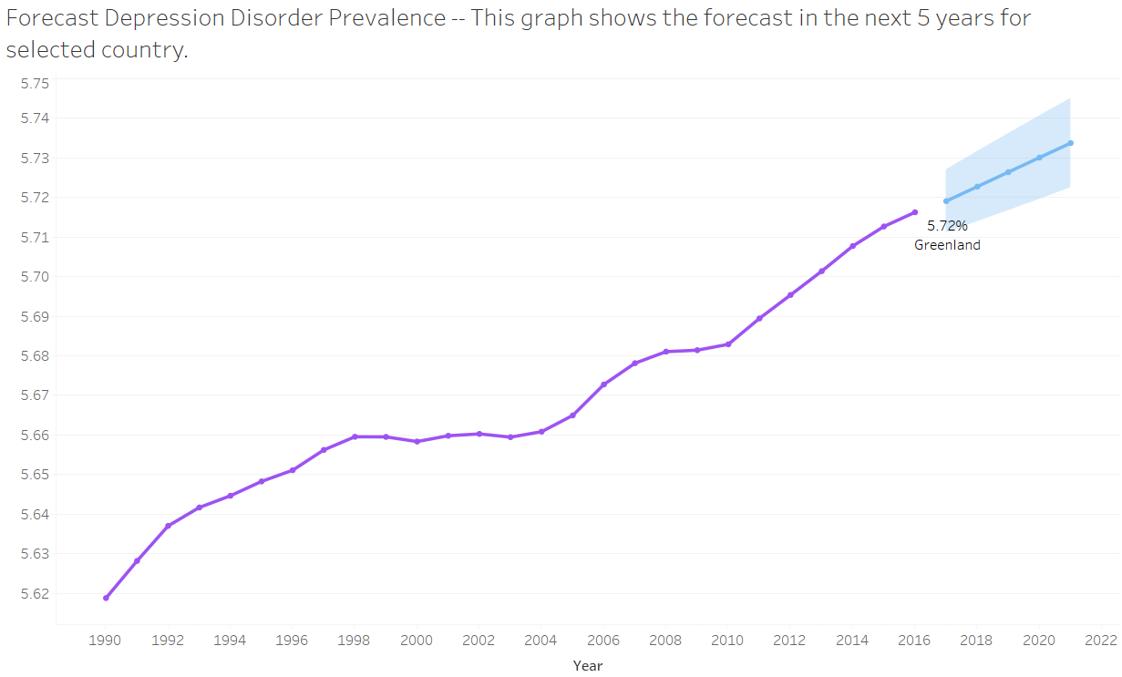

# Relationship Between Anxiety and Depression Rates

To answer Question 6, The scatterplot is used to perform the analysis which confirms a positive correlation between anxiety and depression rates. Countries with high anxiety rates are also likely to have high depression rates.

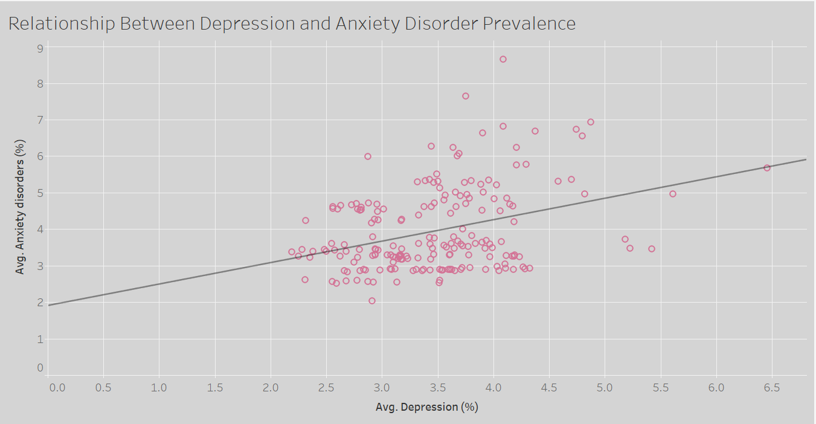

# Depression/Anxiety Rates Compared to Global Average

To answer Question 7, table calculation has been used to calculate the difference in each country to the global average rate. According to the pictures below, if the bar runs to the right, it shows that the country’s prevalence rate is more than the global average

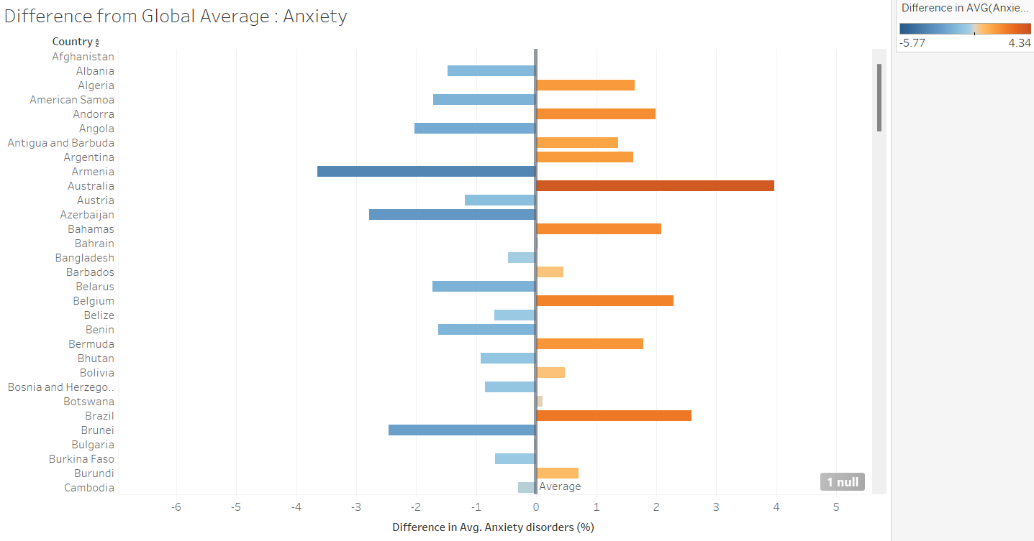

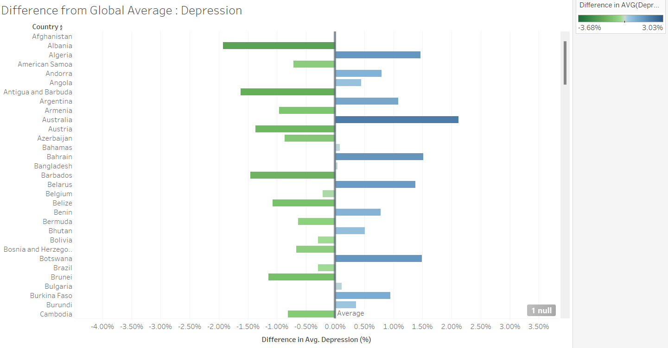

# Dashboards

The dashboards below compile global depression and anxiety statistics about 10 top and bottom countries in Depression and Anxiety disorder as well as the trend over years. 10-year range has been added to the dashboard which is linked to all worksheets in that dashboard.

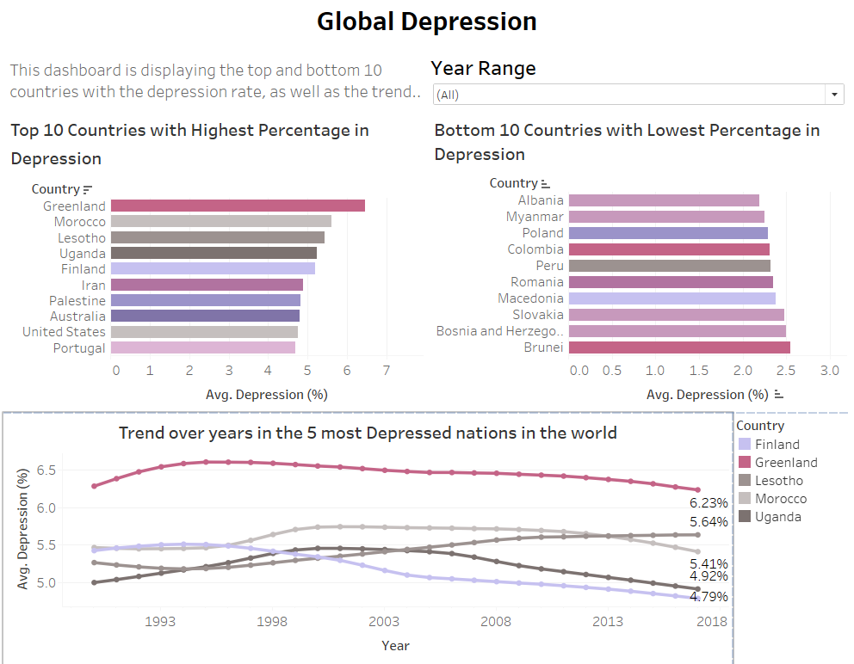

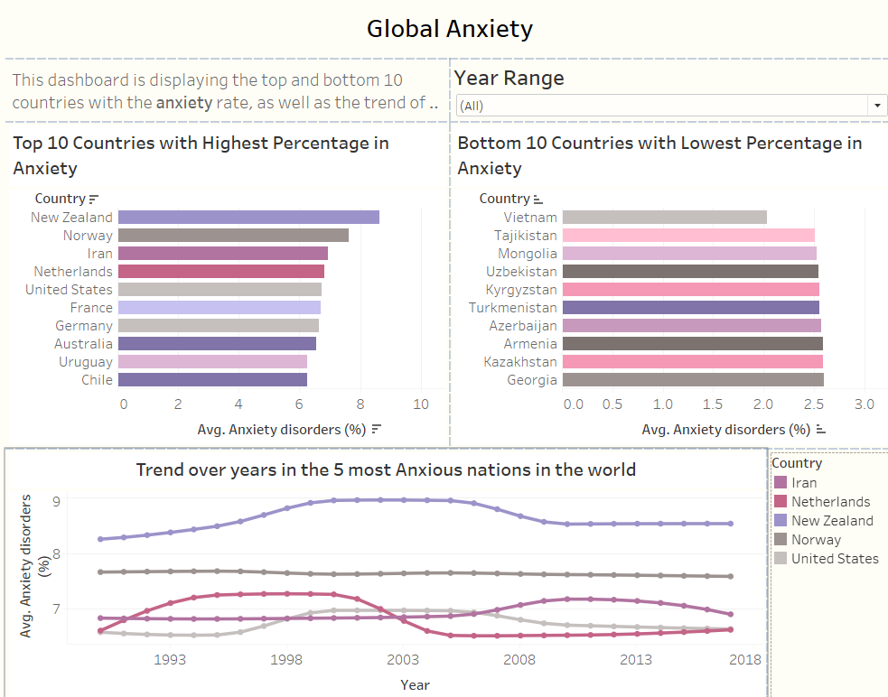

# Data Story

We used the Data Story feature in Tableau to compile all worksheets in one place and provide detailed explanations about what each worksheet displays.

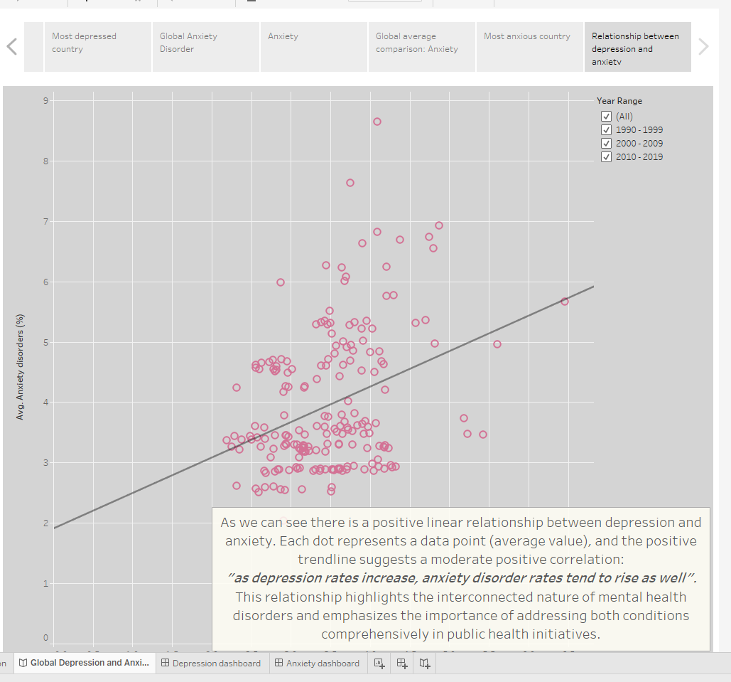

# Power BI

# Analysis Questions:

1. What are the top 5 countries where eating disorders have increased from 1990 to 2017?
2. Is there a relationship between anxiety disorders and drug use disorders globally?
3. How does the mental health burden differ between low-income and high-income countries?
4. What are the top countries where alcohol use disorders have consistently increased or decreased over time?
5. Which countries have the highest cumulative range of mental disorders compared to the global average?
6. Which countries have a higher percentage of addiction to alcohol compared to drug use?
7. How do anxiety and depression rates in developed countries (e.g., Australia, Denmark, Japan) compared to those in undeveloped countries (e.g., Afghanistan, Angola, Algeria)?
8. Depression and Anxiety are witnessed more in Female or Male?

# User Guide

**Bookmarks:**

According to bookmarks in Power BI users can shift to different visuals easier. That’s why we applied this feature in our project and you can use it.   
You just need to click on each title to go directly to the related worksheet.

# Top 5 Countries with Increasing Eating Disorder Trends

The following screenshot is an answer to analysis Question 1 which is about what 5 countries in eating disorder from 1990 to 2017; As this question includes patterns over the years, we used line graph to be more concise. We also use Dax and New measure to evaluate top 5 countries among all.

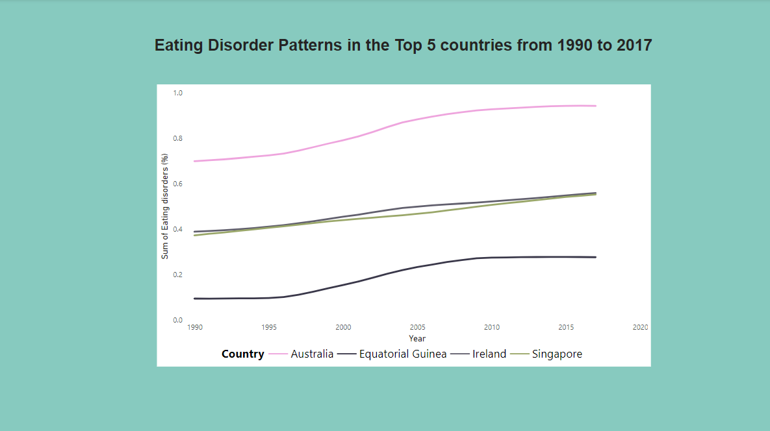

# Global Relationship Between Anxiety and Drug Use Disorders

This screenshot is answering the question 2 about there is a relationship between drug disorders and anxiety?  
 The scatter plot is a good visual tool to display relationship between 2 variables. We use slicer as filter for users to enable them filter different countries and years.

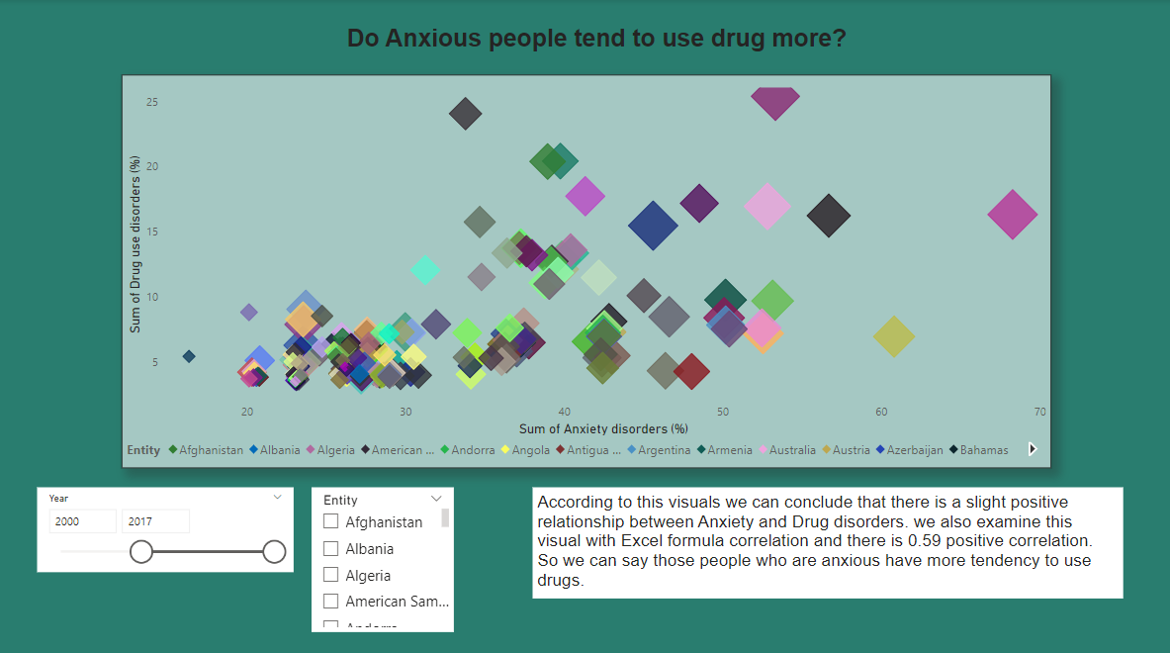

# A Comparison Between 2 Different Categories Country

To answer Questions 3 and 7 which are about a comparison between 2 categories High-income and low-income also Developed and Undeveloped countries we use Bar Charts to visualize and compare these categories.

# Top 5 Countries Experienced Upward and Downward Trends

These visual displays 5 top countries in Alcohol disorder over years and also displaying the increasing or decreasing trend. We use measure capability in Power BI to identify these 5 top countries.

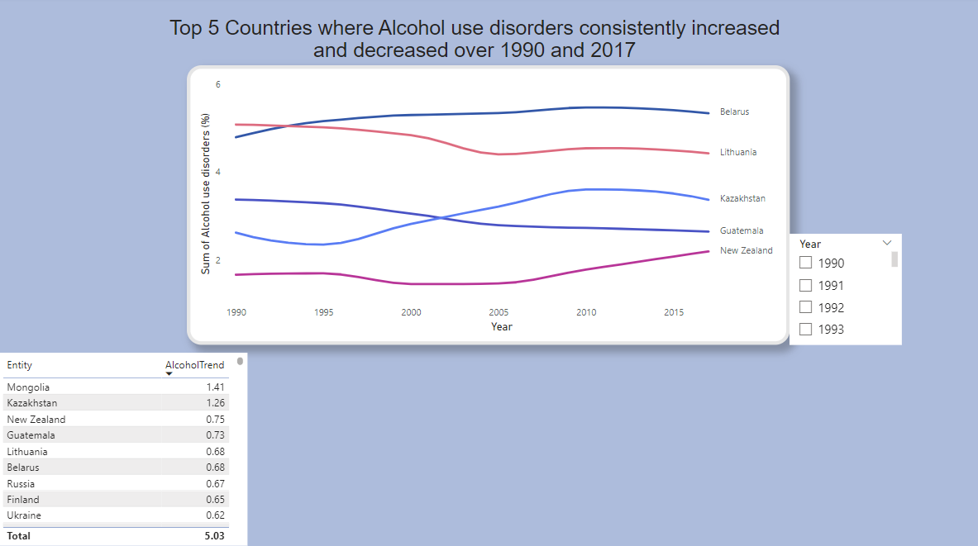

# Countries with Mental Disorders Above Global Average

This visualizes the countries have above range of cumulative disorders of Global average. We use clustered bar chart to visualize more professionally for comparison. Also, we use mark to display Global average and slicer to enable user filtering different years.

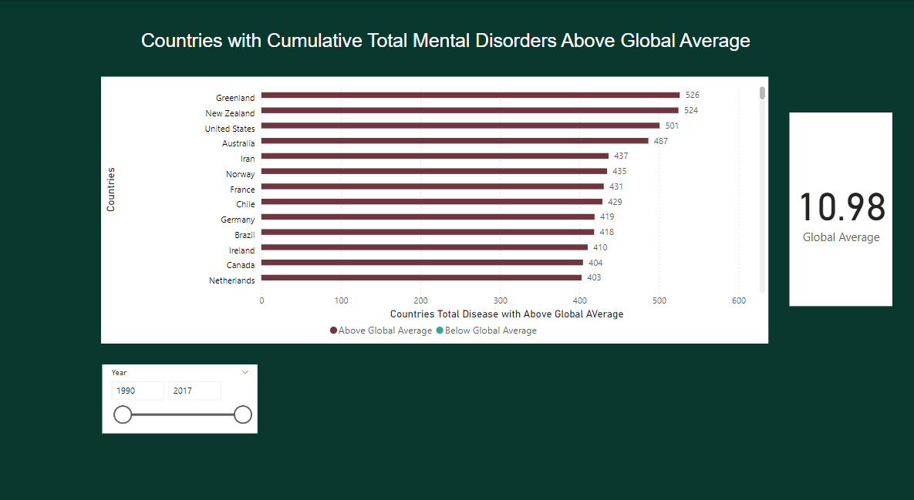

# Global Map in Power BI

This visual responds question 6 which is about countries with higher range of alcohol use disorders than drug disorders. We use maps to visualize better these figures. We enable Tooltip features here to display informative measures when users hover their mouse over each country that we display them with bubbles.

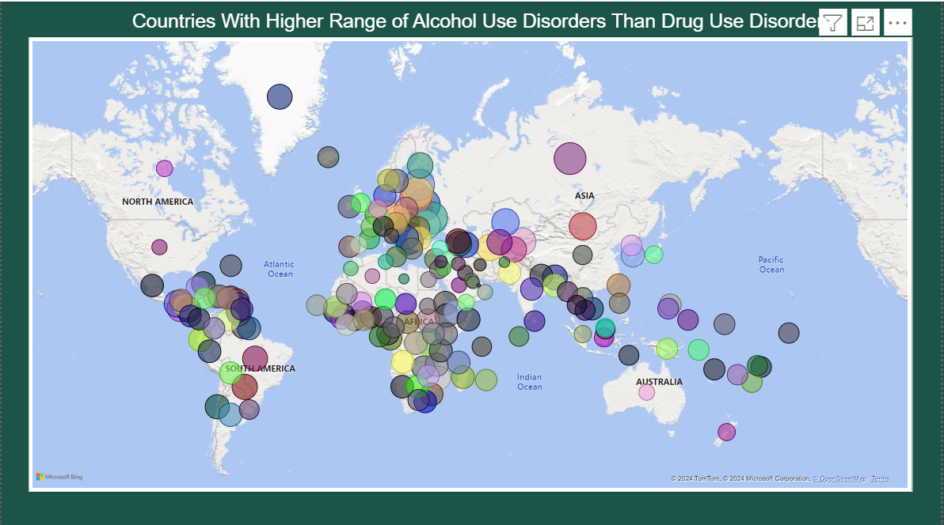

# Conclusion

**In Tableau**, we successfully answered all the analysis questions regarding global trends in anxiety and depression. The visualizations highlight the stark regional differences in anxiety and depression rates, with countries like Greenland, New Zealand, and Morocco exhibiting persistently high rates. These trends emphasize the need for targeted interventions and mental health support systems. The strong correlation between anxiety and depression further suggests that comprehensive mental health programs addressing both disorders simultaneously could lead to impactful results. The visualizations also forecast increases in mental health disorders, signaling an urgent need for proactive policies and public health strategies to mitigate worsening conditions.

**In Power BI**, with this dataset, we were able to answer 7 out of 8 questions. However, if we had been able to answer the 8th question, which relates to the relationship between gender and mental health disorders, we could have achieved even better outcomes. Understanding whether males or females are more exposed to mental disorders is an important aspect that unfortunately, we cannot analyze due to the lack of data.  
When comparing our experience of working with Power BI versus Tableau, we observed that while Tableau offers more complexity and enables the creation of highly professional visualizations, Power BI is more user-friendly and better suited for quick and straightforward analysis. For simpler analysis, Power BI is the preferable choice, whereas Tableau excels in delivering polished and advanced visuals.

# References

**Dataset Link:**

[*https://www.kaggle.com/datasets/thedevastator/uncover-global-trends-in-mental-health-disorder/data*](https://www.kaggle.com/datasets/thedevastator/uncover-global-trends-in-mental-health-disorder/data)

**Picture references:**

(2024). Technologynetworks.com. <https://assets.technologynetworks.com/production/dynamic/images/content/365886/could-we-develop-vaccines-for-depression-and-anxiety-365886-960x540.jpg?cb=12004727>