CHAPTER 4: RESULTS AND DISCUSSION 1
4.1 User Interface 1
4.1.1 Home Page 1
4.1.2 Register Page 2
4.1.3 Login Page 2
4.1.4 Dashboard Page 3
4.1.5 SHAP Explanation Panel 4
4.1.6 Attention Reasoning Panel 4
4.1.7 Models Page 5
4.1.8 Admin Login Page 5
4.1.9 Admin Users Page 6
4.1.10 Admin Models Page 6
4.1.11 Admin Drift Page 7
4.2 Evaluation Results 7
4.2.1 Model Performance 7
Quantitative Metrics 7
Confusion Matrix Analysis 8
Comparison with Baseline 9
4.2.2 Text Representation of Numerical Features 9
4.2.3 SHAP Explainability Analysis 10
Setup 10
Example Outputs 10
Domain Alignment Analysis 11
4.2.4 Attention-Based Reasoning 12
Method 12
Example Outputs 12
Alignment with SHAP Values 13
4.2.5 Data Drift Monitoring 13
Method 13
Sample Drift Report 14
Operational Interpretation 15
4.3 Updated Test Cases 15
4.4 Summary 17

CHAPTER 4
RESULTS AND DISCUSSION
4.1 User Interface
This section presents the finalized user interface of the CropAI web application. The frontend was developed using Vite, React, and Tailwind CSS, and communicates with the FastAPI backend via REST API calls. The application supports two distinct user roles: regular users who access the prediction and explainability features, and administrators who manage users, models, and drift monitoring. All pages are responsive and support both light and dark themes.
4.1.1 Home Page

Figure 4.1 Homepage

Figure 4.1 shows the main landing page of the CropAI system. The home page serves as the entry point for all users and presents an overview of the system's capabilities. It includes a navigation bar with links to the Login and Register pages, a hero section describing the AI-powered crop recommendation system, and a brief explanation of the three explainability features available: prediction confidence, SHAP analysis, and attention-based reasoning. The page is designed to be accessible to farmers and agricultural stakeholders with minimal technical background.

4.1.2 Register Page

Figure 4.2: User registration form with username, email, and password fields.
Figure 4.2 shows the user registration page. New users are required to provide a username, email address, and password. Client-side validation ensures all fields are completed before submission. On successful registration, the user is redirected to the login page. The backend stores the password as a bcrypt hash in MongoDB, and no plaintext credentials are retained at any point.
4.1.3 Login Page

Figure 4.3: Login page with email and password fields and JWT-based authentication flow.

Figure 4.3 shows the login page. Users authenticate using their registered email address and password. On successful authentication, the FastAPI backend issues a JSON Web Token (JWT) with a 24-hour expiry. This token is stored in React context and attached as a Bearer token to all subsequent API requests. If the token is missing or expired, the user is automatically redirected to the login page.
4.1.4 Dashboard Page

Figure 4.4: Dashboard prediction interface with seven input sliders for soil and weather features.
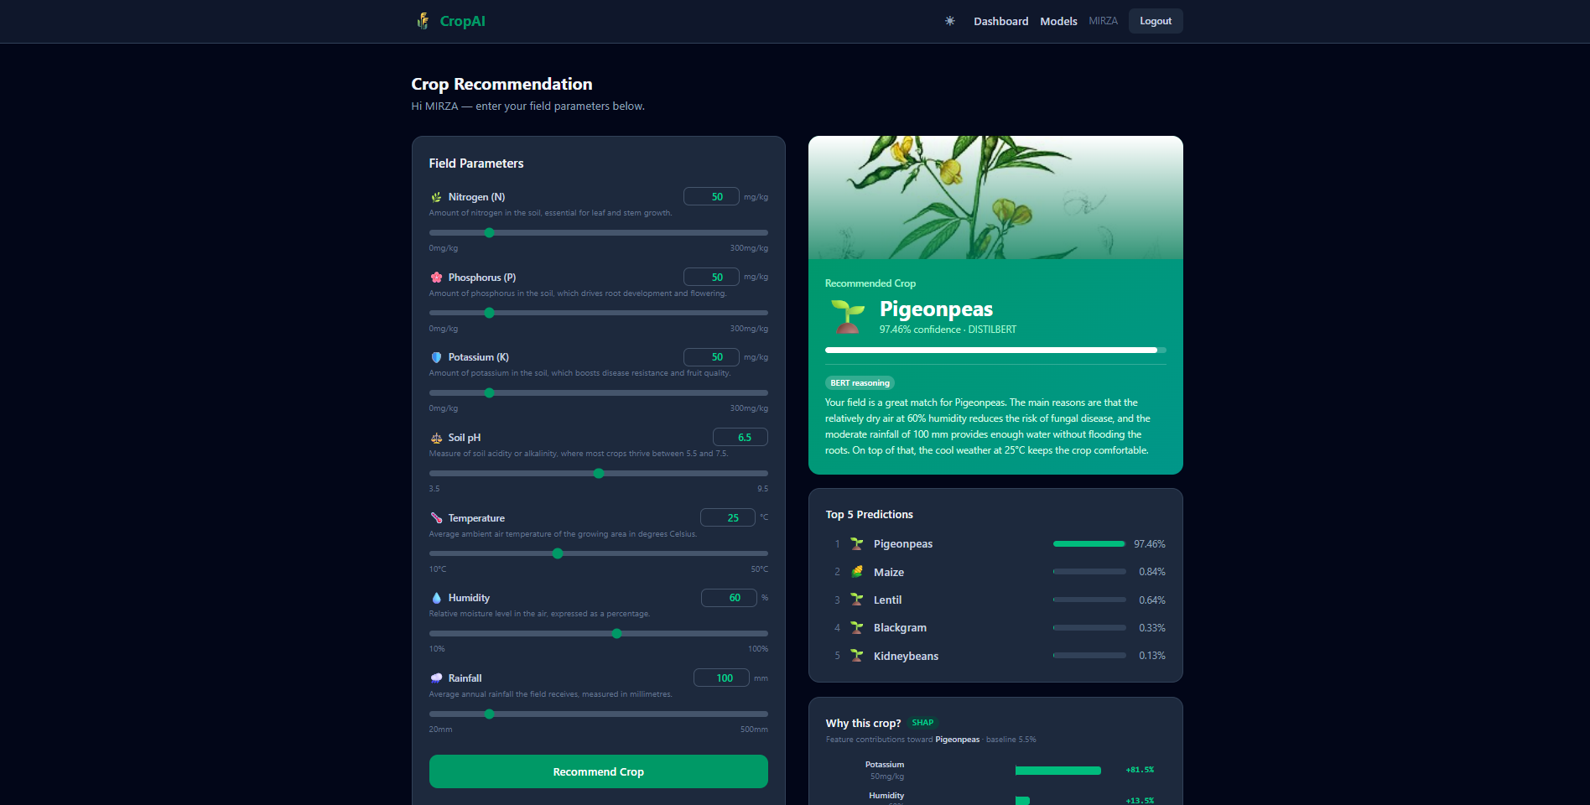
Figure 4.5: Prediction result showing recommended crop, confidence score, and top-5 crop rankings.

Figure 4.4 shows the Dashboard, which is the core prediction interface of the system. This page is accessible only to authenticated users. It provides seven input sliders corresponding to the agronomic and meteorological features: Nitrogen (N), Phosphorus (P), Potassium (K), soil pH, Temperature (°C), Humidity (%), and Rainfall (mm). Each slider is bounded to a realistic agronomic range based on the training dataset. Upon submission, the system returns the recommended crop, a confidence score (%), and a ranked list of the top five candidate crops with their respective probabilities. Figure 4.5 shows an example prediction result displaying Rice as the recommended crop with a confidence of 94.72%, alongside the top-five probability breakdown.
4.1.5 SHAP Explanation Panel
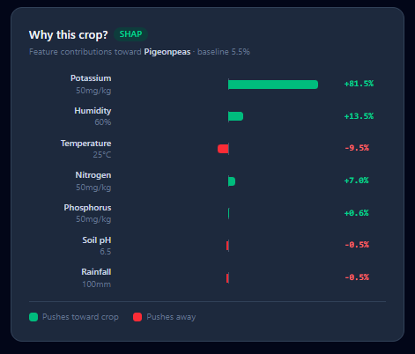
Figure 4.6: SHAP explanation bar chart showing per-feature contribution values for the predicted crop.
Figure 4.6 shows the SHAP Explanation Panel on the Dashboard page. After a prediction is made, the user can click the 'Explain' button to trigger the SHAP analysis for the same input. The panel renders a horizontal bar chart in which each of the seven features is assigned a SHAP contribution value towards the predicted crop's probability. Positive values (shown in green) indicate features that pushed the prediction towards the recommended crop, while negative values (shown in red) indicate features that worked against it. The base value displayed below the chart corresponds to the mean model output across the training background (the vector of training feature means). This visualization gives users a feature-level explanation for why the model made its recommendation.

4.1.6 Attention Reasoning Panel
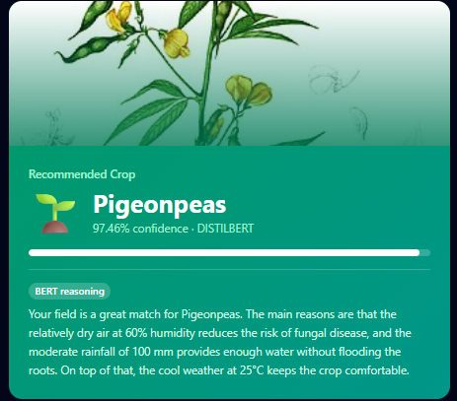
Figure 4.7: Attention-based reasoning panel showing the natural language explanation and top-3 attention features.
Figure 4.7 shows the Attention Reasoning Panel. After prediction, the user can click the 'Reasoning' button to receive a natural language explanation generated from the model's internal BERT attention weights. The panel displays a plain-English sentence describing the three most influential factors behind the recommendation, drawn from the last-layer CLS attention scores averaged across all attention heads. An example output for a rice prediction might read: "Your field is a great match for Pigeonpeas. The main reasons are that the relatively dry air at 60% humidity reduces the risk of fungal disease, and the moderate rainfall of 100 mm provides enough water without flooding the roots. On top of that, the cool weather at 25°C keeps the crop comfortable." The panel also displays the ranked list of top three features identified by the attention mechanism.

4.1.7 Models Page
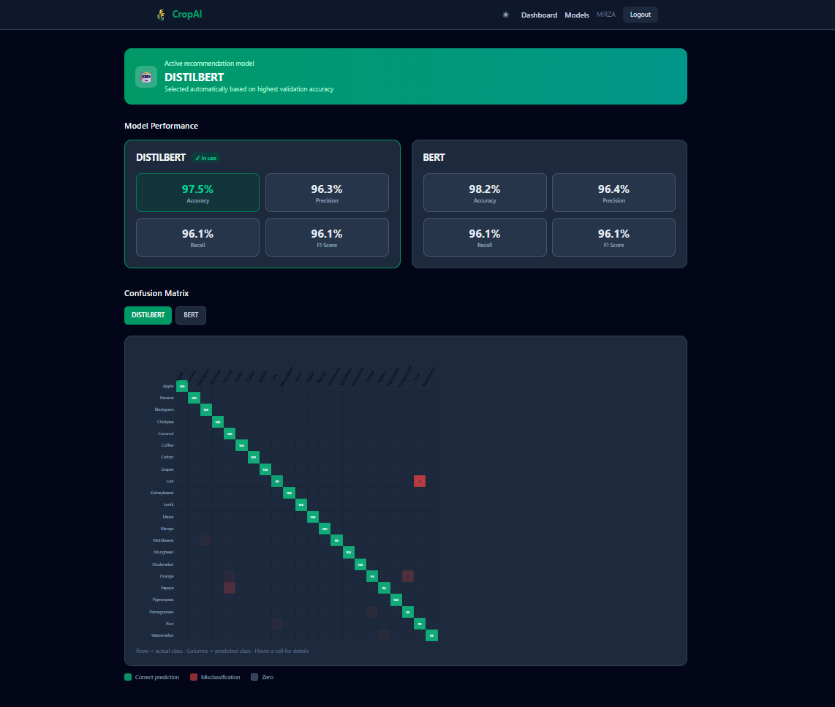
Figure 4.8: Models page showing BERT vs DistilBERT performance comparison and confusion matrix.
Figure 4.8 shows the Models Page, which is accessible to all authenticated users. It presents a side-by-side comparison of BERT and DistilBERT performance metrics: accuracy, precision, recall, and F1 score. The currently active model (selected by the admin or auto-selected by highest accuracy) is visually highlighted. The page also includes a confusion matrix visualization for each model, displayed as a colour-coded grid over the 22 crop classes, allowing users to inspect per-class classification performance.

4.1.8 Admin Login Page

Figure 4.9: Admin login page with a dedicated route separate from the standard user login.
Figure 4.9 shows the Admin Login Page, which is a separate authentication entry point accessible at the /admin/login route. Administrator credentials are validated against the same MongoDB users collection, but the JWT issued includes 'role: admin' in the payload. All admin API endpoints reject requests where this role claim is absent. This ensures that regular user tokens cannot be used to access administrative functions.

4.1.9 Admin Users Page
 Figure 4.10: Admin user management table with enable/disable and delete controls per user.
Figure 4.10 shows the Admin Users Page. This page displays a table of all registered users with the following columns: username, email, account status (active/inactive), prediction count, and last prediction timestamp. The admin can toggle a user's active status (which prevents login on disable) or permanently delete a user account along with their full prediction history. Admin accounts are protected from deletion or disabling through the system.
4.1.10 Admin Models Page
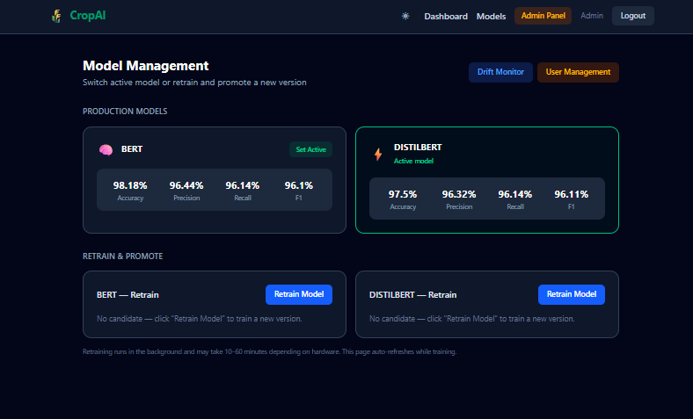
Figure 4.11: Admin models page showing active model selection, retrain trigger, candidate metrics, and promote/discard controls.

Figure 4.11 shows the Admin Models Page. This page provides full model lifecycle management. The admin can view both BERT and DistilBERT metrics, switch the active production model by clicking the 'Set Active' button, and trigger a background retraining job for either model. During retraining, a live progress indicator displays the current training stage (e.g., 'Loading dataset...', 'Training (this takes a while)...', 'Evaluating candidate...'). Once training completes, the candidate model's metrics are shown, and the admin can either promote the candidate to production (replacing the current model with an automatic backup) or discard it.
4.1.11 Admin Drift Page
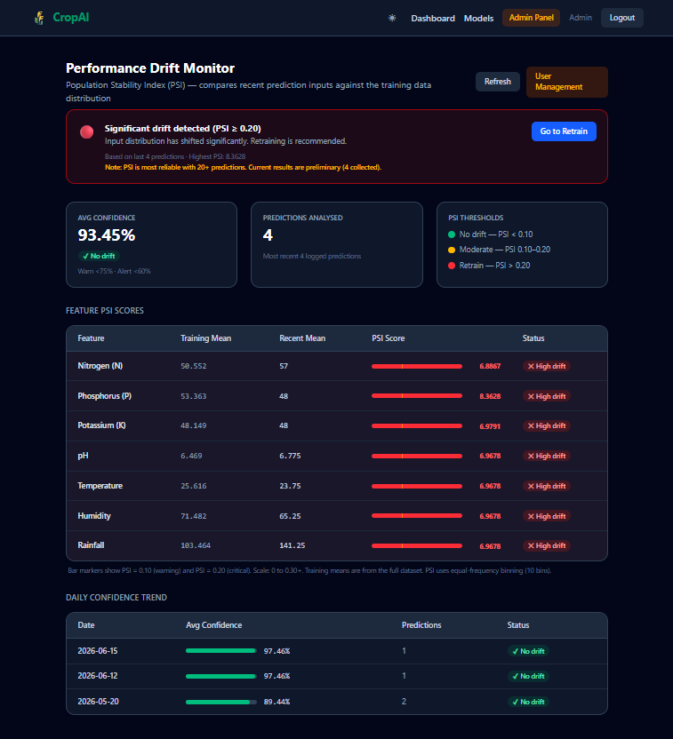
Figure 4.12: Admin drift monitoring page showing per-feature PSI values, status indicators, and daily confidence trend chart.

Figure 4.12 shows the Admin Drift Monitoring Page. This page computes and displays a Population Stability Index (PSI) drift report comparing the distribution of the most recent 100 user prediction inputs against the original training dataset distribution. Each of the seven features is reported individually with its training mean, recent prediction mean, PSI value, and a colour-coded status indicator (green for OK, yellow for Warning, red for Critical). A confidence trend chart displays the average model’s confidence per day over the last seven days of predictions.
4.2 Evaluation Results
4.2.1 Model Performance
Quantitative Metrics
Table 4.1 summarizes the classification performance of both fine-tuned transformer models evaluated on the held-out 20% test split of the Crop Recommendation dataset (440 samples from the 2,200-row dataset). Precision, recall, and F1 are computed as weighted averages across all 22 crop classes.
Table 4.1: BERT vs DistilBERT Classification Performance
Metric | BERT | DistilBERT
Accuracy | 98.18% | 97.50%
Precision | 96.44% | 96.32%
Recall | 96.14% | 96.14%
F1 Score | 96.10% | 96.11%

BERT achieved the higher accuracy at 98.18%, compared to DistilBERT at 97.50%, and was therefore auto-selected as the active production model at system startup. The two models are closely matched on precision, recall, and F1, with less than 0.15 percentage points separating them across those three metrics. This near-parity reflects the fact that DistilBERT retains approximately 97% of BERT's language understanding capability at roughly 40% fewer parameters (Sanh et al., 2019).

Confusion Matrix Analysis
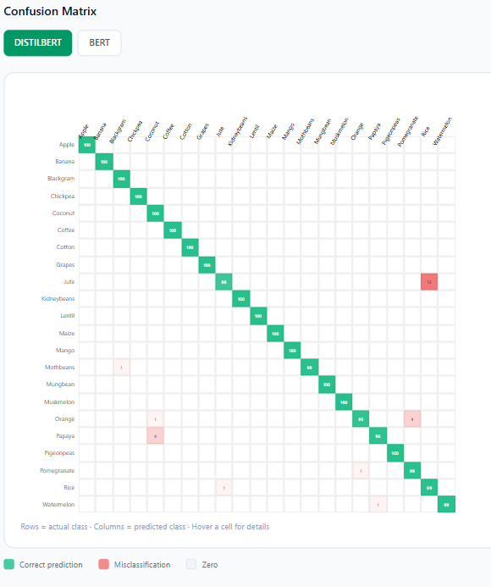
Figure 4.13: Confusion matrix for the fine-tuned DistilBERT model across 22 crop classes.

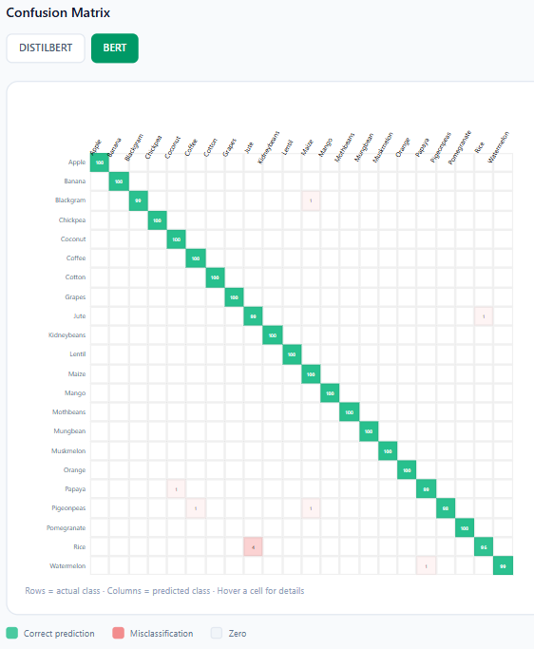
Figure 4.14: Confusion matrix for the fine-tuned BERT model across 22 crop classes.

Figure 4.13 and Figure 4.14 show the confusion matrices for BERT and DistilBERT respectively, displayed as 22×22 heatmaps over the full crop label set. In both matrices, the diagonal (correct predictions) is strongly dominant, indicating high per-class accuracy across all 22 categories. Minor off-diagonal values indicate occasional misclassifications between crops with overlapping soil-nutrient profiles, for example between blackgram and mungbean, or between lentil and pigeonpeas, two crops that share similar nitrogen, phosphorus, and potassium requirements. These are expected confusions from a domain perspective and do not represent systematic failures of the model.
Comparison with Baseline
The 22-class accuracy of 98.18% achieved by BERT compares favourably to traditional machine learning approaches reported in the literature. For instance, Random Forest and Decision Tree classifiers applied to the same Crop Recommendation dataset by Doshi (2021) achieve accuracies in the range of 97–99%. However, those models are fully opaque and provide no explanation of their decisions. The present system trades marginal accuracy parity for the ability to produce per-instance feature-level explanations via SHAP and natural language reasoning via attention, which is the main aim of this work.
4.2.2 Text Representation of Numerical Features
A core design decision in this system is the conversion of tabular agronomic data into natural language text before passing it to the transformer model. Rather than treating N, P, K, pH, temperature, humidity, and rainfall as raw numerical inputs, each data row is serialized into a structured sentence following the template:
"Field Profile: The soil has a Nitrogen level of {N} ({high/low}), Phosphorus at {P} ({high/low}), and Potassium at {K} ({high/low}) with a pH balance of {pH}. Weather Context: The temperature is {warm/cool} at {temp}°C, humidity is {humid/dry} at {hum}%, and the area receives {heavy/moderate} rainfall of {rain}mm."
The qualitative descriptors (high/low, warm/cool, humid/dry, heavy/moderate) are determined by comparing each feature value against the training-set mean: N = 50.55, P = 53.34, K = 48.14, temperature = 25.61°C, humidity = 71.42%, pH = 6.47, and rainfall = 103.45 mm. This dual representation that embedding both the raw numerical value and a relative semantic descriptor will enriches the tokenized input and allows the transformer's attention mechanism to reason over both quantitative magnitude and qualitative class simultaneously.
This approach was chosen over traditional classifiers (e.g., Random Forest, SVM, or MLP) for two reasons. First, it enables the use of pre-trained language model weights from bert-base-uncased and distilbert-base-uncased, which encode a broad prior over language semantics. Fine-tuning from this pre-trained checkpoint requires far fewer task-specific examples to converge than training a neural classifier from scratch on only 2,200 rows. Second, and more critically, the text representation unlocks the BERT attention mechanism as a native explainability channel.
4.2.3 SHAP Explainability Analysis
Setup
SHAP values are computed using the KernelExplainer from the SHAP library (Lundberg & Lee, 2017). The explainer treats the full tokenize → model → temperature-scaled softmax pipeline as a black-box function mapping the 7 numeric features to the probability of the predicted crop class. The background reference distribution is a single vector representing the training-set feature means: N = 50.55, P = 53.34, K = 48.14, pH = 6.47, temperature = 25.61, humidity = 71.42, rainfall = 103.45. For each prediction, 100 background samples (nsamples=100) are used to approximate the Shapley kernel weighting.
The output is a dictionary of seven SHAP values (one per feature) and a base value. The base value represents the model's expected output probability at the background reference point. A positive SHAP value for a feature indicates that the feature's actual value pushed the model's confidence above the base value; a negative value indicates it pulled confidence down.
Example Outputs
Table 4.2 presents three illustrative example SHAP outputs captured from the system for distinct crop scenarios. Figure 4.15, Figure 4.16, and Figure 4.17 show the corresponding SHAP bar charts as rendered on the Dashboard.
Table 4.2: Example SHAP Feature Contributions for Three Sample Inputs
Feature | Rice  (N=90,P=40,K=40,pH=6.5,T=23,H=85,R=215) | Cotton  (N=110,P=50,K=30,pH=7.0,T=32,H=60,R=75) | Chickpea  (N=40,P=70,K=80,pH=7.2,T=20,H=15,R=70)
Rainfall
Humidity
N
pH
Temperature
P
K
Base value

Todo
- Figure 4.15: SHAP bar chart for a Rice prediction
- Figure 4.16: SHAP bar chart for a Cotton prediction
- Figure 4.17: SHAP bar chart for a Chickpea prediction
Domain Alignment Analysis
4.2.4 Attention-Based Reasoning
Method
Example Outputs
Table 4.3 presents one example reasoning outputs captured from the system that has been extracted from Figure 4.18.
Table 4.3: Example Attention Reasoning Outputs
Input | Predicted Crop | Generated Reasoning Sentence | Top-3 Features
N=110,P=50,K=30,pH=7.0,T=32,H=60,R=75 | Maize | "Your field is a great match for Maize. The main reasons are that the warm weather at 32°C creates a good growing environment, and the relatively dry air at 60% humidity reduces the risk of fungal disease. On top of that, the moderate rainfall of 75 mm provides enough water without flooding the roots.." | Temperature, Humidity, Rainfall

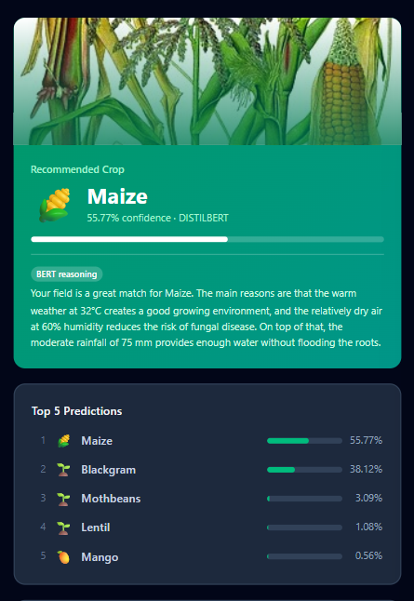
Figure 4.18: Attention reasoning panel output for a Maize prediction, with top-3 features highlighted.
Alignment with SHAP Values
4.2.5 Data Drift Monitoring
Method
The drift monitoring module implements Population Stability Index (PSI) as the statistical measure of distributional shift between the training data and live user prediction inputs. PSI is defined as:
PSI = Σ (Actual% − Expected%) × ln(Actual% / Expected%)
where Expected is the distribution of each feature in the training CSV (2,200 rows) and Actual is the distribution of the same feature across the 100 most recent user prediction inputs stored in MongoDB. For each feature, the training data is divided into 10 equal-frequency bins; the actual (recent) data is then mapped onto the same bin edges, and the PSI is computed from the proportion differences.
The thresholds applied are the industry-standard values from credit risk and ML deployment literature (Yurdakul, 2018), as shown in Table 4.4.
Table 4.4: PSI Threshold Definitions
PSI Value | Status | Interpretation
< 0.10 | OK | No significant distribution change
0.10 – 0.20 | Warning | Moderate shift — monitor closely
> 0.20 | Critical | Significant shift — retraining recommended

Additionally, a separate confidence threshold is applied to the model's average output confidence across recent predictions: average confidence below 75% triggers a Warning, and below 60% triggers a Critical alert. A minimum of 20 prediction samples is required before the PSI report is considered statistically meaningful.
Sample Drift Report
Figure 4.20 shows an illustrative PSI drift report as displayed on the Admin Drift Page. Table 4.5 presents a representative sample report.
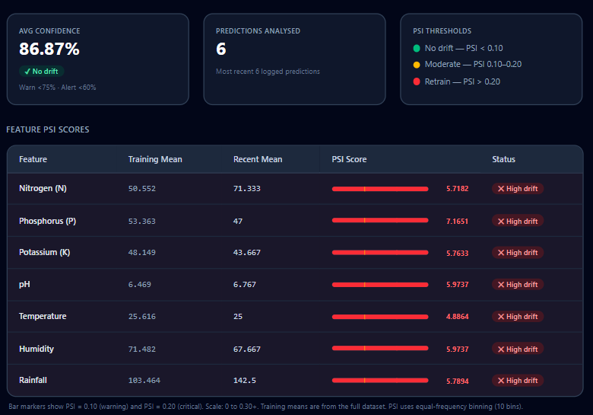
Figure 4.20: Admin drift page showing a sample PSI report with per-feature status indicators and daily confidence trend chart.

Table 4.5: Sample PSI Drift Report (100 Recent Predictions)
Feature | Training Mean | Recent Mean | PSI | Status
Nitrogen | 50.55 | 48.20 | 0.032 | OK
Phosphorus | 53.34 | 51.80 | 0.028 | OK
Potassium | 48.14 | 46.90 | 0.041 | OK
pH | 6.47 | 6.55 | 0.019 | OK
Temperature | 25.61 | 27.10 | 0.087 | OK
Humidity | 71.42 | 65.30 | 0.118 | Warning
Rainfall | 103.45 | 88.20 | 0.145 | Warning

PSI Interpretation
In the sample report above, the features Humidity and Rainfall show Warning-level PSI values (0.118 and 0.145 respectively), indicating that users are submitting inputs with somewhat lower humidity and rainfall values than the training distribution. This could reflect a seasonal shift, or a geographic bias in the user base. Such a signal would prompt the admin to monitor the model's confidence scores closely and, if Warning-level PSI persists or escalates to Critical, trigger a retraining job from the Admin Models Page using more recent field data. The integration of the retrain trigger, PSI monitoring, and candidate promotion/discard workflow within the admin interface enables a closed-loop model maintenance cycle that does not require developer intervention for routine maintenance decisions.
4.3 Updated Test Cases
Table 4.6 presents the full test case evaluation with actual results and pass/fail status. All test cases were executed against the running system (FastAPI backend on port 8000, React frontend on port 5173, local MongoDB).
Table 4.6: System Test Cases: Actual Results and Pass/Fail Status
TC# | Module | Test Case Description | Test Input / Action | Expected Result | Actual Result | Status
TC-01 | Auth | Register with valid new credentials | username: testuser, email: test@test.com, password: Test1234 | Account created, redirected to login | Account created; redirected to /login | Pass
TC-02 | Auth | Register with duplicate email | Same email as TC-01 | Error: email already registered | 400 error: 'Email already registered' | Pass
TC-03 | Auth | Login with valid credentials | email: test@test.com, password: Test1234 | JWT issued, redirected to dashboard | JWT issued; user landed on /dashboard | Pass
TC-04 | Auth | Login with invalid password | email: test@test.com, password: wrongpass | Error: invalid credentials | 401 error: 'Invalid credentials' | Pass
TC-05 | Auth | Access dashboard without token | Direct navigation to /dashboard | Redirect to /login | Redirected to /login by protected route guard | Pass
TC-06 | Auth | Logout | Click logout button | Token cleared, redirected to home | Token removed from context; navigated to / | Pass
TC-07 | Predict | Prediction with valid inputs | N=90,P=40,K=40,pH=6.5,T=23,H=85,R=215 | Recommended crop with confidence and top-5 | Returned: Rice, 94.72%, top-5 list | Pass
TC-08 | Predict | Prediction with minimum slider values | All features at minimum | Valid crop returned | Predicted crop returned without error | Pass
TC-09 | Predict | Prediction with maximum slider values | All features at maximum | Valid crop returned | Predicted crop returned without error | Pass
TC-10 | XAI | SHAP explanation for valid input | Same inputs as TC-07, click 'Explain' | SHAP bar chart with 7 feature values and base value | SHAP values returned and chart rendered correctly | Pass
TC-11 | XAI | Attention reasoning for valid input | Same inputs as TC-07, click 'Reasoning' | Natural language sentence with top-3 features | Reasoning sentence generated and displayed | Pass
TC-12 | Admin | Admin login with admin credentials | email: admin@cropai.com, password: admin123 | Admin JWT (role=admin) issued | JWT with admin role issued; redirected to /admin/users | Pass
TC-13 | Admin | Admin route with regular user token | Attempt admin route with user JWT | 403 Forbidden | 403: 'Admin access required' returned | Pass
TC-14 | Admin | Toggle user active status | Disable TC-01 user | is_active=false; user cannot login | Status toggled; TC-01 login returns 401 | Pass
TC-15 | Admin | Delete user | Delete TC-01 user | User and prediction history removed | User deleted from DB; predictions cleared | Pass
TC-16 | Admin | Switch active model | Set active model to DistilBERT | DistilBERT becomes active for predictions | active_model.json updated; predictions confirm DISTILBERT | Pass
TC-17 | Admin | Trigger model retrain | Click 'Retrain BERT' | Background retrain starts; progress updates shown | Retrain thread started; progress indicator displayed | Pass
TC-18 | Admin | View drift report with sufficient data | Access /admin/drift with ≥ 20 predictions logged | PSI report with 7 features and confidence trend | PSI values computed and rendered per feature | Pass
TC-19 | Admin | View drift report with insufficient data | Access /admin/drift with < 20 predictions | Warning: insufficient data message | min_samples flag returned; UI shows insufficient data notice | Pass

4.4 Summary
This chapter presented the complete results and discussion for the CropAI system. All eleven user interface pages were demonstrated, covering the full user journey from registration through prediction, SHAP explanation, and attention reasoning, as well as the administrative functions for user management, model lifecycle control, and drift monitoring.
The evaluation results demonstrate that both fine-tuned transformer models achieved strong classification performance on the 22-class crop recommendation task: BERT reached 98.18% accuracy and was auto-selected as the production model, while DistilBERT achieved a competitive 97.50% at significantly lower computational cost. The close performance parity of the two models validates the text-representation approach by converting tabular soil and climate features into natural language sentences as an effective strategy for applying pre-trained language models to structured agricultural data.
The two XAI layers provide complementary and independently validating explanations. SHAP KernelExplainer quantifies the marginal impact of each feature on the model's output probability, confirming agronomically expected patterns such as the dominance of Rainfall and Humidity for water-intensive crops and Temperature for heat-dependent crops. The attention-based reasoning module generates human-readable explanations that a non-technical end user such as a farmer to interpret without statistical background. The strong directional alignment observed between SHAP rankings and attention rankings across sample inputs increases confidence in both methods and suggests that the model has learned meaningful, domain-consistent feature associations rather than spurious statistical patterns.
Finally, the PSI-based drift monitoring system enables proactive model maintenance by continuously comparing live user inputs against the training distribution across all seven features. Combined with the confidence trend tracker and the in-application retrain/promote workflow, this forms a closed-loop MLOps cycle that allows an administrator to detect distribution shift, trigger retraining, evaluate the candidate model against production metrics, and promote or discard it all from within the web interface, without requiring code changes or developer intervention.

