1. **i. BubbleSort Algorithm**

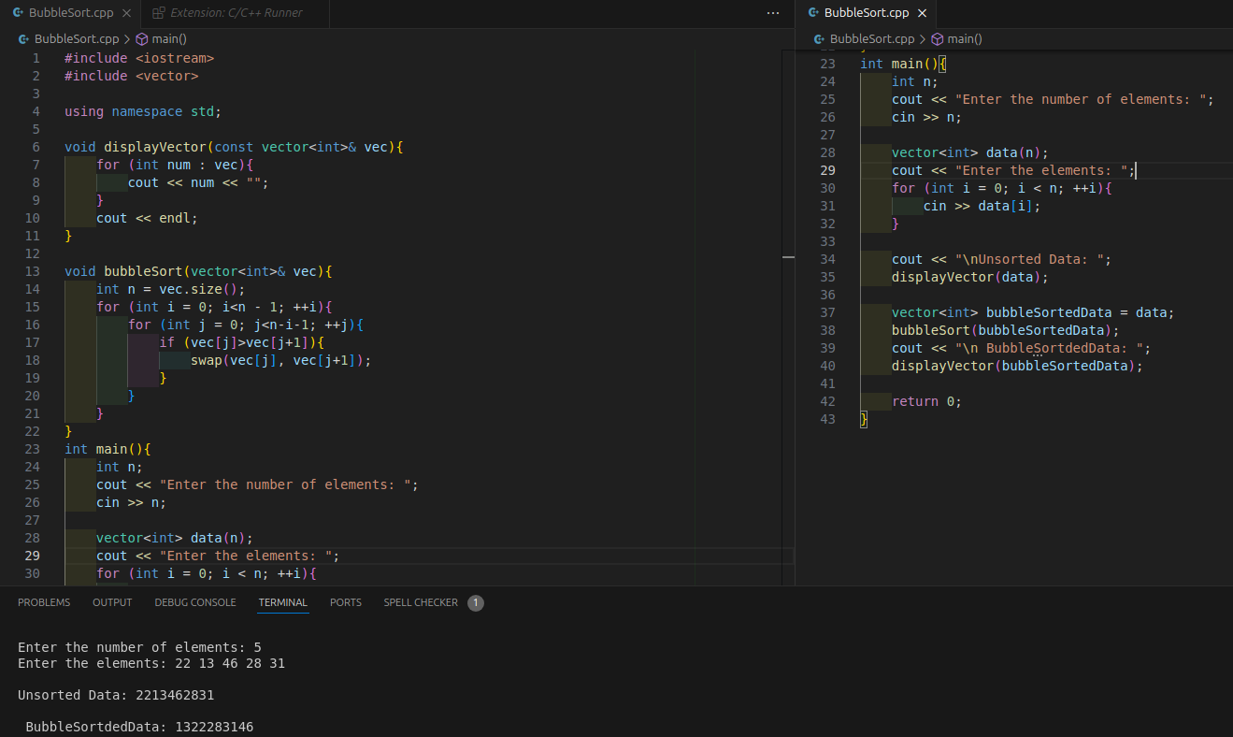

**ii. Selection sort.**

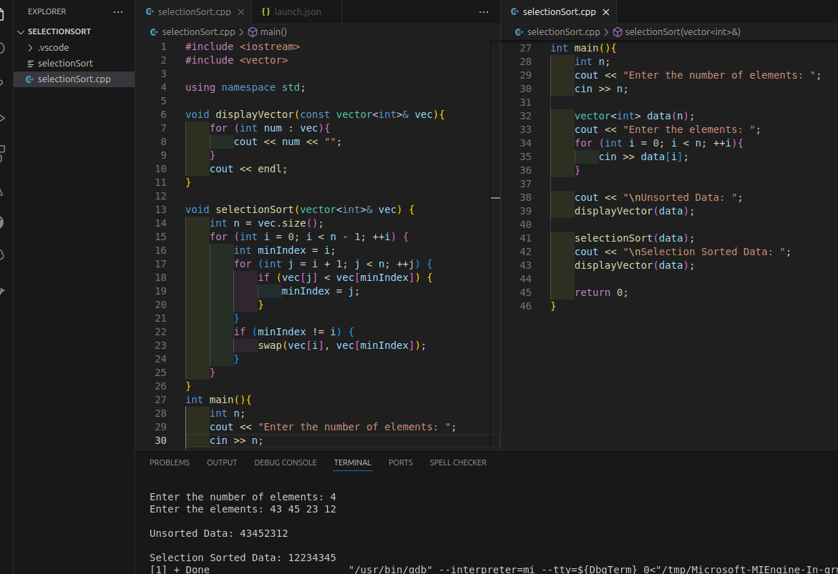

1. **Singly Linked List**

